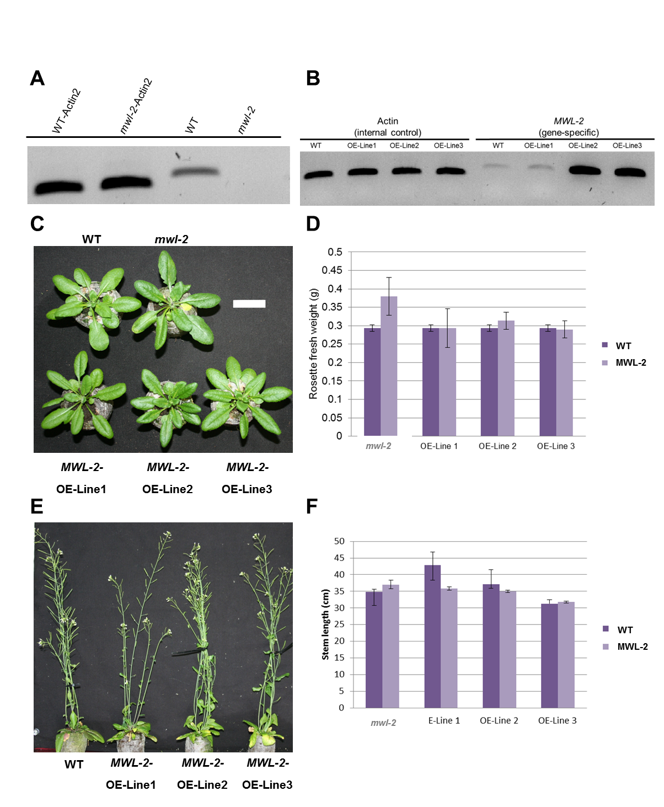
*
S4 Fig. Phenotypic analysis of At4g19370 (MWL-2) single T-DNA knockout line mutants and MWL-2 overexpression lines.
(A) RT-PCR detection of endogenous MWL-2 transcript in the wildtype (WT) plants and absence in the single knockout mutant. (B) Semi-quantitative RT-PCR analysis of MWL-2 overexpression lines 1 to 3 showing detection of MWL-2 transgene in the transgenic lines except for OE1 which could be indicative of positional effect (position in the genome), or co-suppression dominant repression. Actin2 was used as a control gene and RT-PCR was performed on stem tissue. Actin2 and MWL-2 gene-specific oligonucleotide sequences can be found in Table S1. Rosette size (C) and mass (D) of MWL-2 single T-DNA knockout line and overexpression lines 1-3 relative to (WT) control line at four weeks. Qualitative (E) and quantitative (F) stem length of MWL-2 single T-DNA knockout line and overexpression lines relative to WT control at six weeks. For rosette mass n = 3 and for quantitative stem length n = 66. Error bars indicate the standard error while significant difference from the WT based on a two-tailed Student’s t-test (P-value ≤ 0.05) is indicated by *. Scale bar, 3 cm. No significant differences were seen in the growth and development of the single mutant and transgenic OE lines in comparison to the WT controls except for OE-Line 2.

