SUPPLEMENTARY MATERIAL FOR PRACTICAL IMPLICATIONS
(Dental and surgical controversial practices during the marsupialization procedure for the treatment of nasopalatine duct cysts.)

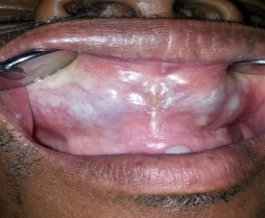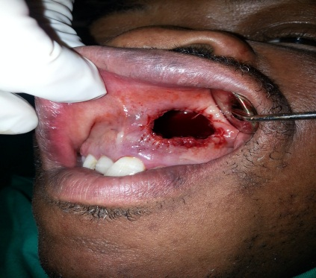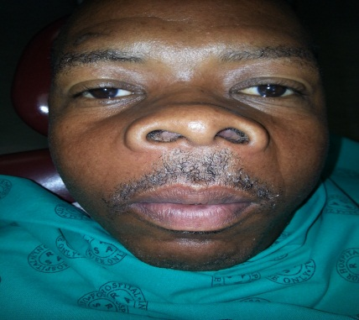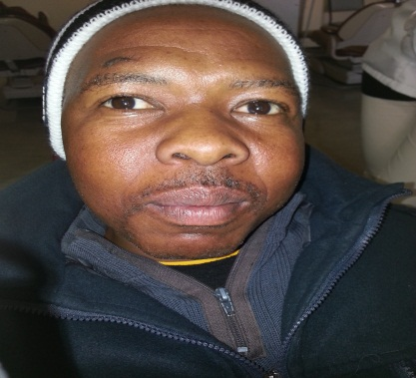
D[Type a quote from the document or the summary of an interesting point. You can position the text box anywhere in the document. Use the Drawing Tools tab to change the formatting of the pull quote text box.]
C[Type a quote from the document or the summary of an interesting point. You can position the text box anywhere in the document. Use the Drawing Tools tab to change the formatting of the pull quote text box.]
B[Type a quote from the document or the summary of an interesting point. You can position the text box anywhere in the document. Use the Drawing Tools tab to change the formatting of the pull quote text box.]
A
The swelling has just collapsed after marsupialization. No packing needed (Fig. A and B). Steady reduction in volume with immediate postoperative changes in facial disfigurement (Fig. C and D).
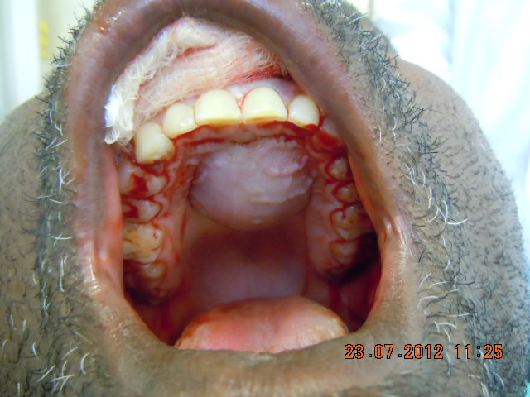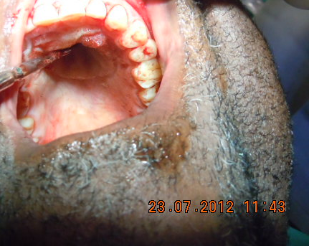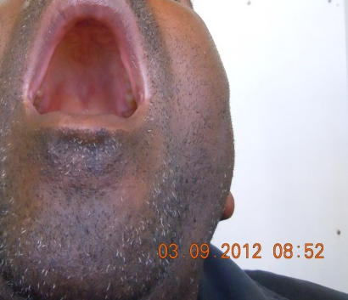
Immediate collapse of the palatal bulging followed by original and normal palate shape two months later (July to September 2012). No postoperative packing of the cystic cavity used.
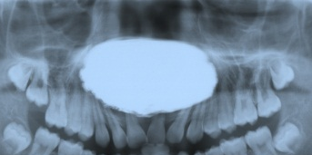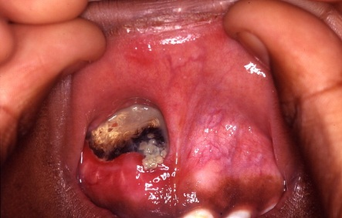
B[Type a quote from the document or the summary of an interesting point. You can position the text box anywhere in the document. Use the Drawing Tools tab to change the formatting of the pull quote text box.]
A[Type a quote from the document or the summary of an interesting point. You can position the text box anywhere in the document. Use the Drawing Tools tab to change the formatting of the pull quote text box.]
The cavity needs to be fully packed with gauze to avoid it becoming a food trap (Fig. A). This creates an intracystic positive pressure opposing the steady reduction of the cystic volume. The gradual removal of the gauze, as it is some times the practice before secondary enucleation is performed, provides exactly the food trap and makes it difficult for patients to maintain good oral hygiene (Fig. B).

