A best way forward to the organisation of entomological training courses in sub-Saharan Africa

Abstract

Despite their significant impact on human life in the Afrotropical Region, Diptera remain understudied. For a large part this is due to a lack of Diptera taxonomic experts and collection curators from the Afrotropical Region (except for South Africa perhaps), the difficulties some developing countries face in maintaining collections, and the low number of digitised specimens. This impedes the use of these Diptera collections for identification services, taxonomic and phylogenetic research, and other biological research areas. The dire need for knowledge transfer and training of young and emerging entomologists in the Afrotropical Region has prompted the Royal Museum for Central Africa and collaborating institutions to organise entomological training courses in the Afrotropical Region. The training courses take place in Africa, in strategic locations, cover a period of ten working days, are taught in English, and are free of cost to participants and lecturers. Here, we first provide a brief history of the evolution of the training courses. Second, we give a short description of the gender, age, educational and professional profile of the applicants and participants of the training courses. Third, we provide as much information as possible on all aspects of the organisation of the training courses. All information is freely available and documents are provided in Word or Excel format to facilitate future use by others. This information will hopefully stimulate and facilitate the organisation of other entomological (or similar) training courses in the Afrotropical Region and other biogeographical regions. Such training courses will stimulate South-South networks for entomology research and the simultaneous training of participants with a different educational or professional background might foster collaborations between universities, other scientific institutions in postgraduate training and research. They may also initiate collaboration between scientific institutions and those involved in management, policy making, outreach, or implementation of legal procedures. We believe that this kind of training courses presents a best way forward in the organisation of similar capacity building activities that will contribute to a sustainable network of entomologists. Finally, these training courses may be one of the many possible ways to reduce the gender inequality gap in biological sciences in the Afrotropical Region.
Keywords: Afrotropical Region, agriculture, biodiversity, capacity building, collection management, Diptera, education, insects, knowledge transfer, pest species, pollination, teaching, true flies.

Introduction
Diptera, or true flies, constitute one of the largest orders of insects on Earth with almost 160,000 described species (Courtney et al., 2009). Approximately 20,000 of these occur in the Afrotropical Region (or sub-Saharan Africa) where they are found across a diversity of habitats (Kirk-Spriggs, 2017). They are a significant group of insects with economic importance and have a considerable impact on the environment. Whilst numerous species are of medical or veterinarian importance or serious agricultural pests, many other Diptera species exert crucial ecosystem functions as they may serve as biological control agents, foods for other animals, pollinators, seed dispersers, or even produce useful products (e.g., Borkent, 2017). The immature stages of many species are predators and parasitoids of pest species, whereas some are scavengers, recycle organic matter or may serve as a supplementary diet for higher organisms.
The four-volume book Manual of Afrotropical Diptera (of which the first three volumes have been published; see: https://www.nhm.ac.uk/our-science/research/projects/manual-afrotropical-diptera.html ) is a collaboration of over 90 international experts on Diptera (Picture 14). It is the first-ever synopsis of the 108 families of true flies that occur in the Afrotropical region. The work provides the basics for understanding the diversity of one of the largest groups of insects in a tropical and sub-tropical region. It is also the first synopsis of its kind for any major insect order occurring in the Afrotropical Region. Remarkably, fewer than ten of the international experts who wrote the various family chapters are from the Afrotropical Region, all of these are white South Africans and all but one are male. While unintentionally, it reflects the underrepresentation of especially black and female African Diptera specialists in the region, a pattern noted by various authors in biological sciences (Graves, 2019; Huang, 2020; Midgley, 2020).
In general, multiple scientific fields and disciplines suffer from skills shortages in Africa (e.g., Dorman et al., 2009; Rasool and Botha, 2011), where this also holds for dipterology, for which there are very few experts in the Afrotropical Region (except for South Africa perhaps). Broadly, skilled professionals are more likely to leave their home countries for work, resulting in a lower skill base remaining. While socioeconomic factors have a broad influence on migration (Rasool and Botha, 2011), developing skills within Africa can mitigate some of the lost skills. While we present a detailed description of the courses we have organised, our primary goal is to make our experiences available to others that they might organise effective training courses in sub-Saharan Africa. The detail we present is intended to show the planning detail needed, but our hope is that the documents will be of broad use in many disciplines.
Moreover, the status of some developing countries’ collections remains uncertain and have suffered from insufficient financial support or may have been destroyed entirely. Amongst other reasons, many of the collections do not have dedicated curators and large parts of the collections have not been digitised. This impedes the use of the Diptera collections for identification services, taxonomic and phylogenetic research, and other biological research areas that require the availability and proximity of a well-identified, staffed and maintained Diptera collection (Kirk-Spriggs, 2017). The latter reference provides an overview of the major Diptera collection resources, and their current status, in the Afrotropical Region.
Given their significant impact on human life and the lack of Diptera taxonomic experts and collection curators in the Afrotropical Region, there is a dire need for knowledge transfer and training of young and emerging entomologists in the region. Very few attempts to establish a network of taxonomic and curator experts have been made for any of the Diptera families of the Afrotropical Region. One exception is the family Tephritidae (fruit flies), for which many training courses have been organised in the region. These include those organised by the Southern African Development Community (SADC) (and funded by the Food and Agriculture Organisation of the United Nations (FAO)) in Mozambique (2020), regional FAO/International Atomic Energy Agency (IAEA) training courses in Benin (2012, 2019), Réunion Is. (2012), Kenya (2017), and Mauritius (2016, 2019), and training courses organised, and/or funded by the U.S. Department of Agriculture (USDA), Animal & Plant Health Inspection Service (APHIS), and the International Center for Insect Physiology and Ecology (ICIPE) in Kenya, and in which the Royal Museum for Central Africa (RMCA, Belgium) was a co-organising partner in three of these (2009, 2010, 2013). The average number of participants in these training courses varied between 10 and 15 people per training course and most participants were invited by either the organiser, the funding agency, or appointed by the respective country’s official body who received the invitation. To accommodate for the growing need for general training courses in entomology, the Invertebrates Section of the Royal Museum for Central Africa (RMCA) (https://www.africamuseum.be/en/research/discover/biology/invertebrates) and co-organising institutes have organised several training courses covering all aspects of dipterology in the Afrotropical Region.
The Invertebrates Unit at the RMCA has a strong expertise in the taxonomy, phylogeny, biogeography and biodiversity of tropical African invertebrates, including Diptera. Initially, the research on Diptera of the unit focused on true fruit flies (Tephritidae), with emphasis on those groups that are frugivorous on cultivated crops and wild plants. Its main objectives were to define the diversity in different agro-ecological and biogeographical zones, and to monitor their seasonal abundance and spread, with the ultimate aim to develop integrated pest management strategies to control several pest species. The research was, however, strongly impeded by a lack of African taxonomists who were able to identify Afrotropical fruit flies. To accommodate the growing demand for African taxonomic specialists, the RMCA launched biennial training courses on ‘Taxonomy of Tephritidae of the Afrotropical Region’, whereby participants received training in the morphology, classification, identification, identification methods, collection, and preservation methods of Tephritidae. The course also included several general ecological aspects, such as host plant range, phenology, and control. Five successful training courses were organised between 2009 and 2018 (Table 1). In recent years, the focus of the research within the unit broadened towards other Diptera families that provide ecosystem functions, such as pollination: Bombyliidae (bee flies), Nemestrinidae (tangle-veined flies), Calliphoridae (blow flies, including the subfamily Rhiniinae (nose flies)), Syrphidae (hoverflies or flower flies), and pangonine Tabanidae (horse flies). As a result, training course objectives also shifted to these groups and five of these pollinating Diptera-focused training courses have been organised.
The training courses were designed for 11–15 African scientists and professionals confronted with the identification and ecology of African Diptera. Training courses take place over ten working days and are taught in English. The training team consists of one local organiser and 3–4 expert lecturers. For the latter, in addition to staff members of the RMCA, several African experts are invited to strengthen South-South collaborations (Picture 14). The training includes ex-cathedra courses on morphology, classification, identification, identification methods, collection methods, and preservation methods of Diptera, with a special focus on a set of target families listed above. Practical exercises are used to test and provide feedback on the topics presented in the courses. Participants are asked to bring material they may have collected for identification during the practical work sessions. At the end of each training course, participants are requested to evaluate their experience so that the feedback can be used to improve subsequent training sessions.
The RMCA, together with partner institutes in Africa and Europe, has now organised ten training courses (Table 1), and has received a large amount of constructive feedback from both the participants, the local organisers and the expert lecturers which has improved the overall organisation of the training courses (see Lessons learned, conclusions and future perspectives below). Here, we compile all practical information and experience gained in these training courses and present a best way forward in the organisation of similar capacity building activities. This practical guide has three sections. First, we provide a brief history of the evolution of the training courses. Second, we give a short description of the gender, age, educational and professional profile of the applicants and participants of the training courses. Throughout the document we refer to people who applied for a training course as ‘applicants’ and applicants selected to participate in the training as ‘participants’. Third, we provide as much information as possible on all aspects of the organisation of the training courses. This will hopefully stimulate and facilitate the organisation of other entomological (or similar) training courses in the Afrotropical Region and other biogeographical regions. Indeed, all information presented herein is freely available and documents are provided in Word or Excel format to facilitate future use by others. Given that the authors have organised two major types of training courses (one focussing on a single family (Tephritidae), another focussing on pollinating Diptera), we provide the information for both training courses separately wherever relevant.

A brief history of the training courses
All ten training courses discussed herein were organised by the RMCA and co-organised by a number of other institutes. The first training courses focused on Afrotropical fruit flies (Diptera: Tephritidae) (Table 1). The first three of these (2009, 2011, 2013), took place at the RMCA in Belgium and were co-organised by the Sokoine University of Agriculture (SUA, Morogoro, Tanzania) (Table 1). The last two fruit fly training courses took place at SUA in Tanzania (2015, 2018). Lecturers of all fruit fly training courses were from the RMCA and SUA, together with lecturers from different African institutions, such as Citrus Research International (CRI, Nelspruit, South Africa), University of Abomey-Calavi (UAC, Benin), University of Pretoria (UP, South Africa), and experts from other regions (University of Queensland, Brisbane, Australia). From 2017 onwards, the focus shifted to pollinating Diptera with emphasis on Bombyliidae, Nemestrinidae, Rhiniinae (Calliphoridae), Syrphidae, and Pangoninae (Tabanidae) (Table 1) (but see Discussion on the expert training courses below). The pollinating Diptera training courses took place in Kenya (2017), Tanzania (2019, 2021, 2023) and South Africa (2022). The 2017 training in Kenya was co-organised by the International Centre of Insect Physiology and Ecology (ICIPE, Nairobi, Kenya), with lecturers from the KwaZulu-Natal Museum (KZNM, Pietermaritzburg, South Africa), the National Museum Bloemfontein (BMSA, Bloemfontein, South Africa), and the National Museums of Kenya (NMK, Nairobi, Kenya). The 2019 and 2021 training courses were co-organised by SUA, with lecturers from KZNM and the Natural History Museum UK (NHMUK, London, UK). The 2022 training in South Africa was co-organised by the University of KwaZulu-Natal (UKZN) and the KwaZulu-Natal Museum (KZNM) with lecturers from KZNM, BMSA, and assistance from the Albany Museum (AMGS, Makhanda, South Africa). This training took place at Shawswood in the Karkloof Region of the province of KwaZulu-Natal (South Africa), which is a self-catering accommodation (see Discussion below). Finally, the 2023 training course was co-organised by SUA with lecturers from KZNM and the African Natural History Research Trust (ANHRT, Herefordshire, UK) (Picture 14).
The five fruit fly training courses and the 2023 pollinating flies training course were entirely financed through the RMCA’s framework agreement with the Belgian Directorate-General Development Cooperation and Humanitarian Aid (DGD; https://diplomatie.belgium.be/en/about-us/directorate-general-development-cooperation-and-humanitarian-aid-dgd) (Table 1). The 2017 Kenya training course was financed by the JRS Biodiversity Foundation (https://jrsbiodiversity.org/), through the PINDIP (Pollinator Information Network for two-winged Insects (Diptera)) project, while the 2019 and 2021 pollinating Diptera training courses were co-financed through the Belgian DGD and JRS. The 2022 training in South Africa training was co-financed by JRS, the Belgian Science Policy Office (Belspo; https://www.belspo.be/) and the National Research Foundation of South Africa (https://www.nrf.ac.za/) through the DIPTATEACH project (Diptera Museum collections as a source for Taxonomic research and Teaching activities). More information on the projects can be found on the PINDIP website (https://www.pindip.org/projects-1).

Profile of applicants and participants
In the following section we give a short assessment of the applicants and participants based on their nationality, gender, age, home institution, and educational and professional background. The data of the applicants and participants of the 2022 training in South Africa is not considered, since this training was restricted to young and emerging tertiary students and technicians of South Africa only.
Nationality:
Overall, we received a total of 375 applications for the nine training courses, but with a large variation in applications per training course (24‒73) (Table 1). For all training courses together, we received more applications from men (233), than from women (142). Applications were received from 27 countries. Most applicants were from Tanzania (66), Cameroon (30), South Africa (29), and Kenya (28) (Table 2; Fig. 1A). A total of 114 participants from 17 countries have been trained so far, with 11‒15 participants per training course. Most were from Tanzania (16), South Africa (14), and Cameroon (12) (Tabel 2; Fig. 1B).
Gender, age, and professional/educational background:
Of the 114 participants, 55 were women and 59 were men (Tables 1 and 2; Fig. 2). The youngest applicant was 22 years of age and the oldest was 61 years of age, but note that the latter was an exception, being a partner directly involved in some of RMCA’s ongoing scientific projects and that there is usually a maximum age limit of 45 years to be eligible for participation. The age distribution per gender of all applicants is provided in Fig. 2 (2A for men, 2B for women). The mean age of applicants was 34.6 years (33.8 for eligible applicants ≤ 45 years) and that of participants was 33.1 years. Female applicants were on average younger than male applicants (men: 34.6 yrs ; women: 32.4 yrs; student’s t-test: t = 4.58; df = 369 ; p <0.001) (the age of four men was unknown) even when we only considered eligible applicants (i.e., maximum age of 45 yrs) (men: 34.8 yrs; women: 32.3 yrs; t = 4.00 ; df = 350 ; p <0.001). Female participants were on average younger than male participants (men: 34.5 yrs; women: 31.6 yrs; t = 2.93; df = 112; p = 0.004) (Fig. 2C).
Applicants are asked to provide a brief description of their main professional activities. Based on this information, they were classified into one of the following categories: ‘researcher’, ‘technical assistant’, ‘research assistant’, ‘lecturer assistant’, ‘officer’, ‘student’, ‘lecturer’, or ‘other’. In case more than one category was applicable (e.g., some lecturers have a limited research activity or vice versa), the category to which most of their time is allocated was chosen. We have made the distinction between ‘technical assistant’ (assistant focusing on technical aspects of experiments, e.g., engineer, technician involved in rearing programmes, etc. with limited background in biology) and ‘research assistant’ (person with a scientific educational or biological background focusing on scientific aspects of experiments, but not subscribed as MSc or PhD student). A ‘student’ is either subscribed as MSc or PhD student at a university. Most applications were received from researchers (101), technical assistants (65), officers (51), and students (49) (Fig. 3A) and the number of participants in each category is a good reflection of the number of applicants per category (Fig. 3B).
Home institution:
We have grouped the home institution of applicants and participants into six categories: ‘university or higher educational institute’, ‘international research institute’, ‘national research institute’, ‘museum’, ‘government’ or ‘other’. ‘National Research Institutes’ are institutes with a pure scientific profile, which are partly autonomous, although most of these are part of one of the countries’ governmental departments. ‘Government’ comprises governmental institutes whose main task is not scientific (e.g., agricultural, or environmental ministries, pest surveillance or plant protection offices, etc.). We received applications from 147 different universities or higher educational institutes, (inter)national research institutes, museums, governmental departments, or other institutes (Supplementary Materials S1). Most applications were received from universities or higher educational institutes (145), national research institutes (87), or governmental departments (87) (Fig. 4A). The relative proportion of these categories for the participants reflects the proportions of the applications, with 43.5% and 23.2% of the participants from universities and national research institutes, respectively (Fig. 4B).

Practical and scientific information on the organisation of entomological training courses
This section is based on our experiences compiled during all nine training courses that we have organised to date. We have grouped all information in the following sections: ‘applicants’, ‘local organiser and expert lecturers’, ‘training programme’, ‘teaching materials’ and ‘finances’. All forms and agreements that are discussed are provided as Supplementary Materials S2‒S12 in Word or Excel format to ease adaptations for future use. In Supplementary Materials S14 you will find pictures taken during the training courses and that illustrate the various aspects of the training courses.
Applicants
In this section we describe the announcement of the training and the application procedure, the selection procedure, the confirmation of selected applicants of participation at the training course, and the practicalities before the training course.
Announcement and application procedure
Training courses are announced on the RMCA website (https://www.africamuseum.be/en/research/training), the PINDIP website (https://www.pindip.org/), the DIPoDIP Facebook page (https://web.facebook.com/pollinatingdiptera/), and through specific email lists for Tephritidae and Diptera contacts in the Afrotropical Region, which the RMCA has compiled over the past 15 years (including the Belgian embassies in Africa). Other relevant sites take over the announcement and post it on their own websites. The announcement of the training course (Supplementary Materials 2), comprises the following items: context of the training, preliminary training programme, profile of the participants, admission requirements, instructions for applicants, and scholarship conditions.
- Context of the training: In this paragraph the general context of the training course is given. The training is one of the projected outcomes of ongoing projects of the Invertebrates Section of the Department of Biology at the RMCA. In addition, the aims of the training, the organisation team (i.e., RMCA and co-organising institutes), the local organiser and expert lecturers are briefly presented. It also mentions the funders. Specifically for training on Dipteran pollinators, if applicants want to find out more about the previous training courses, they are referred to the PINDIP website (https://www.pindip.org/trainings).

- Preliminary training programme: A preliminary programme is provided so that applicants can judge whether the training is suitable for their needs. A final programme (see Training Programme below), is provided in the ‘Practicalities’ which are provided at a later date, but before the start of the training course (see Practicalities before the training course).

- Profile of the participants: The training course receives 11–15 participants, among whom employees from agricultural institutes, professors or lecturers of agricultural or biological faculties, researchers from national and international institutes, MSc or PhD students, post-docs, etc. Participants must be engaged with the Diptera target group or groups on a professional level and must have a minimum level of knowledge in basic dipterology or ecology which they have to detail in the motivation letter. The applicants’ maximum age at the start of the training should not exceed 45 years of age. The RMCA has a strong policy of equality of opportunities, and we give special attention to the participation of women in the training courses.

- Admission requirements: In general, it is very important to consider the requirements of the bodies that fund the training, wherever it may be held and whomsoever they may be. Since the training courses held thus far were financed (partly or entirely) by the Belgian DGD, there were certain admission requirements that we followed. Only applicants residing in sub-Saharan Africa (see country list below), and working for an institute, NGO, ministry, research institute, university or higher education institute, could be taken into consideration. Applications from consultants or individuals were generally not accepted, except for candidates from the private sector clearly showing a link to entomology in their professional work. DGD supports collaboration with a number of priority countries. These have changed over the years, reflecting different policies. Under the current regulations of Belgian DGD, participants must be citizens of one of the following countries: Benin, Burkina Faso, Burundi, Democratic Republic of Congo, Guinea, Kenya, Madagascar, Mali, Mozambique, Niger, Rwanda, Senegal, South Africa, Tanzania, Uganda, and Zimbabwe. Yet, if applicants are citizens from another African country, we asked them to contact us before submitting their application. This is because training courses are sometimes co-funded by other funding agencies that allow participants from countries other than those listed above. Scientists with a diploma other than MSc or PhD should demonstrate a record of substantial work related to the subject that is presented (Diptera of the target families; plant-pollinator networks, etc.). All applications are subject to an evaluation by experts (see Evaluation procedure). As the training documents (Manual of Afrotropical Diptera, identification keys, scientific articles, presentations, instructions) are in English, the candidate has to have a good mastery of the language as well and provide their level of English. Non anglophone applicants must provide proof of their level of English or state explicitly their knowledge of the language.

- Instructions for applicants: a complete application contains six separate documents that the applicant must submit. These data are kept until closure of the financial report, and erased afterwards, which is 2–3 months after the end of the training course. The call for a training course is open for three months.
Application form:
An application form can be downloaded from the RMCA website at the following address: https://www.africamuseum.be/en/research/training or from the PINDIP website (https://www.pindip.org/). This application form must be completed, dated, and signed by the applicant. The application form is provided as Supplementary Materials S3.

Motivation letter:
This letter is required to allow the organisers to obtain more information on the motivation and ongoing and future projected activities of the applicant. The motivation letter, written by the applicant, needs to outline why the applicant considers his/herself a good candidate for the training. It should contain an overview of their experience and knowledge of the subject of the training and the immediate perspectives offered by the training in the progress of the applicant’s professional activities (direct or indirect benefits of the training in future research/work). In addition, the letter should demonstrate what would be the benefits of the training to the applicant’s home institute, i.e., how the applicant will use the training results to accomplish biodiversity conservation or pest control objectives in Society by the applicant and the applicant’s institute. An overview should be provided of the applicant’s projects as to the use of the knowledge gained during the training and their intentions to share the knowledge gained during the training, including how the applicant considers the training as a way of strengthening their research network and ongoing or future collaborations with similar institutes, and, more specifically, the perspectives of a continued collaboration between the applicant, the applicants institute, and the (co-) organising institutes. Finally, the applicant needs to specify the activities and results foreseen in the distribution of the knowledge gained during training and indicate the specific target audience and the estimated number of people that could benefit from these retrocession activities (scientific / colleagues of the institute / students / schoolteachers / children / community). They must describe which information channels will be used [e.g., website (a web address must be provided), blog, presentations, education, video, etc.)].

Letter from the employer:
The employer (research institute, ministry, university, etc.), needs to provide a letter to authorise the participation in the requested training, confirming the direct benefits to the institute, confirming the applicant’s current position within the institute, and indicating a commitment to make beneficial use of the newly acquired expertise. The employer must date, sign, and stamp the letter. The name, position, and address of the employer must be clearly mentioned.

Letter of recommendation:
Applicants must provide a letter of recommendation indicating at least why the applicant is particularly well placed or suited for the training. The person providing the letter must date and sign the letter with a clear mention of his/her name, position, and address.

Copies of relevant diplomas:
Applicants must provide copies of relevant diplomas. A good quality copy of the highest diploma is essential.

Copy of the personal data sheet of the applicant’s passport:
A copy of the personal data sheet of the applicant’s passport is needed to verify the personal data of the applicant (e.g., age and nationality which are two eligibility criteria) and to provide the correct flight tickets if needed.

Only complete application files are taken into consideration. The complete application file must be sent before a deadline (usually three months before the start of the training course), to an email address specifically created for the training course. Applicants receive an acknowledgement of receipt of the application within a week after the application form is received. Applications are checked for their completeness and if not complete they may be completed only upon specific request from the main training organiser. All applicants are personally informed of the results within one month of the deadline for application submission.

- Scholarship conditions: In this section we explain that the training comprises ten working days and list the expenses that are reimbursed by the RMCA. The latter include local travel expenses, visa costs, and daily stipends. A fixed allowance is foreseen to cover board, individual transport (i.e., from home to airport of departure in the country of origin and vice versa), and personal expenses of the selected applicant. International travel expenses comprise a round-trip ticket in economy class which is ordered and provided by the main organising institute. Accommodation is provided by the local organiser. In case the accommodation is not full board, a daily allowance (‘stipend’ or ‘per diem’), is given to the participants. In the case of self-catering accommodation, participants are expected to participate in the preparation of the meals and cleaning of the communal area.
Participants are kept informed before their departure of the mandatory procedures required for travel to the country in which the training takes place (e.g., negative PCR COVID test, certificate of vaccination against yellow fever, or any other official document required). Participants need to respect the mandatory health measures applied in the country or by the local organising institute. If during the training, a health crisis was to occur and a lockdown period would be enforced, the continuation of the training will be made as far as possible (online classes), until the safe repatriation of the participants can be ensured.

Selection procedure

The selection of participants for the training uses administrative and scientific criteria. The administrative criteria must be fulfilled before the scientific criteria are considered.

Administrative criteria: these comprise criteria related to the admissibility of the application. These are: age, partner country, and completeness of the six requested documents (see Instructions for application).

Scientific criteria: these comprise criteria related to the relevant scientific experience, ongoing collaboration, potential collaboration, motivation of the applicant, and three additional criteria (gender, change-maker, the inclusion of private sector). Scores (e.g., + 1) indicate the points received by the candidate with respect to the strength of compliance with the criterion. Below, we give a more detailed explanation of these criteria for the Taxonomy and ecology of African fruit flies training course and for the Taxonomy and systematics of African pollinating flies training course.

Taxonomy and ecology of African fruit flies training course

++++ : Score: 4.5 or 5: highly relevant applicant: The applicant is a researcher working on Tephritidae pest control (at a university or museum). Training these applicants in Tephritidae taxonomy, ecology, and control is considered essential for their future professional activities.
+++ : Score: 3–4: very relevant applicant: The applicant is working on insect pest species, but not specifically on Tephritidae, or participates in research on crop protection, but not specifically on the control of Tephritidae. Training of the candidate will allow him/her to expand his/her research to Tephritidae and will thus be an added value to their current professional activities.
++ : Score: 2 or 2.5: relevant applicant: The applicant is working on, or teaching about, the biology of insects in general or is a general curator. The applicant has experience in dipterology, but not in Tephritidae taxonomy, ecology, or control. Training the candidate will have limited value to his/her ongoing professional activities.
+ : Score: 1 or 1.5: less relevant applicant: The applicant is not working on Diptera or is working or teaching in general biology, but not specifically in entomology or Diptera taxonomy or ecology (e.g., pest control or pollination biology). Training these candidates in Tephritidae taxonomy, ecology, and control, does not seem to have a relevant added value to their professional activities.
-: Score: 0 or 0.5: applicant not relevant: The applicant is not working or teaching in entomology, but in other biological aspects. Training these candidates in Tephritidae taxonomy, ecology, and control, will not have any relevant added value to their professional activities.

Taxonomy and systematics of African pollinating flies training course

Relevant scientific experience:
++++ : Score: 4.5 or 5: highly relevant applicant: The applicant is either a Diptera collection manager (at a university or museum) or working on Diptera of the target families, pollination networks, pest control, or related fields in entomology. Training these applicants in Diptera taxonomy is considered essential for their future professional activities.
+++ : Score: 3–4: very relevant applicant: The applicant is working on pollinators, but not specifically on Diptera or participates in research on crop protection, but not specifically on pollination. Training of the candidate will allow him/her to expand his/her research to Diptera and will thus be an added value to their current professional activities.
++ : Score: 2 or 2.5: relevant applicant: The applicant is working on, or teaching about, the biology of insects in general or is a general curator. The applicant has experience in dipterology, but not in pollination biology or pest species. Training the candidate will have limited value to his/her ongoing professional activities.
+ : Score: 1 or 1.5: less relevant applicant: The applicant is not working on Diptera or is working or teaching in general biology, but not specifically in entomology or Diptera taxonomy or ecology (e.g., pest control or pollination biology). Training these candidates in Diptera taxonomy does not seem to have a relevant added value to their professional activities.
-: Score: 0 or 0.5: applicant not relevant: The applicant is not working or teaching in entomology, but in other biological aspects. Training these candidates in Diptera taxonomy will not have any relevant added value to their professional activities.

Ongoing collaboration: Candidates from institutes, universities, NGOs, and others who have a current ongoing collaboration with the main or co-organising institute(s) will get a score of + 1 to strengthen and reinforce the collaboration.

Potential collaboration: Candidates from institutes, universities, NGOs, and others who do not have a current ongoing collaboration with the main or co-organising institute(s), but who show a willingness to collaborate with these get a score of + 1.

Motivation: candidates with an excellent motivation letter receive a score of + 1.

Additional criteria
- gender advantage: + 1 if woman.
- change-makers: + 1 to + 2 for a moderate to good profile, respectively. The selection of candidates has the ambition to form change-makers that contribute to the main strategic objectives of the Belgian DGD, which are inspired from the Sustainable Development Goals set by the United Nations. For the fruit fly training courses these are Strategic Objective 4: “Health and sustainable food production have been improved through the prevention and mitigation of risks that originate at the interface between humans, animals and their various environments” and Strategic Objective 6: “Target groups have acquired the knowledge and skills necessary to promote and contribute to a fair, inclusive, sustainable and equitable world”. For the pollinating Diptera training courses these are Strategic Objective 1 “The biodiversity of African threatened ecosystems is better conserved” and Strategic Objective 6. The selection of candidates comprises not only scientific selection criteria but also criteria on how the strategic objectives will be reached (e.g., website, blog, presentations, education, video, etc.) and on how the training results will be used to accomplish the strategic objectives in Society by the participant and/or the participant’s institute (as part of the application form and motivational letter).
- inclusion of private sector: + 1: The RMCA offers a system of open bursaries whereby candidates from NGOs, the private sector, museums, research institutes and universities, etc. are allowed to be selected to participate in the training. Those from the private sector will get a score of + 1.

Scoring of the applications is done by at least the main organiser and local organiser, but additional people (i.e., expert lecturers), may be asked to score the applications. All general information of the applicants and the scores can be filled in on a scoring sheet (Supplementary Materials S4). Applicants that do not fulfill the administrative criteria are not ranked. Applications are ranked according to their scores. Yet, we aim for a final selection with a good balance for gender, age, geographical distribution, and professional background so the main organiser may make changes to the ranking.

All applicants are informed by email on the outcome of the selection procedure. An invitation to participate in the training course is provided by the main organising institute to the selected applicants (Supplementary Materials S5). Participants are expected to prepare a 5–10 min. presentation of their past, current, and future activities related to the training course. Participants will present these on Day 2 of the training course (see: The training programme below).

Confirmation of participation

Selected applicants who agree to participate in the training must sign a confirmation-of-participation letter (Supplementary Materials S6), in which they agree with the conditions of the scholarship, proceed with the application for a passport and visa (if required), and agree to take part in the training for the entire period. This letter also lists the items that are part of the scholarship. Participants are asked to give consent to the use of pictures for educational and scientific use (e.g., presentation and posters at conferences, talks to schools and the public, newsletters, publications, etc.).

Practicalities before the training course

International participants or lecturers will arrive at an International Airport. Flight tickets are arranged by the main organiser and are selected so that all participants or lecturers arrive on the same day whenever possible. If this is not feasible, hotel rooms are booked and travel from the airport to the hotel is arranged. Travel from the airport to the hotel is arranged for all participants or lecturers, which allows the organisation of a single transport from the hotel accommodation to the training accommodation.

On Day 1, participants and lecturers arrive at the training accommodation. General information on the accommodation should be provided in advance: name of the hotel and contact person, email address, telephone number and website. If participants or lecturers have special dietary needs (e.g., food allergies, lactose intolerance, etc.), the local organiser and accommodation manager should be informed in advance. In case the accommodation is self-catering, participants and lecturers are expected to participate in the preparation of the meals. Participants need to be informed of the items they require to provide themselves (e.g., towels, bedding (including pillow), etc.).

The last training day will be on Day 12. Information on the day of departure (Day 13) needs to be provided. This includes the time of departure, the means of travel, and an update on the time of departure at the airport or information on the hotel at the town of departure for international participants or lecturers if needed. Contact details (name, telephone number, email address), should be provided in case of urgent issues if the local organiser does not travel with the participants and lecturers to the city of departure.

Local organiser and expert lecturers

The main and local organiser and expert lecturers take care of all arrangements and training materials.

The local organiser takes care of the following aspects of the training:

- Accommodation for the participants and lecturers.
- Training facilities: the training facilities should be sufficiently large so that participants can work two by two at a microscope and still be able to use the identification keys or the Manual of Afrotropical Diptera, and a laptop. Moreover, some of the practical aspects, such as the sorting, pinning, and labeling of the specimens require much more space with large tables and sufficient space to set microscopes and books aside. The room needs to be sufficiently illuminated and should have the necessary teaching materials as indicated in Supplementary Materials S8 and which cannot be brought by the lecturers: seven microscopes, a projector, sufficient plugs, adapters, and extension cords for the microscopes, laptops, and the data projector. Internet access should be provided to consult websites or online identification tools. Emergency battery operated lighting for microscope work should also be sourced in case of power outages.
- Organisation of lunch and coffee/tea breaks at the training facilities.
- Information and contact details for the accommodation.
- Transport from the international airport of arrival to the training accommodation on the first day of the training.
- Transport from the training accommodation to the international airport of departure on the last day of the training.
- Transport from the training accommodation to the training venue.
- Transport from the training accommodation/venue to the field where field work takes place.
- Payment of the daily allowances (‘stipends’ or ‘per diems’) to the participants and lecturers.
- An import permit for material brought in by the participants, a collecting permit to collect specimens in the field and an export permit to allow participants to take back the collected, pinned and labelled specimens back to their institute.
- The signing of the certificates of participation for the participants.
- The organisation of an awards function with the awarding of certificates and a closing event on the last working day (day 12) of the training.

The local organiser provides his/her contacts to the participants and lecturers in advance.

Besides the general administrative aspects, the main organiser takes care of the following aspects of the training:
- Distribution of the announcement of the training.
- Acknowledging the receipt of applications and general check of the integrality of applications.
- Selection process (note that the selection process is done by the main and local organiser, and expert lecturers).
- Informing the applicants of the results of the selection.
- Agreements between the main organising institute and co-organising institute(s) (including the transfer of the necessary budget to the local organiser).
- Agreements between the main organising institute and external expert lecturers.
- If applicable, flight tickets for all participants and lecturers.
- Ordering and transport of the sets of entomological materials and the volumes of the Manual of Afrotropical Diptera.
- The feedback questionnaire and certificates of attendance.
- Import and export permits for Diptera specimens used during the training.
- The financial and written report on the training.

The RMCA provides an agreement between the RMCA and each of the expert lecturers not affiliated with the RMCA, with respect to the reimbursement of costs, the payment of an expert fee, and a description of the contributions of the lecturer to the organisation of the entomological training course (Supplementary Materials S9). The agreement must be signed by both parties before the start of the training course. Per diems are paid at the start of the training course, and all other costs are reimbursed after the training upon receipt of proof of payment by the lecturer. Lecturers are expected to prepare a 5–10 min presentation of their past, current, and future activities related to the training, which are presented on Day 2 of the training course (see: The training programme below).

The main organiser and external expert lecturers organise all PowerPoint presentations of the lectures and the teaching materials, as indicated in Supplementary Materials S8, except for the larger equipment which is provided by the local organiser (see above).

Training programme

The training courses in “Taxonomy and ecology of African fruit flies” and “Taxonomy and systematics of African pollinating flies” comprises 14 and 13 days, respectively (arrival, 10 days of teaching for fruit fly training, nine days of training for pollinating Diptera training, and departure). The programme consists of theoretical lessons in combination with practical exercises in the field or the laboratory (Pictures 2–13, 15–16). More specifically, the theoretical lessons comprise ex-cathedra lectures on morphology, classification, identification, identification methods, collection, and preservation methods of Tephritidae or Diptera (true two-winged flies). The practical exercises comprise fieldwork (Pictures 2–8) and laboratory work (preservation and conservation of specimens (Pictures 9–12) and identification sessions to family, genus, and species level depending on the Diptera family (Pictures 15–16)). We appoint one or more of the lecturers as responsible for each of the training aspects. Factoring in local weather conditions, there may be changes in the programme. Each training day consists of 1‒2 morning session and 2 afternoon sessions. A set of identified museum specimens, of a variety of species, genera and families, is provided by the lecturers to make sure that the entire morphological range of the taxon group of interest can be demonstrated to the participants. Each training day ends with a short evaluation of the sessions of that day. Participants work in pairs using a single microscope (Picture 11, 15–16). Working in pairs allows continual peer assessment and discussions during the identification process. Lecturers use an extra microscope with an imaging system for group demonstrations.
Below we give a full programme for both the fruit fly training and the pollinating Diptera training. At the end of the day programme, we provide a comments section with more details on that specific day.

Taxonomy and ecology of African fruit flies training course
The training course in taxonomy and ecology of African fruit flies (Diptera: Tephritidae), comprises 14 days (day of arrival, five workdays of teaching in week 1, two days off during the weekend, five workdays in week 2, day of departure). The course consists of (a) lessons on ecology, morphology, systematics, physiology and monitoring of frugivorous fruit flies (Diptera: Tephritidae) and (b) practicals on the use of tools for morphological and molecular identification of fruit flies, as well as on the analysis of monitoring data. Focus is given to the fruit fly species of agricultural importance in Africa. We appoint one or more of the lecturers as the responsible(s) for each of the training aspects. Each training day consists of morning and afternoon sessions. The afternoon sessions cover practical demonstrations of the theory taught in the morning sessions.
Participants work in pairs using a complete microscope set (including dissection material) and rely on their cellular phone and PC for the use of fact sheets and dichotomous keys (both PDF and printouts) and multimedia applications, which are all provided at arrival. During practical, the participants are generally assisted by two trainers. Lecturers use an extra microscope for demonstrations.

Day 1

This day comprises travel from the city of arrival to the training accommodation. Upon arrival, lunch is provided at the accommodation. Afterwards, participants receive an overview of the practicalities and a presentation of the capacity building projects of the organisers at the training facilities. In the evening there is a welcome function with snacks provided.

Day 2

08:00–09:00: Breakfast.
09:00–12:30: Official opening and practicalities – presentation of the course structuring. Introduction of lecturers – each lecturer will present a 15-minute presentation to introduce themself (past, current and future (projected) activities. Introduction of participants: all participants will shortly introduce themselves (past, current and future (projected) activities). Handout of training materials.
12:30–14:00: Lunch.
14:00–16.30: Visit to the field sites and tour of orchards, laboratories and rearing facilities.

Comments: The general objective of the Day 2 is to describe the practicalities of the training course, provide background information about participants and show the field site facilities of importance for research on fruit flies.

Day 3

08:00–09:00: Breakfast.
09:00–10:00: Lecture: trapping and rearing methodologies. Preservation methods (Part 1).
10: 00–11:00: Lecture: trapping and rearing methodologies. Preservation methods (Part 2).
11:00–11:30: Coffee/tea break.
11: 30–12:30: Lecture: pest monitoring. Data collection and record keeping.
12:30–14:00: Lunch.
14:00–15.30: Practical - deploying traps in the field sites (orchards).
15:30–16:30: Practical - fruits collection and rearing.

Comments: The morning is dedicated to ex cathedra lessons on fruit fly monitoring (trapping rearing, data collection). The afternoon is dedicated to practicals on the same topics, using the teaching facilities (experimental orchards in the surroundings) and the equipment (trap, lures, insecticides), provided by the organisers.

Day 4

08:00–09:00: Breakfast.
09:00–11:00: Lecture: introduction to the family Tephritidae and morphological terminology. Pest groups of importance in Africa. Their ecology and management
11:00–11:30: Coffee/tea break.
11: 30–12:30: Lecture: fact sheets, dichotomous and multi-entry keys for fruit fly identification.
12:30–14:00: Lunch.
14:00–16:30: Practical: identification of morphological structures, use of identification keys, and comparative scoring of character states, using dichotomous and multi-entry keys.

Comments: The morning is dedicated to a general introduction to Tephritidae, with focus on ecology, higher phylogeny, morphology and to the morphological identification of their characters and character states. The afternoon is dedicated to practicals on the identification of fruit fly morphological structures. Focus is provided on the comparative use of different identification tools (fact sheets, dichotomous keys, mobile applications for facilitated identification, full multi-entry key).

Day 5

08:00–09:00: Breakfast.
09:00–10:00: Major pest groups occurring in Africa. Ecology and pest management.
10:00–11:00: Lecture: ecology, taxonomy and morphological identification of the genus Ceratitis.
11:00–11:30: Coffee/tea break.
11: 30–12:30: Lecture: ecology, taxonomy and morphological identification of the genera Bactrocera and Zeugodacus.
12:30–14:00: Lunch.
14:00–16:30: Practical: morphological identification of the genera Bactrocera and Zeugodacus.

Comments: The morning is dedicated to a general introduction to fruit flies of agricultural importance in Africa and to ex cathedra lessons on ecology, classification and morphological identification of the genera Bactrocera and Zeugodacus. The afternoon is dedicated to practicals and relies on specimens from these genera distributed by the trainers, and to be identified by the participants through the comparative use of the identification tools available for these genera.

Day 6

08:00–09:00: Breakfast.
09:00–10:00: The sterile insect technique (SIT) in pest management.
10:00–11:00: Lecture: ecology, taxonomy and morphological identification of the genus Dacus.
11:00–11:30: Coffee/tea break.
11: 30–12:30: Lecture: ecology, taxonomy and morphological identification of the genera Ceratitis, Trirhithrum and Capparimyia.
12:30–14:00: Lunch.
14:00–16:30: Practical: morphological identification of the genera Dacus, Ceratitis, Trirhithrum, and Capparimyia.

Comments: The morning is dedicated to a general introduction to SIT and to ex cathedra lessons on ecology, classification and morphological identification of the genera Dacus, Ceratititis, Trirhithrum, and Capparimyia. The practical in the afternoon relies on specimens from these genera distributed by the trainers, and to be identified by the participants through the comparative use of the identification tools available for these genera.

Day 7–8

Weekend break.

Day 9

08:00–09:00: Breakfast.
09:00–10:00: Lecture: genetic tools for species identification.
10:00–11:00: Lecture: genomic tools for species identification.
11:00–11:30: Coffee/tea break.
11: 30–12:30: Lecture: open access repositories of genetic and distributional data.
12:30–14:00: Lunch.
14:00–15:00: Practical: DNA barcoding identification on the BOLD system platform.
15:00–16:30: Practical: DNA extraction, PCR, electrophoresis in the molecular laboratory

Comments: The morning is dedicated to a general introduction to genetic and genomic tools for species identification and origin tracing, and to the use open-access repositories of genetic and distributional data. The practical in the afternoon includes: (a) the molecular identification of query DNA sequences (provided by the instructors) on the BOLD system platform; and (b) a demonstration of DNA extraction and amplification to be performed in the molecular laboratory.

Day 10

08:00–09:00: Breakfast.
09:00–10:00: Lecture: fruit fly behaviour and physiological adaptation.
10:00–11:00: Lecture: host range, host status and categories, and infestation rate data analysis.
11:00–11:30: Coffee/tea break.
11: 30–12:30: Lecture: monitoring data analysis.
12:30–14:00: Lunch.
14:00–16:30: Practical: host range and infestation rate and monitoring data analysis.

Comments: The morning is dedicated to behaviour and physiology of fruit flies and to experimental setup and data analysis in monitoring and rearing programmes. The practical in the afternoon deals with the analysis of abundance and infestation data collected during actual monitoring surveys or laboratory experiments.

Day 11

08:00–09:00: Breakfast.
09:00–10:00: Lecture: digital imaging and image metadata collection.
10:00–11:00: Practical: digital imaging.
11:00–11:30: Coffee/tea break.
11: 30–12:30: Practical: servicing traps deployed in the field.
12:30–14:00: Lunch.
14:00–15:00: Practical: morphological identification of specimens from the field.
15:00–16:00: Practical: analysis of data from the fieldwork (focus on attractants and sites).

Comments: The morning is dedicated to a general introduction to digital imaging and image record keeping, with a dedicated practical. The participants then service the traps which were deployed in the field on Day 2. In the afternoon they identify the specimens collected and deal with the comparative analysis of abundances across sites and from different attractants.

Day 12

08:00–09:00: Breakfast.
09:00–10:00: Lecture: fruit phenology and insect population dynamics.
10:00–11:00: Lecture: agroecological management of infestations.
11:00–11:30: Coffee/tea break.
11: 30–12:30: Lecture: integrated pest management (IPM).
12:30–14:00: Lunch.
14:00–16:30: Practical: morphological identification of specimens brought by participants.

Comments: The morning is dedicated to ex cathedra lessons on insect population dynamics, agroecology and IPM. During the practical in the afternoon, the participants are assisted by the instructor in the identification of specimens from their own countries (with focus on specimens for which identification is problematic).

Day 13

08:00–09:00: Breakfast.
09:00–10:00: Lecture: legislation and quarantine aspects. Pest free areas and areas at low pest prevalence.
10:00–11:00: Lecture: networking, regional groups, symposia.
11:00–11:30: Coffee/tea break.
11: 30–12:30: General discussion: future planning and collaborations.
12:30–14:00: Lunch.
14:00–15:30: Feedback questionnaire and final remarks and discussion.
15:00–16:30: Handling out participation certificates.

Comments: The morning is dedicated to ex cathedra lessons on quarantine legislations and to symposia and regional groups of interest, to promote national and international networking. A general discussion follows on possible collaboration plans. Particular attention is dedicated to the discussion of a feedback questionnaire, which is circulated among the participants, and which is used to generate a report outlining the strengths and weaknesses of the training course. All the course training materials including mobile applications, multimedia identification keys, fact sheets, slide presentations and dedicated scientific literature is distributed to the participants.

Day 14

07:00–08:30: Breakfast
10:00: Depart from training accommodation to the international airport of departure.

Comments: After breakfast, the local organiser organises transport from the training accommodation to the international airport of departure. Participants who do not have an outgoing flight on this day are booked in a hotel close to the airport, be taken to the airport the following day. Hotel bookings and transport to the airport are arranged by the local organiser.

Taxonomy and systematics of African pollinating flies training course

Day 1

This day comprises travel from the city of arrival to the training accommodation. Upon arrival, lunch is provided at the accommodation. Afterwards, participants receive an overview of the practicalities and a presentation of the capacity building projects of the organisers at the training facilities. In the evening there is a welcome function with snacks provided.

Day 2

07:00–08:30: Breakfast.
08:30–10:00: Official opening and practicalities – introduction of lecturers – each lecturer will present a 5–10 minute presentation to introduce themselves (past, current and future (projected) activities.
10:00–10:30: Coffee/tea break.
10:30–11:00: Introduction of participants: all participants will present a 5–10 minute presentation to introduce themselves (past, current and future (projected) activities) Part 1.
11:00–11:30: Coffee/tea break.
11:30–12:30: Introduction of participants: all participants will present a 5–10 minute presentation to introduce themselves (past, current and future (projected) activities) Part 2.
12:30–14:00: Lunch.
14:00–15:00: Lecture: dipterology in the Afrotropical Region and introduction of the Manual of Afrotropical Diptera.
15:00–15:30: Coffee/tea break.
15:30–16:00: Lecture: general morphology of Diptera – distribution of the entomological materials (Fig. 5).
16:00–17:00: Active and passive trapping methodologies.
17:00–17:15: Evaluation of the training day.

Comments: We ask the local organiser to invite the head of the local organising institute to officially open the training course. The focus of the morning session is to give an overview of the practicalities of the training and on participant and lecturer backgrounds and introductions. The focus of the afternoon session is on general aspects of dipterology and on providing information on, and distribution of, the entomological materials (see Teaching Materials below).

Day 3

07:00–08:30: Breakfast.
08:30–12:30: Practical: deployment of Malaise traps and other trapping devices (pan traps, baited traps, etc.) at the field site and use of insect nets (Pictures 2–8).
12:30–14:00: Lunch.
14:00–14:30: Lecture: insect preservation.
14:30–15:00: Lecture: pinning of insects.
15:00–15:30: Coffee/tea break.
15:30–17:00: Practical: pinning and labelling of collected Diptera (Pictures 9–12).
17:00–17:15: Evaluation of the training day.

Comments: The morning session is dedicated to fieldwork. Beforehand, the local organiser and lecturers select a field site where the deployment of trapping devices is demonstrated by the lecturers. The participants also receive a demonstration on the use of an insect net and insect pooter and collect their own Diptera. The afternoon starts with a lecture on insect preservation and a demonstration on direct pinning and staging. Afterwards, the participants pin their own collected Diptera which is evaluated by the lecturers.

Day 4

07:00–08:30: Breakfast.
08:30–11:00: Servicing of traps and collection of Diptera with sweep nets (Pictures 3–5).
11:00–11:30: Coffee/tea break.
11:30–12:30: Practical: pinning and labelling of collected Diptera (Pictures 9–12).
12:30–14:00: Lunch.
14:00–15:00: Practical: pinning and labelling of collected Diptera (Pictures 9–12).
15:00–15:30: Coffee/tea break.
15:30–17:00: Lecture: metadata management and collections holding systems.
17:00–17:15: Evaluation of the training day.

Comments: In the morning session we visit the field site again to service traps. Collected Diptera are taken to the training facilities and serve as material for the participants to practise direct pinning and staging. The lecturers provide the participants with a label sheet which the participants must cut and add to the specimens. The pinning and labelling are evaluated by the lecturers. The afternoon session ends with a lecture on data management and collections holding systems.

Day 5

07:00–08:30: Breakfast.
08:30–09:00: Lecture: introduction to identification keys for Afrotropical Diptera (Key to families – adults).
09:00–11:00: Practical: identification of Diptera to families* (Pictures 15–16).
11:00–11:30: Coffee/tea break.
11:30–13:00: Practical: identification of Diptera to families* (Pictures 15–16).
13:00–14:00: Lunch.
14:00–15:00: Practical: identification of Diptera to families* (Pictures 15–16).
15:00–15:30: Coffee/tea break.
15:30–17:00: Practical: identification of Diptera to families* (Pictures 15–16).
17:00–17:15: Evaluation of the training day.

*Museum specimens.

Comments: The morning sessions start with a lecture on the use of the family identification key in Volume 1 of the Manual of Afrotropical Diptera. Participants are then provided with a training set of pinned and labelled Diptera to identify (see: Local organiser and lecturers below). This set will take them to all major sections of the family key and allows the participants to become familiar with the general morphology and terminology of Afrotropical Diptera. Usually, the participants will have to continue with this set on Day 8.

Day 6‒7

Weekend break.

Day 8

07:00–08:30: Breakfast.
08:30–09:00: Practical: labelling of collected specimens and male genital dissections.
09:00–11:00: Practical: identification of Diptera to families*.
11:00–11:30: Coffee/tea break.
11:30–13:00: Practical: identification of Diptera to families*.
13:00–14:00: Lunch.
14:00–15:00: Practical: identification of Diptera to families*.
15:00–15:30: Coffee/tea break.
15:30–17:00: Practical: identification of Diptera to families*.
17:00–17:15: Evaluation of the training day.

*Own collected material and museum specimens.

Comments: This entire day is allocated to the use of the family key from Volume 1 of the Manual of Afrotropical Diptera, with a demonstration session on the dissection of Diptera male genitalia. For this demonstration, we use three large hoverflies (Syrphidae) or bee flies (Bombyliidae). Participants who have completed the training set are allowed to identify their own collected, pinned and labelled specimens.

Day 9

07:00–08:30: Breakfast.
09:00–11:00: Practical: identification of Diptera to families*.
11:00–11:30: Coffee/tea break.
11:30–13:00: Practical: identification of Diptera to families*.
13:00–14:00: Lunch.
14:00–15:00: Practical: identification of Diptera to families*.
15:00–15:30: Coffee/tea break.
15:30–17:00: Practical: identification of Diptera to families*.
17:00–17:15: Evaluation of the training day.

*Own collected material and museum specimens.

Comments: This entire day is allocated to the use of the family key from Volume 1 of the Manual of Afrotropical Diptera. Participants continue to identify their own collected, pinned and labelled specimens.

Day 10

07:00–08:30: Breakfast.
09:00–11:00: Lecture: taxonomy and identification of the family Syrphidae.
11:00–11:30: Coffee/tea break.
11:30–13:00 Practical: preparation of male genitalia of Syrphidae.
13:00–14:00: Lunch.
14:00–15:00: Practical: identification of Syrphidae to genera.
15:00–15:30: Coffee/tea break.
15:30–17:00: Practical: identification of Syrphidae to genera.
17:00–17:15: Evaluation of the training day.

Comments: The day is allocated to one of the target families of the RMCA projects: hoverflies or flower flies (Syrphidae). The participants receive a training set of pinned and labelled specimens that will take them through all major sections in the identification key to the genera of Syrphidae from Volume 3 of the Manual of Afrotropical Diptera.

Day 11

07:00–08:30: Breakfast.
09:00–11:00: Lecture: taxonomy and identification of the families Calliphoridae and Nemestrinidae.
11:00–11:30: Coffee/tea break.
11:30–13:00 Practical: identification of Calliphoridae to genera.
13:00–14:00: Lunch.
14:00–15:00: Practical: identification of Calliphoridae to genera.
15:00–15:30: Coffee/tea break.
15:30–17:00: Practical: identification of Nemestrinidae to genera.
17:00–17:15: Evaluation of the training day.

Comments: The day is allocated to the other target families of the RMCA projects: blow flies (Calliphoridae) and tangle-veined flies (Nemestrinidae). The participants receive a training set of pinned specimens that will take them through all major sections of the identification keys to the genera of these families from Volume 2 of the Manual of Afrotropical Diptera. The Calliphoridae key used is an unpublished key compiled by Arianna Thomas-Cabianca, Ana Isabel Martínez-Sánchez and Santos Rojo. This key will most probably be replaced when Volume 4 of the Manual of Afrotropical Diptera is published (in which the Rhiniinae are still considered a separate family, Rhiniidae).

Day 12

07:00–08:30: Breakfast.
09:00–11:00: Practical: fieldwork: collect your own Diptera with evaluation by lecturers.
11:00–11:30: Coffee/tea break.
11:30–13:00: Practical: pin, label and store your own Diptera with evaluation by lecturers.
13:00–14:00: Lunch.
14:00–15:00: Practical: identification of collected Diptera, with evaluation by lecturers.
15:00–15:30: Coffee/tea break.
15:30–17:00: Discussion on future collaboration, questionnaire and first, general evaluation of the training course
17:00: Awarding of certificates and closing event (cocktail function).

Comments: On day 12 we repeat the entire procedure of collecting, pinning, labelling and identifying Diptera, with specimens that the participants collected that morning. Lecturers provide feedback to the participants. The afternoon includes a discussion on potential future collaborations among the participants and among participants and lecturers, and is moderated by one of the lecturers. Thereafter, the participants are asked to complete an anonymous questionnaire to evaluate the quality of all aspects of the training course (Supplementary Materials S10). Finally, all participants who have successfully completed the training course receive a certificate, signed by the Directors of the main organising and co-organising institutes. An example of a certificate is provided as Supplementary Materials S11. Certificates are awarded during a closing function organised by the local organising institute.

Day 13

07:00–08:30: Breakfast
10:00: Depart from training accommodation to the international airport of departure.

Comments: After breakfast, the local organiser organises transport from the training accommodation to the international airport of departure. Participants who don’t have an outgoing flight on this day are booked in a hotel close to the airport to be taken to the airport the following day. Hotel booking and transport to the airport are arranged by the local organiser.

Teaching materials

Here, we present an overview to the teaching materials that each of the participants, lecturers and local organiser receives at the start of the training course.

Taxonomy and ecology of African fruit flies training course

The basis of the teaching sessions are the identification tools and fact sheets developed for larval and adult fruit flies (see https://fruitflies.africamuseum.be/outputs). These are provided in electronic format (through USB keys), or can be directly downloaded from dedicated websites. Each participant receives a basic set of entomological equipment to be used for the microscope identification of specimens during the hands on sessions. The set contains: straight preparation needle, watchmaker’s forceps, blunt end forceps, excavated glass block, glass beads, absolute ethanol. The specimens to be identified are provided and circulated by the trainers during the practicals. The participants are also encouraged to bring their own specimen samples during the practicals. Copies of the presentations are provided in electronic format, either in PDF or PPT formats. In addition, for further reference and use, a list of suitable publications (which may comprise taxonomic works, traditional identification keys, articles on ecology, management, etc.) is provided.

Taxonomy and systematics of African pollinating flies training course
The basis of the teaching sessions is the Volumes 1–3 of the Manual of Afrotropical Diptera. At the onset of the training course, each participant, lecturer and local organiser receives a hard copy of all three volumes. Purchasing/ordering of hard copies of all volumes of the Manual of Afrotropical Diptera from overseas (outside of South Africa) must be made online through the Pro Visions books website (https://www.provisions.co.za/). Within South Africa, hard copies can be ordered directly from the publishers, SANBI (https://www.sanbi.org/), South Africa. In the United Kingdom copies are available from Pemberley Natural History Books (https://www.pemberleybooks.com/). All those receiving copies are informed beforehand that the three volumes together weigh approximately 10 kg, and that allowance for this must be made if they are flying back from the training course. An free gratis electronic version of the volumes of the Manual of Afrotropical Diptera may also be downloaded at:
https://www.nhm.ac.uk/our-science/our-work/biodiversity/manual-afrotropical-diptera.html

The full reference of the three volumes are as follows:

- Kirk-Spriggs, A.H. & Sinclair, B.J. (eds). 2017. Manual of Afrotropical Diptera. Volume 1. Introductory chapters and keys to Diptera families. Suricata 4. South African National Biodiversity Institute, Pretoria.
- Kirk-Spriggs, A.H. & Sinclair, B.J. (eds). 2017. Manual of Afrotropical Diptera. Volume 2. Nematocerous Diptera and lower Brachycera. Suricata 5. South African National Biodiversity Institute, Pretoria.
- Kirk-Spriggs, A.H. & Sinclair, B.J. (eds). 2021. Manual of Afrotropical Diptera. Volume 3. Brachycera–Cyclorrhapha, excluding Calyptratae. Suricata 8. South African National Biodiversity Institute, Pretoria.

PDF files of the presentations of the lectures are shared after the training course on a USB stick, as well as all documents with relevant entomological information (e.g., suppliers of entomological equipment, copies of other relevant documents, such as entomological newsletters, etc.).

Moreover, each participant, local organiser and lecturer receives a basic set of entomological equipment related to the collection, preparation, preservation and management of Diptera collections. This set includes the following items (Fig. 5):

- A general entomological set (dissection set) (Fig. 5A). The set contains: anatomical scissors, microscopy scissors, preparation needle (straight), preparation needle (bowed), forceps (pointed ends), forceps (blunt ends), Leonard forceps, scalpel holder, scalpel blades
- Watchmaker’s forceps (Fig. 5B)
- Stork-billed forceps (Fig. 5C)
- Staedtler pigment liner (0.3) for writing labels (Fig. 5D)
- Staedtler pigment liner (0.5) for writing labels (Fig. 5E)
- Itex-box low model for storage of pinned small flies (Fig. 5F)
- Itex-box high model for storage of pinned large flies (Fig. 5G)
- Petri dish (diameter 55 mm) for sorting insects (Fig. 5H)
- Two falcon tubes of 50 ml for the storage of insects in ethanol (Fig. 5I)
- Insect glue (Fig. 5J)
- Insecticide (2 tablets) (Fig. 5K)
- Fungicide (thymol), 10 g (Fig. 5L)
- Insect net, white, 40 cm diameter (Fig. 5M)
- Insect pooter (medium size) (Fig. 5N)
- Metal pinning block (Fig. 5O)
- Insect pins Ento Sphinx (size 1) (100 pins) (Fig. 5P)
- Insect pins Ento Sphinx (size 2) (100 pins) (Fig. 5Q)
- Insect pins Ento Sphinx (size 3) (100 pins) (Fig. 5R)
- Insect pins black tempered Ento Sphinx (size 3) (100 pins) (Fig. 5S)
- Minuten pins Ento Sphinx size (0.10 mm) (200 pins) (Fig. 5T)
- Minuten pins Ento Sphinx size (0.15 mm) (200 pins) (Fig. 5U)
- Nu-poly strips for staging with minuten pins (Fig. 5V)
- Piece of 12 mm Plastazote sheet to line insect boxes (Fig. 5W)
- Insect cardboard glue boards - lined (30 pieces) (Fig. 5X)
- Insect box for transport (15 x 18 cm) (Fig. 5Y)
- A small vial with ethyl acetate for killing insects
- Thick card (200 gm) for printing labels

All training materials are provided at the start of the training. Each participant, local organiser and expert lecturer is responsible for their own material; lost materials are not replaced. In 2021, the total value of all entomological teaching materials added up to 240 € (= 200 USD) per person (excluding VAT) and 150 € (= 125 USD) for the three volumes of the Manual of Afrotropical Diptera (including transport costs; excluding VAT) (see: Finances below and Supplementary Materials S12).

Finances
Our training courses are ‘all in’ and paid through a variety of funders, of which the Belgian DGD currently is the most important. No costs are incurred by participants, the local organiser, and the expert lecturers. This is highlighted in the letter of invitation of the selected applicants to take part in the training course (Supplementary Materials S4), the agreement between the main organising institute and the local organising institute (Supplementary Materials S7), and the agreement between the main organising institute and the expert lecturers (Supplementary Materials S9).
The budget for the first six training courses varied between 32,000‒40,000 €. The budget for the training courses in 2019 and 2021 was approximately 51,000 €. The major difference between these two and the previous six training courses was that each participant, lecturer, and local organiser received a set of entomological equipment and the published volumes of the Manual of Afrotropical Diptera. Also, prices for flight tickets have increased substantially. The 2022 training course in South Africa was not as expensive compared to the other training courses, because the training facilities were self-catering whereby participants and lecturers prepared the meals. Moreover, this training was restricted to students and technicians affiliated with South African institutes so that travel costs were low.
A detailed overview of all costs involved in the organisation of an entomological training courses course in the Afrotropical Region can be found in Supplementary Materials S12. The Excel sheet can be easily modified for the number of participants and expert lecturers. The current file gives the budget for 12 participants and four expert lecturers. We consider four major categories of costs: 1. The participants, 2. The expert lecturers, 3. The local organiser, and 4. The training course materials. Below, we discuss the different items in more detail:
1 Participants costs
1.1 Flight tickets: international participants receive economy flight tickets, which are arranged by the main training institute.
1.2 Travel in the country of origin/visa: a fixed budget of 150 € to cover costs for visa, vaccinations and health tests (e.g., covid) when applicable, and local travel within the country of origin (e.g., to obtain the visa, to travel to the airport of departure, etc.).
1.3 Hotel costs in the city of arrival/departure. In cases where the city of international arrivals and of the city of training accommodation are different, the local organising institute must provide transport from the international airport of arrival to the training accommodation. Sometimes people arrive a day in advance and require a hotel for the night. Similarly, participants and lecturers travel together from the training accommodation to the city of international departure if feasible; not all people may depart on that day and need to spend a night at a hotel to depart the following day.
1.4 Transport costs from the city of arrival/departure to training accommodation: these are the costs related to travel jointly from the airport of international travel to the training accommodation on Day 1, and from the training accommodation to the city of international departures on Day 13.
1.5 Training accommodation: these are the costs for accommodation during the training course. Participants share double rooms and the pairing of participants is discussed in advance, and agreed upon, with the participants.
1.6 Daily stipend (or ‘per diem’): if one or more of the meals are not covered by the organisation or hotel, these costs should be covered. The per diem is set to 30 € per day, including weekend days, and irrespective of whether breakfast is included or not.
1.7 Food: these are the costs related to the meals if not covered by the accommodation costs. Usually, only breakfast is included in the accommodation. Lunch is provided by the local organising institute and dinner costs are usually covered by daily stipends. In the case the accommodation is self-catering, all meals must be covered by the budget (in this case it may be decided not to provide a daily stipend). This budget also covers the costs for the coffee/tea breaks.

2 Expert lecturers participation costs
2.1 Flight tickets: see 1.1.
2.2 Hotel costs in the city of arrival/departure: see 1.2.
2.3 Transport costs from the city of arrival/departure to training accommodation: see 1.3.
2.4 Training accommodation: see 1.4. Lecturers have a single room.
2.5 Daily stipends (or ‘per diem’): see 1.5.
2.6 Consultancy fee: This is a teaching fee that each external lecturer receives for the provision of teaching; the fee is 500 € (for a ten working days training).

3 Local organisation costs
3.1 Secretarial support: this covers local organisational costs, such as copies, paper, badges, local travel for the local organiser concerning the organisation of the training (e.g., mileage for prior scouting of hotels and training facilities), rental of facilities (if required), etc.
3.2 Insurance and permits: part of the activities is fieldwork and an additional insurance and/or collecting permit may be required.
3.3 Local organisation transport costs: these are the costs related to the local travel during the training course, such as the travel between the local accommodation and training facilities and the transport to field sites for the demonstration of collection techniques and the collecting of specimens.
3.4 End reception or closing ceremony: this covers the costs for the closing event on Day 12, i.e., a cocktail function with the awarding of the certificates.

4 Training course materials
4.1 For the Taxonomy and systematics of African pollinating flies training course each participant, external lecturer and local organiser receives a copy of each of Volumes 1–3 of the Manual of Afrotropical Diptera. The current cost for a set of three volumes is 150 €.
4.2 Entomological materials: this covers the costs for the entomological equipment the participants, expert lecturers and local organiser receive at the start of the training course, as described under Teaching Materials above. The current cost per person for the full set is approximately 240 €.
4.3 Entomological equipment and consumables for demonstrations: this covers the costs for any entomological equipment and consumables needed for the practicals; it does not cover the costs for collecting materials, such as Malaise traps, Tephri-traps, pan traps, etc. which are provided by the lecturers.

Lessons learned, conclusions and future perspectives

Currently, our entomological training courses take place in Africa, at strategic locations, cover a period of ten working days and are taught in English. The training courses are a combination of theoretical lectures and practical sessions, with a strong focus on all practical aspects of Diptera collecting, preservation, collection management and identification. Participants receive a basic set of state-of-the-art entomological equipment and (for the pollinating Diptera training course), a set of Volumes 1–3 of the Manual of Afrotropical Diptera. In future training courses, and when published, participants will also receive the fourth volume of this series. The training courses are ‘all-in’ and there are no costs for either participants or lecturers. The total budget required for the organisation of an entomological training course of 12 participants, one local organiser and four expert lecturers in sub-Saharan Africa for a duration of two weeks amounts to 50,000 € (50,000 USD) (2023 prices). These costs may be reduced if the teaching facility is self-catering and/or participants are from a single country, such as the 2022 training course in Shawswood (South Africa), which could be organised for 25,000 €. Yet, in the case of a self-catering accommodation cultural differences among participants from different African countries may need to be taken into account.

The training approach outlined here has many advantages. The most important one being that it contributes towards diminishing gender inequality. Indeed, men continue to outnumber women 2 to 1 in scientific fields and, on average, have more productive careers and accumulate more impact (Huang et al. 2020). Huang et al. (2020), demonstrated that, for example, in biology the gender gap exceeds 35% in scientific productivity. Women are under-represented in science and a great number of them are lost to science at various points along their career. The underrepresentation of women, and in particular black women in the scientific community incurs costs to science and Society and hampers the ambitions of girls. The overall quality of science is impacted, because innovative ideas stem from teams that represent diverse perspectives. The achievement of gender diversity in science has been linked to substantial increases in scientific outputs, creativity and innovation (Huang et al. 2020). In our training courses, on average, we received 60% more applications from men as compared to women. Yet, the RMCA has a strong equality of opportunities policy, and we intentionally prioritise the participation of historically disempowered groups, like early-career black female scientists. As such, we manage to have an approximately equal gender balance in the training courses (48% women, 52% men).

Other advantages of these kind of training courses are that bringing participants from several African countries and institutions together in a similar training setting will stimulate South-South networks for entomology research. Moreover, the simultaneous training of participants with a different educational or professional background might foster collaborations between universities and other scientific institutions in postgraduate training and research. Finally, the training courses may initiate collaboration between scientific institutions and those involved in management, policy making, outreach, or implementation of legal procedures. RMCA recently initiated a novel programme, with the objective of gradually shifting from North-South to South-South training courses. For example, for the Taxonomy and ecology of African fruit flies training course, a maximum of six people, who successfully completed one of the earlier training courses, will receive additional training (i.e., ‘train-the-trainers’ strategy). In this respect, a first workshop to ‘train the trainers’ was held in December 2022 at Stellenbosch University (South Africa), on the identification of African fruit flies (see Supplementary Materials S13, for programme). This advanced course was complemented in 2023 by a training course exclusively attended by lecturers from African institutions. Similarly, two advanced training courses on the Taxonomy and systematics of African pollinating Flies will take place in South Africa and Rwanda (or Burundi) in 2025 and 2027, respectively. For these training courses, we will select four people who attended one of the previous training courses and each of them will have to train three of the new participants. Each group will be supervised by one of the previous lecturers and one of the groups will be composed of French speaking supervisor, trainer and participants. After two such training courses, eight entomologists from the Afrotropical Region will be able to organise similar training courses independently.

The upcoming training courses will be announced on the website of the RMCA, the PINDIP website (https://www.pindip.org), the DIPoDIP Facebook page (https://www.facebook.com/pollinatingdiptera/), and dedicated mailing lists. Additional information on the pollinating Diptera training courses can be obtained by subscribing to the PINDIP Newsletter via the PINDIP website, or by following the DIPoDIP Facebook page. Additional information on the fruit fly training courses can be obtained through enlisting on the regional Tephritid Workers of Europe, Africa and the Middle East (TEAM) mailing list, or on the Tephritid Workers Database (TWD), which is a web-based database for sharing information on tephritid fruit flies. For these new training courses, we hope to have a functional online application system through a newly developed RMCA website on pollinating Diptera.

The documents and information provided in this guide should also largely cover the information needed to organise comparable training courses on other Diptera families or even different insect orders in the Afrotropical Region, and elsewhere. Indeed, many of the practical components of the training course are not discipline specific and could have broad use for educators or other individuals who are interested in running short courses. It is to be hoped that African colleagues or institutes will organise training courses in sub-Saharan Africa and will find the information provided in this guide useful.

Acknowledgements

The training courses have been financed through the Directorate-General for Development Cooperation and Humanitarian Aid (DGD), the Belgian Science Policy Office (Belspo), the National Research Foundation of South Africa (NRF-South Africa) and the JRS Biodiversity Foundation. Financial support through DGD was received in the framework of the AGROVEG (Agro-ecological methodology in Vegetable Crops), DIPoDIP (Diversity of Pollinating Diptera in South African biodiversity hotspots), and DISPEST (Redefining DISpersal potential for adequate fruit fly PEST management) projects. We thank Vermandel Entomology Speciaalzaak, Watkins and Doncaster, The Naturalist and VWR for allowing us to use their pictures of the entomological materials (Fig. 5). All people in the photographs have given consent for their use.

References

Borkent; A., 2017. 30. Chaoboridae (Phantom Midges). In: Kirk-Spriggs, A.H., Sinclair, B.J. (Eds), Manual of Afrotropical Diptera. Volume 2. Nematocerous Diptera and lower Brachycera. Suricata 5. South African National Biodiversity Institute, Pretoria, pp. 671–675.
Courtney, G.W., Pape, T., Skevington, J.H., Sinclair, B.J., 2009. 9. Biodiversity of Diptera. In: Foottit, R.G. & Adler, P.H. (Eds), Insect biodiversity: science and society, Volume I, Second Edition. Blackwell Publishing., UK, pp. 185–222.

Dorman; K., Satterthwaite, L., Howard, A., Woodrow, S., Derbew, M., Reznick, R., Dubrowski, A., 2009. Addressing the severe shortage of health care providers in Ethiopia: bench model teaching of technical skills. Medical Education 43: 621–627. https://doi.org/10.1111/j.1365-2923.2009.03381.x

Graves J.L., 2019. African Americans in evolutionary science: where we have been, and what’s next. Evolution: Education and Outreach 12: 18. https://doi.org/10.1186/s12052-019-0110-5

Huang, J., Gates, A.J., Sinatra, R., Barabási, A.-L., 2020. Historical comparison of gender inequality in scientific careers across countries and disciplines. Proceedings of the National Academy of Sciences of the USA 117: 4609–4616.

Kirk-Spriggs, A.H., 2017. 1. Introduction and brief history of Afrotropical dipterology. In: Kirk-Spriggs, A.H., Sinclair, B.J. (Eds), Manual of Afrotropical Diptera. Volume 1. Introductory Chapters and keys to Diptera families. Suricata 4. South African National Biodiversity Institute, Pretoria, pp. 1–68.

Midgley J.J., 2020. A question worth asking. South African Journal of Science 116: 1–3. https://doi.org/10.17159/sajs.2020/8591
Rasool, F., Botha, C.J., 2011. The nature, extent and effect of skills shortages on skills migration in South Africa : original research. SA Journal of Human Resource Management 9. Available at: https://journals.co.za/doi/10.10520/EJC95944 (accessed: 22 January 2024).

Table headings

Table 1. Overview of ten entomological training courses organised by the RMCA: Royal Museum for Central Africa and co-organising partner institutes (ANHRT: African Natural History Research Trust; ICIPE: International Center of Insect Physiology and Ecology; KZNM: KwaZulu-Natal Museum; NHMUK: Natural History Museum London; NMK: National Museum of Kenya; SUA: Sokoine University of Agriculture; UKZN: University of KwaZulu-Natal), the funding agencies (DGD-Belgium: Belgian Directorate for Development Cooperation and Humanitarian Aid; Belspo: Belgian Science Policy Office; NRF: National Research Foundation-South Africa;, the budget used, and the number of male and female applicants (appl.) and participants (part.).

Table 2. Number of male and female applicants and participants per country, over nine entomological training courses organised by the RMCA and co-organising institutes. The 2022 training in South Africa was excluded as all 12 participants were from South Africa.

Figure legends

Figure 1. Pie chart indicating the country of origin of 375 applicants (A) and 114 participants (B) of nine training courses organised by the RMCA and co-organising institutes.

Figure 2. Column chart showing the age distribution of all submitted and eligible (maximum age ≤ 45 years; one exception of a male participant of age 47 is shown; one exception of a male participant of age 61 is not shown) applications (red) and all selected applications (i.e., participants) (green) for men (A) and women (B), and the age distribution of participants for men (dark blue) and women (bright green) (C) of nine training courses organised by the RMCA and co-organising institutes.

Figure 3. Pie chart indicating the professional or educational background of the 375 applicants (A) and 114 participants (B) of nine training courses organised by the RMCA and co-organising institutes.

Figure 4. Pie chart indicating the home institution of the 375 applicants (A) and 114 participants (B) of nine training courses organised by the RMCA and co-organising institutes.

Figure 5. Entomological materials received by each of the participants, lecturers and local organiser of the Taxonomy and systematics of African pollinating flies training courses (all © Vermandel, unless otherwise stated): A. general entomological set; B. watchmaker’s forceps; C. stork-billed forceps; D. Staedtler pigment liner (0.3 (© Staedtler); E. Staedtler pigment liner (0.5) (© Staedtler); F. Itex-box (low); G. Itex-box (high); I. petri dish (Ø 55 mm) (© VWR); J. 50 ml falcon tubes; J. insect glue; K. insecticide; L. fungicide (thymol); M. insect net (Ø 40 cm); N. insect pooter; O. metal pinning block (© Watkins and Doncaster); P. insect pins (size 1); Q. insect pins (size 2); R. insect pins (size 3); S. insect pins, black tempered (size 3); T. minuten pins (size 0.10 mm); U. minuten pins (size 0.15 mm); V. Nu-poly strips; W. 12mm Plastazote sheet; X. insect cardboard glue boards - lined; Y. insect transport box (size 15 x 18 cm). See the text for the entomological materials used during the Taxonomy of Tephritidae of the Afrotropical Region training courses.

Figure 1
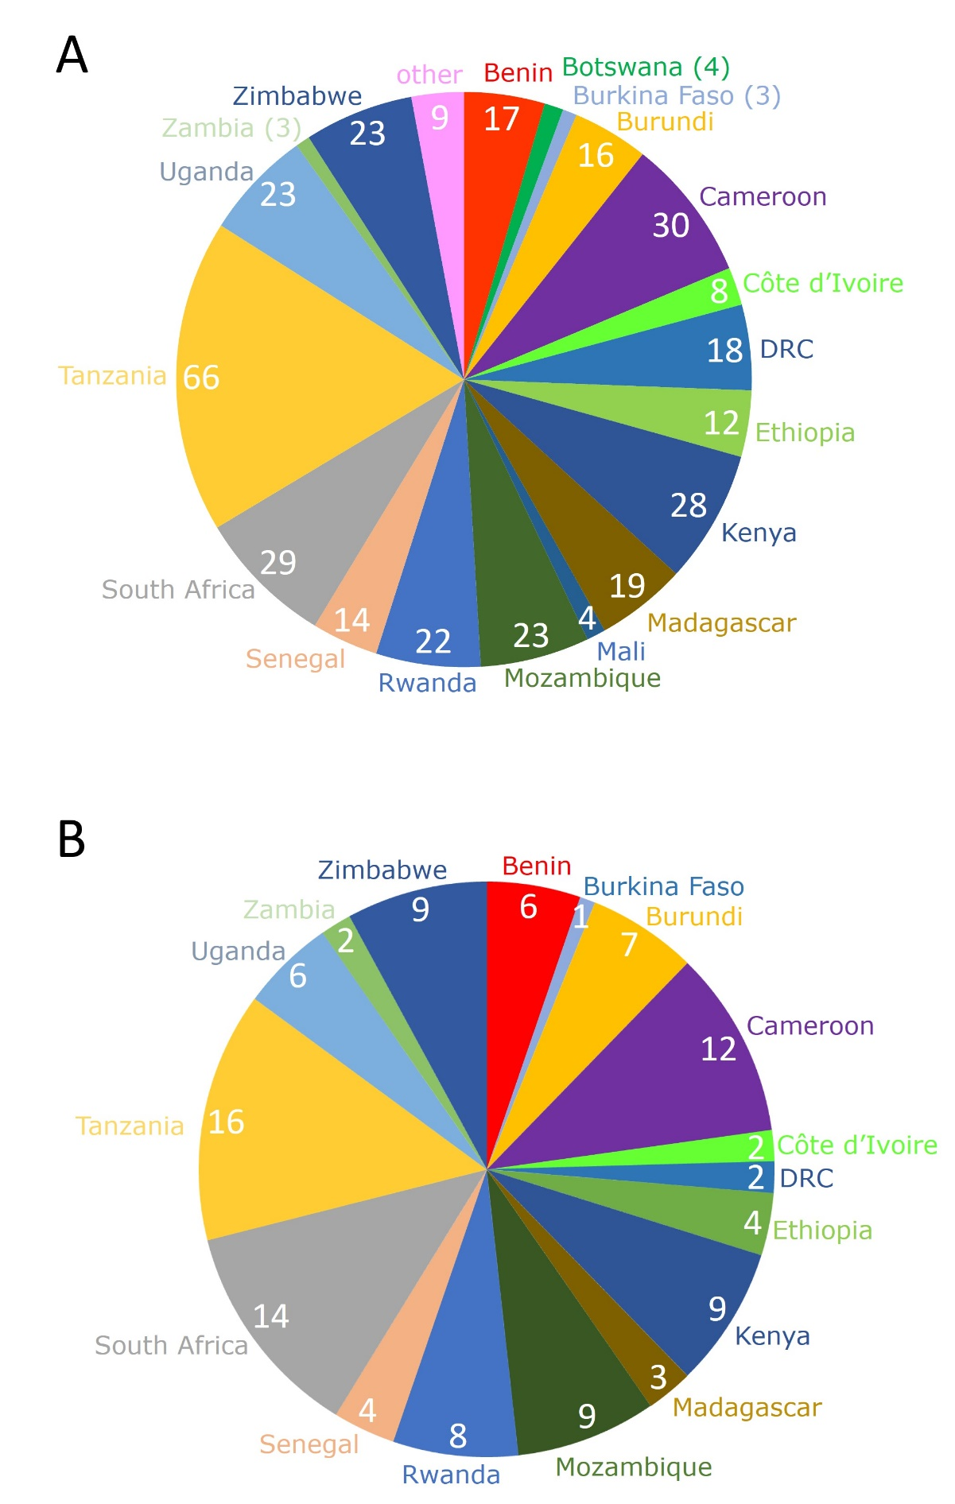
Figure 2

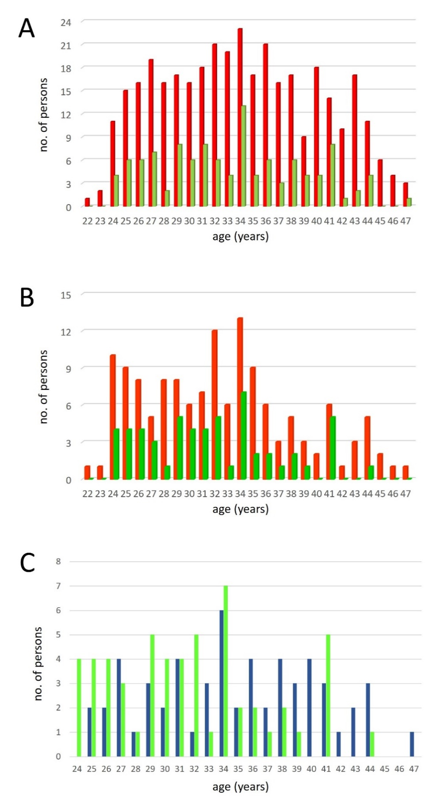
Figure 3
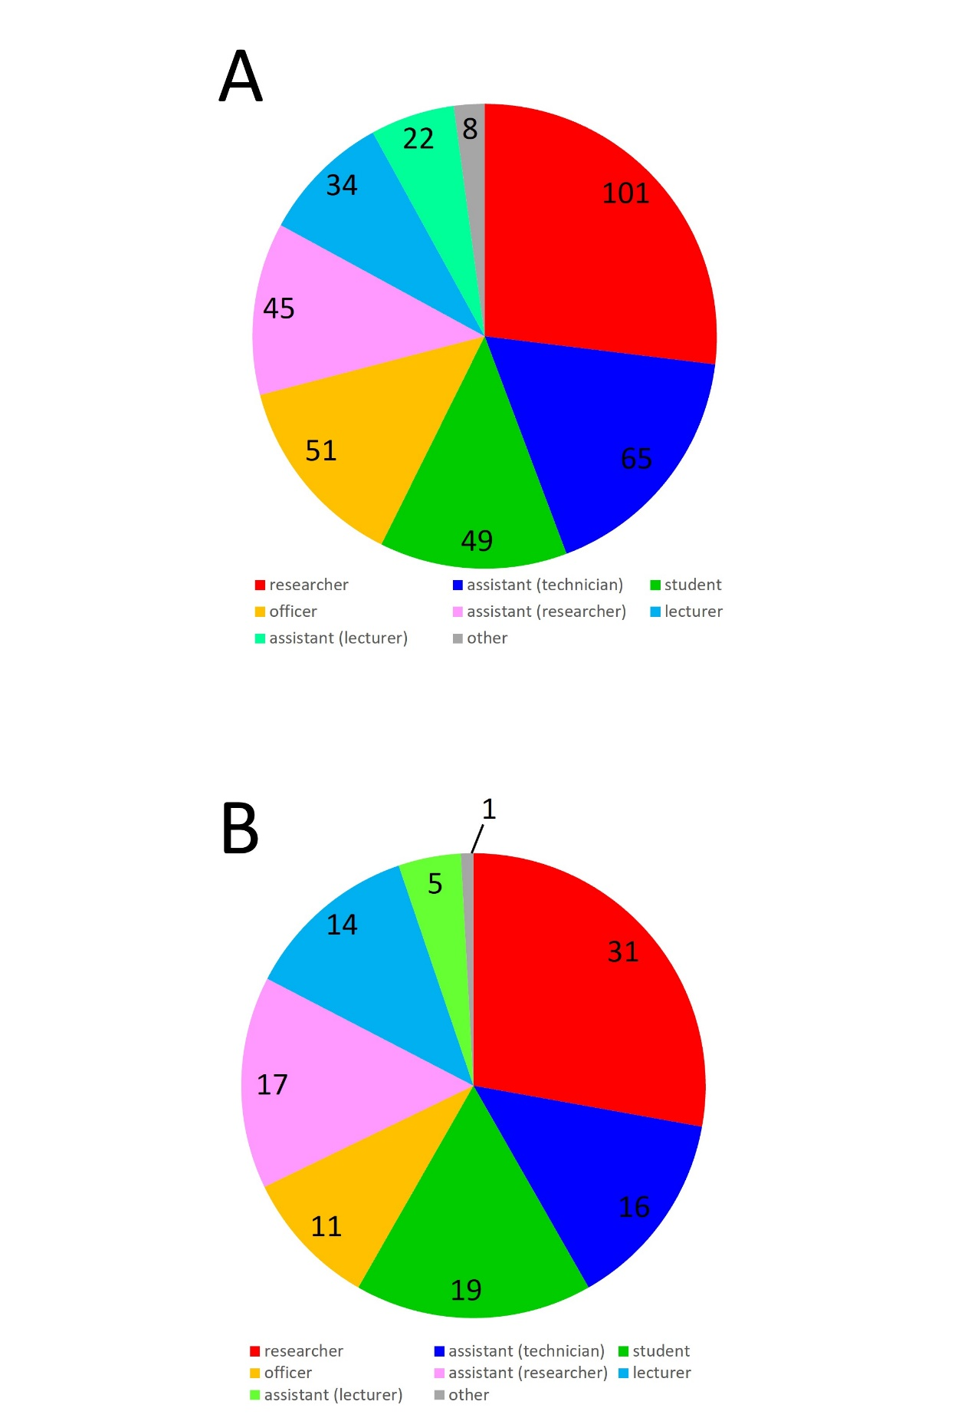
Figure 4
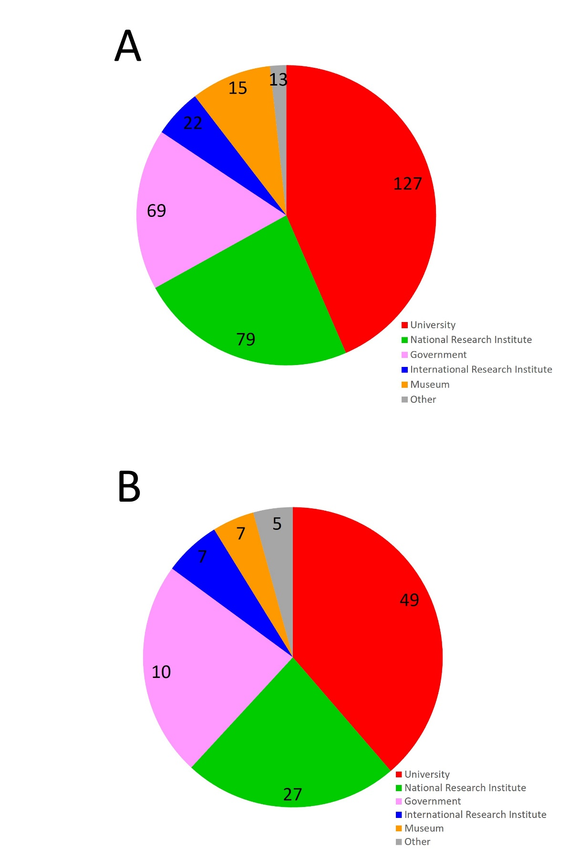

Figure 5
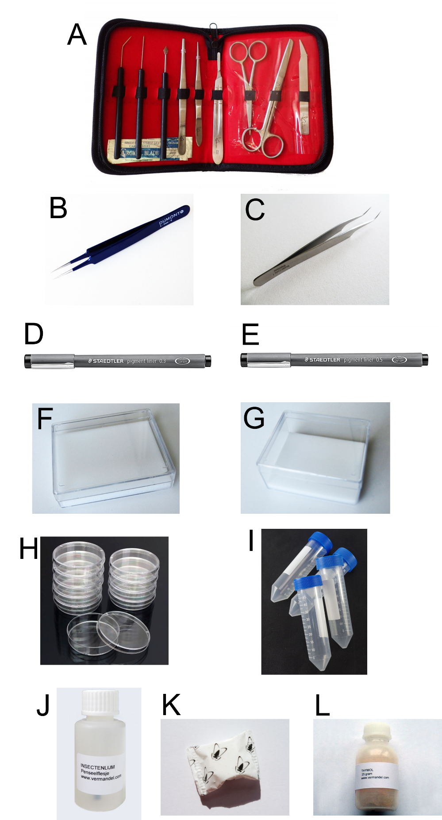
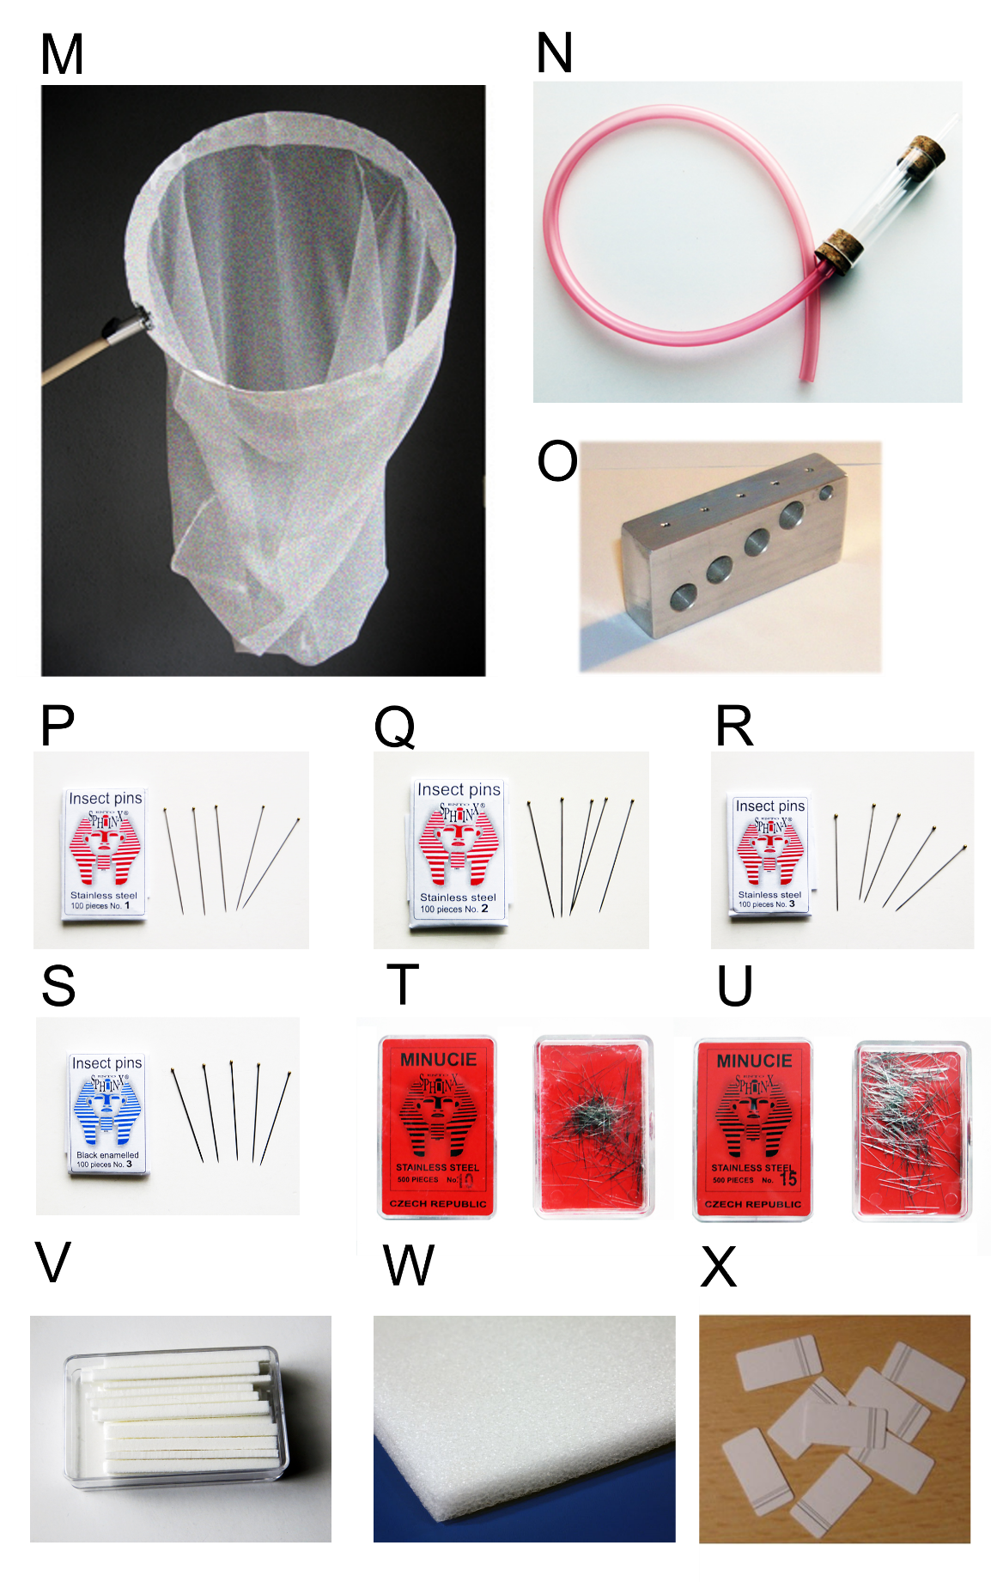

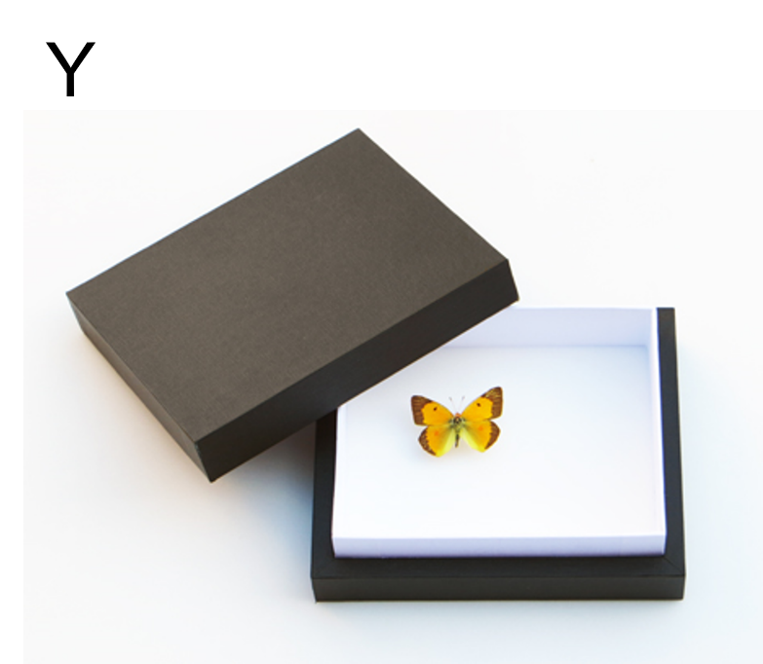

Supplementary Materials

Supplementary Materials S1: List of 141 universities or higher educational institutes, (inter)national research institutes, museums, governmental departments, or other institutes from which applications for the entomological training courses were received.

Supplementary Materials S2: Example of the announcement for applications.

Supplementary Materials S3: Example of the application form.

Supplementary Materials S4: Example of a general information and scoring table for the applications. This example provides the input of scores from the main organiser and the local organiser.

Supplementary Materials S5: Invitation letter for the selected applicants to participate in the training course.

Supplementary Materials S6: Confirmation letter to participate in the training course which the selected participants need to sign before the start of the training course.

Supplementary Materials S7: Example of the agreement between the main organising institute and the local organising institute with respect to the organisation of the training course. The agreement must be signed by both parties before the start of the training course.

Supplementary Materials S8: List of teaching and practical materials needed to organise the training course. We differentiate between materials that need to be provided by the main organising institute or by the local organising institute. For more information on the materials see the text.

Supplementary Materials S9: Example of the agreement between the main organising institute and each expert lecturer not affiliated with the main organising institute for the reimbursement of costs, the payment of an expert fee, and the contributions of the lecturer to the organisation of the training course. The agreement must be signed by both parties before the start of the training course.

Supplementary Materials S10: An anonymous questionnaire used for the evaluation of all aspects of the training course which the participants may fill in. The questionnaire also has a general section at the end where specific comments (e.g., suggestions for improvement) can be given.

Supplementary Materials S11: Example of a certificate that each participant receives after successful completion of the training course.

Supplementary Materials S12: Financial overview of the organisation of the training course. The excel sheet can be easily modified to allow variation in the number of participants or lecturers.

Supplementary Materials S13: Full programme of the first advances training on the Taxonomy and ecology of African fruit flies.

Pictures:

1.Group picture of the fifth training course on pollinating Diptera (2023, Tanzania, Morogoro). Back row from left to right: Sija Kabota (lecturer, Sokoine University of Agriculture, Tanzania), John Midgley (lecturer, KwaZulu-Natal Museum, South Africa), Simon Muhayimana (Center of Excellence in Biodiversity and Natural Resource Management, Rwanda), Emerensiana S. Kajuna (secretary, Sokoine University of Agriculture, Tanzania), Arlène Ingabire (Burundi Agricultural Sciences Institute, Burundi), Tewodros Mulugeta (Kotebe Metropolitan University, Ethiopia), Ashley Kirk-Spriggs (lecturer, African Natural History Research Trust, UK), Stéphanie Kengni (University of Ngaoundere, Cameroon), Jarmaine Magoai (National Museum Bloemfontein, South Africa), Melanie de Morney (South African National Parks, South Africa), Christopher Sabuni (local organizer, Sokoine University of Agriculture, Tanzania), Upenda Richard (lab assistant, Sokoine University of Agriculture, Tanzania), Kelvin Kemei (National Museums of Kenya, Kenya). Front row from left to right: Antoine Irakiza (Burundi Agricultural Sciences Institute, Burundi), Tanatswa Gara (Africa University, Zimbabwe Entomology Support Program in Malaria, Zimbabwe), Kurt Jordaens (lecturer, Royal Museum for Central Africa, Belgium), Prof. Alleni Malisa (Director Sokoine Pest Management Center, Sokoine University of Agriculture, Tanzania), Ramadhana Majubwa (local promotor AGROVEV project, Sokoine University of Agriculture, Tanzania), Happy Leonard (Tanzania Agriculture Research Institute, Tanzania), Donath Nkuriyikimana (Diane Fossey Gorilla Fund, Rwanda), Jenipher Tairo (Sokoine University of Agriculture, Tanzania) © J. Muro (Sokoine University of Agriculture, Tanzania)

2. Kurt Jordaens of the Royal Museum for Central Africa (Belgium) demonstrating the use of an insect net in the field during the fifth training course on pollinating Diptera (2023, Tanzania, Morogoro). From left to right: Antoine Irakiza (Burundi Agricultural Sciences Institute, Burundi), Donath Nkurikiyimana (Diane Fossey Gorilla Fund, Rwanda), Stéphanie Kengni (University of Ngaoundere, Cameroon), Jarmaine Magoai (National Museum Bloemfontein, South Africa), Jenipher Tairo (Sokoine University of Agriculture, Tanzania), Tewodros Mulugeta (Kotebe Metropolitan University, Ethiopia), Happy Leonard (Tanzania Agriculture Research Institute, Tanzania), Arlène Ingabire (Burundi Agricultural Sciences Institute, Burundi), Kelvin Kemei (National Museums of Kenya, Kenya), Simon Muhayimana (Center of Excellence in Biodiversity and Natural Resource Management, Rwanda), Kurt Jordaens (Royal Museum for Central Africa, Belgium), and John Midgley (KwaZulu-Natal Museum, South Africa).

3. Happy Leonard (Tanzania Agriculture Research Institute, Tanzania) collecting Diptera with the use of an insect net during the fifth training course on pollinating Diptera (2023, Tanzania, Morogoro).

4. Kelvin Kemei (National Museums Kenya, Kenya) and Donath Nkurikiyimana (Diane Fossey Gorilla Fund, Rwanda) collecting Diptera with the use of an insect net during the fifth training course on pollinating Diptera (2023, Tanzania, Morogoro).

5. Bonolo Mosime and Oageng Modise (both University of KwaZulu-Natal, South Africa) emptying a yellow pan trap to collect Diptera during the fourth training course on pollinating Diptera (2022, South Africa, Karkloof).

6. John Midgley (with hat) of the KwaZulu-Natal Museum (South Africa) and Ashley Kirk-Spriggs (without hat) of the African Natural History Research Trust (UK) demonstrating the deployment of a Gressitt and Gressitt style (6m) Malaise trap during the fifth training course on pollinating Diptera (2023, Tanzania, Morogoro). Also in the picture (from back to front): Kelvin Kemei (National Museums of Kenya, Kenya), Simon Muhayimana (Center of Excellence in Biodiversity and Natural Resource Management, Rwanda), Tanatswa Gara (Africa University, Zimbabwe Entomology Support Program in Malaria, Zimbabwe), and Christopher Sabuni (local organiser of the Pest Management Centre of the Sokoine University of Agriculture, Tanzania).

7. Burgert Muller (National Museum Bloemfontein, South Africa) demonstrating the deployment of a Townes style Malaise trap during the fourth training course on pollinating Diptera (2022, South Africa, Karkloof). Clockwise from back: Carly Vlotman (Stellenbosch University, South Africa), Jacomine Zaayman (University of Pretoria, South Africa), Burgert Muller (National Museum Bloemfontein, South Africa), Wilmari Uys (University of Cape Town, South Africa), and Arjan Engelen (Stellenbosch University, South Africa).

8. Jarmaine Magoai (National Museum Bloemfontein, South Africa) (left) and Melanie De Morney (South African National Parks, South Africa) (right) deploying of a Townes style Malaise trap during the during the fifth training course on pollinating Diptera (2023, Tanzania, Morogoro).

9. John Midgley of the KwaZulu-Natal Museum demonstrating direct pinning during the fifth training course on pollinating Diptera (2023, Tanzania, Morogoro). Clockwise from top left: Antoine Irakiza (Burundi Agricultural Sciences Institute, Burundi), Arlène Ingabire (Burundi Agricultural Sciences Institute, Burundi), John Midgley (KwaZulu-Natal Museum, South Africa), Donath Nkurikiyimana (Diane Fossey Gorilla Fund, Rwanda), Tanatswa Gara (Africa University, Zimbabwe Entomology Support Program in Malaria, Zimbabwe), Melanie De Morney (South African National Parks, South Africa), and Jarmaine Magoai (National Museum Bloemfontein, South Africa).

10. Ashley Kirk-Spriggs of the African Natural History Research Trust (UK); then at the National Museum Bloemfontein (South Africa) (front, right) explaining the use of a pinning block to Longin Ndayikeza (Burundian Office for the Protection of the Environment, Burundi) during the first training course on pollinating Diptera (2017, Nairobi, Kenya). Also in the picture: Kudzai Mafuwe (National Museum Bulawayo, Zimbabwe) (back), Eugène Sinzinkayo (Burundian Office for the Protection of the Environment, Burundi) (front).

11. Tanatswa Gara (Africa University, Zimbabwe Entomology Support Program in Malaria, Zimbabwe) and Tewodros Mulugeta (Kotebe Metropolitan University, Ethiopia) cutting labels with collecting information of the pinned Diptera, during the fifth training course on pollinating Diptera (2023, Tanzania, Morogoro).
12. Longin Ndayikeza (Burundian Office for the Protection of the Environment, Burundi) adding labels to the pinned Diptera during the first training course on pollinating Diptera (2017, Nairobi, Kenya).

13. Insect box showing some properly pinned and labelled Diptera by one of the participants during the fifth training course on pollinating Diptera (2023, Tanzania, Morogoro). A collecting and export permit is provided by the local organiser so that participants can take the material back to their institutions.

14. Each of the participants, lecturers, and local organiser receives a set of the first three volumes of the Manual of Afrotropical Diptera at the start of the training course.

15. Participants work in pairs during the entire training course. This picture is taken at the fifth training course on pollinating Diptera (2023, Tanzania, Morogoro). Front row: Jarmaine Magoai (National Museum Bloemfontein, South Africa) (left) and Melanie De Morney (South African National Parks, South Africa) (right); second row: Antoine Irakiza (Burundi Agricultural Sciences Institute, Burundi) (left), Happy Leonard (Tanzania Agriculture Research Institute, Tanzania) (middle), and Stéphanie Kengni (University of Ngaoundere, Cameroon) (right); third row: Kelvin Kemei (National Museums of Kenya, Kenya) (left) and Simon Muhayimana (Center of Excellence in Biodiversity and Natural Resource Management, Rwanda); fourth row: Cesilia Kijalo (Sokoine University of Morogoro, Tanzania; local organising committee).

16. Mandisa Ndlovu (KwaZulu-Natal Museum, South Africa) and Oageng Modise (University of KwaZulu-Natal, South Africa) using the family key in the first volume of the Manual of Afrotropical Diptera to identify Diptera collected during the fourth training course on pollinating Diptera (2022, South Africa, Karkloof).

