Supplementary tables and figures
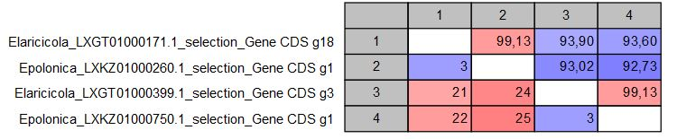
Figure S1: Gene duplication information for E. polonica and E. laricicola (amino acid percentage similarity shown in the upper right grouping of block and number of differences shown in the lower left grouping of blocks). Colours indicate level of similarity, with red most similar, and purple less similar.

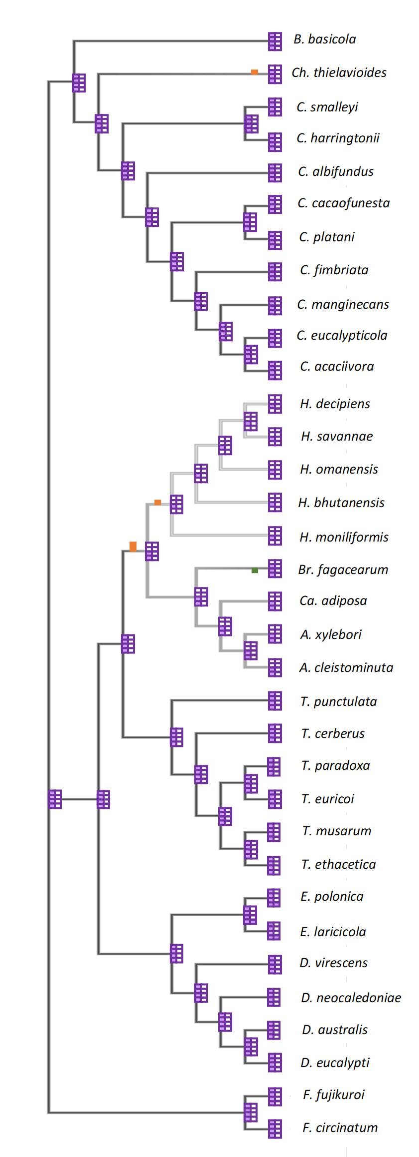
Figure S2: Ancestral history of CDO 1-4 genes using a Wagner parsimony analysis in Count. Gene loss events are represented by orange blocks, and gene gains by green blocks. The CDO presence is evidenced through purple blocks at each node and at the terminal nodes.

