Supplementary Information

Fig. S1A

Fig. S1B
Figure S1: Relative abundance of the major (A) bacterial and (B) fungal phyla (≥5%) in Hardveld, Sandveld, and Wet-sandveld ecological zones.

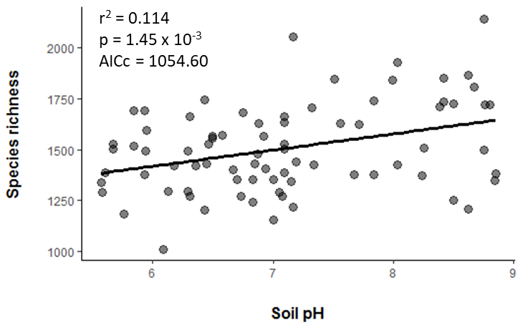
Fig. S2A

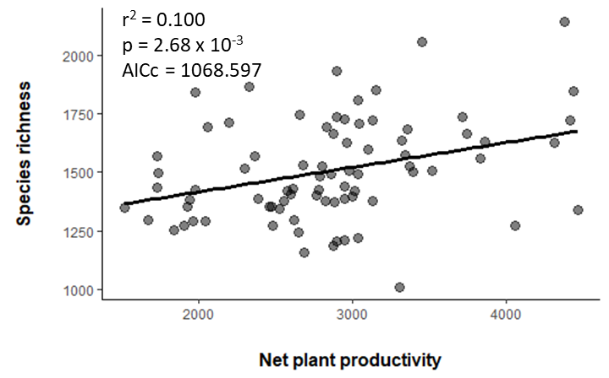
Fig. S2B

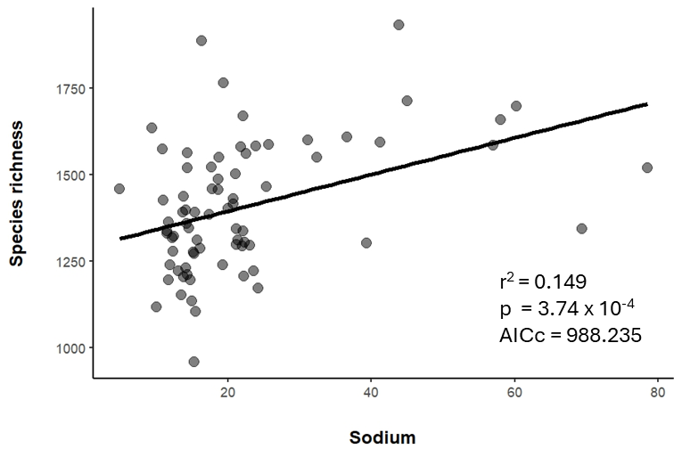
Fig. S2C
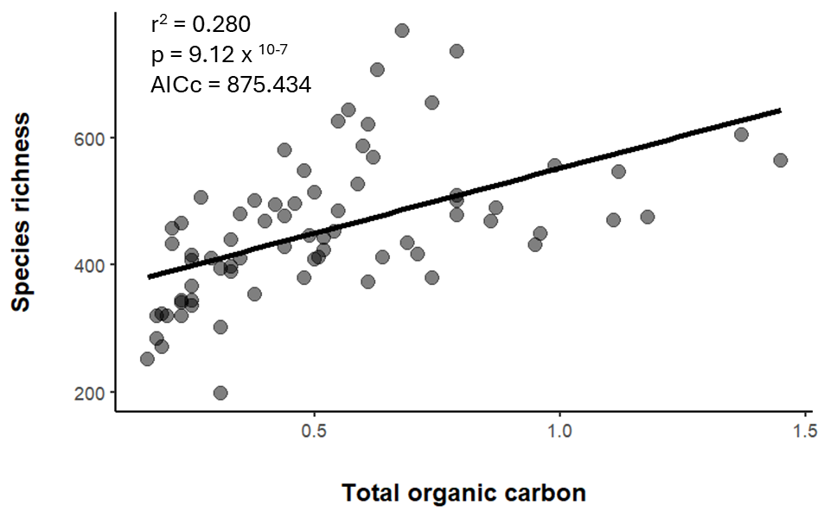
Fig. S2D
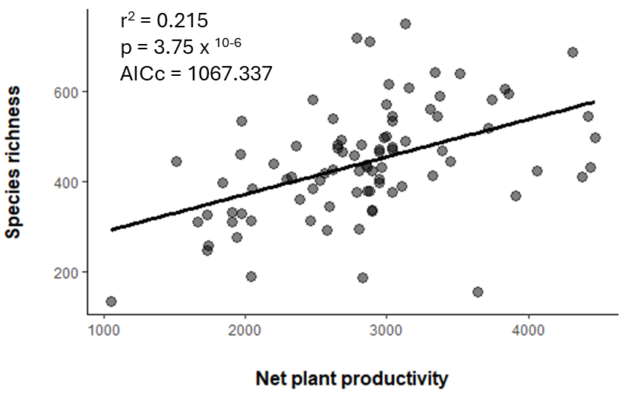
Fig. S2E

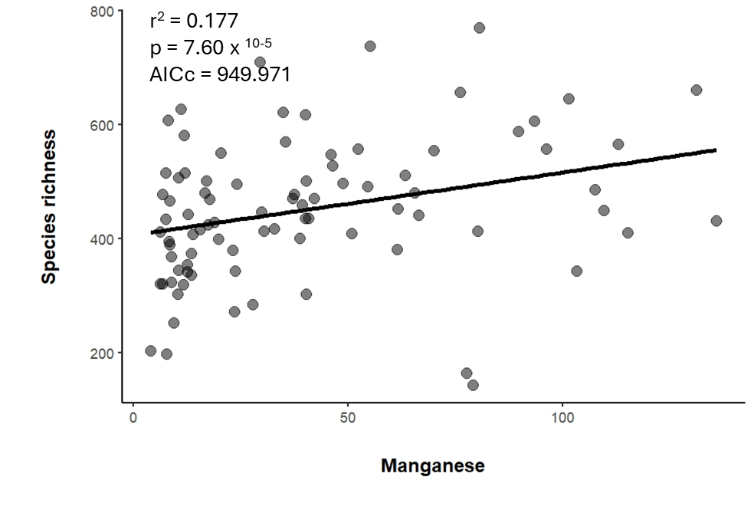
Fig. S2F
Figure S2: Relationship between the predictor variables from the Best subset model and microbial richness: bacterial (A-C) and fungal (D-F) across different ecological zones.

Fig. S3A

Fig. S3B
Figure S3: The correlation analysis between environmental variables and dominant (A) bacterial and (B) fungal relative abundances at the phylum level. Blue and red represent positive and negative correlations, respectively.

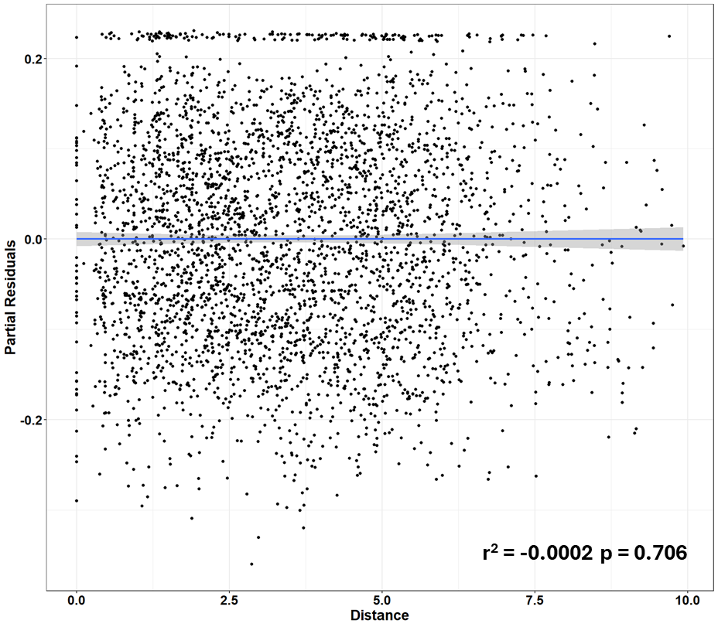
Fig. S4A

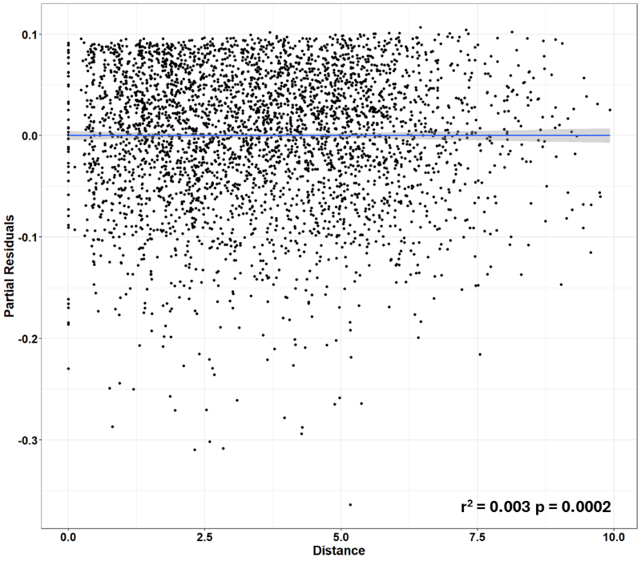
Fig. S4B
Figure S4. Partial residual plots showing the relationship between Bray-Curtis dissimilarity and the geographic distance of A) bacterial and (B) fungal communities. The p values indicate the significance of geographic distance.
6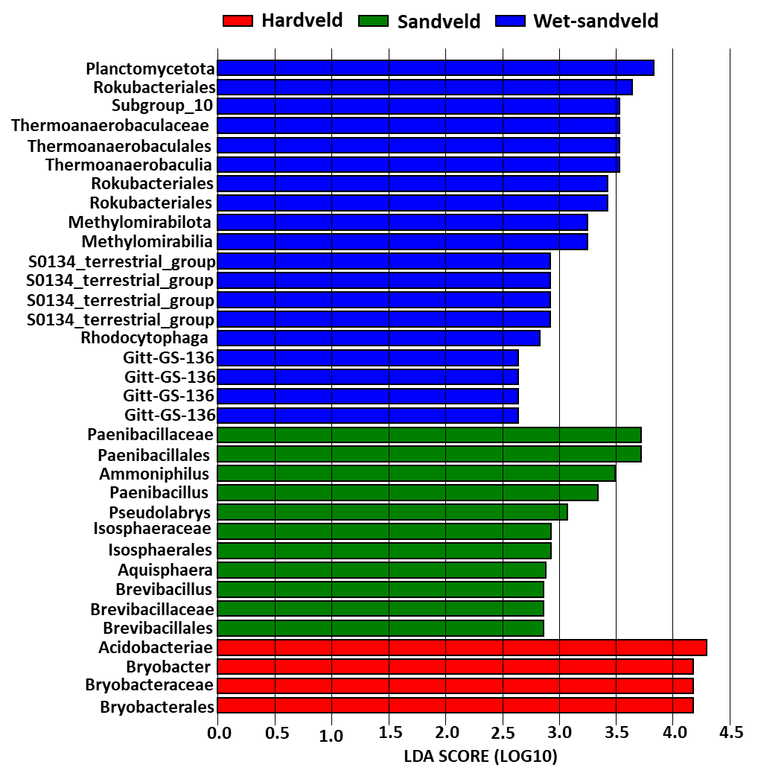

Fig. S5A

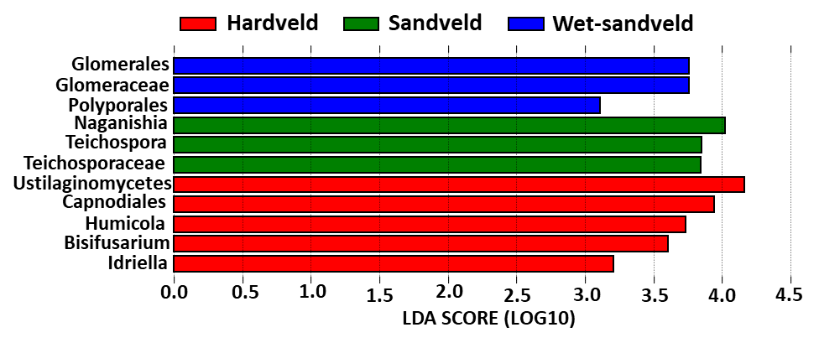
Fig. S5B

Figure S5: Plot of LDA scores of differentially abundant taxa in A) Bacterial communities and B) Fungal communities.

Figure S6: Co-occurrence incidence of bacteria-bacteria, bacteria-fungi, and fungi-fungi interactions across the different pH networks.

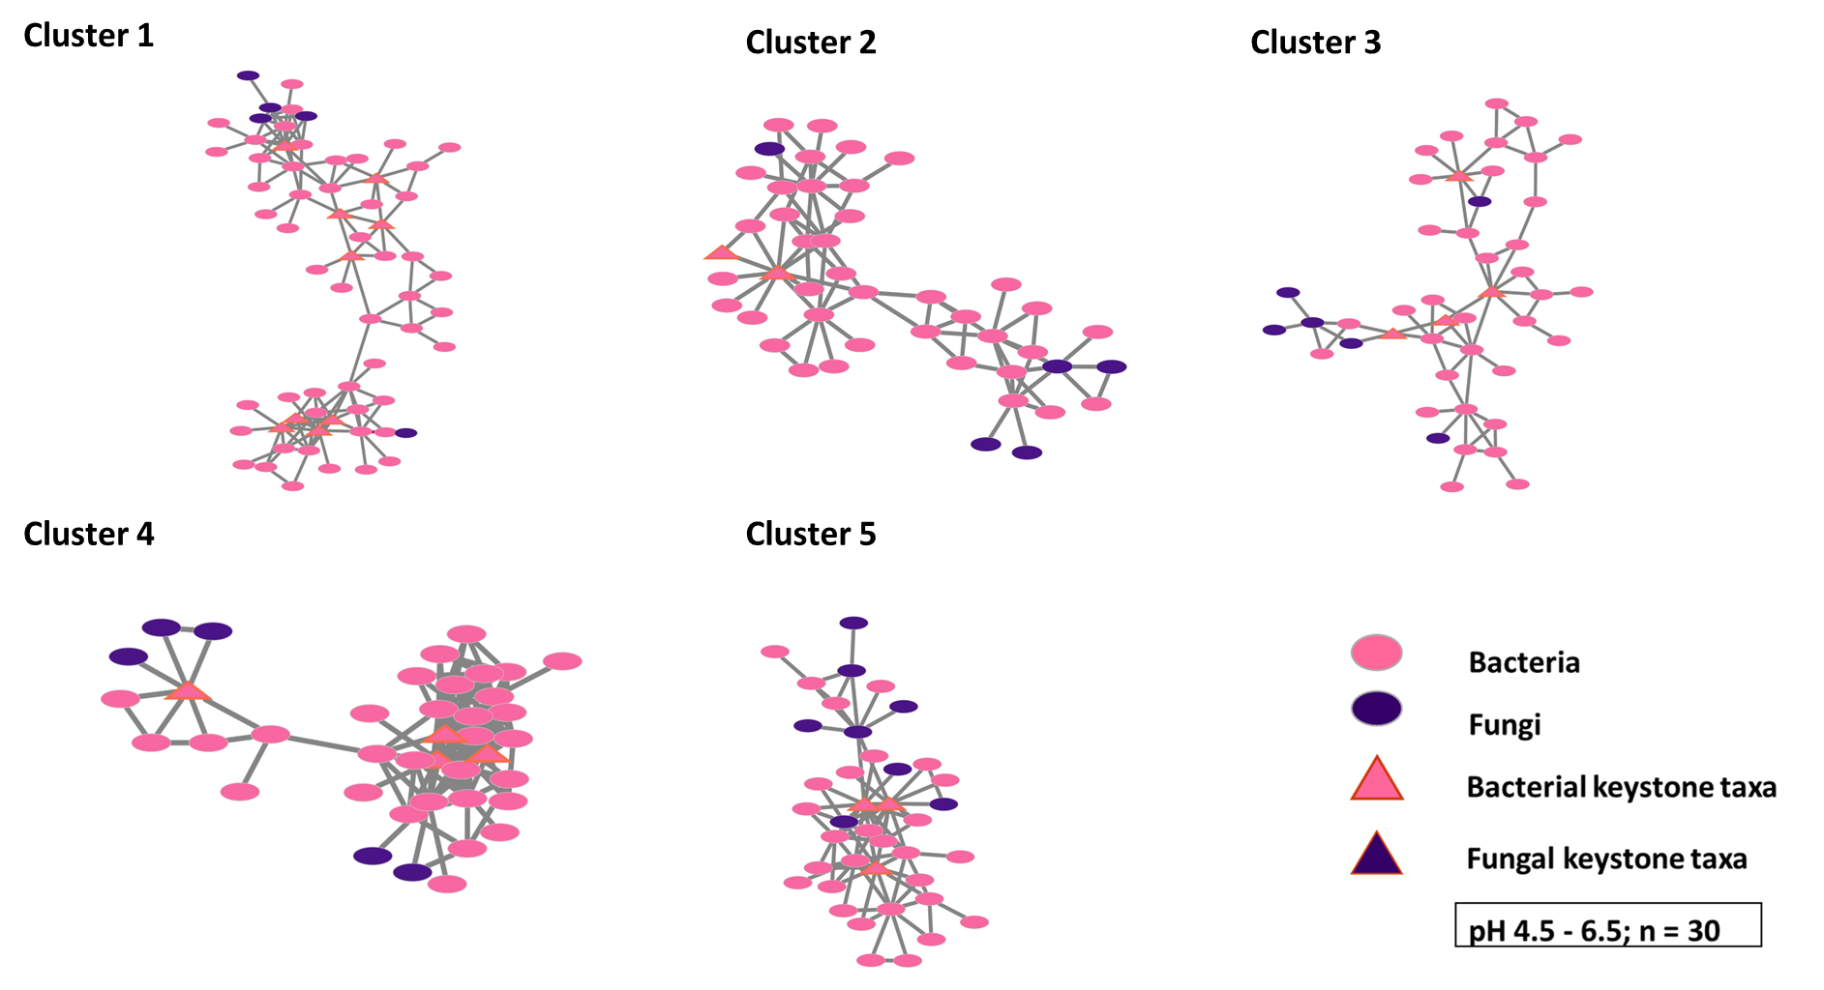
Fig. S7A

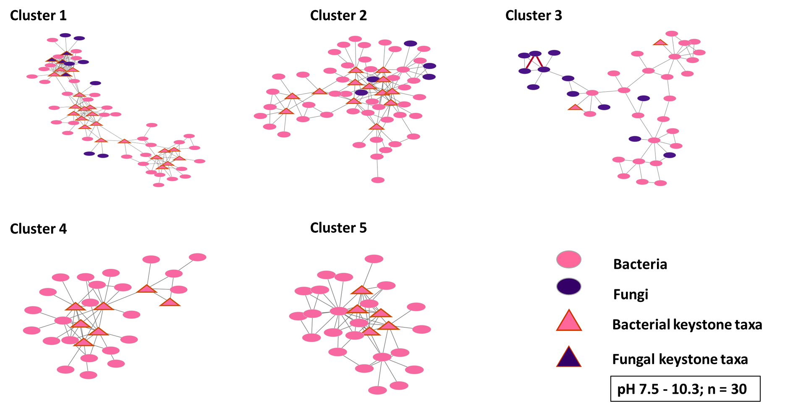
Fig. S7B

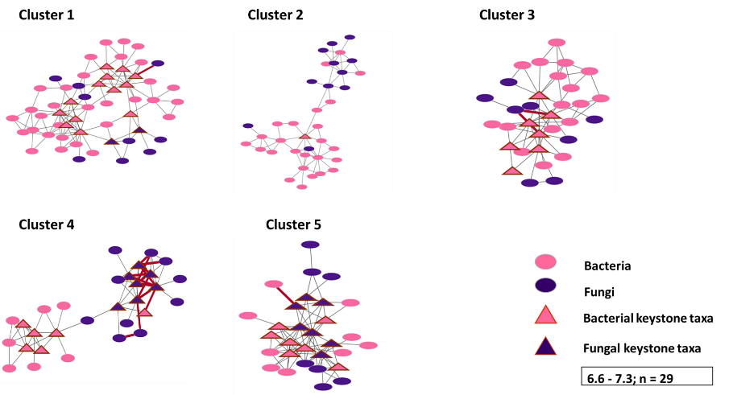

Fig. S7C
Figure S7: Co-occurrence network clusters of bacterial and fungal communities in A) acidic, B) alkaline, and C) neutral soils.

