Supplementary Data
Thiophene site activation: Synthesis and structures of Fischer carbene complexes
with 3,3ˈ- and 2,3ˈ-bithienyl substituents

Zandria Lamprecht,ª Mmushi M. Moeng,ª David C. Liles,ª Simon Lotzª and Daniela I. Bezuidenhout*^{a,b}
- Department of Chemistry, University of Pretoria, Private Bag X20, Hatfield 0028, Pretoria, South Africa.
- Molecular Sciences Institute, School of Chemistry, University of the Witwatersrand, Johannesburg 2050, South Africa.

Contents:

Synthesis
Syn S1: Synthesis of chromium and tungsten mixed metal thiophene biscarbene complex (21ab/ba)…………………………………………………………..….S4
Scheme S1: Mixed metal biscarbene complexes from thiophene substrates……………………………………………………………………………………………………..S4

Crystallography
Figure S1: The molecular structures with atom numbering of 2b, 4b, 10a, 10b and 21ab/ba with atomic
displacement ellipsoids shown at the 50% probability level………………………………………………………………………………………………………………………..……..S5
Figure S2: Thiophene-thiophene inter-ring rotation illustrated by drawing a mean plane through each thiophene
ring, showing a 85.32˚ rotation in 1a (a), and 6.38˚ rotation in 7a (b)………………………………………………………………………………………………………………..S5
Figure S3: Intermolecular hydrogen interactions of the planar (a) and non-planar (b) molecular structures of 10b
along with the difference in columnar packing, viewed down the crystallographic a-axis (a) and b-axis (b)……………………..……………………………….S6
Table S1: Selected bond lengths (Å), bond angles (˚) and torsion angles (˚) of the structures 2b, 4b, 10a, 10b (planar) and
21ab/ba……………………………………………………………………………………………………………………………….…………………………………………………………………………….S7
Table S2: Crystal data and structure refinement for complexes 1a, 2a, 2b, 4a, 4b and 7a…………………………………………………………………………….…...S8
Table S3: Crystal data and structure refinement for complexes 8a, 10a, 10b (non-planar and planar), 13ab/ba, 14b and 21ab/ba………………….S9

Spectroscopy (NMR)
Figure S4: Atom numerical numbering scheme of bithienylene atoms used in NMR spectral assignment.…………………………………………….…….….S10
Figure S5: ¹H NMR spectrum of 1a in CDCl₃………………………………………………………………………………………………………………………………………..…….…..…S11
Figure S6: ¹³C NMR spectrum of 1a in CDCl₃…………………………………………………………………………………………………………………………………………………….S11
Figure S7: ¹H NMR spectrum of 1b in CDCl₃……………………………………………………………………………………………………………………………………………..….…..S12
Figure S8: ¹³C NMR spectrum of 1b in CDCl₃……………………………………………………………………………………………………..…….……………………………….……..S12
Figure S9: ¹H NMR spectrum of 2a in CDCl₃…………………………………………………..…………………………………………………………………………………….….…..…S13
Figure S10: ¹³C NMR spectrum of 2a in CDCl₃………………………………………………………………………………………………………………………………………….……….S13
Figure S11: ¹H NMR spectrum of 2b in CDCl₃.………………………………………………………………………………………………………………………………..…………….…..S14
Figure S12: ¹³C NMR spectrum of 2b in CDCl₃………………………………………………………………………………………………………………………………….………….……S14
Figure S13: ¹H NMR spectrum of 3a in CDCl₃……………………………………………………………………………………………………………………….………………………..…S15
Figure S14: ¹H NMR spectrum of a mixture of 3a (65%) and 4a (35%) in CDCl₃……………..……………………………………………………………………………...…S15
Figure S15: ¹³C NMR spectrum of a mixture of 3a and 4a in CDCl₃…………………………………………………………………………………………………………..….…..S16
Figure S16: ¹H NMR spectrum spectrum of a mixture of 3b (44%) and 4b (56%) in CDCl₃…………………..…………………………….……………..………………S16
Figure S17: ¹³C NMR spectrum of a mixture of 3b (44%) and 4b (56%) in CDCl₃ ………………………………………………………………………………………...….S17
Figure S18: ¹H NMR spectrum of 4a in CDCl₃……………………………………………………………………………………………………………………………………………….…..S17
Figure S19: ¹³C NMR spectrum of 4a in CDCl₃...................………………………………………………………………………………………………………………………………..S18
Figure S20: ¹H NMR spectrum of 4b in CDCl₃…………………………………………………………………..………………………………………..……………………………….…...S18
Figure S21: ¹³C NMR spectrum of 4b in CDCl₃…………………………………..……………………………………………………………………………………………………..………S19
Figure S22: ¹H NMR spectrum of 5a in CDCl₃………………………..……………………………………………………………………………….…………………………………..…...S19
Figure S23: ¹³C NMR spectrum of 5a in CDCl₃………………………………..………………………………………………………………………………………………………………..S20
Figure S24: ¹H NMR spectrum of 5b in CDCl₃…………………….………………………..……………………………………………………………………………………………....….S20
Figure S25: ¹H NMR spectrum of 6a in CDCl₃……………………………………………………………………………………………………………………….…………………..….…..S21
Figure S26: ¹³C NMR spectrum of 6a in CDCl₃…………………………………………………………………………………………………………………………………………………..S21
Figure S27: ¹H NMR spectrum of 6b in CDCl₃……………………………………………………………………………………………………………………….……………………..……S22
Figure S28: ¹³C NMR spectrum of 6b in CDCl₃…………………………………………………………………………………………………………………………………………………..S22
Figure S29: ¹H NMR spectrum of 7a in CDCl₃…………………………………………………………………………………………………………………………………………………...S23
Figure S30: ¹³C NMR spectrum of 7a in CDCl₃…………………………………………………………………………………………………………………………………………….…….S23
Figure S31: ¹H NMR spectrum of 7b in CDCl₃……………………………………………………………………………………………………………………….…………………………..S24
Figure S32: ¹³C NMR spectrum of 7b in CDCl₃……………………………………………………………………………………………………………………….………………………....S24
Figure S33: ¹H NMR spectrum of 8a in CDCl₃…………………………………….……………………………………………………………………………………………………………..S25
Figure S34: ¹³C NMR spectrum of 8a in CDCl₃……………………………………………..……………………………………………………………………………………………………S25
Figure S35: ¹H NMR spectrum of 9a in CDCl₃…………………………………………………………………………………………..………………………..................................S26
Figure S36: ¹³C NMR spectrum of 9a in CDCl₃…………………………………………………………………………………………………………………………………………………..S26
Figure S37: ¹H NMR spectrum of a mixture of 10a (53%) and 12a* (47%) in CDCl₃…………………………………………………………………………………………..S27
Figure S38: ¹³C NMR spectrum of 10a and 12a in CDCl₃……………………………………………………………………………………………………………………………………S27
Figure S39: ¹H NMR spectrum of 10b in CDCl₃………………………………………………………………………………………………………………………………………………….S28
Figure S40: ¹³C NMR spectrum of 10b in CDCl₃…………………………………………………………………………………………………………………………………………………S28
Figure S41: ¹H NMR spectrum of 11a in CDCl₃………………………………………………………………………………………………………………………………………………….S29
Figure S42: ¹H NMR spectrum of 13ab in CDCl₃…………………………………………………………………………………………………………………….………………………….S29
Figure S43: ¹H NMR spectrum of 13ab (75%) and 13ba* (25%) in CDCl₃…………………………………………………………………………………………………………..S30
Figure S44: ¹³C NMR spectrum of 13ab (75%) and 13ba (25%) in CDCl₃……………………………………………………………………………………………………………S30
Figure S45: ¹H NMR spectrum of 14a in CDCl₃……………………………………………………………………………………………………………………………………………….…S31
Figure S46: ¹³C NMR spectrum of 14a in CDCl₃……………………………………………………………………………………………………………………….………………………..S31
Figure S47: ¹H NMR spectrum of 14b in CDCl₃………………………………………………………………………………………………………………………….………………………S32
Figure S48: ¹³C NMR spectrum of 14b in CDCl₃…………………………………………………………………………………………………………………………………………………S32
Figure S49: ¹H NMR spectrum of a mixture of 15a(63%) and 16a(37%) in CDCl₃………………………………………………………………………………………………S33
Figure S50: ¹³C NMR spectrum of a mixture of 15a and 16a in CDCl₃……………….……………………………………………………………………….………………..…S33
Figure S51: ¹H NMR spectrum of 16a in CDCl₃………………………………………………………………………………………………………………………….……………………...S34
Figure S52: ¹³C NMR spectrum of 16a in CDCl₃………………………………………………………………………………………………………………………….……………………..S34
Figure S53: ¹H NMR spectrum of 16b in CDCl₃………………………………………………………………………………………………………………………………………………….S35
Figure S54: ¹³C NMR spectrum of 16b in CDCl₃…………………………………………………………………………………………………………………………………………………S35
Figure S55: ¹H NMR spectrum of 17a in CDCl₃………………………………………………………………………………………………………………………………………………….S36
Figure S56: ¹H NMR spectrum of 19a in CDCl₃………………………………………………………………………………………………………………………………………………….S36
Figure S57: ¹³C NMR spectrum of 19a in CDCl₃………………………………………………………………………………………………………………………….……………………..S37
Figure S58: ¹H NMR spectrum of 20a in CDCl₃…………………………………………………………………………………………………………………………………………………S37
Figure S59: ¹³C NMR spectrum of 20a in CDCl₃………………………………………………………………………………………………………………………….…………………….S38
Figure S60: ¹H NMR spectrum of 21ab/ba (73%) and chromium thiophene biscarbene (27%) in CDCl₃……………………………………………………………S38
Figure S61: ¹³C NMR spectrum of 21ab/ba (73%) and chromium thiophene biscarbene (27%) in CDCl₃…………………………………………………………..S39

Synthesis
Syn S1: Synthesis of chromium and tungsten mixed metal thiophene biscarbene complex (21ab/ba)

Scheme S1. Mixed metal biscarbene complexes from thiophene substrates.
Method:

LDA was prepared by adding 1.25 mL n-BuLi (1.6 M, 2 mmol) to approximately 15.00 mL THF at -20 ⁰C under an inert N₂ (g) atmosphere, while being stirred. 0.28 mL (2 mmol) diisopropylamine was added and stirring was continued for 10 minutes. A transparent light yellow LDA solution was obtained. The LDA was then cooled to -78 ⁰C and 0.21 mL (2 mmol) bromothiophene was added dropwise. The solution was stirred for 30 minutes at -78 ⁰C. 0.71 g (2 mmol) white tungsten hexacarbonyl powder was added in small portions and the solution was stirred for 30 minutes. The solution was allowed to heat up to -50 ⁰C from time to time as to ensure that all the metal carbonyl precursor dissolved. A bright yellow solution was obtained and the mixture was allowed to stir at room temperature for 20 minutes (the solution’s temperature was kept below 0 ⁰C) to obtain an orange solution. At -50 ⁰C 1.98 mL (3.2 mmol) n-BuLi was added and the solution was allowed to stir for 10 minutes. 0.44 g (2 mmol) white chromium hexacarbonyl powder was added. A light red orange solution was obtained after stirring for 15 minutes at -50 ⁰C. The solution was allowed to stir for 40 minutes at room temperature and a brown black solution was obtained. The solution was then evaporated under reduced pressure. [Et₃O][BF₄] 1.09 g (5.7 mmol) dissolved in DCM was added to the reaction mixture (also dissolved in DCM) at -40 ⁰C. LiBF₄ salt was removed by a filter and the reaction mixture dried. The reaction mixture was then dissolved in DCM and dried on silica gel. The sample, absorbed onto silica gel, was dry-loaded and the products were separated by column chromatography. Pure hexane was used as the initial eluent. The polarity was increased gradually with increasing volumes of DCM until pure DCM was used. Six bands were collected and dried.

21ab/ba: Yield: 0.85 g (1.20 mmol, 60%), purple crystals. ʋ_{CO}(hexane)/cm⁻¹ 2072w and 2068w (A₁⁽¹⁾, W), 2057m (A₁⁽¹⁾, Cr), 1991vw (B₁), 1962sh (A₁⁽²⁾), 1955vs (E). δ¹H(500.139MHz; CDCl₃; Me₄Si) 7.98 (1 H, d, ³J_{3,4} 4.5, H3), 8.08 (1 H, d, ³J_{4,3} 4.5, H4), 5.01 (2 H, q, ³J 7.0, C2CH₂), ), 5.23 (2 H, q, ³J 7.0, C5CH₂), 1.69 (3 H, t, ³J 7.0, C2CH₃) 1.71 (3 H, t, ³J 7.0, C5CH₃). δ¹³C(125.75 MHz; CDCl₃; Me₄Si) 295.0 (C_{carb} W), 321.5 (C_{carb} Cr), 202.7 (CO_{trans} W), 197.0 (CO_{cis} W), 223.7 (CO_{trans} Cr), 216.4 (CO_{cis} Cr), 161.5 (C2), 137.4 (C3), 137.2 (C4), 158.5 (C5), 79.0 (CH₂ W), 76.6 (CH₂ Cr), 14.9 (CH₃ W) 15.2 (CH₃ Cr).

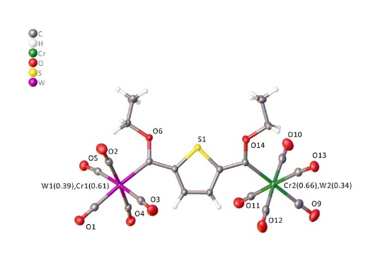
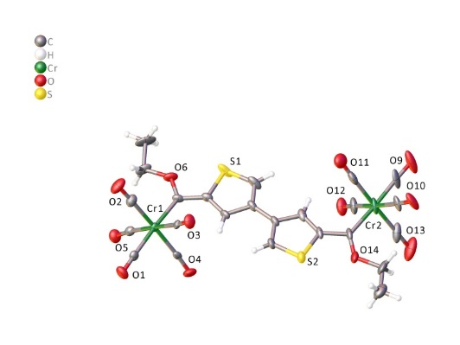
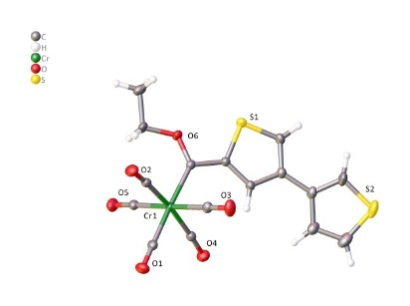
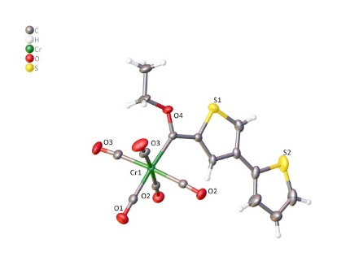
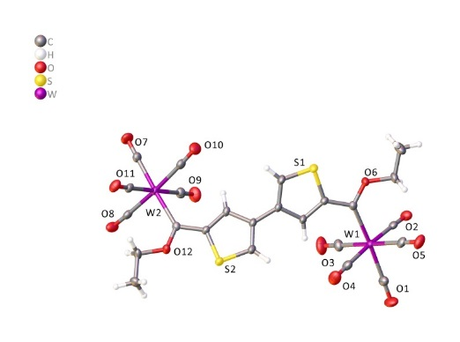
Crystallography
4b T2-C5ˈT3ˈ

10a C5T3-C5ˈT3ˈ
2b C5T3-T3ˈ
10b C5T3-C5ˈT3ˈ (planar)
21ab/ba
Figure S1: The molecular structures with atom numbering of 2b, 4b, 10a, 10b and 21ab/ba with atomic displacement ellipsoids shown at the 50% probability level.
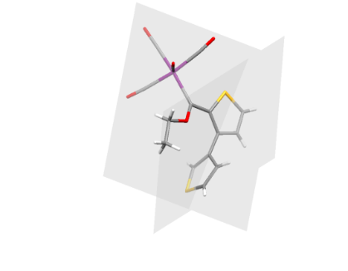
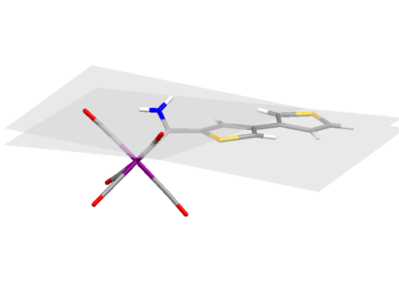
(a)

(b)

Figure S2: Thiophene-thiophene inter-ring rotation illustrated by drawing a mean plane through each thiophene ring, showing a 85.32˚ rotation in 1a (a), and 6.38˚ rotation in 7a (b).
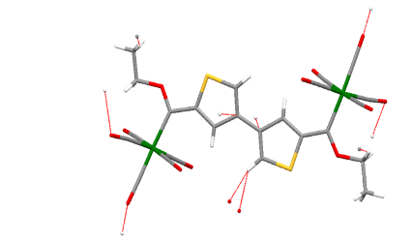
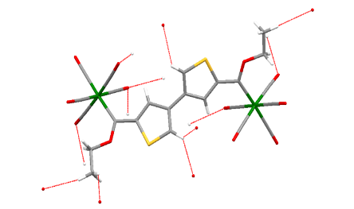
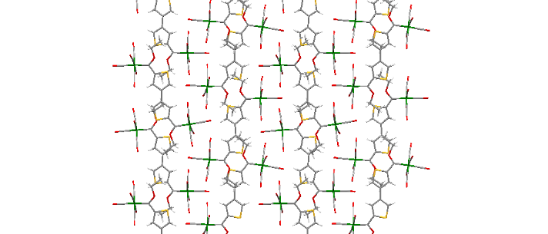
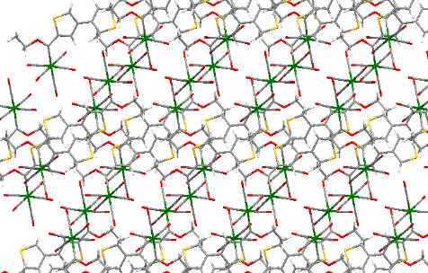
2.390
2.466
2.630
2.648
2.875
2.874
2.876
2.466
2.654
2.874
2.632
2.540
2.704
2.707
2.540
2.705
2.543
2.707
2.655
2.543
2.655
2.632

(a)

(b)

Figure S3: Intermolecular hydrogen interactions of the planar (a) and non-planar (b) molecular structures of 10b along with the difference in columnar packing, viewed down the crystallographic a-axis (a) and b-axis (b).

Table S1: Selected bond lengths (Å), bond angles (˚) and torsion angles (˚) of the structures 2b, 4b, 10a, 10b (planar) and 21ab/ba.
 | 2b | 4b | 10a | 10b planar | 21ab/ba
Bond lengths (Å)
W/Cr–C_{carb} | 2.0683(11) | 2.064(2) | 2.182(2)  2.180(2) | 2.020(12)  2.072(14) | 2.1324(13)  2.1312(13)
C_{carb}–C_{ipso} | 1.4612(14) | 1.459(3) | 1.468(3)  1.464(3) | 1.510(19)  1.464(17) | 1.4730(17)  1.4681(18)
C_{carb}–X_{O}ª | 1.3249(12) | 1.325(2) | 1.328(3)  1.329(2) | 1.323(14)  1.311(16) | 1.3186(16)  1.3215(16)
C2–C3 | 1.3786(15) | 1.367(3) | 1.371(2) | 1.385(17) | 1.3844(18)
C3–C4 | 1.4151(14) | 1.429(3) | 1,422(3) | 1.433(16) | 1.4024(18)
C4–C5 | 1.3819(14) | 1.391(3) | 1.380(3) | 1.404(17) | 1.3872(19)
C'2–C'3 | 1.369(3) | 1.375(8) | 1.369(3) | 1.361(15)
C'3–C'4 | 1.422(7) | 1.445(9) | 1.424(3) | 1.442(15)
C'4–C'5 | 1.375(11) | 1.344(6) | 1.384(3) | 1.366(17)
C–C'_{interring} | 1.4681(15) | 1.457(3) | 1.474(3) | 1.492(18)
Bond angles (°)
C_{ipso}–C_{Carb}–X_{O} | 105.54(9) | 105.27(17) | 104.91(17)  104.91(17) | 103.5(11)  105.9(11) | 105.60(11)  105.70(11)
C_{ipso}–C_{Carb}–W/Cr | 124.82(7) | 125.32(14) | 125.42(15)  125.38(15) | 125.7(8)  122.9(10) | 125.45(9)  124.94(9)
W/Cr–C_{Carb}–X_{O} | 129.57(8) | 129.41(15) | 129.67(15)  129.66(14) | 130.8(11)  131.2(9) | 128.82(9)  129.12(9)
Torsion angles (°)
W/Cr-C_{carb}-C_{ipso}-C_{T} | 9.63(16) | 0.000(1) | 7.1(3)  10.4(3) | -11.2(18)  -1.9(17) | 18.1(2)  19.4(2)
X_{O}-C_{carb}-C_{ipso}-C_{T} | -173.03(11) | 180.000(1) | -172.9(2)  -171.9(2) | 169.2(12)  179.9(11) | -165.64(14)  -165.79(14)
C_{X}-X_{O}-C_{carb}-W/Cr | -3.78(16) | 0.000(1) | -2.1(3)  -5.1(3) | 0.5(16)  0.1(17) | -2.37(19)  -5.7(2)
C_{T}-C_{ipso}-C'_{ipso}-C'_{T}  (inter-ring) | 21.5(4)  21.3(2) | 0.000(3)  -180.000(2) | -145.6(2)  -148.0(2) | -171.9(11)  -171.6(11)
ªX=Heteroatom carbene substituent
Table S2: Crystal data and structure refinement for complexes 1a, 2a, 2b, 4a, 4b and 7a.
 | 1a | 2a | 2b | 4a | 4b | 7a
Empirical formula | C₁₆H₁₀O₆S₂W | C₁₆H₁₀O₆S₂W | C₁₆H₁₀CrO₆S₂ | C₁₆H₁₀O₆S₂W | C₁₆H₁₀CrO₆S₂ | C₁₄H₇NO₅S₂W
Formula weight | 546.21 | 546.21 | 414.36 | 546.21 | 414.36 | 517.18
Temperature/K | 296(2) | 150(2) | 150(2) | 150(2) | 150(2) | 150(2)
Crystal system | Monoclinic | Triclinic | Triclinic | monoclinic | Monoclinic | monoclinic
Space group | C2/c | P-1 | P-1 | P2₁/n | P2₁/m | P2₁/c
a/Å | 25.8271(9) | 9.4040(4) | 9.3470(3) | 9.4695(5) | 9.2784(5) | 15.0862(7)
b/Å | 9.8922(3) | 9.4621(4) | 9.3966(3) | 15.9316(9) | 7.4228(4) | 6.3806(3)
c/Å | 16.0236(6) | 11.9416(6) | 11.7912(4) | 12.1269(6) | 13.4474(7) | 17.6370(8)
α/° | 90 | 104.5461(13) | 104.8016(10) | 90 | 90 | 90
β/° | 119.0920(9) | 100.9950(13) | 101.1029(10) | 100.961(2) | 107.043(2) | 111.6292(11)
γ/° | 90 | 114.9769(12) | 114.6176(10) | 90 | 90 | 90
Volume/Å³ | 3577.3(2) | 877.38(7) | 855.96(5) | 1796.14(17) | 885.47(8) | 1578.18(13)
Z | 8 | 2 | 2 | 4 | 2 | 4
ρ_{calc}g/cm³ | 2.028 | 2.068 | 1.608 | 2.020 | 1.554 | 2.177
μ/mm⁻¹ | 6.720 | 6.850 | 0.941 | 6.692 | 0.910 | 7.607
F(000) | 2080.0 | 520.0 | 420.0 | 1040.0 | 420.0 | 976.0
Crystal size/mm³ | 0.376 × 0.219 × 0.121 | 0.275 × 0.187 × 0.123 | 0.291 × 0.280 × 0.202 | 0.315 × 0.219 × 0.160 | 0.288 × 0.194 × 0.142 | 0.255 × 0.171 × 0.100
Radiation | MoKα  (λ = 0.71073) | MoKα  (λ = 0.71073) | MoKα  (λ = 0.71073) | MoKα  (λ = 0.71073) | MoKα  (λ = 0.71073) | MoKα  (λ = 0.71073)
2Θ range for data collection/° | 4.854 to 61.008 | 5.078 to 52.966 | 5.098 to 61.006 | 5.074 to 61.012 | 4.592 to 56.862 | 4.742 to 56.564
Index ranges | -36 ≤ h ≤ 36,  -14 ≤ k ≤ 14,  -22 ≤ l ≤ 22 | -11 ≤ h ≤ 11,  -11 ≤ k ≤ 11,  -14 ≤ l ≤ 14 | -13 ≤ h ≤ 13,  -13 ≤ k ≤ 13,  -16 ≤ l ≤ 16 | -13 ≤ h ≤ 13,  -22 ≤ k ≤ 22,  -17 ≤ l ≤ 17 | -12 ≤ h ≤ 12,  -9 ≤ k ≤ 9,  -17 ≤ l ≤ 17 | -20 ≤ h ≤ 20,  -8 ≤ k ≤ 8,  -23 ≤ l ≤ 23
Reflections collected | 130184 | 29277 | 61227 | 84158 | 46836 | 73402
Independent reflections | 5462  [R_{int} = 0.0361, R_{sigma} = 0.0101] | 3627  [R_{int} = 0.1032, R_{sigma} = 0.0607] | 5240  [R_{int} = 0.0281, R_{sigma} = 0.0106] | 5485  [R_{int} = 0.0751, R_{sigma} = 0.0280] | 2385  [R_{int} = 0.0462, R_{sigma} = 0.0160] | 3911  [R_{int} = 0.0396, R_{sigma} = 0.0127]
Data/restraints/  Parameters | 5462/0/240 | 3627/0/240 | 5240/0/240 | 5485/5/240 | 2385/10/149 | 3911/10/227
Goodness-of-fit  on F² | 1.106 | 1.173 | 1.107 | 1.125 | 1.064 | 1.155
Final R indexes  [I>=2σ (I)] | R₁ = 0.0169, wR₂ = 0.0443 | R₁ = 0.0359, wR₂ = 0.0672 | R₁ = 0.0304, wR₂ = 0.0815 | R₁ = 0.0221, wR₂ = 0.0485 | R₁ = 0.0309, wR₂ = 0.0759 | R₁ = 0.0146, wR₂ = 0.0368
Final R indexes  [all data] | R₁ = 0.0177, wR₂ = 0.0449 | R₁ = 0.0595, wR₂ = 0.0759 | R₁ = 0.0317, wR₂ = 0.0829 | R₁ = 0.0298, wR₂ = 0.0502 | R₁ = 0.0391, wR₂ = 0.0798 | R₁ = 0.0155, wR₂ = 0.0373
Largest diff. peak/hole / e Å⁻³ | 2.05/-0.56 | 1.80/-2.40 | 0.74/-0.23 | 0.52/-1.70 | 0.51/-0.49 | 1.48/-0.34
CCDC No. | 1847979 | 1847981 | 1847982 | 1847983 | 1847984 | 1847985

Table S3: Crystal data and structure refinement for complexes 8a, 10a, 10b (non-planar and planar), 13ab/ba, 14b and 21ab/ba.
 | 8a | 10a | 10b non-planar | 10b planar | 13ab/ba | 14b | 21ab/ba
Empirical formula | C₁₆H₁₁NO₅S₂W | C₂₄H₁₄O₁₂S₂W₂ | C₂₄H₁₄Cr₂O₁₂S₂ | C₂₄H₁₄Cr₂O₁₂S₂ | C₂₄H₁₄Cr_{1.02}O₁₂S₂W_{0.98} | C_{24.04}H_{14.08}Cl_{0.08}Cr₂O₁₂S₂ | C₂₀H₁₂Cr_{1.27}O₁₂SW_{0.73}
Formula weight | 545.23 | 926.17 | 662.47 | 662.47 | 791.68 | 665.75 | 676.61
Temperature/K | 298(2) | 150(2) | 150(2) | 150(2) | 150(2) | 150(2) | 150(2)
Crystal system | Monoclinic | Monoclinic | Monoclinic | Monoclinic | triclinic | orthorhombic | monoclinic
Space group | P2₁/n | P2₁/c | P2₁/c | P2₁ | P-1 | Pnc2 | P2₁/n
a/Å | 10.8320(12) | 12.4930(4) | 12.3253(9) | 7.5497(16) | 10.0864(4) | 7.4681(4) | 14.4569(15)
b/Å | 13.7759(16) | 13.4795(4) | 13.4388(11) | 20.777(5) | 12.0186(5) | 30.7531(17) | 11.8657(12)
c/Å | 12.5121(14) | 17.2193(5) | 16.9932(13) | 17.538(4) | 12.2851(5) | 11.9780(7) | 14.6609(15)
α/° | 90 | 90 | 90 | 90 | 79.9640(12) | 90 | 90
β/° | 100.455(3) | 101.0390(9) | 101.303(2) | 95.276(6) | 84.2810(12) | 90 | 110.604(4)
γ/° | 90 | 90 | 90 | 90 | 74.4530(11) | 90 | 90
Volume/Å³ | 1836.1(4) | 2846.07(15) | 2760.1(4) | 2739.3(11) | 1410.61(10) | 2751.0(3) | 2354.1(4)
Z | 4 | 4 | 4 | 4 | 2 | 4 | 4
ρ_{calc}g/cm³ | 1.972 | 2.162 | 1.594 | 1.606 | 1.864 | 1.607 | 1.909
μ/mm⁻¹ | 6.544 | 8.284 | 1.000 | 1.007 | 4.594 | 1.011 | 4.301
F(000) | 1040.0 | 1736.0 | 1336.0 | 1336.0 | 766.0 | 1342.0 | 1314.0
Crystal size/mm³ | 0.237 × 0.229 × 0.223 | 0.184 × 0.160 × 0.103 | 0.206 × 0.195 × 0.025 | 0.360 × 0.050 × 0.040 | 0.358 × 0.322 × 0.179 | 0.484 × 0.054 × 0.054 | 0.312 × 0.228 × 0.197
Radiation | MoKα (λ = 0.71073) | MoKα (λ = 0.71073) | MoKα (λ = 0.71073) | MoKα (λ = 0.71073) | MoKα (λ = 0.71073) | MoKα (λ = 0.71073) | MoKα (λ = 0.71073)
2Θ range for data collection/° | 4.438 to 56.976 | 4.49 to 56.564 | 4.532 to 52.744 | 4.664 to 52.73 | 4.198 to 61.012 | 5.23 to 54.252 | 4.538 to 80.498
Index ranges | -14 ≤ h ≤ 14, -18 ≤ k ≤ 18, -16 ≤ l ≤ 16 | -16 ≤ h ≤ 16, -17 ≤ k ≤ 17, -22 ≤ l ≤ 22 | -15 ≤ h ≤ 15, -16 ≤ k ≤ 16, -21 ≤ l ≤ 21 | -9 ≤ h ≤ 9, -25 ≤ k ≤ 25, -21 ≤ l ≤ 21 | -14 ≤ h ≤ 14, -17 ≤ k ≤ 17, -17 ≤ l ≤ 17 | -9 ≤ h ≤ 9, -39 ≤ k ≤ 39, -15 ≤ l ≤ 15 | -26 ≤ h ≤ 26, -21 ≤ k ≤ 21, -26 ≤ l ≤ 26
Reflections collected | 64590 | 108980 | 81888 | 91715 | 69304 | 63332 | 185935
Independent reflections | 4649 [R_{int} = 0.0839, R_{sigma} = 0.0384] | 7060 [R_{int} = 0.0370, R_{sigma} = 0.0132] | 5638 [R_{int} = 0.0681, R_{sigma} = 0.0304] | 11197 [R_{int} = 0.0717, R_{sigma} = 0.0482] | 8631 [R_{int} = 0.0456, R_{sigma} = 0.0227] | 6101 [R_{int} = 0.0450, R_{sigma} = 0.0245] | 14679 [R_{int} = 0.0515, R_{sigma} = 0.0270]
Data/restraints/  Parameters | 4649/5/241 | 7060/0/363 | 5638/0/363 | 11197/668/731 | 8631/10/378 | 6101/1/371 | 14679/0/320
Goodness-of-fit  on F² | 1.039 | 1.133 | 1.038 | 1.152 | 1.136 | 1.061 | 1.149
Final R indexes  [I>=2σ (I)] | R₁ = 0.0283, wR₂ = 0.0481 | R₁ = 0.0169, wR₂ = 0.0434 | R₁ = 0.0406, wR₂ = 0.0870 | R₁ = 0.0686, wR₂ = 0.1557 | R₁ = 0.0204, wR₂ = 0.0502 | R₁ = 0.0238, wR₂ = 0.0543 | R₁ = 0.0315, wR₂ = 0.0604
Final R indexes  [all data] | R₁ = 0.0533, wR₂ = 0.0540 | R₁ = 0.0200, wR₂ = 0.0447 | R₁ = 0.0653, wR₂ = 0.0982 | R₁ = 0.0929, wR₂ = 0.1674 | R₁ = 0.0239, wR₂ = 0.0513 | R₁ = 0.0269, wR₂ = 0.0554 | R₁ = 0.0464, wR₂ = 0.0631
Largest diff. peak/hole / e Å⁻³ | 0.55/-0.65 | 1.35/-0.37 | 0.39/-0.31 | 1.45/-0.69 | 1.60/-0.31 | 0.27/-0.27 | 1.77/-0.49
CCDC No. | 1847986 | 1847974 | 1847975 | 1847976 | 1847977 | 1847978 | 1847980

Spectroscopy (NMR)
Figure S4: Atom numerical numbering scheme of bithienylene atoms used in NMR spectral assignment.

Figure S5: ¹H NMR spectrum of 1a in CDCl_{3.} * Organic decomposition product.
Figure S6: ¹³C NMR spectrum of 1a in CDCl₃.

Figure S7: ¹H NMR spectrum of 1b in CDCl₃. * Organic decomposition product (ester).
Figure S8: ¹³C NMR spectrum of 1b in CDCl₃.

Figure S9: ¹H NMR spectrum of 2a in CDCl₃. * Organic decomposition product.
Figure S10: ¹³C NMR spectrum of 2a in CDCl₃.
Figure S11: ¹H NMR spectrum of 2b in CDCl₃. * Organic decomposition product (ester).
Figure S12: ¹³C NMR spectrum of 2b in CDCl₃.
Figure S13: ¹H NMR spectrum of 3a in CDCl₃.

Figure S14: ¹H NMR spectrum of a mixture of 3a (65%) and 4a* (35%) in CDCl₃

Figure S15: ¹³C NMR spectrum of a mixture of 3a (65%) and 4a (35%) in CDCl₃

Figure S16: ¹H NMR spectrum of a mixture of 3b* (44%) and 4b (56%)in CDCl₃

Figure S17: ¹³C NMR spectrum of a mixture of 3b (44%) and 4b (56%) in CDCl₃

Figure S18: ¹H NMR spectrum of 4a in CDCl₃.

Figure S19: ¹³C NMR spectrum of 4a in CDCl₃.

Figure S20: ¹H NMR spectrum of 4b in CDCl₃.

Figure S21: ¹³C NMR spectrum of 4b in CDCl₃.

Figure S22: ¹H NMR spectrum of 5a in CDCl_{3.}

Figure S23: ¹³C NMR spectrum of 5a in CDCl₃

Figure S24: ¹H NMR spectrum of 5b in CDCl₃.

Figure S25: ¹H NMR spectrum of 6a in CDCl₃

Figure S26: ¹³C NMR spectrum of 6a in CDCl₃
Figure S27: ¹H NMR spectrum of 6b in CDCl₃.

Figure S28: ¹³C NMR spectrum of 6b in CDCl₃.

Figure S29: ¹H NMR spectrum of 7a in CDCl₃.

Figure S30: ¹³C NMR spectrum of 7a in CDCl₃.

Figure S31: ¹H NMR spectrum of 7b in CDCl₃.

Figure S32: ¹³C NMR spectrum of 7b in CDCl₃.

Figure S33: ¹H NMR spectrum of 8a in CDCl₃.

Figure S34: ¹³C NMR spectrum of 8a in CDCl₃.

Figure S35: ¹H NMR spectrum of 9a in CDCl₃.
Figure S36: ¹³C NMR spectrum of 9a in CDCl₃.

Figure S37: ¹H NMR spectrum of a mixture of 10a (53%) and 12a* (47%) in CDCl₃.

Figure S38: ¹³C NMR spectrum of 10a and 12a in CDCl₃.

Figure S39: ¹H NMR spectrum of 10b in CDCl₃

Figure S40: ¹³C NMR spectrum of 10b in CDCl₃.

Figure S41: ¹H NMR spectrum of 11a in CDCl₃.

Figure S42: ¹H NMR spectrum of 13ab in CDCl₃.

Figure S43: ¹H NMR spectrum of 13ab (75%) and 13ba* (25%) in CDCl₃.

Figure S44: ¹³C NMR spectrum of 13ab (75%) and 13ba (25%) in CDCl₃.

Figure S45: ¹H NMR spectrum of 14a in CDCl₃

Figure S46: ¹³C NMR spectrum of 14a in CDCl₃.

Figure S47: ¹H NMR spectrum of 14b in CDCl₃
Figure S48: ¹³C NMR spectrum of 14b in CDCl₃.

Figure S49: ¹H NMR spectrum of a mixture of 15a (63%) and 16a* (37%) in CDCl₃.
Figure S50: ¹³C NMR spectrum of a mixture of 15a (63%) and 16a (37%) in CDCl₃.

Figure S51: ¹H NMR spectrum of 16a in CDCl₃.
Figure S52: ¹³C NMR spectrum of 16a in CDCl₃.

Figure S53: ¹H NMR spectrum of 16b in CDCl₃. * Organic decomposition byproduct (ester)

Figure S54: ¹³C NMR spectrum of 16b in CDCl₃.

Figure S55: ¹H NMR spectrum of 17a in CDCl₃. * Organic decomposition product (ester)
Figure S56: ¹H NMR spectrum of 19a in CDCl₃

Figure S57: ¹³C NMR spectrum of 19a in CDCl₃

Figure 58: ¹H NMR spectrum of 20a in CDCl₃

Figure S59: ¹³C NMR spectrum of 20a in CDCl₃

Figure S60: ¹H NMR spectrum of 21ab/ba (73%) and chromium thiophene biscarbene (27%) in CDCl₃

Figure S61: ¹³C NMR spectrum of 21ab/ba (73%) and chromium thiophene biscarbene (27%) in CDCl₃

