Supplementary Material 4

Figure 1. List of the sixteen barriers ranked by importance.
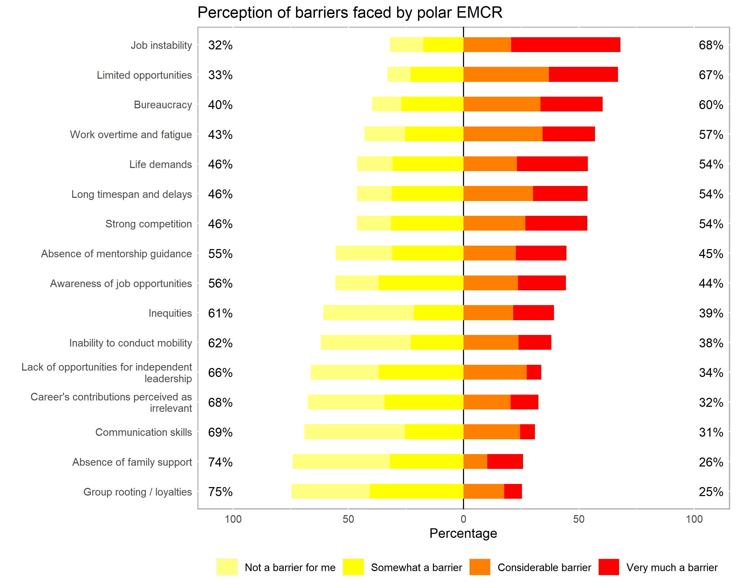

Figure 2. List of the sixteen career drivers ranked by importance.
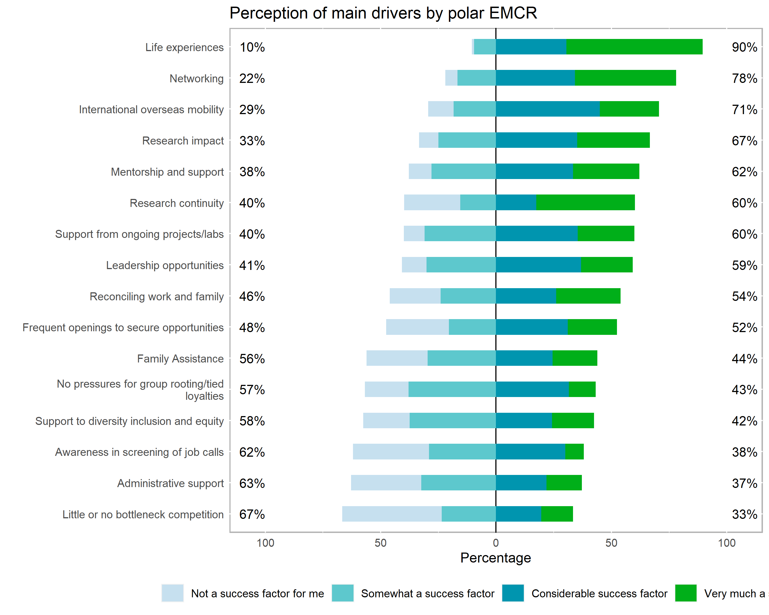

Table 1. Factor analysis based on polychoric correlation matrix for the barriers.

Barrier | Factor 2 | Factor 1 | Factor 3
Work overtime and fatigue | 0.381 | 0.232
Communication skills |  | 0.997
Awareness of job opportunities | 0.408 | 0.339 | 0.558
Limited opportunities | 0.261 | 0.311 | 0.607
Strong competition | 0.433 | 0.354 | 0.336
Bureaucracy | 0.328
Group rooting / loyalties | 0.529 | 0.235 | -0.195
Job instability | 0.679 | 0.215 | 0.179
Life demands | 0.781 | 0.287 | -0.271
Absence of family support | 0.432 | 0.609 | -0.203
Inequities | 0.501 | 0.517 | -0.101
SS loadings | 2.463 | 2.211 | 0.993
Proportion Variance | 0.224 | 0.201 | 0.090
Cumulative Variance | 0.224 | 0.425 | 0.515

Note: Bold font indicates values greater than 0.50.

Table 2. Factor analysis based on polychoric correlation matrix for the drivers.

Driver | Factor 2 | Factor 1 | Factor 3
Life experiences | 0.426 | 0.453 | -0.345
Networking | 0.693 | 0.369 | -0.531
Support from ongoing projects/labs | 0.482 | 0.451
Administrative support | 0.509 | 0.478 | 0.451
Mentorship and support | 0.430 | 0.299 | 0.248
Leadership opportunities | 0.486 | 0.371 | 0.265
International overseas mobility | 0.552 | 0.210
Research continuity | 0.614 | 0.324 | 0.560
Reconciling work and family | 0.400 | 0.419 | 0.641
Family assistance |  | 0.997
Research impact | 0.443 | 0.205 | 0.254
SS loadings | 2.612 | 2.362 | 1.530
Proportion Variance | 0.237 | 0.215 | 0.139
Cumulative Variance | 0.237 | 0.452 | 0.591

Note: Bold font indicates values greater than 0.50.

