Supplemntary Information
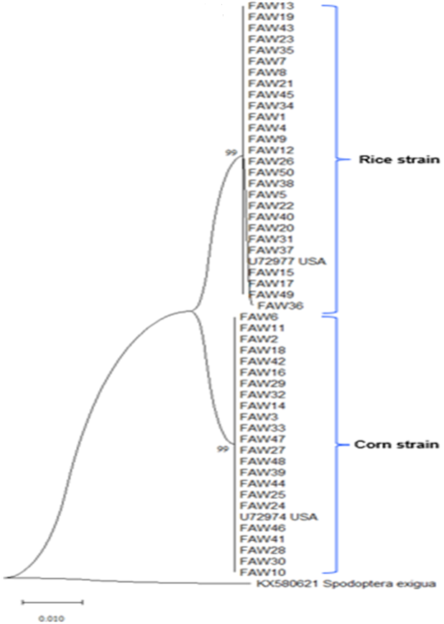
Figure S1. Phylogenetic analysis of Spodoptera frugiperda based on mtCOI sequences from the GenBank (https://blast.ncbi.-nlm.nih.gov/Blast.cgi). As an out-group, a sequence from S. exigua (KX580621) is included, while the USA rice (U72977) and corn (U72974) strains are used as references. Samples from this study, which are labeled as FAW1 to FAW50, have also been submitted to GenBank.

