Additional file 4: Secondary data management flow chart
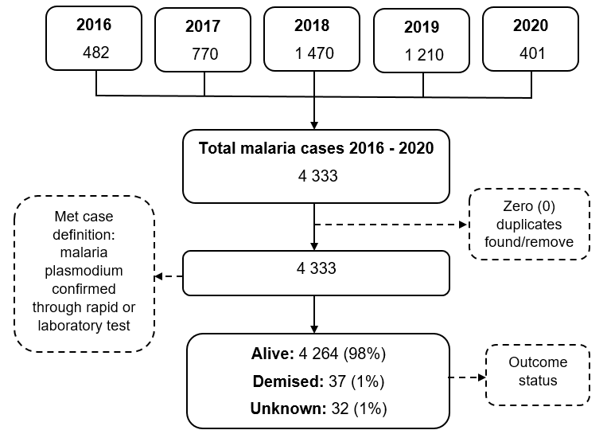
Figure S1: Flow chart depicting data management of malaria data retrieved from DHIS2, January 2016 to December 2020

