Supplementary file 1:

Table 1: List of contaminating genera identified in this study based on information from previous studies on possible bacterial contaminants.
Genus | Habitat | Genus | Habitat | Genus | Habitat
Acidibacter | Water | Ezakiella | Human | Nocardioides | Soil
Aciditerrimonas | Soil | Flavobacterium | Water | Nosocomiicoccus | Hospital surfaces
Acidovorax | Water/environment | Fusobacterium | Human | Ornithinimicrobium | Green algae
Acinetobacter | Animal/environment | Gemella | Human | Panacagrimonas | Soil
Actinomyces | Human | Geodermatophilus | Soil | Pantoea | Plant
Actinophytocola | Soil | Gp6 | Non-bacterial | Pelomonas | Soil
Actinotalea | Soil | Granulicatella | Human | Peptoniphilus | Human
Actinotignum | Human | Haemophilus | Human | Povalibacter | Plant
Aerococcus | Human | Haliscomenobacter | Environment | Prevotella | Human
Anaerococcus | Human | Herbaspirillum | Plant | Prosthecobacter | Environment
Anaerosphaera | Human | Hydrogenophaga | Soil | Pseudomonas | Human/environment
Aquabacterium | Water | Hydrotalea | Water | Pseudonocardia | Water/environment
Armatimonas | Aquatic | Kocuria | Food | Ralstonia | Soil/environment
Arthrobacter | Soil | Kosakonia | Environment | Ramlibacter | Soil
Azospirillum | Soil | Lactobacillus | Food | Rheinheimera | Soil
Bacillus | Environment/human | Lactococcus | Food | Rhodococcus | Environment
Bergeyella | Human | Lautropia | Human | Rubrivivax | Environment
Blastococcus | Water/environment | Leptotrichia | Human | Rudanella | Environment
Bordetella | Human | Leuconostoc | Plant | Ruminococcus | Human
Brevibacterium | Environment/mammal | Limnobacter | Water | Salmonella | Food
Campylobacter | Food | Lysinibacillus | Soil/environment | Selenomonas | Human
Cellvibrio | Soil | Lysobacter | Soil | Snodgrassella | Insect
Comamonas | Soil/environment | Marmoricola | Soil | Solibacillus | Air
Corynebacterium | Animal | Massilia | Soil/environment | Spirillospora | Environment
Craurococcus | Environment | Meiothermus | water | Staphylococcus | Animal
Cryptosporangium | Plant | Methylobacterium | Water | Stenotrophomonas | Soil/environment
Dechloromonas | Environment | Methyloversatilis | Water | Streptococcus | Human
Dietzia | Plant | Microbacterium | Soil/environment | Tetrasphaera | Water
Domibacillus | Soil | Micrococcus | Human | Turicella | Human
Enhydrobacter | Water | Micromonospora | Environment | Vampirovibrio | Algae
Enterobacter | Human/environment | Mobiluncus | Human | Variovorax | Soil
Escherichia | Human | Mycobacterium | Mammal | Veillonella | Human
Exiguobacterium | Water | Neisseria | Human

Table 2: Published 16S rRNA gene sequences retrieved from GenBank and included in the Anaplasma phylogenetic analysis in this study.
Accession number | Genus/Species | Strain/Isolate | Accession number | Genus/Species | Strain/Isolate
AF414870.1 | Anaplasma ovis | OVI | MF576175.1 | Anaplasma | ST Mymensingh
CP015994.1 | Anaplasma ovis | Haibei | MH762077.1 | Anaplasma capra | AK-Rm-429
CP000030.1 | Anaplasma marginale | St. Maries | U03775.1 | Anaplasma bovis | NA
CP001759.1 | Anaplasma centrale | Israel | KU586025.1 | “Candidatus Anaplasma boleense” | WHANSP-48
OQ909445 | Anaplasma | KNP2 platys-like | MG869522.1 | Anaplasma | Zhengxiaocun
KU686784.1 | Anaplasma centrale | Uganda | MG869519.1 | Anaplasma | Wangmang
MK814419.1 | Anaplasma platys | Apla1 | LC269823.1 | Anaplasma | ZAM dog-181
CP046391.1 | Anaplasma platys | S3 | AY570538.1 | Anaplasma | SA dog-1108
U54806.1 | Anaplasma | Omatjenne | OK560162.1 | Anaplasma bovis-like | 9100t
CP006618.1 | Anaplasma phagocytophilum | Dog2 | NR118489.1 | Anaplasma odocoilei | UMUM76
KF843825.1 | “Candidatus Anaplasma camelii” | Camel 7 | MK814449.1 | Anaplasma | Mymensingh
KF843824.1 | “Candidatus Anaplasma camelii” | Camel 4 | LC558313.1 | Anaplasma | Om5
MK575506.1 | Anaplasma | Mongolia | NR074513.2* | Ehrlichia ruminantium | Welgevonden
* Outgroup
Table 3: Published 16S rRNA gene sequences retrieved from GenBank and included in the Coxiella phylogenetic analysis in this study. Coxiella-like endosymbionts (CLE) are identified according to their tick host.
Accession number | Species | Strain/ Isolate | Accession number | Species | Strain/ Isolate
CP011126.1 | “Candidatus Coxiella mudrowiae” | CRt | KP994833.1 | CLE Rhipicephalus decoloratus | Rhdeco1
CP024961.1 | “Candidatus Coxiella mudrowiae” | CRS-CAT | KP994835.1 | CLE Rhipicephalus evertsi | Rhever1
KU892220.1 | CLE Rhipicephalus sanguineus | NA | KP994839.1 | CLE Rhipicephalus microplus | Rhmicro1
CP000890.1 | Coxiella burnetii | RSA 331 | KP994824.1 | CLE Ixodes hexagonus | Ihexa2
MN263245.1 | Coxiella burnetii | B10 | KP994826.1 | CLE Ixodes ricinus | Iric2
KC170759.1 | CLE Haemaphysalis obesa | TPSD8 | KP994795.1 | CLE Ornithodoros rupestris | Orupes1
KP994843.1 | CLE Rhipicephalus sanguineus | Rhsa1 | KP994816.1 | CLE Haemaphysalis punctata | Haepun5
KP994769.1 | CLE Argas monachus | Amo02 | KP994810.1 | CLE Amblyomma variegatum | Avar2
KP994799.1 | CLE Ornithodoros spheniscus | Osphe1 | EF413063.1 | Coxiella cheraxi | TO-98
KP994812.1 | CLE Dermacentor marginatus | Dmar2 | KP994804.1 | CLE Amblyomma americanum | Aame2
KP994814.1 | CLE Dermacentor silvarum | Dsilv2 | U11021.1* | Rickettsia rickettsii | NA
MZ836861 | CLE Rhipicephalus sanguineus | no3-51
* Outgroup

Table 4: Published 16S rRNA gene sequences retrieved from GenBank and included in the Ehrlichia/Wolbachia phylogenetic analysis in this study.
Accession number | Species | Strain/ Isolate | Accession number | Species | Strain/ Isolate
AB074459.1 | “Candidatus Ehrlichia shimanensis” | TS37 | EU833482.1 | Wolbachia radopholus | NA
KY425523.1 | “Candidatus Ehrlichia sp.” | Y272 | KX155505.1 | “Candidatus Wolbachia massiliensis” | PL13
NR074513.2 | Ehrlichia ruminantium | Welgevonden | DQ402518.1 | “Candidatus Wolbachia inokumae” | NA
NR044747.1 | Ehrlichia ewingii | Stillwater | DQ402520.1 | “Candidatus Wolbachia brouquii” | NA
NR074500.2 | Ehrlichia chaffeensis | Arkansas | JX669531.1 | Uncultured bacterium | S3RP2010C1
NR025962.1 | Ehrlichia muris | AS145 | KX155506.1 | Wolbachia pipientis | a.alb6-Marseille
DQ647318.1 | Ehrlichia sp. | HF | MN383047.1 | Wolbachia endosymbiont Aedes aegypti | WSF1-1
NR148800.1 | Ehrlichia minasensis | UFMG-EV
NR118741.1 | Ehrlichia canis | Oklahoma | NR 043755.1* | Rickettsia conorii raoultii | Khabarovsk
MK507008.1 | Ehrlichia canis | CuD125
JN121380.1 | Uncultured Ehrlichia | D28A
* Outgroup
Table 5: Published 16S rRNA gene sequences retrieved from GenBank and included in the Rickettsia phylogenetic analysis in this study.
Accession number | Species | Strain/ Isolate | Accession number | Species | Strain/ Isolate
DQ015802.1 | Uncultured bacterium | ELB16-030 | NR 074394.1 | Rickettsia typhi | Wilmington
NR 025967 | Rickettsia honei | RB | NR 044656.2 | Rickettsia prowazekii | Brein1
KC331445.1 | Uncultured bacterium | lp227 | L36098 | Rickettsia africae | ESF-5
MK616425.1 | Uncultured Rickettsiales | LG126_1 | U11021 | Rickettsia rickettsii | Sawtooth
MK616428.1 | Uncultured Rickettsiales | LG127_2 | NR 036848.1 | Rickettsia sibirica | 246
MG563925.1 | “Candidatus Megaera benefice” | 1M-2 | NR 074469.2 | Rickettsia conorii | heilongjiangensis 054
MG827267.1 | Uncultured Rickettsia | OTU389 | D38622 | Orientia tsutsugamushi | Gilliam
AF322442.1 | Rickettsia limoniae | Gent | D38626 | Orientia tsutsugamushi | Kuroki
NR 029155.1 | Rickettsia canadensis | 2678 | GU937608 | Occidentia massiliensis | Os18
NR 074484.2 | Rickettsia bellii | RML369-C | NR149220 | Occidentia massiliensis | Os18
NR 074459.2 | Rickettsia japonica | YH
NR 036773.1 | Rickettsia australis | NIAID Phillips 32 | NR 074500.2* | Ehrlichia chaffeensis | Arkansas
* Outgroup

Table 6: Published 16S rRNA gene sequences retrieved from GenBank and included in the Borrelia phylogenetic analysis in this study.
Accession number | Species | Strain/ Isolate | Accession number | Species | Strain/ Isolate
Borrelia |  |  | NR 136451.1 | Spirochaeta lutea | JC230
AB007450.1 | Borrelia garinii | ChY13p | NR 117123.1 | Spirochaeta thermophila | DSM 6578
AJ224130.1 | Borrelia burgdorferi | CA446 | NR 044756.2 | Spirochaeta halophila | RS1
EF570070.1 | Borrelia sp | SCW-41 | NR 043329.1 | Spirochaeta dissipatitropha | ASpC2
MZ564265.1 | Uncultured Borrelia sp | K102 | AY599019.1 | Spirochaeta aurantia | M1
AB113315.1 | Borrelia duttonii | VS4 | Trepnonema
CP025785.1 | “Candidatus Borreliella tachyglossi” | Bc-F10-1268 | NR 181480.1 | Treponema peruense | RCC2812
JF681792.1 | Borrelia microti | Abyek | NR 180741.1 | Treponema phagedenis | B43.1
AF210137.1 | Borrelia parkeri | NA | NR 118740.1 | Treponema pectinovorum | 8:A:33768
AY166715.1 | Borrelia lonestari | NA | Cristispira
Spirochaeta |  |  | U42638.1 | Cristispira | CP1
NR 044505.1 | Spirochaeta cellobiosiphila | SIP1
NR 134185.1 | Spirochaeta psychrophila | MO-SPC1 | NR043259.1* | Leptospira borgpetersenii | Veldrat Batavia 46
NR 117137.1 | Spirochaeta isovalerica | DSM 2461
* Outgroup

Table 7: Summary of all samples from 2016, 2017, and 2019, providing information on raw sequence read counts, post-quality control read counts, and final read counts. Final read counts were calculated after chimeras, possible contaminants, and uncharacterized sequences were removed.
Sample ID | Tissue Type | Raw read count | Post-quality control read count | Final read count
Year: 2016
Y1M3 | Midgut | 2002 | 1055 | 1055
Y1M4 | Midgut | 3338 | 1804 | 1801
Y1M6 | Midgut | 1709 | 1002 | 1002
Y1M7 | Midgut | 1304 | 590 | 590
Y1M8 | Midgut | 1291 | 643 | 643
Y1M9 | Midgut | 3386 | 1618 | 1616
Y1M10 | Midgut | 4758 | 2371 | 2369
Y1S1 | Salivary gland | 6593 | 1842 | 1381
Y1S2 | Salivary gland | 1820 | 913 | 910
Y1S3 | Salivary gland | 864 | 428 | 428*
Y1S5 | Salivary gland | 1502 | 438 | 423*
Y1S7 | Salivary gland | 1972 | 905 | 905
Y1S8 | Salivary gland | 1611 | 750 | 750
Y1S9 | Salivary gland | 1990 | 1005 | 1000
Y1S10 | Salivary gland | 4101 | 1663 | 1659
Total read counts |  | 38241 | 17027 | 16532
Year: 2017
Y2M1 | Midgut | 2699 | 1418 | 1295
Y2M2 | Midgut | 997 | 605 | 599
Y2M8 | Midgut | 1035 | 587 | 587
Y2M9 | Midgut | 2741 | 1428 | 1422
Y2S1 | Salivary gland | 1132 | 607 | 607
Y2S2 | Salivary gland | 1075 | 627 | 625
Y2S3 | Salivary gland | 1639 | 923 | 558
Y2S4 | Salivary gland | 1354 | 746 | 743
Y2S8 | Salivary gland | 1731 | 987 | 987
Y2S10 | Salivary gland | 1239 | 628 | 601
Total read counts |  | 15642 | 8556 | 8024
Year: 2019
Y3M1 | Midgut | 9317 | 7509 | 4918
Y3M3 | Midgut | 7882 | 6389 | 1374
Y3M5 | Midgut | 6041 | 4823 | 1539
Y3M6 | Midgut | 8544 | 7085 | 4400
Y3M12 | Midgut | 200 | 153 | 70*
Y3M15 | Midgut | 6432 | 2911 | 273*
Y3S3 | Salivary gland | 2241 | 1646 | 268*
Y3S5 | Salivary gland | 2055 | 1543 | 715
Y3S6 | Salivary gland | 2032 | 1504 | 1055
Y3S10 | Salivary gland | 8083 | 6061 | 2225
Y3S12 | Salivary gland | 9580 | 7763 | 1224
Y3S15 | Salivary gland | 18288 | 7196 | 1155
Total read counts |  | 80695 | 54583 | 18605
*Low read count samples were removed from further analysis

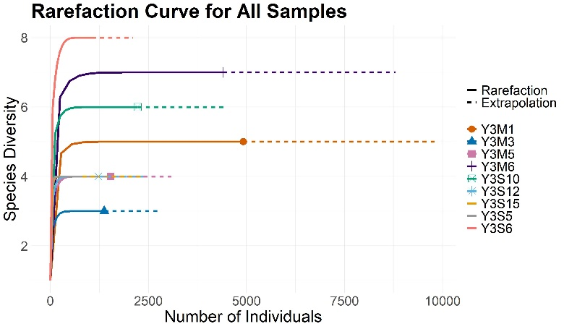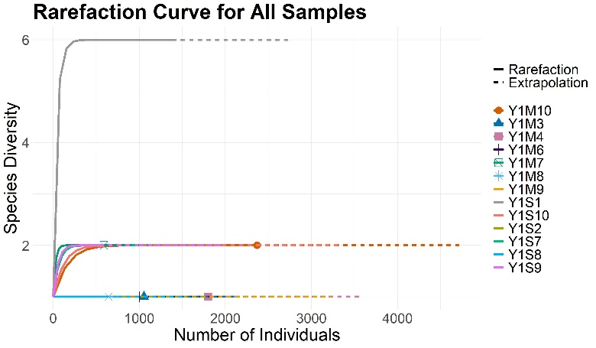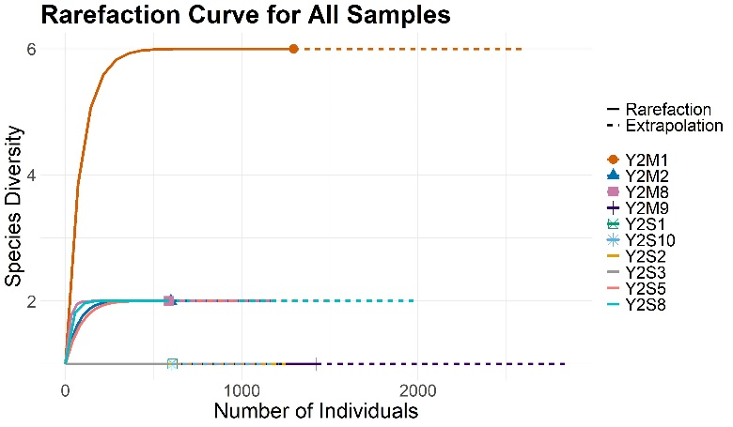

A
B
C
Figure 1: Rarefaction curves performed using the iNEXT package, for the bacterial microbiome data generated from midgut and salivay gland pools from Rhipicephalus sanguineus tick samples collected from dogs in (A) 2016, (B) 2017, and (C) 2019.

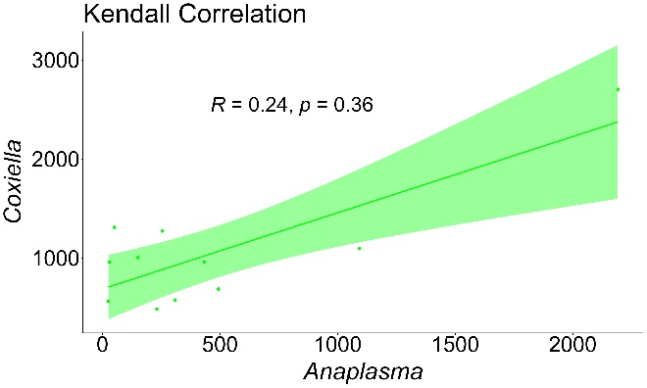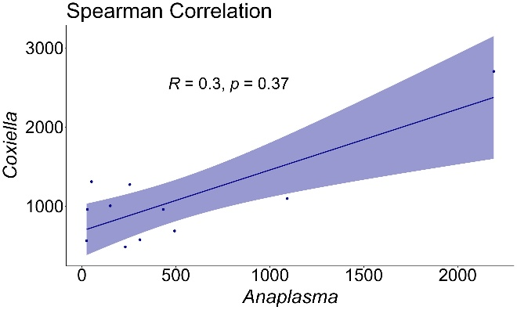

Figure 2: Kendall Correlation and Spearman Correlation tests indicating the association between the number of Anaplasma sequence reads and Coxiella sequence reads from the bacterial microbiome of Rhipicephalus sanguineus ticks collected from the study site in 2017 and 2019.
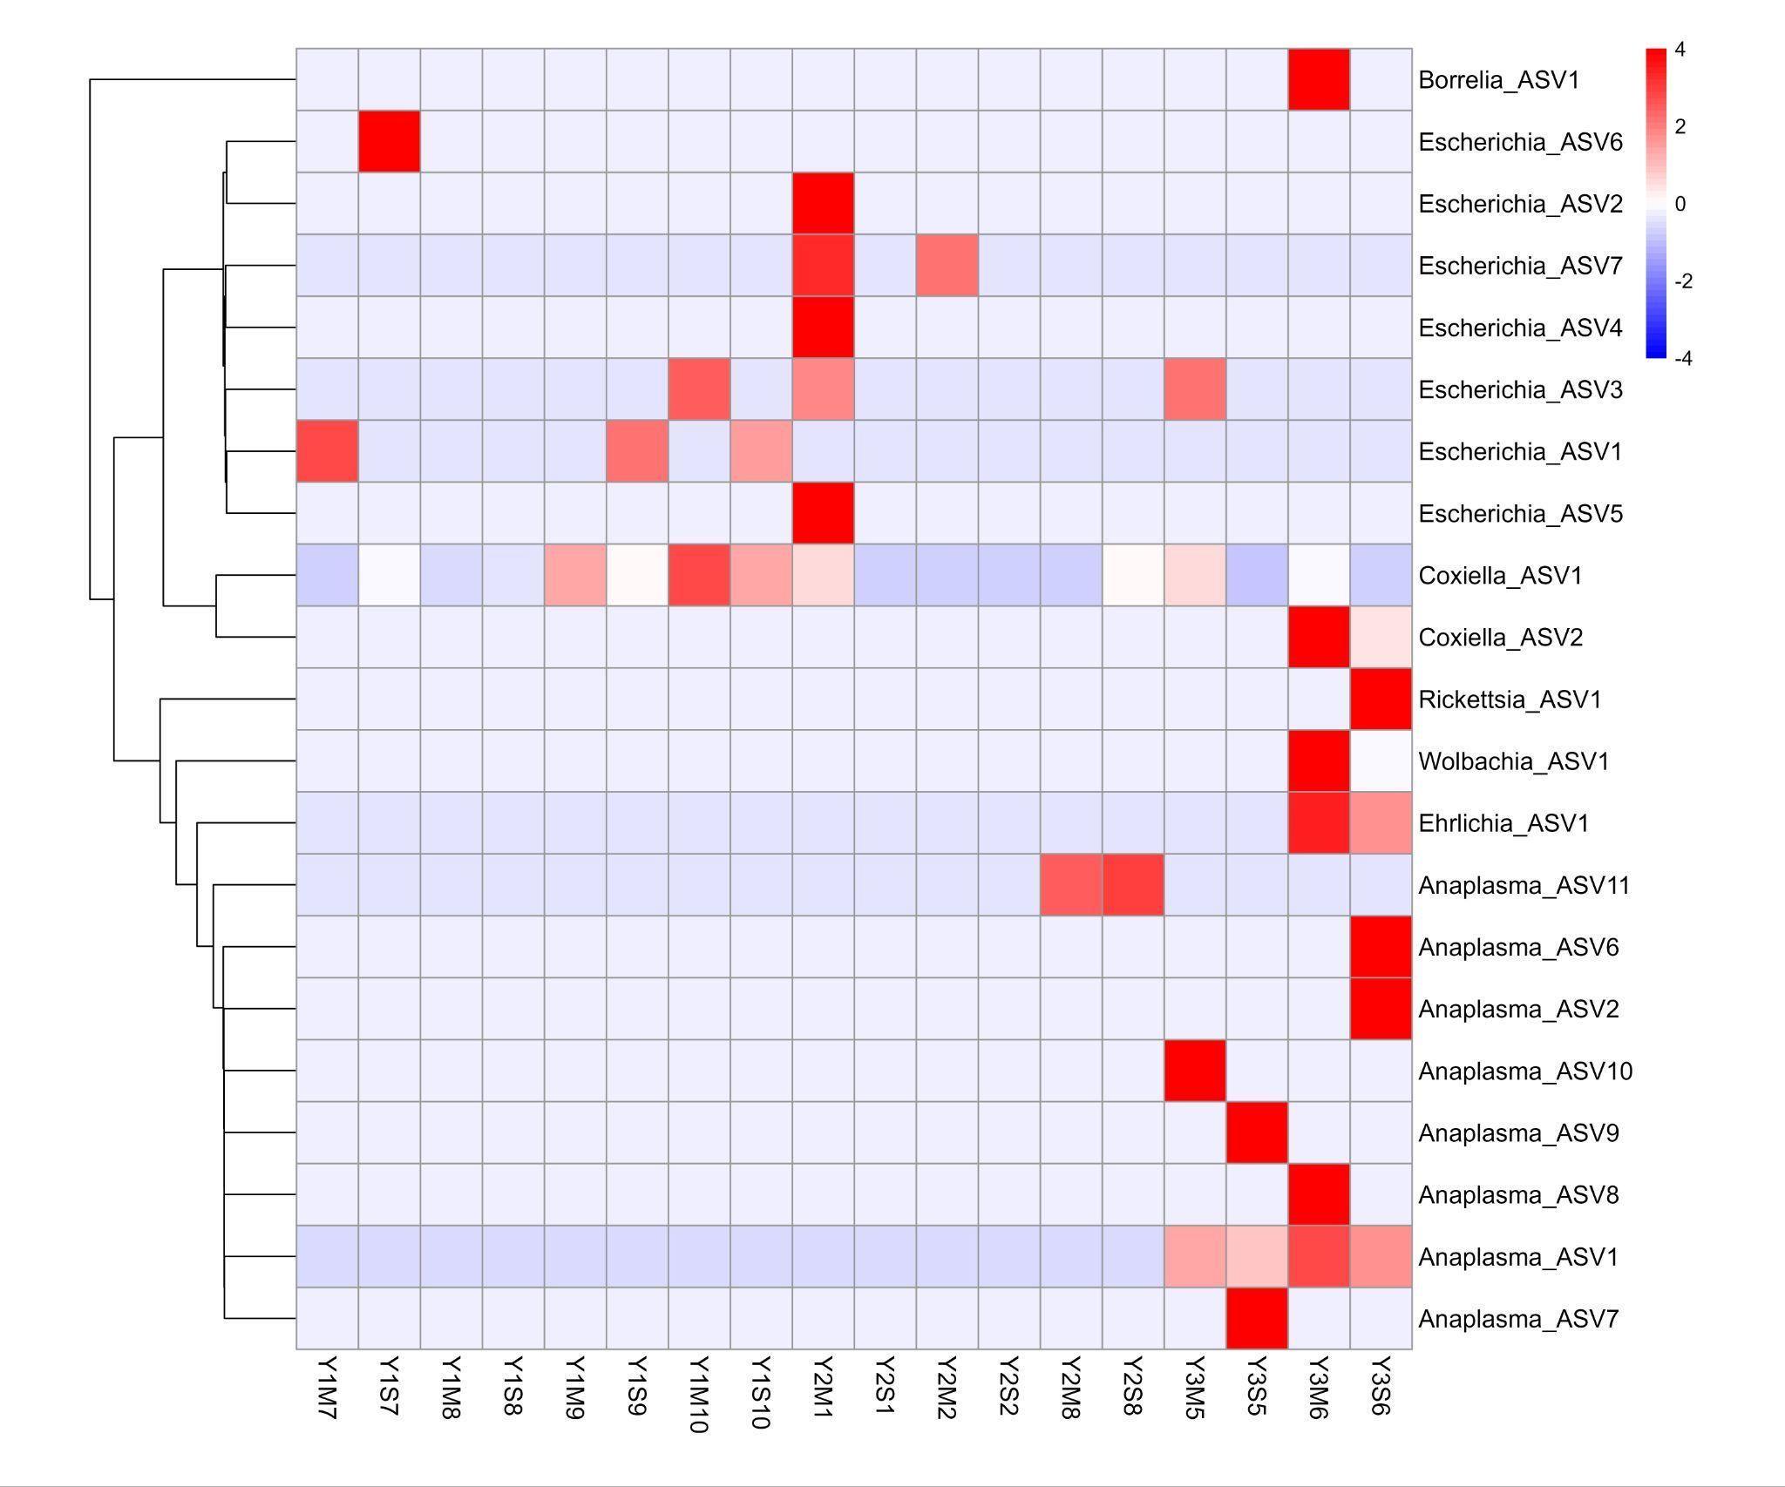
Figure 3: A heatmap visualizing differences in bacterial microbiome profiles of Rhipicephalus sanguineus s.l. midgut (M) and salivary gland (S) samples collected from dogs in Hluvukani, Bushbuckridge, Mpumalanga, South Africa, during 2016 (Y1), 2017 (Y2), and 2019 (Y3). The colour scale ranges from blue to red, where blue represents lower-than-average abundance and red indicates higher-than-average abundance, based on z-scores computed for each bacterial ASV. The dendrogram to the left of the heatmap reflects clustering based on pairwise alignment scores. Robust statistical testing could not be performed due to the small sample size.

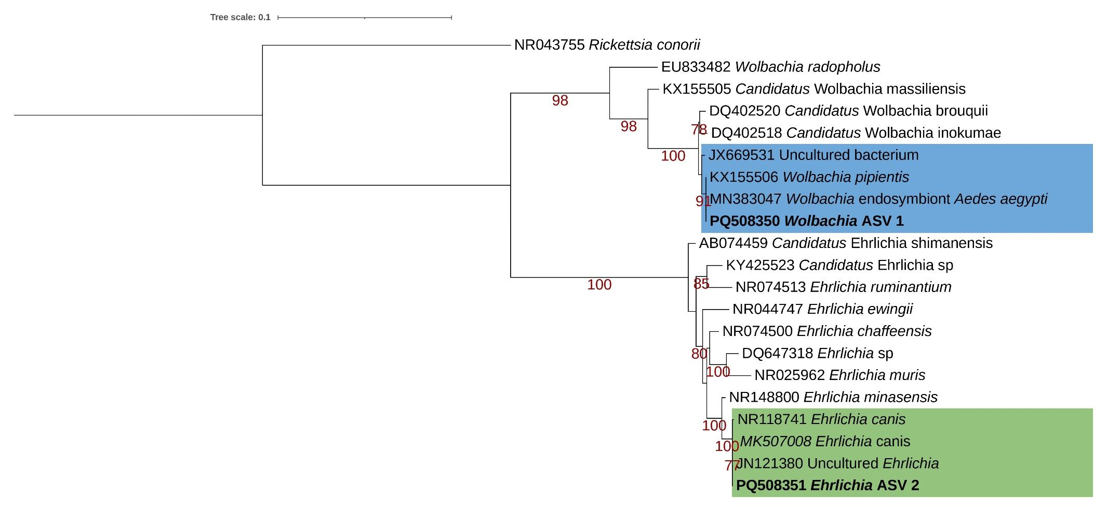
Figure 4: Maximum likelihood analysis indicating the relationships of Ehrlichia amplicon sequence variants detected in this study with known Ehrlichia and Wolbachia sequences from GenBank. A maximum likelihood inference was conducted using the TIM3+F+I+G4 model and 1000 bootstrap replicates (alignment length 1251 bp). Maximum likelihood bootstrap values (>75) are indicated below the branch. Ehrlichia amplicon sequence variants are indicated in bold. Ehrlichia sequences are indicated in a green box, while Wolbachia sequences are indicated in a blue box.
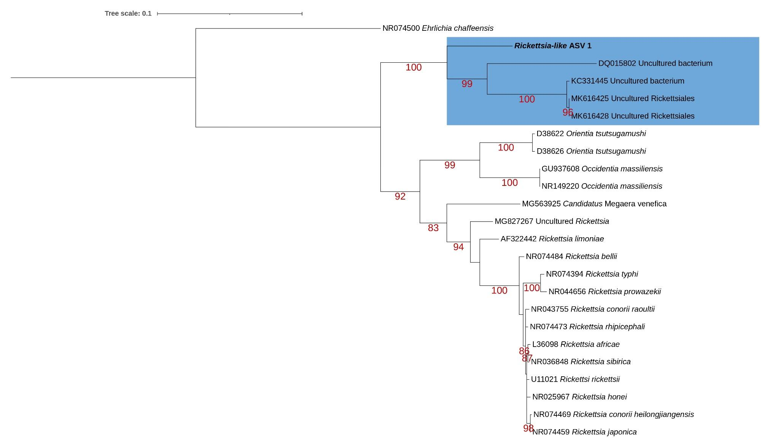

Figure 5: Maximum likelihood analysis indicating the relationship of a Rickettsia-like amplicon sequence variant detected in this study with known Rickettsia sequences from GenBank. A maximum likelihood inference was conducted using the GTR+F+I+G4 model and 1000 bootstrap replicates (alignment length 1251 bp). Maximum likelihood bootstrap values (>75) are indicated below the branch. The Rickettsia-like amplicon sequence variant is indicated in bold. Uncultured Rickettsiales sequences are indicated in a blue box.
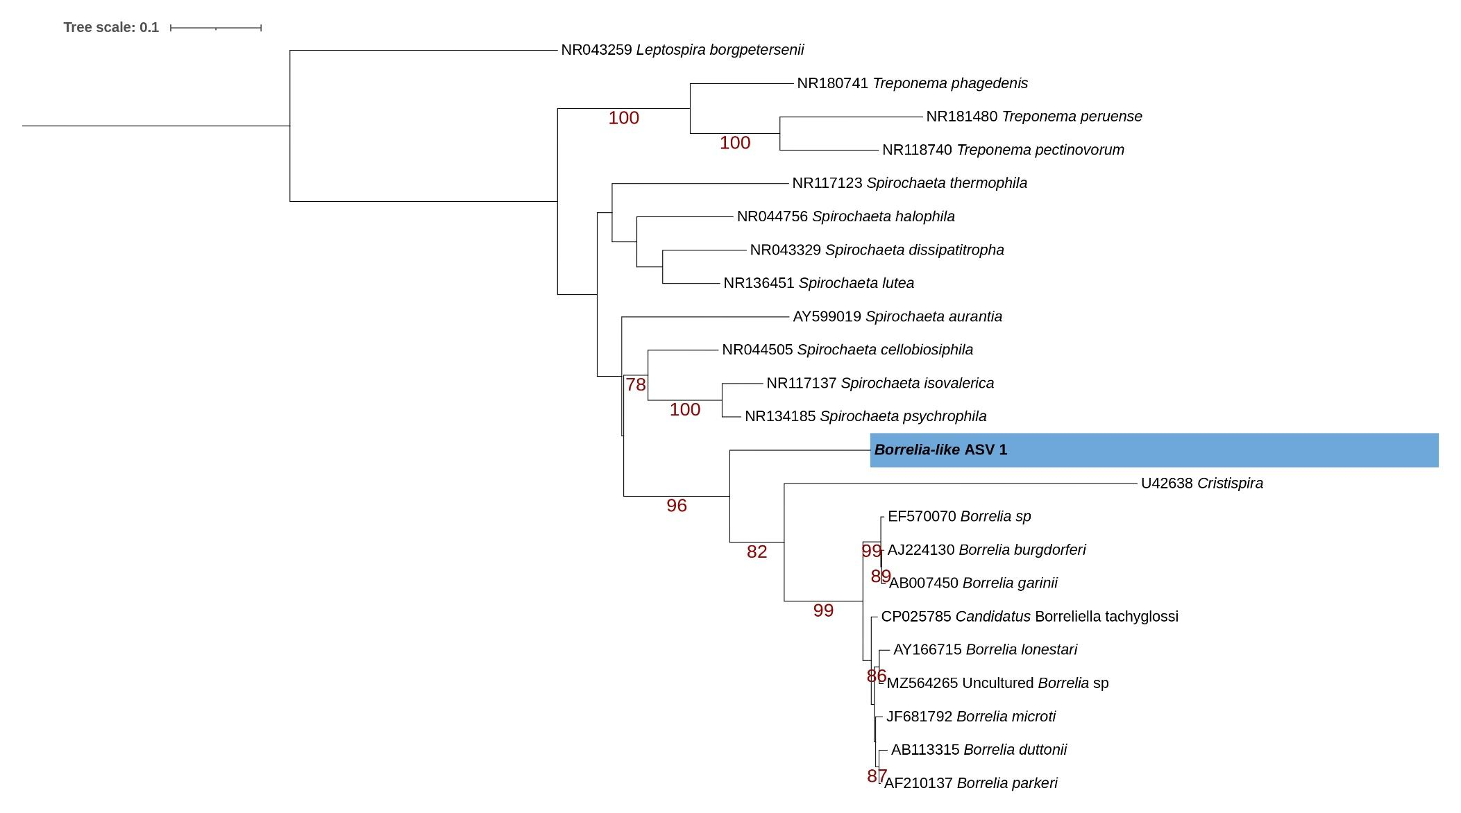
Figure 6: Maximum likelihood analysis indicating the relationship of a Borrelia-like amplicon sequence variant detected in this study with known sequences from taxa within the Borreliaceae family. A maximum likelihood inference was conducted using the TIM3+F+I+G4 model and 1000 bootstrap replicates (alignment length 1297 bp). Maximum likelihood bootstrap values are indicated below the branch. The Borrelia-like amplicon sequence variant is indicated in bold and highlighted in a blue box.

