Supplementary materials
4
Figure SM1: Potential drop technique used for measuring crack propagation.

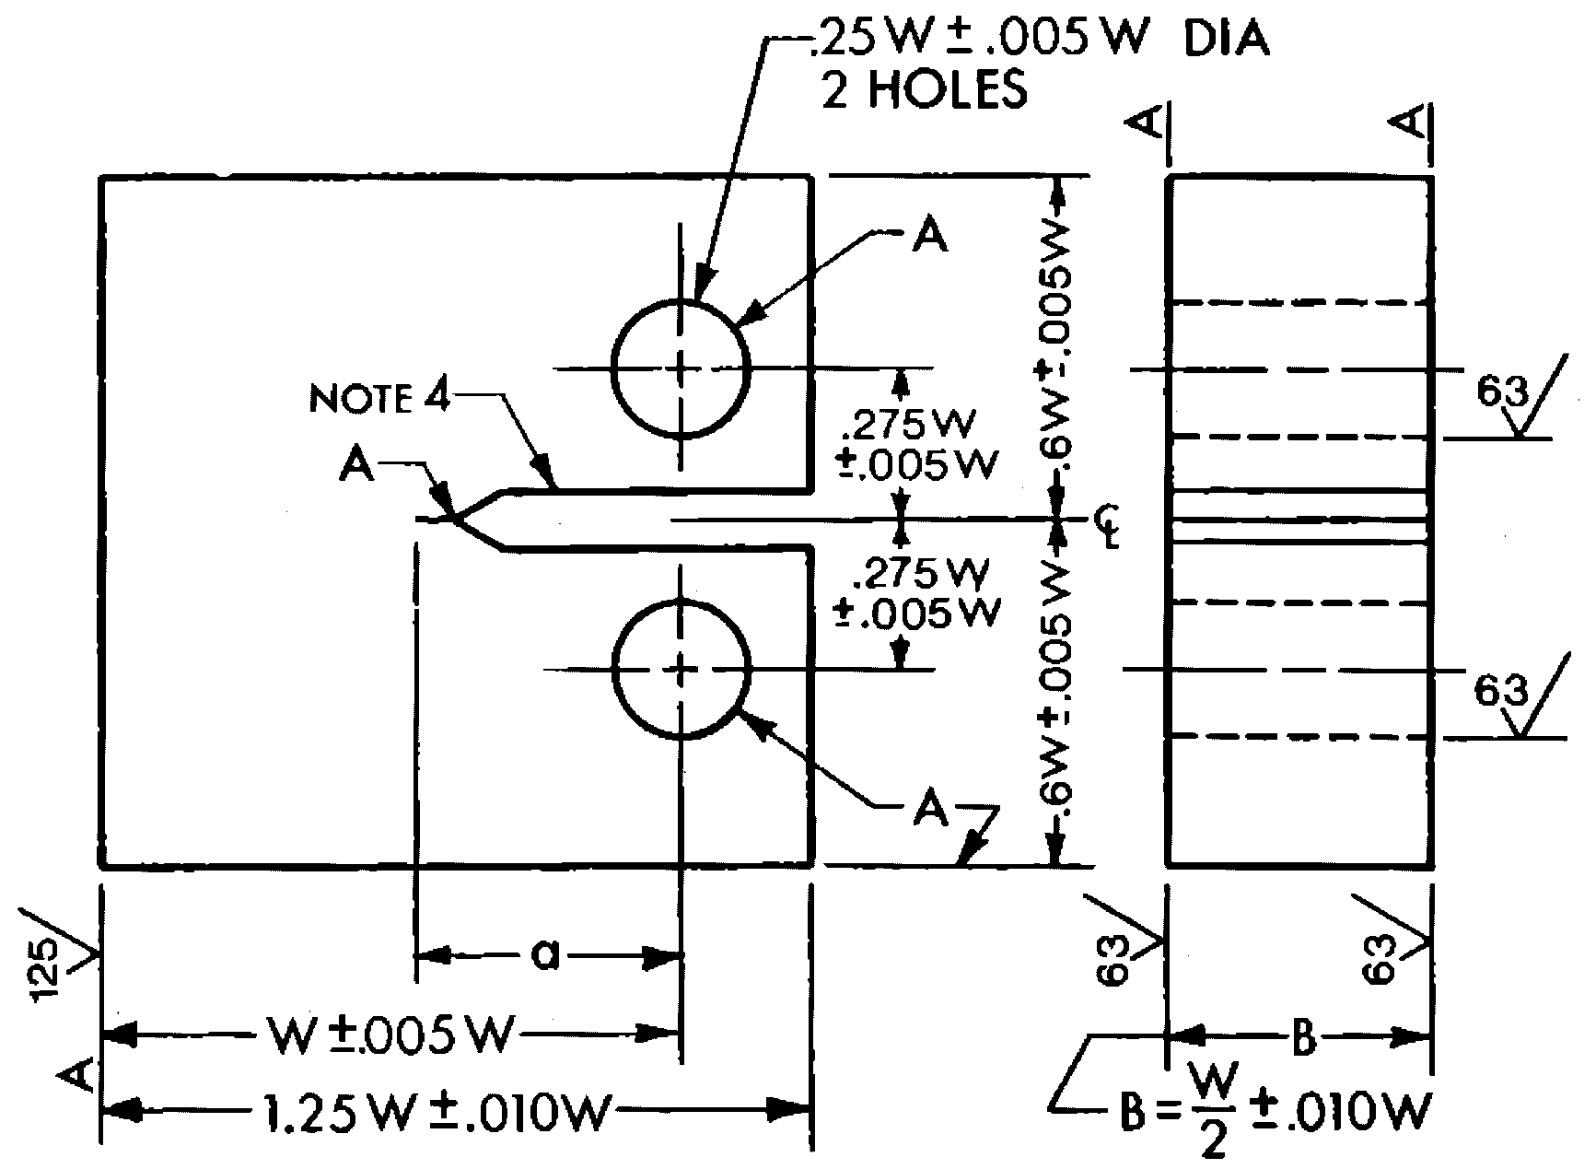
Figure SM2: Specimen with standard dimensions and tolerances.
Figure SM3: Crack propagation rate as a function of stress intensity of steel exposed to 9% CO-91% CO₂ with 8 ppm O₂ at 25°C and 45°C.

Figure SM4: Crack propagation rate as a function of stress intensity of steel exposed to 9% CO-91% CO₂ with 8 ppm O₂ at 25°C.

Figure SM5: The fracture mechanical characteristics of the steel were analyzed in 1% CO – 99% CO₂ at 45°C and 0.1 ppm O₂ as well as 8 ppm O₂.

Figure SM6: The fracture mechanical characteristics of the steel were analyzed in 1% CO – 99% CO₂ with 0.1 ppm O₂ at 45° and 25°C.
Figure SM7: Effect of the applied potential of steel exposed to 50% CO, at 800 kPa and 45°.

Figure SM8: Effect of the applied potential of steel exposed to 50% CO, at 25°C and 800 kPa.
Figure SM9: Effect of the applied potential of steel stressed to 20 MPa√m and exposed to 50% CO, at 800 kPa and 45°C.

