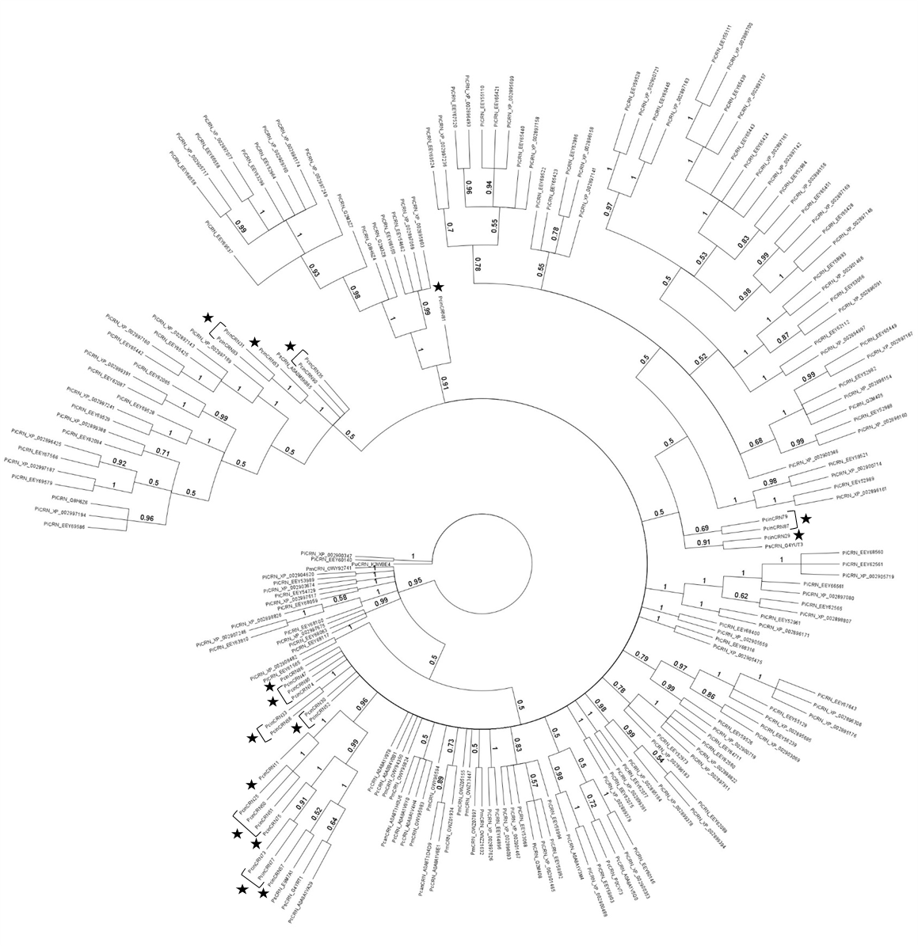
Supplementary Figure 1. Evolutionary relatedness of identified PcinCRNs to CRNs from other Phytophthora spp. Alignment of predicted N-terminal regions of putative Phytophthora cinnamomi crinkling and necrosis (PcinCRN) effectors with the N-terminal regions of CRNs from other Phytophthora spp. resulted in the construction of a phylogenetic tree using Bayesian inference analysis. Support for branches is indicated by posterior probability values, which are displayed for each node to the second significant digit with a posterior probability cut-off of < 0.5. Putative PcinCRN effectors proteins are indicated with stars. All 25 PcinCRNs were found to be similar to CRNs from other Phytophthora spp.

