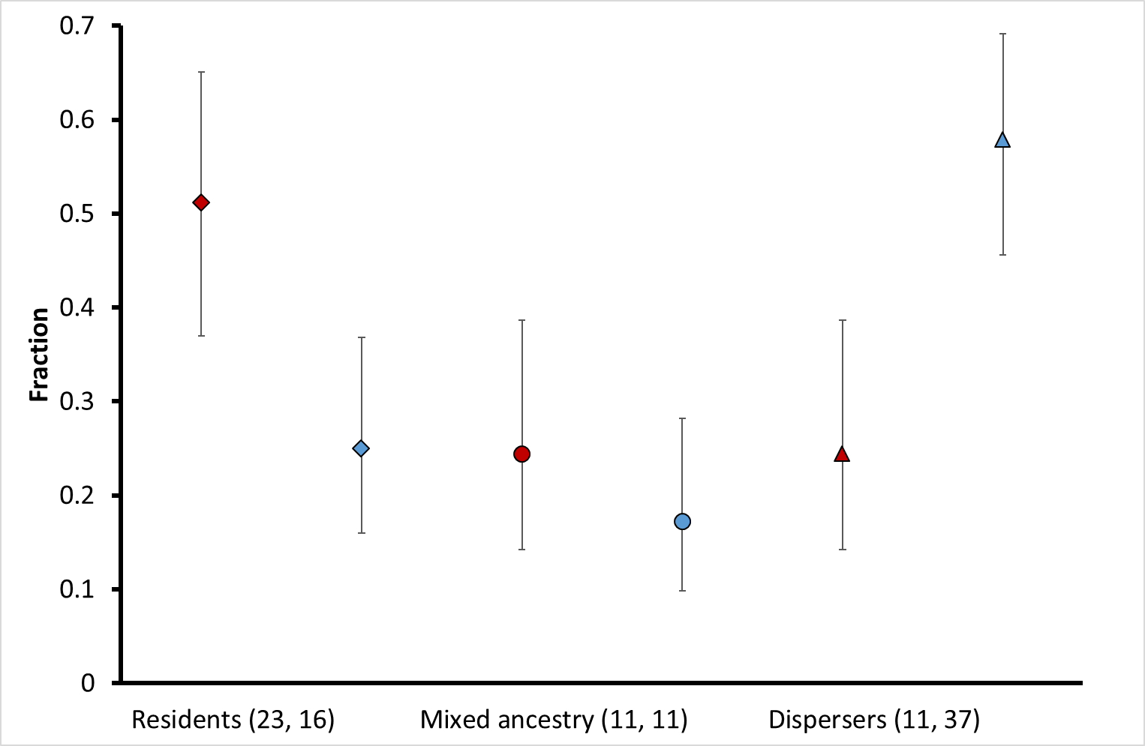
Fraction of candidate residents, candidate dispersers and individuals with mixed ancestry.
Red data points: northern Kruger, blue data points: southern Kruger, diamonds: candidate residents, circles: individuals with mixed ancestry (probably consisting of both residents and dispersers), triangles: candidate dispersers, error bars: 95% confidence interval. Horizontal axis, values between brackets: sample size of respectively northern and southern Kruger.
Candidate resident: > 90% of the genetic make-up assigned to local microsatellite cluster, candidate disperser: < 20% of the genetic make-up assigned to local microsatellite cluster. Mixed ancestry: between 20% and 90% of the genetic make-up assigned to local microsatellite cluster.

