S1 Fig. Results of the updated literature search

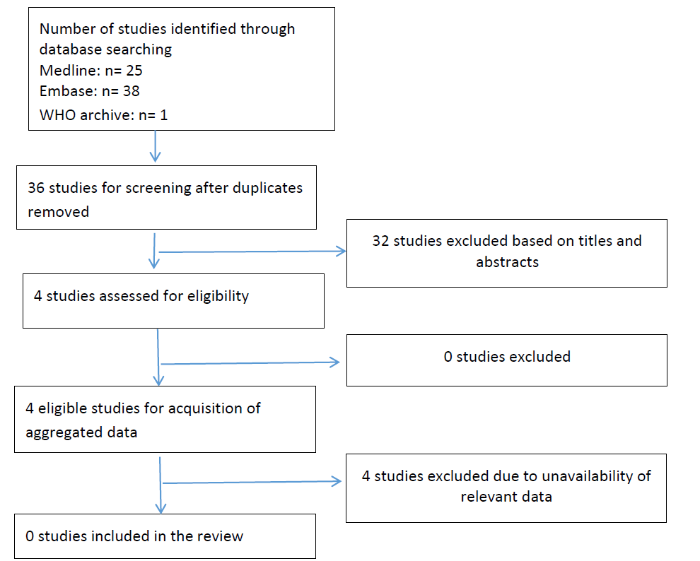
WHO: World Health Organization

