Supplementary Information
Lippert interpretation
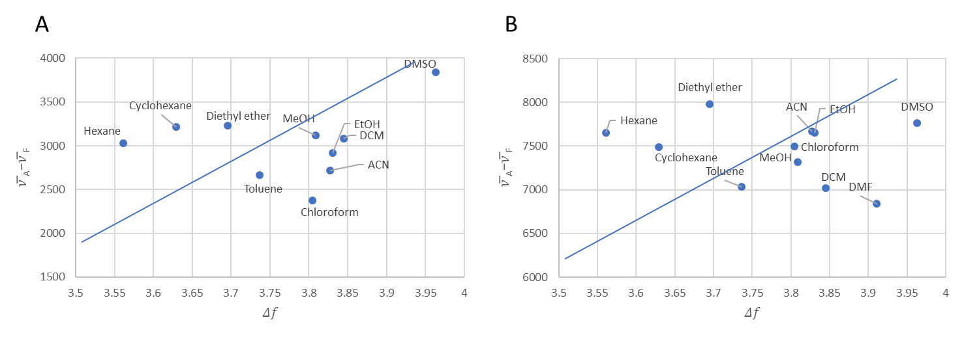
Figure S1: Lippert equation applied to linseed oil in different solvents, the first plot being the peak at 315 nm (λ_{em}) which arises with 300 nm incident light (λ_{ex}) and the second plot being the peak at 330 nm nm (λ_{em}) which arises with 315 nm excitation light (λ_{ex}). The lines are estimates of how the plots should be distributed if the fluorescence obeys the Lippert equation.
In solution the fluorophore is stabilized by the presence of dipole moments in the solvent that orientate around the dipole moment of the fluorophore. Solvents are known to shift the emission peak to longer wavelengths (higher energy) due to the stabilization of the excited state by a polar solvent molecule [1]. Some fluorophores are significantly affected by changes in polarity, for example trans-4-dimethylamino-4’-(1-oxobutyl) stilbene (DOS) where a change in solvent can lead to a shift to 200 nm longer emission wavelengths. Solvent effects can be interpreted by the Lippert equation (eq 1.1).
$${\overline{ν}}_{A}-{\overline{ν}}_{F}=\frac{2}{hc}\left(\frac{ε-1}{2ε+1}-\frac{n^{2}-1}{2n^{2}+1}\right)\frac{{\left(μ_{E }-μ_{G }\right)}^{2}}{a^{3}}+constant \left(1.1\right)$$
$$Δ\overline{ν}=\frac{2}{hc}Δf\frac{{\left(μ_{E }-μ_{G }\right)}^{2}}{a^{3}}+constant \left(1.2\right)$$
Where ${\overline{ν}}_{A}$ and ${\overline{ν}}_{F}$ are the wavenumbers (cm⁻¹) of the absorption and fluorescence, respectively. Planck’s constant (h) and the speed of light (c) are the two constants. The values that describe the properties of the fluorophore are: $a^{3}$, the area of the cavity in which the fluorophore resides, along with the excited- ($μ_{E })$and ground-state ${(μ}_{G })$ dipole moments. The properties of the solvent, dielectric constant ($ε$) and the refractive index ($n)$ will cause a change in the energy gap. The dielectric constant is a static property of the solvent which describes the molecular polarizability, which results in the reorientation of the solvent dipoles around the excited state. In contrast, the refractive index is a high-frequency response and depends on the motion of electrons within the solvent molecules. An increase in the refractive index would result in both the ground and excited states to be instantaneously stabilized from the movements of electrons in the solvent molecules, thus decreasing the energy gap. An increase in the dielectric constant will also result in a stabilization of the ground and excited states, and thus decrease the bad gap energy. However, where the refractive index results in an instantaneous stabilization, the stabilization from the dielectric constant only occurs after a reorientation of the solvent dipoles. In the Lippert equation, it is assumed that the solvent relaxation is complete prior to emission.

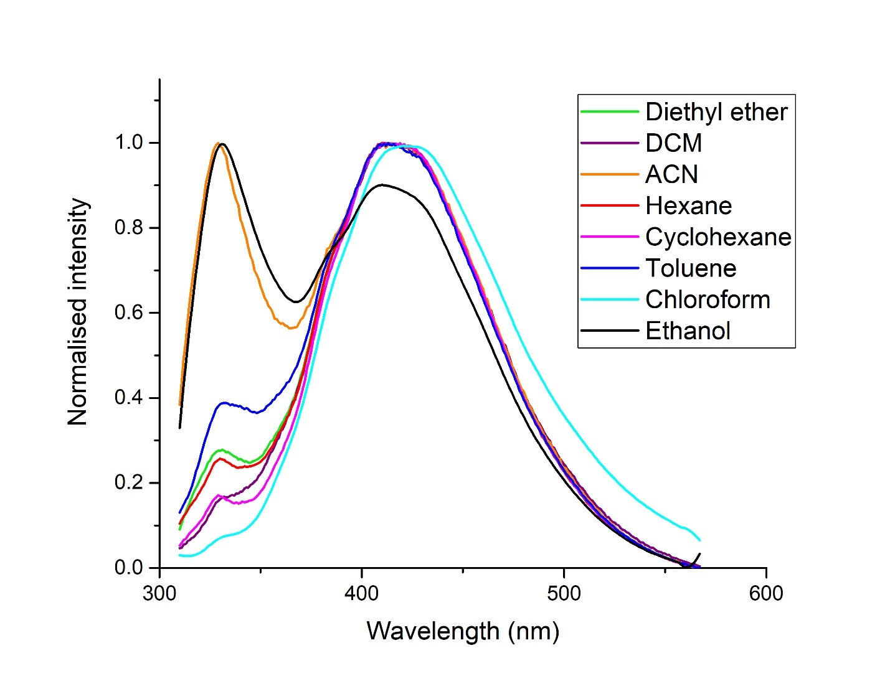
Figure S2: Fluorescence intensity of liquid linseed oil in various solvents using an excitation wavelength of 300 nm.

Chromatography studies
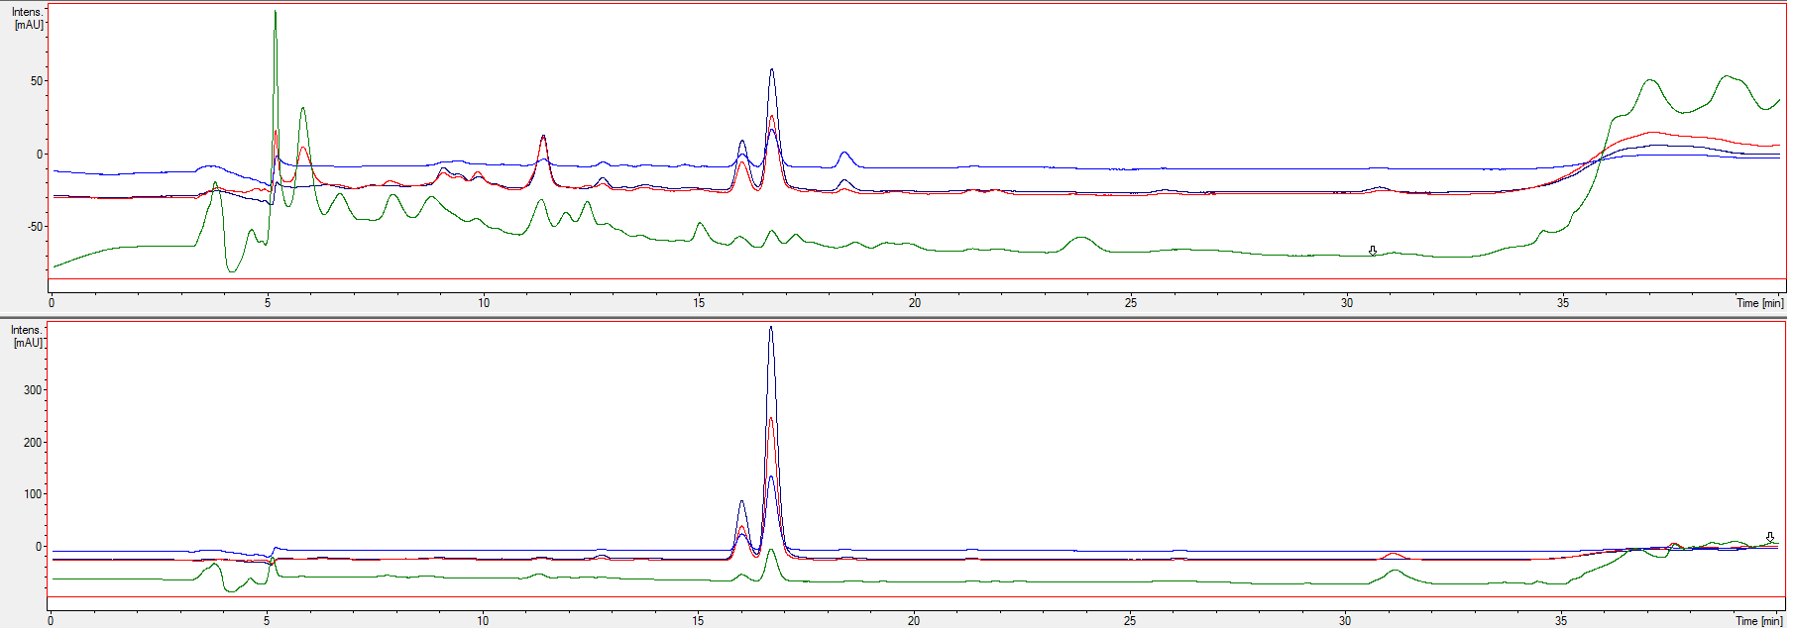
Figure S3: UV chromatograms of methanol extracts of cured LO film (top) and liquid LO (below) at different wavelengths: 240 nm – green; 260 nm – red; 280 nm – navy blue; 300 nm – light blue.

Photos of colour changes and UV-induced fluorescence (λ_{ex} 365 nm)
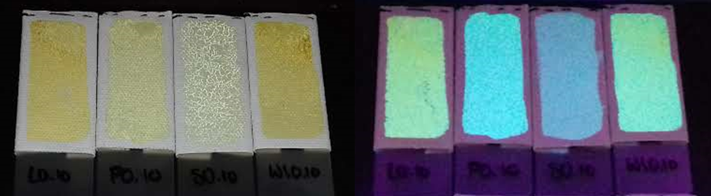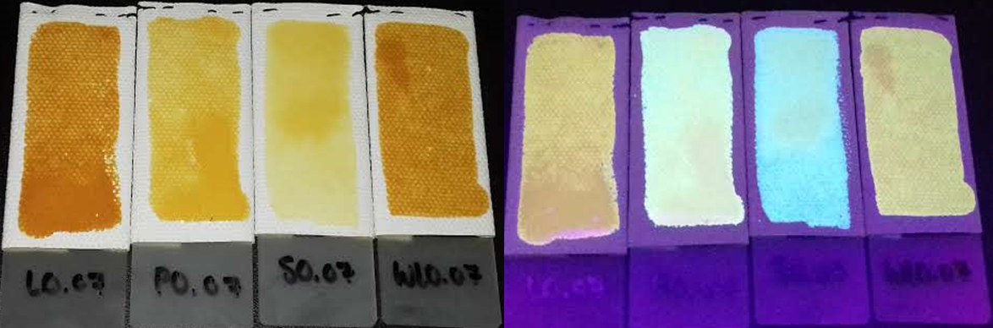
LO PO SO WLO
LO PO SO WLO
LO PO SO WLO
Figure S4: Fluorescence colours of the different oils after 1 week of UV exposure (top) and after 24 hr exposure to ammonia vapour (bottom). LO- Linseed oil; PO- Poppy seed oil; SO- Stand oil; WLO- water-miscible linseed oil.

Fluorescent changes in Poppy seed oil
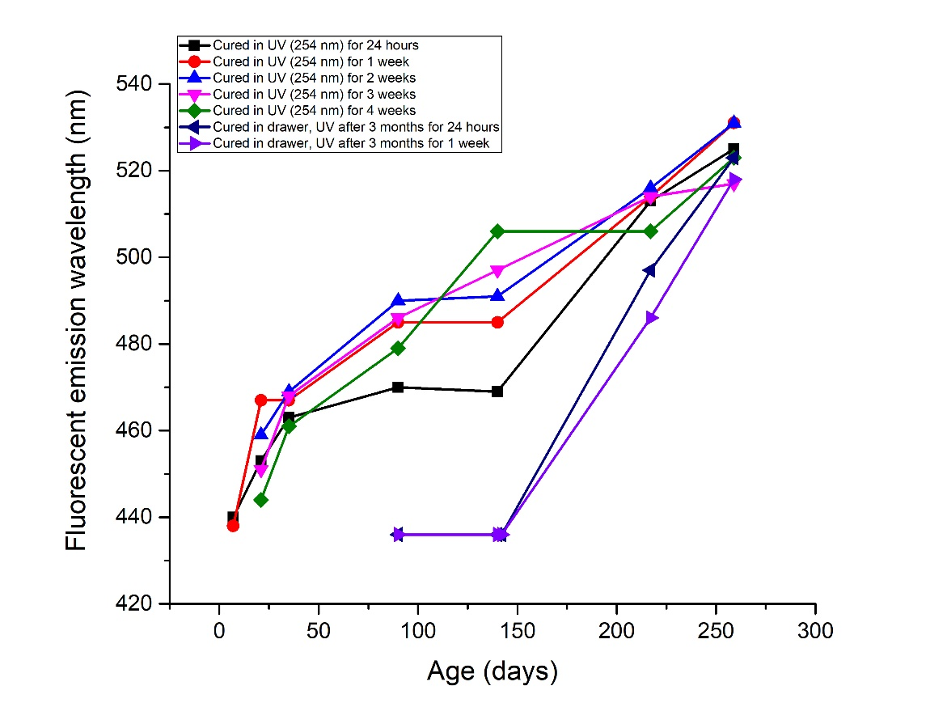
Figure S5: Rate of the fluorescence emission maximum changes of poppy seed oil various exposure times to UV light (254 nm) and then subsequent storage in dark drawers. The excitation wavelength was 360 nm for all measurements.
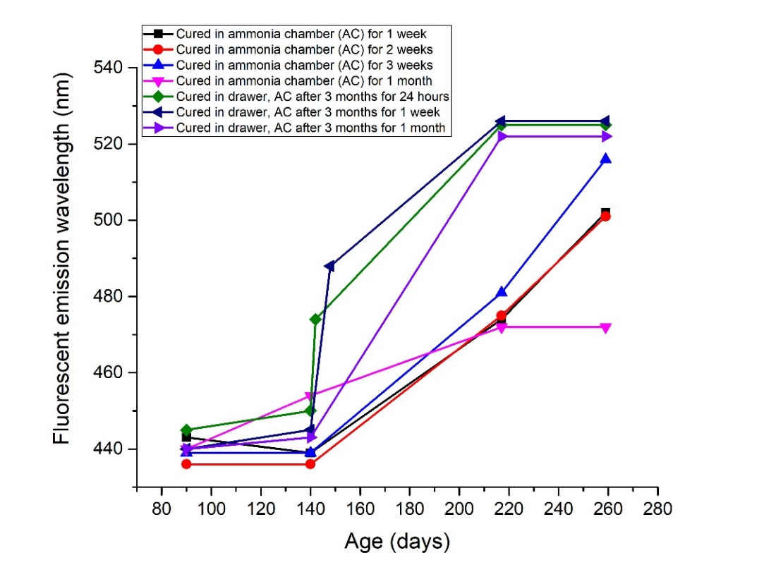
Figure S6: Rate of fluorescent changes of poppy seed oil after exposure to ammonia vapor, and subsequent storage in a dark drawer. The excitation wavelength was 360 nm for all measurements.

Fluorescent changes in Stand oil
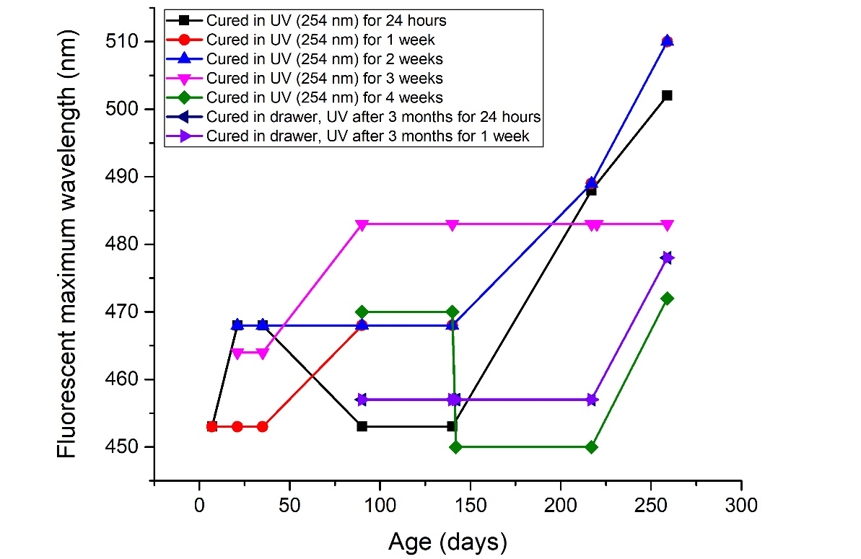
Figure S7: Rate of the fluorescence emission maximum changes of stand oil various exposure times to UV light (254 nm) and then subsequent storage in dark drawers. The excitation wavelength was 360 nm for all measurements.
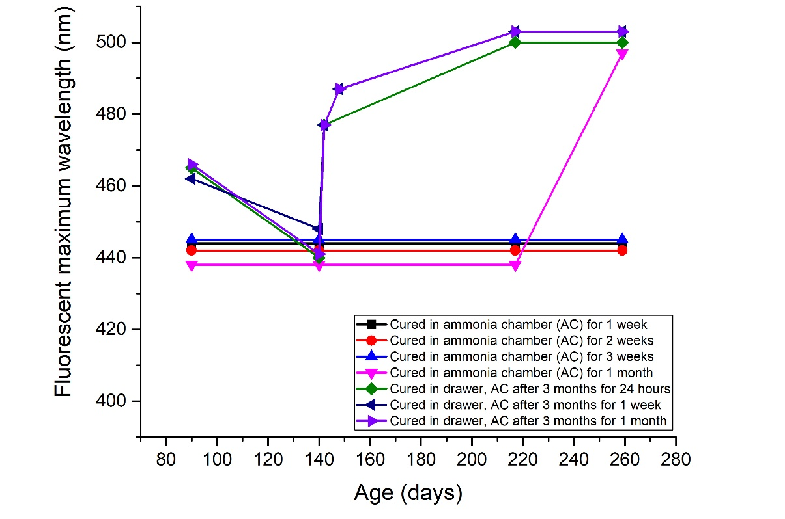
Figure S8: Rate of fluorescent changes of stand oil after exposure to ammonia vapor, and subsequent storage in a dark drawer. The excitation wavelength was 360 nm for all measurements.

Fluorescent changes in water-miscible linseed oil
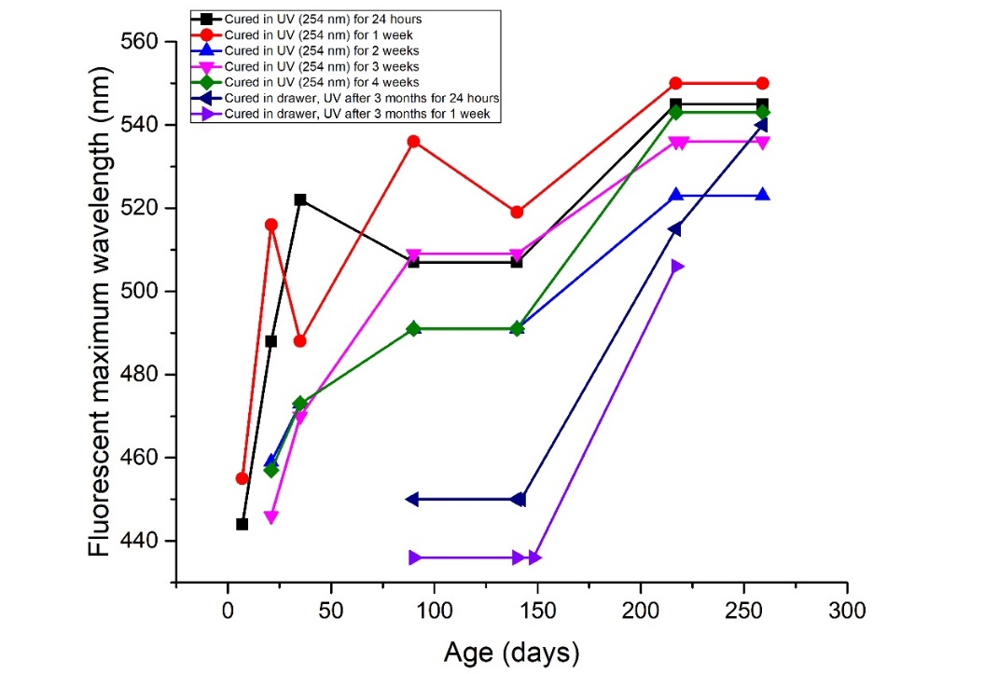
Figure S9: Rate of the fluorescence emission maximum changes of water-miscible linseed oil various exposure times to UV light (254 nm) and then subsequent storage in dark drawers. The excitation wavelength was 360 nm for all measurements.

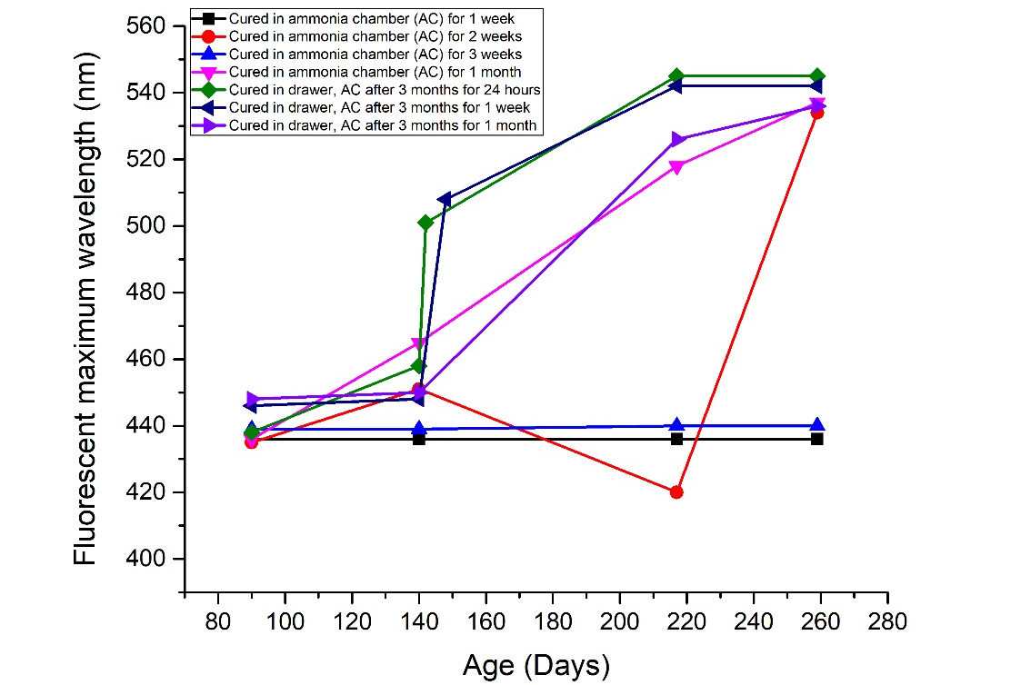
Figure S10: Rate of fluorescent changes of stand oil after exposure to ammonia vapor, and subsequent storage in a dark drawer. The excitation wavelength was 360 nm for all measurements.

Linseed oil and poppy seed oil showed the most homogenous yellow discoloration over the painted area. As the water-miscible oil dried, the painted surface started forming drops instead of drying as painted. These drops formed an agglomerate of linseed oil, that yellow much faster than other oils once dried. This heterogeneity of the surface discoloration cause variation in the fluorescence intensity as the exact position at which the fluorescence is measured could not be perfectly reproduced. Stand oil did not form drops but had sections where the stand oil is applied thicker, due to the viscosity the oil did not roll out to form a uniform surface.
References:
[1] Lakowicz JR. Principles of fluorescence spectroscopy. New York: Plenum Press; 1983.

