Supplementary

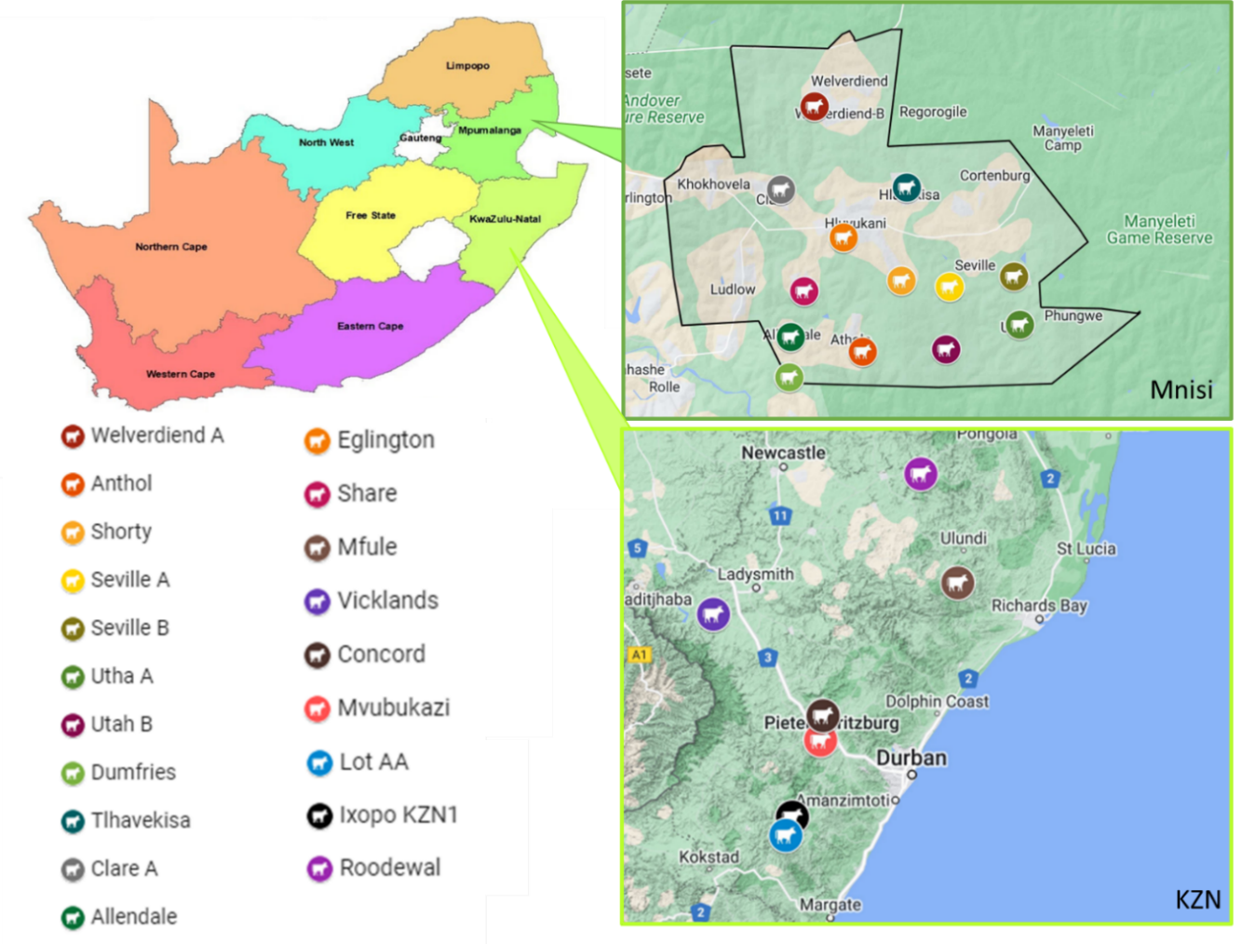

Figure S1. A map of South Africa, indicating the locations of the ticks collected in the Mnisi area (outlined in black) in Mpumalanga and KwaZulu-Natal. The sampling locations are indicated by the coloured markers and the names of the corresponding dip station/farm is indicated on the left.

Table S1. Summary of the RNA sequencing library size (RNA-sequencing reads) for each sample. The median library size and logCPM cutoff value is also listed.
 | Sample Name | RNA-sequencing library size (reads)
ClinVet | Rm_Gland | 79,454,546
ClinVet | Rm_Gut | 79,454,784
ClinVet | Rm_Larva | 92,869,634
ClinVet | Rm_Nymph | 99,912,014
ClinVet | Rm_Ovary | 78,923,042
Mnisi | SAMPCLA3_GUT | 111,704,028
Mnisi | SAMPCLA3_Ovary | 108,044,142
Mnisi | SAMPCLA3_SG | 117,933,746
Mnisi | SAMPUTA_GUT | 114,849,306
Mnisi | SAMPUTA_Ovary | 112,586,438
Mnisi | SAMPUTA_SG | 115,877,372
Mnisi | SAMPWV1_GUT | 103,977,528
Mnisi | SAMPWV1_Ovary | 107,658,188
Mnisi | SAMPWV1_SG | 110,913,592
Median library size |  | 107,851,165
logCPM cutoff value* |  | 0.1
*$logCPM Cutoff=10÷median library size (million)=10÷107.851165×{10}^{6}=0.09272037071≈0.1$

Table S2. Table with consensus sequences used to annotate gene and mRNA features of subolesin.
Name | Consensus sequence* | Description | Reference
TATA Box | TATAWAWN | Binds TATA-binding protein (TBP) | (Juo et al., 1996)
Arthropod initiation factor (INR) | DCAKT | 25% of arthropod RNA polymerase II-transcribed promoters contain one or more copies of the sequence TCAGT beginning within the interval (-10, +10) | (Cherbas and Cherbas, 1993)
DPE | RGWYVT | Binds Transcription factor IID (TFIID) | (Bhagavan and Ha, 2015)
GC Box | GGGCGG | Binds SP1 transactivator Sp1 | (Bhagavan and Ha, 2015)
CAAT Box | GGCCAATCT | Binds CAAT enhancer binding protein (C/EBP) | (Bhagavan and Ha, 2015)
TCA | TCAKTY | Inr consensus in Drosophila | (Kadonaga, 2012)
TCT | YYCTTTYY | Binds TBP-related factor 2 (TRF2) | (Kadonaga, 2012)
BREu | SSRCGCC | Binds Transcription factor IIB (TFIIB) | (Kadonaga, 2012)
BREd | RTDKKKK | Binds Transcription factor IIB (TFIIB) | (Kadonaga, 2012)
Focused INR Drosophila | TCAGTY | (A+1) for focused promoters in Drosophila based on | (Kadonaga, 2012)
Polyadenylation (Poly-A) signal | AAUAAA |  | (Proudfoot, 2011)
NFκB | GGGRNYYYCC | Consensus binding sequence of NFκB | (Chen et al., 1998)
*The International Union of Pure and Applied Chemistry (IUPAC) standard single character code for DNA bases was used to represent the consensus sequences.

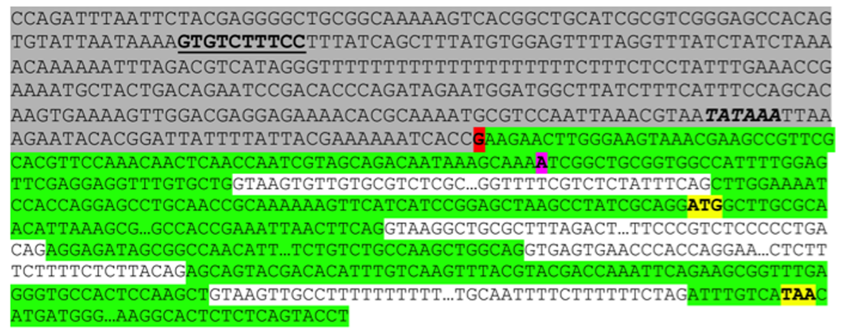
A
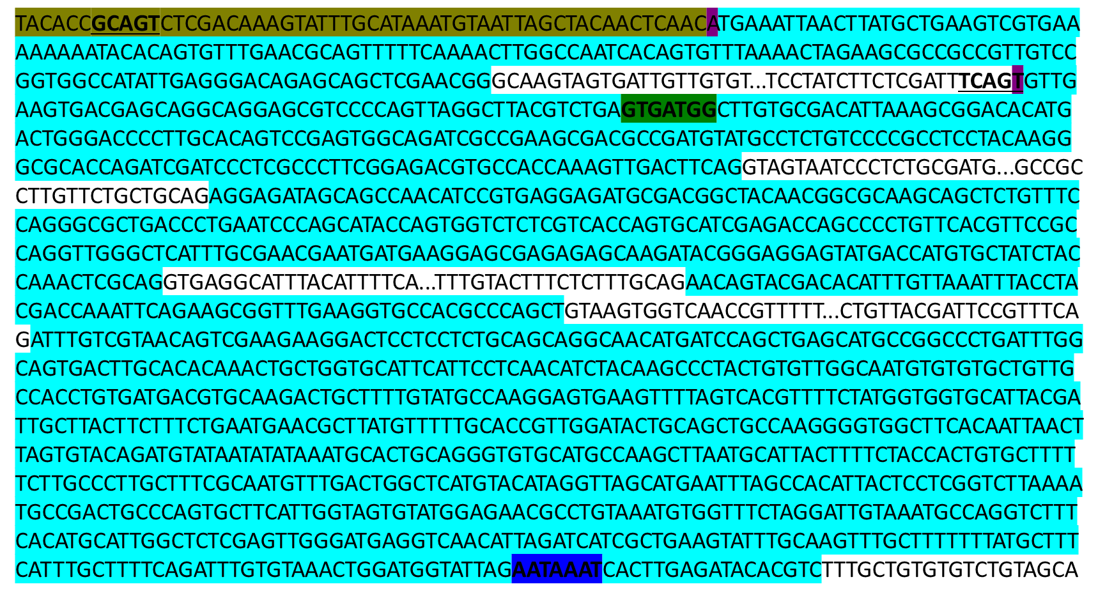
B
Figure S2. (A) Nucleotide sequence of the I. scapularis subolesin gene, containing promoter (grey), exon (green) and intron (white) regions first and translation start and stop codons (yellow). Shown additionally is the putative NF-kB binding site (bold underlined), major (red) and minor (light purple) transcription start site, translation start and stop codons (yellow). Only the exon/intron junction sequences are shown. In the mRNA, Poly-A starts after the last nucleotide in exon 5. Taken from (Naranjo et al., 2013). (B) Nucleotide sequence of the R. microplus subolesin gene, containing 5’ UTR (dark yellow), exon (light blue) and intron (white) regions, putative transcription start sites (dark purple), arthropod initiation factors (bold and underlined), Kozak sequence (dark green) and polyadenylation signal sequence (dark blue).

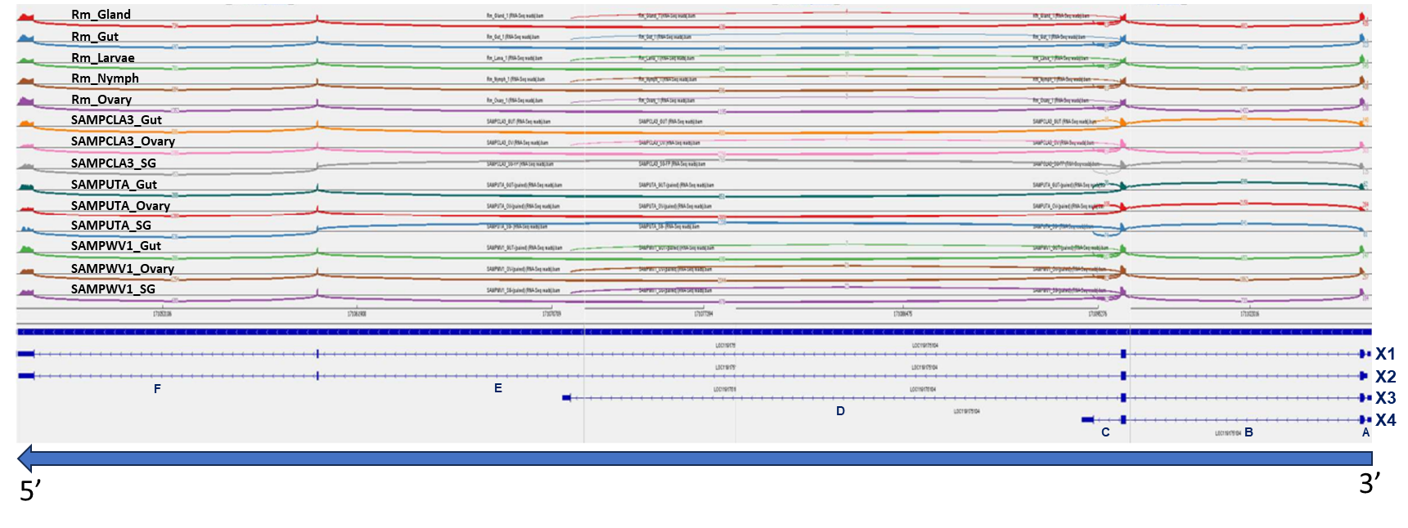
Figure S3. Sashimi Plot indicating the read coverage for each exon junction of the subolesin gene. The name of each sample is indicated in black text above the curving lines. The mRNA species (X1-X4) are indicated in dark blue at the bottom of the image and the arrow at the bottom indicates the direction of transcription/translation, with dark blue bars representing exons and striped lines indicating introns. Each capital letter (A-F) refers to the intron indicated above it. The number of RNA sequencing reads (TPM normalised) supporting each intron is indicated by the curved line connecting exons to each other and corresponds to the support values in Table 1. The Sashimi plot was generated using Integrative Genomics Viewer (IGV, v.2.16.2).

x

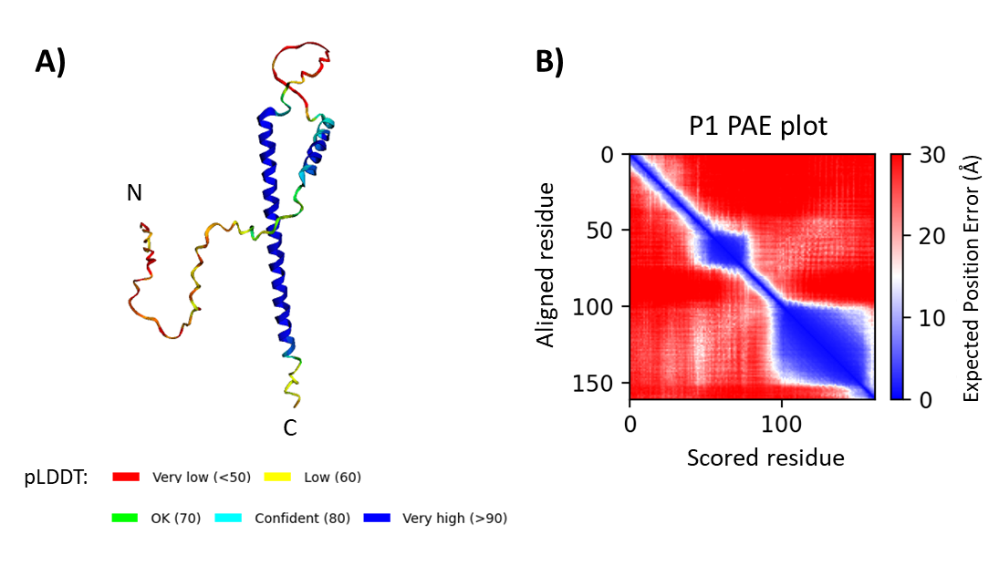

Figure S4. Predicted 3D structure of the putative P1 Subolesin protein variant and pLDDT and PAE confidence scores. (A) Predicted 3D structure of the P1 Subolesin protein variant created using ColabFold v.1.5.3. The N and C terminals are indicated on the structure. The structure is coloured according to the pLDDT (predicted local distance difference test) score, which increases in confidence from 0-100. High confidence means that the predicted structure could have a favourable comparison to experimental models. (B) The PAE plot of indicates the PAE (predicted aligned error) score for each residue of the predicted 3D structure of the P1 Subolesin variant. The aligned residues are indicated on the left y-axis and on the x-axis, and the expected position error (PAE score) is indicated on the right y-axis. A high PAE score represents a high expected position error, thus low confidence in the predicted relative position of the residues.

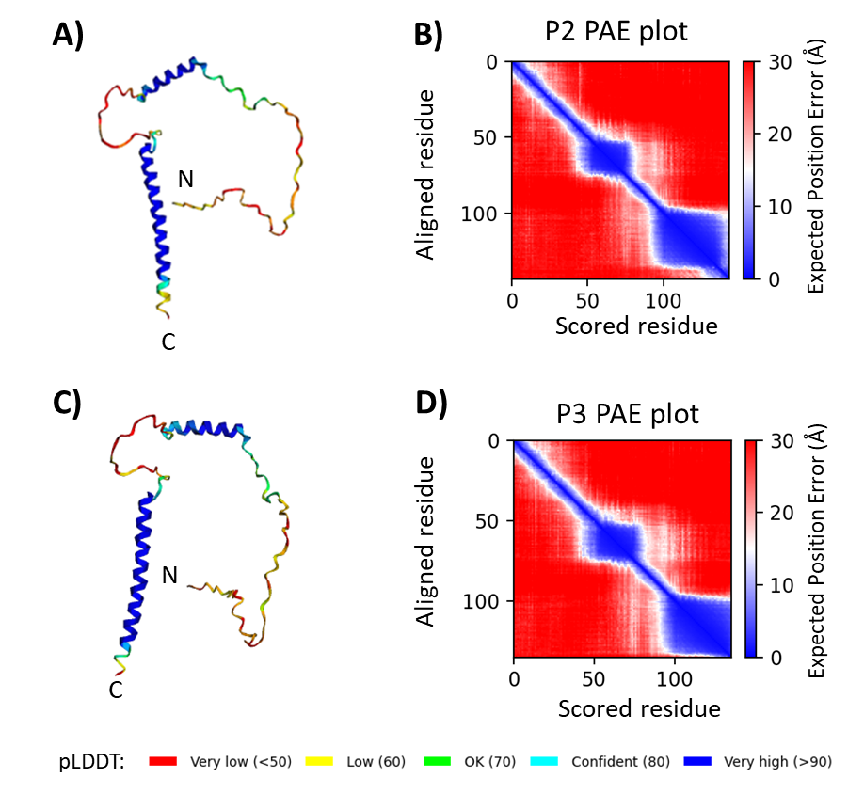

Figure S5. Predicted 3D structure of the putative P2 and P3 Subolesin protein variant and pLDDT and PAE confidence scores. (A) Predicted 3D structure of the P2 Subolesin protein variant created using ColabFold v.1.5.3. The N and C terminals are indicated on the structure. The structure is coloured according to the pLDDT (predicted local distance difference test) score, which increases in confidence from 0-100. High confidence means that the predicted structure could have a favourable comparison to experimental models. (B) The PAE plot of indicates the PAE (predicted aligned error) score for each residue of the predicted 3D structure of the P2 Subolesin variant. The aligned residues are indicated on the left y-axis and on the x-axis, and the expected position error (PAE score) is indicated on the right y-axis. A high PAE score represents a high expected position error, thus low confidence in the predicted relative position of the residues. Similarly, the (C) predicted 3D structure and (D) PAE plot of the P3 Subolesin protein variants are indicated.

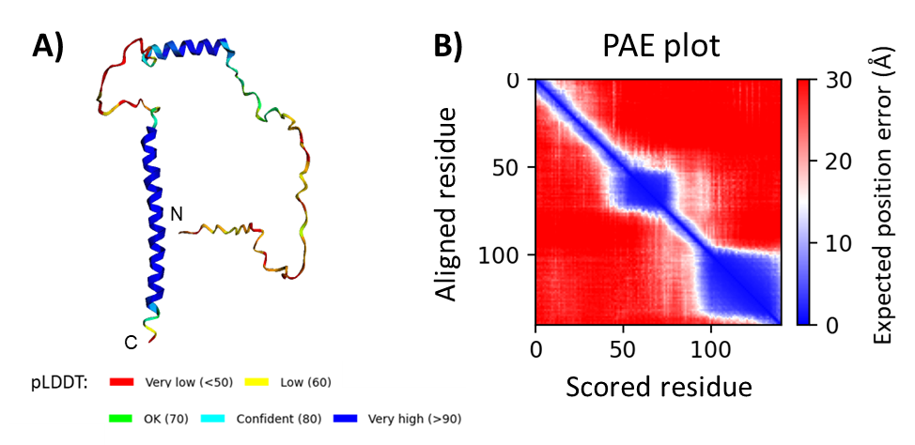

Figure S6. Predicted 3D structure of the putative Clare Subolesin protein variant and pLDDT and PAE confidence scores. (A) Predicted 3D structure of the Clare Subolesin protein variant created using ColabFold v.1.5.3. The N and C terminals are indicated on the structure. The structure is coloured according to the pLDDT (predicted local distance difference test) score, which increases in confidence from 0-100. High confidence means that the predicted structure could have a favourable comparison to experimental models. (B) The PAE plot of indicates the PAE (predicted aligned error) score for each residue of the predicted 3D structure of the Clare P4 Subolesin variant. The aligned residues are indicated on the left y-axis and on the x-axis, and the expected position error (PAE score) is indicated on the right y-axis. A high PAE score represents a high expected position error, thus low confidence in the predicted relative position of the residues.

X
x

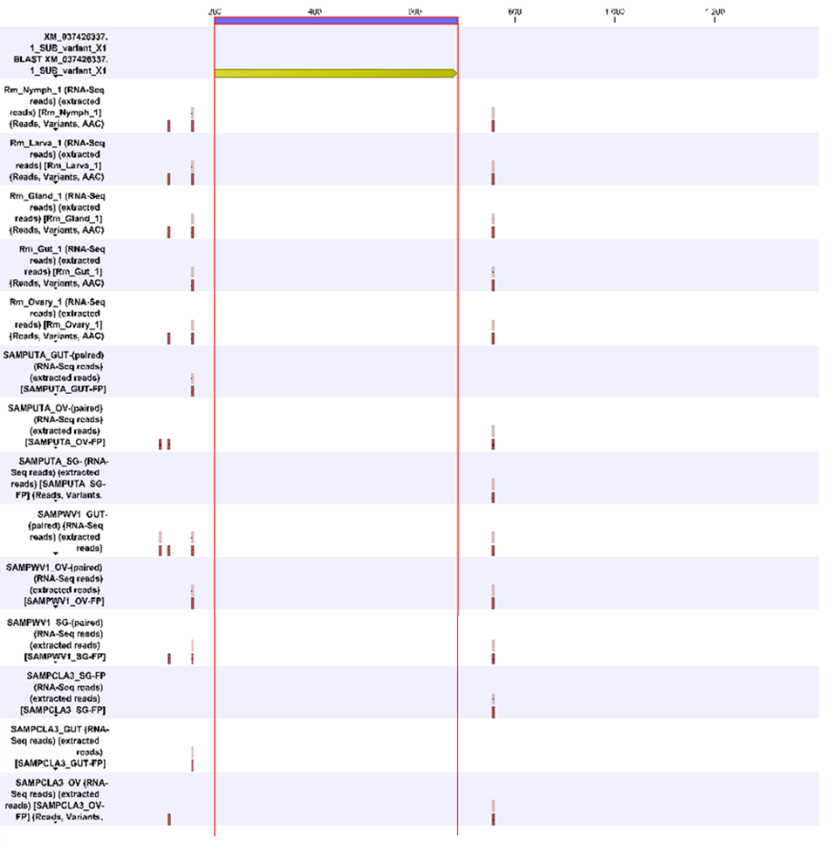

Figure S7. Variants detected in the subolesin X1 mRNA species in RNA sequencing data from tick samples collected from Mnisi and ClinVet. The name of each sample is indicated on the left side, and the section enclosed by vertical red lines indicates the coding sequence (CDS). Nucleotide changes are indicated by the small red squares. A single dark red square indicates that only a single variant was called at a certain position, whereas more than one square indicates that more than one variant was called at that position. Tabulated statistics on variants detected are listed in supplementary.

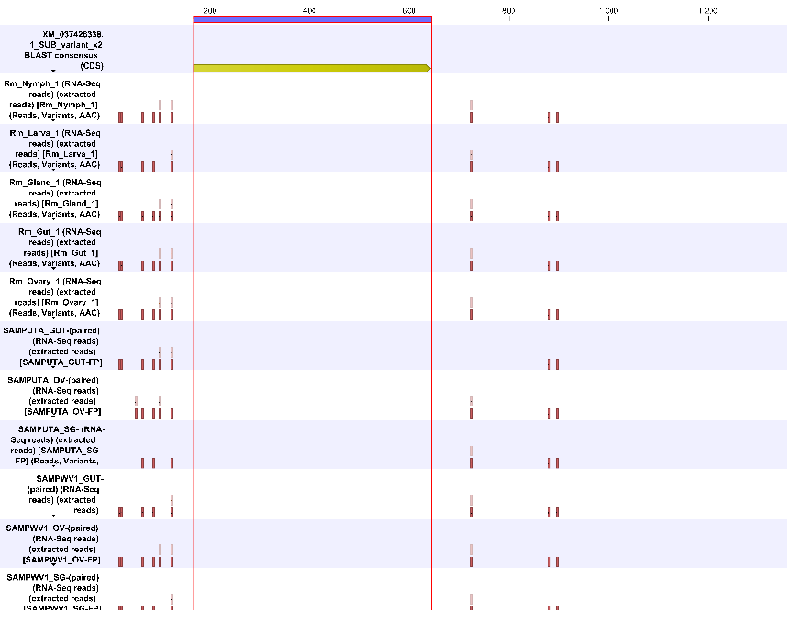
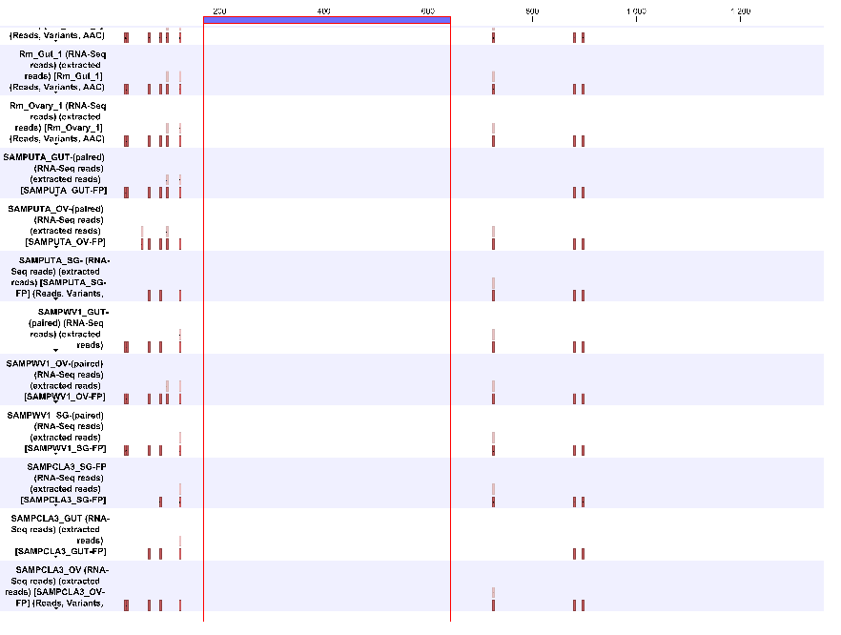
Figure S8. Variants detected in the subolesin X2 mRNA species in RNA sequencing data from tick samples collected from Mnisi and ClinVet. The name of each sample is indicated on the left side, and the section enclosed by vertical red lines indicates the coding sequence (CDS). Nucleotide changes are indicated by the small red squares. A single dark red square indicates that only a single variant was called at a certain position, whereas more than one square indicates that more than one variant was called at that position. Tabulated statistics on variants detected are listed in supplementary.

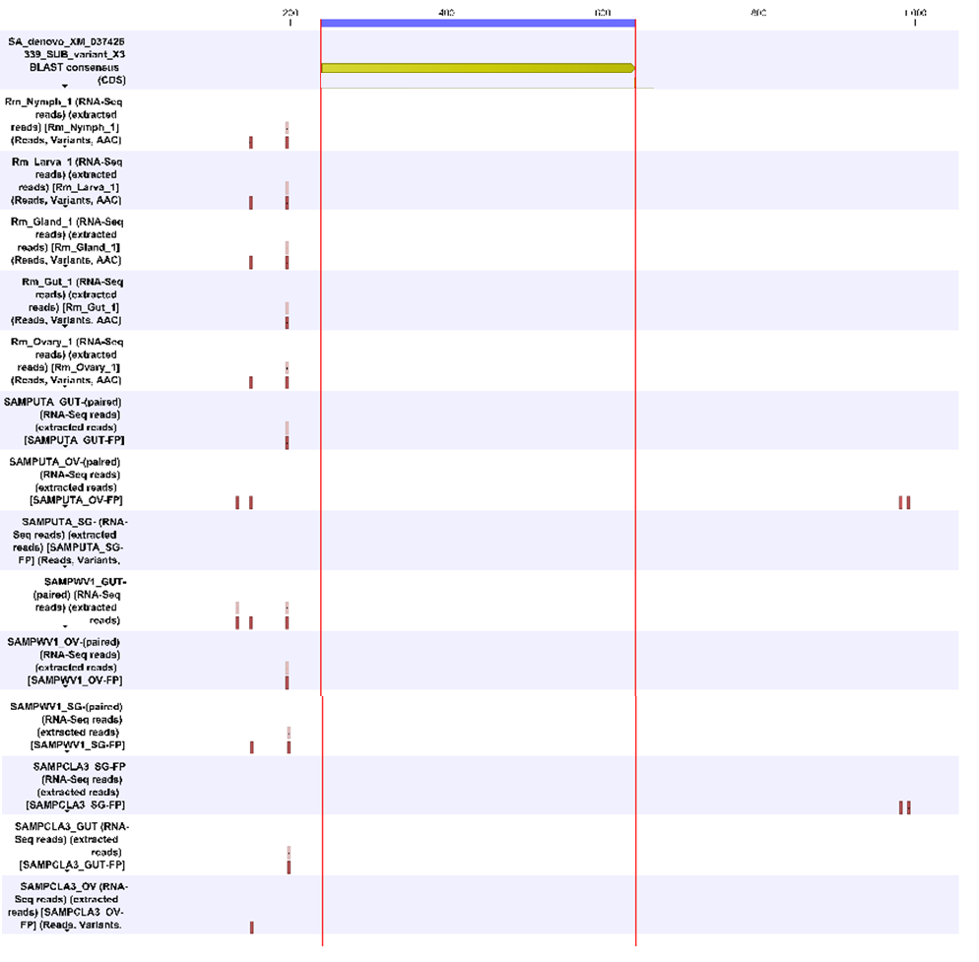
Figure S9 Variants detected in the subolesin X3 mRNA species in RNA sequencing data from tick samples collected from Mnisi and ClinVet. The name of each sample is indicated on the left side, and the section enclosed by vertical red lines indicates the coding sequence (CDS). Nucleotide changes are indicated by the small red squares. A single dark red square indicates that only a single variant was called at a certain position, whereas more than one square indicates that more than one variant was called at that position. Tabulated statistics on variants detected are listed in supplementary.

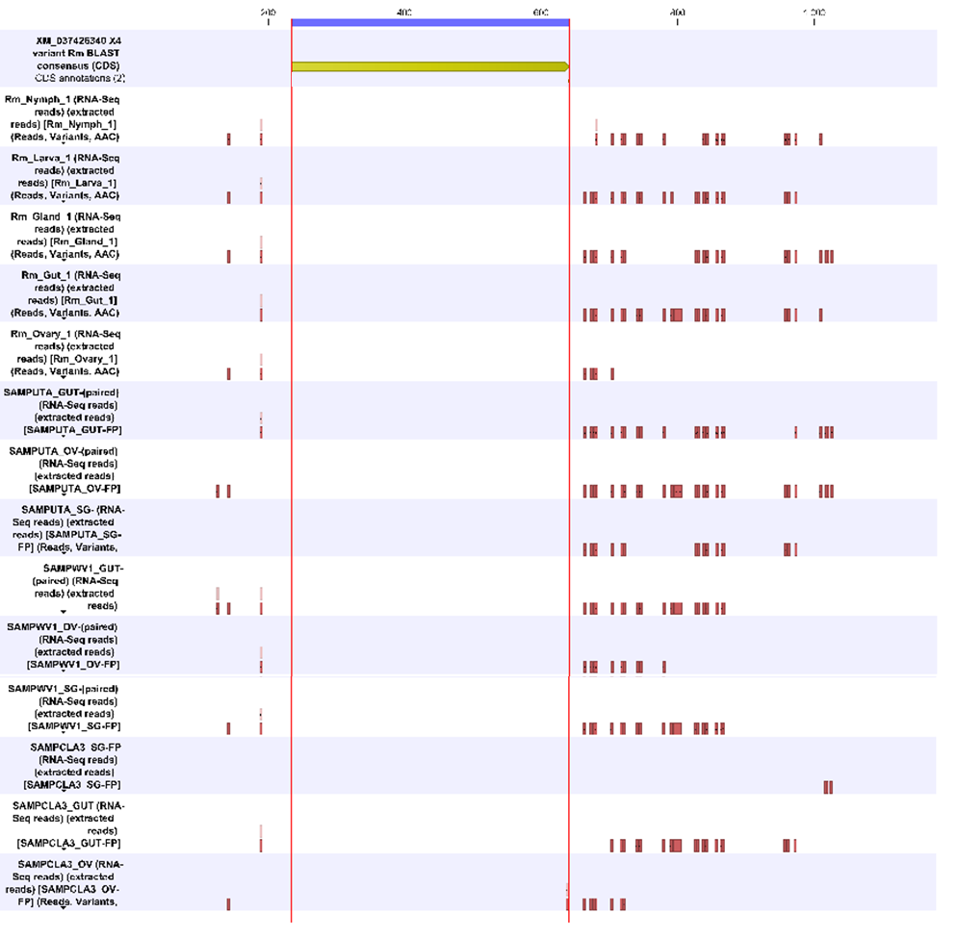
Figure S10. Variants detected in the subolesin X4 mRNA species in RNA sequencing data from tick samples collected from Mnisi and ClinVet. The name of each sample is indicated on the left side, and the section enclosed by vertical red lines indicates the coding sequence (CDS). Nucleotide changes are indicated by the small red squares. A single dark red square indicates that only a single variant was called at a certain position, whereas more than one square indicates that more than one variant was called at that position. Tabulated statistics on variants detected are listed in supplementary.

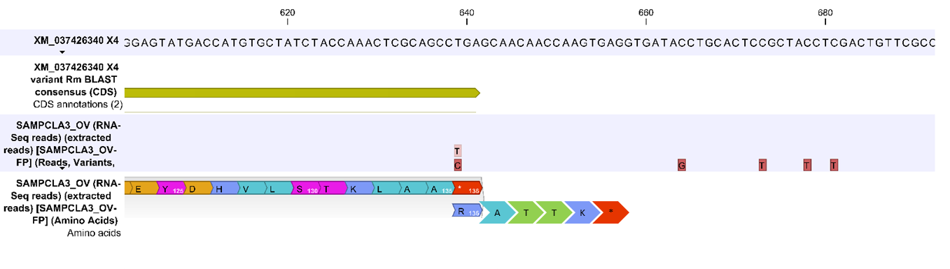
Figure S11. Single nucleotide variant detected in the X4 mRNA species CDS of the subolesin sequence identified from Clare dip station and its translational consequences. The variant includes a change from a thymine to a cytosine (639 T>C). This variant is non-synonymous and changes a stop codon to an arginine, resulting in the addition of four more amino acids, namely alanine (A), threonine (T), threonine (T) and lysine (K) before the next stop codon.

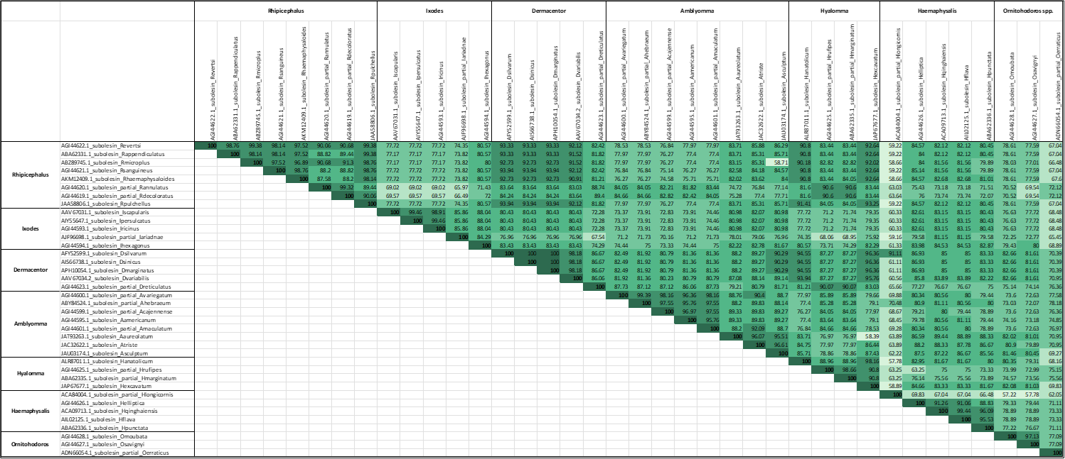
Figure S12. Percentage of identity among Subolesin amino acid sequences from different tick species. Identity is indicated numerically in each block and also using colour, with the highest percent identity (100%) in dark green and the lowest percent identity (57.78%) in white. Complete and partial Subolesin sequences were obtained from NCBI. Sequences were aligned using MAFFT v.7 server (Katoh et al., 2017) with default settings, except for the gap opening penalty which was increased to 5.0. The percentage identity was calculated using Ident and Sim (Stothard, 2000)

