Supplementary Table 2: Tests of association among three groups: HIV-infected tobacco users, non-users, and HIV-uninfected controls

sCD40L
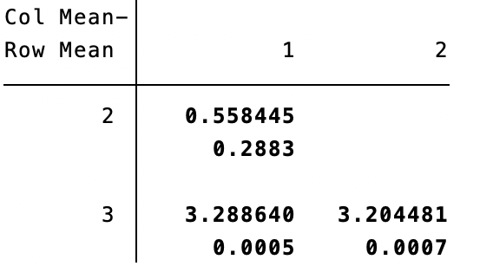
sCD62P
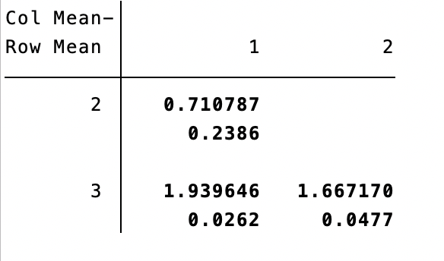
PDGF-BB
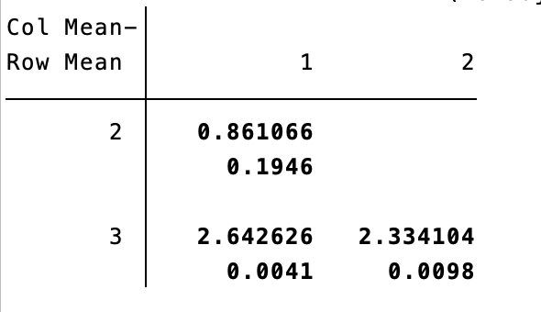
Groups: 1 = All HIV-infected smokers (n=55); 2 = All HIV-infected non-smokers (n=144); 3 = HIV-uninfected controls (n=15)

