Supplementary Materials
Fungal diversity as a key driver of soil multifunctionality along a European latitudinal gradient
Xingguo Han^{1,*}, Anna Doménech-Pascual², Jonathan Donhauser³, Constantin M. Zohner⁴, Lidong Mo⁴, Thomas W. Crowther⁴, Joan Pere Casas-Ruiz², Karen Jordaan⁵, Jean-Baptiste Ramond^{5,6}, Anna M. Romaní², Anders Priemé^{3,7}, Aline Frossard^{1,*}
1​. Forest Soils and Biogeochemistry, Swiss Federal Institute for Forest, Snow and Landscape Research (WSL), Birmensdorf, Switzerland
2. Research Group on Ecology of Inland Waters (GRECO), Institute of Aquatic Ecology, University of Girona, Girona, Spain
3. Center for Volatile Interactions, Department of Biology, University of Copenhagen, Copenhagen, Denmark
4. Institute of Integrative Biology, ETH Zurich (Swiss Federal Institute of Technology), Zurich, Switzerland
5. Centre for Microbial Ecology and Genomics, Department of Biochemistry, Genetics and Microbiology, University of Pretoria, Pretoria, South Africa
6. Extreme Ecosystem Microbiomics & Ecogenomics (E²ME) Lab., Facultad de Ciencias Biológicas, Pontificia Universidad Católica de Chile, Santiago, Chile
7. Center for Volatile Interactions (VOLT), University of Copenhagen, Copenhagen, Denmark
* For correspondence: xingguo.han@wsl.ch; aline.frossard@wsl.ch
Forest Soils and Biogeochemistry, Swiss Federal Institute for Forest, Snow and Landscape Research (WSL), Birmensdorf, Switzerland
Tel: +41 44 739 28 07

Supplementary Tables

Supplementary Table S1. Number of reads of prokaryotic and fungal reads in each sample.
 |  |  | Prokaryotes | Fungi
Place | Sample ID | Replicates | Nr. of Reads | Nr. of Reads
Total reads |  |  | 1 015 605 | 1 052 362
Tabernas, Spain | Sample101 | 1 | 10842 | 12502
Tabernas, Spain | Sample102 | 2 | 10525 | 14525
Tabernas, Spain | Sample103 | 3 | 10842 | 14126
Tabernas, Spain | Sample104 | 4 | 8255 | 1898
Tabernas, Spain | Sample105 | 5 | 10572 | 17552
Coy, Spain | Sample76 | 1 | 7123 | 11633
Coy, Spain | Sample77 | 2 | 6699 | 13287
Coy, Spain | Sample78 | 3 | 7341 | 14117
Coy, Spain | Sample79 | 4 | 7446 | 15366
Coy, Spain | Sample80 | 5 | 9368 | 16250
Gavarres, Spain | Sample51 | 1 | 10606 | 16132
Gavarres, Spain | Sample52 | 2 | 10456 | 17149
Gavarres, Spain | Sample53 | 3 | 10772 | 12015
Gavarres, Spain | Sample54 | 4 | 9782 | 13070
Gavarres, Spain | Sample55 | 5 | 9140 | 14256
Montpellier, France | Sample441 | 1 | 13515 | 14278
Montpellier, France | Sample442 | 2 | 11728 | 15038
Montpellier, France | Sample443 | 3 | 14946 | 15579
Montpellier, France | Sample444 | 4 | 13998 | 14615
Montpellier, France | Sample445 | 5 | 12611 | 15312
Grenoble, France | Sample436 | 1 | 12679 | 9930
Grenoble, France | Sample437 | 2 | 13695 | 14904
Grenoble, France | Sample438 | 3 | 13003 | 14148
Grenoble, France | Sample439 | 4 | 13123 | 15675
Grenoble, France | Sample440 | 5 | 9385 | 14012
Lausanne, Switzerland | Sample381 | 1 | 14094 | 13319
Lausanne, Switzerland | Sample382 | 2 | 12661 | 13859
Lausanne, Switzerland | Sample383 | 3 | 12602 | 7905
Lausanne, Switzerland | Sample384 | 4 | 13046 | 12854
Lausanne, Switzerland | Sample385 | 5 | 14380 | 14057
Muhlbach, Germany | Sample431 | 1 | 12865 | 12017
Muhlbach, Germany | Sample432 | 2 | 13265 | 14181
Muhlbach, Germany | Sample433 | 3 | 12244 | 15197
Muhlbach, Germany | Sample434 | 4 | 9333 | 12290
Muhlbach, Germany | Sample435 | 5 | 12883 | 12723
Kohlerholz, Germany | Sample426 | 1 | 15109 | 10873
Kohlerholz, Germany | Sample427 | 2 | 12488 | 11803
Kohlerholz, Germany | Sample428 | 3 | 15981 | 11401
Kohlerholz, Germany | Sample429 | 4 | 16126 | 10141
Kohlerholz, Germany | Sample430 | 5 | 14703 | 11629
Gribskov, Denmark | Sample356 | 1 | 13787 | 13038
Gribskov, Denmark | Sample357 | 2 | 14787 | 12841
Gribskov, Denmark | Sample358 | 3 | 14381 | 14762
Gribskov, Denmark | Sample359 | 4 | 17956 | 14455
Gribskov, Denmark | Sample360 | 5 | 12703 | 13263
Linderöd, Sweden | Sample421 | 1 | 13008 | 14466
Linderöd, Sweden | Sample422 | 2 | 16762 | 13557
Linderöd, Sweden | Sample423 | 3 | 14954 | 15654
Linderöd, Sweden | Sample424 | 4 | 17161 | 13368
Linderöd, Sweden | Sample425 | 5 | 20068 | 14374
Långasjönäs, Sweden | Sample416 | 1 | 13354 | 13384
Långasjönäs, Sweden | Sample417 | 2 | 13752 | 14342
Långasjönäs, Sweden | Sample418 | 3 | 15816 | 12700
Långasjönäs, Sweden | Sample419 | 4 | 12858 | 15019
Långasjönäs, Sweden | Sample420 | 5 | 14403 | 14861
Dångamålaö, Sweden | Sample331 | 1 | 18215 | 15341
Dångamålaö, Sweden | Sample332 | 2 | 17993 | 15154
Dångamålaö, Sweden | Sample333 | 3 | 16229 | 15724
Dångamålaö, Sweden | Sample334 | 4 | 15162 | 16304
Dångamålaö, Sweden | Sample335 | 5 | 16745 | 14690
Boxholm, Sweden | Sample411 | 1 | 13834 | 14555
Boxholm, Sweden | Sample412 | 2 | 13778 | 15345
Boxholm, Sweden | Sample413 | 3 | 14914 | 15834
Boxholm, Sweden | Sample414 | 4 | 13507 | 14822
Boxholm, Sweden | Sample415 | 5 | 15101 | 17128
Gävle,  Sweden | Sample406 | 1 | 15327 | 13821
Gävle,  Sweden | Sample407 | 2 | 15301 | 15897
Gävle,  Sweden | Sample408 | 3 | 17152 | 16082
Gävle,  Sweden | Sample409 | 4 | 15493 | 10687
Gävle,  Sweden | Sample410 | 5 | 18260 | 15405
Sundsvall, Sweden | Sample306 | 1 | 17630 | 16301
Sundsvall, Sweden | Sample307 | 2 | 17573 | 16938
Sundsvall, Sweden | Sample308 | 3 | 15944 | 18533
Sundsvall, Sweden | Sample309 | 4 | 15216 | 17322
Sundsvall, Sweden | Sample310 | 5 | 16249 | 14777

Supplementary Table S2. Contributions of climate, land cover, and environmental variables to microbial community structure (beta-diversity) across the studied sites based on Adonis analyses (permutational multivariate analysis of variance). SOM: soil organic matter. ns P > 0.05. * P < 0.05. ** P < 0.01. *** P < 0.001.
Variables | Prokaryotes |  | Fungi
Variables | R² | P | R² | P
Biome | 0.29 | *** | 0.21 | ***
Land cover | 0.26 | *** | 0.20 | ***
Latitude | 0.12 | *** | 0.06 | ***
MAT | 0.11 | *** | 0.06 | ***
pH | 0.11 | *** | 0.05 | ***
In situ soil temperature | 0.09 | *** | 0.05 | ***
MAP | 0.08 | *** | 0.05 | ***
In situ water content | 0.07 | *** | 0.04 | ***
Phosphate (PO₄³⁻) | 0.07 | *** | 0.04 | ***
Sand | 0.06 | *** | 0.04 | ***
SOM | 0.05 | *** | 0.04 | ***
Litter | 0.04 | *** | 0.04 | ***

Supplementary Table S3. Linear relationships between soil multifunctionality (SMF) and microbial (prokaryotes and fungi) richness, Shannon index, network complexity along latitude across all biomes and within each biome. Ns = P > 0.05, * = P < 0.05, ** = P < 0.01, *** = P < 0.001.
 |  | Prokaryotes |  |  |  |  |  | Fungi
Biome | Number of samples | Richness |  | Shannon index |  | Network complexity |  | Richness |  | Shannon index |  | Network complexity
Biome | Number of samples | R² | P | R² | P | R² | P | R² | P | R² | P | R² | P
All biomes | N = 75 | < 0.01 | ns | < 0.01 | ns | < 0.01 | ns | 0.18 | *** | 0.06 | * | 0.10 | **
Mediterranean biomes | N = 20 | 0.05 | ns | -0.07 | ns | 0.17 | ns | -0.10 | ns | <0.01 | ns | -0.13 | ns
Temperate biomes | N = 35 | -0.19 | ** | -0.17 | * | -0.30 | *** | 0.34 | *** | 0.21 | ** | 0.29 | ***
Boreal biomes | N = 20 | 0.55 | *** | 0.57 | *** | 0.44 | *** | 0.03 | ns | -0.25 | * | -0.15 | ns

Supplementary Figures
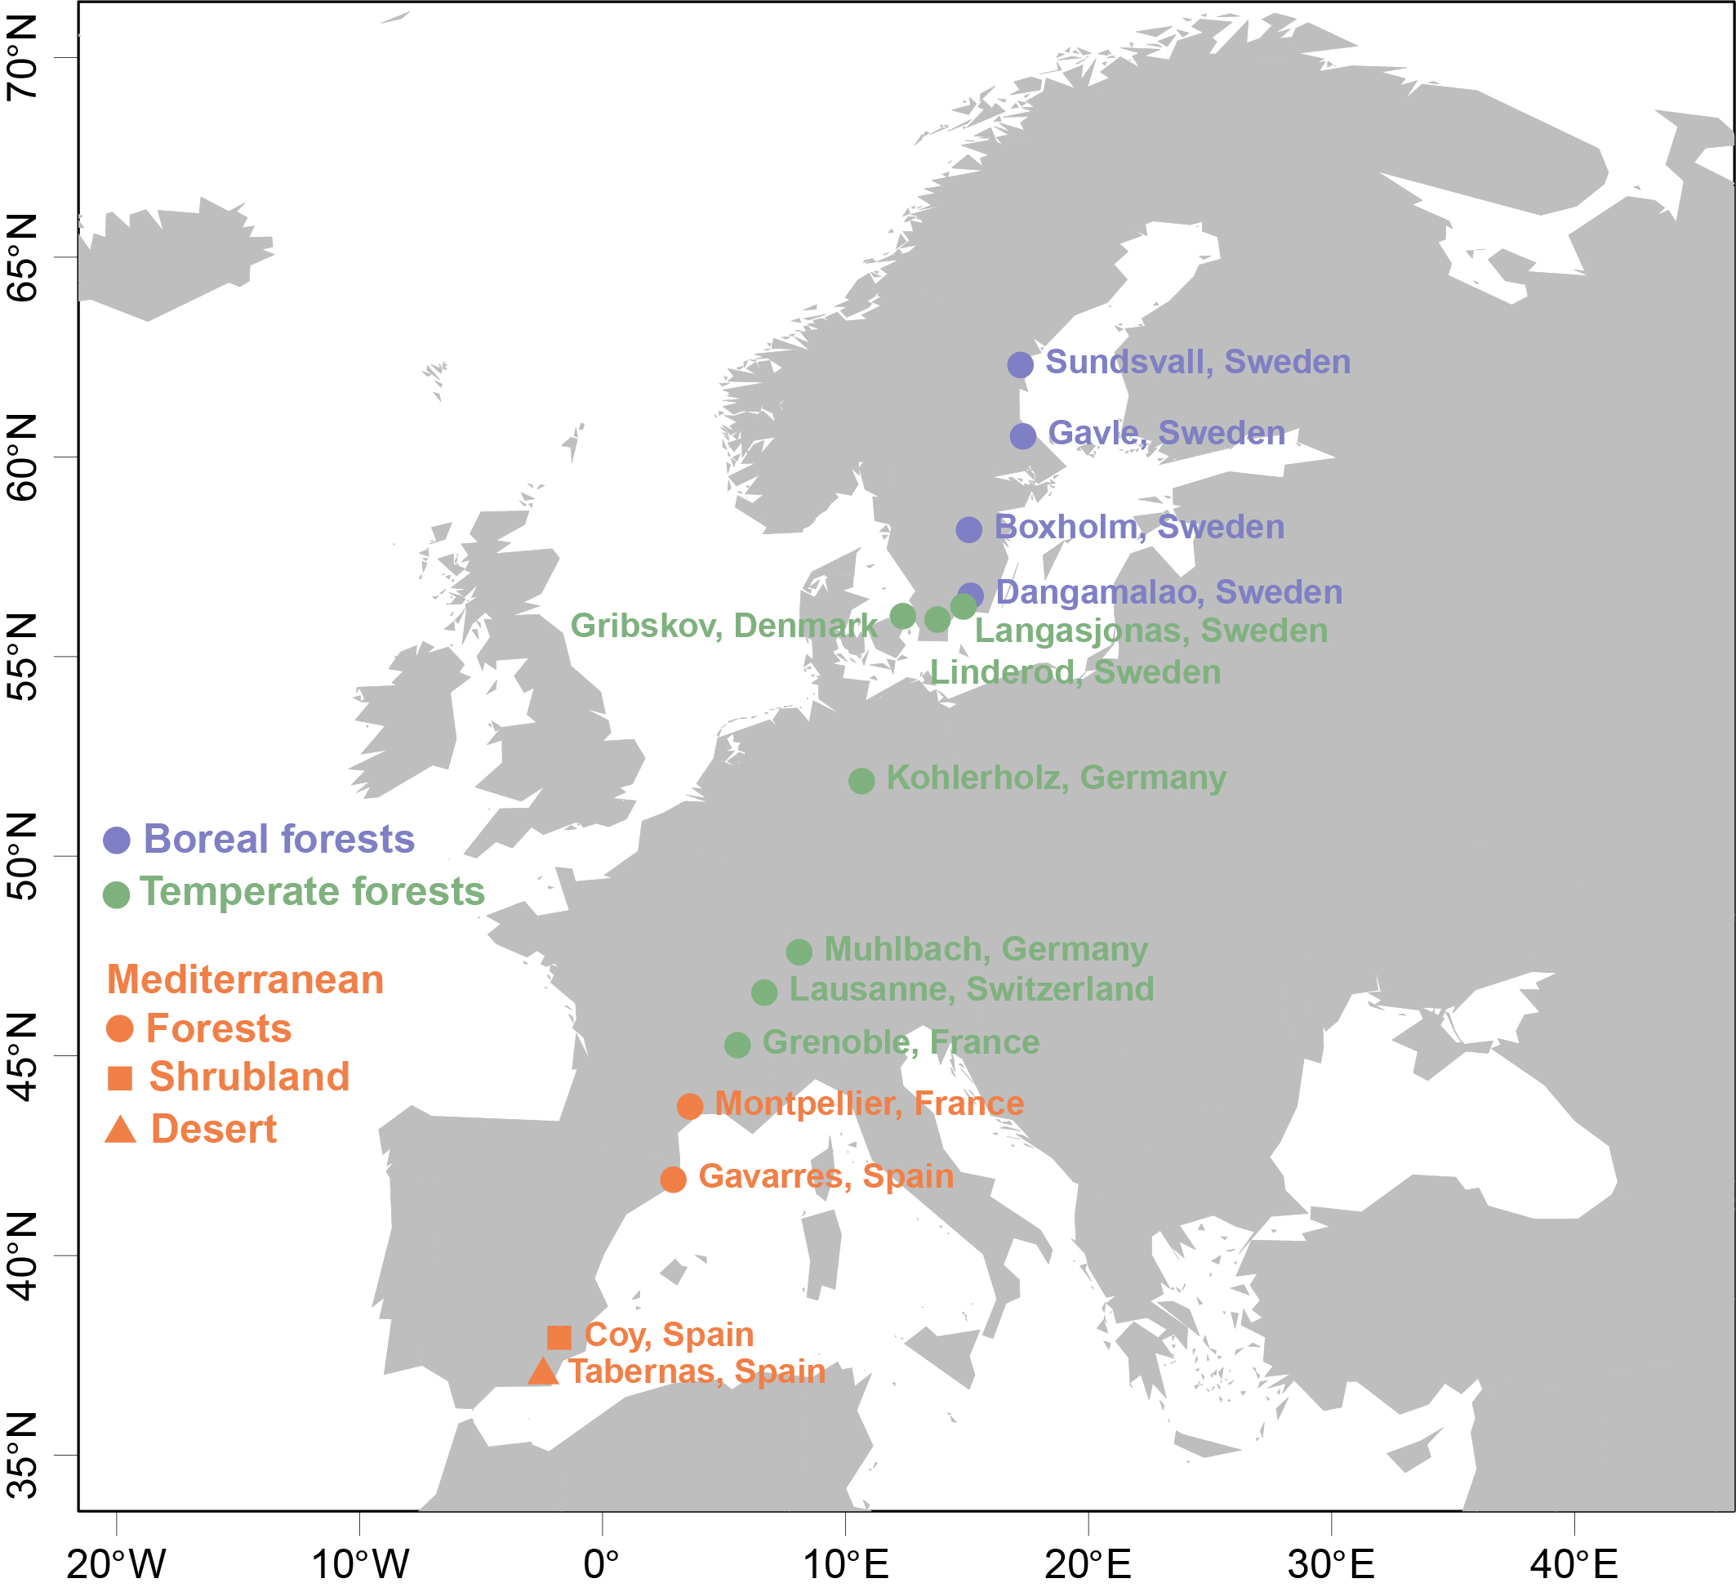

Supplementary Fig. S1. Map of sites along the European altitudinal gradient, spanning from southern Spain to central Sweden.

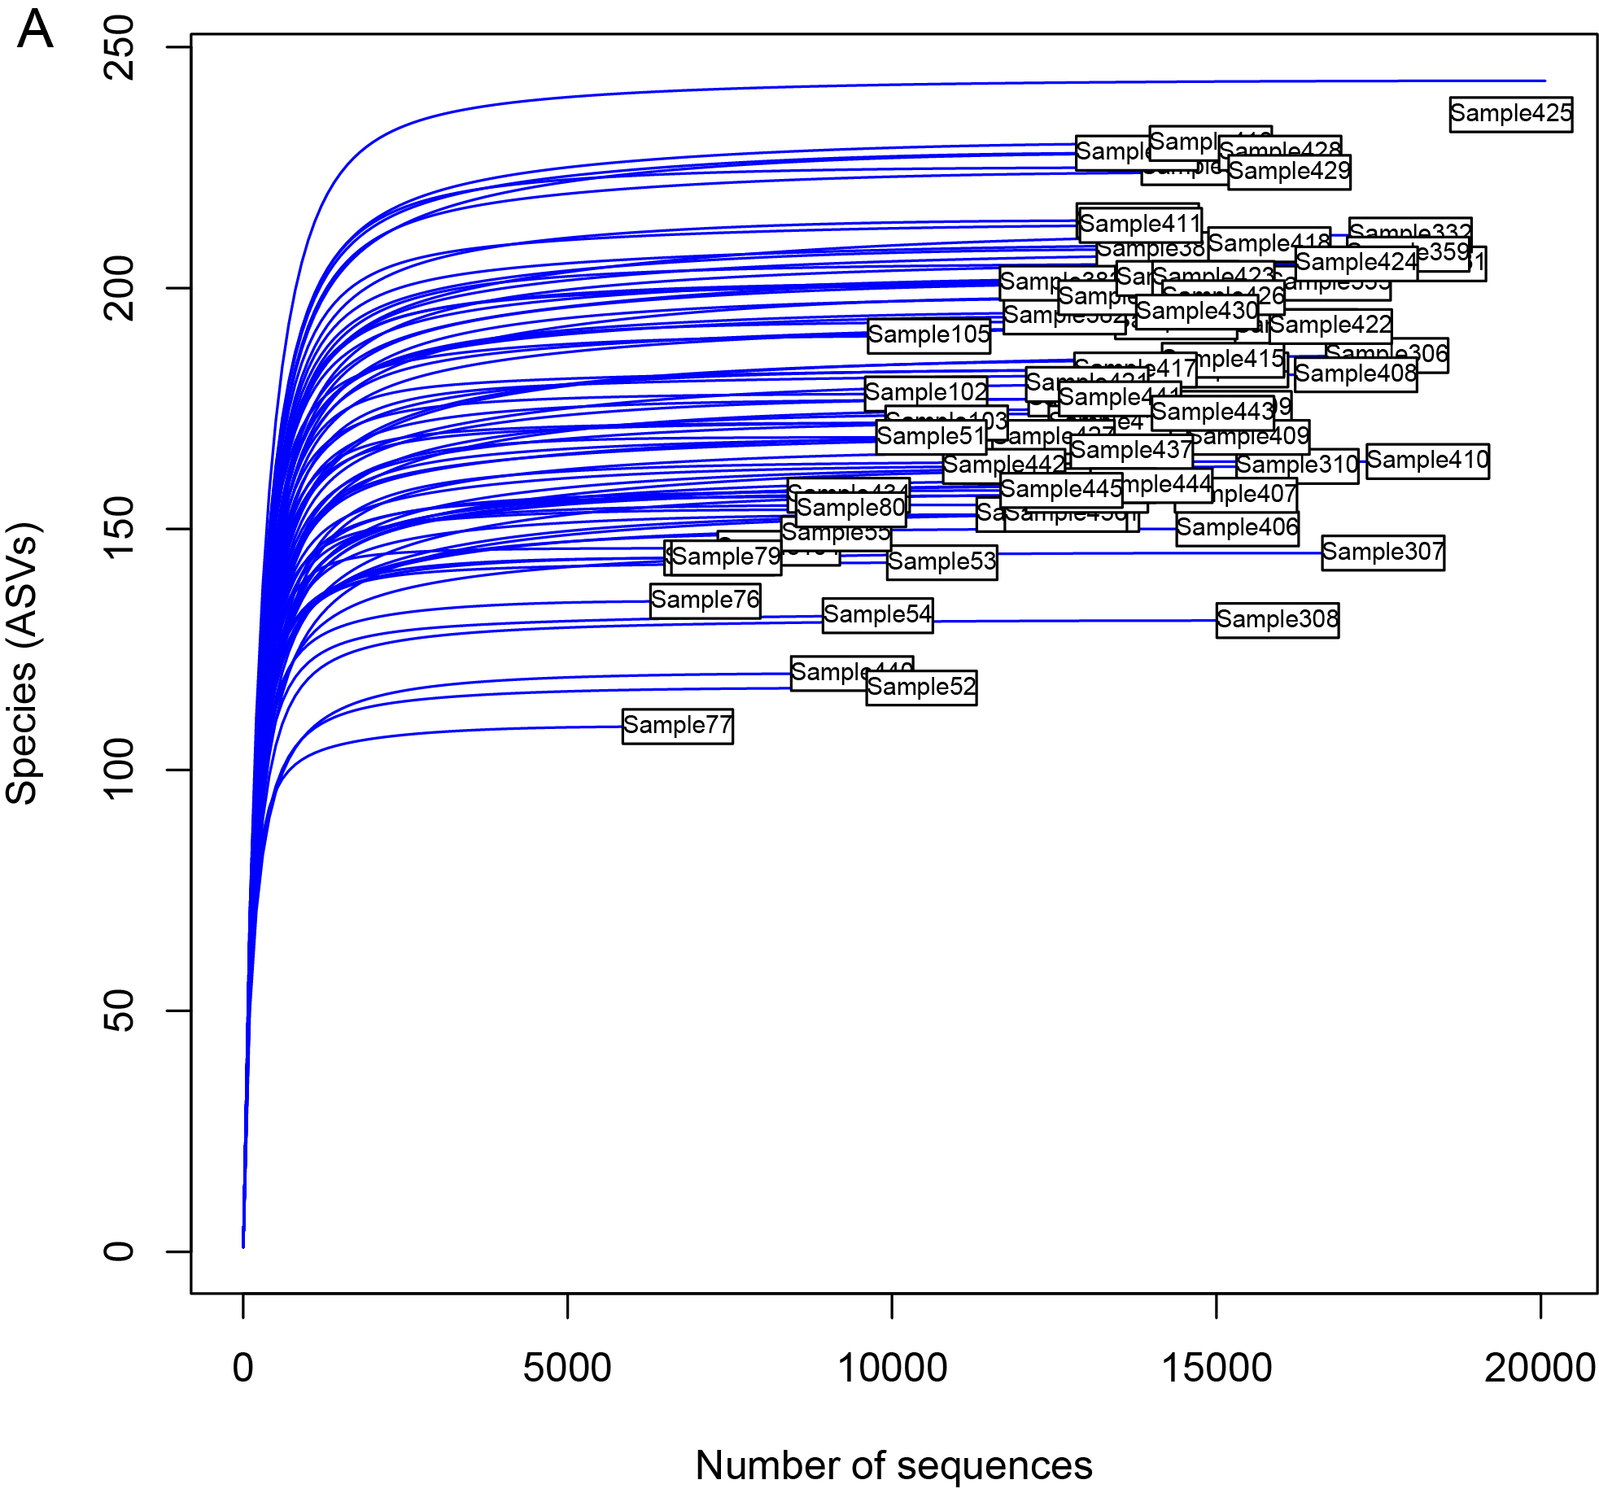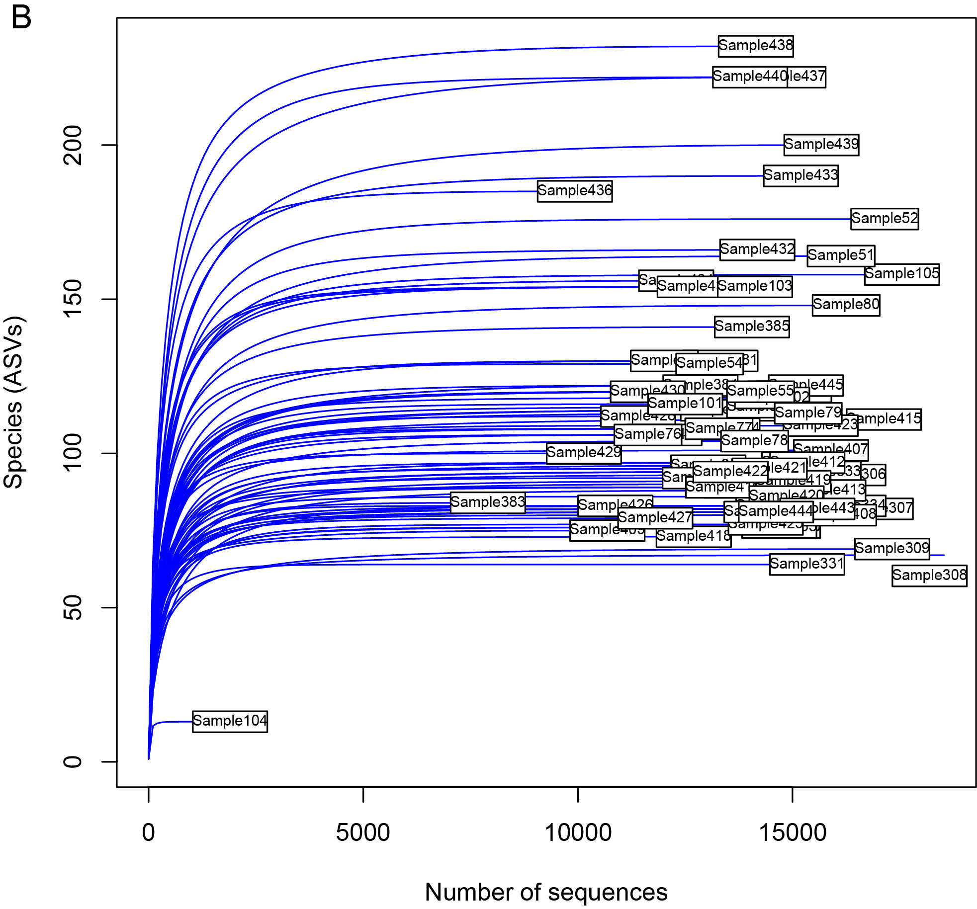

Supplementary Fig. S2. Rarefaction curves of prokaryotic (A) and fungal (B) communities. Sample IDs are shown in Supplementary Table S1. All samples were deeply sequenced except for Sample 104, which was removed due to bad quality.

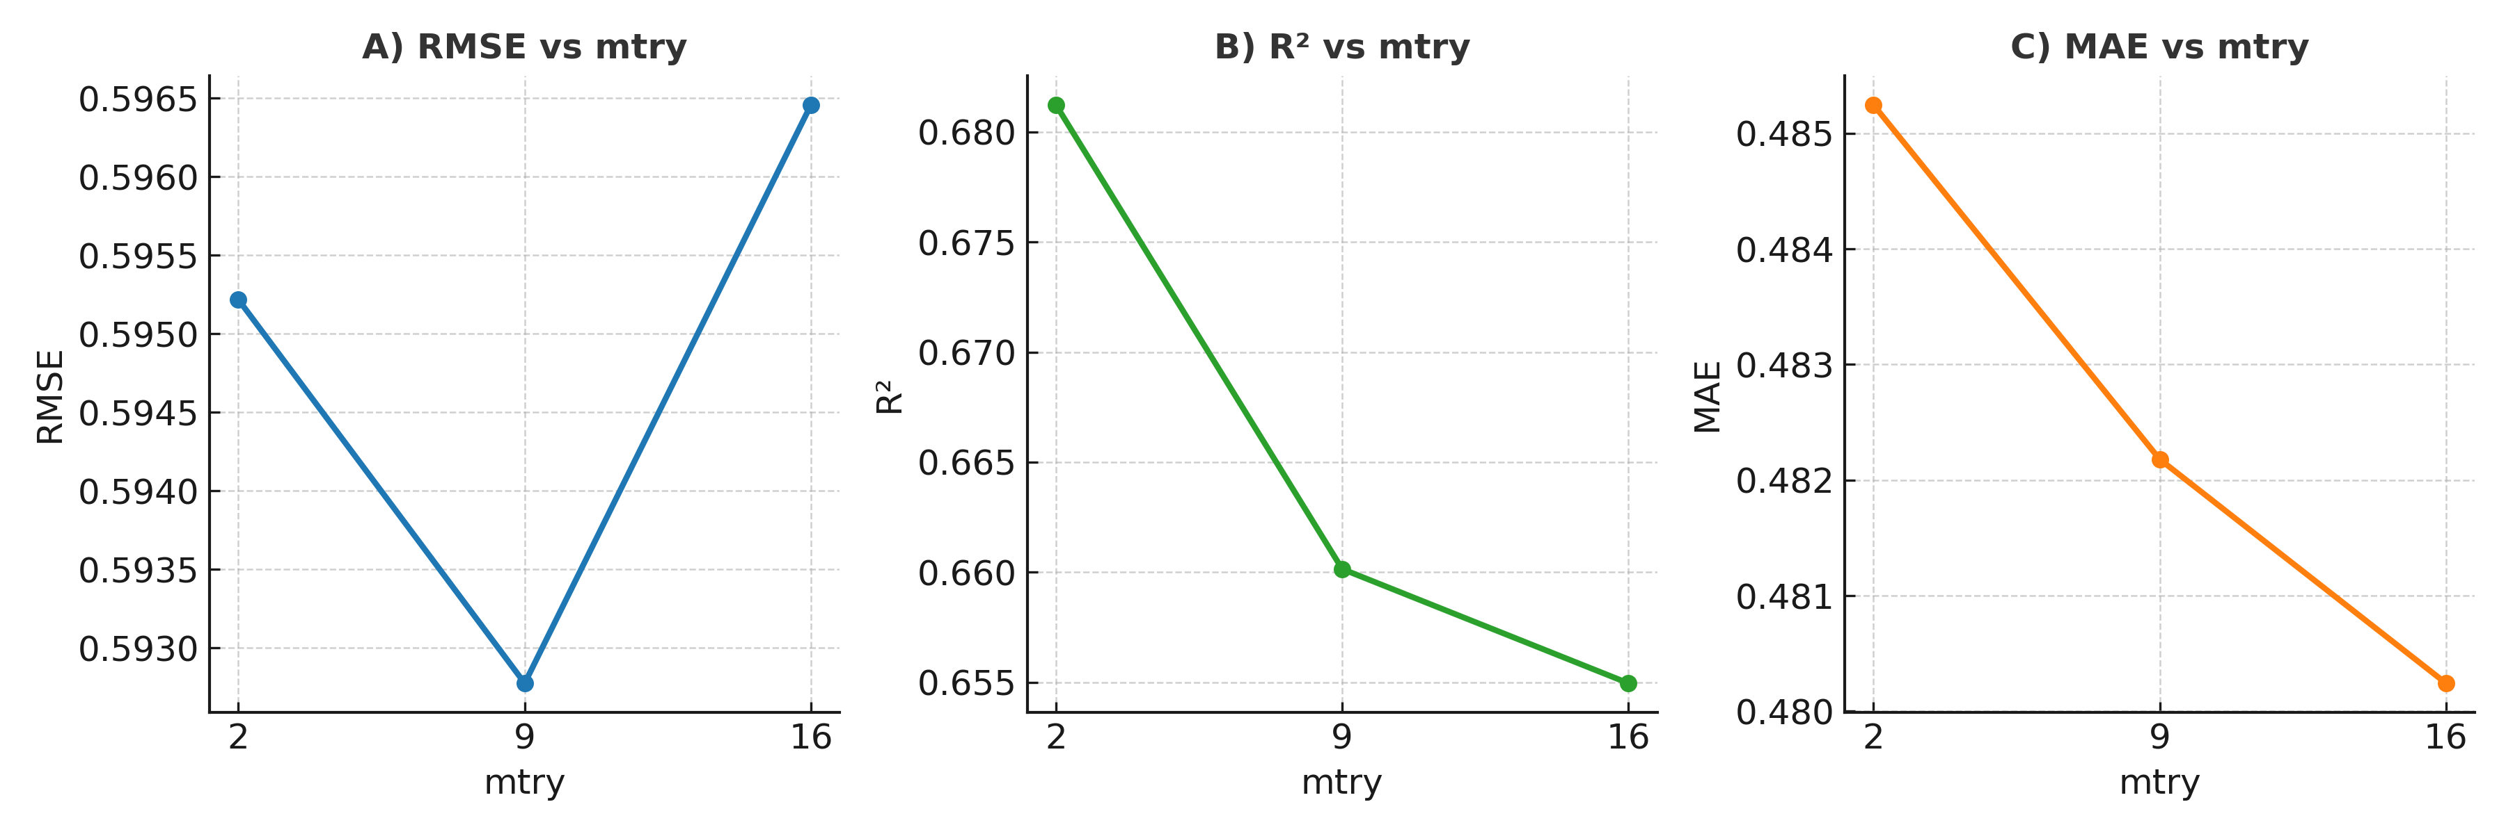
Supplementary Fig. S3. Cross-validation results for Random Forest models predicting soil multifunctionality (SMF). Model performance was evaluated across different values of mtry (number of predictors sampled at each split). (A) Root mean square error (RMSE), (B) model explanatory power (R²), and (C) mean absolute error (MAE). The optimal configuration was obtained at mtry = 9, yielding the lowest RMSE (~0.59) with stable R² (~0.66–0.68) and MAE (~0.48).

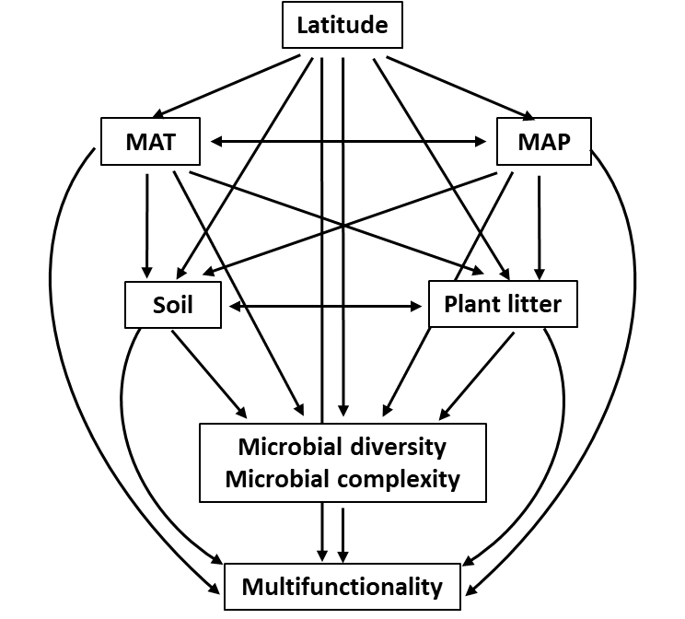

Supplementary Fig. S4. A priori structural equation modeling (SEM) describing the effects of multiple predictors on soil microbial diversity. MAP: mean annual precipitation, MAT: mean annual temperature. Soil includes pH, SOM, PO₄³⁻, NH₄⁺, and C/N ratio. Plant litter: biomass, C and N content. Multifunctionality refers to soil multifunctionality (SMF).

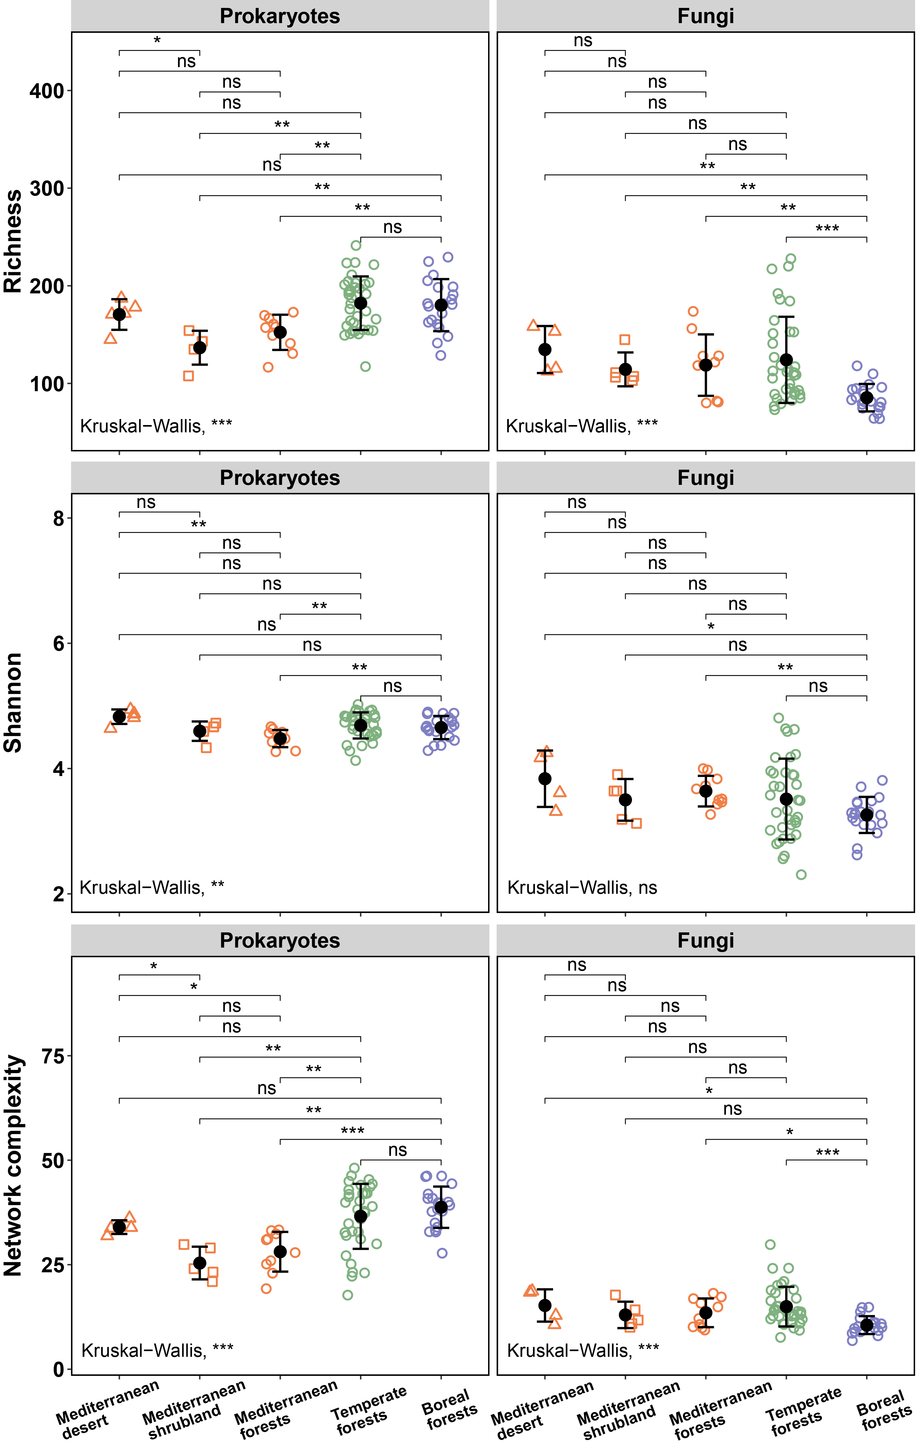

Supplementary Fig. S5. Difference between alpha-diversity metrics (richness, Shannon index and network complexity) of prokaryotic and fungal communities between biomes. Kruskal-Wallis test was used to examine the significant difference across all biomes. Significance tests were done between each two of the five biomes by using a pairwise Wilcoxon Rank Sum Test. Standard errors are shown in black. Significance levels: ns not-significant, * P < 0.05, ** P < 0.01, *** P < 0.001.

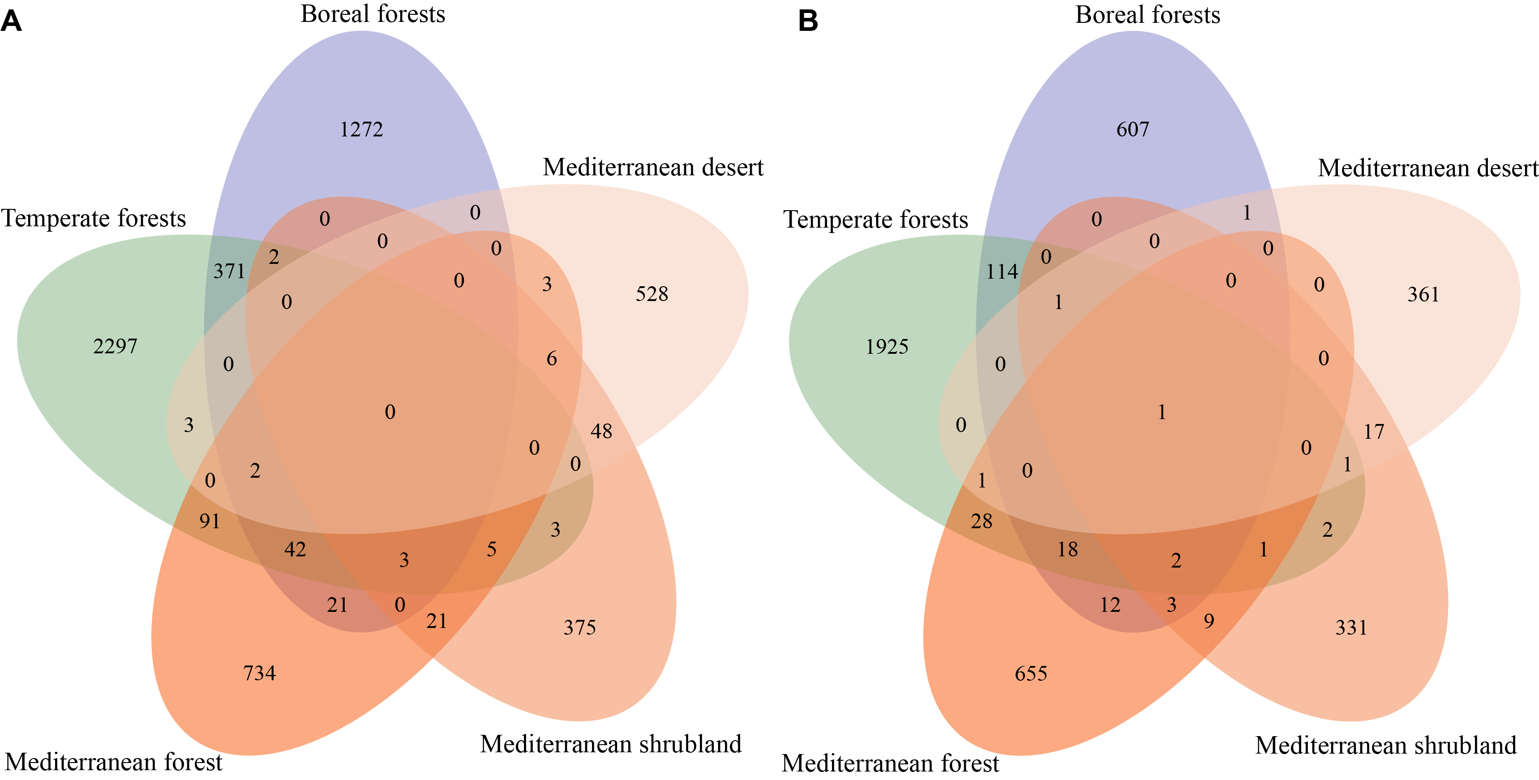

Supplementary Fig. S6. Number of shared ASVs in the prokaryotic (A) and fungal (B) communities between different biomes.

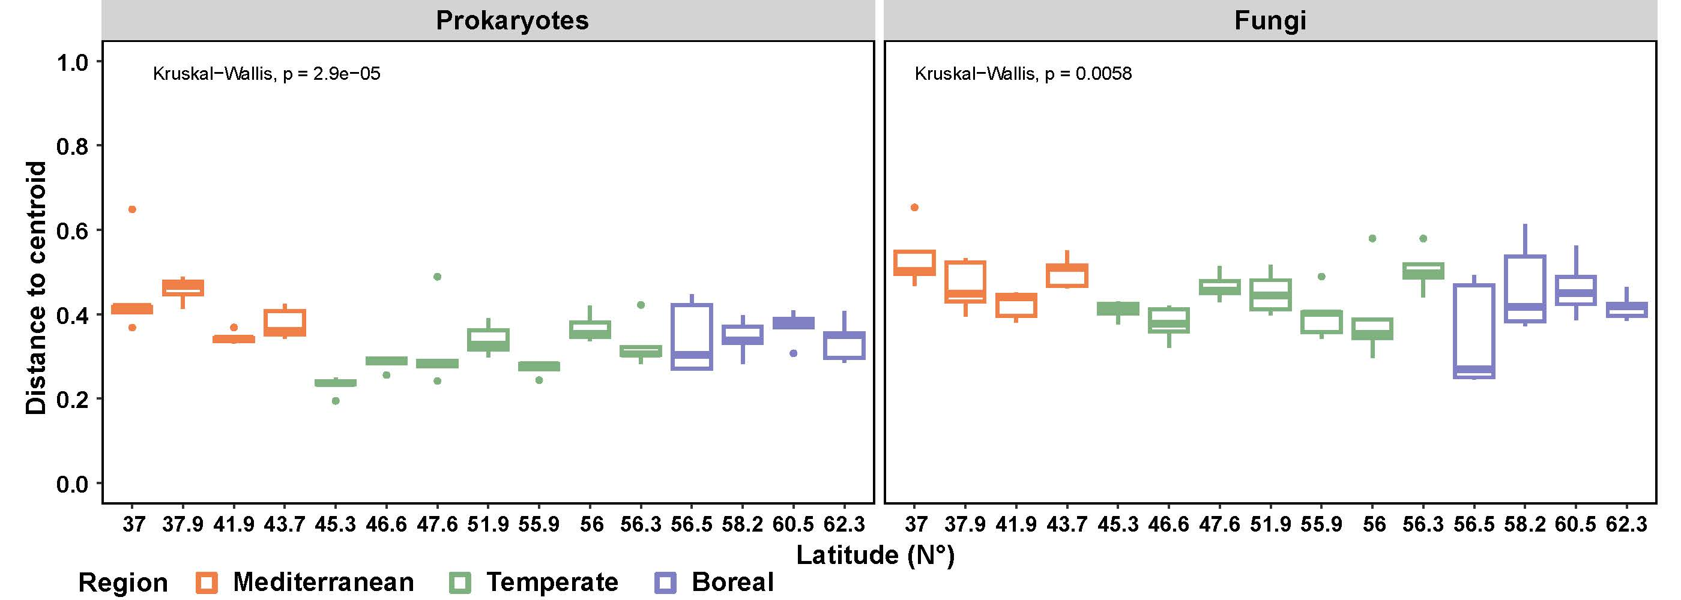

Supplementary Fig. S7. Homogeneity of groups dispersions within sites in prokaryotic and fungal communities. Distance to centroid was calculated in multivariate space using the function betadisper() from the R package vegan. Orange, green and blue indicate the Mediterranean desert, shrubland and forests, temperate forests, and boreal forests with latitude, respectively.

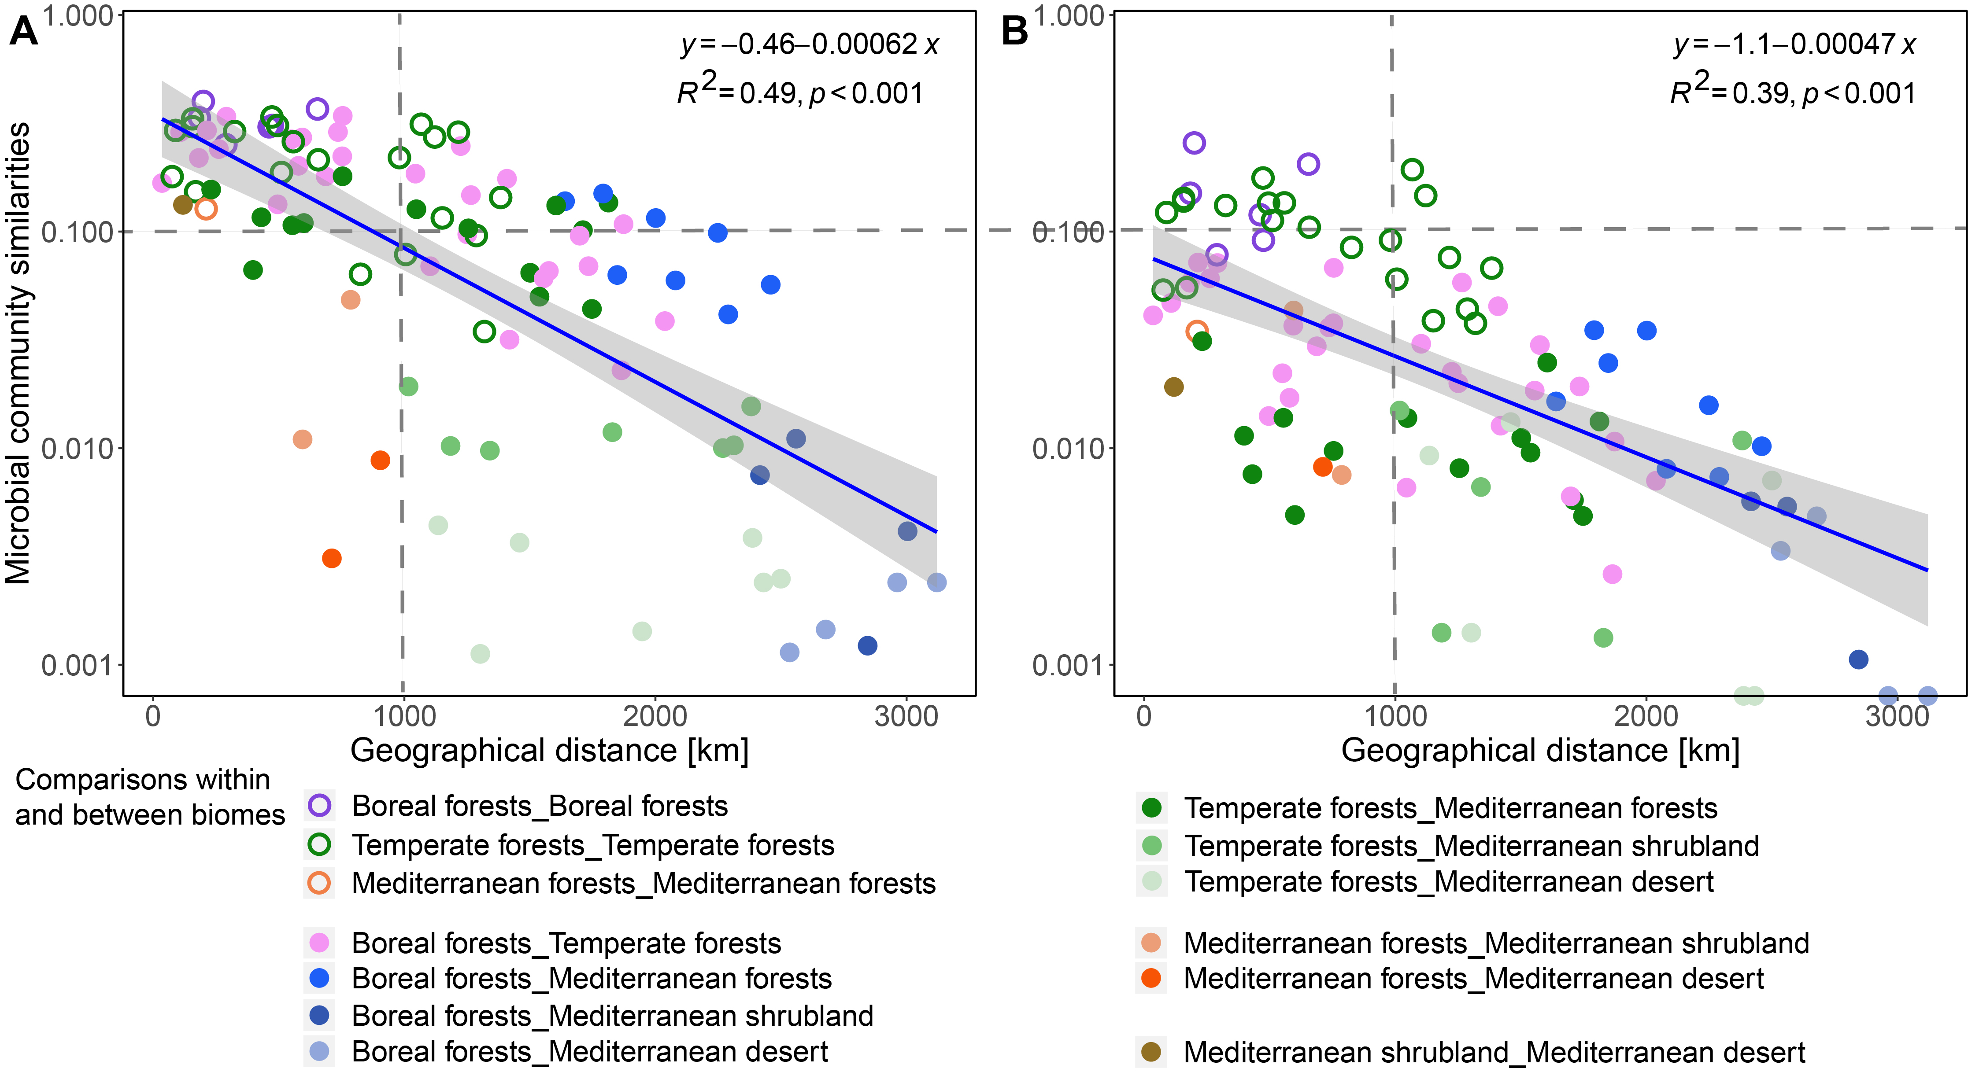

Supplementary Fig. S8. Similarities of soil prokaryotic (A) and fungal (B) community structures between sites along the geographical distance. Distance matrix of microbial community structure was calculated with the relative abundances of ASVs based on Bray–Curtis distance similarities. Y-axis values were log10 transformed.

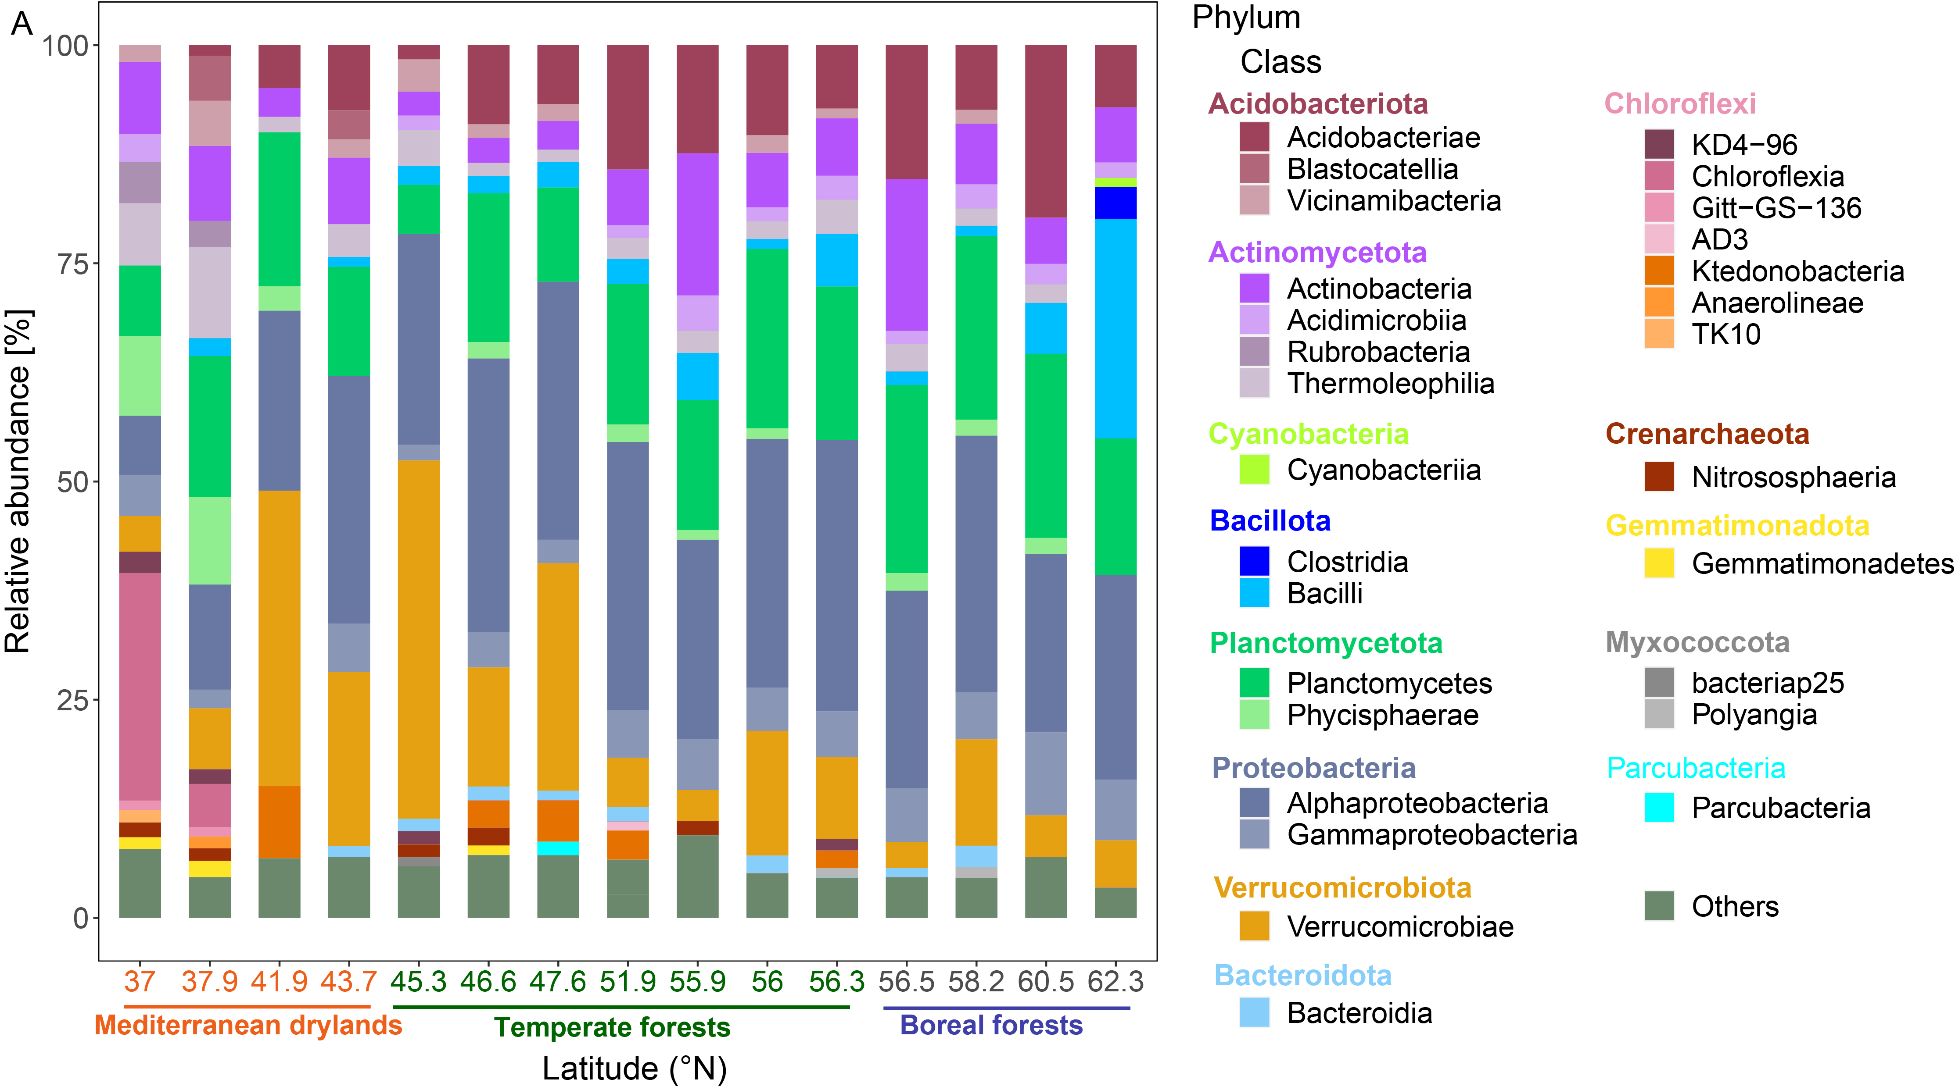
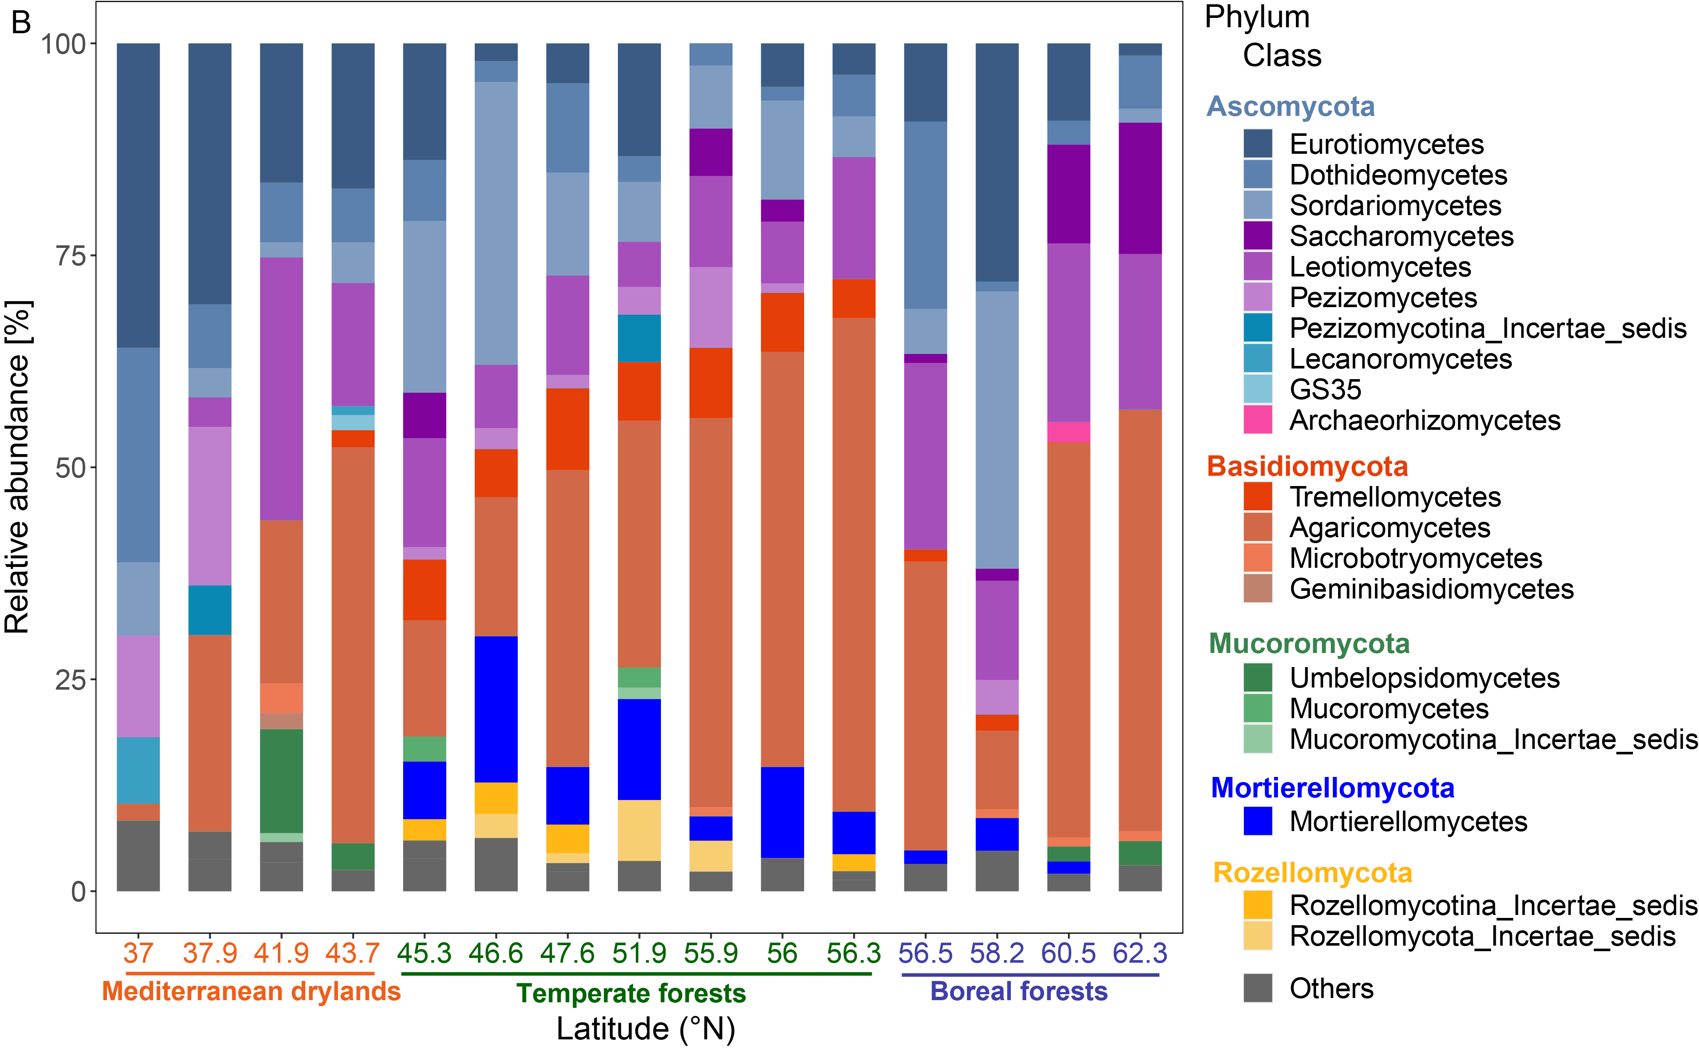

Supplementary Fig. S9. Relative abundances of the dominant phyla and classes in the prokaryotic (A) and fungal (B) communities along the latitudinal gradient.

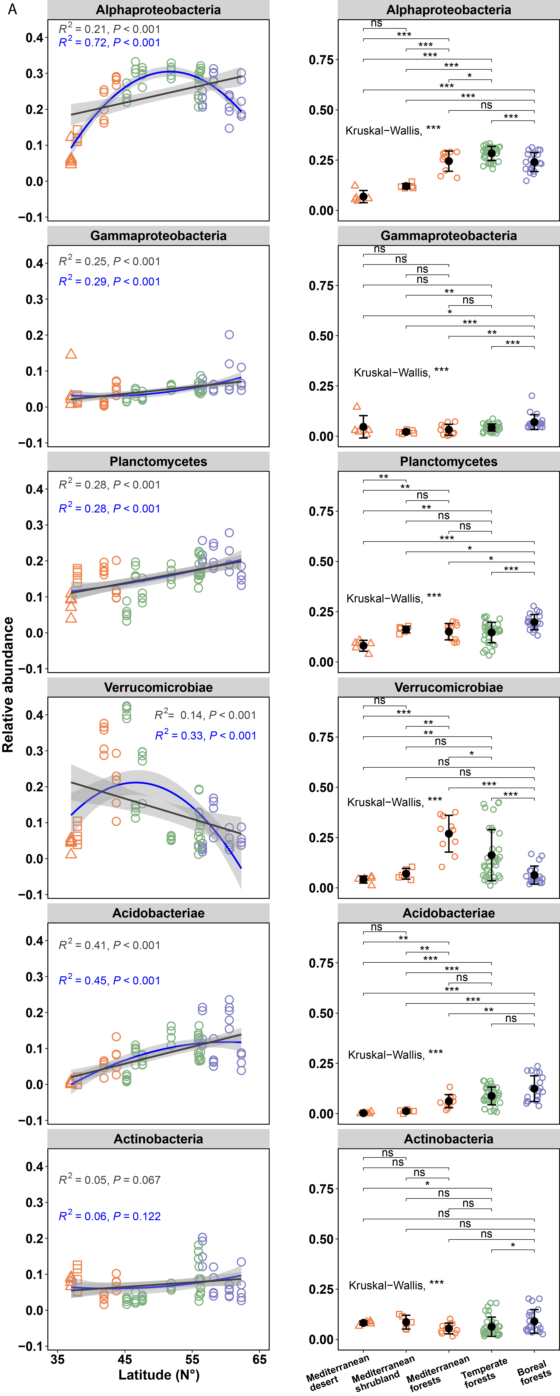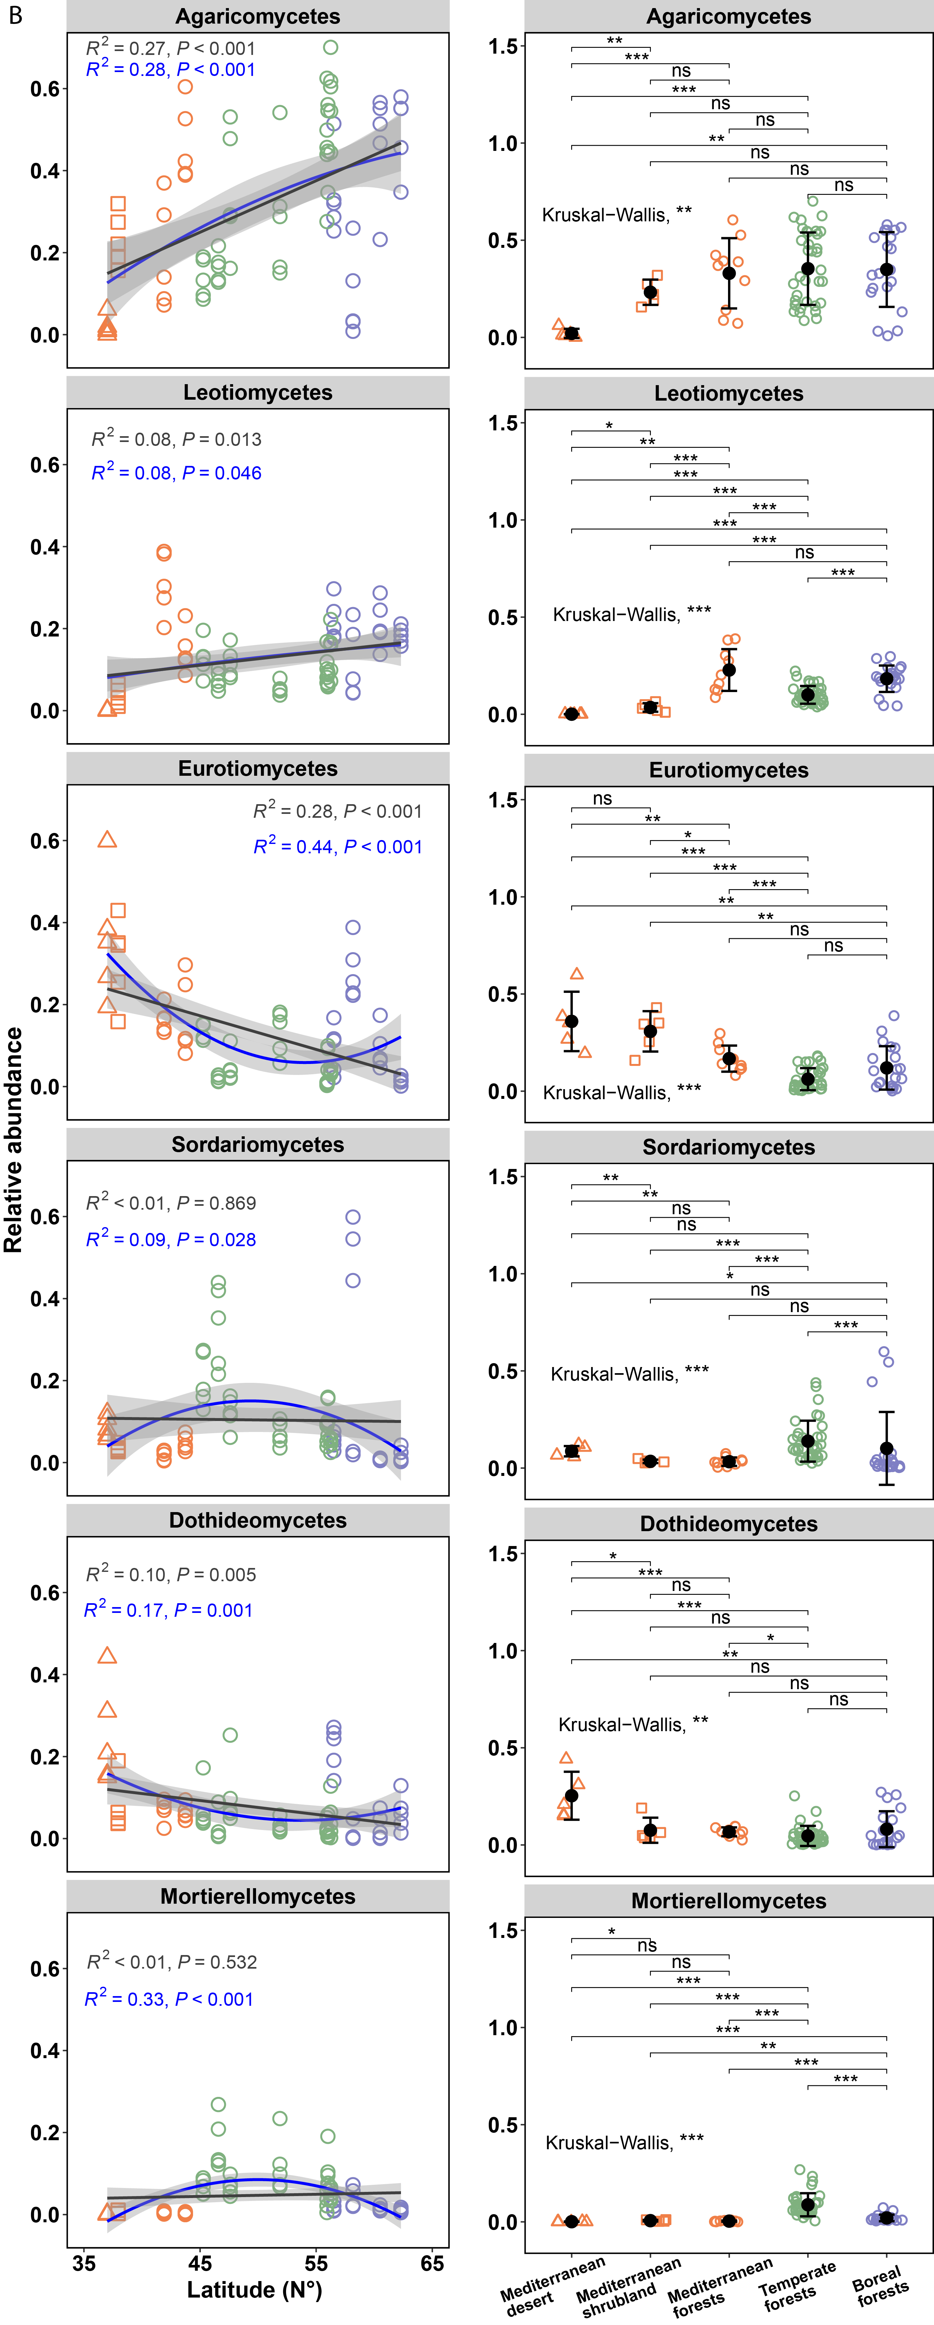

Supplementary Fig. S10. Relative abundances of dominant classes of bacterial (A) and fungal (B) communities with latitude and between biomes. Patterns were modelled by both linear regressions and polynomial regressions with a degree of 2. Kruskal-Wallis test was used to examine the significant difference across all biomes. Significance tests were done between each two of the five biomes by using a pairwise Wilcoxon Rank Sum Test. Standard errors are shown in black. Significance levels: ns not-significant, * P < 0.05, ** P < 0.01, *** P < 0.001.

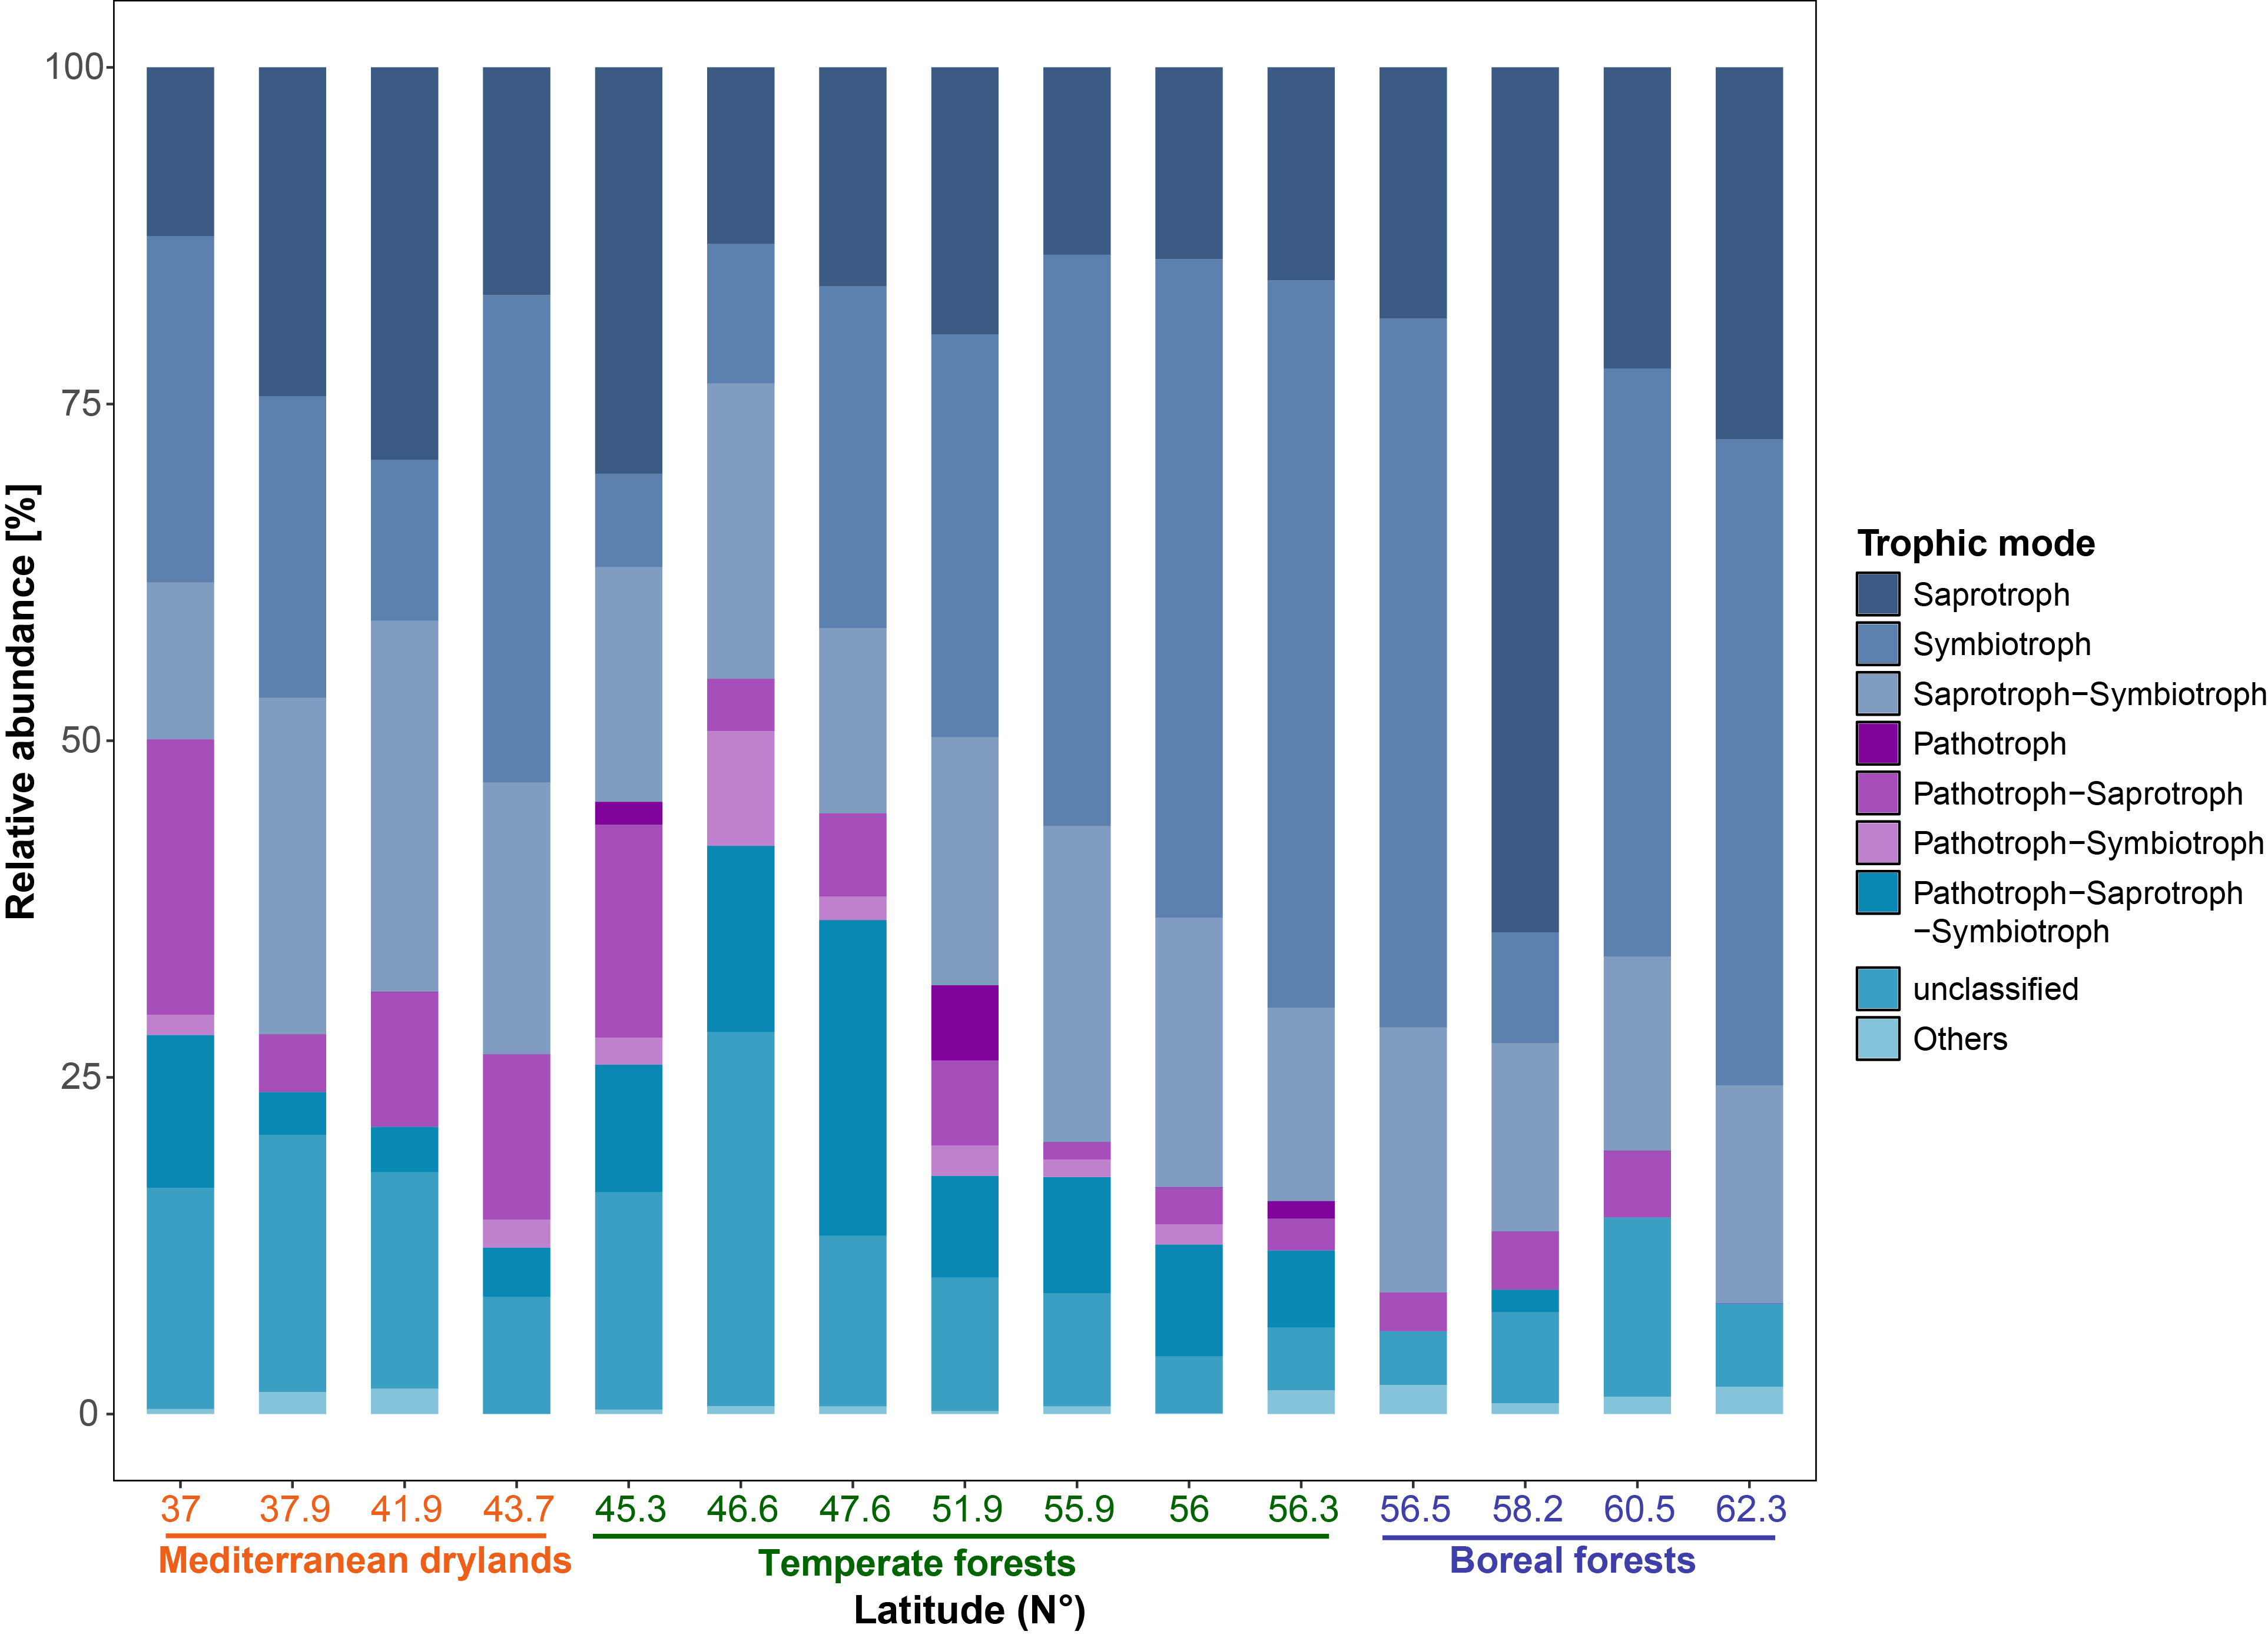

Supplementary Fig. S11. Relative abundances of fungal group of taxa based on their trophic mode. Fungal taxonomic classification into trophic mode was done by the function funguild_assign() against the FUNGuild database from the R package FUNGuildR.

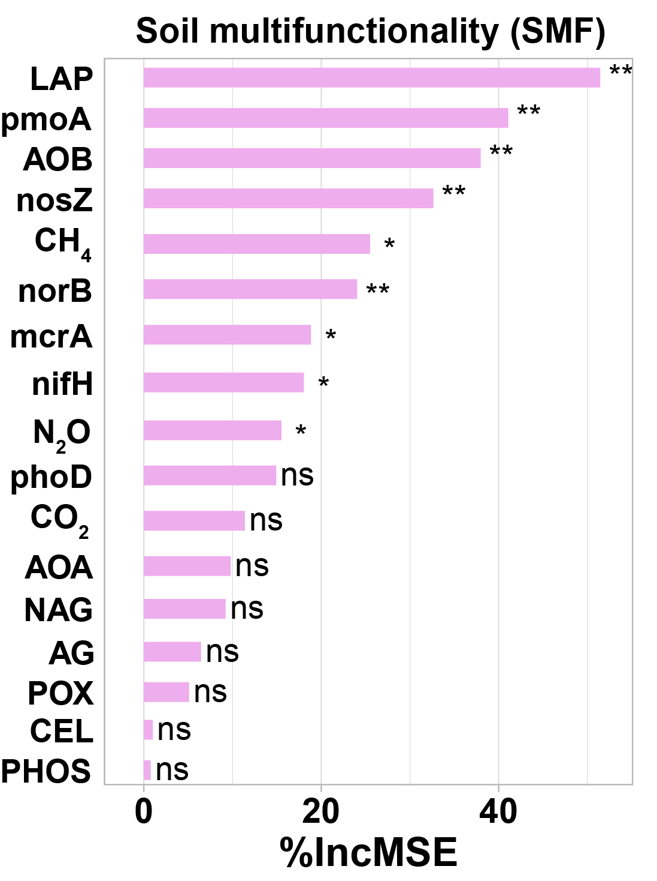

Supplementary Fig. S12. Random Forest mean predictor importance (% of increase in the mean square error [IncMSE]) of different functional parameters on soil multifunctionality. Significance levels of each predictor are as follows: ns not significant, *P < 0.05, **P < 0.01. AG: α-glucosidase, CEL: cellobiohydrolase, POX: Phenol oxidase, NAG: N-acetyl-glucosaminidase, LAP: Leucine aminopeptidase, PHOS: Phosphatase, AOA: archaeal amoA, AOB: bacterial amoA. mcrA: CH₄ production: Methyl Coenzyme M Reductase A, pmoA: CH₄ oxidation: particulate methane monooxygenase, nifH: nitrogen fixation: nitrogenase reductase, norB: N₂O production: nitric oxide reductase, nosZ: N₂O consumption: nitrous oxide reductase, phoD: organic P hydrolysis: alkaline phosphatase D.

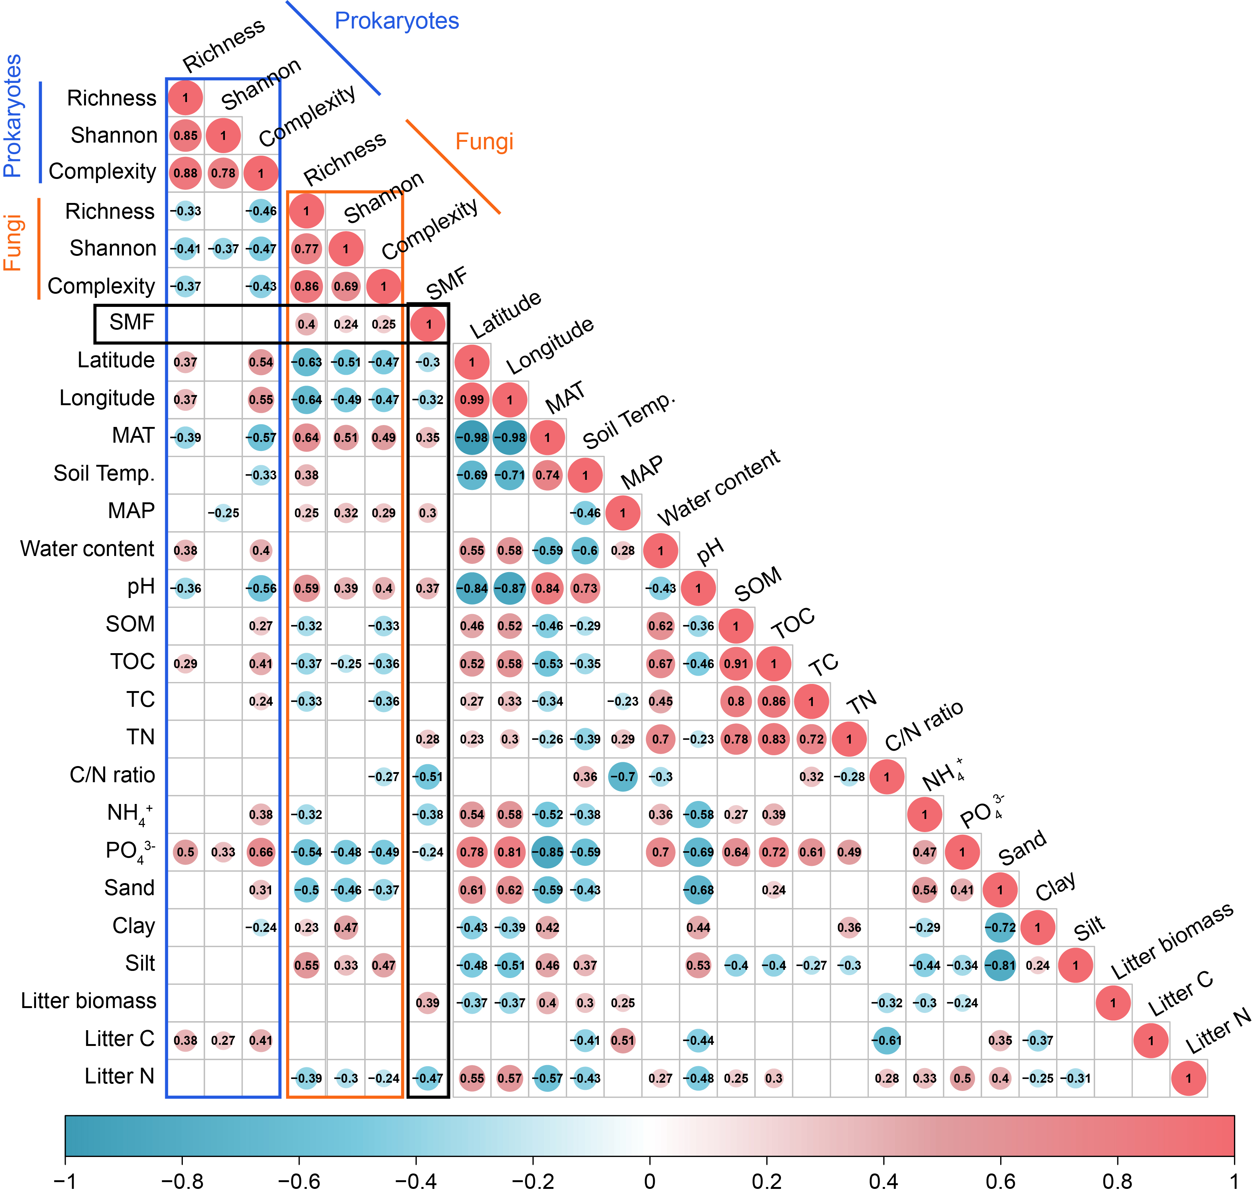

Supplementary Fig. 13. Spearman correlations between soil multifunctionality index (SMF), microbial alpha-diversity and network complexity, geographic, climatic, and edaphic properties. Only significant correlations (P < 0.05) are shown. Numbers in the circles are Spearman coefficients. SMF: Soil multifunctionality, MAT: mean annual temperature, MAP: mean annual precipitation, Soil Temp.: In situ soil temperature, Water content: In situ water content.

