Supplementary material
Using indicators to assess the status of biological invasions and their management on islands—the Prince Edward Islands, South Africa as an example
Laura Fernández Winzer^{1,2*}, Michelle Greve³, Peter C. le Roux³, Katelyn T. Faulkner^{1,4}, John R. U. Wilson^{1,2}

¹South African National Biodiversity Institute, Kirstenbosch Research Centre, Cape Town, South Africa,
²Centre for Invasion Biology, Department of Zoology & Botany, Stellenbosch University, Stellenbosch, South Africa
³Department of Plant and Soil Sciences, University of Pretoria, Pretoria, South Africa
⁴Department of Zoology and Entomology, University of Pretoria, Pretoria, South Africa

*Corresponding author: Laura Fernández Winzer: laura.f.winzer@gmail.com

S1 Supplementary material for the Introduction
Comparison of Indicator frameworks

Besides Wilson et al. (2018), a different indicator framework, the Antarctic Biological Invasions Indicators (ABII), had been previously developed for the broader Antarctic to monitor biological invasions (McGeoch et al. 2015; see Table S1). Some of the indicators in the ABII are equivalent to those of the framework of Wilson et al. (2018) (Table 1), but the framework of Wilson and colleagues explicitly covers the various aspects of biological invasions (pathways, sites and interventions) that need to be addressed to meet GBF Target 6. The working definitions for invasive species also differ between the frameworks. The Wilson et al. (2018) framework considers a taxon as invasive when it has a ‘self-sustaining population outside of captivity or cultivation, with individuals surviving and reproducing a significant distance from the original point of introduction’. This follows the Darwin Core term ‘degree of establishment’ [dwc:degreeOfEstablishment, Groom et al. 2019), and is based on the Unified Framework for Biological Invasions (Blackburn et al. 2011). The definition used by the ABII is aligned with the Intergovernmental Science-Policy Platform on Biodiversity and Ecosystem Services (IPBES 2023) and invasive taxa are those that have spread and caused negative impacts to biodiversity.
In addition, the GBF has identified seven indicators for Target 6: a Headline indicator, three Component indicators and three Complimentary indicators (Table S1). However, these indicators are not yet fully developed (https://www.cbd.int/gbf/targets/6) and thus it is not known how they should be scored (at least as of 26 April 2024). Interestingly, when compared with the indicators from Wilson et al. (2018), the GBF does not have analogous indicators to assess invasions at sites (neither does ABII), or interventions.
Table S1 The indicators of the Antarctic Biological Invasions Indicator (ABII) scheme (McGeoch et al. 2015) with the analogous indicators from Wilson et al. (2018), and from the Global Biodiversity Framework (GBF) Target 6. Note that the indicator numbers for the Wilson et. al. (2018) framework reflect those in Table 1 as opposed of numbers in the original source. The GBF headline indicator ‘Rate of invasive alien species establishment’ and the Component indicator ‘Rate of invasive alien species spread’ were not included in the table as they do not possess equivalent indicators in the other frameworks. IAS = invasive alien species
Antarctic Biological Invasions Indicators |  | Indicators from Wilson et al. (2018) |  | GBF Target 6 Indicators
Driver: Number and trends in activities associated with invasion risk | Number of tourists, scientists and facilities per biogeographic region | Pathways | 1.1: Introduction pathway prominence
 |  |  | 1.2 Introduction rates | Component  indicators | Number of invasive alien species introduction events
Pressure: Number of alien invasive species per biogeographic region | Alien and invasive taxa: plants, mammals, birds, freshwater fish, insects and other invertebrates | Species | 2.1: Number and status of alien species | Complementary  indicators | Number of invasive alien species on national lists as per the Global Register of Introduced and Invasive Species
 |  | Species | 2.2. Extent | Complementary  indicators | Trends in abundance, temporal occurrence and spatial distribution of non-indigenous species, particularly invasive, non-indigenous species, notably in risk areas (in relation to the main vectors and pathways of spreading of such species)
 |  | Species | 2.3 Abundance of alien species | Complementary  indicators
State: Red List Index for Impacts of Invasive alien species | Trends in the extinction risk of birds impacted by invasive species | Species | 2.4: Impact of alien species | Component  indicators | Rate of invasive species impact and rate of impact
 |  |  |  | Complementary  indicators | Red List Index (impacts of invasive alien species)
Response: Policy adoption and activities relevant to invasion management | Trends in adoption of multinational agreements relevant to reducing IAS threats to biodiversity in the Antarctic | Interventions | 4.1: Quality of regulatory framework, and  4.3: Planning coverage
 | Trends in IAS -relevant submissions to the ATCM (prospective change to indicator of management activity) | Interventions | 4.4: Pathways treated,  4.5: Species treated  4.6: Sites treated
 | Trends in invasive species eradications across the region | Interventions | 4.8 Effectiveness of species treatments

S2 Supplementary material for Methods
Data collection and calculation of indicators
A systematic literature review was performed on Web of Science on 20 August 2024, using the terms: ("Marion Island" OR "Prince Edward Islands") AND ((introduced OR alien* OR invasive* OR non-native*) AND (species)). The search provided 203 results that were scrutinised by reading the title and abstract to determine if they had been consulted already, and if they contained data that could be incorporated. Out of the 203, 192 had either been cited (57) or were not relevant (135) for this manuscript. The remaining 11 were further examined to determine if they needed to be included (that is, if they included new pertinent data) and for which indicators. Two of these sources had been previously identified but had not been utilised. These 11 references were incorporated into the study, but simply provided extra information or to reinforce the findings of other citations already included, and thus their inclusion did not result in changes to the estimates for the indicators (see Appendix 3 for the complete list).
The first draft of the PEIs’ species list (Appendix 1) was developed following Greve et. al. (2017). Additional taxa were added from a number of different data sources by scouring the literature. Greve et al. (2017) did not have a comprehensive list of species that were recorded only once; therefore, most species added to the Greve et al. list were species that were transient. E.g. 14 taxa were added from Watkins and Cooper (1986) and the list was compared with Pagad (2020) (PEIs species list from GBIF), but all records were present already in our species list. Finally, the list was compared to that from Leihy et. al. (2023), and three more taxa were added (Astemolaelaps, Blattella germanica, and Passer domesticus). This last source also has information on occurrence, eradication, introduction status, first date observed and estimated date of introduction.
Pathways
For each species, the literature was exhaustively searched for information on the mode of introduction. Greve et al. (2017) had some information on pathways, but for several species, pathway information was fairly unspecific. E.g. many species are thought to have been introduced accidentally as contaminant, but the literature was unclear about what the suspected contaminant was. Therefore, for many species, the pathway could not be determined and has been categorised as ‘unknown’.
Information on recent introductions was obtained from officials of the South African DFFE (e.g., the Biodiversity Officer: Control and Pesticide Risk Manager Debbie Muir) and taxonomic experts that identified specimens. Additionally, the introduction pathways [classified using the introduction pathway framework of the CBD (CBD 2014)], and year of introduction to the PEIs were noted for each species where these were obtainable (Gremmen and Smith 1999).
Introduction pathway prominence (indicator 1.1) is an estimate of the size of the pathway to the region of interest rather than what has travelled along it (or could in light of biosecurity interventions), and not a measure of propagule pressure along the pathways, nor the number of introductions that a pathway facilitates; and so does not, for example, consider the extent of hull fouling on the ship, or the number of propagules on the helicopter. This is estimated using socio-economic data, such as the number of ship visits, number of helicopter visits, etc. There are few visits by both ships and helicopters (usually once a year for both), and thus both of these pathways have been rated as having a ‘minor’ ‘introduction pathway prominence’.
Species
Regarding the scoring of alien species status on the species list (Appendix 1; number and status of alien species, indicator 2.1), for species for which occurrenceStatus=doubtful or cryptogenic, degreeOfEstablishment and introductionStatus will be NA, together with confidence and source. The information regarding what degree of establishment a taxon reached while present is reflected in the historyOfInvasion column (last column). If a taxon appears in the bibliography as ‘transient’ or ‘not established’, then it is considered as ‘absent’ in the ‘occurrenceStatus’ column.

To estimate the Impact of alien species (indicator 2.3), EICAT scores were assessed by assigning a single value to each species, which is the maximum recorded environmental impact in the Prince Edward Islands (Blackburn et al. 2014; Hawkins et al. 2015). These values were based on Greve et al (2017) who also based their assessments on Blackburn et al. (2014)’s framework. Greve et al. (2017) used the same categories that are used in EICAT: Massive (MV), Major (MR), Moderate (MO), Minor (MN) and Minimal (MC). EICAT categories and definitions can be found in the metadata for the species list (Appendix 2). The EICAT scores per species are presented in the Species list (Appendix 1). Note that the assessments considered here are based solely on studies conducted on the PEIs, while standard EICAT assessments are typically based on global data. If a species' occurrence status is currently classified as 'doubtful', the EICAT assessment reflects the impact data available from when the species was confirmed to be present. Only one score was updated compared to Greve et al. (2017), Elymus repens. Greve et al. (2017) reported the species as having 'Major' impacts following the EICAT workflow, but Michelle Greve updated this score to 'Moderate' [Gremmen (1975) stated that E. repens dominated the vegetation of a stand, and Chown and Froneman (2008) stated that it can form dense stands that smother the native vegetation]. Therefore, it was updated from Invasion status Category C3 which means 'naturalised but not invasive', and Impact: Major (causes changes in community composition, which are reversible if the alien species is removed); to C1 (same meaning as C3) but Moderate impact (causes declines in population densities, but no changes in community composition). This level of detail can be found in Appendix 1 (Species list), column ‘historyOfInvasion’.

Sites

Extent of area that suffers ‘Major’ impacts from invasions (indicator 3)
Although this indicator was not directly assessed, an estimated area could be calculated by considering the four species with Massive (house mouse) and Major impacts (three invasive plants: Agrostis stolonifera, Festuca rubra and Sagina procumbens). The house mouse is found across most of Marion Island, and its distribution partially overlaps with that of the widespread invasive plants. However, the extent of this overlap remains unknown, as the last assessments were conducted over a decade ago by le Roux et al. (2013). In contrast, Prince Edward Island does not have a mouse invasion. For this island, the indicator could be calculated by assessing the area occupied by the three invasive plant species, which are the same as those present on Marion Island.

Interventions
Money spent (indicator 4.2): a budget was provided by Debbie Muir with expenses on herbicide, pesticide and personal protective equipment (PPE). However, the time invested by the ECOs on managing invasive species has not been included in the calculations of money spent, as there was no information provided on either the salary of the ECOs or how many hours per month or year they invest in controlling invasive taxa.

Effectiveness of species treatments (indicator 4.8)
A ‘First party assessment’ is performed by the ECOs (they assess their own work), and they produce one report every year where they report on their management actions and findings. Then, a ‘Second party assessment’ occurs every three years to perform quality assurance: a DFFE member goes to the island and checks that everything is properly used/done. This assessment involves field assessments and checking ECOs' reports.

S3 Supplementary material for Results

Pathways (indicators 1.1 - 1.4)
From the 1700s, Marion Island was visited sporadically by sealers who introduced species either intentionally (e.g., the trout as release in nature - fishery in the wild) or accidentally (e.g., the house mouse as transport stowaway - hitchhikers on a ship, Table S2; and see Table S3 for criteria used to determine pathway prominence). In 1948 the islands were annexed by South Africa, which used the islands for scientific research and environmental monitoring. The first biosecurity measures were officially implemented in 1996 when the first management plan for the islands was produced, although some actions had been implemented since the 1980s through an informal code of conduct. Opportunities for introductions have, therefore, changed markedly over time (Table S4). The volume of food and other cargo transported to the Prince Edward Islands (PEIs) has also been variable over time, although no long-term pattern is apparent (Fig. S1). No pathways were considered “major” because, in all, no pathways to the islands are prominent due to low overall visits to the islands (Greve et al. 2017). Out of 44 pathways, only three are present within the islands (Table S5).
We specified a confidence level to the scoring of introduction pathway prominence according to Wilson et al. (2018) (see Table 2). We have scored every pathway that is now prohibited as ‘high’ confidence (i.e. deliberate introductions), those for which we have volume/numbers of goods/people as ‘medium’, and those for which we do not have data as ‘low’.
Table S2 Breakdown of pathway categories and their introduction pathway prominence on the Prince Edward Islands (PEIs) as of December 2023.
 | Category | Subcategory | Introduction pathway prominence
Movement  of  commodity | Release in nature | Biological control | not present
Movement  of  commodity | Release in nature | Erosion control/ dune stabilization (windbreaks, hedges, …) | not present
Movement  of  commodity | Release in nature | Fishery in the wild (including game fishing) | not present
Movement  of  commodity | Release in nature | Hunting | not present
Movement  of  commodity | Release in nature | Landscape/flora/fauna ‘improvement’ in the wild | not present
Movement  of  commodity | Release in nature | Introduction for conservation purposes or wildlife management | not present
Movement  of  commodity | Release in nature | Release in nature for use (other than above, e.g., fur, transport, medical use) | not present
Movement  of  commodity | Release in nature | Other intentional release | not present
Movement  of  commodity | Escape from confinement | Agriculture (including Biofuel feedstocks) | not present
Movement  of  commodity | Escape from confinement | Aquaculture / mariculture | not present
Movement  of  commodity | Escape from confinement | Botanical garden/zoo/aquaria (excluding domestic aquaria) | not present
Movement  of  commodity | Escape from confinement | Pet/aquarium/terrarium species (including live food for such species) | not present
Movement  of  commodity | Escape from confinement | Farmed animals (including animals left under limited control) | not present
Movement  of  commodity | Escape from confinement | Forestry (including reforestation) | not present
Movement  of  commodity | Escape from confinement | Fur farms | not present
Movement  of  commodity | Escape from confinement | Horticulture | not present
Movement  of  commodity | Escape from confinement | Ornamental purpose other than horticulture | not present
Movement  of  commodity | Escape from confinement | Research and ex-situ breeding (in facilities) | not present
Movement  of  commodity | Escape from confinement | Live food and live bait | not present
Movement  of  commodity | Escape from confinement | Other escape from confinement | not present
Movement  of  commodity | Transport – contaminant  Transport - stowaway | Nursery material contaminant | not present
Movement  of  commodity | Transport – contaminant  Transport - stowaway | Bait contaminant | not present
Movement  of  commodity | Transport – contaminant  Transport - stowaway | Food contaminant (including of live food) | moderate
Movement  of  commodity | Transport – contaminant  Transport - stowaway | Contaminant of animals (except parasites, species transported by host/vector) | not present
Movement  of  commodity | Transport – contaminant  Transport - stowaway | Parasites of animals (including species transported by host and vector) | not present
Movement  of  commodity | Transport – contaminant  Transport - stowaway | Contaminant of plants (except parasites, species transported by host/vector) | not present
Movement  of  commodity | Transport – contaminant  Transport - stowaway | Parasites of plants (including species transported by host and vector) | not present
Movement  of  commodity | Transport – contaminant  Transport - stowaway | Seed contaminant | not present
Movement  of  commodity | Transport – contaminant  Transport - stowaway | Timber trade contaminant | not present
Movement  of  commodity | Transport – contaminant  Transport - stowaway | Habitat material contaminant (soil, vegetation,…) | not present
Vector | Transport – contaminant  Transport - stowaway | Angling/fishing equipment | minor
Vector | Transport – contaminant  Transport - stowaway | Container/bulk cargo | moderate
Vector | Transport – contaminant  Transport - stowaway | Hitchhikers in or on airplane | minor
Vector | Transport – contaminant  Transport - stowaway | Hitchhikers on ship/boat (excluding ballast water and hull fouling) | minor
Vector | Transport – contaminant  Transport - stowaway | Machinery/equipment | minor
Vector | Transport – contaminant  Transport - stowaway | People and their luggage/equipment | moderate
Vector | Transport – contaminant  Transport - stowaway | Organic packing material, in particular wood packaging | not present
Vector | Transport – contaminant  Transport - stowaway | Ship/boat ballast water | minor
Vector | Transport – contaminant  Transport - stowaway | Ship/boat hull fouling | minor
Vector | Transport – contaminant  Transport - stowaway | Vehicles (car, train, …) | not present
Vector | Transport – contaminant  Transport - stowaway | Other means of transport | not present
Spread | Corridor | Interconnected waterways/basins/seas | not present
Spread | Corridor | Tunnels and land bridges | not present
Spread | Unaided | Natural dispersal | minor

Table S3. Table indicating ballpark values used to estimate pathway prominence in the PEIs. Values for different pathways were estimated based on expert opinion and would only be applicable for the PEIs and similar remote sub-Antarctic islands.
Vessels
Minor | < 3 vessels
Moderate | > 3 but < 10 vessels
Major | > 10 vessels
People
Minor | <10 people
Moderate | >10 but < 1 000 people
Major | > 1 000 people
Tonnage
Minor | <20 000 kg
Moderate | > 20 000 but < 100 000 kg
Major | > 100 000 kg

Table S4 Number of recorded introductions by pathway category, subcategory and decade, and corresponding confidence level (i.e., introduction rates). For full details see Appendix 1. In this case, each taxon was assigned to a single introduction pathway, although multiple pathways could have been operating

Pathway categories & subcategories |  | 1800s | 1810s | 1870s | 1910s | 1930s | 1940s | 1950s | 1960s | 1970s | 1980s | 1990s | 2000s | 2010s | 2020s | Unknown | Total | Confidence
Release | Landscape Improvement |  |  |  |  |  |  | 3 |  |  |  |  |  |  |  |  | 3 | High
Release | Biological Control |  | 1 |  |  |  | 2 |  |  | 1 |  |  |  |  |  |  | 4 | High
Release | Fishery In Wild |  |  |  |  |  |  | 1 | 1 |  |  |  |  |  |  |  | 2 | High
Release | Hunting | 1 |  |  |  |  |  | 1 |  |  |  |  |  |  |  |  | 2 | High
Escape | Pets |  | 2 |  |  |  | 2 |  | 3 | 1 |  |  |  |  |  |  | 8 | High
Escape | Farmed Animals |  |  |  |  |  | 2 | 3 |  |  |  |  |  |  |  |  | 5 | High
Contaminant | Food Contaminant |  |  |  |  |  |  | 1 |  | 4 |  | 4 | 1 |  |  |  | 10 | Low
Stowaway | Machinery And Equipment |  |  |  |  |  |  |  | 2 |  | 3 | 2 | 1 |  |  |  | 8 | Medium
Stowaway | People And Luggage |  |  |  |  |  |  |  | 1 |  |  |  |  |  |  |  | 1 | Medium
Stowaway | Ship Excluding Ballast Water Or Hull Fouling |  | 1 |  |  |  |  | 1 |  | 1 |  |  |  |  |  |  | 3 | High
Unaided | Natural Dispersal |  |  |  |  |  |  |  |  |  | 1 |  | 1 |  |  |  | 2 | Low
Unknown |  |  |  | 2 | 1 | 1 | 3 | 3 | 17 | 5 | 8 | 11 | 1 | 1 | 1 | 7 | 61
Total |  | 1 | 4 | 2 | 1 | 1 | 9 | 13 | 24 | 12 | 12 | 17 | 4 | 1 | 1 | 7 | 109 | ~Medium

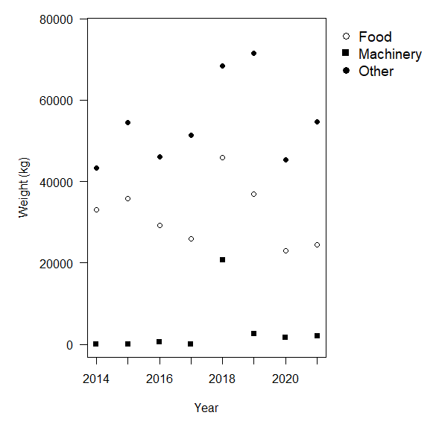
Fig. S1 The volume of goods transported to the Prince Edward Islands (PEIs) (2014–2021). The volume of food and other cargo transported to the PEIs has been variable over time and no long-term pattern is apparent. Occasional work on the research base or upgrading of facilities results in peaks in the machinery transported (cf. 2018). These data were used to estimate the indicator ‘introduction pathway prominence’ for the food contaminant, container and bulk cargo, and machinery and equipment pathways. While the ‘machinery and equipment’ pathway has ‘minor’ introduction pathway prominence, the introduction pathway prominence of the ‘food contaminant’ and the ‘container and bulk cargo’ pathways are moderate (Table S2).

Table S5 Three within-country pathways are present by which alien species are known, or strongly suspected on the Prince Edward Islands.
Pathway category: subcategory | Within-country pathway prominence | Examples of within-country dispersal
Transport-stowaway: People/equipment | Not known | Lee and Chown (2011) found 420 seeds carried on 225 different clothes items on expeditioners that were returning to the South African mainland from Marion Island. These propagules could have potentially been spread around the island (at least three seeds were of highly invasive plant species). The prominence of the pathway on the island has not, however, been specifically monitored.
Transport-stowaway:  Container and bulk cargo | Minor | Sagina procumbens was possibly spread across the island during hut restocking, when containers are dropped at huts by helicopter. This happens once a year. Other plants could have been spread by this means too. The invasive slug Deroceras panormitanum has been spread around Marion Island through wooden crates that are packed around the research station prior to aircraft and ship operations (Chown et al. 2002; Fig. 3c).
Unaided | Moderate | Several plant species have spread over fairly large distances on Prince Edward Island during a time when no humans visited the island. It can be expected that most increases in the range of invasive species on Marion Island are similarly unaided.

Species

Number and status of alien species (indicator 2.1)
The number of species and their introduction status was initially based on Greve et al. (2017) and updated based on expert knowledge, rechecking the original sources and incorporating more recently published papers (see Appendix 1 for the PEIs species list and Appendix 2 for the metadata). The number of alien taxa and introduction status (i.e., invasive, naturalised) varied by taxonomic group (invertebrates, plants, fungus and mammals) (Fig. S2).

Fig. S2 Number of alien taxa present on the Prince Edward Islands as of December 2023 and their current status based on the unified framework for biological invasions (Blackburn et al. 2011), with a break-down into the regulatory groupings of the NEM:BA A&IS Regulations. T = terrestrial, FW = freshwater, M = marine. Microbes in this classification includes fungi

Extent of alien species (indicator 2.2)
The DFFE (Department of Forestry, Fisheries and the Environment) Assistant Director of Environmental Resource Management, Charles Hope, provided up to date maps of extent of invasion for three plant species: Agrostis gigantea (black bent grass), Luzula multiflora (woodrush), and Rumex acetosella (sheep sorrel). Agrostis gigantea was present at three sites: Longridge (0.15 ha; Fig. S3), Old Base (1 ha; Fig. S4) and the new research base (0.24 ha; Fig. S5) (widespread species); L. multiflora at the only site currently present: Sealers Cave (1.2 ha; Fig. S6); and R. acetosella also at only site: Gentoo Lake (0.1 ha; Fig. S7). This information was collected by the Environmental Control Officers (ECOs) up until 2022 and confirmed by a second party assessment during the April/May 2023 voyage.
Values in hectares were transformed into half minute grid cells (hmgc) in order to add the values into the Species list (Appendix 1, column ‘RangeHMGC’). Conversion values used: 1 hmgc = 0.59 km² , 1 ha = 0.01 km². Therefore: A. gigantea: 0.49 ha = 0.0049 km² = 0.008 hmgc; L. multiflora: 1.2 ha = 0.012 km² = 0.02 hmgc; R. acetosella 0.1 ha = 0.001 km² = 0.0017 hmgc.
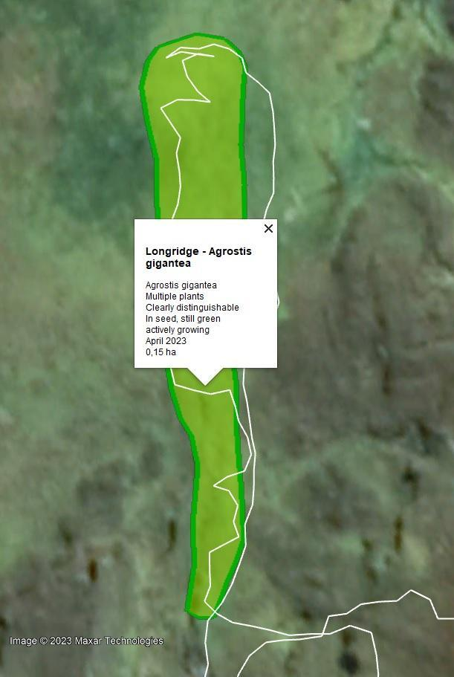
Fig. S3 Polygon showing the extent of Agrostis gigantea (black bent grass) in 2022 at Longridge site (0.15 ha). Map credit: Charles Hope (Department of Forestry, Fisheries and the Environment)

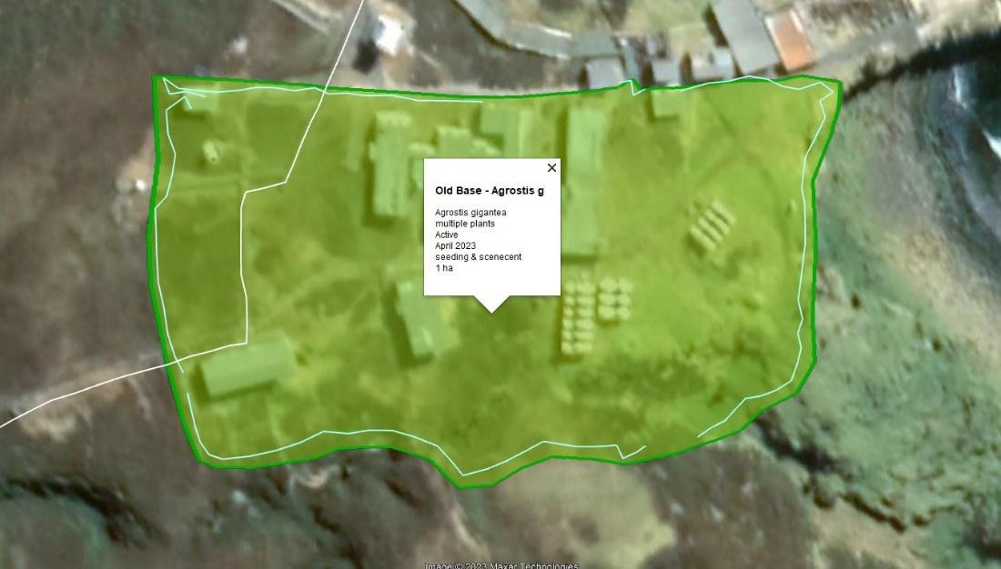
Fig. S4 Polygon showing the extent of Agrostis gigantea (black bent grass) in 2022 at the Old Base (1 ha). Map credit: Charles Hope (Department of Forestry, Fisheries and the Environment)
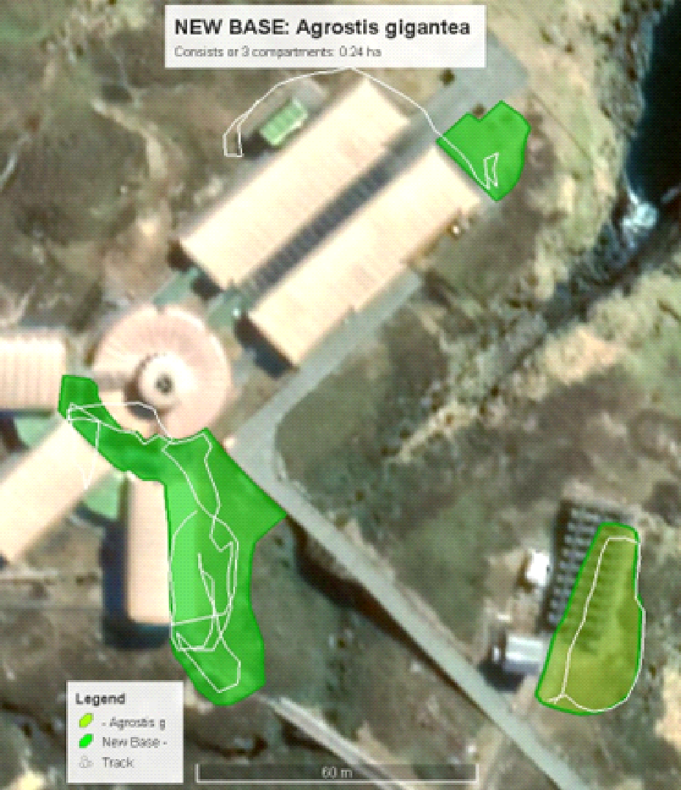
Fig. S5 Three polygons highlight the extent of Agrostis gigantea (black bent grass) in 2022 at the new research base. Map credit: Charles Hope (Department of Forestry, Fisheries and the Environment)
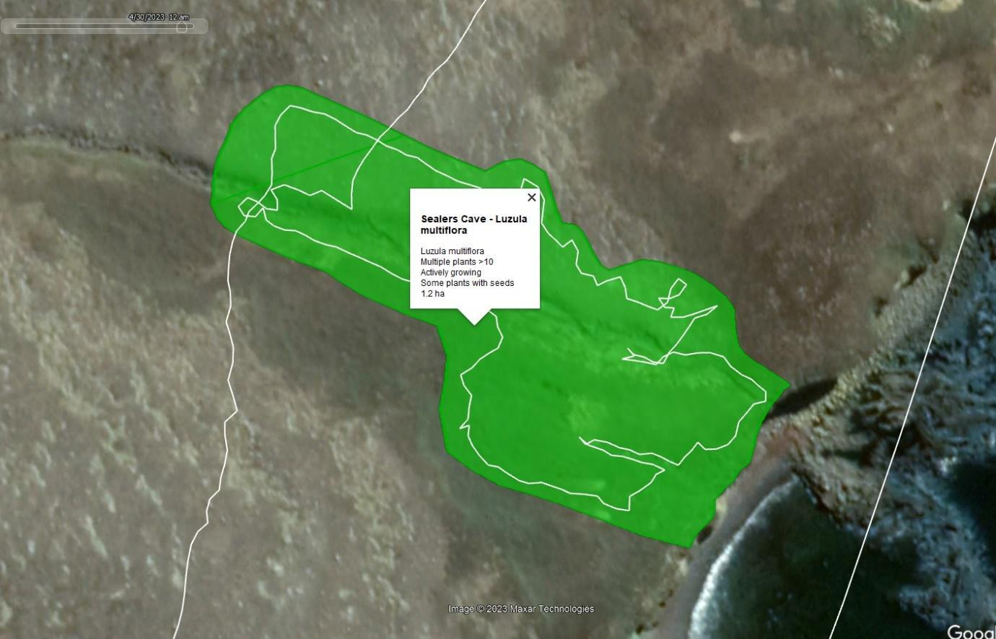
Fig. S6 A polygon showing the extent of the plant species Luzula multiflora (woodrush) at Sealers Cove site (1.2 ha), in Marion Island. Map credit: Charles Hope (Department of Forestry, Fisheries and the Environment)
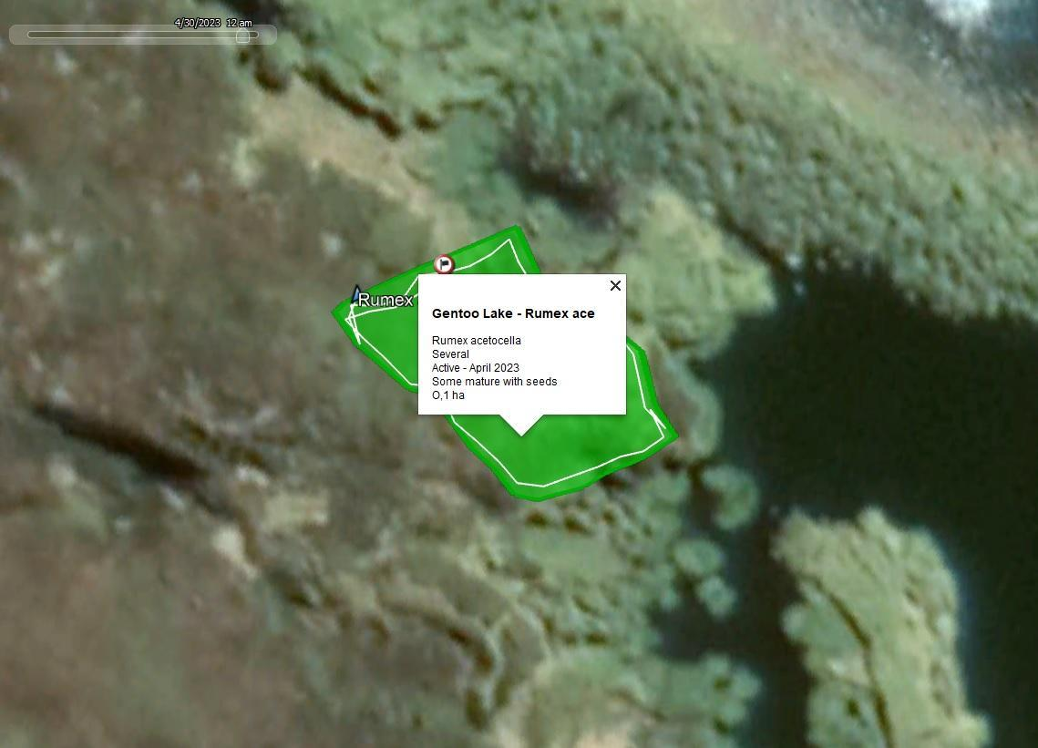
Fig. S7 Polygon shows the extent of invasion of the plant species Rumex acetosella (sheep sorrel) at Gentoo Lake site (0.1 ha). Map credit: Charles Hope (Department of Forestry, Fisheries and the Environment)

Abundance of alien species (indicator 2.3)
Abundance of invertebrates on the Prince Edward Islands varies with vegetation type (Gabriel et al. 2001; Hugo et al. 2006; Fig. S8), habitat (Barendse et al. 2002), altitude (Kgopong 2019) and collection method (e.g., active search, pitfall trap, Khoza et al. 2005).
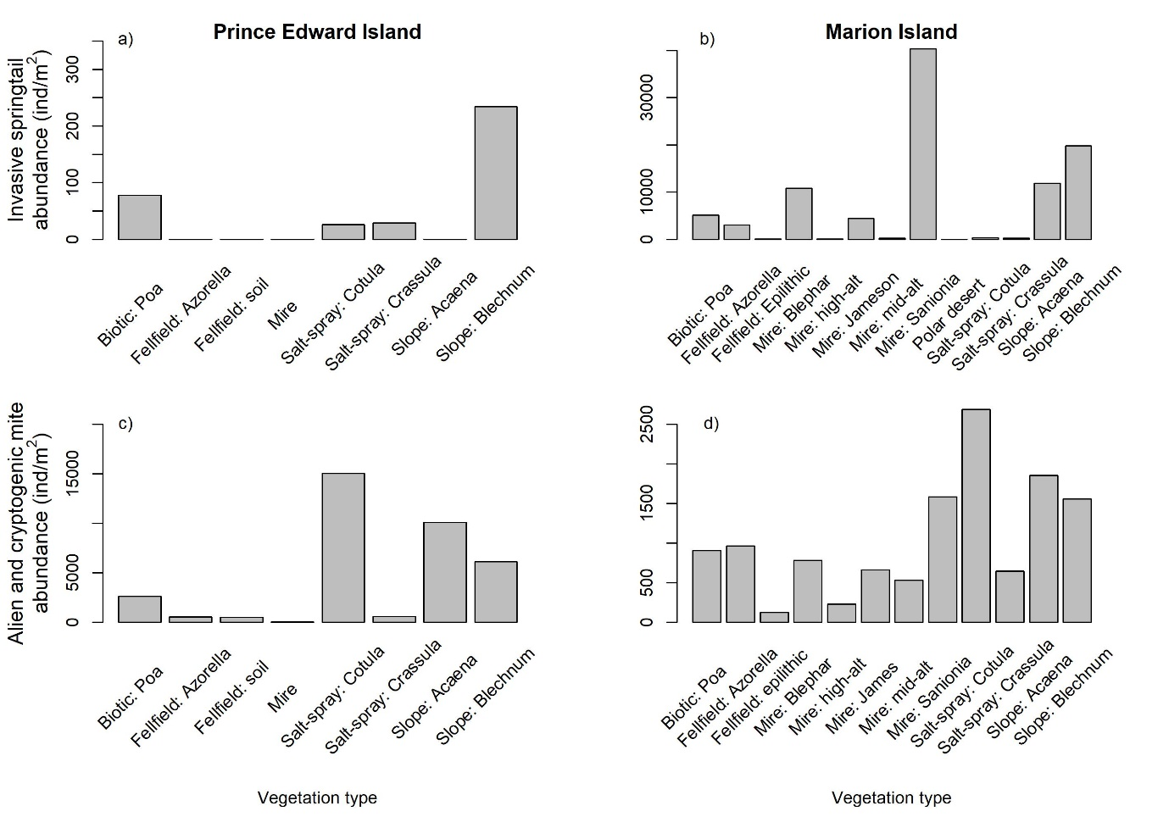
Fig. S8 Abundance of a) invasive springtails on Prince Edward Island, b) invasive springtails on Marion Island, c) alien and cryptogenic mites on Prince Edward Island, and d) alien and cryptogenic mites on Marion Island, in terms of individuals per square metre. Labels on the x-axis indicate vegetation type and, where appropriate, the plant species or the altitude sampled within the vegetation type. Note that the y-axis limits differ between panels. Biotic: Poa = Biotic grassland and herbfield (Poa cookii); Azorella = Azorella selago; Salt-spray = Coastal salt-spray; Cotula = Cotula plumosa; Crassula = Crassula moschata; Acaena = Acaena magellanica; Blechnum = Blechnum penna-marina; Blephar = Blepharidophyllum densifolium; high-alt = high-altitude; James = Jamesoniella colorata; mid-alt = mid-altitude; Sanionia = Sanionia uncinata

Impact of alien species (2.4)
The information on the impacts of alien terrestrial invertebrates on the PEIs remains minimal, considering the amount of alien and invasive invertebrates on the islands (28), and the scarce amount of species that have data on their impacts (six, see Table 3). According to Greve et al. (2017), the European slug Deroceras panormitanum (Fig. 3c) acts as a decomposer, but ‘mineralises nitrogen at a considerable slower rate than a comparative indigenous decomposer'; therefore, the impact is minor. Interestingly, slugs do not seem to be a common prey for mice, as slug remains are rarely found in mouse stomach contents, and starved, captured mice refuse slugs but readily consume native invertebrates (Smith et al., 2002; as cited in: Smith 2007). The spread of the parasitic wasp Aphidius matricariae (an aphid parasitoid) is facilitated by the presence of an established alien invasive aphid (Rhopalosiphum padi) as noted by Lee and Chown (2016) in: Houghton et al. (2019). Aphidius matricariae exclusively targets R. padi (Lee et al. 2007) and controls its populations (Greve et al. 2017). Therefore, its impact is considered minor, as it preys only on an alien species, potentially providing a beneficial biological control—albeit an unintentional one. For more details on impact for the other species, see column ‘historyOfInvasion’ in Appendix 1.
No SEICAT (Socio-Economic Classification of Alien Taxa) assessments have been done for the Prince Edward Islands to date. Given the low human footprint on the PEIs, it is likely that socio-economic impacts are of ‘Minimal Concern’ or at most ‘minimal’ in terms of the house mouse.

Interventions
Input – Quality of regulatory framework (indicator 4.1)
The NEM:BA A&IS Regulations (National Environmental Management: Biodiversity Act Alien and Invasive Species) that govern the PEIs were promulgated in 2014 and updated in 2020. These regulations consist of a list of alien and invasive species present in the country classified into different categories and the regulations concerning their management (Kumschick et al. 2020; Wilson and Kumschick 2024).
Thirteen taxa are listed for the PEIs in the 2020 NEM:BA A&IS Regulations (Table S6) (although this study found evidence that 25 taxa are invasive). However, it is notable that two taxa that are being managed on the islands, are not listed in the regulations, while four taxa, which are listed in the regulations, are currently not receiving management (e.g., considered too widespread to manage, see Table S6 for more details). No risk analyses have been conducted for the taxa listed on the regulations for the PEIs.
Table S6 Alien taxa listed under the NEM:BA A&IS Regulations of 2020 for the Prince Edward Islands (PEIs) or for which an eradication plan has been developed [cf. Appendix 1; Wilson (2023)]. Only listings relevant to the PEIs are included here. Information on the implemented control measure was obtained mainly from the Department of Environmental Affairs (DEA) and DST-NRF CIB 2012–2013, last updated in 2021, personal communication with the Department of Forestry, Fisheries and the Environment’s Specialist Programme Manager Debbie Muir, or indicated otherwise. Technically, as the PEIs are off-shore islands, the following are also listed as management targets [Alectoris chukar (Chukar partridge), Oryctolagus cuniculus (the European rabbit), Rattus norvegicus, R. rattus, and R. tanezumi (the Norwegian, brown and Asian house rat respectively)], and the following as eradication targets [Capra hircus (goat) and Felis catus (domestic cat)], but none of these are currently present on the islands. PEI is the Prince Edward Island and MI is Marion Island.
Scientific name | Vernacular name | Regulatory listing | Introduction Status | Treated or monitored | Notes on control implemented
Agrostis castellana | bent grass | Eradication target (PEI)  Management target (MI) | Present but not naturalised | Yes | Inflorescences are cut and bagged, and the remaining parts of the plants sprayed with herbicide (Debbie Muir pers. comm. 22 May 2023). However, the form of A. castellana occurring on MI is very difficult to distinguish from A. stolonifera, and further efforts are required to clarify the distribution of this species, likely supplemented with DNA barcoding as a means to validate identification based on morphology.
Agrostis gigantea | black bent grass | Eradication target | Naturalised but not invasive | Yes | Mechanical removal of aboveground biomass and herbicide application (Glyphosate; 2.5% Kilo Max)
Agrostis stolonifera | creeping bent grass | Eradication target (PEI)  Management target (MI) | Invasive | No | None implemented (successful eradication deemed unfeasible; Greve et al. 2017)
Alopecurus geniculatus | marsh foxtail | Eradication target | Doubtful (eradication to be confirmed) | Yes | Manual removal was conducted; assumed to be no longer present since 2012 (Greve et al. 2017)
Cerastium fontanum | common mouse-ear chickweed | Management target | Invasive | No | None implemented because it is widespread (Greve et al. 2017; DEA and DST-NRF CIB 2021)
Elymus repens | couch grass | Eradication target | Naturalised not invasive | Yes | Mechanical removal of aboveground biomass and herbicide application (Glyphosate; 2.5% Kilo Max 700g/kg)
Festuca rubra | creeping red fescue | Eradication target | Naturalised not invasive | Yes | Herbicide application (Glyphosate; 2.5 Kilo Max)
Holcus lanatus | common velvet grass | Not listed | Doubtful (eradication to be confirmed) | Yes | The species was manually removed in 2012, site and surrounding areas have been monitored monthly since removal to detect any regrowth or new plants
Juncus cf. effusus | common rush | Not listed | Present | Yes | It was thought to have been eradicated in 2022 (Debbie Muir, pers. comm. 2023), but populations were missed and it was last seen in May 2024 (Michelle Greve pers. obs. 2024).
Luzula multiflora | woodrush | Eradication target | Naturalised not invasive | Yes | Herbicide application (Glyphosate; 2.5% Kilo Max). A study has been recommended to confirm that it differs from the native subantarctic Luzula species (and so unequivocally alien)
Mus musculus | house mouse | Eradication target (MI) | Invasive | Yes | Baited traps are deployed both outside and inside the base and huts to protect food and human health (Wolfaardt pers. comm. 2022). Mice are not yet, otherwise, subject to control, although an eradication is being planned through the ‘Mouse-free Marion Project’, due to start in 2025 if enough funds are raised
Poa pratensis | Kentucky bluegrass | Eradication target (PEI)  Management target (MI) | Invasive | No | None implemented (Greve et al. 2017; DEA and DST-NRF CIB 2021)
Porcellio scaber | common rough woodlouse | Not listed | Doubtful (eradication to be confirmed) | Yes | The woodlouse is believed to have been successfully eradicated in 2012, but this needs to be monitored for confirmation. Control is recommended via application of pyrethroid (Super Crackdown)
Rumex acetosella | sheep sorrel | Eradication target | Naturalised not invasive | Yes | Mechanical removal of aboveground biomass (inflorescence is cut and then plant pulled) (Debbie Muir pers. comm. 22 May 2023)
Sagina procumbens | birdeye pearlwort | Management target | Invasive | No | None implemented (successful eradication deemed unfeasible by Greve et al. 2017), but the potential for classical biocontrol is under investigation
Stellaria media | common chickweed | Eradication target (PEI)  Management target (MI) | Doubtful | Yes | It used to be sprayed with herbicide (2.5% Kilo Max). It has not been seen more recently, currently being monitored. Used to be widespread, so will be difficult to confirm eradication

Input - Money spent (indicator 4.2)
The DFFE budget allocated for herbicides (comprising two different types) and equipment, including personal protective equipment (PPE), for alien species control on the PEIs from 2011 to 2022 amounted to ZAR 58 664 (after adjusting for inflation this amount would be equivalent to ZAR 63,717 in 2024, and USD 3,614 at the current exchange rate; Fig. S9). The sole pesticide utilised on Marion Island to control invertebrates was donated, and its monetary value is yet to be determined. In 2006, a targeted attempt was undertaken to control the invasive plant Elymus repens (couch grass), involving the removal of above-ground material and a considerable amount of the below-ground rhizomes, along with herbicide application. The total expenditure for this operation was ZAR 201 378, inclusive of labour costs and helicopter transport for biomass removal.
The predominant expense in controlling biological invasions on Marion Island lies in the time dedicated to this task by the Environmental Control Officers (ECOs). ECOs are employed by the DFFE; they undertake various responsibilities, and there is no available estimate of the time dedicated specifically to alien species monitoring and management. Continuous management (or monitoring) efforts on Prince Edward Island are impractical due to the absence of regular human presence on the island.
Money was spent on herbicides and pesticides to control invasive plants and the invertebrate, respectively (Fig. S9). The budget included the purchase of PPE that the ECOs who apply the chemicals must wear.

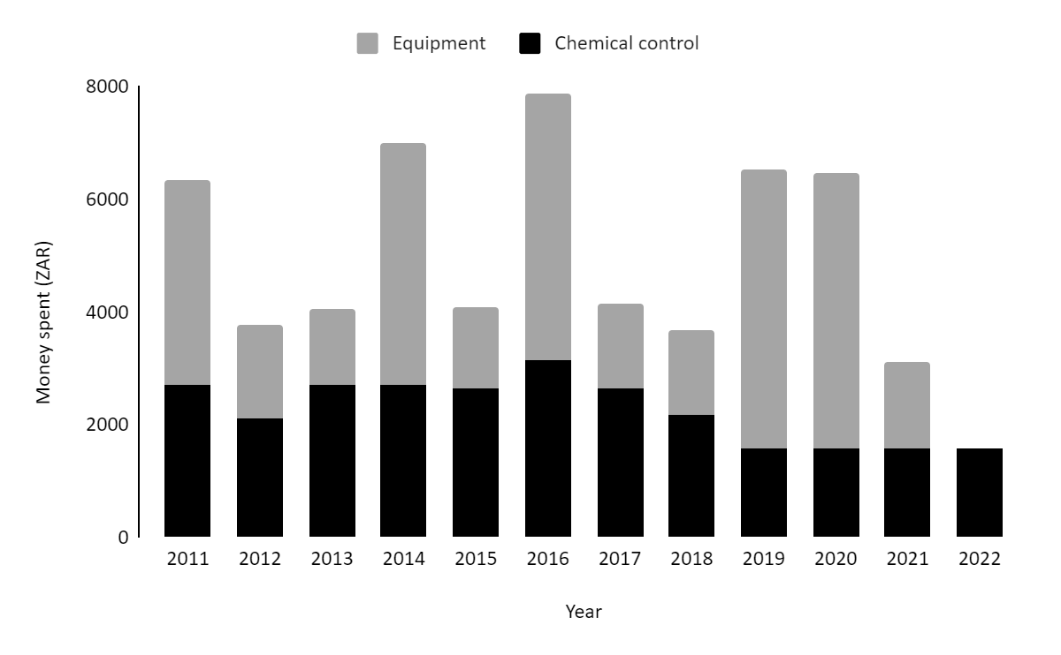
Fig. S9 Money spent on Marion Island invasive species control: 'Equipment' includes personal protective equipment for the Environmental Control Officers who apply the chemicals, plus the tools they need. ‘Chemical control’ includes costs of herbicides. Labour costs are not included, but almost certainly will be significantly more than the costs reported here

Herbicide use for invasive grasses: CIB staff (Suzaan Kritzinger-Klopper and Steven Chown) removed above-ground material of Elymus repens (syn. Elytrigia repens) and some of the below-ground rhizomes and applied glyphosate herbicide during the relief voyage in 2006. The total cost of the operation was ZAR 201 378 (after adjusting for inflation this amount would be equivalent to ZAR 550 939 in 2024, and USD 31,304 at the current exchange rate) including three helicopter trips to remove plant material (1 000 kg) and human resources but excluding the costs of herbicide and its application over the subsequent years. The herbicide treatments were supposed to be continued by the island-based ECOs every second month and a re-assessment of the situation made in April 2007.

Input - Planning coverage (indicator 4.3)
Two management plans have been formulated for the PEIs: one in 1996 (PEIMPWG 1996), and another in 2010 (DEA 2010). Originally, management plans were slated for revision and update every four years, yet the first revision is still in progress. As a result, the estimates provided for this indicator pertain to the 2010 Management Plan. As part of the Management Plan, the former Department of Environmental Affairs (DEA) and the former DST-NRF Centre of Excellence for Invasion Biology (CIB) collaborated on the development of an eradication strategy titled 'Eradication, monitoring, and control of alien and invasive species on Marion Island'. This strategy undergoes annual revision and updates by the DFFE alien species management team (Debbie Muir, pers. comm. 2023). The current iteration of the eradication plan classifies species into three distinct categories based on their priority for control: high, medium, and low. The plan aims to divide the list into an active priority list (comprising taxa currently present and managed) and a historical list of taxa requiring only monitoring (those with doubtful presence requiring confirmation of eradication). This facilitates an evaluation of changes in the extent of invasive species and the efficacy of control measures. To aid this assessment, data have been integrated into maps illustrating historical and current invasions (Figs. S6.3–6.7).
The ‘Mouse-Free Marion' eradication project is currently in its planning phase with fundraising efforts underway. The planned cost for the mouse eradication as of December 2022 was ~ZAR 450 million (more than USD 24 million). The planned eradication, if successful, will be the largest eradication of rodents from an island globally (Preston et al. 2019; Springer 2022).

Output - Pathways treated (indicator 4.4)
To prevent accidental introductions with expeditioners and their equipment and belongings, expeditioners are required to inspect their belongings (e.g., clothes, equipment) and remove any alien species or propagules before they leave for the PEIs. Guidance on how these inspections should be performed is provided in a ‘Gear Checks’ document (see below). Expeditioners also sign a document, the ‘Biosecurity self-audit checklist and declaration’, confirming that they have followed the required biosecurity measures. As propagules can easily become entrapped in Velcro there is a ‘minimum Velcro policy’, with expeditioners encouraged to use belongings (e.g., clothes) that lack Velcro, and as of 2022 all clothing supplied by DFFE was Velcro-free. During the voyage to Marion Island, the outer field gear and equipment of expeditioners that is not in the cargo hold is inspected for biological material.
The transport of propagules (e.g., seeds) from sites close to the base on Marion Island to elsewhere on the island is reduced through biosecurity measures. For example, walkways have been built around the base where some of the non-invasive alien plants grow, and there are restrictions to prevent expeditioners from traversing the ground between these walkways, thus reducing the spread of plant propagules. Additionally, during hut restocking, containers are transported from the helicopter deck at the base, and not from the vegetation around the base, to the huts.
Equipment, food and other goods are transported to Marion Island in shipping containers. Before they are packed in South Africa, these containers are cleaned using a high-pressure hose, and all cargo are inspected for alien species or propagules. Fresh produce is prohibited, and all other foods must be irradiated (e.g., eggs), frozen (e.g., meats and vegetables), or otherwise sterilised (e.g., canned). Such rules aim to prevent the introduction of alien species as contaminants with the food transported to the islands.



‘Gear Checks’ document:

SANAP VOYAGE PARTICIPANTS

GEAR CHECKS
_________________________________________________________________________________

Dear SANAP Voyage Participant

One of the most serious threats to the conservation of our sub-Antarctic islands and Antarctica is the introduction of alien plants and invertebrates. Alien species are often able to out-compete local, more vulnerable species, rapidly invading and seriously altering natural communities. The harmful effects of cats and rodents on the naturally-occurring birds on oceanic islands are well-known, but deleterious effects have been shown from the introductions of alien plants and invertebrates as well. Introduced diseases could also be potentially disastrous for Antarctica and the islands’ wildlife, particularly seabirds and seals.

SANAP is trying its best to avoid introducing new species to the Antarctic and sub-Antarctic, but for this to be successful a determined and continued effort is required by all involved. YOU can help to protect our islands and Antarctica by doing the following when packing your personal effects for SANAP voyages:

GEAR (Footwear & Clothing):
- Please carefully check all footwear (inside, soles, laces) and remove any encrusted dirt or mud and any plant material, especially seeds, which you may find. Try to avoid packing or taking footwear which has Velcro strapping. Please check and thoroughly clean both your field and indoor footwear.
- In the same way, check the hems, pockets and Velcro strips of all clothing that you intend to take ashore, including socks, gloves and jerseys, for seeds and other plant material, and remove anything found using tweezers or forceps. Preferably do not take clothing with Velcro (unless unused). All clothing should be washed before packing, and the piece of luggage properly sealed once it is full.

GEAR (Luggage):
- Also, carefully check all your luggage containers, e.g. “trommels”, personal kitbags, suitcases, backpacks, day packs, camera and video bags or any other bags or containers, which you plan to take ashore, for seeds, other plant material and invertebrates (organic matter). Be especially careful when checking between seams, in “hidden” pockets, underneath stiffeners and liners and all Velcro material.
- It is advisable to spray luggage containers with a domestic pyrethrin-based insecticide before packing – preferably the night before so that they can air. Moth balls can be placed in luggage containers, however, they have a strong odour.
GEAR (Equipment & Other):
- Ensure that all equipment you are taking ashore is free of invertebrates, e.g. spiders have been known to live inside desk-top computer cases and in lab equipment. Also check any items such as camera tripods, surveying poles, walking sticks, hiking (“trek”) poles, etc. for adhering soil and mud and ensure these are properly cleaned.
- Other: Check books, video cassettes, etc. for fish-moths, cockroaches or any other invertebrates.

PACKING & PACKAGING:
- It is necessary to pack indoors during the day, and preferably off the floor (e.g. on a low table or bed) to avoid any invertebrates getting into your belongings. However, if do you have to pack at night, it is essential that you pack in a closed room (with all windows and doors shut) to avoid contamination. Avoid packing directly under strong lights, as flying invertebrates (such as moths) are attracted to these areas.
- Do not take any loose polystyrene packaging material (“beads” and “chips” are specifically banned, as they can easily “escape” into the environment), cardboard or unnecessary plastic wrapping to the island. Cockroaches favour corrugated cardboard boxes, and may lay their eggs between the cardboard layers. Use reusable plastic “tote” bins for gear and reusable plastic bubble-wrap to protect fragile items. Remove as much packaging as possible from your belongings, as this minimises waste carried to the island (which then needs to be returned to South Africa).

FOOD:
- No fresh produce of any description, including fruit, vegetables and meat (even though they are available on the ship) may be taken ashore to the islands.
- If you are packing any personal food items, such as energy bars containing seeds, ensure that they are well-sealed, cannot germinate and do not carry live organisms (e.g. moulds, fungi, weevils, worms, etc.).

PERSONAL PACKAGES:
- If you are an overwintering expedition member and are expecting personal packages from colleagues, friends or relatives to be sent to the island after you have arrived there, then you have an important responsibility to inform them carefully to follow these guidelines. In these ways you will be contributing to keeping Antarctica and the islands as pristine as possible.

“BOOT-WASHING CEREMONY”:
- On the southbound voyage, all who are going ashore (including ship-based personnel making day visits only) must take part in a compulsory “Boot-washing Ceremony”, where a register will be signed.
- Your gear (footwear, outer clothing, bags, etc.) will then be checked by the Environmental Control Officer/Conservation Officer and you will be required to scrub the soles of all your footwear (not only your field boots) in a disinfectant solution, such as bleach or Virkon S, to prevent the transmission of fungi and diseases to the continent and islands.

BIODEGRADABLE/ENVIRONMENTALLY FRIENDLY PRODUCTS:
- There is a wide variety of biodegradable/environmentally friendly products available. Where possible, try and buy these rather than conventional products when choosing your toiletries, etc.

MANY THANKS FOR YOUR CO-OPERATION
WE HOPE YOU ENJOY YOUR VISIT
SANAP Management
September 2009 (Version 4)

Output - Species and Sites treated (indicators 4.5 and 4.6 respectively)
Among the 13 regulated invasive taxa, which include 11 currently present and two with uncertain presence, nine taxa have been managed solely on Marion Island (Table S6). Additional attention is directed towards two species, Holcus lanatus (common velvet grass) and Porcellio scaber (common rough woodlouse). These species are not listed in the regulations and are undergoing monitoring to validate eradication efforts. Juncus cf. effusus (common rush) was being monitored to confirm eradication in 2022 and 2023, but a population was missed during eradication, and ‘rediscovered’ in 2023 (Michelle Greve pers. obs.). Consequently, the total number of managed species amounts to twelve.
The sites where management efforts occur are predominantly situated on the eastern side of Marion Island, with the majority located within a kilometre of the research base (the most distant site being < 5 km from the base).

Outcome - Effectiveness of pathway treatments (indicator 4.7)
Based on species that have already established on the PEIs, and on which species have already established on other sub-Antarctic islands, we assume that several species that occur in mainland South Africa can establish on the PEIs, despite the fact that the climate of the islands is very different to that of mainland South Africa.
No alien marine species have been recorded from the PEIs. Recent marine introductions may have been prevented by the management interventions that tackle ballast water and hull fouling. But, the marine environment around the islands is also likely unsuitable for the marine species of mainland South Africa. As sea temperatures around the islands are increasing due to climate change, the interventions in place to prevent marine introductions will be increasingly important in future.

Outcome - Effectiveness of species and site treatments (indicators 4.8 and 4.9 respectively)
The success of species treatment depends on the environmental control officers (ECOs) that form part of the overwintering team on MI. They are responsible for many tasks but are only supervised on site for three weeks (which may not always be effective or adequate) and the eradication plans that they follow are not always updated with the latest recommendations (Neethling 2019).
Four species believed to have been eradicated remain part of the eradication plan for ongoing monitoring until confirmation of eradication is obtained through four independent assessment reports spanning 12 years.
The maximum number of mice captured with traps at the research station was 412 in 2022, but numbers vary annually with survey effort (Table S7). For instance, in 2018, 255 mice were captured, followed by 62 in 2019 (data collected by ECOs Mr. Mishumo Masithembi and Gcobani Tshangana). There is a lack of available data to evaluate the efficacy of house mice control at the field huts. However, considering the limited extent of the research station and huts within the species' habitat range, coupled with the mice's ability to traverse the landscape, it can be inferred that the impact of control measures is minimal. At most, localised and temporary reductions in densities may occur.
Table S7 Number of mice caught by month and year at Marion Island research station from April–May 2018 to December 2022. The maximum number of mice captured in one month occurred in April–May 2018, but the maximum capture of mice per year occurred in 2022. Data are missing for some months in 2018, 2020 and 2021. Data collected by Mr Mishumo Masithambi and Gcobani Tshangana
 | 2018 | 2019 | 2020 | 2021 | 2022
January | no data | 1 | 0 | no data | 0
February | no data | 8 | 8 | no data | 0
March | no data | 27 | 0 | no data | 100
April– May | 200 | 8 | no data | 60 | 155
June | 20 | 10 | no data | 16 | 103
July | 19 | 5 | no data | 6 | 35
August | 1 | 2 | no data | 0 | 6
September | 4 | 1 | no data | 4 | 8
October | 5 | 0 | no data | 1 | 0
November | 2 | 0 | no data | 0 | 5
December | 4 | 0 | no data | 0 | 0
Total | 255 | 62 | 8 | 87 | 412

S4 Supplementary material for Discussion
Several gaps remain in relation to species identification and lack of data for certain taxa on nativity, status, abundance, and impacts. Two taxa have not been identified to species level, and it is unknown if they are native or alien (called ‘cryptogenic’: Cillibidae and Dendrolaelaps spp., Appendix 1). For one mite, nativity is uncertain (David Marshall and Lizel Hugo pers. comm. 2022), and different publications state opposite views [see e.g., Chown et al. (2002) and Chown and Froneman (2008)]. This is problematic as this is the most abundant mite on Marion Island. If the taxon’s status (alien or native) is not confirmed, it will not be appropriately managed, and the status of biological invasions and their management on the PEIs cannot be determined with certainty (as indicator estimates are less reliable). Another example is Luzula cf. multiflora. The taxon on the PEIs is a Luzula, but the exact species remains to be verified. There is a native subantarctic Luzula, and, therefore, it could be a native species. Yet, currently the species is considered alien, and is being actively managed with herbicide.
Data gaps and challenges for interventions are numerous. For example, no estimates have been made on money spent to control invasions, as detailed expenditures have not, as of yet, been accessible. The DFFE provided data on cost of herbicides, pesticides and PPE, but not on, for example, the number of hours per month that the ECOs invest on invasive species control, or on their salaries. Current management plans seem outdated, and progress reports frequently lack sufficient detail. Consequently, it is not possible to assess the effectiveness of implementing these plans. Monitoring of species treated is performed, but is not systematic, although the DFFE has a plan to improve this (Debbie Muir, pers. comm.).
Mice eradication remains a massive challenge in terms of logistics and funding. Besides being an immensely expensive exercise, as more data become available from failed attempts on other islands, the new information needs to be incorporated into the planning to avoid repeating known unsuccessful practices, which causes further delays.
A general challenge that would threaten the PEIs native ecosystems and landscapes is the possibility that the South African government might open the land to tourism, mining and gas exploration. This is not new, as there are official records from 1998 from the Department of Environmental Affairs and Tourism, indicating that the possibility of opening Marion Island to tourism was being considered (Coastal Policy Green Paper, www.gov.za/documents/coastal-policy-green-paper). This was after the PEIs were designated a special nature reserve. The islands are a bird watchers’ paradise, and many tourists are interested to travel there to bird watch, as proved by the ‘Flock to Marion’ initiative organised by BirdLife South Africa. They have organised bird watching cruises to create awareness and raise funds for the Mouse Free Marion eradication project in 2022, and another one is planned for January 2025 (www.birdlife.org.za/flock-to-marion-again-2025/). These cruises cannot go close to Marion Island (no landing occurs), but they become fully booked quickly, so there is a high interest from the community to reach these remote places. Another potential project could allow companies to explore for oil and/or gas (Lombard et al. 2008). If any of these plans go ahead, it would invariably lead to further alien species introductions, as well as aid in alien invasive species spread.

References
Barendse J, Mercer RD, Marshall DJ, Chown SL (2002) Habitat specificity of mites on sub-Antarctic Marion Island. Environmental Entomology 31(4):612–625. http://dx.doi.org/10.1603/0046-225X-31.4.612
Blackburn TM, Pyšek P, Bacher S, Carlton JT, Duncan RP, Jarošík V, Wilson JRU, Richardson DM (2011) A proposed unified framework for biological invasions. Trends Ecol Evol 26(7):333-339. https://doi.org/10.1016/j.tree.2011.03.023
CCAMLR. 2023. Schedule of Conservation Measures in Force 2023/24. https://www.ccamlr.org/en/system/files/e-schedule2022-23.pdf
Cooper J, Headland RK (1991) A history of South African involvement in Antarctica and at the Prince Edward Islands. S Afr J Antarct Res. 21(2):77-91.
DEA (2010) Department of Environmental Affairs Directorate: Antarctica and Islands. Prince Edward Islands Management Plan Version 0.2.
DEA and DST-NRF CIB (2021) Eradication, monitoring and control of alien and invasive alien species on Marion Island. Department of Environmental Affairs and DST-NRF Centre of Excellence for Invasion Biology. 23 pp.
DIISE (2015) The Database of Island Invasive Species Eradications, developed by Island Conservation, Coastal Conservation Action Laboratory UCSC, IUCN SSC Invasive Species Specialist Group, University of Auckland and Landcare Research New Zealand. http://diise.islandconservation.org
Gabriel AGA, Chown SL, Barendse L, Marshall DJ, Mercer RD, Pugh PJA, Smith VR (2001) Biological invasions of Southern Ocean islands: the Collembola of Marion Island as a test of generalities. Ecography 24:421–430. https://doi.org/10.1034/j.1600-0587.2001.d01-198.x
Greve M, Steyn C, Mathakutha R, Chown SL (2017) Terrestrial invasions on sub-Antarctic Marion and Prince Edward Islands. Bothalia-African Biodivers Cons 47(2):1-21. https://doi.org/10.4102/abc.v47i2.2143
Groom Q, Desmet P, Reyserhove L, Adriaens T, Oldoni D, Vanderhoeven S, Baskauf SJ, Chapman A, McGeoch M, Walls R, Wieczorek J, Wilson JRU, Zermoglio PFF, Simpson A (2019) Improving Darwin Core for research and management of alien species. Biodiversity Information Science and Standards 3: e38084. https://doi.org/10.3897/biss.3.38084
Hugo EA, Chown SL, McGeoch MA (2006) The microarthropods of sub-Antarctic Prince Edward Island: a quantitative assessment. Polar Biology 30(1):109–119. http://dx.doi.org/10.1007/s00300-006-0166-x
IPBES (2019) Global assessment report on biodiversity and ecosystem services of the Intergovernmental Science-Policy Platform on Biodiversity and Ecosystem Services. IPBES secretariat, Bonn, Germany
IPBES (2023) Summary for Policymakers of the Thematic Assessment Report on Invasive Alien Species and their Control of the Intergovernmental Science-Policy Platform on Biodiversity and Ecosystem Services. Roy HE, Pauchard A, Stoett P et al. IPBES secretariat, Bonn, Germany. https://doi.org/10.5281/zenodo.7430692
Kgopong RM (2019) The impacts of invasive plants on springtail diversity on sub-Antarctic Marion island. PhD dissertation, Stellenbosch University, Stellenbosch.
Khoza TT, Dippenaar SM, Dippenaar-Schoeman AS (2005) The biodiversity and species composition of the spider community of Marion Island, a recent survey (Arachnida: Araneae). Koedoe 48(2):103–107. http://dx.doi.org/10.4102/koedoe.v48i2.94
Kumschick S, Foxcroft LC, Wilson JR (2020) Analysing the Risks Posed by Biological Invasions to South Africa. In: van Wilgen BW, Measey J, Richardson DM, Wilson JR, Zengeya TA (Eds) Biological invasions in South Africa. Springer, Cham, Switzerland, 573–595. https://doi.org/10.1007/978-3-030-32394-3_20
McGeoch MA, Shaw JD, Terauds A, Lee JE, Chown SL (2015) Monitoring biological invasion across the broader Antarctic: a baseline and indicator framework. Glob Environ Change 32:108-125. https://doi.org/10.1016/j.gloenvcha.2014.12.012
Neethling H (2019) 2nd Party Assessment, Invasive Alien Plant Programme, 2019 Marion Relief Voyage. 11 April–16 May 2019
Preston GR, Dilley BJ, Cooper J, Beaumont J, Chauke F, Chown SL, ... Ryan PG (2019) South Africa works towards eradicating introduced house mice from sub-Antarctic Marion Island: the largest island yet attempted for mice. In Island invasives: scaling up to meet the challenge (pp. 40-46). IUCN. https://portals.iucn.org/library/node/48358
Springer K (2022) Island eradications of introduced predators can be game changing, providing the planning is done correctly. Saving Marion Island’s seabirds, The Mouse Free Marion Project Newsletter 2:2–10.
Wilson JR (2023) A list of taxa currently and historically regulated under South Africa’s National Environmental Management: Biodiversity Act, Alien & Invasive Species Regulations. http://dx.doi.org/10.5281/zenodo.7638966
Wilson JR, Faulkner KT, Rahlao SJ, Richardson DM, Zengeya TA, Van Wilgen BW (2018) Indicators for monitoring biological invasions at a national level. J App Ecol 55(6):2612-2620. https://doi.org/10.1111/1365-2664.13251
Wilson JRU, Kumschick S (2024) The regulation of alien species in South Africa. South African Journal of Science. https://doi.org/10.17159/sajs.2024/17002

Listed as Elytrigia repens (L.) Desv. ex Nevski (= Agropyron repens (L.) P. Beauv., Elymus repens (L.) Gould) under the NEM:BA A&IS Lists of 2020.

