^{Supplement Data File}

⁶⁸Ga-Radiolabeling Of NODASA-Functionalized Phage Display-Derived Peptides For Prospective Assessment As Tuberculosis-Specific PET Radiotracers

Christiaan A. Gouws¹, Tricia Naicker¹, Beatriz G. de la Torre², Fernando Albericio², Janie Duvenhage³, Hendrik G. Kruger¹, Biljana Marjanovic-Painter⁴, Sipho Mdanda³, Jan R. Zeevaart^{3,4,5}, Thomas Ebenhan^{3,5}*, Thavendran Govender⁶*

1 Catalysis and Peptide Research Unit, School of Health Sciences and School of Chemistry and Physics, University of KwaZulu-Natal, Durban 4001, South Africa
2 School of Chemistry and Physics, University of KwaZulu-Natal, Durban 4001, South Africa
3 Nuclear Medicine Research Infrastructure NPC, Pretoria, South Africa
4 Radiochemistry, the South African Nuclear Energy Corporation (Necsa) SOC Ltd, Pelindaba, South Africa
5 Department of Nuclear Medicine, University of Pretoria, Pretoria, South Africa
6 Department of Chemistry, University of Zululand, KwaDlangezwa 3886, South Africa

- LCMS analysis conditions
LCMS analysis described in Figure S1-S5 was acquired using a PDA-coupled ESI-LCMS (Shimadzu, Japan) mounted with a YMC-Triart C18 (5 μm, 4.6 × 150 mm) column (YMC Co., LTD, Japan). Mobile-phase A consisted of 0.1% TFA in water and Mobile-phase B consisted of 0.1% TFA in acetonitrile. The LCMS system operated at a flow rate of 10 mL/min, and the PDA detector was set to monitor absorbance at a wavelength of 220 nm. The mobile-phase gradient followed this protocol: the column was initially pre-equilibrated with 5% B for the first 7.5 minutes. At 7.5 minutes into the run, the sample was injected, and subsequently, a mobile-phase gradient from 5% B to 60% B was applied over the next 15 minutes. At 22.5 minutes into the run, the column entered a wash phase at 95% B for 5 minutes, followed by re-equilibration to 5%B.
- Chemical synthesis of NODASA-H8 and NODASA-PH1
H8 and PH1 core sequences with the 6-aminohexanoic acid linker were successfully synthesized using standard Fmoc/tert-butyl (tBu)-solid phase peptide synthesis protocol. LCMS analysis of a small aliquot of cleaved peptide showed a single UV peak (>98% peak area) correlating with desired Fmoc-protected product m/z (Figure S1/S2, calculated M+2H: Fmoc-H8 = 679.1, found 679.1; Fmoc-PH1 = 701.3, found 701.3).
Subsequent on-resin NODASA functionalization steps were successful in yielding NODASA-H8 and NODASA-PH1 as determined by LCMS analysis of crude products extracted from the TFA cleavage cocktail (Figure S3/S4, calculated M+2H: NOSASA-H8 = 739.6, found 739.6; PH1 = 761.6, found 761.6).
Cyclization of the two cysteines in NODASA-PH1 was achieved slowly over 48 hours through air oxidation without indications of inter-molecular polymerized peptide precipitates. LCMS analysis indicated ~50% cyclization (m/z = 760.6) was achieved at 24 hours, and >85% at 48 hours (Figure S5).
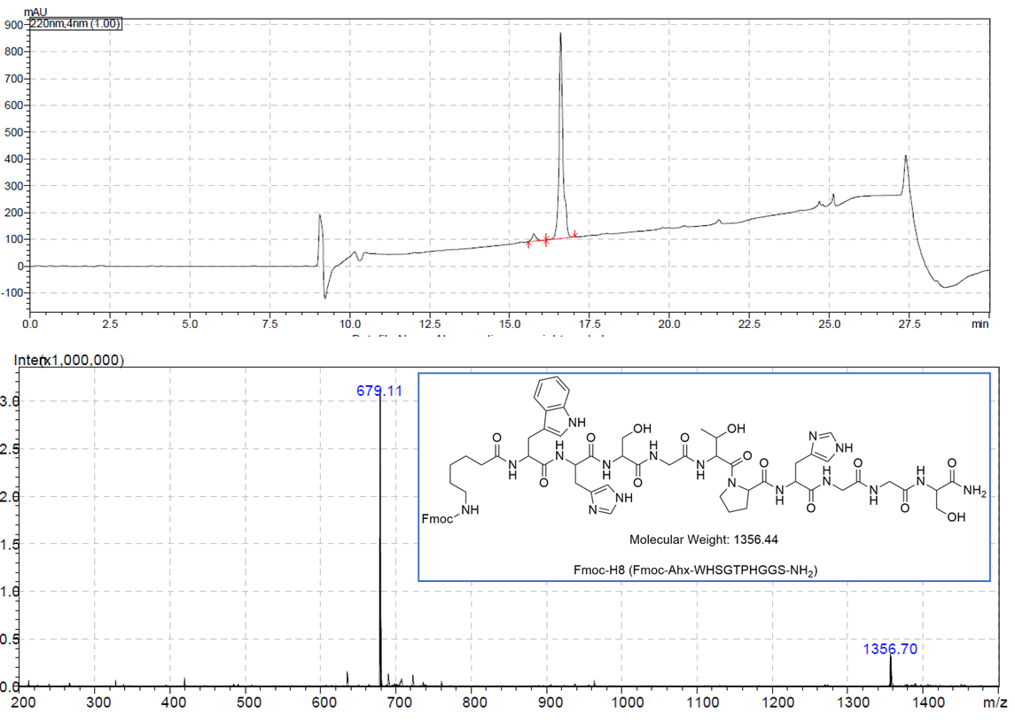Figure S1: LCMS analysis acquired for Fmoc-H8 indicating M+2H = 679.1 m/z.
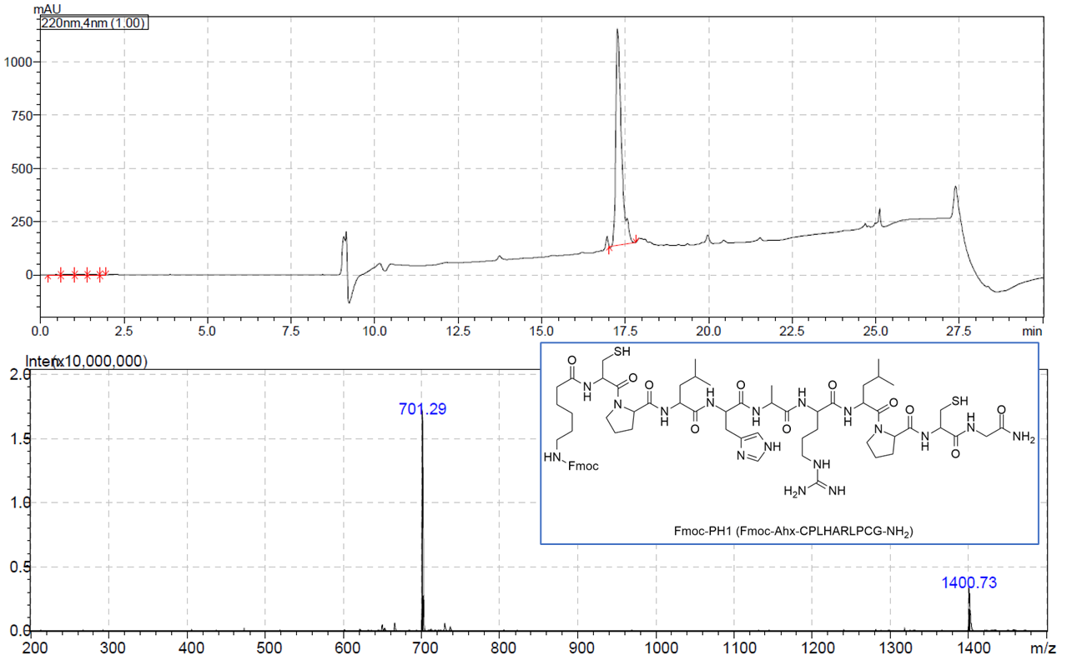
Figure S2: LCMS analysis acquired for Fmoc-PH1 indicating M+2H = 701.3 m/z.

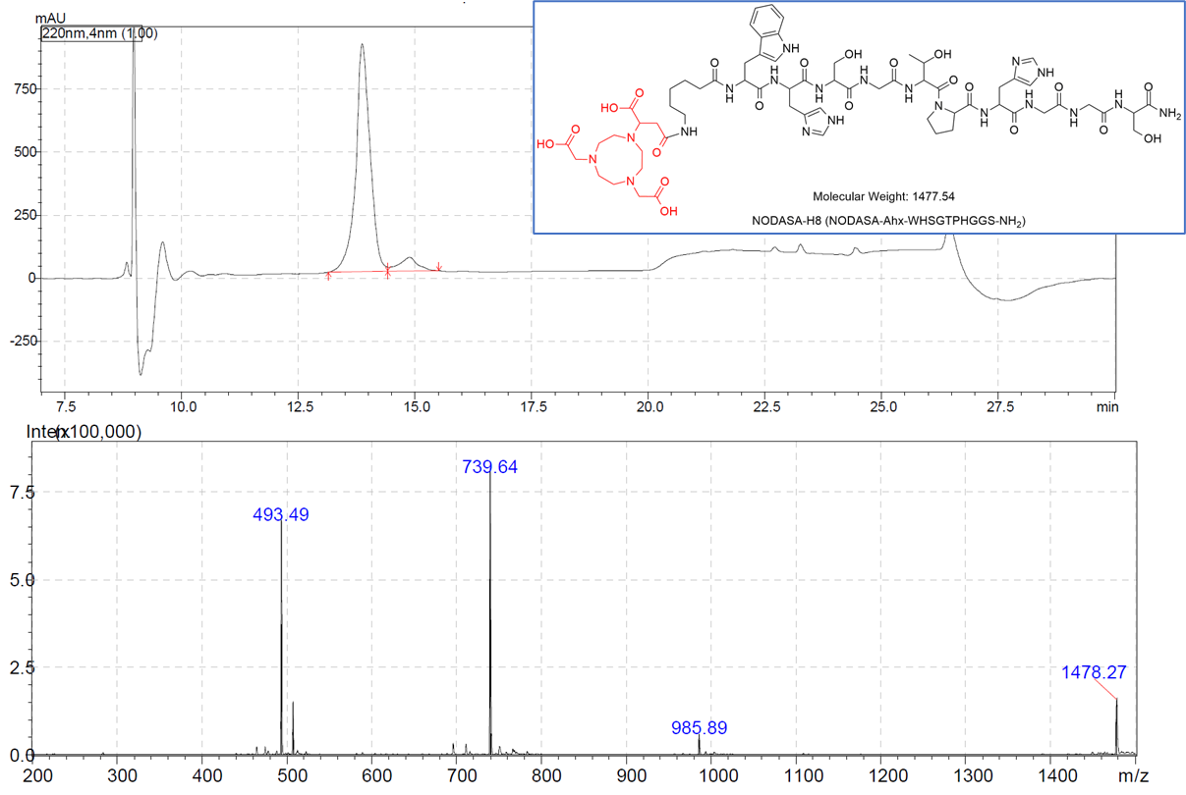Figure S3: LCMS analysis acquired for NODASA-H8 synthesis product indicating M+2H = 739.6 m/z.
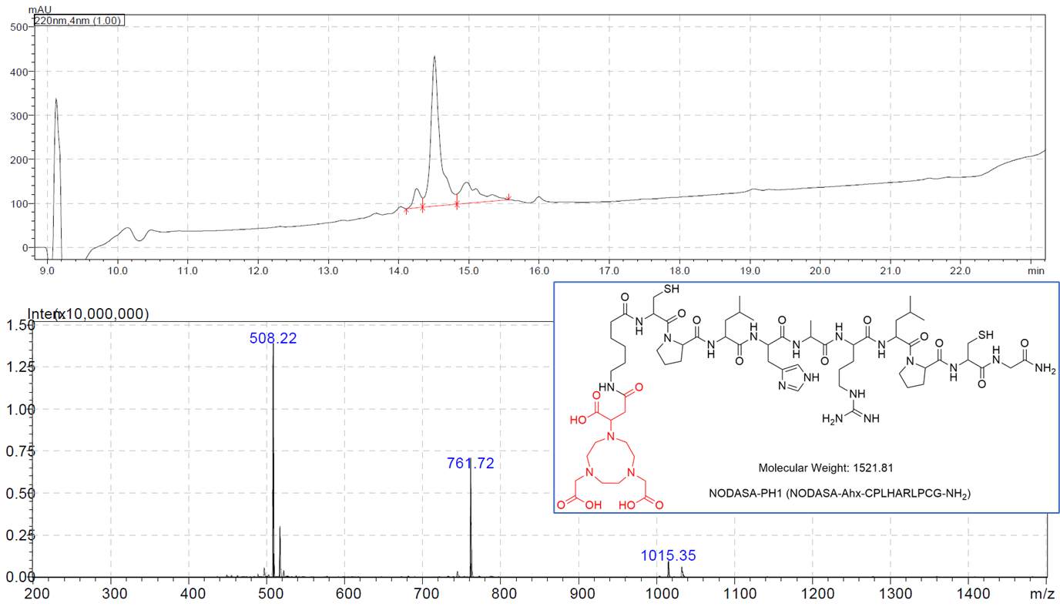
Figure S4: LCMS analysis acquired for NODASA-PH1 synthesis product indicating M+2H = 761.7 m/z.

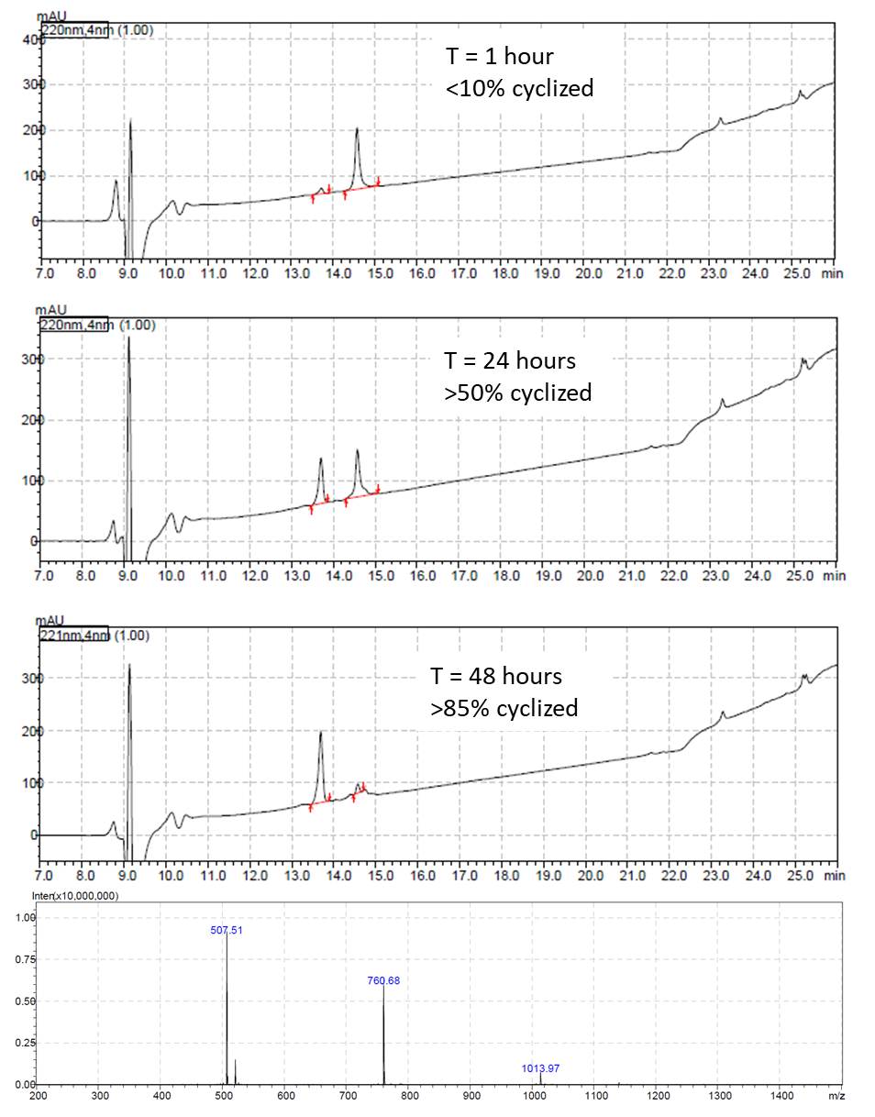Figure S5: LCMS analysis of PH1 cyclization at different timepoints during the cyclization reaction (first 3 chromatograms), and ESI-MS signal of cyclized NODASA-PH1 (bottom) indicating M+2H = 760.7 m/z.

- LCMS analysis of ^{nat}Ga-NODASA-peptide compounds

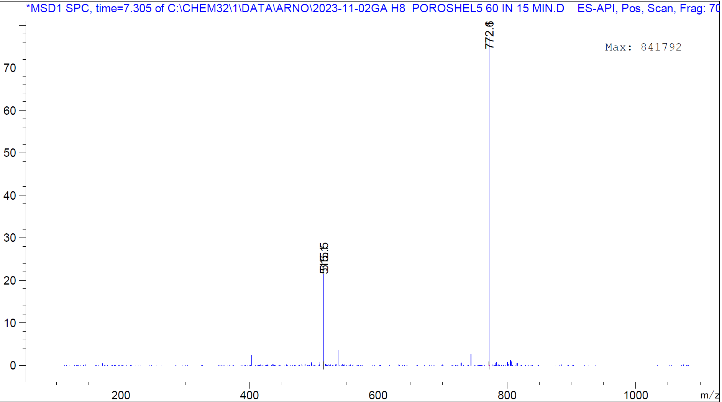Figure S6: LCMS analysis of ^{nat}Ga-NODASA-H8 (M+2H = 772.3 m/z).

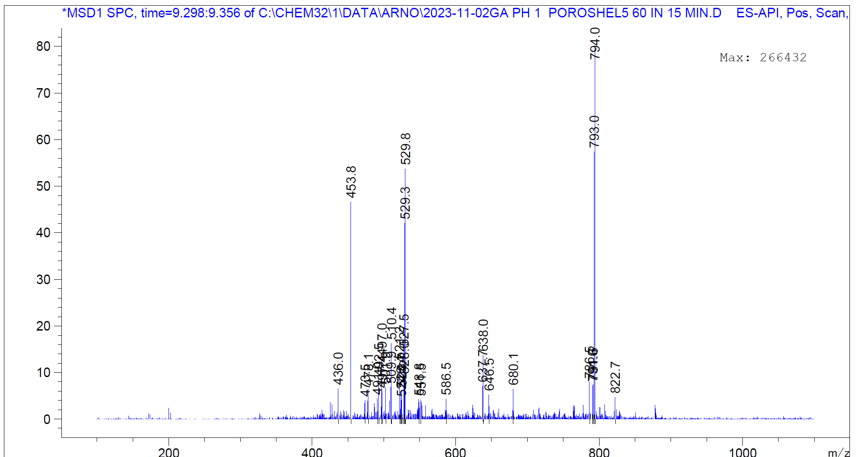Figure S7: LCMS analysis of ^{nat}Ga-NODASA-PH1 (M+2H = 793.0 m/z)

- iTLC analysis of [⁶⁸Ga]Ga-NODASA-peptide compounds
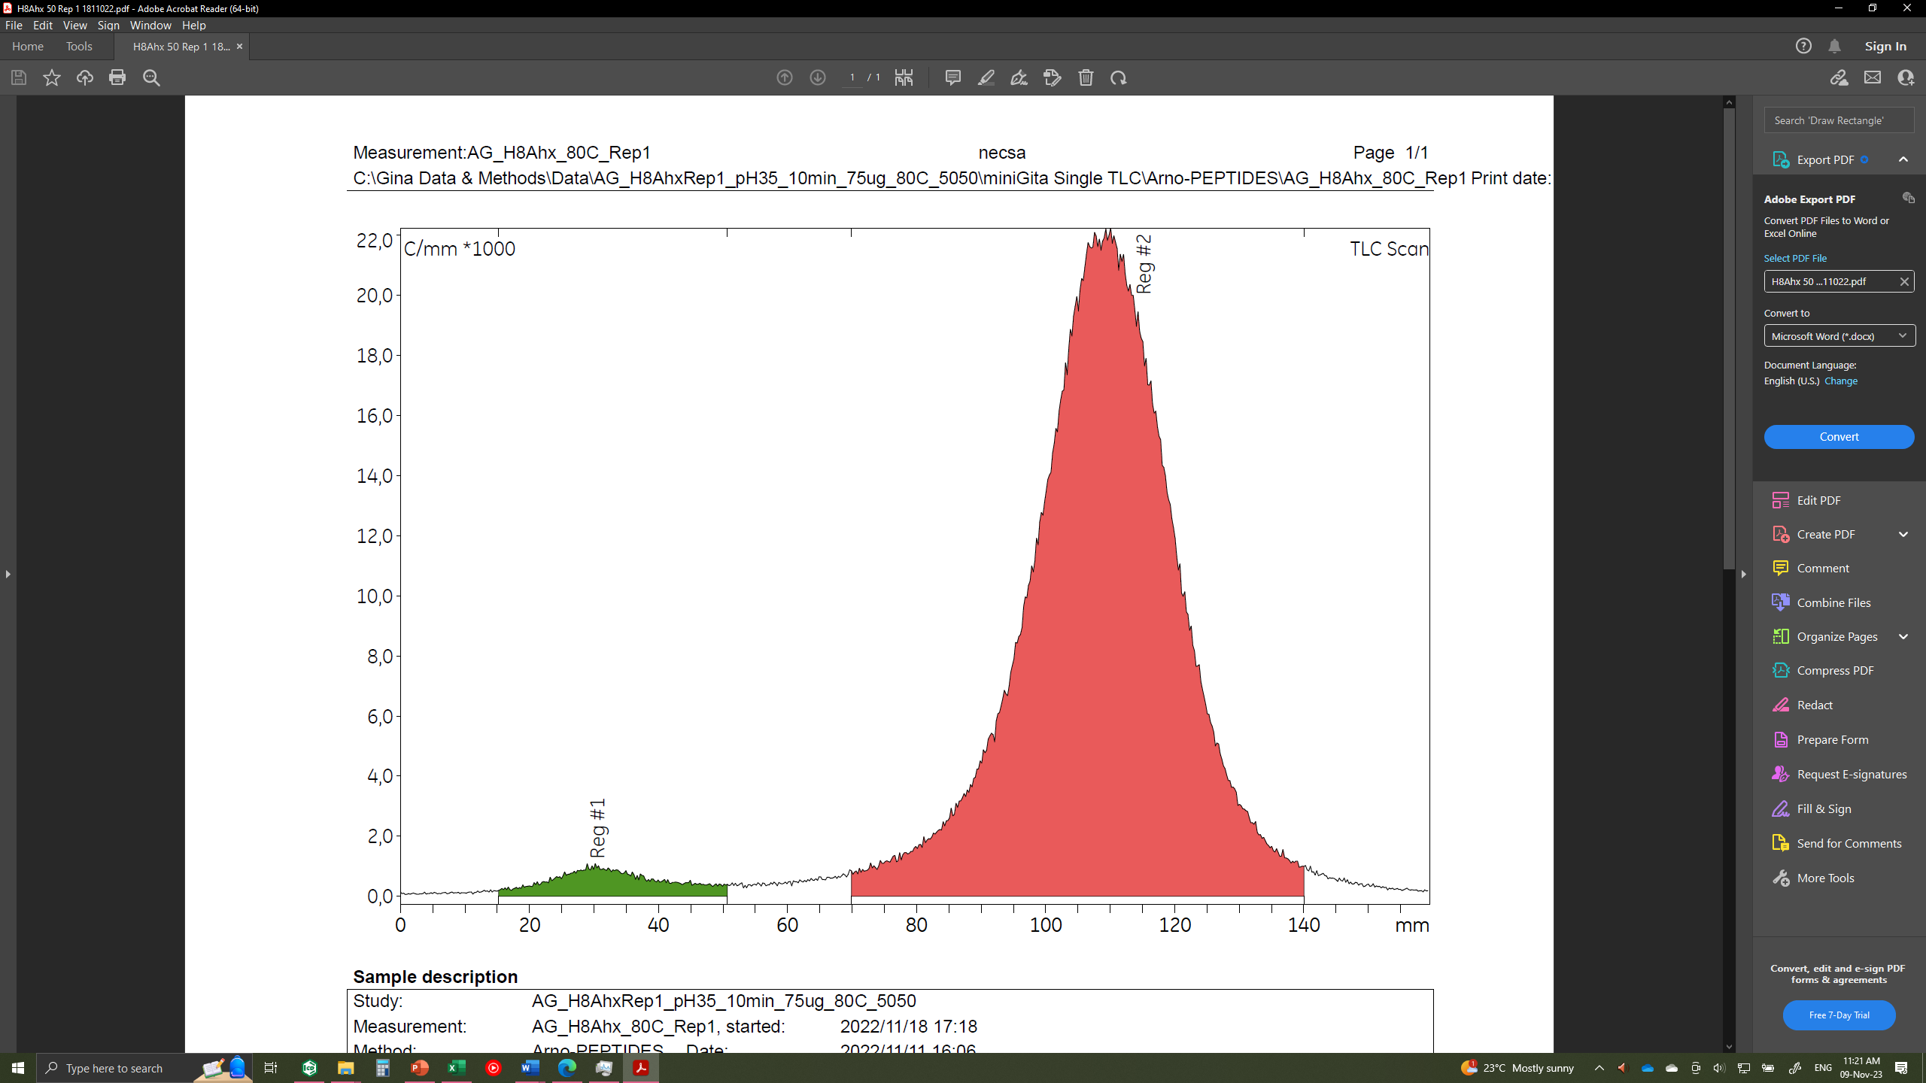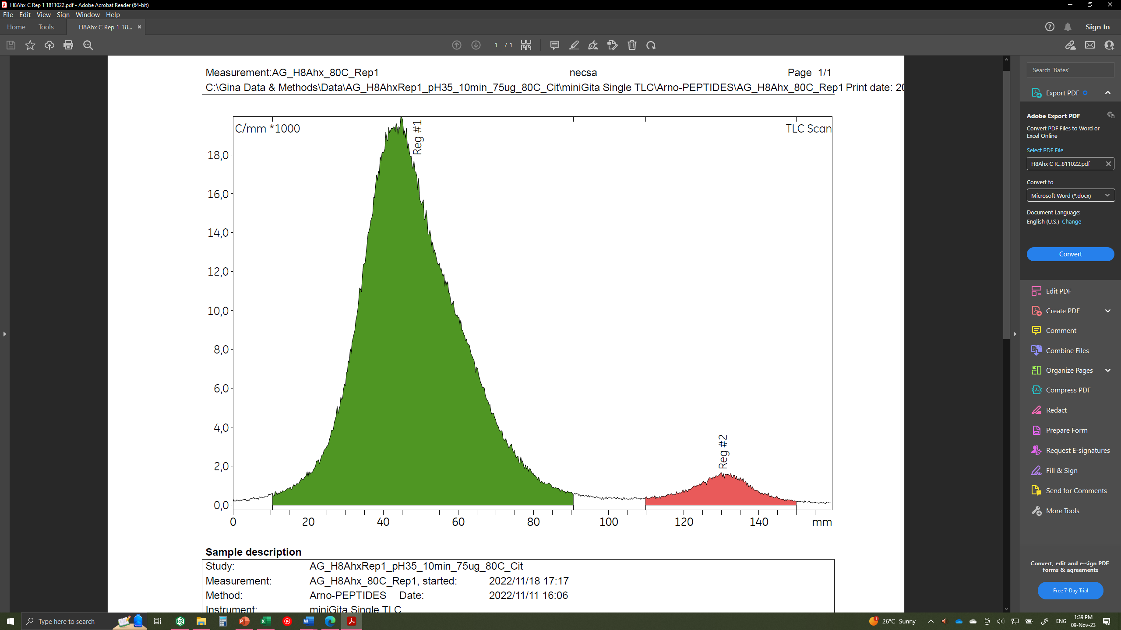
Figure S8: ITLC chromatograms acquired from analysis of [⁶⁸Ga]Ga-NODASA-H8. (A) Developed in 1.0 M ammonium acetate/methanol 1:1 (v/v) to determine the %LE; ⁶⁸Ga-colloids + free unreacted ⁶⁸Ga-species (Rf = 0.19) and [⁶⁸Ga]Ga-NODASA-H8 (Rf = 0.69). (B) Developed in 0.1 M citrate solution (pH 5-5.5) to determine the percentage of unreacted free unreacted ⁶⁸Ga-species; [⁶⁸Ga]Ga-NODASA-H8 + ⁶⁸Ga-colloids (Rf = 0.28) and free unreacted ⁶⁸Ga-species (Rf = 0.82)

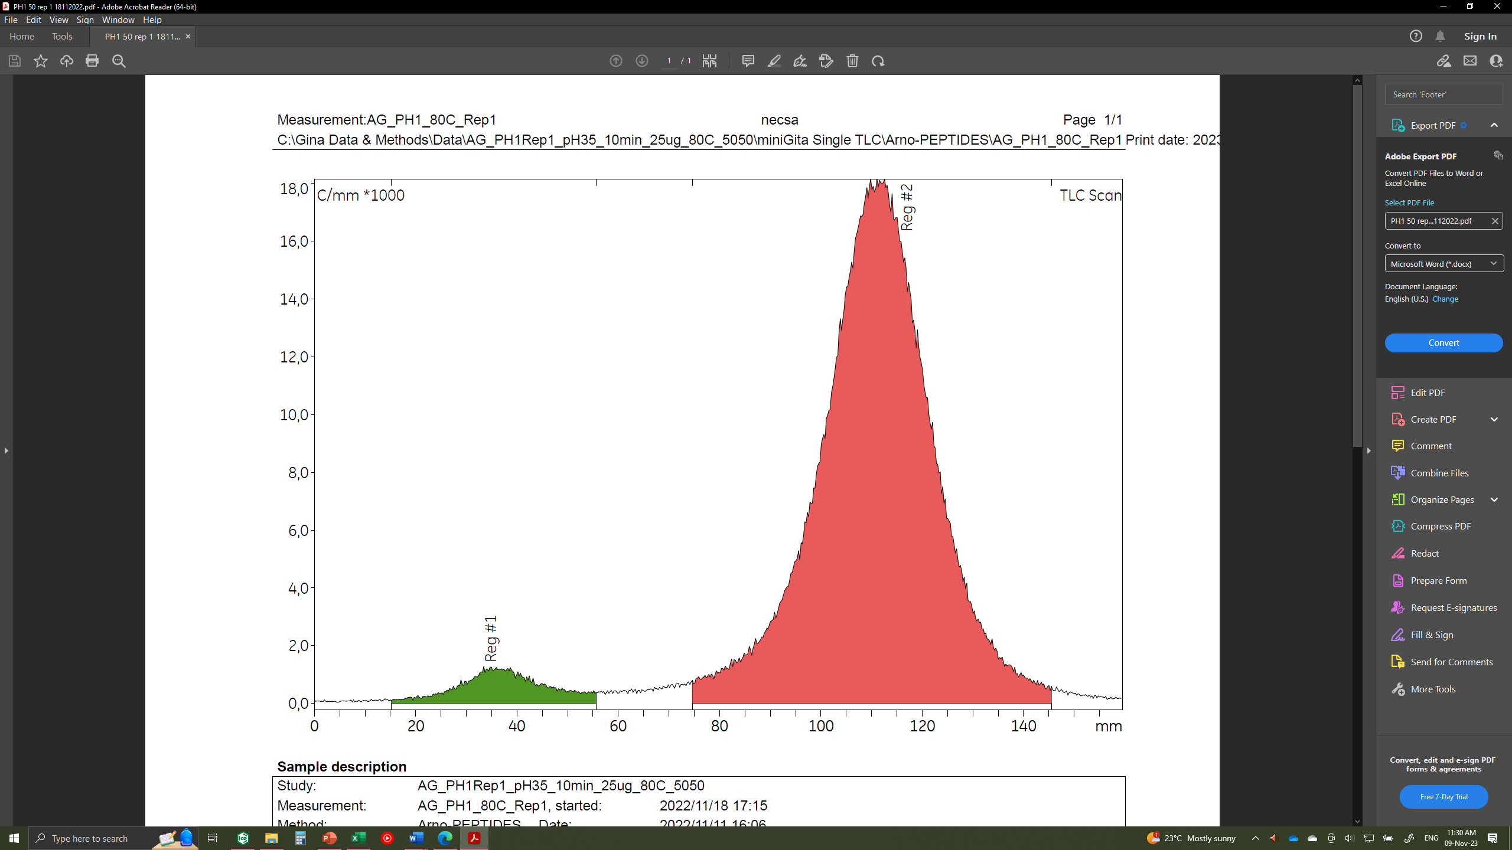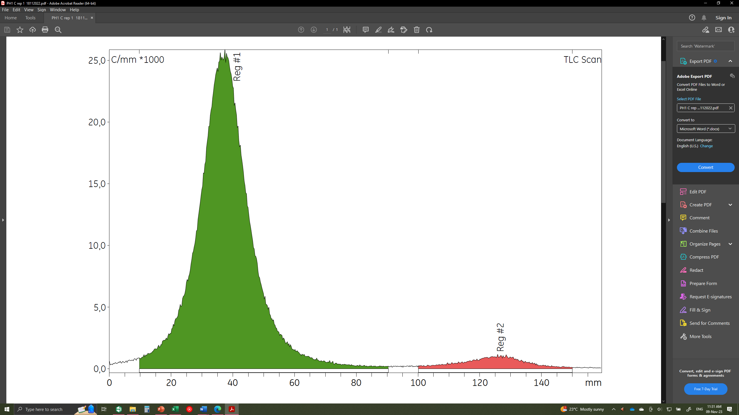
Figure S9: ITLC chromatograms acquired from analysis of [⁶⁸Ga]Ga-NODASA-PH1. (A) Developed in 1.0 M ammonium acetate/methanol 1:1 (v/v) to determine the %LE; ⁶⁸Ga-colloids + free unreacted ⁶⁸Ga-species (Rf = 0.22) and [⁶⁸Ga]Ga-NODASA-H8 (Rf = 0.70). (B) Developed in 0.1 M citrate solution (pH 5-5.5) to determine the percentage of unreacted free ⁶⁸Ga-species; [⁶⁸Ga]Ga-NODASA-PH1 + ⁶⁸Ga-colloids (Rf = 0.24) and free unreacted ⁶⁸Ga-species (Rf = 0.79)

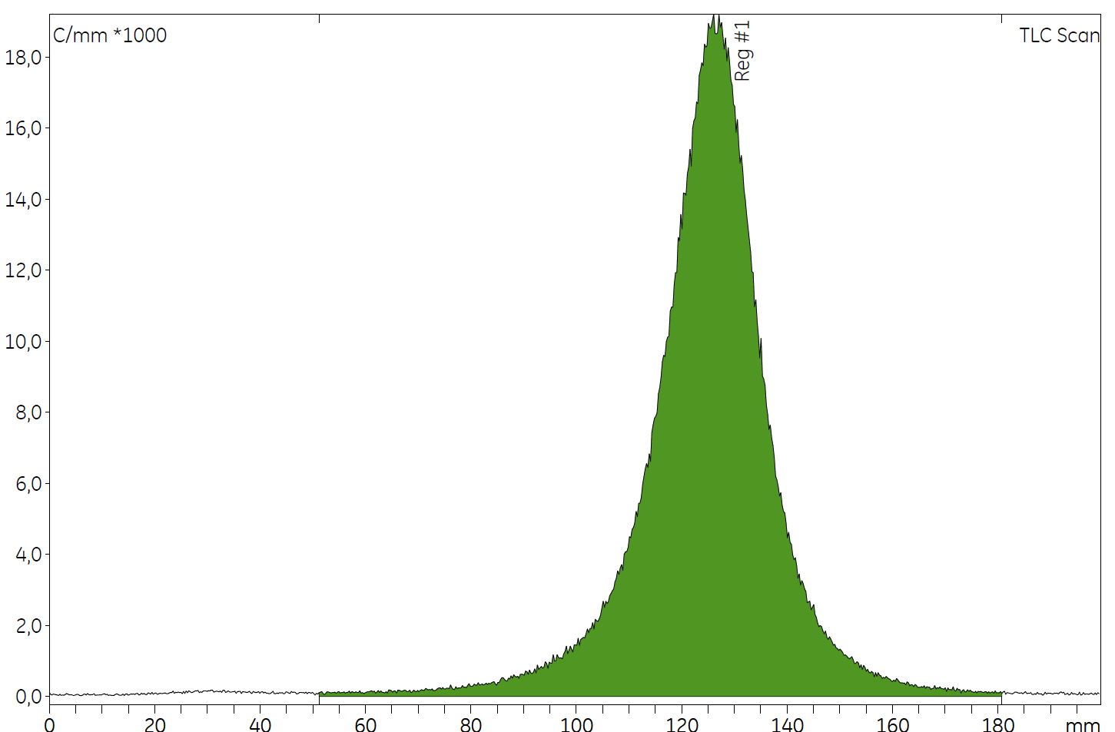
Figure S10: ITLC chromatograms acquired from analysis of [⁶⁸Ga]-EDTA (Rf = 0.65) developed in 0.1 M citrate solution (pH 5-5.5).

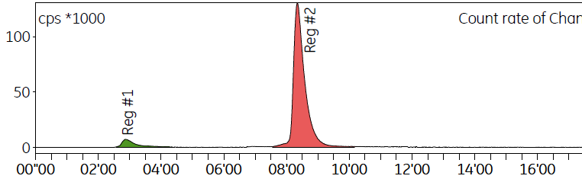
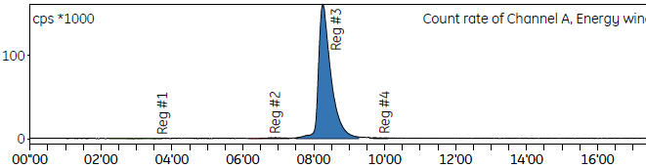
Figure S11: Select examples of crude (top) and SPE-purified (bottom) [⁶⁸Ga]Ga-NODASA-H8 products.

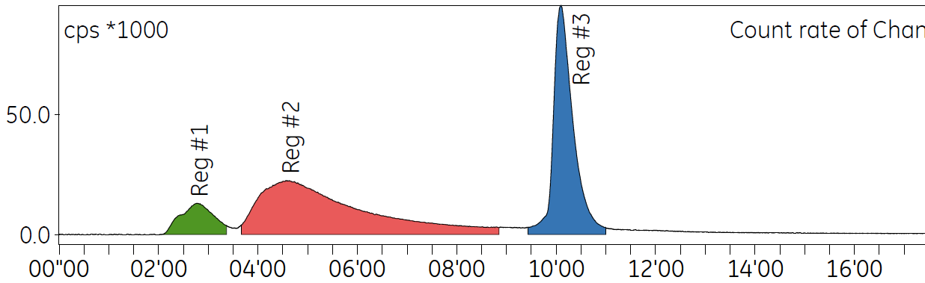
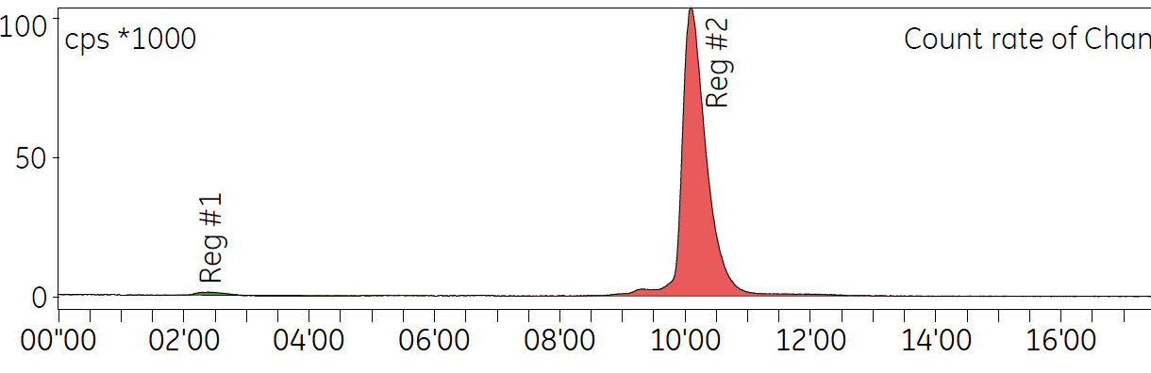Figure S12: Select examples of crude (top) and SPE-purified (bottom) [⁶⁸Ga]Ga-NODASA-PH1 products.

