Appendix A - Supplementary Materials
Materials and Methods
Participants and Samples
We enrolled a subset of participants from the Evidence for Contraceptive Options and HIV Outcomes (ECHO) Trial, conducted at 12 sites in South Africa, Zambia, Kenya and eSwatini between Dec 14, 2015, and Sept 12, 2017, which achieved a retention rate of over 93% [1]. The ECHO trial recruited HIV-negative, sexually active non-pregnant women aged 16-35 years who sought contraception, had no medical contraindications, and had not used any of the study contraceptive methods in the previous six months. Participants were randomized to receive either copper IUD, LNG-implant, or DMPA-IM (Table 1). The Human Research Ethics Committees at the Universities of Witwatersrand and Cape Town approved the study protocols (Reference numbers: 141112 and 714/2018, respectively). All participants provided written informed consent and demographic, behavioral, and medical information. Study staff collected health history, demographic data, and other metadata using standardized case report forms during the parent ECHO trial.
We collected lateral wall vaginal swab samples from women enrolled at the Setshaba Research Centre (SRC) in Tshwane (n=53) and the MatCH Research Unit (MRU) in the eThekwini District, South Africa (n=109). We collected samples immediately before contraceptive initiation, and at 1 (M1) and 3 (M3) months when medroxyprogesterone acetate (MPA) concentrations were near peak and trough levels, respectively. Participants were HIV-seronegative at baseline, and none had been using HIV preexposure prophylaxis (PrEP). We stored swabs dry at -80ºC at Bio Analytical Research Corporation (BARC) in Johannesburg, South Africa and transferred to Dr. Masson’s laboratory at the University of Cape Town, South Africa and to Dr. Buck’s lab at Virginia Commonwealth University (VCU) in May 2020 on dry ice with temperature monitoring. We processed swabs for DNA using Qiagen DNeasy Powersoil kits per manufacturer instructions upon their arrival at VCU and DNA was eluted in nuclease-free water and kept -20ºC.
2.2 16S rRNA Taxonomic Surveys
We performed 16S rRNA gene surveys as previously described [2] and DNA was amplified using indexed primers targeting the V1-V3 variable regions of the 16S rRNA genes. We sequenced the amplified samples on an Illumina MiSeq sequencer using 2x300 base paired end protocols to a targeted depth of 50,000 reads per sample. Sequences were deposited in the Sequence Read Archive under BioProject (SUB12094402). We assigned vagitypes as described previously, with vaginal 16S rRNA profiles categorized into community state types (CSTs) according to the taxon with the highest proportion of reads (≥30%). For samples with no single dominant taxon (<30% of reads), a “No Type” classification was assigned [2]. Alternatively, we designated vagitypes dominated by L. crispatus, L. gasseri or L. jensenii as “optimal”, those dominated by L. iners as “intermediate” and those lacking Lactobacillus species as “non-optimal” [3].
2.3 Diversity analysis
We analyzed read counts of taxa present in at least 2% of the samples at >0.1% abundance. We excluded three samples that had fewer than 5,000 high-quality reads. We normalized the samples by rarefaction to the depth of 5,000 reads. Alpha diversity was quantified by two metrics: (a) the Shannon index, which measures species richness based on both the number of different species present and their relative abundance and (b) the inverse Simpson index, which assesses species richness and evenness within a community. We calculated these metrics using the vegan package in R [4]. Differences in alpha diversities were measured by the paired Wilcoxon test. We measured and visualized beta diversity using Non-Metric Multi-Dimensional Scaling, and assessed Bray-Curtis distance differences using the Adonis test in the vegan package in R [4]. As an alternative method, for measuring beta diversity, we normalized the pretreated reads table using the centered log ratio (clr) transformation [5]. A constant of 0.5 was added to each count before analysis to eliminate zero counts [6]. We visualized beta diversity by analyzing the clr transformed reads table using a t-distributed stochastic neighbor embedding plot in the Rtsne package in R [7,8].
2.4 Longitudinal Analysis
Poisson regression models were fit to test for homogenous associations of vaginal microbiome and month across pairs of contraceptive method. For each pair of contraceptive method, a Poisson regression model was fit to vaginal microbiome (optimal, intermediate, non-optimal) counts across time. Thus, vaginal microbiome counts were modeled as a function of contraceptive method, month, and vaginal microbiome class using both a homogenous association model (no three-way interaction) and a non-homogenous association model (includes the three-way interaction). We compared these two models (i.e. a test for homogenous association) using an analysis of deviance chi-square test in R [4].
2.5 Transition analysis
We used the R package msm to fit a continuous-time Markov chain model (R package markovchain [9]) for vagitype transitions as previously described [10]. The model takes as input the subject, state, and visit for each sample. The states were optimal vaginal microbiome (L. crispatus, L. gasseri or L. jensenii dominant), intermediate (L. iners dominant), and non-optimal (including all other vaginal microbiomes). We used 95% confidence intervals for transition probabilities to determine whether there were statistically significant differences between vaginal microbiome states groups.
2.6 Cytokine and Antimicrobial Peptide Quantification
We measured cytokines and immune markers – including Macrophage inflammatory protein (MIP)-1α (CCL3), MIP-1β (CCL4), MIP-3α (CCL20), interferon gamma-induced protein 10 (IP-10; CXCL10), regulated on activation, normal T cell expressed and secreted (RANTES; CCL5), interleukin (IL)-6, IL-8, IL-1β and tumor necrosis factor (TNF)-α, interferon (IFN)-α, and secretory leukocyte peptidase inhibitor (SLPI) using customized Human Magnetic Luminex Screening Assays (R&D Systems, Minneapolis, USA) as described previously [11]. We quantified Human beta defensin (HBD)-1 and -2 using Enzyme Linked Immunosorbent Assay kits (Novus Biologicals, Colorado, USA).
2.7 Mixed Model using Cytokine and Antimicrobial Expression Levels.
We modeled each cytokine and antimicrobial peptide expression level via a mixed effects model that includes a random subject effect and covariates for contraceptive method, visit (baseline, month 1, month 3), BMI, active sexually transmitted infection status, and vaginal microbiome class (Optimal, Intermediate, Suboptimal). We generated an analysis of variance table for each fixed effect covariate (see Supplementary Table 2).

1. Evidence for Contraceptive Options and HIV Outcomes (ECHO) trial consortium. HIV incidence among women using intramuscular depot medroxyprogesterone acetate, a copper intrauterine device, or a levonorgestrel implant for contraception: a randomised, multicentre, open-label trial. Lancet Lond Engl 2019 Jul 27;394(10195):303–13. https://doi.org/10.1016/S0140-6736(19)31288-7
2. Fettweis JM, Serrano MG, Brooks JP, Edwards DJ, Girerd PH, Parikh HI, et al. The vaginal microbiome and preterm birth. Nat Med 2019 Jun;25(6):1012–21. https://doi.org/10.1038/s41591-019-0450-2
3. McKinnon LR, Achilles SL, Bradshaw CS, Burgener A, Crucitti T, Fredricks DN, et al. The evolving facets of bacterial vaginosis: implications for HIV transmission. AIDS Res Hum Retroviruses 2019 Mar 1;35(3):219–28. https://doi.org/10.1089/aid.2018.0304
4. Oksanen J, Simpson GL, Blanchet FG, Kindt R, Legendre P, Minchin PR, et al. vegan: community ecology package. R package version 2.6-4 [Internet]. 2022. Available from: https://github.com/vegandevs/vegan (accessed in May 2022)
5. Quinn TP, Erb I, Gloor G, Notredame C, Richardson MF, Crowley TM. A field guide for the compositional analysis of any-omics data. GigaScience 2019 Sep 1;8(9):giz107. https://doi.org/10.1093/gigascience/giz107
6. Huang C, Callahan BJ, Wu MC, Holloway ST, Brochu H, Lu W, et al. Phylogeny-guided microbiome OTU-specific association test (POST). Microbiome 2022 Jun 7;10(1):86. https://doi.org/10.1186/s40168-022-01266-3
7. Maaten L van der, Hinton G. Visualizing data using t-SNE. J Mach Learn Res 2008;9(86):2579–605. https://doi.org/10.1162/jmlr.2008.9.86.2579
8. Krijthe JH. Rtsne: T-distributed stochastic neighbor embedding using Barnes-Hut implementation [Internet]. 2015. Available from: https://github.com/jkrijthe/Rtsne. https://doi.org/10.32614/CRAN.package.Rtsne
9. Spedicato GA. Discrete time Markov chains with R. R J 2017;9(2):84–104. https://doi.org/10.32614/RJ-2017-036
10. Brooks JP, Buck GA, Chen G, Diao L, Edwards DJ, Fettweis JM, et al. Changes in vaginal community state types reflect major shifts in the microbiome. Microb Ecol Health Dis 2017 Apr 10;28(1):1303265. https://doi.org/10.1080/16512235.2017.1303265
11. Radzey N, Harryparsad R, Meyer B, Chen PL, Gao X, Morrison C, et al. Genital inflammatory status and the innate immune response to contraceptive initiation. Am J Reprod Immunol 2022;88(2):e13542. https://doi.org/10.1111/aji.13542

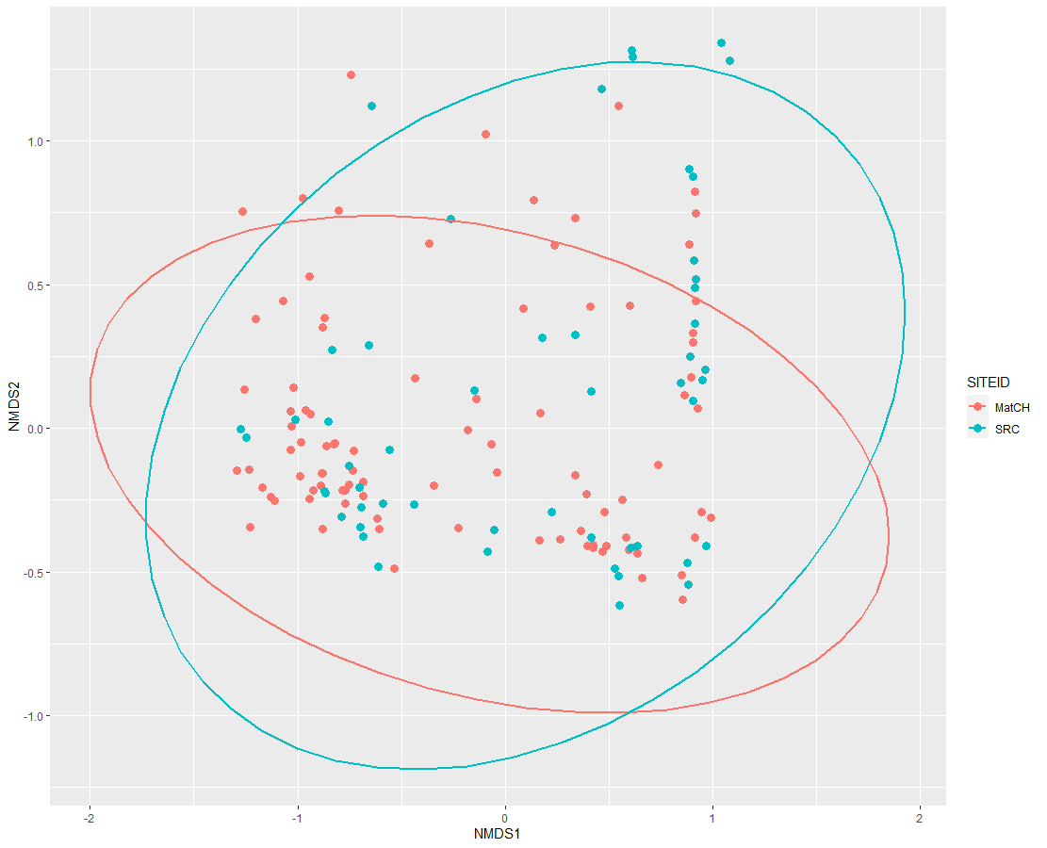
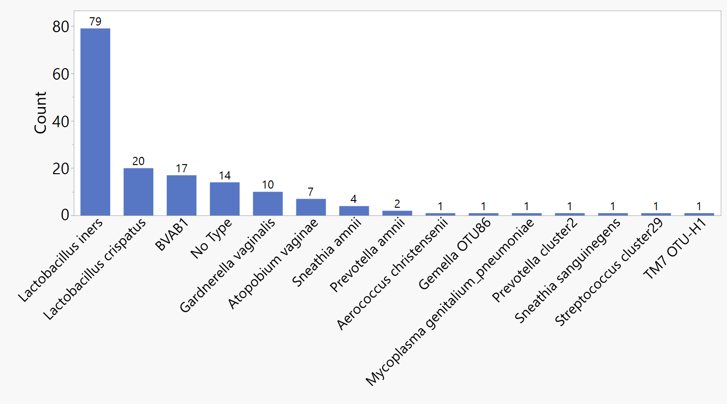
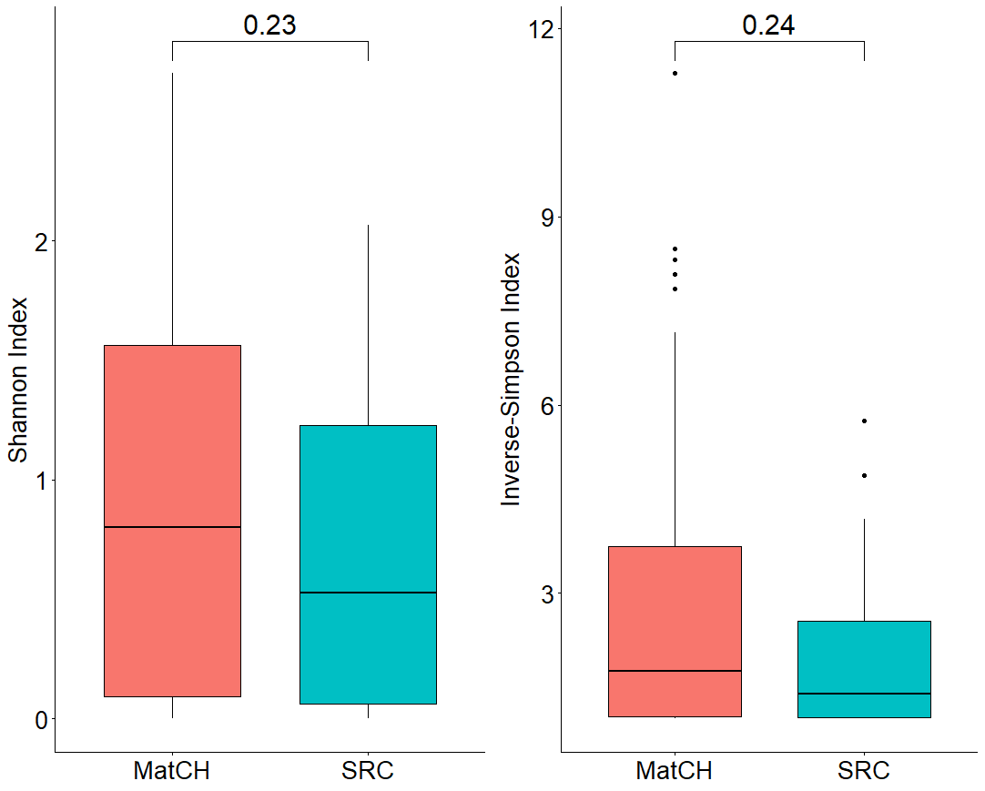
Study site
MatCH
Setshaba
100%
80%
60%
40%
20%
0%
Vagitypes
CST
CST I
CST III
CST IV
Setshaba
B
C
D
E
A
Shannon index
Inverse-Simpson index
MatCH SRC MatCH SRC
0.23
0.24
MatCH
SRC
NMDS1
NMDS2
MatCH
Lactobacillus gasseri
Lactobacillus crispatus
Lactobacillus jensenii
Lactobacillus iners
Gardnerella vaginalis
Lachnospiraceae BVAB1
Sneathia amnii
Atopobium vaginae
Prevotella cluster2
Supplementary Figure 1. Baseline vaginal microbiome profiles by study site (Tshwane and in the eThekwini District, South Africa, 2015-2017). A, Frequencies of vagitypes in baseline cohorts. The number of women with vaginal microbiomes characterized as each vagitype. Vagitypes are characterized as vaginal microbiome profiles exhibiting at least 30% of a single taxon as previously described [2]. B, Hierarchical clustering of the 15 most abundant taxa according to the site of collection using the ‘pheatmap’ package in R software with default settings. Community state types (CSTs) and sites of collection are color-coded. Only three of the five Community State Types as originally defined; i.e., CST I which is predominantly L. crispatus, CST II which is predominantly L. jensenii, CST III which is predominantly L. iners, CST IV which is comprised of multiple anaerobic taxa, and CST V which is predominantly L. gasseri, were identified. CSTII (L. jensenii) and CSTV (L. gasseri) were absent. C, Stacked bar charts illustrating little differences in the abundances of the identified vagitypes in the MatCH and Setshaba study sites. D, Shannon and Reverse Simpson measures of the alpha diversity; i.e., the within sample diversity, of the two baseline study sites illustrating no significant differences (p=0.23 or 0.24 respectively). E, Bray Curtis diversities of the samples from the two study sites again showing no significant differences (p=0.2587) between the vaginal microbiomes from the two study sites.

Relative abundance

Supplementary Table 1. Transition frequencies in the vaginal microbiomes of women using different contraceptive methods in Tshwane and in the eThekwini District, South Africa, 2015-2017.​

Supplementary Table 2. Fixed Effects Tests. Mixed effect model using immune markers and multiple covariates (Tshwane and in the eThekwini District, South Africa, 2015-2017). A mixed effect model was fit to each cytokine and antimicrobial peptide including a random subject effect and covariates for contraceptive method (copper-IUD, DMPA-IM, LNG-implant), visit (baseline, month 1 or 3), BMI, active STI, and vaginal microbiome profile (Optimal, Intermediate, Nonoptimal). ​
​

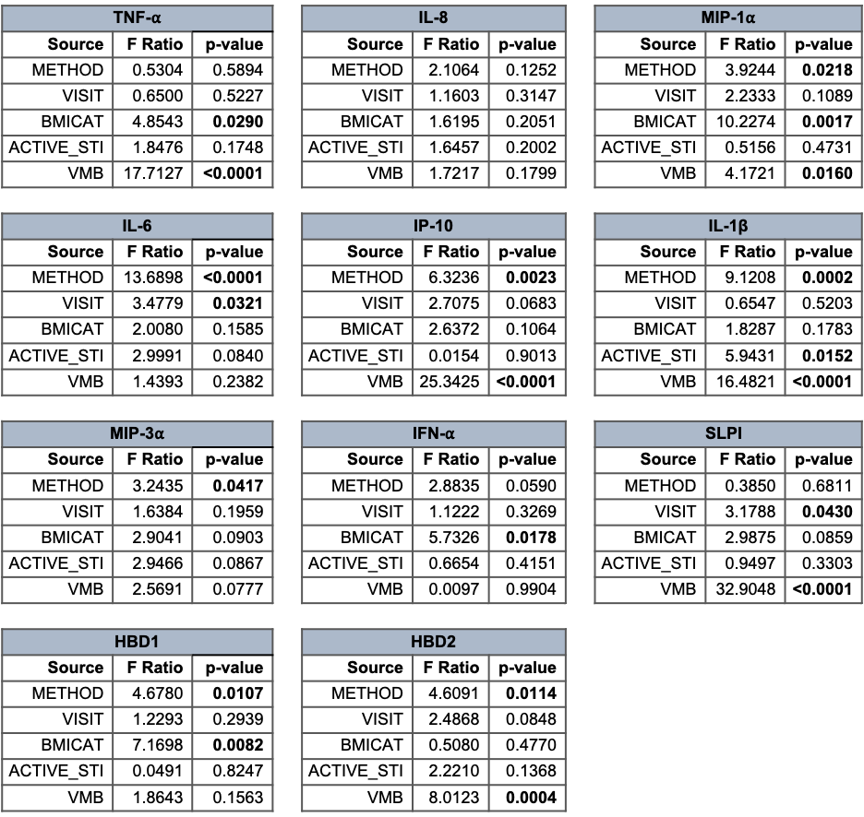

Supplementary Table 3. Differences in cytokine, chemokine and antimicrobial peptide levels samples from women with different microbiome profiles at baseline, month 1 and month 3 in Tshwane and in the eThekwini District, South Africa, 2015-2017. Significance (P values) is shown comparing the levels between samples with nonoptimal (NonOp) or Intermediate (Int), nonoptimal to optimal (Op), and intermediate to optimal for each factor in women using copper-IUD, DMPA or LNG-implant contraception. Yellow highlighted text indicates significantly lower levels, and Red highlighted text indicates significantly higher levels of that cytokine in either the intermediate or optimal vaginal microbiomes. ​

