A multi-scale environmental niche model for the endangered dhole Cuon alpinus

M.P. Khatiwada, K. Kunkel, W. Wright, B. Acharya, S.S. Aung, N. Bhumpakphan,
T.C. Cheng, C. Davis, T.P. Ean, K.M.P.M.B. Ferraz, P. Ghaskadbi, Y.P. Ghimirey, M. Gilbert,
B.K. Gupta, B. Habib, I. Haidir, L. Havmøller, R.W. Havmøller, K.E. Jenks, J.F. Kamler,
A.P. Khatiwada, S. Li, D.W. Macdonald, F. Machmudah, Y. Mekiln, C. Namgyal,
V.A. Nawangsari, D. Ngoprasert, S. Nurvianto, H.A. Rahman, S.C. Rahman, A. Rasphone,
P. Roux, N. Seuaturien, N.M. Shwe, N. Songsasen, R. Steinmetz, R. Sukmasuang, P. Thinley, W. Tipkantha, K. Traylor-Holzer, H. Wahyudi and F. Dalerum

Supplementary material is published as supplied by the authors. It is not checked for accuracy, copyedited, typeset or proofread. The responsibility for accuracy and file functionality remains with the authors.

Supplementary Material 1 Description of the study region.

Topography
The topography of the study region is highly diverse and ranges from sea level to the world’s highest point at the summit of Mt. Everest (8,848 meters above sea level). The topography of mainland China is characterized by higher elevation in the west and lower elevation in the east and includes all major landform types. Mountains and plateaus occupy 59% of mainland China's total land area followed by basins (19%), plains (12%), and hills (10%). The Indian subcontinent consists of the Indo-Gangetic plain and peninsular India. Southeast Asia encompasses the southeast corner of Asia and includes an assemblage of peninsulas, archipelagos, and partially enclosed seas (Gupta, 2005). Several large, elongated river basins that begin in the Himalayan highlands separates Southeast Asia from China and northwest India.

Climate
Much of mainland China's climate is influenced by seasonal movement of large air masses between the Pacific Ocean and the Chinese mainland. Mainland China can be divided into six climatic zones - the boreal, the temperate, the warm temperate, the sub-tropical, the tropical and the highland climate (Zhou, 1993). The climate of the Indian subcontinent is highly diverse, including half of the climate zones of the world. The Himalayan Mountains restrict horizontal exchange of oceanic and continental air masses and create characteristic climates including tropical, dry and temperate areas (Xue & Yanai, 2005). In contrast, all Southeast Asia lies within a tropical climate zone and subsequently has a relatively consistent sub-tropical or tropical climate.

Vegetation
The topographic and climatic diversity of the study region has resulted in an enormous variation in vegetation. From north to south, mainland China's vegetation includes the cold temperature deciduous forest zone, the temperature mixed forest zone, the warm temperature deciduous broadleaf evergreen forest zone, the northern evergreen forest zone, the broadleaf evergreen forest zone, the southern subtropical broadleaf evergreen forest zone and the rain forest zone. From east to west, vegetation types include mixed forest, semi-humid forest and steppe, semi-arid steppe, desert or extreme arid desert. The vegetation of the Indian subcontinent similarly varies according to climate and altitude, and includes tropical rain forest, tropical wet evergreen forest, desert and dry shrub, temperate grassland, deciduous and mixed forest and highland. The vegetation of Southeast Asia consists of tropical-evergreen forest in the equatorial lowlands and open tropical-deciduous or monsoon forest in areas of seasonal drought (Leinbach & Frederick, 2020).

Wildlife
The profusion of climate zones and vegetation types have allowed a diversity of animal life in mainland China that is higher than in any other country covering similar latitude. Mainland China harbors over 2700 terrestrial vertebrate species, with a high proportion of endemic species. The Indian subcontinent represents five of the fourteen major ecological regions of the world, and harbors approximately 12 percent of the world's faunal diversity, including 933 species of mammals, 4,494 birds, 923 reptiles, 332 amphibians and 342 freshwater fishes (SACEP, 2016). Southeast Asia lies at the interface of the Indian and the Australian zoogeographic regions. The tropical rainforests in many parts of Southeast Asia include complex animal communities that fill specialized ecological niches (Leinbach & Frederick, 2020).

Human population and economy
The study region harbors 3.9 billion people, which is approximately half of the global human population (Asia Development Bank, 2022). Of these, 1.38 billion resides in mainland China, 1.8 billion on the Indian subcontinent and 0.7 billion in Southeast Asia. These population numbers translate into some of the highest human population densities in the world, with an average density of 153 people / km² in mainland China, 350 people / km² on the Indian subcontinent and 153 / km² in Southeast Asia. The region contains some of the largest urban centers in the world, and urbanization is still increasing rapidly (Asia Development Bank, 2022). Yet, a sizable part of the human population still lives in rural settlements (Asia Development Bank, 2022), and some parts of the study region have levels of urbanization substantially below the global average (OECD/European Commission, 2020). The region showed substantial economic growth during the past few decades, and the economic growth rate in China (gross domestic product [GDP] growth rate of 8.1%) and on the Indian subcontinent (GDP growth rate of 8.3%) are still both higher than the global average of 6.0%, but the economic growth in Southeast Asia is substantially lower (GDP growth rate of 2.9%) (Asia Development Bank, 2022). Economic wealth is unevenly distributed, with several countries having income gaps substantially higher than the global and regional averages (Chancel et al., 2022). The rising human population and increased economic growth has led to substantial land cover changes, which primarily consist of an increased spread of croplands and built-up areas (Potapov et al., 2022). Approximately 14% of land areas are protected (Juffe-Bignoli, 2014) which is somewhat below the global average of 16.6% (UNEP-WCMC and IUCN 2022). Bhutan (25%), Thailand (18%), Laos (18%) and Nepal (16%) have the highest proportion of their land area protected, whereas the country with the largest number of protected areas is India (149 000 km²) (UNEP-WCMC and IUCN, 2022).

References
Asia Development Bank. (2022) Key indicators for Asia and the Pacific 2022. Asian Development Bank, Manilla, Philippines.
Chancel, L., Piketty, T., Saez, E. & Zucman, G. (2022) World inequality report 2022. World Inequality Lab, Paris, France.
Gupta, A (ed.) (2005) Landforms of Southeast Asia. The Physical Geography of Southeast Asia. Oxford University Press. Oxford, UK.
Juffe-Bignoli, D., Bhatt, S., Park, S., Eassom, A., Belle, E.M.S., Murti, R., Buyck, C., Raza Rizvi, A., Rao, M., Lewis, E., MacSharry, B. & Kingston, N. (2014) Asia protected planet 2014. UNEP-WCMC, Cambridge, UK.
Leinbach, T. & Frederick, W. (2020) Southeast Asia. The Encyclopedia Brittanica. https://www.britannica.com/. Accessed 7 March 2023.
OECD/European Commission. (2020) Cities in the World: A New Perspective on Urbanisation. OECD Urban Studies, OECD Publishing, Paris, France.
Potapov, P., Hansen, M.C., Pickens, A., Hernandez-Serna, A., Tyukavina, A., Turubanova, S., Zalles, V. et al. (2022) The global 2000-2020 land cover and land use change dataset derived from the landsat archive: first results. Frontiers in Remote Sensing, 3, 856903.
SACEP (South Asia Co-operative Environment Programme). (2016) South Asia’s Biodiversity: Status, Trends and Challenges. SACEP, Colombo, Sri Lanka.
UNEP-WCMC & IUCN. (2022) Protected Planet: The World Database on Protected Areas (WDPA). Cambridge: UNEP-WCMC and Gland, www.protectedplanet.net. Accessed 7 March 2023.
Xue, Y. & Yanai, M. (2005) Asia, Climate of South. In Encyclopedia of World Climatology (eds. J.E. Oliver), pp. 115-120. Encyclopedia of Earth Sciences Series. Springer, Dordrecht, Netherland.
Zhou, L. (1993) Theories and Practice of Chinese Agricultural Zonation. USTC Press, Hefei. China.
Supplementary Material 2 Detailed descriptions of environmental variables, dhole Cuon alpinus occurrence data and GIS processing of data.

Climate variables
Climate variables included annual mean temperature, temperature seasonality, maximum temperature of warmest month, minimum temperature of coldest month, annual precipitation, precipitation seasonality, precipitation of wettest month, precipitation of driest month and isothermality. All climate variables were derived from the CHELSA (Climatologies at High resolution for the Earth Land Surface Area) data base (Karger et al., 2021), which contains down scaled climate data at a 30-arc sec resolution (approximately 900x900 m at the equator). We used average data from 1979 to 2013. The temperature data is primarily based on statistical down scaling of atmospheric temperatures, whereas precipitation data is based on an algorithm that incorporates orographic predictors with a subsequent bias correction.

Ecological variables
Ecological variables included biome, land cover, the normalized difference in vegetation index (NDVI) and tree cover. Biome classification followed Olson et al. (2001). We grouped the original 13 major biomes occurring in our study area into six new classes: broad leafed forests (including tropical & subtropical moist broadleaf forests, tropical & subtropical dry broadleaf forests and temperate broadleaf & mixed forests), coniferous forest (including tropical & subtropical coniferous forests and temperate conifer forests), boreal forests (including boreal forests/taiga), grasslands and savannas (including tropical & subtropical grasslands, savannas & scrublands, temperate grasslands, savannas & scrublands, flooded grasslands & savannas, montane grasslands & scrublands), other biomes (including deserts & xeric scrublands and mangroves, as well as rock & ice. We used the global land cover from 2009 provided by the European Space Agency (ESA), which has a resolution of approximately 300 m (Arino et al., 2012). The data are based on raw information from the Medium Resolution Imaging Spectrometer (MERIS) sensor which have been classed using both supervised (human-verified) and unsupervised (automated) classification algorithms. The data set contains 23 different land cover classes, 7 of which were found in our study region; cultivated terrestrial areas and managed lands, woody trees, herbs, shrubs, natural and semi natural aquatic vegetation, artificial surfaces, and bare areas. We used the Normalized Difference Vegetation Index (NDVI) as an index of primary productivity. To avoid inherent issues with varying cloud cover, we calculated NDVI as the average of six days in June (June 1st ,6th ,11th,16th, 21st and 26th) and six days in July (July 1st, 6th,11th ,16th, 21st and 26th) of 2020. We obtained tree cover from raster data of approximately 30 m resolution provided by Hansen et al. (2013). Tree cover data contained canopy closure, expressed as a percentage, for all vegetation taller than 5 m.

Geophysical variables
Geophysical variables included elevation, aspect, slope, terrain ruggedness and soil type. Elevation, aspect, slope and terrain ruggedness were derived from the Global Multi-resolution Terrain Elevation Data 2010 (GMTED 2010) (Danielson & Gesch, 2011). Elevation was provided as a global digital elevation model (DEM) at a resolution of 30 arc sec whereas aspect, slope and terrain ruggedness were provided by the USGS with a resolution of 7.5 arc sec (approximately 250 m. at the equator). Aspect was calculated following Horn’s (1981) algorithm using a 3x3 pixel neighborhood size. To avoid issues related to circularity, we converted the aspect to an index of "northness", which ranges from -1 in the south to 1 in the north, using the equation:

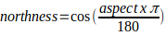
Slope and terrain ruggedness were similarly calculated using 3x3 cell neighborhood sizes. Slope was calculated as the maximum change in elevation between the center cell in the neighborhood and its eight neighbors (Burrough & McDonell, 1998). Terrain ruggedness is a quantitative measurement of terrain heterogeneity which is calculated by summarizing the change in elevation within each neighborhood (Riley, DeGloria & Elliot, 1999). Soil type was provided by the Food and Agriculture Organization of the United Nations (2015). We re-classified the original 79 soil types into 9 broad categories with similar properties following the World Reference Base for Soil Resources (IUSS Working Group WRB, 2022); soils with clay enriched sub-soils, soils with little or no profile differentiation, soils with pronounced accumulation of organic matter in the mineral topsoil, soils distinguished by Fe/Al chemistry, soils with thick organic layers, soils with limitations to root growth, soils formed from the arid climate, shallow soils rich in humus formed from carbonates and soils with depth surface.

Human impact variables
Human impact variables included densities of large livestock, densities of medium-sized livestock, density of domestic fowls, human footprint, human population density and land protection status. Livestock densities were derived from Gilbert et al. (2010). We grouped the original six livestock classes into three new ones depending on livestock size and weight; large livestock, medium-sized livestock, and domestic fowl. Horses, cattle and buffaloes were combined into the large livestock layer, whereas goats, pigs and sheep were combined into the medium-sized livestock layer. All farmed birds, e.g., chickens and ducks, were combined to a domestic fowl layer. The data on human footprint consisted of data on the Human Influence Index (HII) normalized by biome and realm, and was provided at a resolution of 30 arc sec. The HII was created from human population density, human land use and infrastructure (built-up areas, nighttime lights, land use/land cover), and human access (coastlines, roads, railroads, navigable rivers) (WCS & CIESIN, 2005). Human population density came from the Gridded Population of the World, Version 4 (CIESIN, 2016). Population density was adjusted to match 2015 revision of United Nations country totals and was based on national censuses and population registers. We downloaded information regarding land protection status from the world database on protected areas (UNEP-WCMC & IUCN, 2022). This database contains polygons of all protected areas as well as their protection status. We used a two-class system including only protected or unprotected land.

GIS processing of environmental data
All environmental variables were projected to the Asia North Albert's Equal Area Conic coordinate system (ESRI: 102025). Data provided in vector format (i.e., biome, soil and protected areas) were first transformed into a raster of 250 x 250 m resolution prior to further processing. All rasters, including the ones transformed from vectors, were aggregated to the nearest smallest cell size to respective scale, i.e., 8 km x 8 km and 2 x 2 km, using average as the aggregation function for continuous variables and mode for discrete variables (i.e., biome, land cover, soil and protected areas). These values were further re-sampled to the final scales and outlines using bilinear interpolation for continuous variables and the nearest neighbor method for categorical variables. Hence, for discrete variables the output cells contained the most common class of biome, and soil, and only cells which contained at least 50% of protected areas were classed as protected.

Dhole occurrence data
Most dhole occurrence data were recorded through camera trap surveys (93.5%), although both direct observations and indirect observations, such as tracks and signs, were included in the data. Most dhole occurrence data was contributed from Thailand (598 observations) followed by India (219) and Cambodia (215), Bhutan (168), Indonesia (121), Laos (105), Malaysia (61), Myanmar (44), mainland China (35), Nepal (33) and Bangladesh (5). Data were recorded by experienced field biologists which we assume have provided species identification with a high reliability.

References
Arino, O., Ramos, P., Jose, J., Kalogirou, V., Bontemps, S., Defourny, P. & Van, B. (2012) Global Land Cover Map for 2009. European Space Agency and Université catholique de Louvain, PANGAEA.
Burrough, P.A. & McDonell, R.A. (1998) Principles of Geographical Information Systems. Oxford University Press, Oxford, UK.
CIESIN (Center for International Earth Science Information Network). (2016) Gridded Population of the World, Version 4 (GPWv4). Population density adjusted to match 2015, Revision UN WPP Country Totals. NASA Socioeconomic Data and Applications Center (SEDAC), New York, USA.
Danielson, J.J. & Gesch, D.B. (2011) Global Multi-resolution Terrain Elevation Data 2010 (GMTED2010). U.S. Geological Survey Open-File Report.
Food and Agriculture Organization of the United Nations. (2015) FAO Soils Portal. Available at https://www.fao.org/soils-portal/en/. Accessed 10 March 2023.
Gilbert, M., Nicolas, G., Cinardi, G., Van Boeckel, T.P., Vanwembeke, S.O., Wint, G.R.W. & Robinson, T.P. (2018) Global distribution data for cattle, buffaloes, horses, sheep, goats, pigs, chickens and ducks in 2010. Scientific Data, 5, 180227.
Hansen, M.C., Potapov, P.V., Moore, R., Hancher, M., Turubanova, S.A., Tyukavina, A., Thau, D., et al. (2013) High-resolution global maps of 21st-century forest cover change. Science. 342, 850-853.
Horn, B.K.P. (1981) Hill shading and the reflectance map. Proceedings of the IEEE. 69, 14-47.
IUSS Working Group WRB. (2022) World Reference Base for Soil sources: International Soil Classification System for Naming Soils and Creating Legends for Soil Maps. 4th edition. International Union of Soil Sciences (IUSS), Austria.
Karger, D.N., Lange, S., Hari, C., Reyer, C.P. & Zimmermann, N.E. (2021) CHELSA-W5E5 v1. 1: W5E5 v1. 0 downscaled with CHELSA v2. 0.
Olson, D.M., Dinerstein, E., Wikramanayake, E.D., Burgess, N.D., Powell, G.V.N., Underwood, E.C., D'Amico, J.A. et al. (2001) Terrestrial ecoregions of the world: a new map of life on Earth. Bioscience, 51, 933-938.
Riley, S.J., DeGloria S.D. & Elliot R. (1999) A terrain ruggedness index that quantifies topographic heterogeneity. Intermountain Journal of Sciences. 5, 1-4: 23-27.
UNEP-WCMC & IUCN. (2022) Protected Planet: The World Database on Protected Areas (WDPA). Cambridge: UNEP-WCMC and Gland, Switzerland. www.protectedplanet.net. Accessed 7 March 2023.
WCS & CIESIN. (2005) Last of the Wild Project, Version 2, 2005 (LWP-2): Global Human Footprint Dataset. NASA Socioeconomic Data and Applications Center (SEDAC), New York, USA.
Supplementary Table 1 List of sources for the dhole occurrence data used to create the MaxEnt models. The data were compiled during a workshop on dhole population and habitat viability held by the dhole working group of the IUCN Species Survival Commission Canid Specialist group in Thailand 2019.
Country | Location | Data Type¹ | Year |  | Source
Bangladesh | Sangu-Matamuhuri Reserve Forest | CT | 2015 |  | Scott Trageser, Creative Conservation Alliance, Avenue 3, Road 13 A, House 925, Mirpur DOHS, Dhaka, Bangladesh
Bangladesh | Sangu-Matamuhuri Reserve Forest | CT | 2016 |  | Caeser Rahman, Creative Conservation Alliance, Avenue 3, Road 13 A, House 925, Mirpur DOHS, Dhaka, Bangladesh
Bangladesh | Chittagong Hill Treks | CT | 2015, 2016, 2018 |  | Hasan Rahman, Department of Entomology and Wildlife Ecology, University of Delaware, Newark, DE 19716, USA
Bhutan | Royal Manas National Park | CT | 2014, 2015 |  | Singye Wangmo, Department of forest and Park services, FJPP+F3C, Thimphu, Bhutan
Bhutan | Gasa, Bharshong Naro Thimpu,Rimchu Punakha and Paro Bhutan | CT | 2014-2016 |  | Phuntsho Thinley, Ugyen Wangchuck Institute for Conservation and Environmental Research, Department of Forest and Park Services, Lamai Goenpa, Bumthang 32001, Bhutan
Bhutan | Shetemy and Ada sho | DS | 2018, 2019 |  | Yoenten Phuentshok, National Centre for Animal Health, Department of Livestock, Ministry of Agriculture and Forests, Serbithang, Thimphu 11001, Bhutan
Cambodia | Mondulkiri Protected Forest and Phnom Prich Wildife Sanctuary | CT | 2008-2012 |  | Rachel Crouthers, World Wild Fund for Nature Cambodia, Street 322, Phnom Penh 12302, Cambodia
Cambodia | Srepok Wildlife Sanctuary | CT | 2014, 2016 |  | Susana Rostro-Gracia, Wildlife Conservation Research Unit, Department of Zoology, University of Oxford, The Recanati-Kaplan Centre, Tubney House, Abingdon Road, Tubney, Abingdon OX13 5QL, UK
Cambodia | Phnom Prich Wildlife Sanctuary | CT | 2016, 2019 |  | Jan F. Kamler, Wildlife Conservation Research Unit, Department of Zoology, University of Oxford, The Recanati-Kaplan Centre, Tubney house, Tubney, Oxford, UX13 5QL, UK
Cambodia | Central Cardamom Protection Forest | CT | 2013, 2014 |  | Phanna Chan, Ministry of Environment, 48 Samdach Sihanouk Blvd., Phnom Penh 12301, Cambodia
China | Xinjiang Lop Nur Wild Camel National Nature Reserve | CT | 2012 |  | Yadong Xue, Chinese Academy of Forestry, No.1, Dongxiaofu, Xiangshan Road, Haidian District, Beijing 100091, China
China | Xishuangbannan National Nature Reserve | CT | 2018 |  | Bai et al. 2018. Biodiversity Science, Bai,D., Chen,Y., Li, ,J., Tao, Q., Wang, L., Piao, Y., Shi, K. 2018. Mammal diversity in Shangyong Nature Reserve, Xishuangbanna, Yunnan Province. Biodiv Sci. 26: 75-78.
China | Yarlung Zangbo Grand Canyon National Nature Reserve | CT | 2013 |  | Li Sheng, School of Life Sciences, Institute of Ecology, Peking University, Beijing 100871, China
China | Wolong National Nature Reserve and Heishuihe Nature Reserve | CT | 2012, 2014 |  | Li Sheng, School of Life Sciences, Institute of Ecology, Peking University, Beijing 100871, China
China | Qilianshan National Park | CT | 2016, 2018 |  | Liu Yanlin, Chinese Academy of Science, 52 Sanlihe Rd., Xicheng District, Beijing, China
China | Baizha Timberland | DS | 2017 |  | Li Sheng, School of Life Sciences, Institute of Ecology, Peking University, Beijing 100871, China
China | Guanyinshan National Nature Reserve | DS | 2008 |  | Li Sheng, School of Life Sciences, Institute of Ecology, Peking University, Beijing 100871, China
China | Baimaxueshan National Nature Reserve | CT | 2016 |  | Li Sheng, School of Life Sciences, Institute of Ecology, Peking University, Beijing 100871, China
China | Qilianshan National Nature Reserve, Yanchiwan National Nature Reserve,Daxueshan Nature Reserve and Gaoligongshan National Nature Reserve | CT | 2017, 2018 |  | Li Sheng, School of Life Sciences, Institute of Ecology, Peking University, Beijing 100871, China
China | Wolong National Nature Reserve, Yiwu Nature Reserve and Tongbiguan Nature Reserve | CT | 2015-2017 |  | Song Dazhao, China Felid Conservation Alliance, Jingyitianlang 51-1-503, No. 58, Yuqiao east road, Tongzhou District, 101110 Beijing, China
China | Lop Nur Wild Camel National Nature Reserve and Yanchiwan National Nature Reserve | CT | 2011, 2014 |  | Yadong Xue, Chinese Academy of Forestry, No.1, Dongxiaofu, Xiangshan Road, Haidian District, Beijing 100091, China
China | Western Yunnan Province | CT | 2018 |  | Li Fei , Kadoorie Farm and Botanic Garden, Lam Kam Road, Tai Po, New Territories, Hong Kong
India | Pench Tiger Reserve | CT | 2006,2008-2013 |  | Aniruddha Majumder, State Forest Research Institute, Polipather, Jabalpur, Madhya Pradesh 482008, India
India | Mudumalai | CT | 2007-2010 |  | Tharmalingham Ramesh, Salim Ali Centre for Ornithology and Natural History, Anaikatti, Coimbatore, Tamil Nadu, 641108, India
India | Tadoba National Park, Nagarhole Tiger Reserve, Pepara Wildlife Sanctuary, Thattekad Wildlife Sanctuary, Anamalai Wildlife Sanctuary, Parambikulam Wildlife Sanctuary, Mudumalai National Park, Sathyamangalam National Park, Bandipur National Park, Tholpetty Wildlife Sanctuary,K Gudi-BR Hills, Nagzira Wildlife Sanctuary, Bhadra Wildlife Sanctuary, Anshi Dandeli Tiger Reserve, Tipeshwar Wildlife Sanctuary, Umred Karhandla Wildlife Sanctuary, Nagzira Wildlife Sanctuary, Barnawapara Wildlife Sanctuary, Kanha National Park, Achanakmar Wildlife Sanctuary, Bandhavgarh National Park, Buxa National Park, Manas National Park, Neora Valley National Park and Eaglenest Wildnest Sanctuary | DS | 2015-2018 |  | Srivathsa, A., Majgaonkar, I., Sharma, S., Singh, P., Punjabi, G.A., Chawla, M.M. and Banerjee, A. 2020. Opportunities for prioritizing and expanding conservation enterprise in India using a guild of carnivores as flagships. Environm. Res. Lett. 15: 064009,
India | Tadoba-Andhari Tiger Reserve | CT | 2015 |  | Ghaskadbi, P., Habib, B., Qureshi, Q. 2016. A whistle in the woods: an ethogram and activity budget for the dhole in central India. J. Mamm. 97:1745–1752,
India | Manas National Park | CT | 2016 |  | Lahkar, D., M.F. Ahmed, R.H. Begum, S.K. Das, B.P. Lahkar, H.K. Sarma., A, Harihar. 2018 Camera-trapping survey to assess diversity, distribution and photographic capture rate of terrestrial mammals in the aftermath of the ethnoolitical conflict in Manas National Park, Assam, India. JoTT. 10: 12008–12017, Lahkar, D., M.F. Ahmed, R.H. Begum, S.K. Das, B.P. Lahkar, H.K. Sarma., A, Harihar. 2018 Camera-trapping survey to assess diversity, distribution and photographic capture rate of terrestrial mammals in the aftermath of the ethnoolitical conflict in Manas National Park, Assam, India. JoTT. 10: 12008–12017
Indonesia | Kerinci Seblat National Park | CT | 2010, 2011, 2015 |  | Hariyo Wibisono, Sintas Indonesia Foundation, Perum Bumi Indraprasta I, Jl. Arimbi 1 No. 7, 16153 Bogor, West Java, Indonesia
Indonesia | Baluran National Park | CT | 2014 |  | Adrian Dwiputra, Centre for Nature-based Climate Solutions, National University of Singapore 117546, Singapore
Indonesia | Kerinci Seblat National Park | CT | 2010, 2012 |  | Wido Rizki Albert, Fauna & Flora International - Indonesia Programme, Jl. Margasatwa Raya, Komplek Margasatwa Baru No. 7A, Pondok Labu, Cilandak, Jakarta, 12450, Indonesia
Indonesia | Kerinci Seblat National Park | CT | 2011, 2009 |  | Wai-Ming Wong, Small Cats Program,Panthera 8 West 40th Street 18th Floor New York, NY 10018, United States
Indonesia | Nagan raya | CT | 2015 |  | Wulan Pusparini, Wildlife Conservation Society,Jalan Malabar 1 No. 11, Babakan, Bogor Tengah - Bogor West Java 16128, Indonesia
Indonesia | Kerinci Seblat National Park | CT | 2014, 2015 |  | Iding Haidir, Wildlife Conservation Research Unit (WildCRU), Department of Biology, Recanati-Kaplan Centre, University of Oxford, Oxford, UX13 5QL, UK
Indonesia | Baluran National Park | CT | 2013, 2014 |  | Sandy Nurvianto, Wildlife Ecology and Management Laboratory, Faculty of Forestry, Universitas GadjahMada, Indonesia, Jl. Agro No. 1 Bulaksumur, Yogyakarta, 55281, Indonesia
Indonesia | Bukit Barisan | CT | 2009 |  | William Marthy, Conservation Society-Indonesia Program, Jalan Tampomas Ujung No. 35 Rt. 3 Rw.3, Kelurahan Babakan, Kec. Bogor Tengah, Bogor 16151, Indonesia
Indonesia | HPAN | CT | 2009, 2012-2014 |  | Elva Gemita, Zoological Society of London -Jl. Papandayan No.18, RT.02/RW.03, Babakan, Kecamatan Bogor Tengah, Kota Bogor, Jawa Barat 16128, Indonesia
Indonesia | Rimbang Baling and Tesso Nilo landscapes | CT | 2012-2015 |  | Febri Widodo, World Wide Fund for Nature, Jalan Cemara Kipas, 28289 Kota, Pekanbaru, Central Sumatra, Indonesia
Indonesia | Baluran National Park | DS | 2015, 2016 |  | Martin Gilbert, Department of Population Medicine and Diagnostic Sciences, Cornell University, Ithaca, New York 14853-6401, USA.
Indonesia | Alas Purwo National Park | CT | 2016 |  | Sandy Nurvianto, Wildlife Ecology and Management Laboratory, Faculty of Forestry, Universitas GadjahMada, Indonesia, Jl. Agro No. 1 Bulaksumur, Yogyakarta, 55281, Indonesia
Laos | Nam Ha National Bio-Diversity Conservation Area | CT | 2014 |  | William V. Bleisch, China Exploration and Research Society, SouthMark Tower B, 23-9, 11 Yip Hing Street, Wang Chuk Hang, Hongkong, China
Laos | Nam Et-Phou Louey National Protected Area | CT | 2003-2006 |  | Arlyne Johnson, Nelson Institute for Environmental Studies, University of Wisconsin-Madison, Spring Green Town, Wisconsin, United States
Laos | Nam Kading | CT | 2011, 2012 |  | Ben Swanepoel, Wildlife Conservation Society, Naxay Village, Xaysettha District, Vientiane, 01000, Lao PDR
Laos | Nam Et–Phou Louey National Protected Area | CT | 2013-2017 |  | Akchousanh Rasphone and David W. Macdonald, Wildlife Conservation Society-Lao PDR Program, Vientiane, Lao People's Democratic Republic and Wildlife Conservation Research Unit, The Recanati-Kaplan Centre, Department of Zoology, Oxford University, Abingdon, UK
Malaysia | Amanjaya Forest Reserve, Gunung Basor-Stong Utara Forest Reserve and Temengor Forest Reserve | CT | 2009-2012 |  | Rayan Rodrigues, Faculty of Biochemistry, Biophysics and Bioinformatics, National Centre for Biological Sciences, Tata Institute of Fundamental Research, Bellary Road, Bangalore 560065, Karnataka, India
Malaysia | Kenyir Wildlife Corridor, Tembat Forest Reserve and Taman Negara Terengganu | CT | 2011-2014 |  | Wai Yee Lam, Panthera Office, Sungai Way Free Trade Industrial Zone, 47300 Petaling Jaya, Selangor, Malaysia
Myanmar | Natamataung | CT | 2011 |  | Bill McShea, Conservation Ecology Center, Smithsonian's National Zoo and Conservation Biology Institute, Front Royal, 3001 Connecticut Ave., NW Washington, DC 20008, USA
Myanmar | Htamanthi Wildlife Sanctuary and Mahamyaing Wildlife Sanctuary | CT | 2012 |  | Nay Myo Shwe, Fauna & Flora International, The David Attenborough Building, Pembroke Street, Cambridge, CB2 3QZ, UK
Myanmar | Baw Chaw Law, Kweenkoh, MaeNyawKee and YoeMuKyo | CT | 2014-2016 |  | Graden Froese, Nicholas School of the Environment, Duke University, P.O. Box 90328, Durham, NC 27708, USA
Myanmar | Lenya Proposed National Park | CT | 2014 |  | Mark Grindley, Fauna & Flora International, Myanmar Programme, 34 D/9, San Yae Twin St,Yangon, Myanmar
Nepal | Kanchenjunga Conservation Area, Bardia National Park and Parsa Natinal Park | CT | 2012-2014 |  | Ambika Prasad Khatiwada, National Trust for Nature Conservation, Khumaltar, Lalitpur 44700, Nepal
Nepal | Bardia National Park and Chitwan National Park | CT | 2017, 2018 |  | Amy Fitzmaurice, Kent Wildlife Trust, Tyland Barn, Chatham Road, Sandling, Maidstone, Kent. ME14 3BD, London,United Kingdom
Nepal | Chitwan National Park and Parsa National Park | DS/ST | 2016, 2017 |  | Bishnu Lama, Biodiversity Conservation Center, Sauraha, Ratnanagar 44204, Chitwan, Nepal
Nepal | Chitwan National Park | DS | 2015 |  | Tika Giri, Chitwan National Park, Sauraha 44200, Chitwan, Nepal
Nepal | Annapurna Conservation Area-Tinjure Milke Area | CT | 2017 |  | Yadav Ghimirey, Friends of Nature, Tyanglahant, Kirtipur 44600, Kathmandu, Nepal
Thailand | Thap Lan National Park | CT | 2014 |  | Dusit Ngoprasert , Conservation Ecology Program, King Mongkut's University of Technology, Bangkok 10150, Thailand
Thailand | Dong Yai Wildlife Sanctuary, Khao Soi Dao Wildlife Sanctuary, Pang Sida National Park, Ta Phraya National Park, Thap Lan National Park, Khao Yai National Park and Thap Lan National Park | CT | 2008-2016 |  | Eric Ash, Freeland Foundation, Maneeya Center Building, 8th Floor, 518/5 Ploenchit Road, Bangkok 10330, Thailand
Thailand | Huay Kha Kaeng Wildlife Sanctuary, Kaeng Krachan National Park, Khao Ang Rue Nai, Khao Yai National Park, Kuiburi National Park, Phu Khieo Wildlife Sanctuary, Salakpra Wildlife Sanctuary, Thap Lan National Park and Thung Yai West | CT | 1999-2001, 2003-2012, 2014 |  | June Tantipissanuh, Conservation Ecology Program, King Mongkut's University of Technology, Thonburi (Bang Khun Thian), 49 Soi Thian Thale 25, Bang Khun Thian Chai Thale Road, Tha Kham, Bang Khun Thian, Bangkok 10150, Thailand
Thailand | Khao Ang Rue Nai, Salakpra Wildlife Sanctuary and Khao Yai National Park | CT | 2010 |  | Nucharin Songsasen, Center for Species Survival, Smithsonian National Zoo & Conservation Biology Institute, Front Royal, Virginia 22630, USA
Thailand | Chaloemratanakosin National Park, Khuean Srinagarindra National Park and Salak Pra Wildlife Sanctuary | CT | 2013-2015 |  | Steve Paglia, Zoological Society of London – Thailand, 36/12 MU 4, T. Nong Bua, A. Kanchanaburi 71190, Thailand
Thailand | Chalerm Ratthanakosin, Huai Kha Khaeng Wildlife Sanctuary, Salakpra WS and Kuiburi National Park | CT | 2013, 2014, 2016 |  | Ronglarp Sukmasuang, Department of Forest Biology, Kasetsart University, 50 Ngamwongwan Rd, Chatuchak Bangkok 10900 Thailand
Thailand | Kuiburi National Park | CT | 2007, 2010 |  | Robert Steinmetz, WWF Thailand, Pisit Building, Pradipat Soi 10, Bangkok, 10400, Thailand
Thailand | Huai Kha Khaeng Wildlife Sanctuary and Thung Yai Naresuan East Wildlife Sanctuary | CT | 2010, 2011 |  | Supagit Vinitpornsawan, Wildlife Conservation Office, National Parks, Wildlife and Plant Conservation Department, Bangkok 10900, Thailand
¹CT, camera trap; DS, direct sighting; ST, signs and tracks.

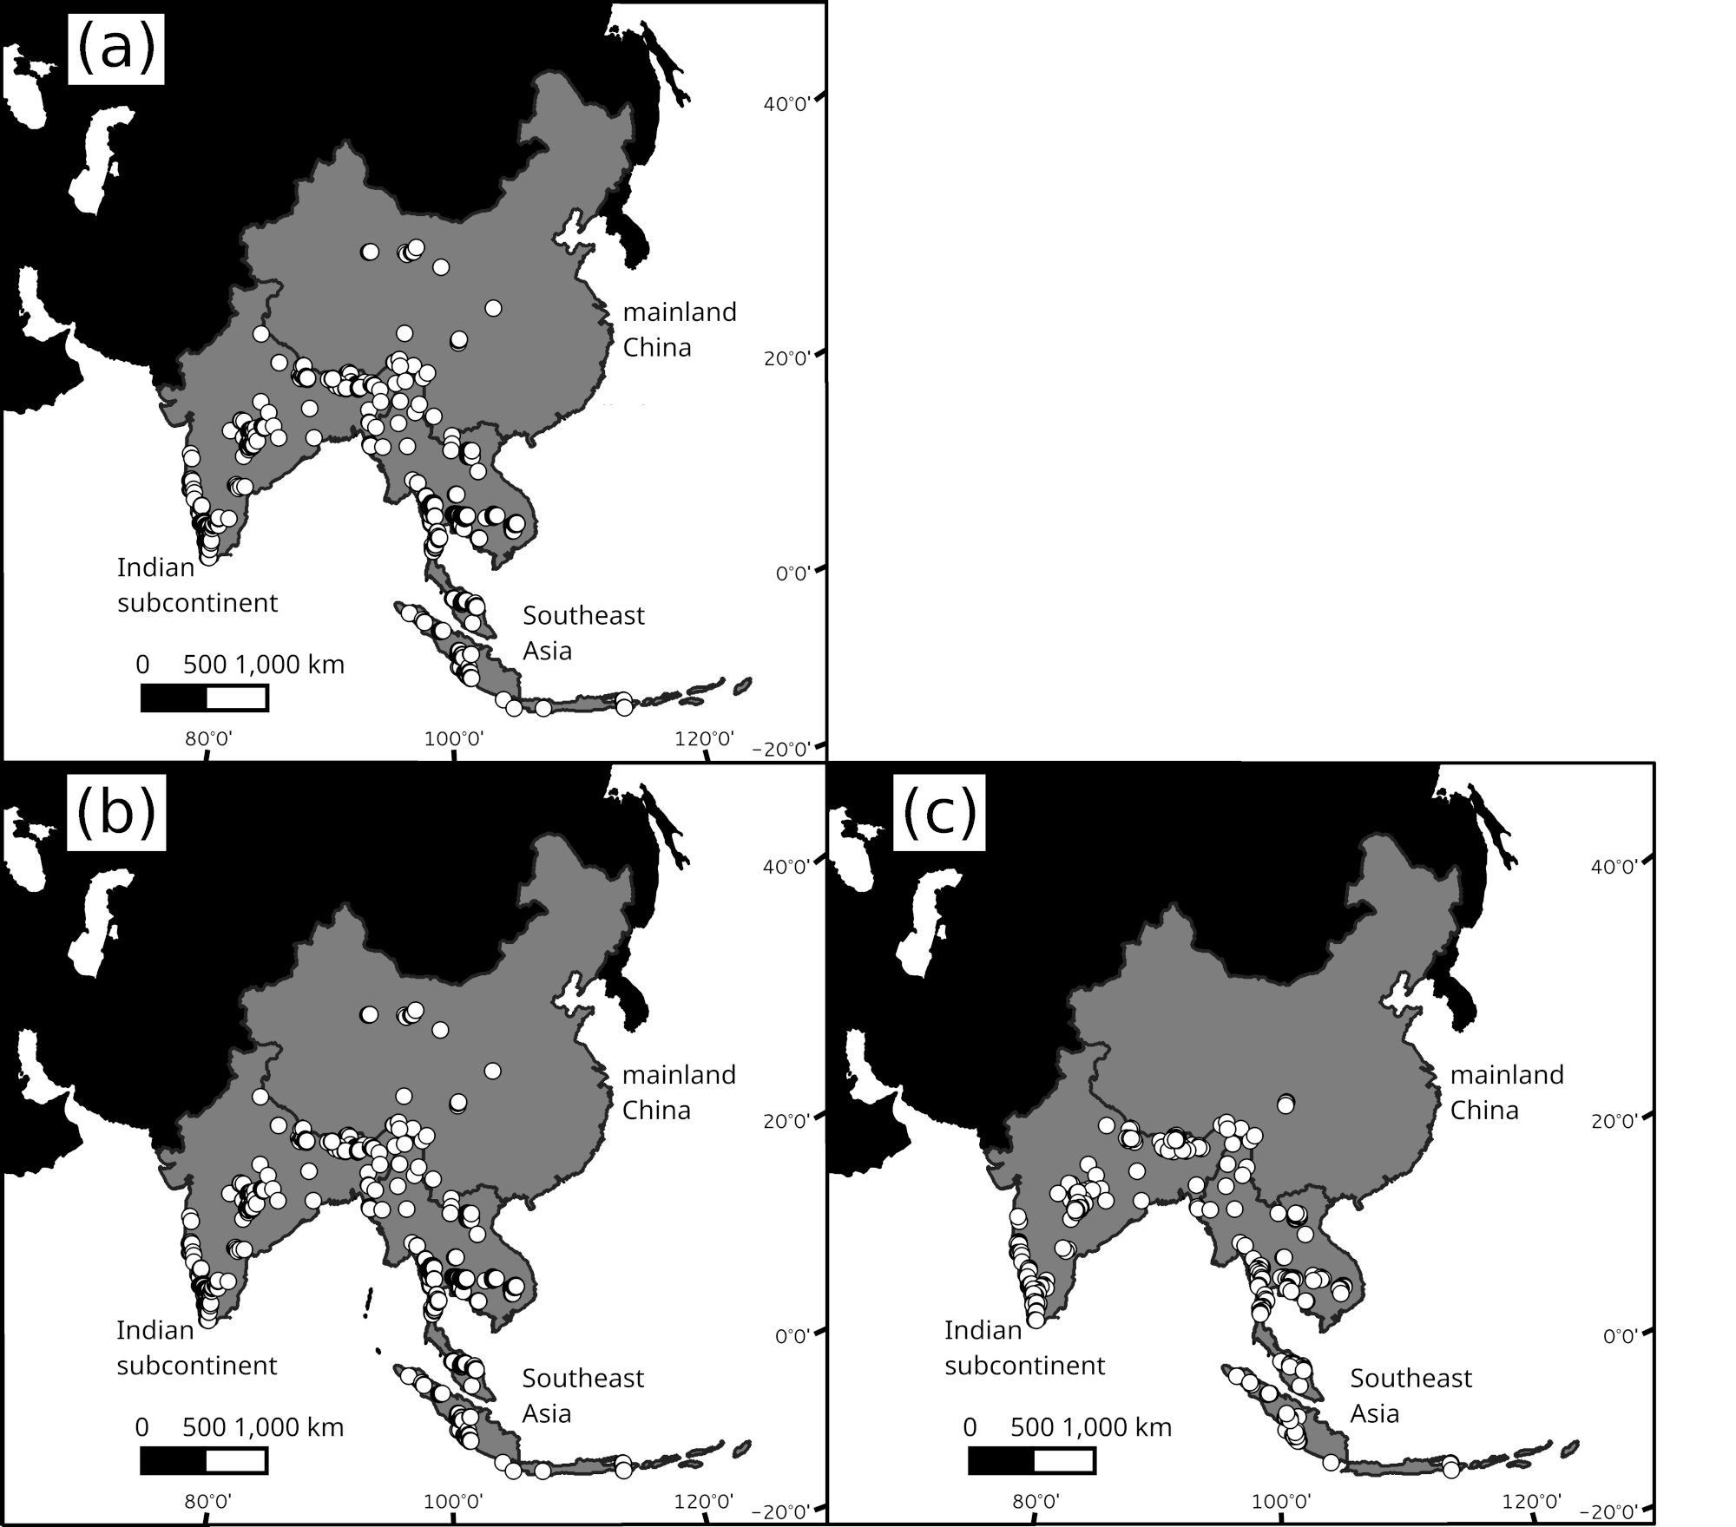
Supplementary Fig. 1 (a) Raw occurrence data for dholes Cuon alpinus used in the study, the occurrence data retained after spatial thinning that was used to train (b) the coarse-scale (8 km x 8 km) and (c) the fine-scale (2 km x 2 km) MaxEnt models.

Supplementary Table 2 Evaluation metrics of the 10 candidate models with the highest empirical support at a coarse-scale (8 x 8 km) and a fine-scale (2 x 2 km) resolution.
Rank | Feature types¹ | Regularization multiplier | AUC | AUC_{test} | AUC_{diff} | OR_{MTP} | AIC_{c} | Δ AIC_{c} | N Coef.
Coarse scale
1 | L,P,T | 1.5 | 0.96 | 0.93 | 0.03 | 0.03 | 6272.54 | 0.00 | 97
2 | L,Q,P,T | 1.5 | 0.96 | 0.93 | 0.03 | 0.03 | 6286.03 | 13.49 | 100
3 | P,T | 1.5 | 0.96 | 0.93 | 0.03 | 0.03 | 6286.64 | 14.10 | 101
4 | L,P,T | 2 | 0.95 | 0.93 | 0.03 | 0.03 | 6293.52 | 20.98 | 80
5 | Q,P,T | 1.5 | 0.96 | 0.93 | 0.03 | 0.03 | 6293.84 | 21.31 | 101
6 | Q,P,T | 2 | 0.95 | 0.93 | 0.03 | 0.03 | 6294.56 | 22.02 | 81
7 | P,T | 2 | 0.95 | 0.93 | 0.03 | 0.03 | 6299.10 | 26.56 | 82
8 | L,Q,P,T | 2 | 0.95 | 0.93 | 0.03 | 0.03 | 6300.99 | 28.45 | 81
9 | T | 1.5 | 0.96 | 0.93 | 0.03 | 0.02 | 6311.40 | 38.86 | 93
10 | P,T | 3 | 0.95 | 0.92 | 0.03 | 0.03 | 6324.44 | 51.90 | 61
Fine scale
1 | L,T | 1.5 | 0.82 | 0.75 | 0.07 | 0.03 | 7266.76 | 0.00 | 87
2 | L,T | 2 | 0.79 | 0.74 | 0.04 | 0.01 | 7271.92 | 5.16 | 58
3 | L,P,T | 1.5 | 0.83 | 0.76 | 0.08 | 0.05 | 7275.11 | 8.35 | 97
4 | Q,T | 1.5 | 0.82 | 0.75 | 0.08 | 0.03 | 7276.24 | 9.48 | 90
5 | L,Q,T | 1.5 | 0.82 | 0.75 | 0.07 | 0.03 | 7278.61 | 11.85 | 90
6 | L | 0.1 | 0.74 | 0.73 | 0.04 | 0.01 | 7279.27 | 12.51 | 27
7 | L | 1 | 0.74 | 0.73 | 0.04 | 0.01 | 7283.12 | 16.36 | 22
8 | L | 0.5 | 0.74 | 0.73 | 0.04 | 0.01 | 7286.43 | 19.68 | 27
9 | T | 2 | 0.80 | 0.74 | 0.05 | 0.02 | 7288.08 | 21.33 | 58
10 | L | 1.5 | 0.74 | 0.73 | 0.04 | 0.01 | 7288.81 | 22.05 | 22
¹L, linear; Q, quadratic; H, hinge; P, product; T, threshold.
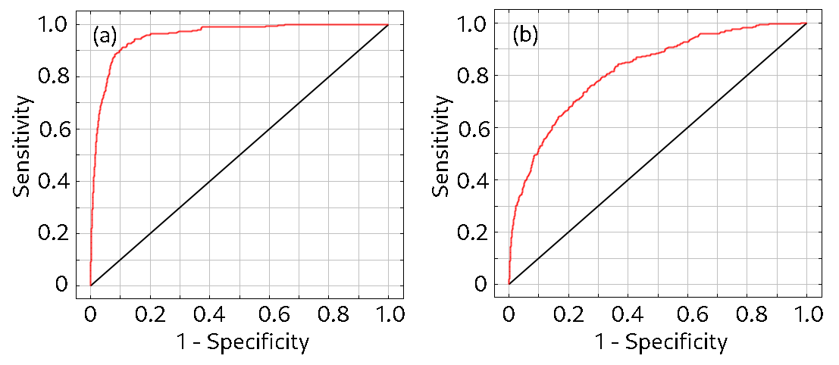
Supplementary Fig. 2 Receiver operating characteristic (ROC) curves for (a) the coarse-scale (8 x 8 km) MaxEnt model used to identify potential dhole range areas throughout Asia and (b) a fine scale (2 x 2 km) model used to quantify relative range suitability within these areas.
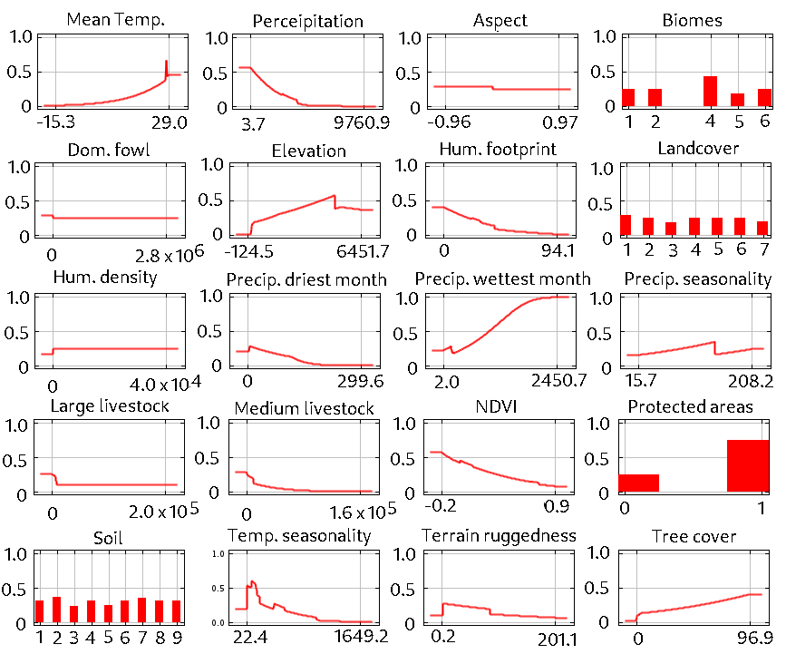
Supplementary Fig. 3 Marginal response curves for a coarse scale (8 km x 8 km) MaxEnt model used to identify potential dhole range areas throughout Asia. The response curves show how the predicted probability of presence changes as each environmental predictor is varied while keeping all other predictors constant.
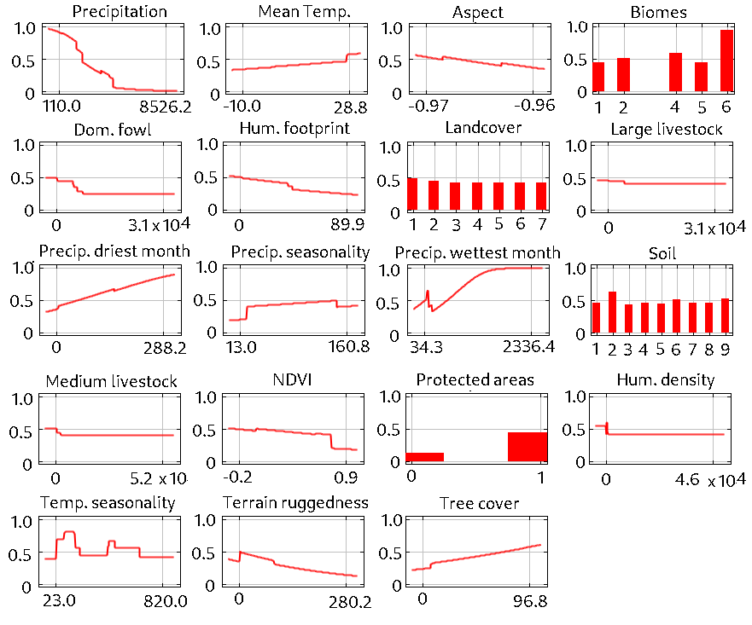
Supplementary Fig. 4 Marginal response curves for a fine scale (2 km x 2 km) model used to quantify relative range suitability within areas identified as suitable dhole range throughout Asia. The response curves show how the predicted probability of presence changes as each environmental predictor is varied while keeping all other predictors constant.

