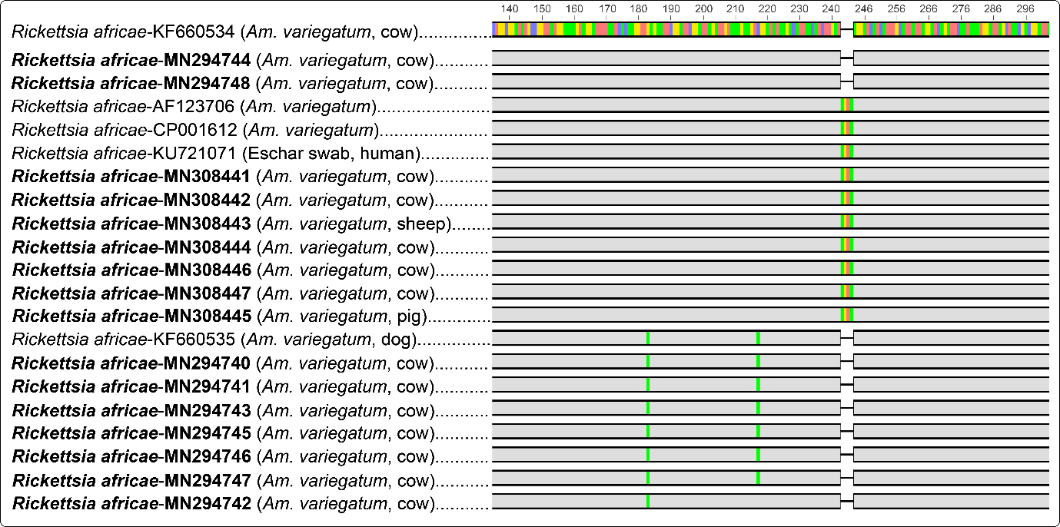
Supplementary Figure 2. Partial ompB gene sequences of Rickettsia africae obtained from this study aligned with GenBank reference sequences. Accession numbers of sequences from this study are in bold. Note the deletion mutation of a 4-base pair motif and several base substitutions in the sequences. Red = Adenine; Blue = Cytosine; Green = Thymine; Yellow = Guanine; Grey = consensus with R. africae reference

