Double celebration at spring graduation for UP doctoral couple
Posted on September 06, 2019
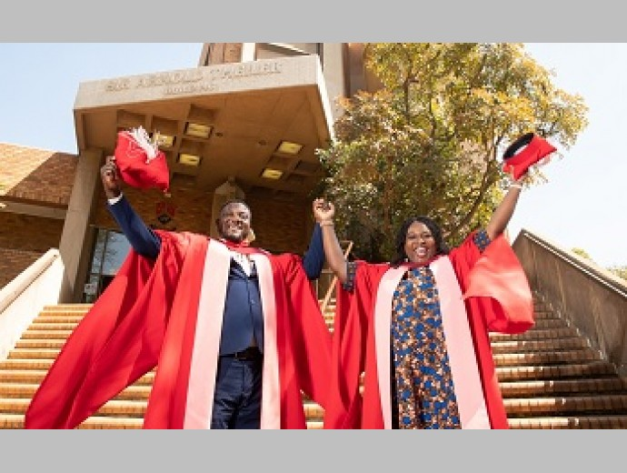
Dr Francis Kolo and Dr Agatha Kolo
It was a double celebration in the Kolo household when husband and wife Francis and Agatha graduated from the University of Pretoria’s (UP) Faculty of Veterinary Science this week with PhDs in Veterinary Science.
Dr Francis Kolo and his wife, Dr Agatha Kolo, met at the Usmanu Danfodiyo University, Sokoto in Nigeria, where they were studying Veterinary Science. “We met at the University in 1997, she was the only girl in our class of 20 boys, and I won her heart. We got married in 2005 after graduation,” said Francis.
He explained that his mother, Christiana Kolo, was a veterinary technician, meaning he grew up with animals around the house. Agatha was interested in health sciences but her father nudged her towards veterinary medicine.
They both did their master’s degrees at UP’s Department of Veterinary Tropical Diseases, where they are currently postdoctoral fellows. Francis obtained his master’s degree (cum laude) in 2016. His PhD was focused on the prevalence and characterisation of Brucella spp. in slaughter animals in Gauteng abattoirs. He looked at the risk of infection to humans from eating uncooked meat or drinking unpasteurised milk from infected animals. The study provided the first evidence of Brucella melitensis biovar 2 and 3 in cattle.
He said he chose this topic because he has a keen interest in the use of the “one-health approach” (looking at diseases that affect animals, humans and the environment) as a tool for the development and improvement of the quality of life of animals and the inhabitants of local communities in Africa.
Agatha, on the other hand, focused her PhD project on the use of next generation sequencing (NGS) techniques to detect zoonotic bacterial pathogens. “NGS is a new method for sequencing genomes at high speed and depths at relatively cost-effective prices. A genome is the total set of genes present in a cell or organism,” she explained. Her research interests lie in the molecular epidemiology of zoonotic vector-borne pathogens. “I have also always loved parasitology from my undergraduate days,” she explained.
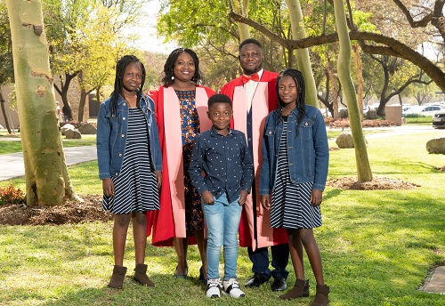
The Kolo family
What was it like doing their PhDs together?
Francis said it was challenging as they were studying and “taking care of three kids”.
“We encouraged each other as a family, and as a firm believer in girl child education, I was motivated to see that my wife reached her full potential with regards to education. Her self-gratification is very important, because education empowers women and this has a good feedback effect on society as a whole.”
For Agatha, the experience was also the cause of emotional, mental and financial strain. “Being a wife and mother of three young kids was especially challenging, trying to ensure that the children’s well-being was not neglected and all their needs were met. We made a lot of sacrifices and gave up some creature comforts to move the family to South Africa. We had each other to depend on though because you know what your partner is going through and we always try to help each other out in whatever challenges each person is facing at a time.”
“Nothing is as difficult as it seems, when you try, you realise it is not that difficult after all,” said Francis.
It is important to study Veterinary Science because the animal populations on the planet must be kept healthy. Food animals are important as they provide animal protein for those who eat meat.
“As a one-health practitioner, it is imperative to protect humans from being infected with animal diseases, as such, when vets control diseases in animals, we apparently control the disease in humans too,” explained Francis.
Do they talk about animals at the dinner table and what are their favourite animals?
“It depends on the circumstances, but we generally unwind when we get home to focus on the kids and their schoolwork. We discuss current affairs and happenings around us and never miss an episode of the soapie Scandal,” laughed Agatha, who said her favourite animal is the giraffe. “Nothing beats the tall elegance of this creature.”
For Francis, man's best friend, the dog, is his favourite.
Professor Marinda Oosthuizen, Deputy Dean: Research and Postgraduate Studies at UP’s Faculty of Veterinary Science, said: “It is indeed a wonderful occasion that Agatha and Francis are graduating together. I think for them it is a dream come true. I was Agatha's supervisor along her PhD journey and I stand very proud today. During her studies she has grown into a strong and independent researcher and I wish her only the best for a bright and very successful future.”
The Faculty of Veterinary Science is the only Veterinary Faculty in South Africa and the leading Veterinary Faculty in Africa. It is ranked within the top 50 veterinary schools in the world. The Faculty has a proud tradition of training professionals to promote animal health that impacts directly on human health, thereby stimulating economic growth and food security. In 2019, it graduated 18 PhDs, thereby continuing to contribute greatly to the veterinary needs not of only South Africa, but those of countries further afield as well.
Author Primarashni Gower
Published by Hlengiwe Mnguni

