Supplementary Materials

Original paper:
How much does light pollution alter vector-disease transmission at scale?
Bernard W.T. Coetzee¹* & Layla van Zyl¹
¹Department of Zoology & Entomology, University of Pretoria, Private Bag 20, Hatfield, 0028, South Africa. *Correspondence: bernard.coetzee@up.ac.za

Materials and methods
Parameterization – Biological data
To obtain data on the reduction of biting due to artificial light, we tested under laboratory conditions, how exposure to different household lights (namely compact fluorescent lights (CFL), light-emitting diodes (LED) and incandescent lights), alters the percentage of Anopheles funestus feeding (van Zyl et al. 2024, Unpublished). Mated, unfed female mosquitoes were exposed to a light treatment, at the onset of darkness, followed by a blood feeding assay.
Zeitgeber time (ZT) was used, where ZT0 indicates the start of the ‘sunrise’ transition period and ZT12 the start of the ‘sunset’ transition period when lights start a dimming cycle. A sample of 400-500 individuals was isolated from the colonies using a hand-held aspirator and placed into cages (NHBS, 2022b). The individuals were then starved of sugar-water for 24 hours before the start of the experiment. The cage was placed in a plastic bag, placing 4 damp cotton balls on top of the cage as a source of humidity in the plastic bag, to help prevent mortality as a result of desiccation prior to the start of the experiment. These individuals were then divided among five small bug dorms (NHBS, 2022a) to each contain 80-100 individuals. We assumed a 50:50 sex ratio and as such each cage contained 40-50 mated, unfed females. To determine the effect of lighting conditions on the percentage of females feeding, we followed existing protocols from the National Institute for Communicable Diseases, which considers individuals independent was used, and as such each cage contained 40-50 independent samples. The bug dorms were placed onto shelves in the experimental room, where the mosquitoes were exposed to their normal ‘sunset’ transition period from ZT12 to ZT12.30. Once complete darkness had set in at ZT12.30 and the mosquitoes had entered their night phase, the bug dorms were placed into the experimental containers, for 1 hour of acclimation from ZT12.30 to ZT13.30. The experimental containers containing their individual treatments of either no light bulb, LED bulb, CFL bulb, incandescent bulb as well as a bug dorm placed on the bench outside the experimental containers were then exposed to their treatments from ZT13.30 to ZT14.00. The experimental container with no light bulb served as a control for the light treatments (hereafter referred to as “light control”), showing what the baseline feeding is in the absence of a light treatment. The bug dorm placed on the bench outside of the experimental containers served as a control for the experimental containers themselves (hereafter referred to as “container control”). The container control served to show that the experimental containers themselves did not inhibit feeding, by allowing comparison of the feeding seen in the absence of an experimental container and light treatment (i.e. the Container control) and the feeding seen in an experimental container in the absence of a light treatment (i.e. the light control experimental container). Therefore, near identical feeding in the container control and the light control experimental container is desired in order to show that the experimental containers are suitable for this experiment. In order to further determine whether the experimental containers are suitable for this experiment, Thermochron I-buttons (Thermochron, 2022) were deployed for a period prior to the start of the experiment, during the experimental period as well as for a period after the end of the experiment in order to measure temperature and humidity (data not shown). During the period of monitoring prior to the start of the experimental period from ZT10 to ZT12 the mosquitoes were aspirated out of the large bug dorms and the experiment was set up, and as such this period served as a calibration period as there was external influences on temperature such as movement and opening of doors. The period of monitoring during the experimental period from ZT12 to ZT14.30 was used to establish whether the light bulbs or experimental containers create an unsuitable environment for the mosquitoes. The short period of monitoring following the experimental period from ZT14.30 to ZT15 served to see whether temperature and humidity recover to pre-experimental conditions. A total of six biological replicates were run to maximise confidence in the results and minimize the effect of human error on the observed patterns, yielding a total sample size of 1656 females.
Immediately after the light treatments, a feeding assay (National Institute for Communicable Diseases, 2022) using the Hemotek membrane feeding system for blood sucking insects (Hemotek® model PS6240, Hemotek Ltd, United Kingdom) was performed. Parafilm was used to cover the feeder plates, defibrinated cattle blood from an accredited abattoir was then added to the plates and the feeder plates were then connected to the heating unit set to 37 °C. The feeder plates were then placed on top of the bug dorms and feeding allowed to take place for 30 minutes in complete darkness. Mosquitoes were then aspirated out of their bug dorms and into paper cups covered by netting and placed into a freezer set to 4°C for 20 minutes to immobalize them. The number of “fed” and “unfed” females were then counted by tipping the mosquitos into a petri dish and examining their abdomen for the presence of blood (Rund et al., 2020). This study was approved by the Faculty of Natural and Agricultural Sciences Research Ethics Committee of the University of Pretoria (reference number NAS115/2022).

Parameterization– Artificial light data
To obtain data on how households across Africa use artificial light, the native range of Anopheles funestus, we used the Environmental Light Field technique - ELF (Nilsson & Smolka, 2021). We extracted data from exemplar households at three project sites during 2023 (South Africa, Mozambique and Uganda). Rather than exact measurements of household lights, the data represents a model itself of whole light intensities, of how artificial lights are typically used in households and at what intensities, as an average across a room. The ELF method uses a calibrated digital camera sensor together with a wide-angle lens to quantify the amount of radiance that reaches the eye of an observer in that specific environment. The widths of the spectral channels of RGB camera sensors is similar to that of animal vision resulting in similar spectral resolution, thus making RGB cameras suitable for the measurement of light in a way similar to which the eyes detect it. Therefore, this method allows for the quantification of biologically relevant light information as it measures the light that organisms would detect. ELF can be used to take photographs from various positions in an environment, and is then used to construct three graphs (Figure 2) that describe the light environment. As light sources are mostly found above the horizontal plane, light can be expected to vary with elevation angle. Therefore, the change in spectral photon radiance (or absolute light intensity) in relation to the elevation angle as shown in Figure 2B is determined. Light within an elevation angle is variable and comprises an array of radiances. The median radiance is used in Figure 2B as this is less likely to be highly affected by single bright light sources, and a range of radiances is then calculated for each elevation gradient as shown in Figure 2C. This range is important as to is related to visual contrasts within the environment and influences the visual perception of the light environment. Figure 2D describes the spectral composition of the light environment at the different elevation angles by showing the relative contributions of the red, green and blue spectral channels.
Model overview
The AnophelesModel package facilitates the parameterization of a mosquito feeding cycle model by incorporating data on mosquito bionomics, biting patterns, human activity, and intervention effects. Extracted from field studies, the package includes various types of data. It integrates real-world entomological data on feeding, host seeking, resting, and oviposition rates, to refine models for evaluating intervention impacts based on actual species and location-specific characteristics. The model assesses the species-specific effects of vector control interventions on vectorial capacity, allowing comparison across mosquito species and the generation of parameterizations for entomological and vector control components in more intricate models of malaria transmission dynamics. Full methods can be found here: https://swisstph.github.io/AnophelesModel/articles/AnophelesModel.html and preprint (Golumbeanu et al., 2023).
Built upon a state transition model from (Chitnis et al., 2008), the AnophelesModel package employs three difference equations to describe the dynamics of not-infected, infected, and infective mosquitoes in a population biting hosts. The transitions within the feeding cycle are represented by probabilities, including host seeking, host found, feeding, resting, ovipositing, and egg development. By estimating the probable reduction of biting propensity, here as a consequence of measured reductions due to artificial light, following (Chitnis et al., 2008), one can alter the PBi parameter, or the probability that a mosquito bites a host of type i after encountering a host of type i. 0 <PBi < 1. The model depicts how a range of lights at different intensities, may reduce biting propensity.
These probabilities, depicted as arrows in Figure 1, are influenced by mosquito ecology, human behavior, and interventions. The documentation outlines various use cases with examples, starting with a general analysis workflow. It covers the package database, data objects, and provides detailed examples of using package functions. Users can learn how to parameterize the embedded entomological model, assess the impact of vector control interventions across mosquito species and locations, and format inputs for downstream analyses with the OpenMalaria individual-based model of malaria transmission dynamics (Smith et al., 2006).

References
Chitnis, N., Smith, T., & Steketee, R. (2008). A mathematical model for the dynamics of malaria in mosquitoes feeding on a heterogeneous host population. Journal of Biological Dynamics, 2(3), 259–285. https://doi.org/10.1080/17513750701769857
Golumbeanu, M., Briët, O., Champagne, C., Lemant, J., Winkel, M., Zogo, B., Gerhards, M., Sinka, M., Chitnis, N., Penny, M., Pothin, E., & Smith, T. (2023). AnophelesModel: An R package to interface mosquito bionomics, human exposure and intervention effects with models of malaria intervention impact [Preprint]. Ecology. https://doi.org/10.1101/2023.10.17.562838
Nilsson, D.-E., & Smolka, J. (2021). Quantifying biologically essential aspects of environmental light. Journal of The Royal Society Interface, 18(177), rsif.2021.0184, 20210184. https://doi.org/10.1098/rsif.2021.0184
Smith, T., Killeen, G. F., Maire, N., Ross, A., Molineaux, L., Tediosi, F., Hutton, G., Utzinger, J., Dietz, K., & Tanner, M. (2006). Mathematical modeling of the impact of malaria vaccines on the clinical epidemiology and natural history of Plasmodium falciparum malaria: Overview. The American Journal of Tropical Medicine and Hygiene, 75(2 Suppl), 1–10. https://doi.org/10.4269/ajtmh.2006.75.2_suppl.0750001

Figures
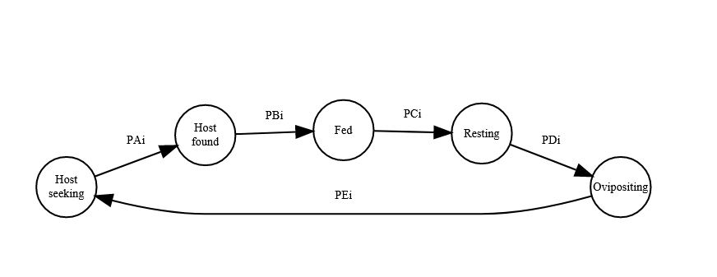
Figure 1. General model workflow.

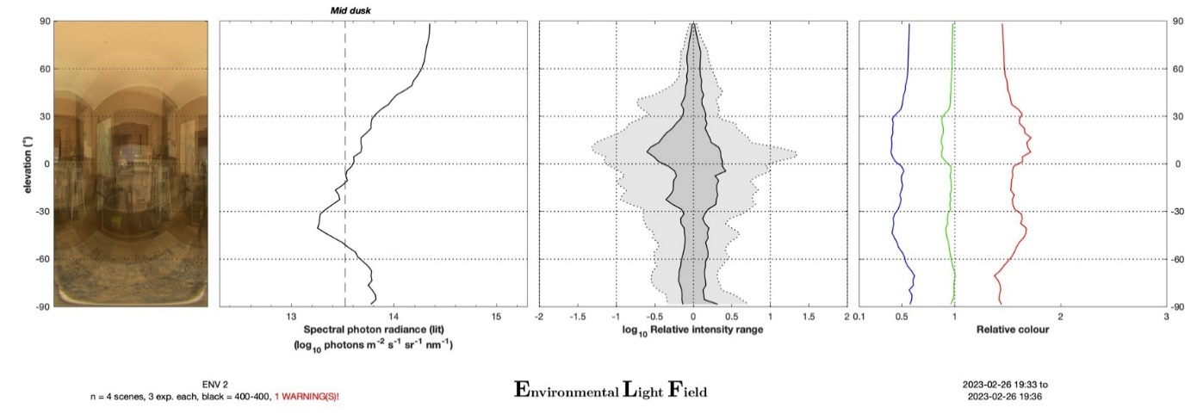
A
B
C
D

Figure 2. ELF chart of an environment, showing the vertical light gradients of the light environment. To characterize this environment images were taken from 4 different positions. (A) Average image of the environment consisting of the images taken from all positions. The graphs show elevation angle versus: (B) intensity (absolute log scale), (C) the intensity range (relative log scale), (D) the contribution of the red, green and blue spectral channels (relative log scale) to the spectral composition of the light environment.

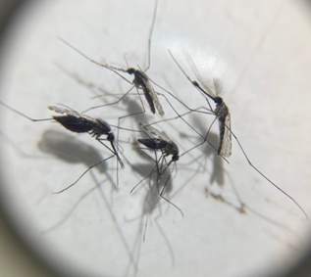
Figure 3. Petri dish with the anaesthetized mosquitoes prior to counting. Image shows the four statuses, including, from the left, a fully fed, unfed, partially fed female as well as a male mosquito.

