The role of hyperthermia in avian tolerance of hot and humid conditions

Additional information

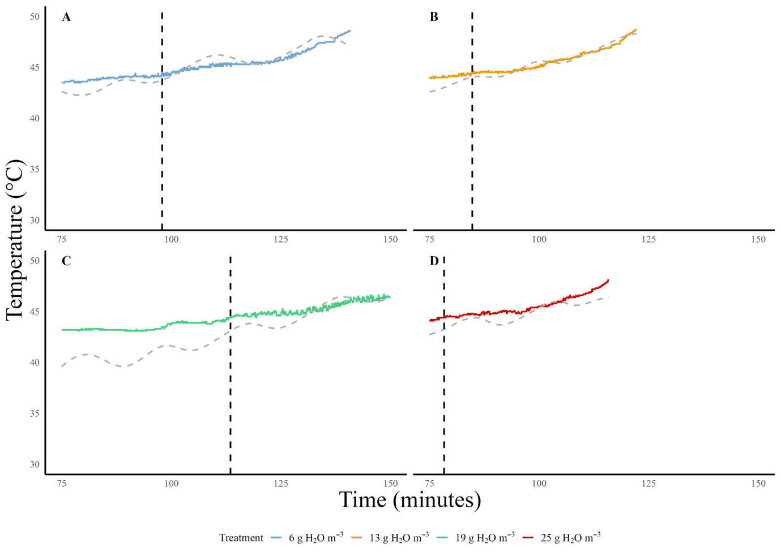
Figure S1 Time series of body temperature (T_{b}) and air temperature (T_{air}) for representative red-billed queleas (Quelea quelea) exposed to increasing T_{air} under four different humidity treatments. Body temperature is shown as a coloured solid line for each treatment: Panel A - 6 g H₂O m⁻³ (blue), Panel B - 13 g H₂O m⁻³ (orange), Panel C - 19 g H₂O m⁻³ (green), and Panel D - 25 g H₂O m⁻³ (red). Vertical black dashed lines indicate the time at which each bird first reached T_{b} = 44.5 °C. Air temperature is plotted as a grey dashed line.

Figure S2 Segmented linear relationship between a.) body temperature (T_{b}), b.) evaporative water loss (EWL), c.) resting metabolic rate (RMR) and d.) evaporative cooling efficiency (EHL/MHP) with air temperature (T_{air}) over four different treatments of humidity [6g m⁻³ (gold line), 13g m⁻³ (green line), 19g m⁻³ (light blue line), 25 g m⁻³ (dark blue line)] in red-billed queleas (Quelea quelea). The dashed line in a.) shows T_{b} = T_{air}.

Table S1.1 Summary of thermoregulatory performance as a function of chamber air temperature (T_{a}) and four absolute humidity treatments (6g m⁻³, 13g m⁻³, 19g m⁻³, 25 g m⁻³) for red-billed quelea (Q.quelea). T_{b} = body temperature, T_{air} = ambient temperature, RMR = resting metabolic rate, EWL = evaporative water loss, EHL= evaporative heat loss, MHP = metabolic heat production. Means, SD and N are reported. Humidity treatment birds (6g m⁻³, 13g m⁻³, 19g m⁻³, 25 0g m⁻³) began respirometry protocols at T_{air} = 34 °C.
 |  | Variable | 6 g m⁻ ³ | 13 g m⁻ ³ | 19 g m⁻ ³ | 25 g m⁻ ³
Body mass (g) |  |  | 17.3±0.6 (10) | 17.8±1.2 (10) | 17.1±0.8 (10) | 17.2±0.5 (10)
Sex ratio (Male;Female) |  |  | 7;3 | 6;4 | 5;5 | 4;6
Body temperature
 |  | Min. T_{b} (°C) | 41.2±0.5 (10)* | 40.9±0.7* | 41.0±0.7 (10)* | 41.2±0.7 (10)*
 |  | Inflection 1
 |  | Inflection T_{air} (°C) | ~34.0 | <34.0 | <34.0 | <34.0
 |  | T_{b} versus T_{air} slope (°C) | 0.31 | 0.28 | 0.39 | 0.28
 |  | Inflection 2
 |  | Second inflection T_{air} (°C) | 45.2 | 45.2 | 44.8 | 43.9
 |  | Second T_{b} versus T_{air} slope (°C) | 1.06 | 0.93 | 0.88 | 0.91
 |  | Max T_{b} (°C) | 48.7±0.2 (10) | 48.6±0.4 (10) | 48.6±0.7 (10) | 48.4±0.2 (10)
 |  | Max T_{air} (°C) | 48.3±0.8 (10) | 49.8±0.8 (10) | 48.1±1.1 (10) | 47.8±0.9 (10)
 |  | T_{b} at onset of panting (°C) | 43.8±1.1 (10) | 41.8±0.6 (10) | 42.1±0.6 (10) | 42.05±0.5 (10)
 |  | T_{a} at onset of panting (°C) | 38.9±1.3 (10) | 37.7±0.7 (10) | 37.4±0.7 (10) | 37.8±0.7 (10)
Resting metabolic rate
(RER = 0.71)
 |  | Min. RMR (W) | 0.3±0.04 (10) | 0.3±0.02 (10) | 0.3±0.04 (10) | 0.3±0.04 (10)
 |  | T_{uc} (°C) | 43.6 | 43.1 | 41.9 | 41.4
 |  | RMR slope (mW °C⁻¹) | 31.1 | 24.02 | 19.9 | 28.0
 |  | Max. RMR (W) | 0.5±0.1 (7) | 0.5±0.1 (10) | 0.5±0.1 (6) | 0.5±0.1 (7)
 |  | Max. RMR/min. RMR | 1.7 | 1.7 | 1.7 | 1.7
Evaporative water loss
 |  | Min. EWL (g h⁻¹) | 0.1±0.1 (10) | 0.1±0.02 (10) | 0.1±0.03 (10) | 0.1±0.03 (10)
 |  | Inflection T_{a} (°C) | ~34.2 | ~34.8 | ~35.6 | < 34
 |  | EWL slope 1 (g h⁻¹ °C⁻¹) | 0.06 | 0.07 | 0.07 | 0.05
 |  | Max. EWL (g h⁻¹) | 0.9±0.2 (7) | 1.0 (1)  0.9±0.07 (10) | 0.9±0.2 (10) | 0.8±0.2 (7)
 |  | Max. EWL/min. EWL | 9.0 | 10.0 | 9.0 | 8.0
Evaporative cooling efficiency (EHL/MHP)
 | Min. EHL/MHP |  | 0.4±0.1 (10) | 0.2±0.1 (10) | 0.2±0.1 (10) | 0.3±0.1 (10)
 |  | EHL/MHP inflection T_{a} - T_{b} | -6.6 | -5.7 | -6.2 | -6.4
 |  | EHL/MHP slope | 0.15 | 0.15 | 0.19 | 0.20
 |  | Inflection 2
 |  | Second EHL/MHP inflection T_{a} - T_{b} | NA | NA | -1.23 | -0.72
 |  | Second EHL/MHP slope | NA | NA | 0.02 | -0.02
 |  | Second EHL/MHP inflection T_{a} | 44.8 | 44.5 | 43.7 | 43.8
 |  | Second EHL/MHP inflection T_{a} Slope | -0.06 | -0.005 | -0.05 | -0.05
 |  | Max. EHL/MHP | 1.4±0.2 (10) | 1.5±0.2 (10) | 1.3±0.2 (10) | 1.3±0.2 (7)

Table S1.2 Mass-specific resting metabolic rates (RMR) and evaporative water loss (EWL) rate at high T_{a} in red-billed Quelea subjected to four treatments of varying absolute humidity. Means, SD and N are reported
 | Variable |  | 6 g m⁻ ³ | 13 g m⁻ ³ | 19 g m⁻ ³ | 25 g m⁻ ³
RMR
 | Min. RMR (mW g⁻¹) |  | 15.6±2.2 (10) | 14.7±1.4 (10) | 16.4±2.7 (10) | 16.1±2.1 (10)
 | RMR slope (mW g⁻¹ °C⁻¹) |  | 1.8 | 1.7 | 1.4 | 0.7
 | Max. RMR (mW g⁻¹) |  | 27.8±4.7 (7) | 32.1 (1)  16.8±6.0 (10) | 27.2±4.4(6) | 27.7±5.3 (7)
 | Min. EWL (mg h⁻¹ g⁻¹) |  | 8.2±2.8 (10) | 5.0±1.3 (10) | 5.7±2.0 (10) | 8.0±1.5 (10)
 | EWL slope (mg h⁻¹ g⁻¹ °C⁻¹) |  | 3.6 | 2.18 | 4.11 | 3.63
 |  | Max. EWL (mg h⁻¹ g⁻¹) | 51.8±7.2 (7) | 60.3 (1)  57.4±10.0 (10) | 52.4±8.1 (10) | 45.9±11.9 (7)

Table S2.1 Tukey HSD post-hoc test comparing maximum body temperature values (T_{b}max) for Q.quelea exposed to increasing T_{air} at four different absolute humidity treatments (6, 13, 19 and 25 g m⁻ ³). Significant difference is indicated by bold p-values (p<0.05). Upper and lower confidence limits (95%) of the honest significant difference (HSD) are provided.
 | HSD | 95% CI  lower | 95% CI  upper | p-value
6gm⁻³ vs. 13gm⁻³ | 0.1 | -0.36 | 0.56 | 0.94
6gm⁻³ vs. 19gm⁻³ | 0.04 | -0.43 | 0.51 | 0.99
6gm⁻³ vs. 25gm⁻³ | 0.34 | -0.13 | 0.80 | 0.22
13gm⁻³ vs. 19gm⁻³ | -0.06 | -0.53 | 0.41 | 0.99
13gm⁻³ vs. 25gm⁻³ | 0.24 | -0.23 | 0.71 | 0.52
19gm⁻³ vs. 25gm⁻³ | 0.3 | -0.17 | 0.77 | 0.33

Table S2.2 Tukey HSD post-hoc test comparing heat tolerance limit (HTL) for Q.quelea exposed to increasing T_{air} at four different absolute humidity treatments (6, 13, 19 and 25 g m⁻ ³). Significant difference is indicated by bold p-values (p<0.05). Upper and lower confidence limits (95%) of the honest significant difference (HSD) are provided.
 | HSD | 95% CI  lower | 95% CI  upper | p-value
6gm⁻³ vs. 13gm⁻³ | -0.99 | -1.99 | 0.02 | 0.06
6gm⁻³ vs. 19gm⁻³ | 0.25 | -0.76 | 1.26 | 0.91
6gm⁻³ vs. 25gm⁻³ | 0.45 | -0.56 | 1.46 | 0.64
13gm⁻³ vs. 19gm⁻³ | 1.24 | 0.23 | 2.25 | 0.01
13gm⁻³ vs. 25gm⁻³ | 1.43 | 0.42 | 2.44 | <0.01
19gm⁻³ vs. 25gm⁻³ | 0.19 | -0.81 | 1.20 | 0.95

Table S2.3 Tukey HSD post-hoc test comparing maximum rates of evaporative water loss (EWL) for Q.quelea exposed to increasing T_{air} at four different absolute humidity treatments (6, 13, 19 and 25 g m⁻ ³). Significant difference is indicated by bold p-values (p<0.05). Upper and lower confidence limits (95%) of the honest significant difference (HSD) are provided.
 | HSD | 95% CI lower | 95% CI upper | p-value
6gm⁻³ vs. 13gm⁻³ | -0.1 | -0.35 | 0.15 | 0.69
6gm⁻³ vs. 19gm⁻³ | 0 | -0.25 | 0.25 | 1
6gm⁻³ vs. 25gm⁻³ | 0.1 | -0.17 | 0.37 | 0.75
13gm⁻³ vs. 19gm⁻³ | 0.1 | -0.13 | 0.33 | 0.63
13gm⁻³ vs. 25gm⁻³ | 0.2 | -0.05 | 0.45 | 0.15
19gm⁻³ vs. 25gm⁻³ | 0.1 | -0.15 | 0.35 | 0.70

Table S2.4 Tukey HSD post-hoc test comparing maximum rates of resting metabolic rate (RMR) for Q.quelea exposed to increasing T_{air} at four different absolute humidity treatments (6, 13, 19 and 25 g m⁻ ³). Significant difference is indicated by bold p-values (p<0.05). Upper and lower confidence limits (95%) of the honest significant difference (HSD) are provided.
 | HSD | 95% CI lower | 95% CI upper | p-value
6gm⁻³ vs. 13gm⁻³ | 0 | -0.14 | 0.14 | 1
6gm⁻³ vs. 19gm⁻³ | 0 | -0.15 | 0.15 | 1
6gm⁻³ vs. 25gm⁻³ | 0 | -0.15 | 0.15 | 1
13gm⁻³ vs. 19gm⁻³ | 0 | -0.14 | 0.14 | 1
13gm⁻³ vs. 25gm⁻³ | 0 | -0.14 | 0.14 | 1
19gm⁻³ vs. 25gm⁻³ | 0 | -0.16 | 0.15 | 1

Table S2.5 Tukey HSD post-hoc test comparing maximum rates of maximum values of evaporative cooling efficiency (EHL/MHP) for Q.quelea exposed to increasing T_{air} at four different absolute humidity treatments (6, 13, 19 and 25 g m⁻ ³). Significant difference is indicated by bold p-values (p<0.05). Upper and lower confidence limits (95%) of the honest significant difference (HSD) are provided.
 | HSD | 95% CI lower | 95% CI upper | p-value
6g m⁻³ vs. 13 g m⁻³ | -0.1 | -0.34 | 0.14 | 0.68
6 g m⁻³ vs. 19 g m⁻³ | 0.1 | -0.14 | 0.34 | 0.68
6 g m⁻³ vs. 25 g m⁻³ | 0.1 | -0.17 | 0.36 | 10.74
13 g m⁻³ vs. 19 g m⁻³ | 0.2 | -0.04 | 0.44 | 1
13 g m⁻³ vs. 25 g m⁻³ | 0.2 | -0.07 | 0.46 | 1
19 g m⁻³ vs. 25 g m⁻³ | 0 | -0.26 | 0.26 | 1

Table S3.1 Pairwise t-test comparing slope 1 of body temperature ~ T_{air} for Q.quelea at four different absolute humidity treatments (6, 13, 19 and 25 g m⁻ ³). Significant difference is indicated by bold p-values (p<0.05). Test statistics, degrees of freedom (df), sample size for each treatment (n), p-value and adjusted p-value (Bonferroni correction) are provided.
Treatment 1 | Treatment 2 | n1 | n2 | t-statistic | df | p-value | adjusted p-value
13 g m⁻³ | 19 g m⁻³ | 56 | 50 | -3.94 | 98.98 | 0.000 | 0.001
13 g m⁻³ | 25 g m⁻³ | 56 | 56 | -1.67 | 109.58 | 0.098 | 0.68
13 g m⁻³ | 6 g m⁻³ | 56 | 58 | -1.78 | 111.99 | 0.077 | 0.46
19 g m⁻³ | 25 g m⁻³ | 50 | 56 | 2.30 | 101.27 | 0.023 | 0.09
19 g m⁻³ | 6 g m⁻³ | 50 | 58 | 2.26 | 101.30 | 0.026 | 0.15
25 g m⁻³ | 6 g m⁻³ | 56 | 58 | -0.08 | 111.70 | 0.94 | 1.000

Table S3.2 Pairwise t-test comparing slope 2 of body temperature ~ T_{air} for Q.quelea at four different absolute humidity treatments (6, 13, 19 and 25 g m⁻ ³). Significant difference is indicated by bold p-values (p<0.05). Test statistics, degrees of freedom (df), sample size for each treatment (n), p-value and adjusted p-value (Bonferroni correction) are provided.
Treatment 1 | Treatment 2 | n1 | n2 | t-statistic | df | p-value | adjusted p-value
13 g m⁻³ | 19 g m⁻³ | 31 | 26 | -1.60 | 54.89 | 0.115 | 1
13 g m⁻³ | 25 g m⁻³ | 31 | 28 | -1.25 | 55.85 | 0.216 | 1
13 g m⁻³ | 6 g m⁻³ | 31 | 28 | -1.22 | 56.98 | 0.229 | 1
19 g m⁻³ | 25 g m⁻³ | 26 | 28 | 0.42 | 51.47 | 0.675 | 1
19 g m⁻³ | 6 g m⁻³ | 26 | 28 | 0.33 | 51.80 | 0.742 | 1
25 g m⁻³ | 6 g m⁻³ | 28 | 28 | -0.06 | 52.61 | 0.954 | 1

Table S3.3 Pairwise t-test comparing evaporative water loss (EWL) ~ T_{air} for Q.quelea at dry air (0 g m⁻ ³) and four different absolute humidity treatments (6, 13, 19 and 25 g m⁻ ³). Significant difference is indicated by bold p-values (p<0.05). Test statistics, degrees of freedom (df), sample size for each treatment (n), p-value and adjusted p-value (Bonferroni correction) are provided.
Treatment 1 | Treatment 2 | n1 | n2 | t-statistic | df | p-value | adjusted p-value
13 g m⁻³ | 19 g m⁻³ | 80 | 66 | -0.36 | 142.24 | 7.18E-01 | 1
13 g m⁻³ | 25 g m⁻³ | 80 | 78 | 0.72 | 153.12 | 4.70E-01 | 1
13 g m⁻³ | 6 g m⁻³ | 80 | 79 | 0.75 | 154.02 | 4.53E-01 | 1
19 g m⁻³ | 25 g m⁻³ | 66 | 78 | 1.11 | 133.73 | 2.71E-01 | 1
19 g m⁻³ | 6 g m⁻³ | 66 | 79 | 1.13 | 134.55 | 2.59E-01 | 1
25 g m⁻³ | 6 g m⁻³ | 78 | 79 | 0.03 | 154.99 | 9.73E-01 | 1

Table S3.4 Pairwise t-test comparing resting metabolic rate (RMR) ~ T_{air} for Q.quelea at dry air (0 g m⁻ ³) and four different absolute humidity treatments (6, 13, 19 and 25 g m⁻ ³). Significant difference is indicated by bold p-values (p<0.05). Test statistics, degrees of freedom (df), sample size for each treatment (n), p-value and adjusted p-value (Bonferroni correction) are provided.

Treatment 1 | Treatment 2 | n1 | n2 | t-statistic | df | p-value | adjusted p-value
13 g m⁻³ | 19 g m⁻³ | 21 | 36 | 1.50 | 40.32 | 0.14 | 1
13 g m⁻³ | 25 g m⁻³ | 21 | 38 | 2.24 | 39.58 | 0.31 | 0.308
13 g m⁻³ | 6 g m⁻³ | 21 | 28 | 1.84 | 39.35 | 0.07 | 0.73
19 g m⁻³ | 25 g m⁻³ | 36 | 38 | 0.87 | 71.76 | 0.39 | 1
19 g m⁻³ | 6 g m⁻³ | 36 | 28 | 0.42 | 60.58 | 0.68 | 1
25 g m⁻³ | 6 g m⁻³ | 38 | 28 | -0.43 | 61.26 | 0.67 | 1

Table S3.5 Pairwise t-test comparing evaporative cooling efficiency (EHL/MHP) ~ T_{air} for Q.quelea at dry air (0 g m⁻ ³) and four different absolute humidity treatments (6, 13, 19 and 25 g m⁻ ³). Significant difference is indicated by bold p-values (p<0.05). Test statistics, degrees of freedom (df), sample size for each treatment (n), p-value and adjusted p-value (Bonferroni correction) are provided.
Treatment 1 | Treatment 2 | n1 | n2 | t-statistic | df | p-value | adjusted p-value
13 g m⁻³ | 19 g m⁻³ | 59 | 50 | 2.22 | 106.06 | 0.029 | 0.29
13 g m⁻³ | 25 g m⁻³ | 59 | 50 | 0.68 | 106.88 | 0.498 | 1
13 g m⁻³ | 6 g m⁻³ | 59 | 61 | -0.29 | 117.71 | 0.773 | 1
19 g m⁻³ | 25 g m⁻³ | 50 | 50 | -1.60 | 97.65 | 0.113 | 1
19 g m⁻³ | 6 g m⁻³ | 50 | 61 | -2.54 | 106.80 | 0.013 | 0.13
25 g m⁻³ | 6 g m⁻³ | 50 | 61 | -0.99 | 108.24 | 0.326 | 1

