Additional file 6 - Funnel plots of secondary outcomes
Preterm premature rupture of membranes
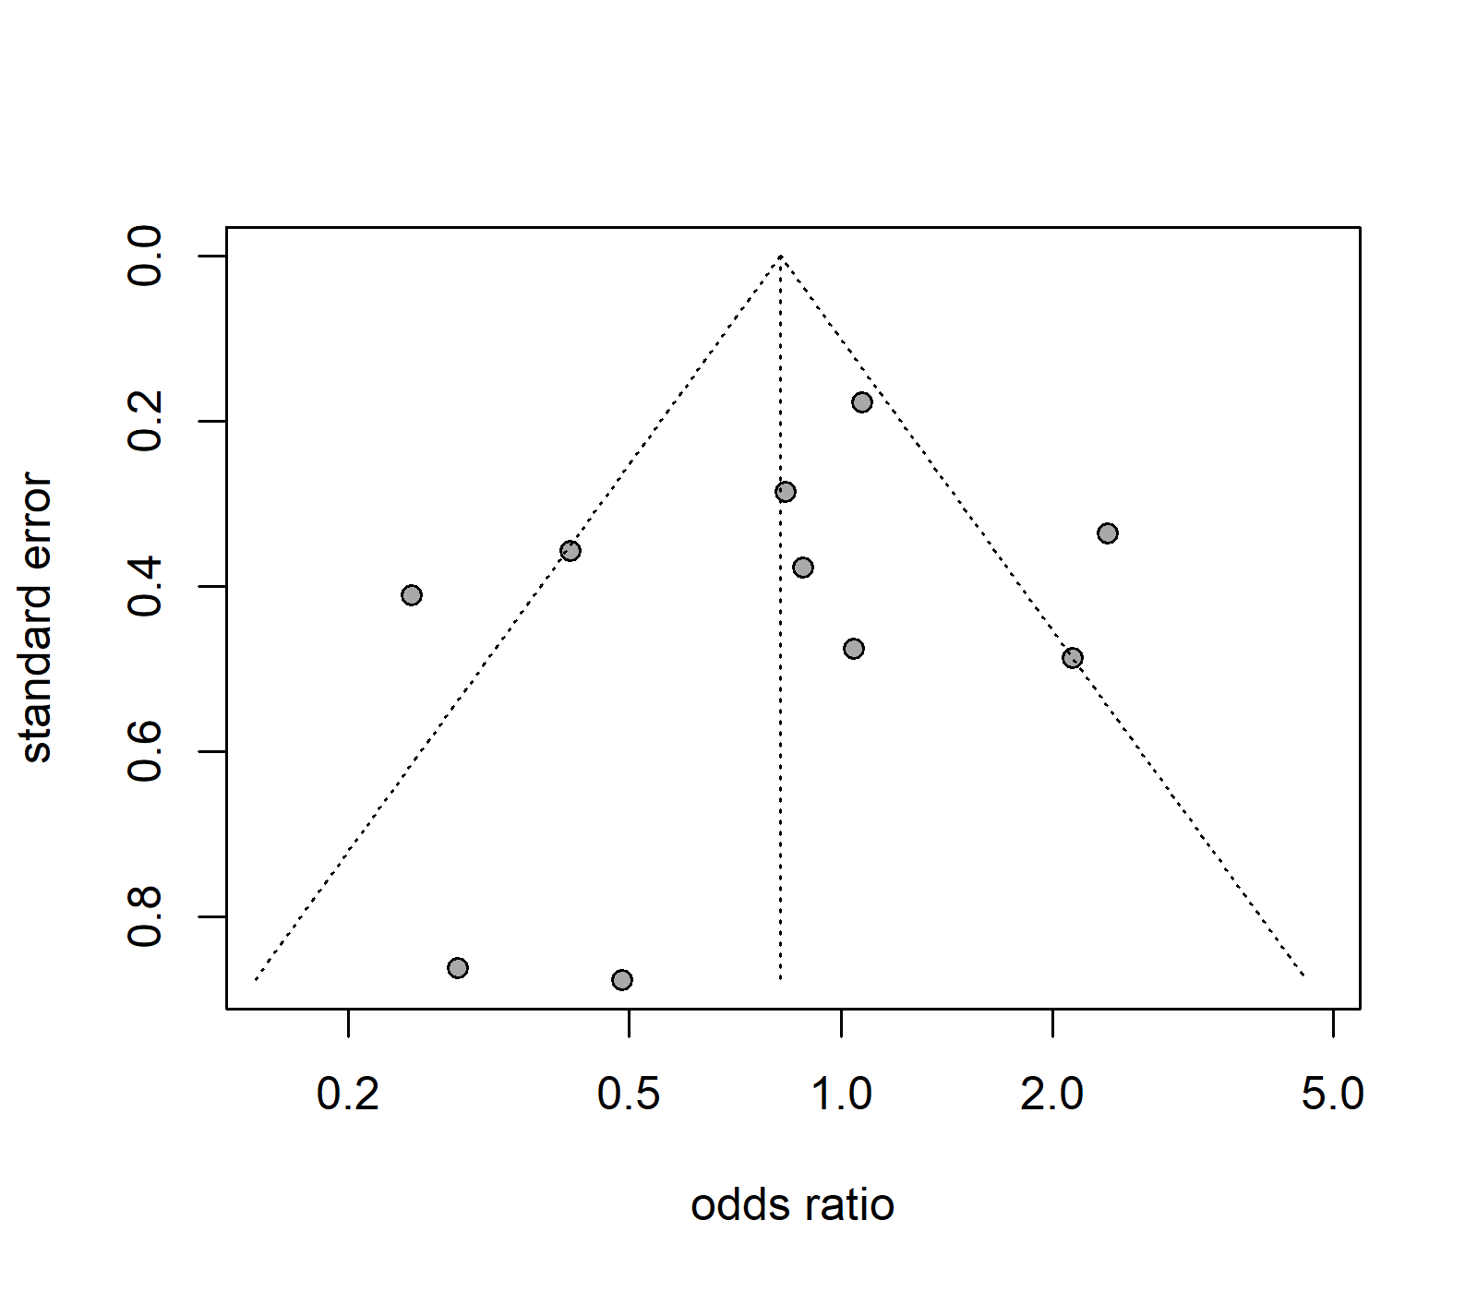
Legend: circle, represents one study; triangle, region where 95% of the data points would lie in absence of small study biases; vertical dashed line, odds ratio from meta-analysis

Premature rupture of membranes
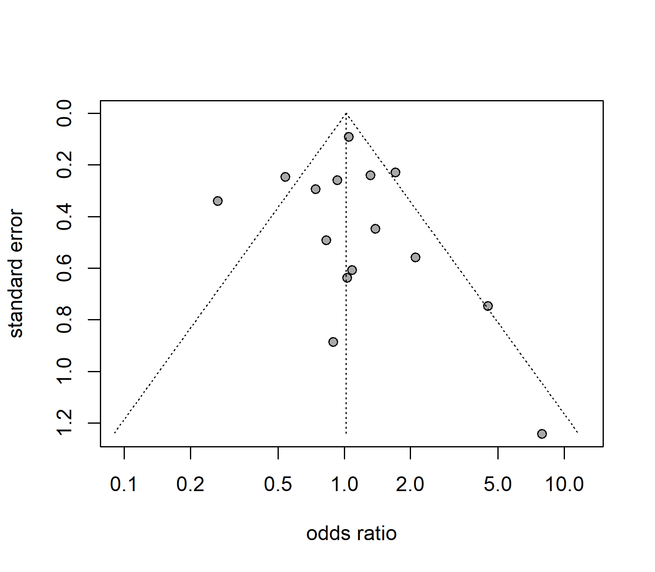
Legend: circle, represents one study; triangle, region where 95% of the data points would lie in absence of small study biases; vertical dashed line, odds ratio from meta-analysis

