SPADE manual
version 0.2.0, September 2014

Nicholas Beeton

Contents

Installation 3
Installing SPADE with R 3
Installing SPADE from the installation file 4
Quick start guide 4
How to run a simple simulation using SPADE 4
Some extra options 5
The SPADE user interface 6
Entering inputs 7
The Parameters tab 7
The Species menu 8
Population dynamics: Species demographics, interactions and dispersal (the Interactions tab) 8
Species interactions 9
Species demographics 9
Dispersal 10
Species management (the Management tab) 10
Fencing and landscape dispersal modifier (the Rasters tab) 12
Running models 14
Run Model 14
Run Non-Spatial Budget 14
Run Non-Spatial Density 14
Run Spatial Budget 15
Exploring outputs 16
Text Box 16
Population-Time Plot 16
Cost-Time Plot 16
Proportional Population 17
Population time series (Pop TS) 17
Cost-benefit map (CB) Map 18
Optimal culling mask (OCM) map 18

Installation
There are two different ways to install SPADE:
- As part of a currently existing installation of R – this is most useful for users already familiar with R, or users who are using an operating system other than Windows (e.g. Mac, Linux)
- By downloading and executing an installation file which automates the process – this is currently only available for 64-bit Windows operating systems.

Installing SPADE with R
The R programming environment can be downloaded freely at http://cran.r-project.org/ - choose your operating system and select the base system. Note: some issues have been noted with Mac-based versions of SPADE so if you are running a Mac and have problems, try downloading R version 2.15.1 instead.
Once R is installed and opened, a number of packages will need to be loaded. These are:
grDevices, gWidgets, gWidgetsRGtk2, raster, rgdal, fields, RGtk2, cairoDevice, deSolve, RgoogleMaps, spam, sp, maps, png, RJSONIO
These can be loaded either by using “Install package(s)” in the Packages menu, or by typing the command:
install.packages(c(“grDevices”, “gWidgets”, “gWidgetsRGtk2”, “raster”, “rgdal”, “fields”, “RGtk2”, “cairoDevice”, “deSolve”, “RgoogleMaps”, “spam”, “sp”, “maps”, “png”, “RJSONIO”))
into the R console.
Note that RGtk2 may require the GTK+ toolbox to be manually installed from http://www.gtk.org/download/index.php.
Once the packages are installed, move to the working directory containing the SPADE_0.2.0.tar.gz file and use this command to install SPADE:
install.packages('C:/Users/nick/Documents/GitHub/SPADE/SPADE_0.1.2.tar.gz', repos = NULL, type = 'source')
Once this is done, the final step is simply to load the SPADE package and open the SPADE user interface using these commands. These can now be repeated every time you want to run SPADE from inside R:
library(SPADE); SPADE()

Installing SPADE from the installation file
Double click on the “SPADE v0.2.0.exe” file and follow the prompts. Once completed, a shortcut will be available and using this will open SPADE directly.
Note: The installation process will overwrite your local user PATH variable (not the system PATH variable which is left unchanged) – if you have any paths in this variable, ensure you save them and add them back in after the installation. This issue occurs because of a limit in the number of characters available for system environment settings in Windows.

Quick start guide

How to run a simple simulation using SPADE
- Follow the necessary steps above to install and open SPADE.
- Go to the Parameters tab and select the vital parameters for your system – to start with, the only thing you really need to do is set the cell size for your input rasters in square kilometres (if you don’t care about units, set it to 1 - all outputs will then describe numbers per cell)
- Go to the Interactions tab and click on the Demographics button. This will then open a window titled Single-species dynamics details.
- Select the model type and then choose the parameters for your model. A simple example would be – for a species with a known maximum growth rate – to select “Logistic births”, set b to the growth rate, and mu to zero.
- If you want to allow the possibility of completely unoccupied cells (as with a species invading a previously unoccupied area), set the Minimum possible population in a cell to 0, otherwise keep it as-is (this is more relevant where we want to model the case where a population is heavily suppressed but will never actually reach 0).
- Click on the Load Carrying Capacity Raster button, and select a raster containing carrying capacity data for the selected species. This should contain raw numbers of animals for each cell in the raster – these will be converted to densities using the cell size information given in Step 2.
- Once you have selected the raster, wait for SPADE to draw all three of the maps in the window (it gets confused if you don’t).
- If the initial state of your species is different to its carrying capacity, click on Load Initial Condition Raster and select a raster representing the initial abundance of the species.
- Press OK to return to the main SPADE window.
- If you want to incorporate one or more management strategies, go to the Management tab and:
  - press Add strategy
  - then select the parameters for your management approach.
  - Repeat steps a and b for each strategy (if more than one)
  - If you have loaded multiple strategies, change between them using the Strategies: option at the top of the tab.
- Press the Run Model button at the bottom left of the main window to run a simulation.
- When it has finished (once all the plots have been done), examine the results using the tabs on the right hand side of the main window.

Some extra options
- Multiple species can be simulated using the Interactions tab and using the Add Species and Remove Species selections in the Species menu.
- Interactions information can be saved and/or loaded as .Rdata files (make sure to specify the extension when saving) using the Load Interactions and Save Interactions selections in the Species menu.
- If the target density and/or cost of a management strategy varies from cell to cell, click the Spatially explicit cost checkbox in the Management tab – from there, make spatially explicit changes to the necessary rasters using Edit or by loading a raster with the relevant button.
Note: Pressing Run Model will run all of the management strategies simultaneously – however, any optimisations using the other three buttons at the bottom left will use only one of the strategies, which it will prompt you to select upon pressing a button.

The SPADE user interface
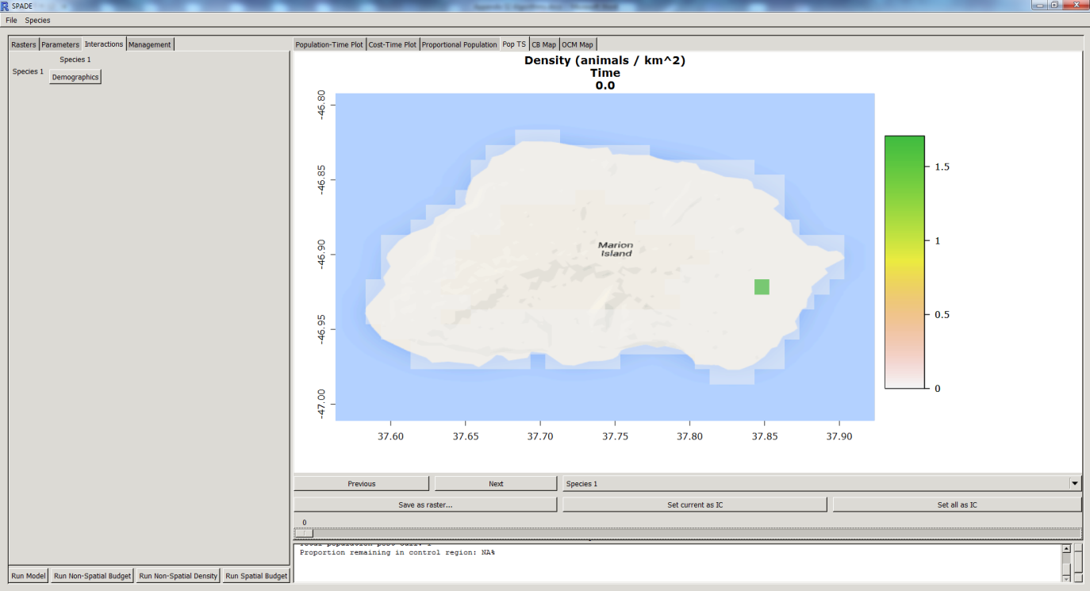
The SPADE user interface is split up into two distinct areas – the input area on the left, and the output area on the right. Running a model in SPADE involves three steps:
- To create a model, use the four tabs in the input areas (Rasters, Parameters, Interactions and Management) and the options in the Species menu (Add Species, Remove Species, Load Interactions and Save Interactions).
- Run models and/or optimisations using the buttons at the bottom of the input area – Run Model, Run Non-Spatial Budget, Run Non-Spatial Density and Run Spatial Budget.
Note: the latter three buttons are under development and may not work or work reliably.
- Examine and save outputs of models in the output area. There are a number of different output tabs – Population-Time Plot, Cost-Time Plot, Proportional Population, Pop TS, CB Map and OCM Map.
Usually after running a model and examining the output, additional steps are taken as the model is changed, re-run and re-examined.
The components of SPADE are described below in the order in which they will usually be utilised when running models.

Entering inputs

The Parameters tab
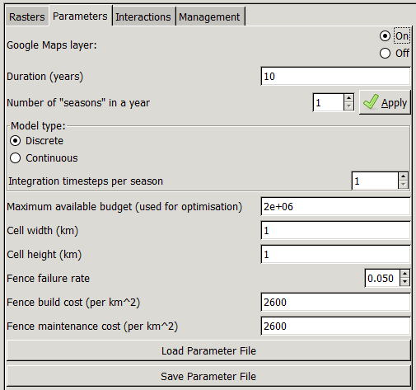
A number of general parameters are available to inform SPADE models. From top to bottom:
Google Maps layer: If this is set to “On” an internet connection is available, and the raster file data (specifically for the carrying capacity for the first species) has projection information attached, SPADE will automatically download the relevant Google Maps tile data as a background for rasters.
Duration (years): How many years the model will be run for. Each year will contain one or more “seasons” which can be given unique properties in the model (in terms of management and dynamics parameters).
Number of “seasons” in a year: Sets the number of seasons in each year (when pressing the Apply button) – a warning will appear reminding the user that changing the number of seasons can mess up already entered data. Thus if more than one season is desired in a SPADE model, it is generally safest to set this before entering data in the Interactions tab.
Model type: Selects either a Discrete or Continuous model and, if continuous, selects the number of integration timesteps for SPADE to run per season. Note that SPADE uses the fourth-order Runge-Kutta method for time integration and so some calculation of points between timesteps will occur.
Maximum available budget: Sets the budget allocation for use over the given time period in the Run Non-Spatial Budget and Run Spatial Budget models.
Cell width/height: Sets cell width or height in kilometres. Note that if a projected raster is used then these will be automatically populated (and can be checked for accuracy).
Fence failure rate: If a fence raster is set up (see Rasters tab below), then this describes the failure rate of a fence – i.e. for every animal that would normally travel from one side of the fence to the other, the fence failure rate describes how many animals will now get through.
Fence build/maintenance cost: The cost in dollars to build a fence (initial cost) and maintain the fence (cost per km² per season).
Load/save parameter file: Loads or saves a .csv file containing parameter information.
Note: the fencing cost and load/save parameter file features are under development and may not work or work reliably.

The Species menu
A small number of options for modifying the Species Interactions Matrix (described below in the Interactions tab) are available in the Species menu:
Add/remove species: Select to either add or remove a species from the matrix. Each additional species will add a row and column from the matrix, and will need to have demographic information included as a minimum – interactions with other species are also available to model. When Add species is selected, the user will be prompted to give a species name. Removing species performs the opposite – the user is prompted to select a currently existing species name (or cancel). Selecting a species will remove all of its data and interactions.
Load/save interactions: The contents of the interaction matrix can be loaded or saved into a SPADE session using an .Rdata file. When loading and saving, a dialog will appear prompting for the location and filename.
Note: When saving an interactions matrix, R will not default to the .Rdata extension – you can save the data with any extension name, but it will always be an .Rdata file. Keep this in mind if you want to examine or edit the interactions matrix outside of the SPADE GUI.

Population dynamics: Species demographics, interactions and dispersal (the Interactions tab)
SPADE represents the local population dynamics as a sum of independent processes. In most models the local population dynamics will involve only the species i whose trajectory is being modelled, but SPADE can also model additional effects involving other species – for example in the cases of predator-prey, competitive, or disease transmission dynamics between species or distinct cohorts within a species.
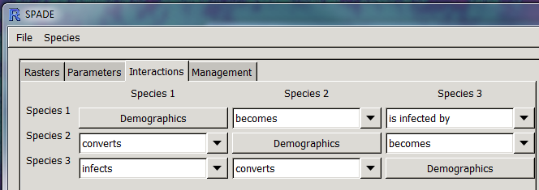
SPADE represents these relationships using an “interactions matrix” representing pairwise interactions between each possible combination of species. For interactions between two distinct species, the type of interaction can be selected using a drop-down menu, and then a model type with parameters can be selected from the resulting detailed sub-window (editable via formulae.csv).

Species interactions
The top line shows the current selected season - for models with multiple seasons (selected in the Parameters tab of the main window), the functional response along with its parameters can be changed from season to season. For example, a disease may be more virulent and operate via a different transmission mode in certain parts of the year, so the year could be split into seasons with a higher or lower transmission coefficient and different functional responses. If this functionality is not required, ticking the checkbox “Keep parameters constant” will set the functional form and parameters for every season to be identical to those currently selected.
The functional form and details can be selected using drop down menus as shown in the image above. Each functional form has its own set of parameters, each settable using the edit boxes given.
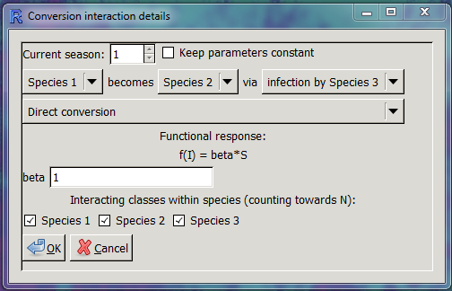
Some functional forms will include a reference to “N”, which represents a collection of distinct cohorts who together comprise a species. For example, frequency-dependent disease transmission in an SIR model has the functional form f(S,I) = βSI/N, where N represents the total population consisting of the Susceptible, Infectious and Recovered classes for that species. For relevant functional forms, the tickboxes under “Interacting classes within species” can be used to specify which classes should comprise the total species population “N”.

Species demographics
For self-interaction, there is a “Demographics” button which opens a sub-window in which the user can specify not only the species’ local population dynamics, but also rasters for the carrying capacity, initial condition and species relative dispersal rate across the modelled domain.
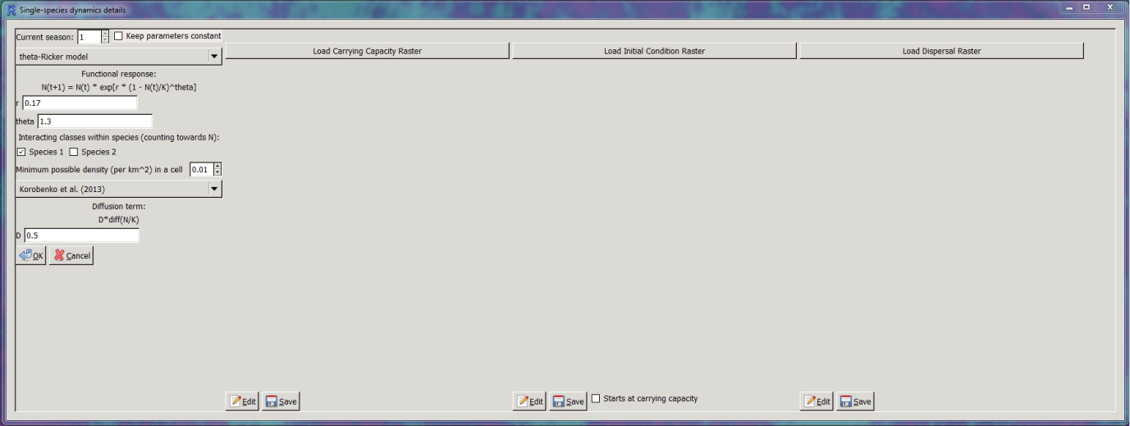
By clicking the relevant buttons, the user can set rasters for each of these. Most standard formats for rasters are accepted (the raster package in R is used to load and store rasters). The only restriction is that all rasters must be of identical size – when loaded, the carrying capacity for the first species is set as the template for raster size and projection. If a valid projection is loaded and an internet connection is available, SPADE will draw locality data in the background using the Rgooglemaps package.
The “single-species dynamics details” window also contains a setting to change the minimum possible density (per km²) in a cell. This is included for modelling cases in which the population can never be assumed to be zero – for example, in the case of management, a species that can only ever be reliably removed down to a certain density. In any cell where the population goes below this threshold at any stage in the modelling process, the population will be reset at the threshold.
Note: In cases where the population is initially absent in some areas, it is important that this is set to zero, otherwise the population will prematurely ‘invade’ previously unoccupied areas of the landscape.

Dispersal
In this window, there are also settings for the dispersal of the given species – as with the demographic model, there is a selection of models available via the drop-down menu (again, editable via formulae.csv) with relevant parameters – usually in some way involving a diffusion coefficient D.
Note: Keep in mind that increasing the rate of diffusion can affect the numerical stability of the method, and may require a subsequent increase in the number of integration timesteps if the method is continuous (or using a continuous method if the method is discrete).
As described in the main paper, the model uses a second-order finite difference method involving the surrounding cells to approximate the Laplacian of each species density at each cell. For the purposes of speed and scalability to large numbers of cells, it uses sparse matrices via the spam package. When the model is first run using a particular raster template (as above, defined by the carrying capacity of the first species), it pre-calculates a matrix containing the linear combination of cells required to calculate the Laplacian for each cell, and uses this matrix during the simulation to calculate the Laplacian at each integration timestep.
In development: There is also scope in SPADE to run reaction-advection-diffusion models –it uses the same process as above but uses a first-order finite difference method to calculate the gradient in addition to the Laplacian. Preliminary work has also been done to include directional dispersal such as would be expected in a wind-dispersing plant, for example.

Species management (the Management tab)
Once the relevant information has been entered for the modelled species, the user is then able to add one or more management strategies to remove animals from particular “species” from the population (these “species” may actually be other user-defined categories, e.g. flowering plants of an invasive weed). If multiple strategies have been added, the user can switch between these by using the Strategies dropdown menu, which numbers each strategy. The rest of the tab is used to describe the currently selected strategy:
Species to manage: the name of the species to manage
Seasons to cull: A checkbox for each season (the number of seasons is set in Parameters tab) in which management is to occur.
Target proportional population in region: When using the Run Non-Spatial Density model, this is chosen as the target population size compared to the initial population, and optimisation is performed to discover the optimal removal rate to achieve this.
Removal method: There are three methods as described in the main article and in Appendix S2 – proportional, absolute, and capped proportional.
Removal rate in first season: The proportion or number of animals to remove in the first season of the first year of management.
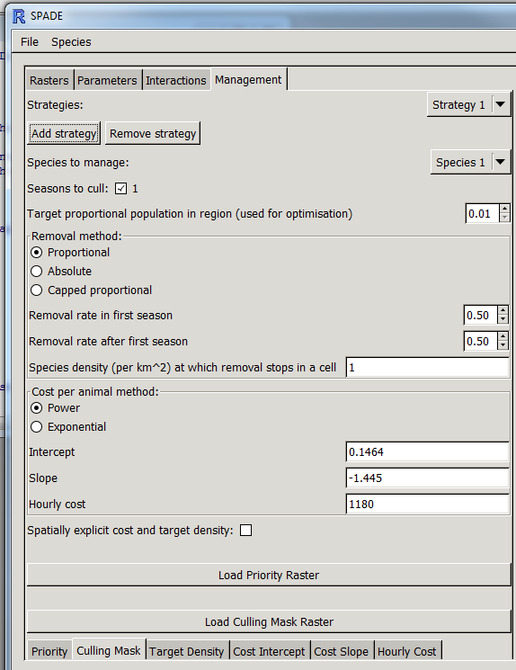
Removal rate after first season: The proportion or number of animals to remove after the first season of the first year of management.
Species density at which removal stops in a cell: As stated – SPADE will not remove where and when the density in a particular cell is at or below this threshold.
Cost per animal method: A choice between two methods for representing the relationship between the cost of management per animal removed and the animal density in the cell – either a power curve method (with parameters Intercept and Slope to describe the number of hours per animal in combination with Hourly cost) or an exponential curve method (with parameters Intercept, Coefficient and Exponential rate).

Spatially explicit cost and target density: Select this checkbox if you want to specify the cost per animal parameters using rasters instead of as a constant value across the spatial domain. Doing so will replace the four input text boxes with buttons labelled Load Target Density Raster and Load <parameter name> Raster for the three parameters for the relevant cost per animal method.
Load Priority Raster: Loads a raster representing the priority score for each cell, for use in cost-benefit analysis, particularly in the Run Spatial Budget model.
Note: the priority raster is currently not incorporated into modelling but will be returned to the Run Spatial Budget model in future versions of SPADE.
Load Culling Mask Raster: Loads a raster masking areas where culling will occur under this management strategy. A value of 1 in a cell represents full culling, 0 represents no culling, and intermediate values represent a proportional amount of culling (e.g. if 1000 animals are to be removed in a timestep, SPADE will automatically normalise a cell with a mask value of 0.5 to remove half as many animals as a cell with a mask value of 1, all while ensuring the total number of animals removed equals 1000).
Raster displays: Six tabs below the management options listed are for the display of the rasters loaded in for the management strategies, i.e. Priority, Culling Mask, Target Density and the three parameters of the cost per animal method.

Fencing and landscape dispersal modifier (the Rasters tab)
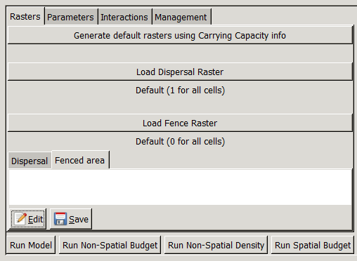
The Rasters tab is not strictly necessary to generate a model, and is generally used where more detailed data about the landscape is available or where there are known and clearly defined spatial barriers to species movement.
Generate default rasters using Carrying Capacity info: This is done by default when the first species’ carrying capacity is defined, but if modifications have been made to the rasters that need undoing, this button can be used.
Load Dispersal Raster: Loads a raster that scales the amount of dispersal occurring in each cell for all species – this is on top of any dispersal scaling defined for individual species in the Interactions tab above. The dispersal in each cell is be defined as:
$$D×D_{\text{species}}×D_{\text{landscape}}$$
where $D$ is the amount of dispersal defined by the parameters and functional form used in the Demographics sub-window, $D_{\text{species}}$ is the dispersal scaling for the individual species at that cell and $D_{\text{landscape}}$ is the dispersal scaling for the entire landscape at that cell.
Raster displays: Two tabs below the options listed are for the display of the loaded rasters, i.e. Dispersal and Fenced area. Below this there are buttons are also included to directly edit the rasters (via a simple spreadsheet-like editor) and save the results to a new file.

Running models
There are four buttons at the bottom of the input area that can be used to run models in SPADE once the necessary inputs have been entered – Run Model, Run Non-Spatial Budget, Run Non-Spatial Density and Run Spatial Budget.
Note: the latter three buttons are under development and may not work or work reliably.

Run Model
To run a basic SPADE model, simply press the button – if there is new raster information, geometry will be calculated, and then the model itself will be run. Once the progress bar has closed and the model has finished, outputs will be available from the output area on the right of the SPADE window.
Note: The time taken for the model will run will depend on the size of the raster, the number of years and seasons the model is set to run for, and the complexity of the model. If progress on the progress bar stops completely, check the R console for errors – sometimes depending on the settings and functional forms used, numerical instability can occur causing the simulation to crash.

Run Non-Spatial Budget
Before running a Non-Spatial Budget model, ensure the Maximum available budget setting is set to the relevant amount for the length of time simulated. Running the non-spatial budget model requires the user to press the button, and then to select the management strategy to optimise over (the model will be run using only this management strategy). Once this is done, SPADE will repeatedly run simulations to determine the maximum removal rate possible within the given budget, as well as the minimum target density that can be used to achieve this rate. Once the progress bar has closed and the model has finished, outputs will be available from the output area on the right of the SPADE window, and the maximum culling rate will be presented in the text box at the bottom of the output area.

Run Non-Spatial Density
This option works in the same way to the above, but is instead based on a threshold for Target proportional population in region defined for the selected management strategy. When run, SPADE will determine the minimum removal rate required to achieve a proportional population size below the target, as well as the maximum target density that can be used to achieve this rate. It will then show these results in the output area.

Run Spatial Budget
As with the non-spatial equivalent, ensure the Maximum available budget setting is set. In addition, the method will use the Priority Raster of the selected management strategy as a multiplier to the given cost-benefit score for each cell.
Note: in the current iteration of SPADE, the cost-benefit score is defined simply as the cost. In future versions this will be updated and likely made user-editable so that users can define their own scores based on the priorities in their data (e.g. maximum reduction per cost, humaneness, social acceptability, etc)
When run, SPADE will repeatedly run simulations to determine the minimum cost-benefit score across all cells and across the entire time period. As for the other methods, it determine the maximum removal rate possible within the given budget, as well as the minimum target density that can be used to achieve this rate. The Spatial Budget model also calculates a subset of the entire spatial region that it estimates is most efficient to target.

Exploring outputs

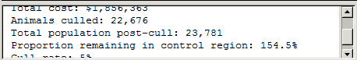
Text Box
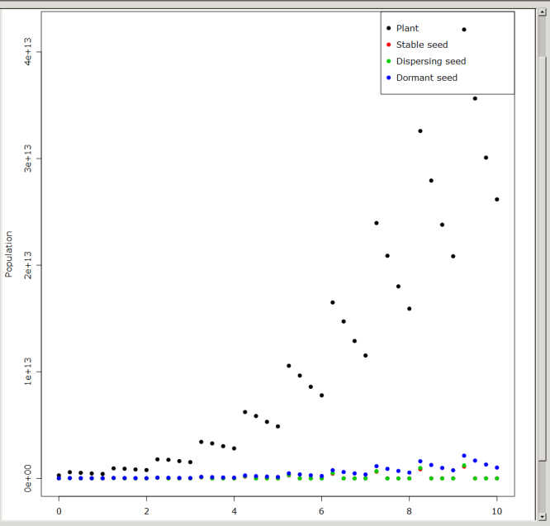
This box displays relevant information for the current (and past) simulations. The information for the most recent simulation will be at the bottom of the text box.

Population-Time Plot
This plot shows the total population for each species for each season over the course of the simulation, with a legend to differentiate each species by name and colour of data points.

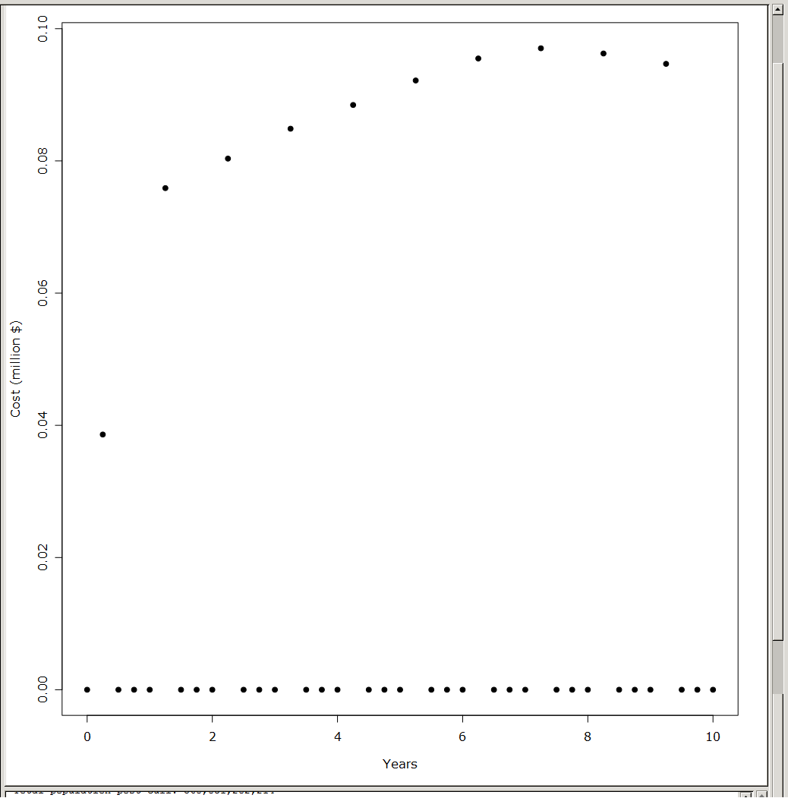
Cost-Time Plot
This plot shows the cost of all management strategies combined for each season over the course of the simulation, with a legend to differentiate each strategy by colour.

Proportional Population
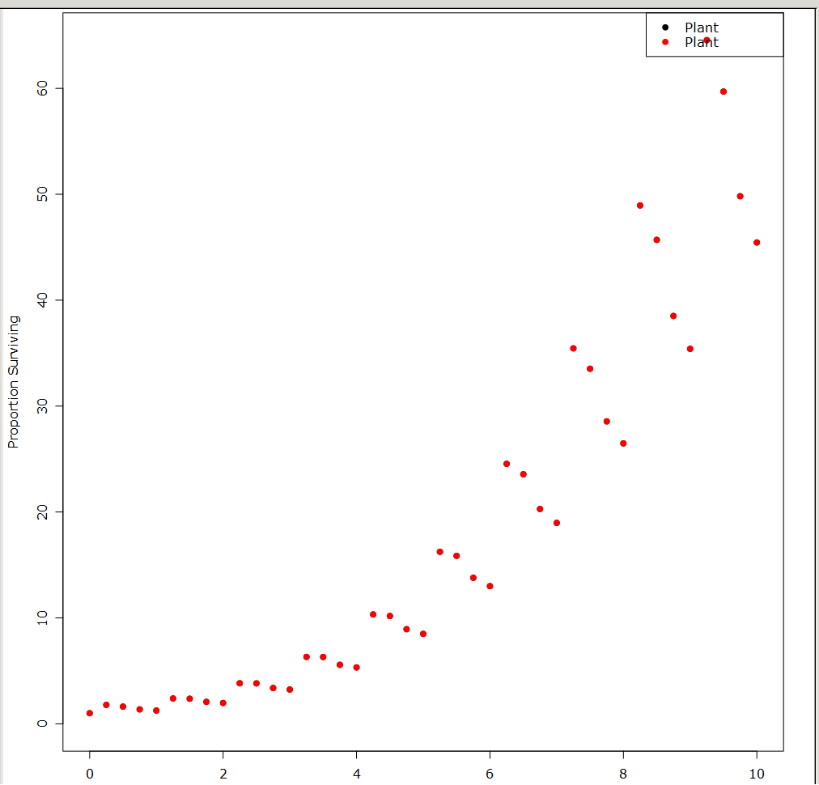
This plot is similar to Population-time Plot but instead shows the relative population compared to the initial population size for each managed species in the managed area only (i.e. cells with culling mask value greater than zero) as opposed to the Population-time Plot which totals over the entire spatial domain).
Note: as with the figure at right, it is possible to have multiple management strategies targeting the same species. In this case, the relevant proportional population plots will overlap.

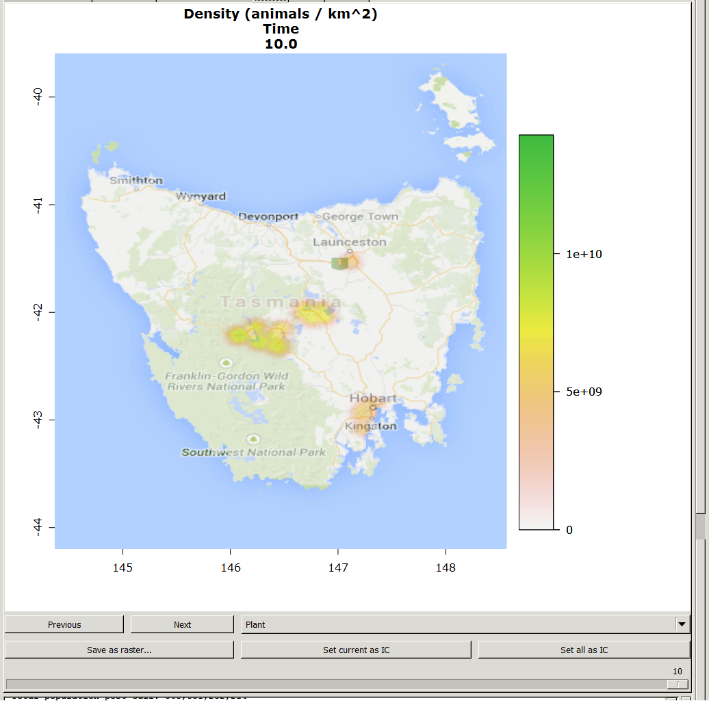
Population time series (Pop TS)
This plot shows the map of a particular selected species abundance across the spatial domain at a selected year and season. A selection of buttons, a slider and a drop-down menu are available to set the required options, as well as store outputs in various forms:
Previous/Next: Selects the previous or next time step in the simulation.
Drop-down menu: Enables user to select the species to be mapped.
Save as raster…: Opens a dialog to save the current species and timestep output as a raster file (in any format supported by the raster package).
Set current as IC: Sets the current species and timestep output as the initial condition of the model for the current species.
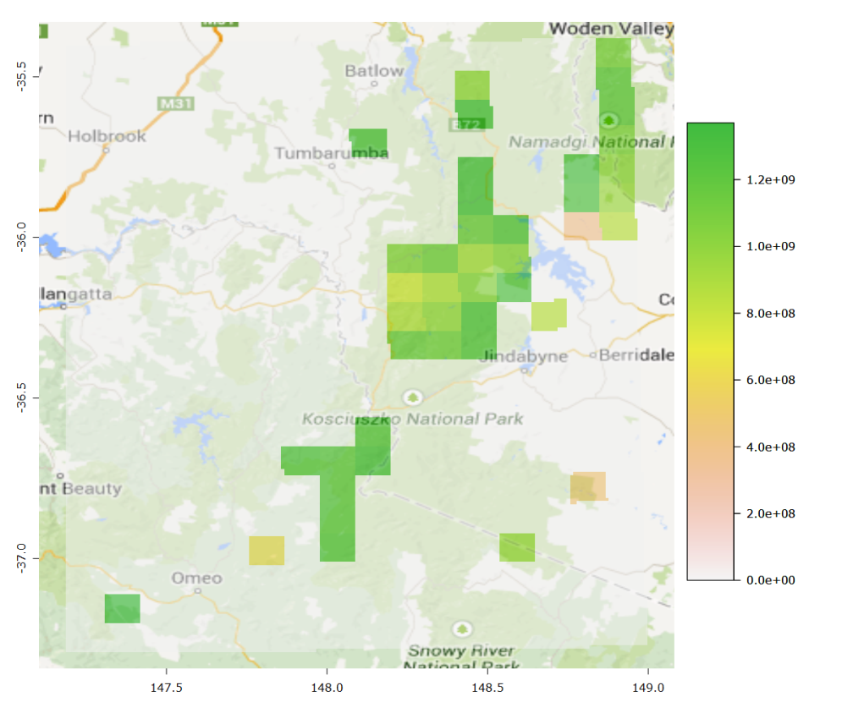
Set all as IC: Sets the current species and timestep output as the initial condition of the model for all species.
Slider: Shows current year and season. Dragging this will vary the time step and automatically update the plot.

Cost-benefit (CB) Map
This map shows the overall cost-benefit score for each cell summed over the duration of the simulation.

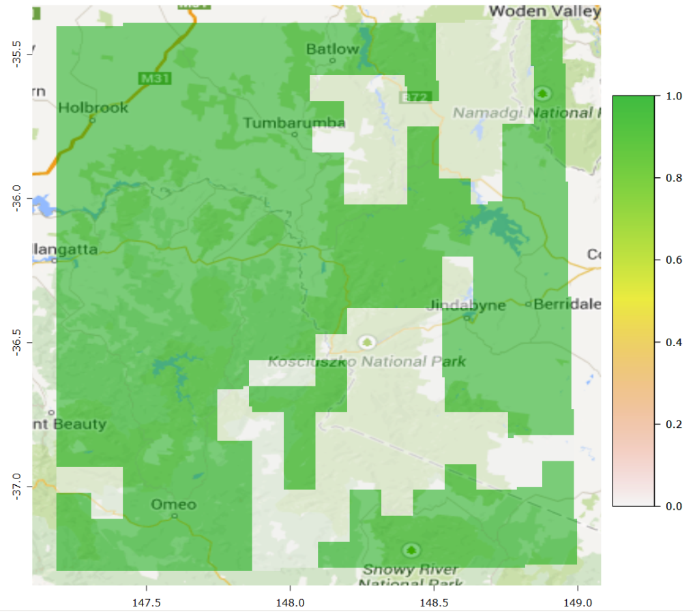
Optimal culling mask (OCM) map
This map is only displayed when running the Run Spatial Budget model. When enabled, it displays the optimal culling mask calculated by SPADE for the given model – green (1) where culling at the specified rate is suggested, and clear (0) where it is not.

