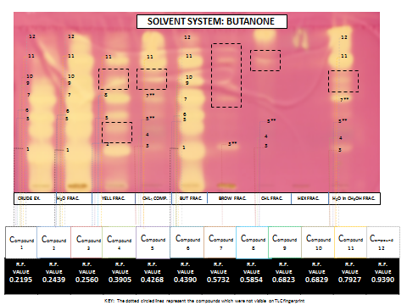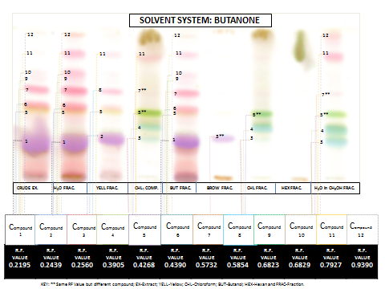
SOLVENT SYSTEM: EBWF
SOLVENT SYSTEM: EBWF
Appendix 1.A. Thin layer chromatography and anti-oxidant qualitative analysis of solvent fractionations using EBWF solvent system (A) sprayed with DPPH solution, (B) sprayed with vanillin in sulphuric acid. KEY: The dotted circled lines represent the compounds which were not visible on the TLC fingerprint sprayed with sprayed with vanillin in sulphuric acid; Rf: retention factor; ** : same Rf value; Ex: extract; Yell: yellow in colour; CHL: chloroform; BUT: Butanol; HEX: Hexane; Frac: fraction.
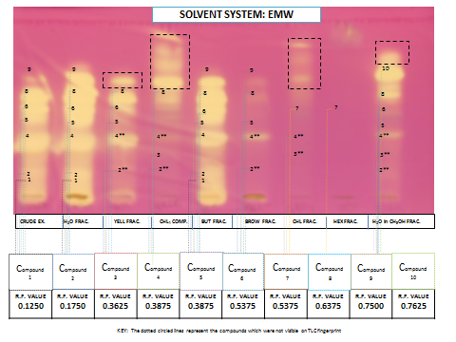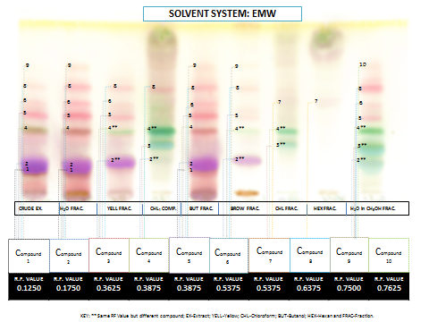
Appendix 2.A. Thin layer chromatography and anti-oxidant qualitative analysis of solvent fractionations using EMW solvent system (A) sprayed with DPPH solution, (B) sprayed with vanillin in sulphuric acid. KEY: The dotted circled lines represent the compounds which were not visible on the TLC fingerprint sprayed with sprayed with vanillin in sulphuric acid; Rf: retention factor; ** : same Rf value; Ex: extract; Yell: yellow in colour; CHL: chloroform; BUT: Butanol; HEX: Hexane; Frac: fraction.
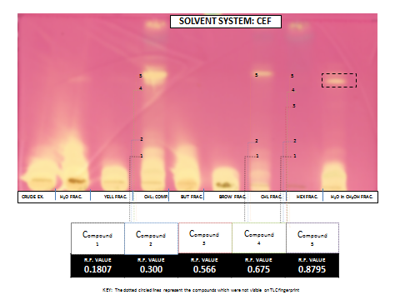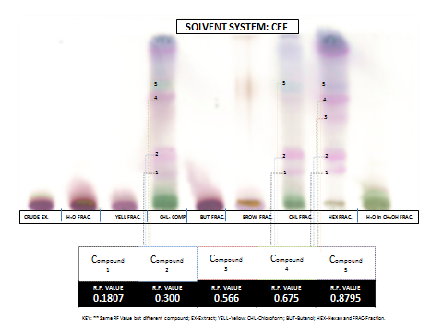
Appendix 3.A. Thin layer chromatography and anti-oxidant qualitative analysis of solvent fractionations using CEF solvent system (A) sprayed with DPPH solution, (B) sprayed with vanillin in sulphuric acid. KEY: The dotted circled lines represent the compounds which were not visible on the TLC fingerprint sprayed with vanillin in sulphuric acid; Rf: retention factor; **: same Rf value; Ex: extract; Yell: yellow in colour; CHL: chloroform; BUT: Butanol; HEX: Hexane; Frac: fraction.

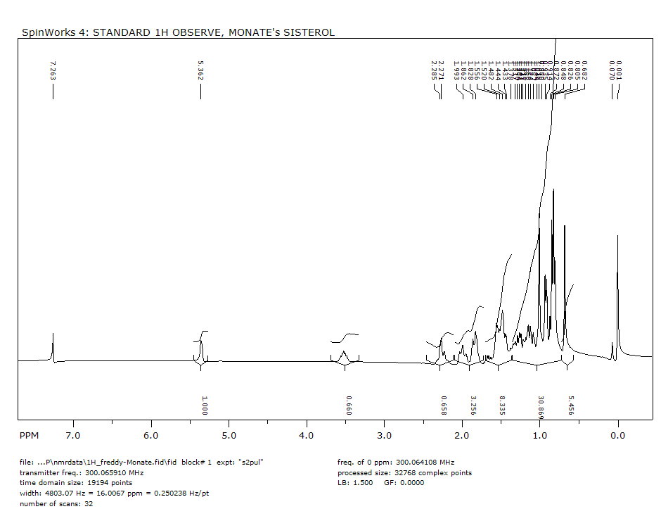

Appendix 1.B. β-sitosterol compound (coded PRCD): 13C.

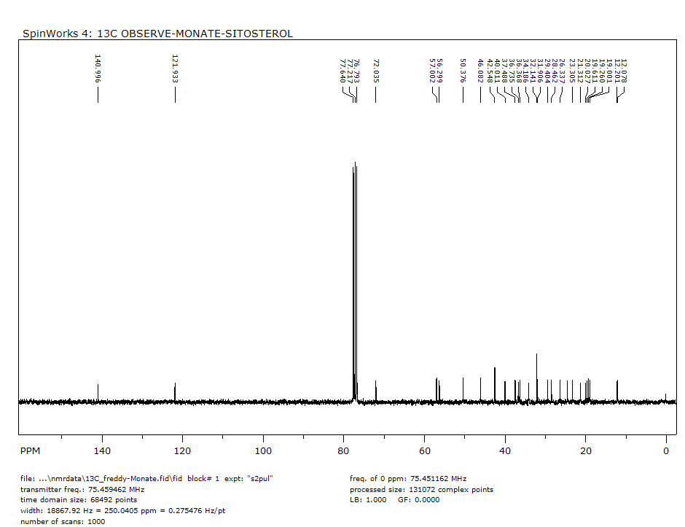

Appendix 2.B. β-sitosterol compound (coded PRCD): 1H-NMR spectrum.

Appendix 3.B. 1H-1H COSY spectrum of β-sitosterol compound.

Appendix 4.B. HMBC spectrum of β-sitosterol compound.

Appendix 5.B. HMQC spectrum of β-sitosterol compound.

