Supplementary Material
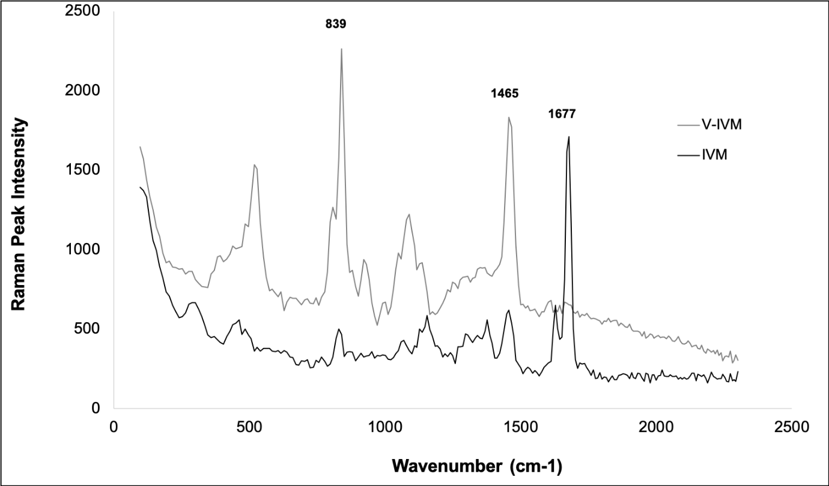
Raman spectroscopy was performed using a Cora 5700 Raman spectrophotometer (Anton Paar, Graz, Austria). The wavelength was set to 1064 nm and scans were collected across the range of 200 – 2000 cm⁻¹.

Supplementary figure 1: Overlay of the Raman spectra obtained for pure ivermectin (IVM) and a veterinary formulation (V-IVM).

The V-IVM exhibited more Raman spectroscopy scattering peaks than the IVM, with distinct scattering observed at 839 and 1465 cm⁻¹. From the Raman scattering, it was not possible to confirm that the veterinary formulation contained ivermectin. It is probable that the Raman scattering shift could be ascribed to a different solid-state form of ivermectin, as this has been reported previously. Based on this, HPLC analysis was used to conclusively identify ivermectin in both samples.

