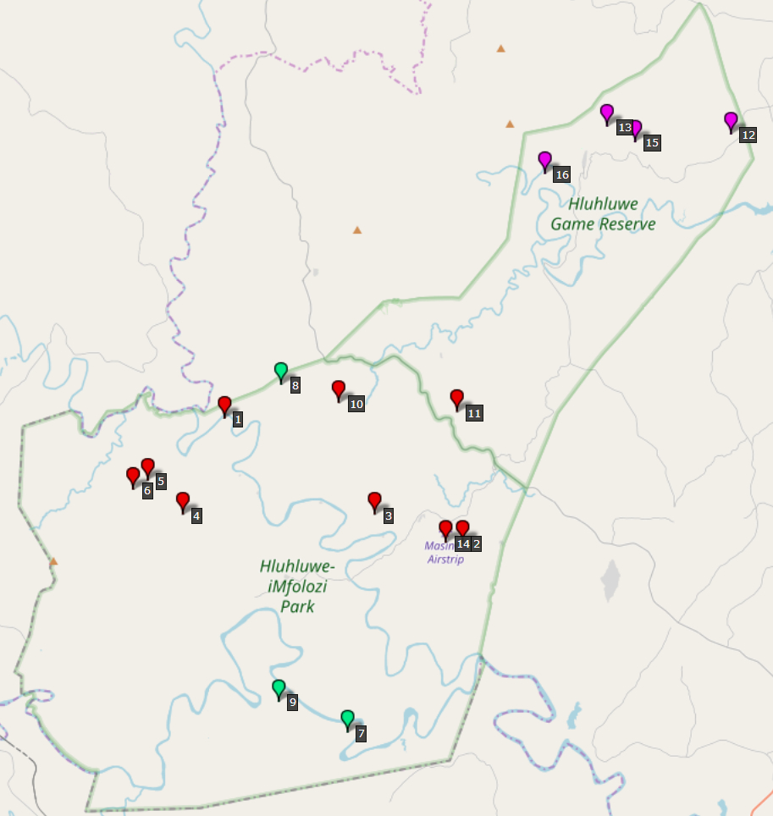
S1 Fig. Map with sampling localities.
Herds 1-13: genotyped herds, red: sampled in 2002, green: sampled in 2003, magenta: sampled in 2004. © OpenStreetMap contributors. The data is available under the Open Database License, and the cartography is licensed as CC BY-SA.

