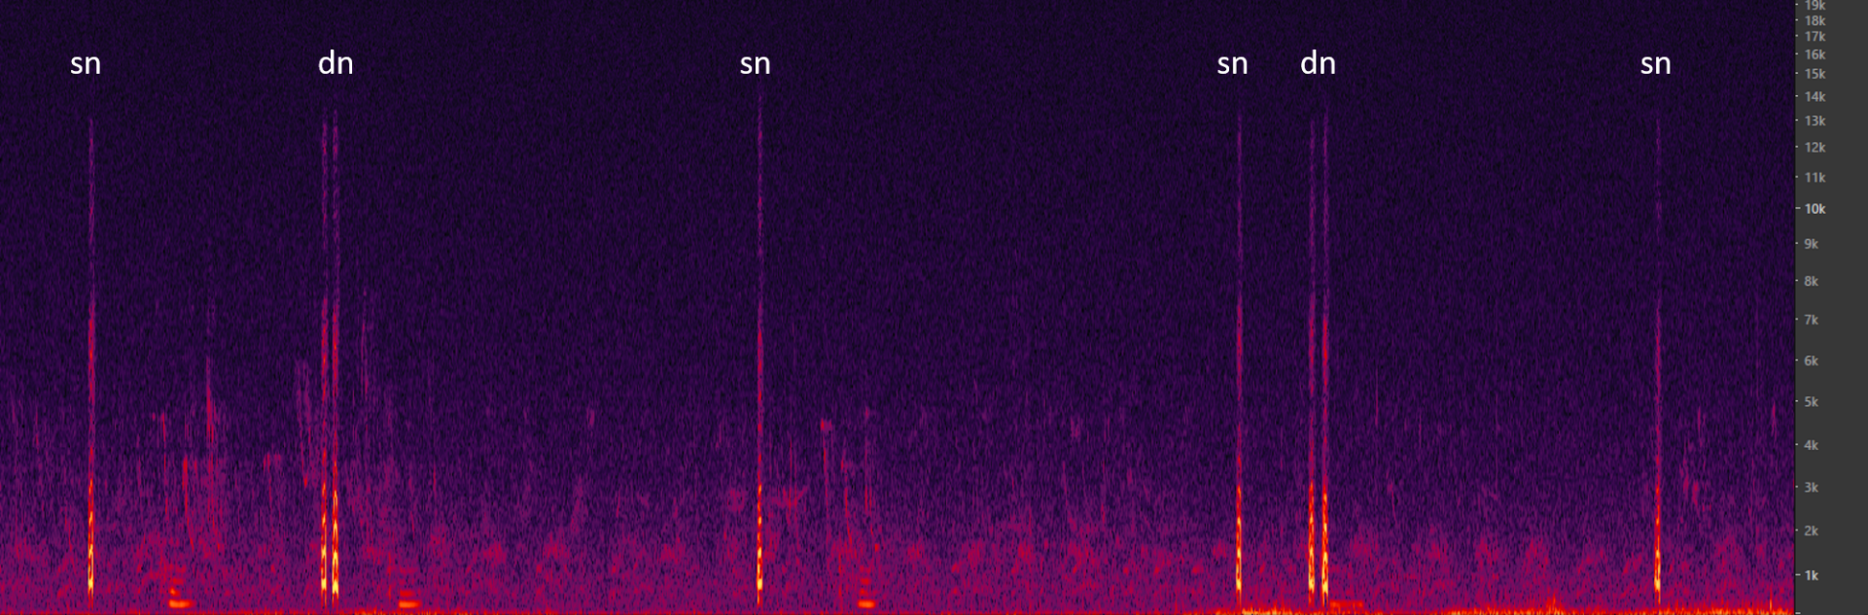
Additional file 3: Fig. S3: Spectrogram showing a 15 seconds cut-out of an example sequence consisting of single note and double note calls with silence intervals between them.

