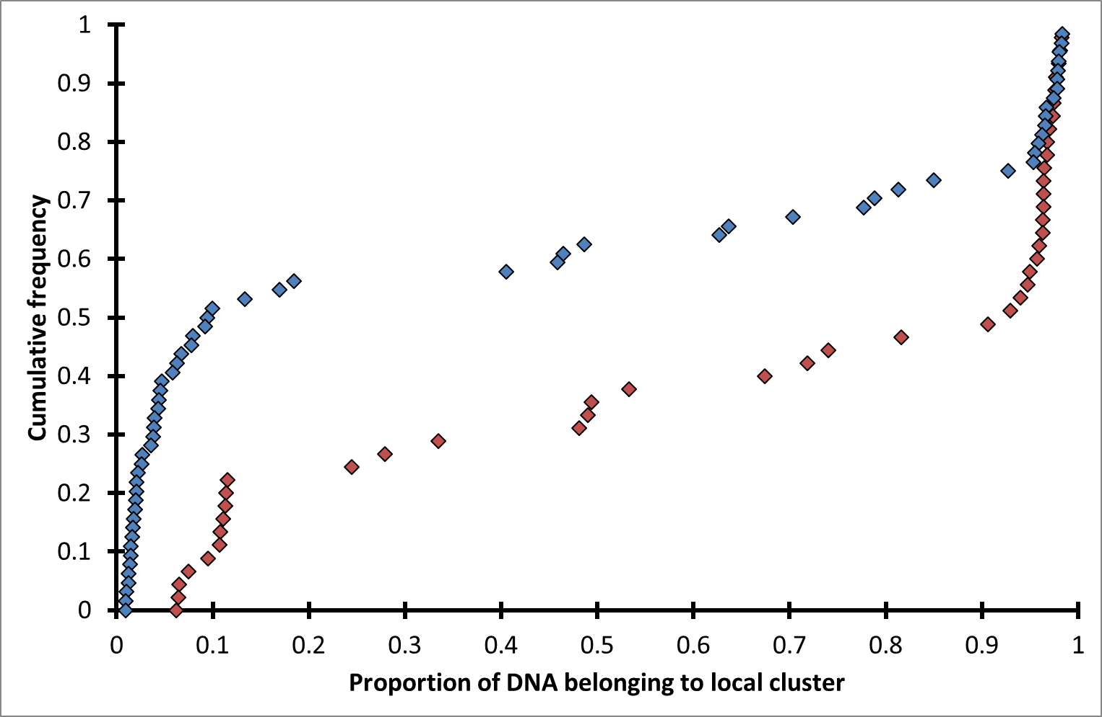
Cumulative frequency distribution of the proportion of DNA per individual assigned to the local microsatellite cluster by the software Structure.
Red data points: northern Kruger, blue data points: southern Kruger.

