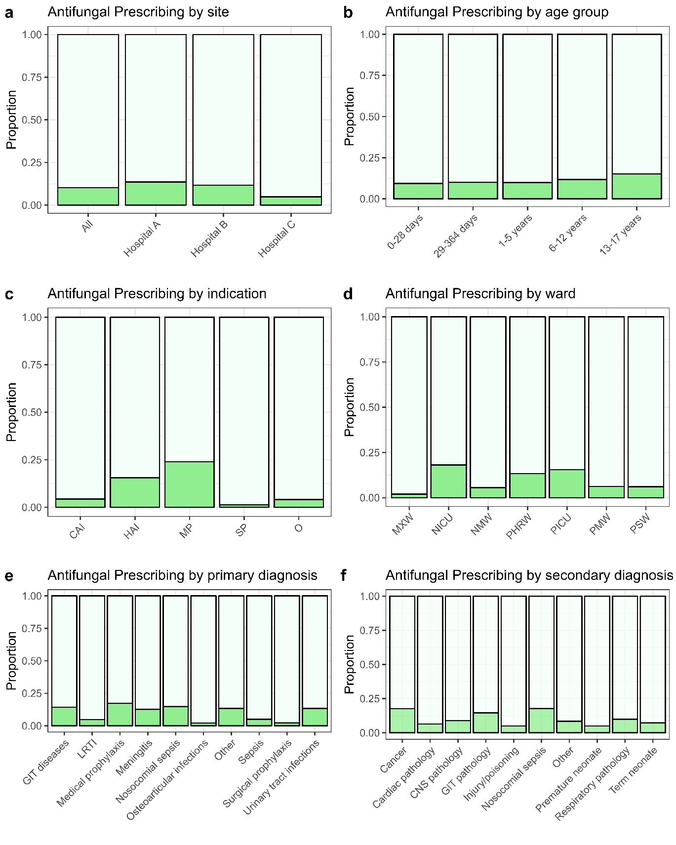
Supplemental Figure: Prevalence of antifungal prescribing stratified by different site and patient characteristics.
Supplemental Figure legend:
CAI = community-acquired infection; HAI = hospital-associated infection; MP = medical prophylaxis; MXW = mixed ward; NICU = neonatal intensive care unit; NMW = neonatal medical ward; O = Other indication; PHRW = paediatric high risk ward; PICU = paediatric intensive care unit; PMW = paediatric medical ward; PSW = paediatric surgical ward; SP = surgical prophylaxis

Supplemental Table 1: Univariate multinomial Poisson regression analyses of factors associated with receipt of who Watch and Aware antibiotic therapy for covariates not included in the final model
 | Characteristic | Relative Risk (95% CI) | P-value
Sex
Receipt of Watch antibiotics | Male | Reference
 | Female | 0.99 (0.69-1.41) | 0.653
Receipt of Reserve antibiotics | Male | Reference
 | Female | 0.67 (0.42-1.07) | 0.094
Preterm Birth
Receipt of Watch antibiotics | No | Reference
 | Yes | 1.73 (1.09-2.74) | 0.021
Receipt of Reserve antibiotics | No | Reference
 | Yes | 2.43 (0.92-6.40) | 0.073
HIV Status
Receipt of Watch antibiotics | Unknown | Reference
 | HEU | 0.93 (0.55-1.58) | 0.802
 | Unexposed | 1.10 (0.63-1.93) | 0.729
 | Positive | 0.76 (0.26-2.25) | 0.622
Receipt of Reserve antibiotics | Unknown | Reference
 | HEU | 2.49 (0.70-8.90) | 0.159
 | Unexposed | 3.33 (1.43-9.71) | 0.027
 | Positive | 1.01 (0.33-3.09) | 0.979
COVID-19
Receipt of Watch antibiotics | No | Reference
 | Yes | 0.98 (0.36-2.66) | 0.970
Receipt of Reserve antibiotics | No | Reference
 | Yes | 0.62 (0.22-1.77) | 0.374
Weight category
Receipt of Watch antibiotics | Normal | Reference
 | Underweight | 1.91 (1.16-3.14) | 0.011
 | Overweight | 1.04 (0.68-1.58) | 0.868
Receipt of Reserve antibiotics | Normal | Reference
 | Underweight | 2.62 (1.41-4.86) | 0.002
 | Overweight | 0.30 (0.03-2.60) | 0.274
Surgery
Receipt of Watch antibiotics | No | Reference
 | Yes | 0.69 (0.40-1.19) | 0.181
Receipt of Reserve antibiotics | No | Reference
 | Yes | 1.27 (0.53-3.01) | 0.594
Note:
CI = confidence interval; HEU = HIV-exposed, uninfected.

Supplemental Table 2: Unadjusted and adjusted models of predictors of paediatric antifungal use in 1189 patients at three academic hospitals in South Africa, 22 September 2021-05 January 2022
 | Characteristic | Relative Risk (95% CI) | P-value | Adjusted  Relative Risk  (95% CI) | P-value
Hospital | Hospital C | Reference |  | Reference
 | Hospital A | 3.02 (2.07-4.51) | <0.001 | 2.00 (1.33-3.10) | 0.001
 | Hospital B | 2.35 (1.58-3.55) | <0.001 | 2.48 (1.63-3.86) | <0.001
Age category | 0-28 days | Reference
 | 29-364 days | 1.04 (0.46-1.92) | 0.903
 | 1-5 years | 1.19 (0.58-2.03) | 0.578
 | 6-12 years | 1.07 (0.67-1.60) | 0.743
 | 13-17 years | 0.92 (0.68-1.25) | 0.601
Indication | CAI | Reference |  | Reference
 | HAI | 3.96 (2.76-5.85) | <0.001 | 2.90 (1.87-4.60) | <0.001
 | MP | 4.08 (2.38-6.87) | <0.001 | 3.30 (1.77-6.05) | <0.001
 | SP | 0.53 (0.20-1.18) | 0.154 | 0.64 (0.22-1.59) | 0.400
 | Other | 0.82 (0.27-1.94) | 0.681 | 0.91 (0.28-2.28) | 0.900
Ward Type | PSW | Reference |  | Reference
 | MXW | 0.33 (0.02-1.43) | 0.238 | 0.23 (0.02-1.07) | 0.140
 | NICU | 4.25 (2.60-7.15) | <0.001 | 2.27 (1.30-4.11) | 0.005
 | NMW | 1.18 (0.60-2.25) | 0.614 | 0.69 (0.33-1.44) | 0.300
 | PHRW | 2.44 (1.51-4.08) | <0.001 | 1.49 (0.85-2.70) | 0.200
 | PICU | 3.80 (2.28-6.48) | <0.001 | 2.15 (1.22-3.95) | 0.010
 | PMW | 1.09 (0.63-1.91) | 0.758 | 1.03 (0.55-1.95) | 0.900
Length of hospitalisation |  | 1.00 (1.00-1.00) | 0.012 | 1.00 (1.00-1.00) | 0.700

Note:
CAI = community-acquired infection; CI = confidence interval; HAI = hospital-associated infection; MP = medical prophylaxis; MXW = mixed ward; NICU = neonatal intensive care unit; NMW = neonatal medical ward; PHRW = paediatric high risk ward; PICU = paediatric intensive care ward; PMW = paediatric medical ward; PSW = paediatric surgical ward; SP = surgical prophylaxis.

