Contents
I. S1: Search Strategy 2
II. S2: Quality appraisal of included studies 15
III. S3: Forest plot for hearing loss 17
IV. S4: Forest plot for facial nerve palsy 18
V. S5: Forest plot for intracranial complications 20
VI. S6a: Forest plot for canal wall down (Individuals) 21
VII. S6b: Forest plot for canal wall down (Ears) 22
VIII. S7a: Forest plot for canal wall up (Individuals) 23
IX. S7b: Forest plot for canal wall up (Ears) 24
X. S8a: Forest plot for recidivistic cholesteatoma (Individuals) 25
XI. S8b: Forest plot for recidivistic cholesteatoma (Ears) 26
XII. S9: Funnel plot for global prevalence 27
XIII. S10: Funnel plot for hearing loss 28
XIV. S11: Funnel plot for Facial nerve palsy 29
XV. GBC PRISMA Checklist 31

S1: Search Strategy
05 April 2025
Querry | Result | Time
(((ALL=(burden of cholesteatoma)) OR ALL=(prevalence of cholesteatoma OR incidence of cholesteatoma OR epidemiology of cholesteatoma OR risk factors, cholesteatoma OR recidivists cholesteatoma or recidivism and cholesteatoma OR recurrence cholesteatoma or residual cholesteatoma )) OR ALL=(socioeconomic factors and cholesteatoma OR poverty and cholesteatoma impacts of cholesteatoma OR treatment of cholesteatoma, canal wall-down or canal wall up OR complication of cholesteatoma OR hearing loss and cholesteatoma, facial nerve palsy and cholesteatoma )) OR ALL=(intracranial complications of cholesteatoma, cholesteatoma and brain abscess, cholesteatoma and meningitis, lateral sinus thrombosis in cholesteatoma OR hearing loss and cholesteatoma dizziness and cholesteatoma OR vertigo and cholesteatoma OR extracranial complication of cholesteatoma OR congenital cholesteatoma OR acquired cholesteatoma) | 2,708 results  Web of Science | 05/04/2025
Search: prevalence of cholesteatoma OR incidence of cholesteatoma OR epidemiology of cholesteatoma OR risk factors, cholesteatoma OR recidivistic cholesteatoma or recidivism and cholesteatoma OR recurrence cholesteatoma or residual cholesteatoma OR socioeconomic factors and cholesteatoma OR poverty and cholesteatoma impacts of cholesteatoma OR treatment of cholesteatoma, canal wall-down or canal wall up OR complication of cholesteatoma OR hearing loss and cholesteatoma, facial nerve palsy and cholesteatoma OR intracranial complications of cholesteatoma, cholesteatoma and brain abscess, cholesteatoma and meningitis, lateral sinus thrombosis in cholesteatoma OR hearing loss and cholesteatoma dizziness and cholesteatoma OR vertigo and cholesteatoma OR extracranial complication of cholesteatoma OR congenital cholesteatoma OR acquired cholesteatoma Filters: Abstract, Free full text, Full text, from 2005/1/1 - 2025/3/30  ((("epidemiology"[MeSH Subheading] OR "epidemiology"[All Fields] OR "prevalence"[All Fields] OR "prevalence"[MeSH Terms] OR "prevalance"[All Fields] OR "prevalences"[All Fields] OR "prevalence s"[All Fields] OR "prevalent"[All Fields] OR "prevalently"[All Fields] OR "prevalents"[All Fields]) AND ("cholesteatoma"[MeSH Terms] OR "cholesteatoma"[All Fields] OR "cholesteatomas"[All Fields])) OR (("epidemiology"[MeSH Subheading] OR "epidemiology"[All Fields] OR "incidence"[All Fields] OR "incidence"[MeSH Terms] OR "incidences"[All Fields] OR "incident"[All Fields] OR "incidents"[All Fields]) AND ("cholesteatoma"[MeSH Terms] OR "cholesteatoma"[All Fields] OR "cholesteatomas"[All Fields])) OR (("epidemiologies"[All Fields] OR "epidemiology"[MeSH Subheading] OR "epidemiology"[All Fields] OR "epidemiology"[MeSH Terms] OR "epidemiology s"[All Fields]) AND ("cholesteatoma"[MeSH Terms] OR "cholesteatoma"[All Fields] OR "cholesteatomas"[All Fields])) OR (("risk factors"[MeSH Terms] OR ("risk"[All Fields] AND "factors"[All Fields]) OR "risk factors"[All Fields]) AND ("cholesteatoma"[MeSH Terms] OR "cholesteatoma"[All Fields] OR "cholesteatomas"[All Fields])) OR (("recidivist"[All Fields] OR "recidivistic"[All Fields] OR "recidivists"[All Fields]) AND ("cholesteatoma"[MeSH Terms] OR "cholesteatoma"[All Fields] OR "cholesteatomas"[All Fields])) OR (("recidivate"[All Fields] OR "recidivated"[All Fields] OR "recidivating"[All Fields] OR "recidivism"[MeSH Terms] OR "recidivism"[All Fields] OR "recidivisms"[All Fields]) AND ("cholesteatoma"[MeSH Terms] OR "cholesteatoma"[All Fields] OR "cholesteatomas"[All Fields])) OR (("recurrance"[All Fields] OR "recurrence"[MeSH Terms] OR "recurrence"[All Fields] OR "recurrences"[All Fields] OR "recurrencies"[All Fields] OR "recurrency"[All Fields] OR "recurrent"[All Fields] OR "recurrently"[All Fields] OR "recurrents"[All Fields]) AND ("cholesteatoma"[MeSH Terms] OR "cholesteatoma"[All Fields] OR "cholesteatomas"[All Fields])) OR (("residual"[All Fields] OR "residuals"[All Fields]) AND ("cholesteatoma"[MeSH Terms] OR "cholesteatoma"[All Fields] OR "cholesteatomas"[All Fields])) OR (("socioeconomic factors"[MeSH Terms] OR ("socioeconomic"[All Fields] AND "factors"[All Fields]) OR "socioeconomic factors"[All Fields]) AND ("cholesteatoma"[MeSH Terms] OR "cholesteatoma"[All Fields] OR "cholesteatomas"[All Fields])) OR (("poverty"[MeSH Terms] OR "poverty"[All Fields] OR "poverty s"[All Fields]) AND ("cholesteatoma"[MeSH Terms] OR "cholesteatoma"[All Fields] OR "cholesteatomas"[All Fields]) AND ("impact"[All Fields] OR "impactful"[All Fields] OR "impacting"[All Fields] OR "impacts"[All Fields] OR "tooth, impacted"[MeSH Terms] OR ("tooth"[All Fields] AND "impacted"[All Fields]) OR "impacted tooth"[All Fields] OR "impacted"[All Fields]) AND ("cholesteatoma"[MeSH Terms] OR "cholesteatoma"[All Fields] OR "cholesteatomas"[All Fields])) OR (("therapeutics"[MeSH Terms] OR "therapeutics"[All Fields] OR "treatments"[All Fields] OR "therapy"[MeSH Subheading] OR "therapy"[All Fields] OR "treatment"[All Fields] OR "treatment s"[All Fields]) AND ("cholesteatoma"[MeSH Terms] OR "cholesteatoma"[All Fields] OR "cholesteatomas"[All Fields]) AND ("canal s"[All Fields] OR "canaled"[All Fields] OR "canals"[All Fields] OR "dental pulp cavity"[MeSH Terms] OR ("dental"[All Fields] AND "pulp"[All Fields] AND "cavity"[All Fields]) OR "dental pulp cavity"[All Fields] OR "canal"[All Fields]) AND "wall-down"[All Fields]) OR (("canal s"[All Fields] OR "canaled"[All Fields] OR "canals"[All Fields] OR "dental pulp cavity"[MeSH Terms] OR ("dental"[All Fields] AND "pulp"[All Fields] AND "cavity"[All Fields]) OR "dental pulp cavity"[All Fields] OR "canal"[All Fields]) AND "wall"[All Fields] AND "up"[All Fields]) OR (("complicances"[All Fields] OR "complicate"[All Fields] OR "complicated"[All Fields] OR "complicates"[All Fields] OR "complicating"[All Fields] OR "complication"[All Fields] OR "complication s"[All Fields] OR "complications"[MeSH Subheading] OR "complications"[All Fields]) AND ("cholesteatoma"[MeSH Terms] OR "cholesteatoma"[All Fields] OR "cholesteatomas"[All Fields])) OR (("hearing loss"[MeSH Terms] OR ("hearing"[All Fields] AND "loss"[All Fields]) OR "hearing loss"[All Fields]) AND ("cholesteatoma"[MeSH Terms] OR "cholesteatoma"[All Fields] OR "cholesteatomas"[All Fields]) AND ("facial paralysis"[MeSH Terms] OR ("facial"[All Fields] AND "paralysis"[All Fields]) OR "facial paralysis"[All Fields] OR ("facial"[All Fields] AND "nerve"[All Fields] AND "palsy"[All Fields]) OR "facial nerve palsy"[All Fields]) AND ("cholesteatoma"[MeSH Terms] OR "cholesteatoma"[All Fields] OR "cholesteatomas"[All Fields])) OR (("intracranial"[All Fields] OR "intracranially"[All Fields]) AND ("complicances"[All Fields] OR "complicate"[All Fields] OR "complicated"[All Fields] OR "complicates"[All Fields] OR "complicating"[All Fields] OR "complication"[All Fields] OR "complication s"[All Fields] OR "complications"[MeSH Subheading] OR "complications"[All Fields]) AND ("cholesteatoma"[MeSH Terms] OR "cholesteatoma"[All Fields] OR "cholesteatomas"[All Fields]) AND ("cholesteatoma"[MeSH Terms] OR "cholesteatoma"[All Fields] OR "cholesteatomas"[All Fields]) AND ("brain abscess"[MeSH Terms] OR ("brain"[All Fields] AND "abscess"[All Fields]) OR "brain abscess"[All Fields]) AND ("cholesteatoma"[MeSH Terms] OR "cholesteatoma"[All Fields] OR "cholesteatomas"[All Fields]) AND ("meningeal"[All Fields] OR "meninges"[MeSH Terms] OR "meninges"[All Fields] OR "meninge"[All Fields] OR "meningism"[MeSH Terms] OR "meningism"[All Fields] OR "meningisms"[All Fields] OR "meningitis"[MeSH Terms] OR "meningitis"[All Fields] OR "meningitides"[All Fields]) AND ("lateral sinus thrombosis"[MeSH Terms] OR ("lateral"[All Fields] AND "sinus"[All Fields] AND "thrombosis"[All Fields]) OR "lateral sinus thrombosis"[All Fields]) AND ("cholesteatoma"[MeSH Terms] OR "cholesteatoma"[All Fields] OR "cholesteatomas"[All Fields])) OR (("hearing loss"[MeSH Terms] OR ("hearing"[All Fields] AND "loss"[All Fields]) OR "hearing loss"[All Fields]) AND ("cholesteatoma"[MeSH Terms] OR "cholesteatoma"[All Fields] OR "cholesteatomas"[All Fields]) AND ("dizziness"[MeSH Terms] OR "dizziness"[All Fields] OR "dizzy"[All Fields] OR "vertigo"[MeSH Terms] OR "vertigo"[All Fields]) AND ("cholesteatoma"[MeSH Terms] OR "cholesteatoma"[All Fields] OR "cholesteatomas"[All Fields])) OR (("vertigo"[MeSH Terms] OR "vertigo"[All Fields] OR "vertigos"[All Fields] OR "vertigoes"[All Fields]) AND ("cholesteatoma"[MeSH Terms] OR "cholesteatoma"[All Fields] OR "cholesteatomas"[All Fields])) OR (("extracranial"[All Fields] OR "extracranially"[All Fields]) AND ("complicances"[All Fields] OR "complicate"[All Fields] OR "complicated"[All Fields] OR "complicates"[All Fields] OR "complicating"[All Fields] OR "complication"[All Fields] OR "complication s"[All Fields] OR "complications"[MeSH Subheading] OR "complications"[All Fields]) AND ("cholesteatoma"[MeSH Terms] OR "cholesteatoma"[All Fields] OR "cholesteatomas"[All Fields])) OR (("congenital"[MeSH Subheading] OR "congenital"[All Fields] OR "congenitally"[All Fields]) AND ("cholesteatoma"[MeSH Terms] OR "cholesteatoma"[All Fields] OR "cholesteatomas"[All Fields])) OR (("acquirable"[All Fields] OR "acquire"[All Fields] OR "acquired"[All Fields] OR "acquirement"[All Fields] OR "acquirements"[All Fields] OR "acquires"[All Fields] OR "acquiring"[All Fields]) AND ("cholesteatoma"[MeSH Terms] OR "cholesteatoma"[All Fields] OR "cholesteatomas"[All Fields]))) AND ((ffrft[Filter]) AND (fha[Filter]) AND (fft[Filter]) AND (2005/1/1:2025/3/30[pdat]))  Translations  prevalence: "epidemiology"[Subheading] OR "epidemiology"[All Fields] OR "prevalence"[All Fields] OR "prevalence"[MeSH Terms] OR "prevalance"[All Fields] OR "prevalences"[All Fields] OR "prevalence's"[All Fields] OR "prevalent"[All Fields] OR "prevalently"[All Fields] OR "prevalents"[All Fields]  cholesteatoma: "cholesteatoma"[MeSH Terms] OR "cholesteatoma"[All Fields] OR "cholesteatomas"[All Fields]  incidence: "epidemiology"[Subheading] OR "epidemiology"[All Fields] OR "incidence"[All Fields] OR "incidence"[MeSH Terms] OR "incidences"[All Fields] OR "incident"[All Fields] OR "incidents"[All Fields]  cholesteatoma: "cholesteatoma"[MeSH Terms] OR "cholesteatoma"[All Fields] OR "cholesteatomas"[All Fields]  epidemiology: "epidemiologies"[All Fields] OR "epidemiology"[Subheading] OR "epidemiology"[All Fields] OR "epidemiology"[MeSH Terms] OR "epidemiology's"[All Fields]  cholesteatoma: "cholesteatoma"[MeSH Terms] OR "cholesteatoma"[All Fields] OR "cholesteatomas"[All Fields]  risk factors: "risk factors"[MeSH Terms] OR ("risk"[All Fields] AND "factors"[All Fields]) OR "risk factors"[All Fields]  , cholesteatoma: "cholesteatoma"[MeSH Terms] OR "cholesteatoma"[All Fields] OR "cholesteatomas"[All Fields]  recidivistic: "recidivist"[All Fields] OR "recidivistic"[All Fields] OR "recidivists"[All Fields]  cholesteatoma: "cholesteatoma"[MeSH Terms] OR "cholesteatoma"[All Fields] OR "cholesteatomas"[All Fields]  recidivism: "recidivate"[All Fields] OR "recidivated"[All Fields] OR "recidivating"[All Fields] OR "recidivism"[MeSH Terms] OR "recidivism"[All Fields] OR "recidivisms"[All Fields]  cholesteatoma: "cholesteatoma"[MeSH Terms] OR "cholesteatoma"[All Fields] OR "cholesteatomas"[All Fields]  recurrence: "recurrance"[All Fields] OR "recurrence"[MeSH Terms] OR "recurrence"[All Fields] OR "recurrences"[All Fields] OR "recurrencies"[All Fields] OR "recurrency"[All Fields] OR "recurrent"[All Fields] OR "recurrently"[All Fields] OR "recurrents"[All Fields]  cholesteatoma: "cholesteatoma"[MeSH Terms] OR "cholesteatoma"[All Fields] OR "cholesteatomas"[All Fields]  residual: "residual"[All Fields] OR "residuals"[All Fields]  cholesteatoma: "cholesteatoma"[MeSH Terms] OR "cholesteatoma"[All Fields] OR "cholesteatomas"[All Fields]  socioeconomic factors: "socioeconomic factors"[MeSH Terms] OR ("socioeconomic"[All Fields] AND "factors"[All Fields]) OR "socioeconomic factors"[All Fields]  cholesteatoma: "cholesteatoma"[MeSH Terms] OR "cholesteatoma"[All Fields] OR "cholesteatomas"[All Fields]  poverty: "poverty"[MeSH Terms] OR "poverty"[All Fields] OR "poverty's"[All Fields]  cholesteatoma: "cholesteatoma"[MeSH Terms] OR "cholesteatoma"[All Fields] OR "cholesteatomas"[All Fields]  impacts: "impact"[All Fields] OR "impactful"[All Fields] OR "impacting"[All Fields] OR "impacts"[All Fields] OR "tooth, impacted"[MeSH Terms] OR ("tooth"[All Fields] AND "impacted"[All Fields]) OR "impacted tooth"[All Fields] OR "impacted"[All Fields]  cholesteatoma: "cholesteatoma"[MeSH Terms] OR "cholesteatoma"[All Fields] OR "cholesteatomas"[All Fields]  treatment: "therapeutics"[MeSH Terms] OR "therapeutics"[All Fields] OR "treatments"[All Fields] OR "therapy"[Subheading] OR "therapy"[All Fields] OR "treatment"[All Fields] OR "treatment's"[All Fields]  cholesteatoma: "cholesteatoma"[MeSH Terms] OR "cholesteatoma"[All Fields] OR "cholesteatomas"[All Fields]  , canal: "canal's"[All Fields] OR "canaled"[All Fields] OR "canals"[All Fields] OR "dental pulp cavity"[MeSH Terms] OR ("dental"[All Fields] AND "pulp"[All Fields] AND "cavity"[All Fields]) OR "dental pulp cavity"[All Fields] OR "canal"[All Fields]  canal: "canal's"[All Fields] OR "canaled"[All Fields] OR "canals"[All Fields] OR "dental pulp cavity"[MeSH Terms] OR ("dental"[All Fields] AND "pulp"[All Fields] AND "cavity"[All Fields]) OR "dental pulp cavity"[All Fields] OR "canal"[All Fields]  complication: "complicances"[All Fields] OR "complicate"[All Fields] OR "complicated"[All Fields] OR "complicates"[All Fields] OR "complicating"[All Fields] OR "complication"[All Fields] OR "complication's"[All Fields] OR "complications"[Subheading] OR "complications"[All Fields]  cholesteatoma: "cholesteatoma"[MeSH Terms] OR "cholesteatoma"[All Fields] OR "cholesteatomas"[All Fields]  hearing loss: "hearing loss"[MeSH Terms] OR ("hearing"[All Fields] AND "loss"[All Fields]) OR "hearing loss"[All Fields]  cholesteatoma: "cholesteatoma"[MeSH Terms] OR "cholesteatoma"[All Fields] OR "cholesteatomas"[All Fields]  , facial nerve palsy: "facial paralysis"[MeSH Terms] OR ("facial"[All Fields] AND "paralysis"[All Fields]) OR "facial paralysis"[All Fields] OR ("facial"[All Fields] AND "nerve"[All Fields] AND "palsy"[All Fields]) OR "facial nerve palsy"[All Fields]  cholesteatoma: "cholesteatoma"[MeSH Terms] OR "cholesteatoma"[All Fields] OR "cholesteatomas"[All Fields]  intracranial: "intracranial"[All Fields] OR "intracranially"[All Fields]  complications: "complicances"[All Fields] OR "complicate"[All Fields] OR "complicated"[All Fields] OR "complicates"[All Fields] OR "complicating"[All Fields] OR "complication"[All Fields] OR "complication's"[All Fields] OR "complications"[Subheading] OR "complications"[All Fields]  cholesteatoma: "cholesteatoma"[MeSH Terms] OR "cholesteatoma"[All Fields] OR "cholesteatomas"[All Fields]  , cholesteatoma: "cholesteatoma"[MeSH Terms] OR "cholesteatoma"[All Fields] OR "cholesteatomas"[All Fields]  brain abscess: "brain abscess"[MeSH Terms] OR ("brain"[All Fields] AND "abscess"[All Fields]) OR "brain abscess"[All Fields]  , cholesteatoma: "cholesteatoma"[MeSH Terms] OR "cholesteatoma"[All Fields] OR "cholesteatomas"[All Fields]  meningitis: "meningeal"[All Fields] OR "meninges"[MeSH Terms] OR "meninges"[All Fields] OR "meninge"[All Fields] OR "meningism"[MeSH Terms] OR "meningism"[All Fields] OR "meningisms"[All Fields] OR "meningitis"[MeSH Terms] OR "meningitis"[All Fields] OR "meningitides"[All Fields]  , lateral sinus thrombosis: "lateral sinus thrombosis"[MeSH Terms] OR ("lateral"[All Fields] AND "sinus"[All Fields] AND "thrombosis"[All Fields]) OR "lateral sinus thrombosis"[All Fields]  cholesteatoma: "cholesteatoma"[MeSH Terms] OR "cholesteatoma"[All Fields] OR "cholesteatomas"[All Fields]  hearing loss: "hearing loss"[MeSH Terms] OR ("hearing"[All Fields] AND "loss"[All Fields]) OR "hearing loss"[All Fields]  cholesteatoma: "cholesteatoma"[MeSH Terms] OR "cholesteatoma"[All Fields] OR "cholesteatomas"[All Fields]  dizziness: "dizziness"[MeSH Terms] OR "dizziness"[All Fields] OR "dizzy"[All Fields] OR "vertigo"[MeSH Terms] OR "vertigo"[All Fields]  cholesteatoma: "cholesteatoma"[MeSH Terms] OR "cholesteatoma"[All Fields] OR "cholesteatomas"[All Fields]  vertigo: "vertigo"[MeSH Terms] OR "vertigo"[All Fields] OR "vertigos"[All Fields] OR "vertigoes"[All Fields]  cholesteatoma: "cholesteatoma"[MeSH Terms] OR "cholesteatoma"[All Fields] OR "cholesteatomas"[All Fields]  extracranial: "extracranial"[All Fields] OR "extracranially"[All Fields]  complication: "complicances"[All Fields] OR "complicate"[All Fields] OR "complicated"[All Fields] OR "complicates"[All Fields] OR "complicating"[All Fields] OR "complication"[All Fields] OR "complication's"[All Fields] OR "complications"[Subheading] OR "complications"[All Fields]  cholesteatoma: "cholesteatoma"[MeSH Terms] OR "cholesteatoma"[All Fields] OR "cholesteatomas"[All Fields]  congenital: "congenital"[Subheading] OR "congenital"[All Fields] OR "congenitally"[All Fields]  cholesteatoma: "cholesteatoma"[MeSH Terms] OR "cholesteatoma"[All Fields] OR "cholesteatomas"[All Fields]  acquired: "acquirable"[All Fields] OR "acquire"[All Fields] OR "acquired"[All Fields] OR "acquirement"[All Fields] OR "acquirements"[All Fields] OR "acquires"[All Fields] OR "acquiring"[All Fields]  cholesteatoma: "cholesteatoma"[MeSH Terms] OR "cholesteatoma"[All Fields] OR "cholesteatomas"[All Fields]  Warnings  prevalence of cholesteatoma OR incidence of cholesteatoma OR epidemiology of cholesteatoma OR risk factors, cholesteatoma OR recidivistic cholesteatoma or recidivism and cholesteatoma OR recurrence cholesteatoma or residual cholesteatoma OR socioeconomic factors and cholesteatoma OR poverty and cholesteatoma impacts of cholesteatoma OR treatment of cholesteatoma, canal wall-down or canal wall up OR complication of cholesteatoma OR hearing loss and cholesteatoma, facial nerve palsy and cholesteatoma OR intracranial complications of cholesteatoma, cholesteatoma and brain abscess, cholesteatoma and meningitis, lateral sinus thrombosis in cholesteatoma OR hearing loss and cholesteatoma dizziness and cholesteatoma OR vertigo and cholesteatoma OR extracranial complication of cholesteatoma OR congenital cholesteatoma OR acquired cholesteatoma  Stop words: of, of, of, and, and, and, of, of, of, and, and, of, and, and, in, and, and, and, of | 1283  PubMed | 21:45:50  05/04/25
275 Trials matching Burden of cholesteatoma in Title Abstract Keyword OR prevalence of cholesteatoma OR incidence of cholesteatoma in Title Abstract Keyword OR incidence of cholesteatoma OR epidemiology of cholesteatoma in Title Abstract Keyword OR complication of cholesteatoma OR hearing loss and cholesteatoma, facial nerve palsy and cholesteatoma OR intracranial complications of cholesteatoma, cholesteatoma and brain abscess, cholesteatoma and meningitis, lateral sinus thrombosis in cholesteatoma OR hearing loss and cholesteatoma dizziness and cholesteatoma OR vertigo and cholesteatoma OR extracranial complication of cholesteatoma OR congenital cholesteatoma OR acquired cholesteatoma in Title Abstract Keyword OR risk factors, cholesteatoma OR recidivistic cholesteatoma or recidivism and cholesteatoma OR recurrence cholesteatoma or residual cholesteatoma OR socioeconomic factors and cholesteatoma OR poverty and cholesteatoma impacts of cholesteatoma OR treatment of cholesteatoma, canal wall-down or canal wall up in Title Abstract Keyword - (Word variations have been searched) | 275 trials  Cochrane library | 050425

PubMed | 1283
Cochrane library | 275 trials
Embase | 81
ICTRP | 58
CINAHL with Full Text | 771
APA PsycInfo | 10
 | 2478

S2: Quality appraisal of included studies
Study | Q1 | Q2 | Q3 | Q4 | Q5 | Q6 | Q7 | Q8 | Q9 | % Yes | Study quality
Spilsbury et al 2010 | Y | Y | Y | Y | Y | Y | Y | Y | Y | 100 | High
Aubry et al 2010 | Y | N | Y | Y | Y | Y | Y | Y | N/A | 77,77778 | High
Alvarez et al 2011 | Y | Y | Y | Y | Y | Y | Y | N | N/A | 77,77778 | High
Yousuf et al 2011 | Y | N | N | Y | Y | Y | Y | N | N/A | 55,55556 | Moderate
Benson & Nwanri, 2012 | Y | Y | Y | Y | Y | Y | Y | Y | Y | 100 | High
Gaillardin et al, 2012 | Y | Y | Y | Y | Y | Y | Y | Y | Y | 100 | High
Vashishth et al, 2013 | Y | N | Unclear | Y | Y | Y | Y | N | N/A | 55,55556 | Moderate
Olusesi & Opaluwah, 2013 | Y | N | Unclear | Y | Y | Y | Y | N | N/A | 55,55556 | Moderate
khalid-raja et.al, 2014 | Y | Y | Y | Y | Y | Y | Y | Y | Y | 100 | High
Kuo et al, 2014 | Y | Y | Y | Y | Y | Y | Y | Y | Y | 100 | High
Prasad et al, 2014 | Y | Y | Y | Y | Y | Y | Y | Y | Y | 100 | High
Yoo et al, 2014 | Y | Y | Y | Y | Y | Y | Y | Y | Y | 100 | High
Roux et al, 2014 | Y | Y | Unclear | Y | Y | Y | Y | N | Y | 77,77778 | High
Neudert et al, 2014 | Y | Y | Y | Y | Y | Y | Y | Y | Y | 100 | High
Ejaz et al 2014 | Y | Y | N | Y | Y | Y | Y | N | N/A | 66,66667 | Moderate
Djurhuus et al, 2015 | Y | Y | Y | Y | Y | Y | Y | Y | Y | 100 | High
McGuire et al, 2015 | Y | Y | Y | Y | Y | Y | Y | Y | N | 100 | High
Choi and Park 2015 | Y | Y | Y | Y | Y | Y | Y | Y | N/A | 88,88889 | High
Chung et al, 2016 | Y | Y | Y | Y | Y | Y | Y | Y | Y | 100 | High
Britze et al, 2017 | Y | Y | Y | Y | Y | Y | Y | Y | Y | 100 | High
Kuo et al, 2017 | Y | Y | Y | Y | Y | Y | Y | Y | Y | 100 | High
Schwarz et al, 2017 | Y | Y | Y | Y | Y | Y | Y | Y | Y | 100 | High
Khan et al 2017 | Y | Y | Y | Y | Y | Y | Y | Y | N/A | 88,88889 | High
Mostafa and Fiky 2018 | Y | Y | Y | Y | Y | Y | Y | Y | N/A | 88,88889 | High
Møller et al, 2019 | Y | Y | Y | Y | Y | Y | Y | Y | Y | 100 | High
Angeli et al, 2020 | Y | Y | Y | Y | Y | Y | Y | Y | Y | 100 | High
Lee et al, 2020 | Y | Y | Y | Y | Y | Y | Y | Y | Y | 100 | High
Nahas et al 2020 syria | Y | Y | Y | Y | Y | Unclear | Unclear | N | Y | 66,66667 | Moderate
Natarajan et al 2020 | Y | N | N | Y | Y | Y | Y | N | N/A | 55,55556 | Moderate
Prasad et al 2020 | Y | Y | Y | Y | Y | Y | Y | Y | N/A | 88,88889 | High
Li et al, 2021 | Y | Y | Y | Y | Y | Y | Y | Y | Y | 100 | High
Qian et al, 2021 | Y | Y | Y | Y | Y | Y | Y | Y | Y | 100 | High
Jenks et al, 2021 | Y | Y | Y | Y | Y | Y | Y | Y | Y | 100 | High
Baljosevic et al, 2021 | Y | Y | Y | Y | Y | Y | Y | Y | Y | 100 | High
Keita et al, 2022 | Y | N | Y | Y | Y | Y | Y | Y | N/A | 77,77778 | High
Kroon et al, 2023 | Y | Y | Y | Y | Y | Y | Y | Y | N/A | 88,88889 | High
Barati and Asadi 2023 | Y | N | Y | Y | Y | Y | Y | Y | N/A | 77,77778 | High
James et al, 2024 | Y | Y | Y | Y | Y | Y | Y | Y | N/A | 88,88889 | High
Ali et al, 2024 | Y | N | Y | Y | Y | Y | Y | Y | N/A | 77,77778 | High
Keskin & Güvenmez, 2024 | Y | Y | Y | Y | Y | Y | Y | Y | N/A | 88,88889 | High
Simon et al, 2024 | Y | N | N | Y | Y | Y | Y | Y | N/A | 66,66667 | Moderate
Yilala, Fancello, and Sanna 2024 | Y | N | Y | Y | Y | Y | Y | Y | N/A | 77,77778 | High
Wilson et al 2025 | Y | N | N | Y | Y | Y | Y | U | N/A | 44,44444 | Low

S3: Forest plot for hearing loss
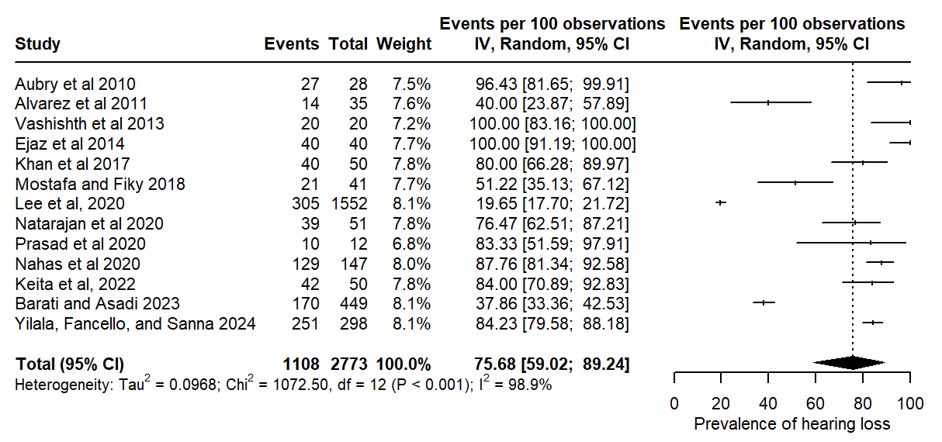

S4: Forest plot for facial nerve palsy
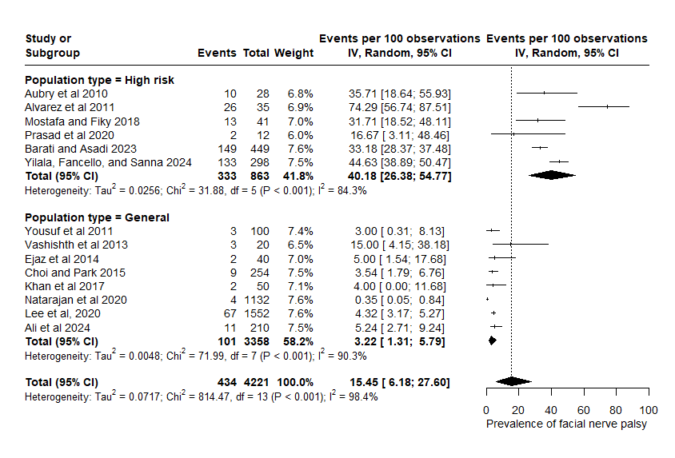

S5: Forest plot for intracranial complications
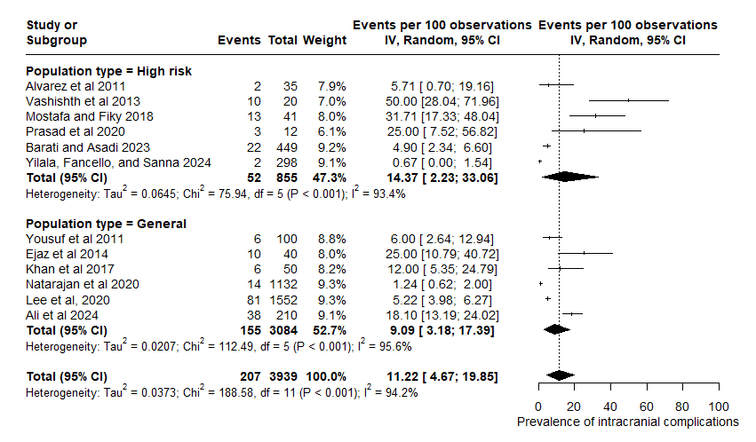

S6a: Forest plot for canal wall down (Individuals)
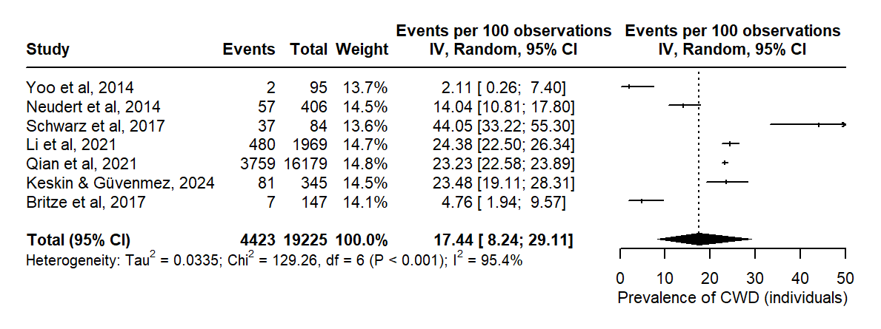

S6b: Forest plot for canal wall down (Ears)
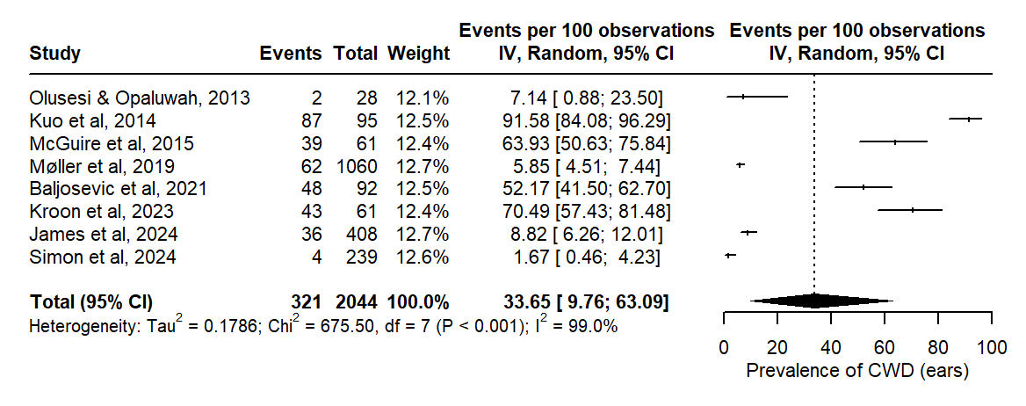

S7a: Forest plot for canal wall up (Individuals)
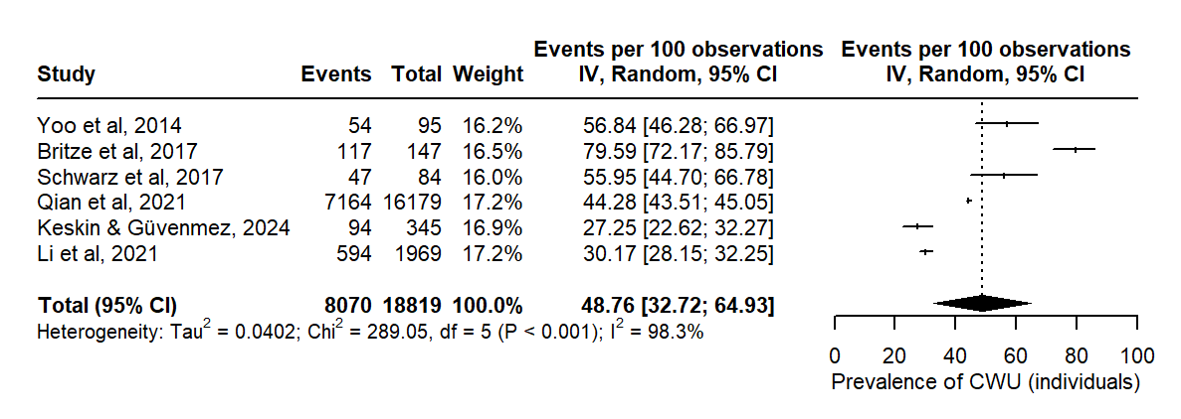

S7b: Forest plot for canal wall up (Ears)
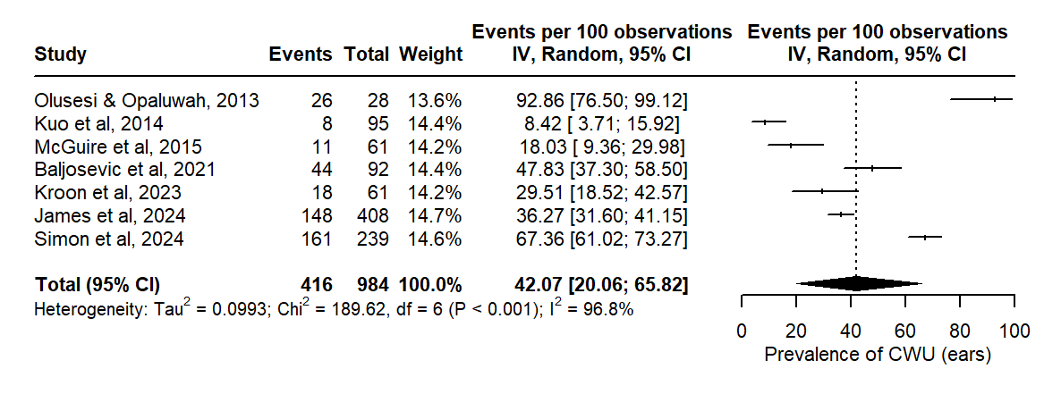

S8a: Forest plot for recidivistic cholesteatoma (Individuals)
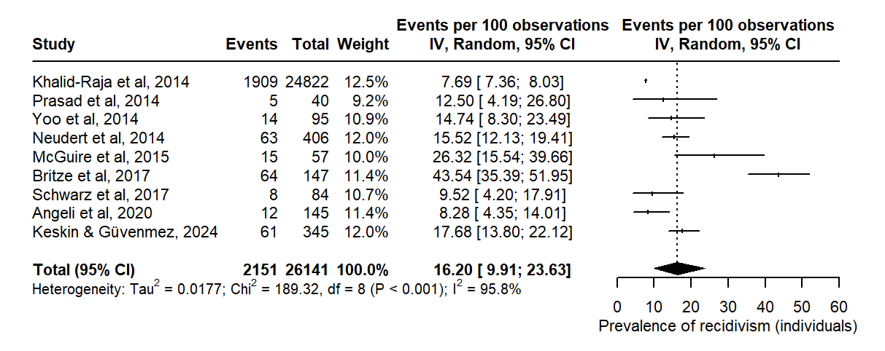

S8b: Forest plot for recidivistic cholesteatoma (Ears)
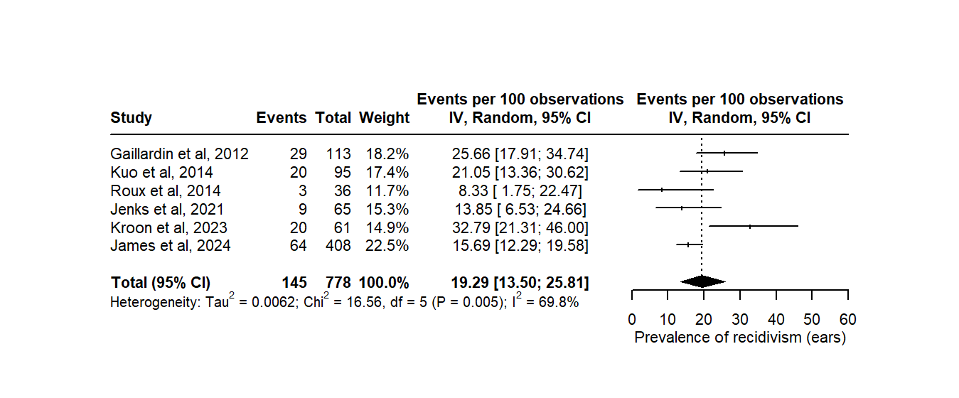

S9: Funnel plot for global prevalence
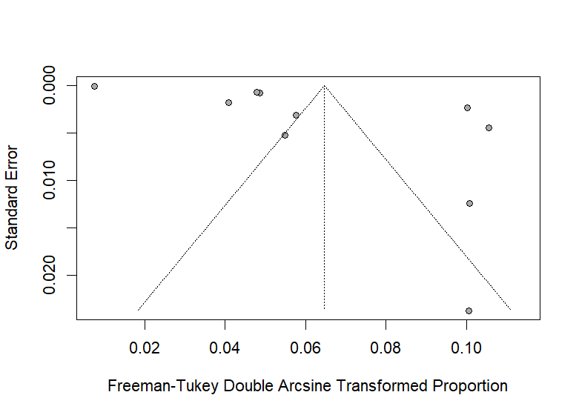

S10: Funnel plot for hearing loss
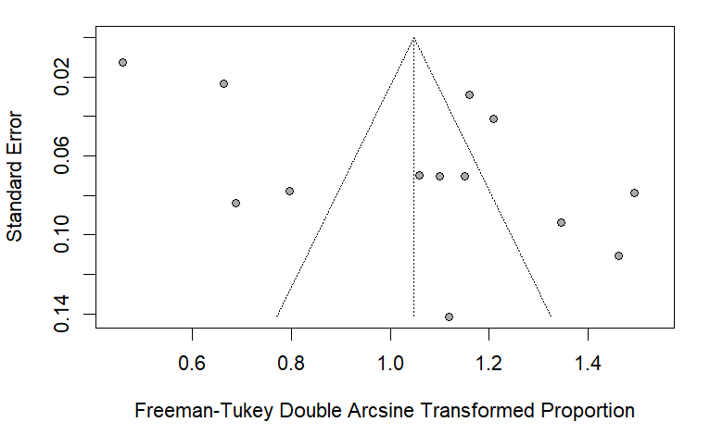

S11: Funnel plot for Facial nerve palsy

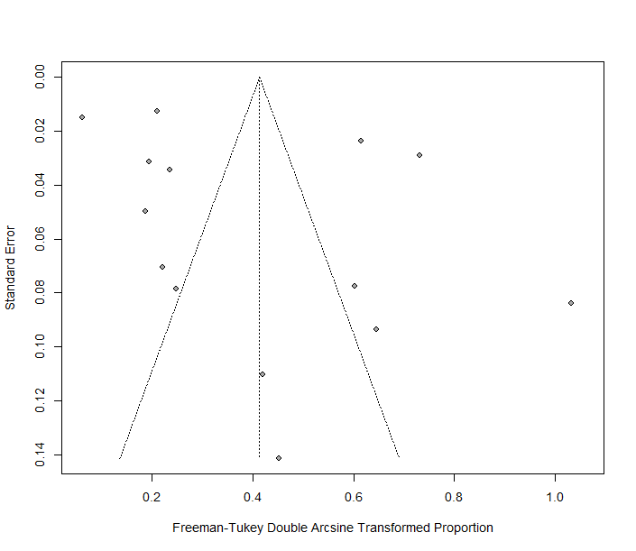
S12: Funnel plot for intracranial complications

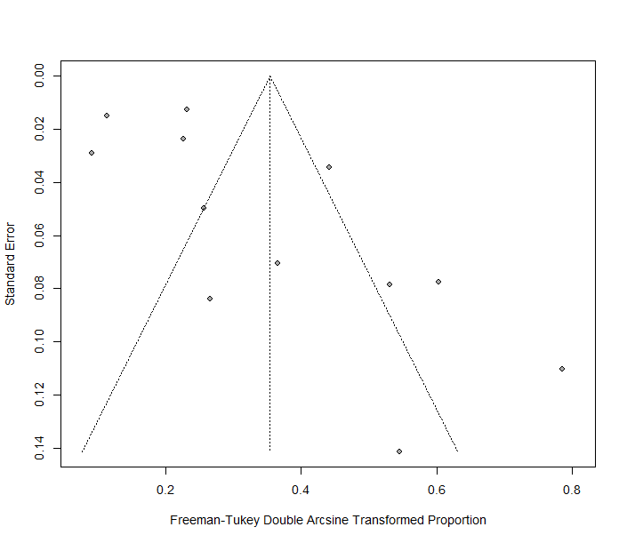

GBC PRISMA Checklist

Section and Topic | Item # | Checklist item | Location where item is reported
TITLE |  |  | Page no.
Title | 1 | Identify the report as a systematic review.  The Global Burden of Cholesteatoma: A systematic review and meta-analysis | 1
ABSTRACT
Abstract | 2 | See the PRISMA 2020 for Abstracts checklist. | 2
INTRODUCTION
Rationale | 3 | Describe the rationale for the review in the context of existing knowledge.  Despite the likelihood of a high burden of cholesteatoma in the African region, there is a glaring lack of comprehensive global prevalence data to inform decision-making and policy development. Most available data are based on hospital-based studies, which may not accurately reflect the true burden of the disease in any region. Furthermore, the few available studies have methodological limitations, including small sample sizes, poor study design, and inadequate diagnostic criteria. This lack of reliable data hinders the development of effective prevention and control strategies, ultimately perpetuating the cycle of neglect and neglect of ear and hearing disorders across the globe. | 5
Objectives | 4 | Provide an explicit statement of the objective(s) or question(s) the review addresses.  To quantify the global and regional prevalence of cholesteatoma  To quantify complications, and select treatment approaches for cholesteatoma,  To quantify the economic implications, and quality of life associated with cholesteatoma | 5
METHODS
Eligibility criteria | 5 | Specify the inclusion and exclusion criteria for the review and how studies were grouped for the syntheses.  we included studies involving patients clinically or radiologically diagnosed of cholesteatomas that provide original data on the prevalence, complications, and recidivism rate of cholesteatoma. We included studies conducted globally without any geographical restrictions.  We excluded studies with irrelevant, incomplete, or unreliable data. These include case reports, editorials, animal studies, and studies with unclear data. Additionally, studies with non-comparable outcomes or those focusing solely on treatment outcomes were also excluded. Reviews were also excluded | 6
Information sources | 6 | Specify all databases, registers, websites, organisations, reference lists and other sources searched or consulted to identify studies. Specify the date when each source was last searched or consulted.  We searched for relevant studies that were published from 01 January 2010 to 31 March 2025 across multiple databases, including PubMed, CINAHL, the Cochrane Library, Embase and WHO International Clinical Trials Registry Platform (ICTRP). we searched the grey literature, reference lists of included studies, and conducted manual searching for eligible articles. We contacted field experts for data on relevant studies they are aware of or involved with that were either not published or captured from the electronic databases.  We conducted the final search on 05 April 2025. | 5
Search strategy | 7 | Present the full search strategies for all databases, registers and websites, including any filters and limits used.  Search strategy is contained in supplementary file | Supplementary file
Selection process | 8 | Specify the methods used to decide whether a study met the inclusion criteria of the review, including how many reviewers screened each record and each report retrieved, whether they worked independently, and if applicable, details of automation tools used in the process.  We assessed if an original study on cholesteatoma included data on the prevalence, complications, and recidivism rate of cholesteatoma.  The studies were reviewed in groups  Duplicates were eliminated using our reference manager  We conducted title and abstract screening  Full articles were reviewed  Reviewers worked independently, data were compared,  Discrepancies were resolved by discussion. | 5,6
Data collection process | 9 | Specify the methods used to collect data from reports, including how many reviewers collected data from each report, whether they worked independently, any processes for obtaining or confirming data from study investigators, and if applicable, details of automation tools used in the process.  Data extractions were performed independently by two authors using standardized forms  Reviewers worked independently | 6
Data items | 10a | List and define all outcomes for which data were sought. Specify whether all results that were compatible with each outcome domain in each study were sought (e.g. for all measures, time points, analyses), and if not, the methods used to decide which results to collect.  Study characteristics  Global prevalence of cholesteatoma  WHO regional prevalence of cholesteatoma  Prevalence Recidivism  Prevalence of complications  Economic implications, and quality of life associated with cholesteatoma | 6
Data items | 10b | List and define all other variables for which data were sought (e.g. participant and intervention characteristics, funding sources). Describe any assumptions made about any missing or unclear information.  We also explored types of surgery  We contacted corresponding authors were data or information were unclear | 6
Study risk of bias assessment | 11 | Specify the methods used to assess risk of bias in the included studies, including details of the tool(s) used, how many reviewers assessed each study and whether they worked independently, and if applicable, details of automation tools used in the process.  Quality appraisal was conducted using the JBI quality appraisal tool  Risk of bias was assessed using funnel plots | 6
Effect measures | 12 | Specify for each outcome the effect measure(s) (e.g. risk ratio, mean difference) used in the synthesis or presentation of results.  Confidence intervals  Effect measure used for each of our specified outcomes included  Risk ratio | 6
Synthesis methods | 13a | Describe the processes used to decide which studies were eligible for each synthesis (e.g. tabulating the study intervention characteristics and comparing against the planned groups for each synthesis (item #5)).  The study characteristics were tabulated and compared across the predefined groups for each synthesis | 6, supplementary file
Synthesis methods | 13b | Describe any methods required to prepare the data for presentation or synthesis, such as handling of missing summary statistics, or data conversions.  Data extractions  Data cleaning  Data transformation  Effect size calculation  Data standardization  Tabulation  Forest plots | 13
Synthesis methods | 13c | Describe any methods used to tabulate or visually display results of individual studies and syntheses.  Study characteristics tables  Result tables  Forest plots  Summary of finding tables  Risk of bias graphs | 13
Synthesis methods | 13d | Describe any methods used to synthesize results and provide a rationale for the choice(s). If meta-analysis was performed, describe the model(s), method(s) to identify the presence and extent of statistical heterogeneity, and software package(s) used.  Random-effects model  I-squared (I²) statistic was used to identify extent of heterogeneity  We used the R ‘meta’ package software | 6
Synthesis methods | 13e | Describe any methods used to explore possible causes of heterogeneity among study results (e.g. subgroup analysis, meta-regression).  Subgroup analysis  Meta-regression | 13
Synthesis methods | 13f | Describe any sensitivity analyses conducted to assess robustness of the synthesized results.  To assess the robustness of the findings, we conducted sensitivity analyses excluding studies with (high risk of bias/ outliers/ unpublished data). | 14
Reporting bias assessment | 14 | Describe any methods used to assess risk of bias due to missing results in a synthesis (arising from reporting biases).  Funnel plots we plotted to visualize asymmetry and to detect potential publication bias | Supplementary file
Certainty assessment | 15 | Describe any methods used to assess certainty (or confidence) in the body of evidence for an outcome.  I-squared (I²) statistic was used | 8
RESULTS
Study selection | 16a | Describe the results of the search and selection process, from the number of records identified in the search to the number of studies included in the review, ideally using a flow diagram.  This is reflected in the flow diagram Fig 1 | 8
Study selection | 16b | Cite studies that might appear to meet the inclusion criteria, but which were excluded, and explain why they were excluded.  Reflected in Figure 1 | 8
Study characteristics | 17 | Cite each included study and present its characteristics.  Reflected in the different forest plots and cited in text and bibliography | 21
Risk of bias in studies | 18 | Present assessments of risk of bias for each included study.  Presented in the funnel plots | 14
Results of individual studies | 19 | For all outcomes, present, for each study: (a) summary statistics for each group (where appropriate) and (b) an effect estimate and its precision (e.g. confidence/credible interval), ideally using structured tables or plots.  These are reflected in the various plots for each outcome | 13, supplementary file
Results of syntheses | 20a | For each synthesis, briefly summarise the characteristics and risk of bias among contributing studies.  These are reflected the quality appraisal | Supplementary file
Results of syntheses | 20b | Present results of all statistical syntheses conducted. If meta-analysis was done, present for each the summary estimate and its precision (e.g. confidence/credible interval) and measures of statistical heterogeneity. If comparing groups, describe the direction of the effect.  These are presented in the results section | 7
Results of syntheses | 20c | Present results of all investigations of possible causes of heterogeneity among study results. | 14
Results of syntheses | 20d | Present results of all sensitivity analyses conducted to assess the robustness of the synthesized results. | 14
Reporting biases | 21 | Present assessments of risk of bias due to missing results (arising from reporting biases) for each synthesis assessed. | 14
Certainty of evidence | 22 | Present assessments of certainty (or confidence) in the body of evidence for each outcome assessed. | 12
DISCUSSION
Discussion | 23a | Provide a general interpretation of the results in the context of other evidence. | 17
Discussion | 23b | Discuss any limitations of the evidence included in the review. | 19
Discussion | 23c | Discuss any limitations of the review processes used. | 19
Discussion | 23d | Discuss implications of the results for practice, policy, and future research. | 20
OTHER INFORMATION
Registration and protocol | 24a | Provide registration information for the review, including register name and registration number, or state that the review was not registered. | 3
Registration and protocol | 24b | Indicate where the review protocol can be accessed, or state that a protocol was not prepared. | PROSPERO  CRD42024533132
Registration and protocol | 24c | Describe and explain any amendments to information provided at registration or in the protocol. | N/A
Support | 25 | Describe sources of financial or non-financial support for the review, and the role of the funders or sponsors in the review. | N/A
Competing interests | 26 | Declare any competing interests of review authors. | No competing interest
Availability of data, code and other materials | 27 | Report which of the following are publicly available and where they can be found: template data collection forms; data extracted from included studies; data used for all analyses; analytic code; any other materials used in the review. | Supplementary file

From: Page MJ, McKenzie JE, Bossuyt PM, Boutron I, Hoffmann TC, Mulrow CD, et al. The PRISMA 2020 statement: an updated guideline for reporting systematic reviews. BMJ 2021;372:n71. doi: 10.1136/bmj.n71. This work is licensed under CC BY 4.0. To view a copy of this license, visit https://creativecommons.org/licenses/by/4.0/

