- Supplementary Data
Fig. S1. Low magnification Bright Field (BF) micrographs of Sr-SiC annealed samples at (a) 1200, and (b) 1300 °C for 5 h. High Angular Annular Dark Field (HAADF) STEM micrographs of Sr-SiC annealed at (a’) 1200, and (b’) 1300 °C for 5 h, along with the Sr EDX maps a’’ and b'’.

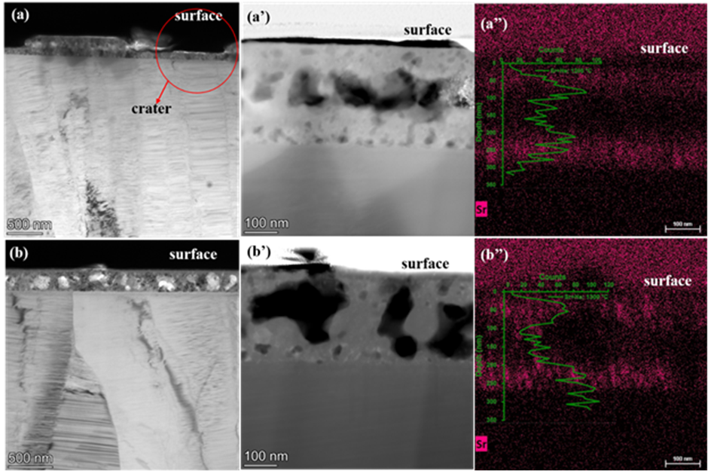
Fig. S2. Low magnification BF TEM micrographs of Sr+He-SiC samples annealed at (a) 1200, and (b) 1300 °C for 5 h. HAADF STEM micrographs of Sr+He-SiC annealed at (a’) 1200, and (b’) 1300 °C for 5 h, together with their EDX Sr maps a’’and b’’. RBS Sr profiles are also included for comparison. The red circle in (a) shows the crater formed as a result of surface exfoliation.

