Supplementary Tables
Table 4. Univariate associations between spine factors and sensitivity of pin determination as penetrating the spinal canal using five cadaver dogs examined by four evaluators with two imaging modalities.
Variable | Level | Parameter estimate (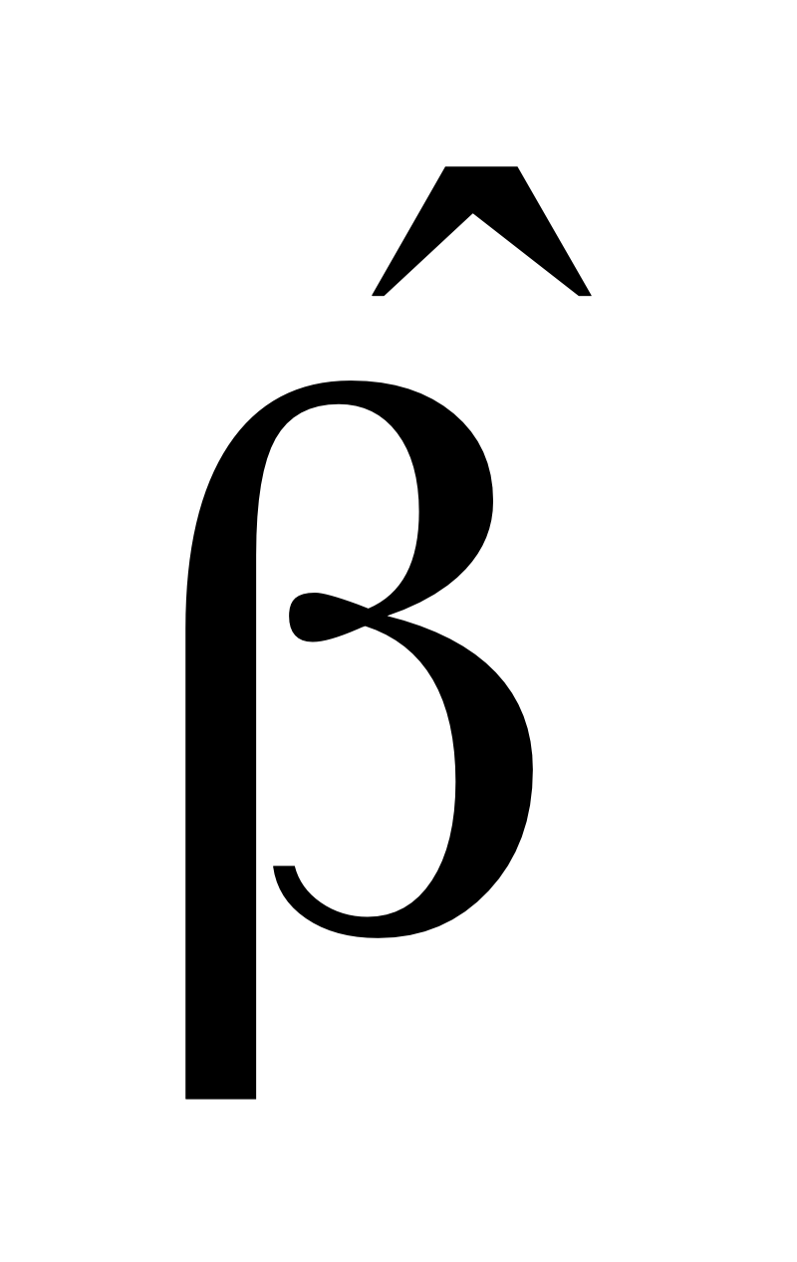) | Odds ratio  (95% CI) | P value
Fluoroscopy | Inverted | -0.934 | 0.39 (0.16, 0.96) | 0.039
 | Standard | Referent
Region | Lumbar | -0.007 | 0.99 (0.29, 3.46) | 0.991
 | Thoracic | Referent
Side | Left | 1.160 | 3.19 (0.92, 11.1) | 0.068
 | Right | Referent
Cranial/caudal pin | Cranial | 0.461 | 1.59 (0.76, 3.30) | 0.217
 | Caudal | Referent
Pins per vertebrae | One | -1.221 | 0.30 (0.06, 1.38) | 0.121
 | Two | Referent
Canal entry | Partial | ND | ND | ND
 | Complete | Referent
Evaluator confidence | 100% | 1.754 | 5.78 (1.82, 18.4) | 0.003
 | < 100% | Referent

CI = confidence interval. ND = no data due to perfect sensitivity for pins with complete penetration.

Table 5. Multivariable associations between spine factors and sensitivity of pin determination as penetrating the spinal canal using five cadaver dogs examined by four evaluators with two imaging modalities. Pins with complete penetration into the canal excluded from analysis due to perfect detection by all evaluators.
Variable | Level | Parameter estimate () | Odds ratio  (95% CI) | P value
Fluoroscopy | Inverted | -0.931 | 0.39 (0.16, 0.97) | 0.042
 | Standard | Referent
Evaluator confidence | 100% | 1.556 | 4.74 (1.48, 15.2) | 0.009
 | < 100% | Referent

CI = confidence interval.

Table 6. Univariate associations between spine factors and specificity of pin determination as penetrating the spinal canal using five cadaver dogs examined by four evaluators with two imaging modalities.
Variable | Level | Parameter estimate () | Odds ratio  (95% CI) | P value
Fluoroscopy | Inverted | 0.301 | 1.35 (0.46, 3.98) | 0.585
 | Standard | Referent
Region | Thoracic | ND | ND | ND
 | Lumbar | Referent
Side | Left | 0.687 | 1.99 (0.24, 16.2) | 0.521
 | Right | Referent
Cranial/caudal pin | Cranial | -0.564 | 0.57 (0.04, 8.44) | 0.681
 | Caudal | Referent
Pins per vertebrae | One | -1.889 | 0.15 (0.01, 2.47) | 0.185
 | Two | Referent
Evaluator confidence | 100% | 2.386 | 10.9 (2.39, 49.4) | 0.002
 | < 100% | Referent

CI = confidence interval. ND = no data due to perfect specificity for pins within thoracic vertebrae.

Table 7. Multivariable associations between spine factors and specificity of pin determination as penetrating the spinal canal using five cadaver dogs examined by four evaluators with two imaging modalities.
Variable | Level | Parameter estimate () | Odds ratio  (95% CI) | P value
Fluoroscopy | Inverted | 0.043 | 1.04 (0.33, 3.30) | 0.942
 | Standard | Referent
Evaluator confidence | 100% | 2.378 | 10.8 (2.35, 49.6) | 0.002
 | < 100% | Referent

CI = confidence interval.

