Supporting Information for “A simple method to account for thermal boundary layers during the estimation of CTmax in small ectotherms” by Rebecca B. Corley, Will Dawson, and Tom R. Bishop

Example R code to correct for dry bath lags or hot plate boundary layers.
The following code generates a toy dataset and corrects the raw CTmax values for either (1) the lag that can be found in the dry bath or (2) the boundary layer generated by the hot plate. Coefficients in the functions come from this study and the models we used to capture the lag and boundary layer effects. Specifically, from the “adjusted bath CTmax” and “adjusted plate CTmax” equations presented in the methods section of the main text. We present the code as an example for how other researchers may want to implement their own corrections.

#########################################################################
#### Create toy data
toydata <- expand.grid(method = c("bath", "plate"),
rawCTmax = c(40, 45, 50, 55, 60),
height = c(1, 4))

#### Bath lag correction
bath_correction <- function(bathset = 20){
as.vector((0.9993619 + (0.9621447 * bathset)))
}

# If the bath CTmax was recorded as 60 celsius, the organism was experiencing:
bath_correction(60)

#### Plate boundary layer correction
plate_correction <- function(height = 0, surfacetemp = 0){

as.vector(surfacetemp + (height * 1.472581) +
(height ^ 2 * -0.0845508) +
(height * surfacetemp * -0.06337333) +
(height ^ 2 * surfacetemp * 0.003346262))
}

# If the ant is 10 mm high, and the surface is 61, the ants body will be:
plate_correction(height = 10, surfacetemp = 61)

#### Use functions on a dataframe

# Correct bath estimates for lag
toydata$CTbathadj <- ifelse(toydata$method == "bath",
bath_correction(toydata$rawCTmax), NA)

# Correct plate estimates for height
toydata$CTplateadj <- ifelse(toydata$method == "plate",
plate_correction(height = toydata$height,
surfacetemp = toydata$rawCTmax),
NA)

toydata
#########################################################################

Table S1. Full ANOVA tables for analysis of unadjusted plate CTmax values (top) and adjusted plate CTmax values (bottom).
 | Degrees of freedom | Sum of squares | Mean square | F value | P value
Unadjusted plate CTmax
Species | 3 | 705.80 | 235.26 | 499.90 | < 0.01
Method | 1 | 174.40 | 174.40 | 370.58 | < 0.01
Species X Method | 3 | 125.10 | 41.70 | 88.62 | < 0.01
Residuals | 90 | 42.40 | 0.47
Adjusted plate CTmax
Species | 3 | 315.34 | 105.11 | 251.60 | < 0.01
Method | 1 | 0.21 | 0.21 | 0.50 | 0.48
Species X Method | 3 | 4.79 | 1.60 | 3.82 | 0.01
Residuals | 90 | 37.60 | 0.42

Table S2. Table showing all Tukey’s honest significant differences between species and bath and plate assay methods. Comparisons presented using unadjusted plate CTmax data (top) and adjusted CTmax data (bottom).
Comparison | CTmax difference | Lower estimate of difference | Upper estimate of difference | Adjusted p value
Unadjusted plate CTmax
L_flavus:Bath-F_rufa:Bath | -4.15 | -5.02 | -3.28 | 0.00
L_niger:Bath-F_rufa:Bath | -2.33 | -3.20 | -1.46 | 0.00
M_rubra:Bath-F_rufa:Bath | -4.03 | -4.89 | -3.18 | 0.00
F_rufa:Plate-F_rufa:Bath | 6.49 | 5.62 | 7.36 | 0.00
L_flavus:Plate-F_rufa:Bath | -3.31 | -4.18 | -2.44 | 0.00
L_niger:Plate-F_rufa:Bath | -1.35 | -2.22 | -0.48 | 0.00
M_rubra:Plate-F_rufa:Bath | -1.65 | -2.50 | -0.80 | 0.00
L_niger:Bath-L_flavus:Bath | 1.82 | 0.95 | 2.69 | 0.00
M_rubra:Bath-L_flavus:Bath | 0.12 | -0.74 | 0.97 | 1.00
F_rufa:Plate-L_flavus:Bath | 10.64 | 9.77 | 11.51 | 0.00
L_flavus:Plate-L_flavus:Bath | 0.84 | -0.03 | 1.71 | 0.07
L_niger:Plate-L_flavus:Bath | 2.80 | 1.93 | 3.67 | 0.00
M_rubra:Plate-L_flavus:Bath | 2.50 | 1.65 | 3.35 | 0.00
M_rubra:Bath-L_niger:Bath | -1.71 | -2.56 | -0.85 | 0.00
F_rufa:Plate-L_niger:Bath | 8.82 | 7.95 | 9.69 | 0.00
L_flavus:Plate-L_niger:Bath | -0.98 | -1.85 | -0.11 | 0.02
L_niger:Plate-L_niger:Bath | 0.98 | 0.11 | 1.85 | 0.02
M_rubra:Plate-L_niger:Bath | 0.68 | -0.17 | 1.53 | 0.22
F_rufa:Plate-M_rubra:Bath | 10.52 | 9.67 | 11.37 | 0.00
L_flavus:Plate-M_rubra:Bath | 0.73 | -0.13 | 1.58 | 0.16
L_niger:Plate-M_rubra:Bath | 2.69 | 1.84 | 3.54 | 0.00
M_rubra:Plate-M_rubra:Bath | 2.38 | 1.55 | 3.22 | 0.00
L_flavus:Plate-F_rufa:Plate | -9.80 | -10.67 | -8.93 | 0.00
L_niger:Plate-F_rufa:Plate | -7.83 | -8.70 | -6.96 | 0.00
M_rubra:Plate-F_rufa:Plate | -8.14 | -8.99 | -7.29 | 0.00
L_niger:Plate-L_flavus:Plate | 1.96 | 1.09 | 2.83 | 0.00
M_rubra:Plate-L_flavus:Plate | 1.66 | 0.81 | 2.51 | 0.00
M_rubra:Plate-L_niger:Plate | -0.30 | -1.16 | 0.55 | 0.95
Adjusted plate CTmax
L_flavus:Bath-F_rufa:Bath | -4.15 | -4.97 | -3.33 | 0.00
L_niger:Bath-F_rufa:Bath | -2.33 | -3.15 | -1.51 | 0.00
M_rubra:Bath-F_rufa:Bath | -4.03 | -4.84 | -3.23 | 0.00
F_rufa:Plate-F_rufa:Bath | 0.62 | -0.20 | 1.44 | 0.28
L_flavus:Plate-F_rufa:Bath | -4.55 | -5.37 | -3.73 | 0.00
L_niger:Plate-F_rufa:Bath | -2.64 | -3.46 | -1.82 | 0.00
M_rubra:Plate-F_rufa:Bath | -3.61 | -4.41 | -2.80 | 0.00
L_niger:Bath-L_flavus:Bath | 1.82 | 1.00 | 2.64 | 0.00
M_rubra:Bath-L_flavus:Bath | 0.12 | -0.69 | 0.92 | 1.00
F_rufa:Plate-L_flavus:Bath | 4.77 | 3.95 | 5.59 | 0.00
L_flavus:Plate-L_flavus:Bath | -0.40 | -1.22 | 0.42 | 0.80
L_niger:Plate-L_flavus:Bath | 1.51 | 0.69 | 2.33 | 0.00
M_rubra:Plate-L_flavus:Bath | 0.54 | -0.26 | 1.35 | 0.42
M_rubra:Bath-L_niger:Bath | -1.71 | -2.51 | -0.90 | 0.00
F_rufa:Plate-L_niger:Bath | 2.95 | 2.13 | 3.77 | 0.00
L_flavus:Plate-L_niger:Bath | -2.22 | -3.04 | -1.40 | 0.00
L_niger:Plate-L_niger:Bath | -0.31 | -1.13 | 0.51 | 0.94
M_rubra:Plate-L_niger:Bath | -1.28 | -2.08 | -0.47 | 0.00
F_rufa:Plate-M_rubra:Bath | 4.65 | 3.85 | 5.46 | 0.00
L_flavus:Plate-M_rubra:Bath | -0.51 | -1.32 | 0.29 | 0.50
L_niger:Plate-M_rubra:Bath | 1.40 | 0.60 | 2.20 | 0.00
M_rubra:Plate-M_rubra:Bath | 0.43 | -0.36 | 1.22 | 0.69
L_flavus:Plate-F_rufa:Plate | -5.16 | -5.98 | -4.34 | 0.00
L_niger:Plate-F_rufa:Plate | -3.25 | -4.07 | -2.44 | 0.00
M_rubra:Plate-F_rufa:Plate | -4.22 | -5.03 | -3.42 | 0.00
L_niger:Plate-L_flavus:Plate | 1.91 | 1.09 | 2.73 | 0.00
M_rubra:Plate-L_flavus:Plate | 0.94 | 0.14 | 1.74 | 0.01
M_rubra:Plate-L_niger:Plate | -0.97 | -1.77 | -0.17 | 0.01

Figure S1

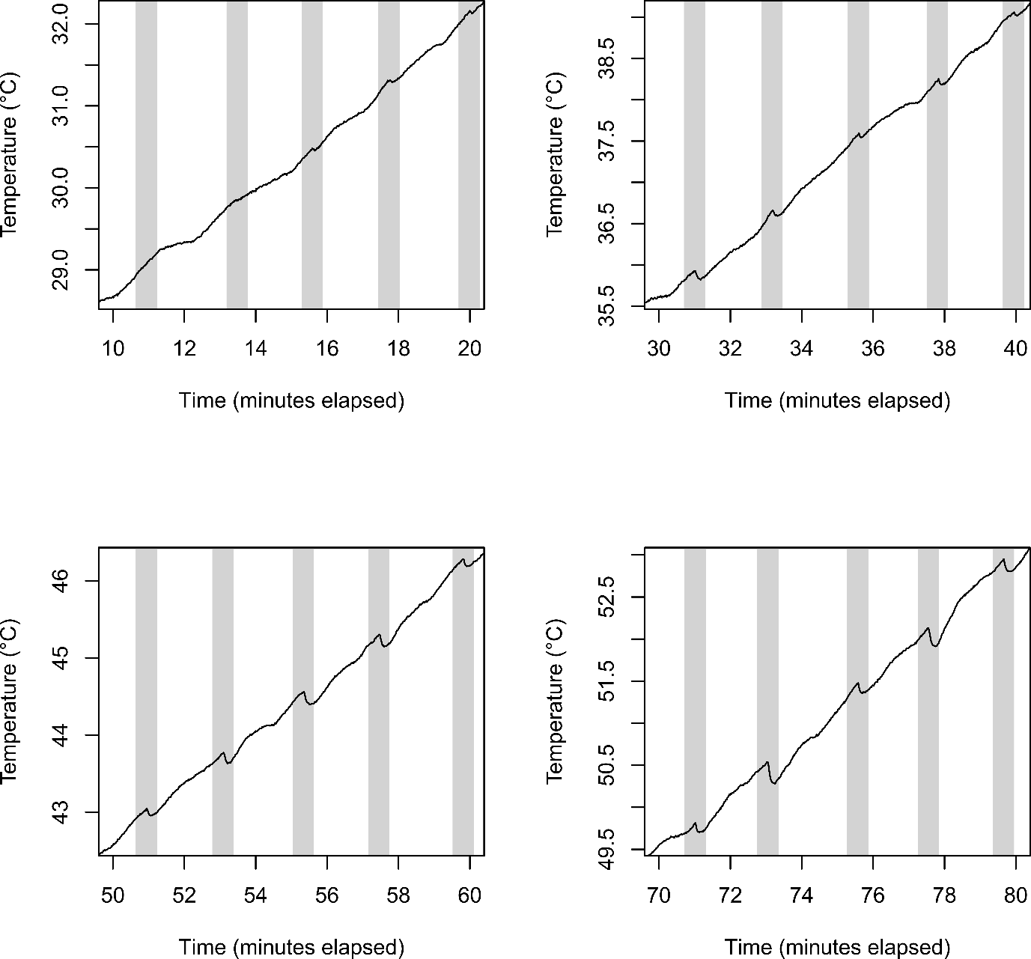 Figure S1. Four example time periods showing the temperature trace (black line) of a type T thermocouple placed within an Eppendorf tube within a dry heat bath during a CTmax experiment. The grey shaded areas represent times when the tube was removed from the block to check for a righting response in the ants. In these periods, the temperature dips slightly (low temperatures, top left) or a lot (high temperatures, bottom right) but recovers quickly once the tube is placed back into the block.

Figure S2
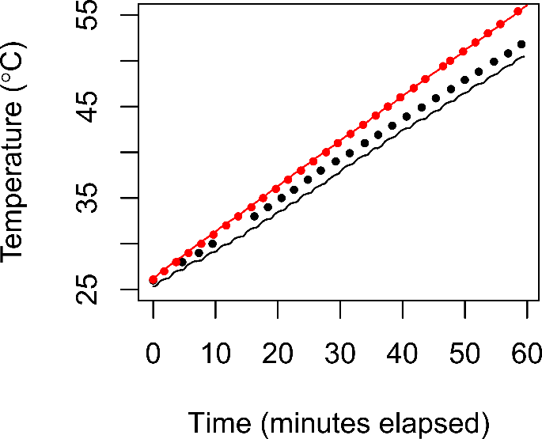
Figure S2. Temperature tracks of the hotplate at 1mm in the air (red) and within an Eppendorf tube within the dry bath (black). Lines represent actual data through tiem as recorded by Type T thermocouples. Point represent advertised temperatures of the hot plate or the bath. Note that the temperatures within the Eppendorfs in the dry bath lag behind the advertised temperatures slightly, and that the realised ramping rate is slightly slower than that on the programmable dry bath. Also note the multiple plateaux in the dry bath (black) data caused by manual programming and ramping.

