Supplementary material

Table S1. Summary of annual aerial southern right whale photo-identification surveys from 1979 to 2022, including dates, aircraft used, flying hours and number of cows with associated calves and unaccompanied adults counted and number of cows identified.

Year | Dates | Aircraft | Flying hours | Cows counted | Cows ID | Unacc counted
1979 | 12-13 Oct | Sikorsky S62A | 12.4 | 27 | 27
1980 | 21-23 Oct | Bell Jet Ranger | 16.4 | 33 | 33
1981 | 6-7 Oct | Bell Jet Ranger | 14.8 | 50 | 50
1982 | 15-16 Oct | Bell Jet Ranger | 14.7 | 40 | 40
1983 | 14-16 Oct | Bell Jet Ranger | 18.6 | 43 | 43
1984 | 8-11 Oct | Bell Jet Ranger | 19.3 | 65 | 65
1985 | 16-18 Oct | Bell Jet Ranger | 15.7 | 53 | 53
1986 | 7-10 Oct | Bell Jet Ranger | 17.3 | 44 | 44
1987 | 15-21 Oct | Bell Jet Ranger | 19.7 | 75 | 75
1988 | 14-17 Oct | Bell Jet Ranger | 19.3 | 68 | 68
1989 | 12-14 Oct | Bell Jet Ranger | 21.5 | 78 | 78
1990 | 16-22 Oct | Bell Jet Ranger | 17.5 | 86 | 75 | 93
1991 | 12-15 Oct | Bell Jet Ranger | 17.1 | 82 | 76 | 56
1992 | 18-23 Oct | Bell Jet Ranger | 18.6 | 88 | 84 | 99
1993 | 12-15 Oct | Hughes500 | 18.4 | 99 | 90 | 185
1994 | 11-14 Oct | Bell Jet Ranger | 19.4 | 96 | 90 | 100
1995 | 14-20 Oct | Bell Jet Ranger | 20.9 | 109 | 96 | 142
1996 | 20-25 Oct | Bell Jet Ranger | 21.9 | 146 | 134 | 131
1997 | 17-20 Oct | Bell Jet Ranger | 22.5 | 129 | 118 | 189
1998 | 8-15 Oct | Bell Jet Ranger | 24.8 | 132 | 111 | 132
1999 | 8-14 Oct | Bell Jet Ranger | 24.6 | 174 | 150 | 162
2000 | 11-15Oct | Bell Jet Ranger | 23.7 | 163 | 150 | 236
2001 | 9-15Oct | Bell Jet Ranger | 25.3 | 179 | 162 | 370
2002 | 7-13 Oct | Bell Jet Ranger | 23.7 | 231 | 185 | 270
2003 | 12-22 Oct | Bell Jet Ranger | 25.3 | 226 | 176 | 251
2004 | 9-14Oct | Bell Jet Ranger | 30.1 | 206 | 182 | 301
2005 | 7-15 Oct | Bell Jet Ranger | 31.8 | 260 | 209 | 164
2006 | 11-19 Oct | Bell Jet Ranger | 32.7 | 275 | 230 | 401
2007 | 16-27 Oct | Bell Jet Ranger | 38.5 | 253 | 185 | 250
2008 | 9-18 Oct | Bell Jet Ranger | 45.2 | 354 | 237 | 433
2009 | 12-23 Oct | Bell Jet Ranger | 33.7 | 338 | 252 | 254
2010 | 14-23 Oct | Bell Jet Ranger | 31.7 | 268 | 212 | 74
2011 | 5-18 Oct | Bell Jet Ranger | 36.1 | 308 | 247 | 124
2012 | 10 Oct-4 Nov | Bell Jet Ranger | 44.6 | 306 | 224 | 57
2013 | 30 Sept-8 Oct | Bell Jet Ranger | 29.3 | 337 | 258 | 201
2014 | 30 Sept-14 Oct | Bell Jet Ranger | 47.9 | 461 | 269 | 87
2015 | 28 Sept-08 Oct | Bell Jet Ranger | 29.5 | 249 | 158 | 15
2016 | 28 Sept-10 Oct | Euro Copter 120 | 21.3 | 55 | 49 | 9
2017 | 2-9 Oct | Euro Copter 120 | 29.5 | 183 | 147 | 161
2018 | 2- 15 Oct | Euro Copter 120 | 37.4 | 537 | 426 | 34
2019 | 1 -5 Oct | Euro Copter 120 | 14.3 | 94 | 79 | 12
2020 | 27-29 Sept | Euro Copter 120 | 12.9 | 67 | 64 | 31
2021 | 3-5 Oct | Euro Copter 120 | 16.6 | 191 | 177 | 32
2022 | 1-5 Oct | Squirrel | 21.6 | 304 | 277 | 50
Total |  |  | 1,077.2 | 7,562.0 | 6,155 | 5,106

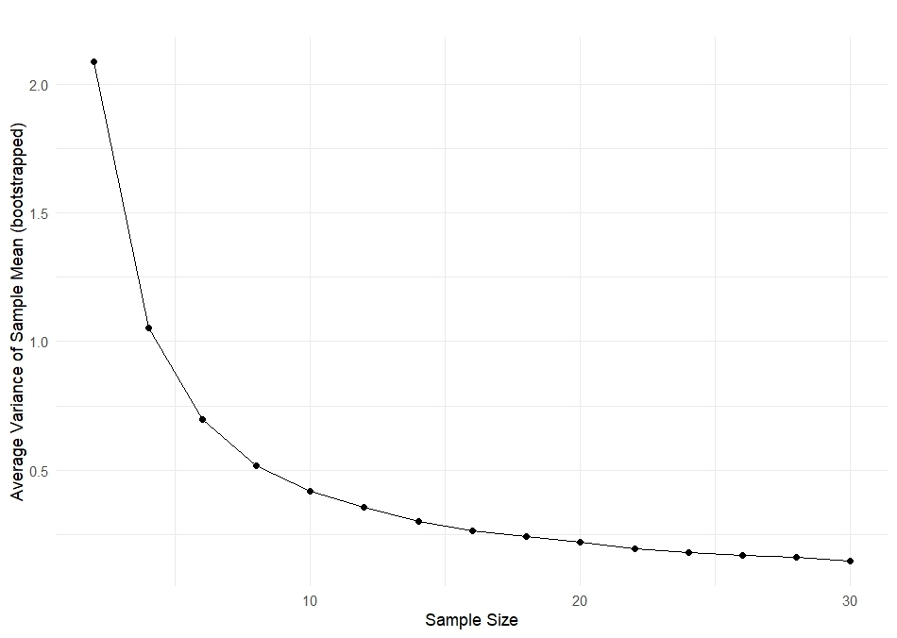
Figure S1. Relationship between sample size and the average variance of bootstrapped mean calving interval estimates. For each year in the dataset, 1,000 bootstrap replicates were drawn at increasing sample sizes (2–30 individuals), and the variance of the sample mean was calculated. Values shown are the mean variance across all years for each sample size. The curve demonstrates diminishing returns in precision with increasing sample size.

