Appendix: Example graphs of scenario analysis results from which the Bayesian Network (BN) model estimated mean values and the 80% prediction intervals were extracted as presented in Table 1. Figures S1 to S3 showed the scenario analysis results of the overall/average the means and 80% prediction intervals that were presented in the last 6 rows in Table 1; Figures S4 to S9 showed the scenario analysis results for the lean cohort at each of the six anterior thoracic spine sections of the means and 80% prediction intervals that were presented in the first 6 rows in Table 1.
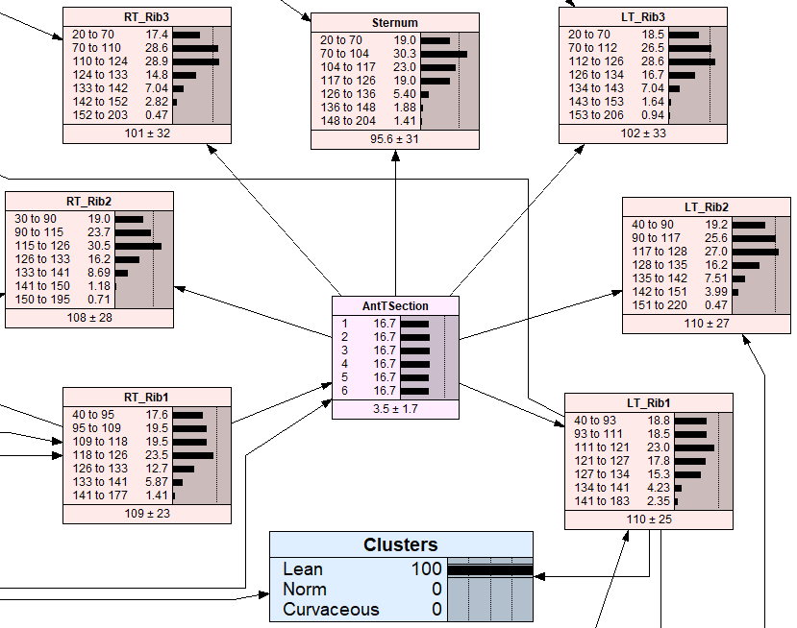
Figure S1: BN scenario analysis results for the Lean cohort of the overall or average (over all six anterior thoracic spine sections) scenario.

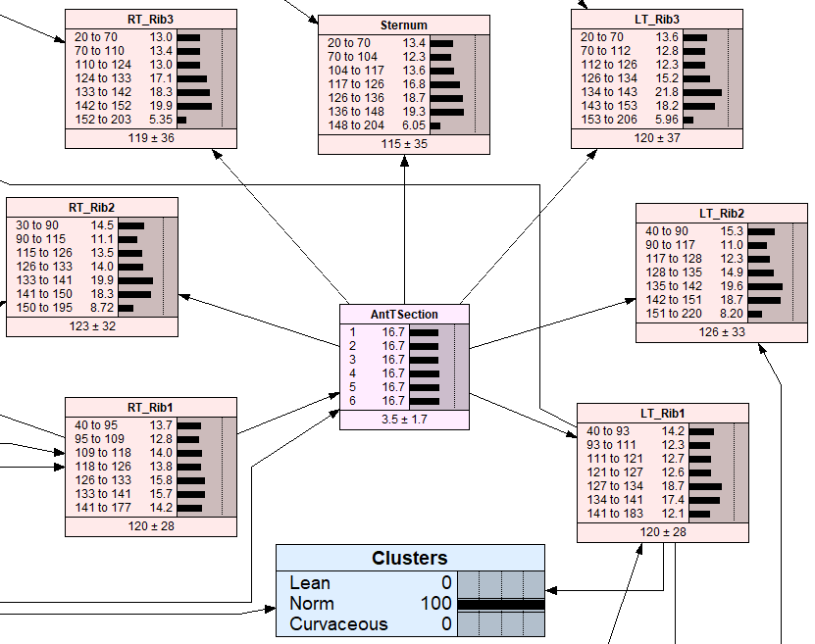
Figure S2: BN scenario analysis results for the Norm cohort of the overall or average (over all six anterior thoracic spine sections) scenario.
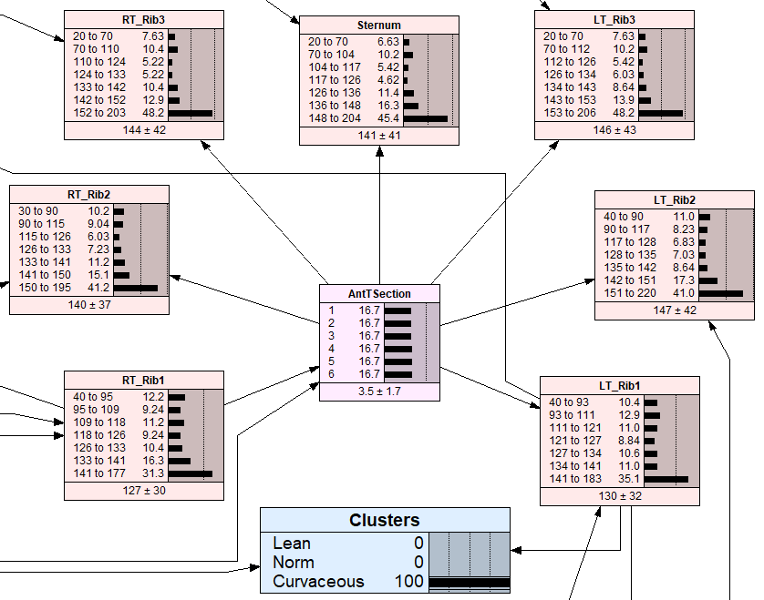
Figure S3: BN scenario analysis results for the Curvaceous cohort of the overall or average (over all six anterior thoracic spine sections) scenario.
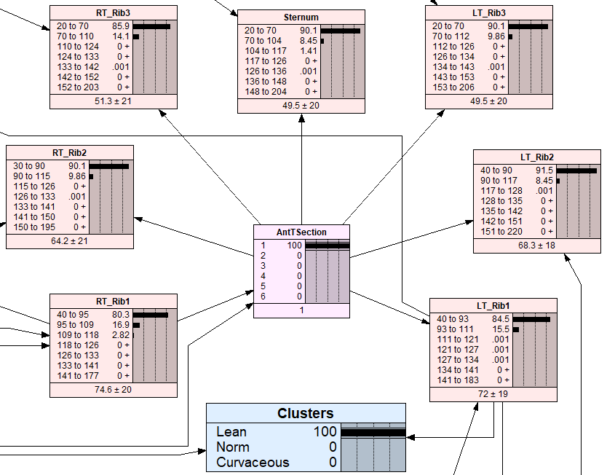
Figure S4: BN scenario analysis results for the Lean cohort and the section 1 of the anterior thoracic spine scenario.
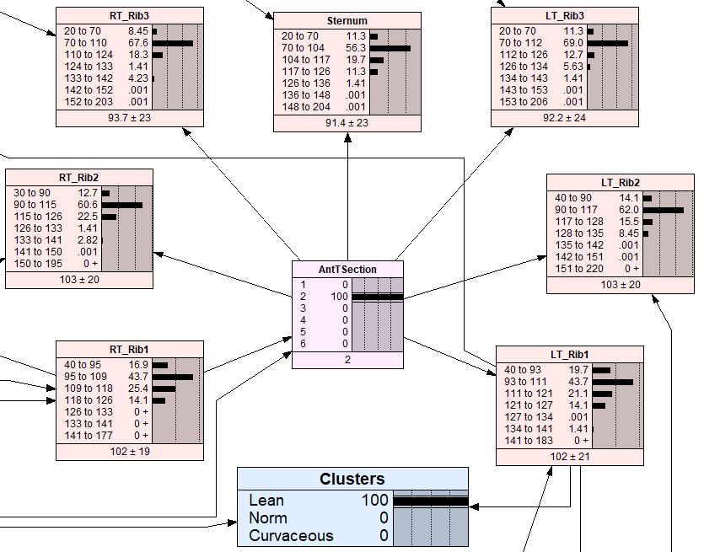
Figure S5: BN scenario analysis results for the Lean cohort and the section 2 of the anterior thoracic spine scenario.
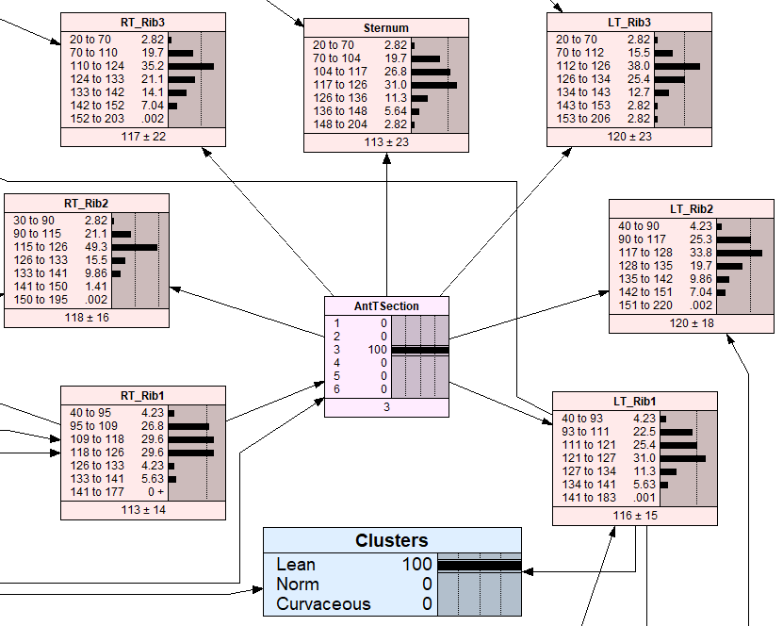
Figure S6: BN scenario analysis results for the Lean cohort and the section 3 of the anterior thoracic spine scenario.
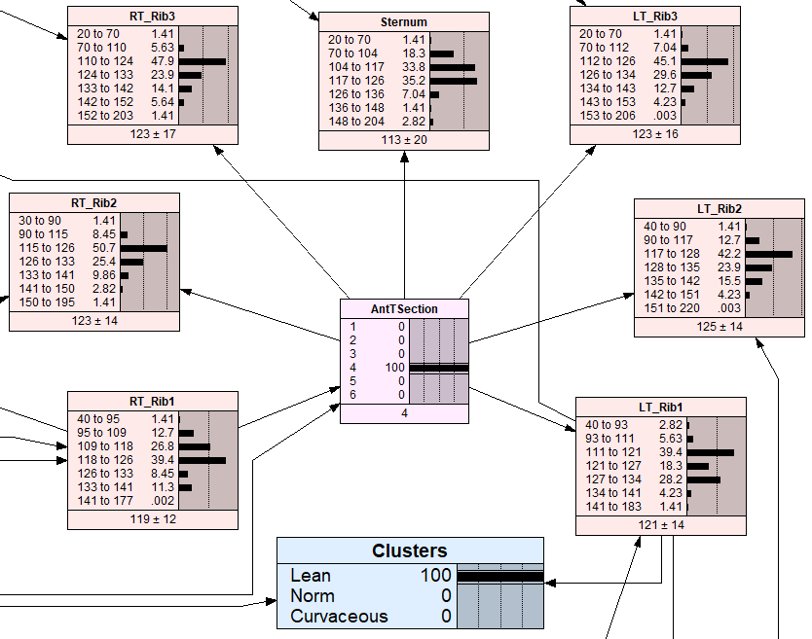
Figure S7: BN scenario analysis results for the Lean cohort and the section 4 of the anterior thoracic spine scenario.
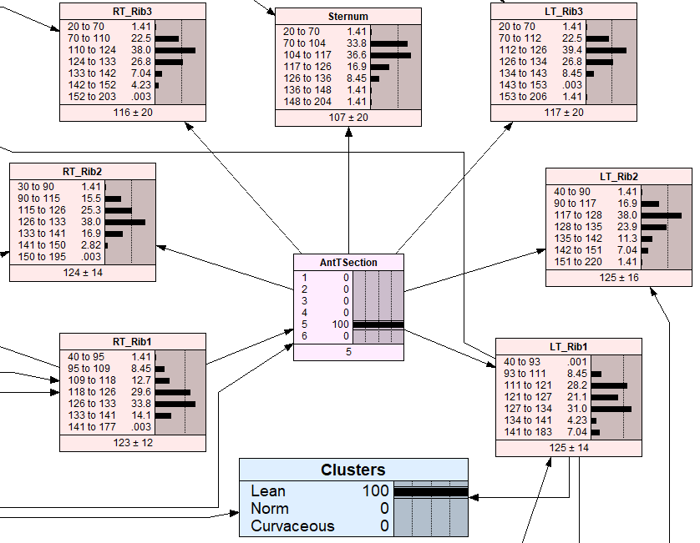
Figure S8: BN scenario analysis results for the Lean cohort and the section 5 of the anterior thoracic spine scenario.
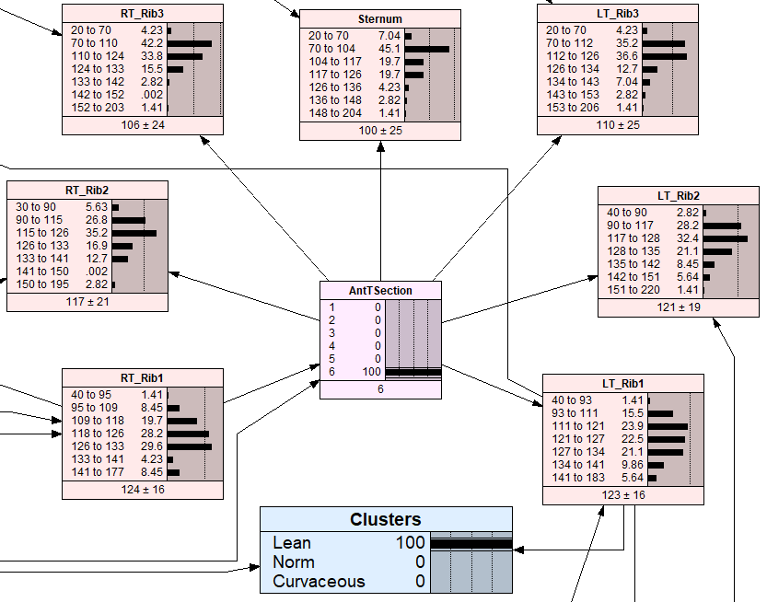
Figure S9: BN scenario analysis results for the Lean cohort and the section 6 of the anterior thoracic spine scenario.

