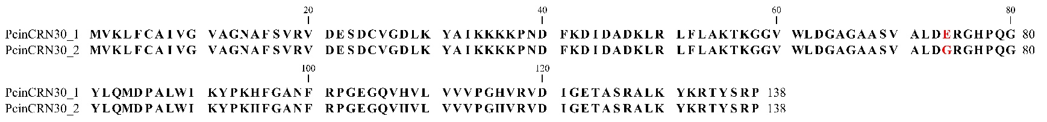
A

B
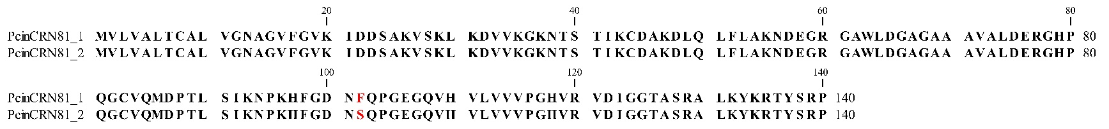

Supplementary Figure 3. Schematic comparing PcinCRN30 and PcinCRN81 protein sequences. The confirmed amino acid sequences of the Phytophthora cinnamomi crinkling and necrosis (PcinCRN) effectors of (A) PcinCRN30_1 and PcinCRN30_2, and (B) PcinCRN81_1 and PcinCRN81_2 were aligned using CLC Main Workbench with a gap open cost value of 10,0 and a gap extension cost value of 1,0. Both PcinCRN30 and PcinCRN81 have a single nucleotide polymorphism (SNP) change between their variants, which results in a non-synonymous amino acid change indicated in red.

