Supplementary Materials

Ascertaining Mother-offspring Temporal Whisker Growth Overlap
A combination of published elephant seal whisker growth rates (Beltran et al., 2015; Lübcker et al., 2016), measured whisker lengths at various ages, and visual inspection of the bulk tissue stable isotope values along the whiskers were used to identify the life-history chronology of each individual (e.g. Lübcker et al., 2020). There are no published growth rates of intrauterine grown whiskers, although SES fetal whiskers during gestation has been reported: 10 mm long at day 60 (n = 1; Ling, 1966). For this study, whisker length of n = 5 new-born pups (< 2 days after birth) were measured during 2013. The new-born whisker length was 65.4 ± 4.0 mm, while those of recently-weaned pups (n = 167) sampled ~21–23-days later were 76.0 ± 9.2 mm long (Lübcker et al., 2016). This translates to a linear growth rate of 0.19 ± 0.20 mm.day⁻¹ (Ling, 1966), similarly reported in Walters et al., (2014). Their whiskers only grew 10.6 mm during the 23-day-sucking period before being weaned (this study), less than the ~12 mm whisker segment left embedded in the muzzle after cutting the whisker when weaned (Fig. 1). The entire whisker sampled from recently weaned SES, therefore, represented intrauterine growth only.
To ascertain that the period represented by the adult females’ whiskers corresponded temporally to the isotope values measured along the length of the whiskers sampled from the recently-weaned SES pups, it was assumed that the whisker growth of adult females commenced during, or shortly after, the annual pelage molt (Lübcker et al., 2016; McHuron et al., 2019; Lübcker et al., 2020). The fasting-enriched δ¹⁵N values of their whiskers start declining at the onset of the post-molt foraging period, which were assumed to overlap with the delayed blastocyst implantation that occurs during the molt, although the timing of the blastocyst implantation can be variable (Ling, 2013; McHuron et al., 2019; Lübcker et al., 2020). Provided that the fetal whiskers can be up to 10 mm long at 60 days after implantation (Ling, 1966), it was important to determine where along the length of the females’ whiskers the corresponding fetal whisker grow started. This was accomplished using an elephant seal-specific asymmetric whisker growth rate constant (Beltran et al., 2015).
After identifying the position (mm) along the length of the females’ whiskers where the onset of the δ¹⁵N depletion occurred (Lübcker et al., 2020), the length of the females’ whisker grown from the start of the whisker growth until where the fetal whisker would have grown 10 mm could then be calculated, using variations of Equation 1S. The time (days) to grow each whisker section was determined as:
T $=\left[\frac{-1}{K}\ln\left(1- \frac{S_{T}}{A}\right)\right]+T_{0}$
Eq. 1S
where $S_{T}$ is the length of the regrowth at time T; $A$ is the asymptotic length (maximum length that the whisker can reach); and K is the curvature parameter (Eq. 1) (K = 0.0132; Beltran et al., 2015). Given the variability in the asymptotic whisker length of SES of different ages, and because some of the whiskers used to determine the asymptotic length could still have been growing, the maximum length of each of the sampled whisker was used as the asymptotic length ($A)$. In cases where the whisker might still be actively growing, the mean asymptotic length derived from the average whisker length (116.6 ± 24.0 mm; mean ± SD) collected from n = 29 adult SES were used, with whisker lengths ranging from 73.0–165.0 mm (this study). The length of the adult female’s whisker grown from the onset of the δ¹⁵N depletion until 60 days when the fetal whisker has grown 10 mm (Ling, 1966) was then estimated. This information was used to determine where along the whisker length of each mother the fetal (intrauterine) whisker growth started.
The onset of the molt-fast associated δ¹⁵N depletion occurred 38.4 ± 12.1 mm from the tip of the whiskers sampled from 17 adult females, corresponding to 31.0 ± 11.5 days of whisker growth since the replacement of the whisker during the molt. The whiskers were approximately 67.9 ± 7.7 mm long after 60 days since the blastocyst implantation occurred, corresponding to the time when the fetal whisker has already grown 10 mm (Ling, 1966). The position along the female’s whisker where the intrauterine whisker growth started was calculated to be 17.6 ± 3.3 mm (Mean ± SE) from the onset of the females fast-related δ¹⁵N depletion (set zero position on x-axis, Fig. 2a, b). The fetal-mother whisker growth, therefore, started approximately 56.0 ± 7.0 mm from the tip of female whiskers. We are confident that the isotopes values of the mother-offspring pairs used to assess the mother-offspring stable isotope correlation coefficients are accurately scaled and comparable.

Supplementary Tables
Table S1: Extended summary of 25 studies that validated, and/or applied, bulk tissue δ¹⁵N and δ¹³C values measured in tissues sampled from offspring of 31 mammal species to infer the foraging habits of their mothers during gestation and/or lactation. Differences between the mother-offspring δ¹⁵N and δ¹³C values are expressed as Δ¹⁵N and Δ¹³C. This is a non-exhaustive list of studies that used the bulk tissue Δ¹⁵N and Δ¹³C values tissue measured in the tissue sampled from offspring to infer the habits of their mothers, and excludes studies performed on fossilized material, bone, and teeth.
Species |  | Tissue |  | Sample size |  | Period |  | Aim |  | Results |  | Reference
Australian sea lion^{I} Neophoca cinerea |  | Whiskers, blood serum |  | n = 14 mother-offspring pairs |  | Early lactation |  | Foraging ecotypes. |  | Whisker Δ¹⁵N_{mother-pup}: Weak correlation (R² = 0.76). Δ¹⁵N_{mother-pup} = +1.3‰;  Δ¹³C_{mother-pup}: Linearly correlated (R² = 0.83); Δ¹³C_{mother-pup} = +0.2‰. |  | Lowther & Goldsworthy, 2011
California sea lions^{I} Zalophus californianus |  | Hair |  | n = 188 pups; n = 8 AF (unpaired) |  | Lactation |  | Inter-colony maternal foraging behaviour. |  | Δ¹⁵N_{mother-pup} = +2.1‰ ± 0.1‰  Δ¹³C_{mother-pup} = -0.8‰ ± 0.2‰ |  | Porras-Peters et al., 2008
Southern elephant seal^{C/I} Mirounga leonina |  | Whole blood |  | Lactating group, n = 17 mother-offspring pairs |  | Lactation |  | Trophic ecology.  Investigated mother-offspring TDFs. |  | Lactating group: Δ¹⁵N_{mother-pup} & Δ¹³C_{mother-pup} linearly correlated; Δ¹⁵N_{mother-pup} = +1.3 ± 0.3‰; Δ¹³C_{mother-pup} = ~ -0.3‰. |  | Ducatez et al., 2008
Galápagos fur seal^{I} (GFS) Arctocephalus galapagoensis  Galápagos sea lions^{I} (GSL) Zalophus wollebaeki |  | Skin biopsy |  | n = 140 GFS pups; n = 90 GLS pups |  | Lactation |  | Inter-colony maternal foraging behaviour. |  | No validation attempted. Applied no mother-pup TDFs. Assumed stable isotope values of pups equally reflected maternal foraging strategy. |  | Wolf et al., 2008
Northern elephant seals^{C/I} Mirounga angustirostris |  | Hair  . |  | n = 85 pups |  | Lactation |  | Inter-colony maternal foraging behaviour. |  | No validation attempted. Applied no mother-pup TDFs. |  | Aurioles et al., 2006
South American sea lion^{I}, Otaria flavescens |  | Whiskers |  | n = 65 pups (unknown age) |  | Mostly intrauterine |  | Foraging ecotypes. |  | No validation attempted. Applied no mother-pup TDFs. Assumed that TDFs remained constant. |  | Baylis et al., 2016
South American sea lion^{I}, Otaria flavescens |  | Serum, blood cells |  | n = 26 pups |  | Late pregnancy (blood) & early lactation |  | Inter-colony maternal foraging behaviour. |  | No validation attempted. Applied no mother-pup TDFs. Assumed that TDFs remained constant. |  | Drago et al., 2010
Steller sea lion^{I} Eumetopias jubatus |  | Whiskers,  milk |  | n = 4 mother-offspring pairs. Includes whisker root of n = 76 milk−pup whisker root pairs |  | Gestation & lactation |  | Investigated mother-offspring TDFs (Did not consider temporal changes in TDFs during gestation). |  | Δ¹⁵N_{mother-pup} late gestation +0.8‰ and;  Δ¹³C = -0.4‰. Δ¹⁵N_{mother-pup} changed from gestation to lactation; Δ¹⁵N lactation +1.6‰ while Δ¹³C near zero (-0.1‰). Average lipid-free pup whisker to milk Δ¹³C = +2.5 ± 0.9‰; Δ¹⁵N = +1.8 ± 0.8‰ |  | Stricker et al., 2015
Bearded seals^{C/I}  Erignathus barbatus |  | Whiskers |  | n = 61 pups |  | Gestation |  | Interannual variation in maternal foraging behaviour. |  | Δ¹⁵N_{mother-pup} = +0.5‰ to +2‰. No mother-pup validation attempted. Applied a general diet-tissue TDFs; did not consider a mother-fetus-specific TDFs. |  | Hindell et al., 2012
Fin whales^{C}  Balaenoptera physalus |  | Muscle,  milk |  | n = 13 pregnant AF & their fetuses (n = 10).  Lactation AF (n = 21) & milk (n = 25) |  | Gestation & lactation |  | Investigated mother-offspring TDFs. |  | Muscle Δ¹⁵N_{mother-foetus} = +1.5‰;  Δ¹³C_{mother-foetus} = 1.1‰.  Milk Δ¹⁵N_{mother- calf} = +0.3‰ compared to calf muscle & Δ¹³C_{mother-calf} = -0.7‰. |  | Borrell et al., 2016
11 species of mammals,  Mixed breeding strategies (mostly income).  *Species list |  | Blood, milk |  | n = 3–5 paired mother-offspring per species |  | Late gestation (blood cells) & early lactation (serum) |  | Investigated mother-offspring TDFs. |  | Plasma Δ¹⁵N_{mother-offspring} = +0.9 ± 0.8‰;  No Δ¹³C_{mother-pup} enrichment (0.0 ± 0.6‰).  Milk Δ¹⁵N_{mother-offspring} = +1.9 ± 0.7‰ & Δ¹³C = +1.9 ± 0.8‰). Interspecific difference in mother-pup TDFs. |  | Jenkins et al., 2001
Northern elephant seals^{C/I} Mirounga angustirostris |  | Serum, blood cells,  milk |  | n = 10 mother-pup pairs sampled after 5 & 22 days of lactation |  | Late gestation (blood cells) & early lactation (Plasma) |  | Investigated mother-offspring TDFs. |  | Blood cell Δ¹⁵N_{mother-pup} first sampling (day 5) & day 22 increased from +0.6 ± 0.4‰ to +1.3 ± 0.3‰ (+0.7± 0.4‰. difference); Serum Δ¹³C_{mother-pup} +1.1‰ and become nonsignificant (day 22).  Δ¹³C_{mother-pup} more dependable. |  | Habran et al., 2010
Meerkat^{I}  Suricata suricatta |  | Hair |  | n = 18 pups & five breeding AF |  | Lactation |  | Investigated mother-offspring TDFs (different time intervals). |  | No temporal trends in Δ¹⁵N_{mother-pup} throughout lactation; Δ¹⁵N_{mother-pup =} +0.4%. |  | Dalerum et al., 2007
Human^{I}  Homo sapiens |  | Hair |  | n = 239 mother-neonate pairs |  | Gestation |  | Investigated mother-offspring TDFs (hair not sequentially analyzed). |  | Hair Δ¹⁵N_{mother-neonate} & Δ¹³C_{mother- neonate} positively correlated; Δ¹⁵N_{mother-pup} = ~ +0.9‰; Δ¹³C_{mother-pup} = ~ +0.4‰. |  | De Luca et al., 2012
Grey seal^{C/I}  Halichoerus |  | Serum, blood cells |  | n = 21 mother-pup pairs |  | Late gestation (blood cells) & lactation (Plasma) |  | Investigated mother-offspring TDFs. |  | Δ¹⁵N = +1.3‰ (serum) to +2.4‰ (blood) during early lactation;  +1.8‰ (serum) to +2.6‰ (blood) late lactation). The Δ¹³C_{mother-pup} were neglectable, except Δ¹³C_{mother-pup} serum = -1.2‰ during late lactation.  Pup serum and milk Δ¹⁵N = +1.3 – +1.8‰. |  | Habran et al., 2019
Human^{I}  Homo sapiens |  | Fingernails |  | n = 17 mother- neonate pairs |  | Gestation & lactation |  | Traced breast feeding in humans. |  | Intrauterine: No Δ¹³C or Δ¹⁵N differences. Lactation; Δ¹⁵N_{mother-neonate} = +2.4‰, no Δ¹³C differences. |  | Fogel et al., 1997
Polar bear^{C}  Ursus maritimus |  | Plasma |  | n = 20 mother-cub pairs |  | Lactation |  | Assessed weaning & fasting. |  | Cub emergence (spring); Δ¹⁵N_{mother-cub = +}1.0‰; Δ¹³C_{mother-cub =} -0.8‰. |  | Polischuk et al., 2001
Antarctic fur seal (AFS) ^{I}  Arctocephalus gazella  Subantarctic fur seal (SAFS) ^{I}  A. tropicalis |  | Whole blood,  milk |  | n = 10 mother-pup pairs |  | Lactation |  | Investigated mother-offspring TDFs. |  | Blood AFS: Δ¹⁵N_{mother-pup} = +1.4 ± 0.2‰; SAFS: Δ¹⁵N_{mother-pup} = +1.2 ± 0.1‰; No Δ¹³C_{mother-pup} differences.  AFS: Lipid-free milk-pup blood Δ¹⁵N_{mother-pup} = +3.0 ± 0.7‰; Δ¹³C_{mother-pup} = -1.2 ± 1.3‰;  SAFS: Milk-lactating female Δ¹⁵N_{mother-pup} = +2.6 ± 0.6‰; Δ¹³C_{mother-pup} = -0.2 ± 0.9‰. |  | Cherel et al., 2015
Gray seal^{C/I}  Halichoerus grypus |  | Whiskers and lanugo (natal coat) |  | Whiskers; n = 25 pups  Lanugo; n =19 |  | Intrauterine |  | Trophic ecology. |  | No mother-pup validation attempted. Applied the diet-tissue TDF of Post (2002), did not consider mother-fetus TDFs. Suggest that fetal hair & whiskers can be used interchangeably. |  | Lerner et al., 2018
Australian sea lion^{I}  Neophoca cinerea |  | Whiskers |  | n = 28 pups |  | Mostly lactation |  | Regional variation in maternal foraging habits. |  | Applied species-specific TDFs determined by Lowther & Goldsworthy, (2011). |  | Lowther et al., 2013
Black bears^{C}  Ursus americanus |  | Hair |  | n = 11 mother-cub pairs |  | Lactation |  | Trophic ecology. |  | Δ¹⁵N_{mother-pup} = +2.5 ± 1.2‰;  Δ¹³C_{mother-pup} = +0.7 ± 1.1‰. |  | Hobson et al., 2000
Guadalupe fur seal^{I} Arctocephalus philippii townsendi |  | Hair |  | n = 10 mother-pup pairs |  | Lactation |  | Investigated mother-offspring TDFs. |  | Δ¹⁵N_{mother-pup} = +1.0 ± 0.4‰;  Δ¹³C_{mother-pup} = -0.2 ±0.6‰. |  | Elorriaga-Verplancken et al., 2016
Red-backed voles^{I} Clethrionomys gapperi |  | Hair |  | n = 11 mother-pup pairs |  | Lactation |  | Investigated mother-offspring TDFs. |  | Δ¹⁵N_{mother-pup} = +1.9‰;  Δ¹³C_{mother-pup} = -1.5‰. |  | Sare et al., 2005
Steller sea lions^{I} Eumetopias jubatus |  | Whiskers |  | n = 266 |  | Intrauterine |  | Inter-colony variation in maternal foraging habits |  | No mother-pup validation attempted. Applied a general diet-tissue TDF, did not consider a mother-fetus-specific TDFs. |  | Scherer et al., 2015
Common noctule bats^{I}  Nyctalus noctula |  | Hair |  | n = 21 AF & n = 20 juveniles |  | Lactation |  | Investigated mother-offspring TDFs. |  | Δ¹⁵N_{mother-pup} = +1.6‰;  Δ¹³C_{mother-pup} = -2.9‰. |  | Kravchenko et al., 2019
*Moose Alces alces, caribou Rangifer tarandus, black-tailed deer Odocoileus hemionus, coyotes Canis latrans, grizzly bears Ursus arctos horribilis, domestic rabbits Oryctolagus cuniculus, rats Rattus norvegicus, cows Bos taurus, sheep Ovis aries, pigs Sus scrofa, & cats Felis catus.
^{I}Income breeding strategy during period represented by sampled tissue; ^{C}Capital breeding strategy during period represented by sampled tissue; ^{C/I} Species considered semi-capital breeders during period represented by sampled tissue.

Table S2: Piecewise Linear Regression Models (y = a + bx) characterizing the changes observed in the bulk δ¹³C values during different life-history events measured sequentially along the length of whiskers sampled from juvenile (n = 560 whisker segments) and breeding adult female (n = 805 segments) southern elephant seals (Mirounga leonina). The standard error (SE) with lower and upper 95% confidence intervals in brackets are reported.
Period |  |  |  | Segments |  | Slope (b) |  |  | y-axis intercept (a) |  |  | Predicted Δ¹³C_{Start-End} (‰)
 |  |  |  | n |  | Estimate | SE (95% CI) |  | Estimate | SE
Juvenile¹
Intrauterine growth |  |  |  | 78 |  | -0.058 | 0.009 (-0.076; -0.410) |  | -21.6 | 0.011 |  | -2.3
Lactation/Fasting |  |  |  | 170 |  | -0.022 | 0.007 (-0.037; -0.008) |  | -20.5 | 0.007 |  | -0.5
Foraging |  |  |  | 312 |  | 0.001 | 0.002 (-0.006; 0.004) |  | -20.2 | 0.002 |  | <0.1
Adult Female^{2*}
Fastingª |  |  |  | 136 |  | -0.009 | 0.008 (-0.025; 0.008) |  | -19.5 | 0.045 |  | -0.4
Fasting^{b} |  |  |  | 108 |  | 0.036 | 0.027 (0.018; 0.090) |  | -19.2 | 0.073 |  | +0.5
Transition |  |  |  | 231 |  | -0.037 | 0.006 (-0.049; -0.025) |  | -18.8 | 0.045 |  | -1.1
Foraging/Gestation |  |  |  | 330 |  | 0.008 | 0.003 (0.001; 0.014) |  | -20.5 | 0.008 |  | +0.3
¹Piecewise Linear Regression Model standard error = 0.546; P < 0.001; Adj. R² = 0.29 (df = 554); x-axis estimated break-points on set plot position (±SE) = -9.6 ± 4.5 mm, -30.7 ± 3.5 mm.
²Piecewise Linear Regression Model standard error = 0.968; P < 0.001; Adj. R² = 0.12 (df = 813); x-axis estimated break-points (±SE) = 7.9 ± 5.6 mm, -6.4 ± 3.0 mm, and -34.4 ± 3.5 mm.
*Plucked whisker values excluded.
ªSee Fig. 3, δ¹³C values decrease at onset of whisker growth while on land fastingª, but enriched again during the same period^{b}.
Table S3: Least Trimmed Squares Robust Regression Models (LtsReg, y = a + bx) characterizing the changes observed in the bulk tissue δ¹⁵N and δ¹³C values during gestation measured sequentially along the length of whiskers sampled from paired mother-offspring southern elephant seals (Mirounga leonina). SE = Standard error.
Pair |  |  | Segments |  |  | Slope (b) |  |  | y-axis intercept (a) |  |  | Adj. R² |  | LtsReg Output
 |  |  | n |  |  | Estimate | SE |  | Estimate | SE
δ¹⁵N
Pair 1 |  | Mother |  | 39 |  | -0.007 | 0.001 |  | 9.7 | 0.076 |  | 0.57 |  | F_{(1, 37)} = 51.22; SE = 0.128‰; P < 0.001.
 |  | Pup |  | 27 |  | 0.013 | 0.002 |  | 9.6 | 0.085 |  | 0.74 |  | F_{(1, 22)} = 65.78; SE = 0.136‰; P < 0.001.
Pair 2 |  | Mother |  | 43 |  | -0.027 | 0.001 |  | 11.8 | 0.159 |  | 0.93 |  | F_{(1, 30)} = 387.90; SE = 0.147‰; P < 0.001.
 |  | Pup |  | 18 |  | 0.017 | 0.002 |  | 9.7 | 0.085 |  | 0.87 |  | F_{(1, 15)} = 108.70; SE = 0.115‰; P < 0.001.
Pair 3 |  | Mother |  | 28 |  | 0.004 | 0.002 |  | 8.5 | 0.161 |  | 0.16 |  | F_{(1, 23)} = 5.66; SE = 0.136‰; P < 0.05.
 |  | Pup |  | 29 |  | 0.005 | 0.003 |  | 10.1 | 0.158 |  | 0.08 |  | F_{(1, 27)} = 3.57; SE = 0.315‰; P = 0.070.
Pair 4 |  | Mother |  | 39 |  | -0.009 | 0.001 |  | 10.1 | 0.086 |  | 0.70 |  | F_{(1, 28)} = 68.07; SE = 0.110‰; P < 0.001.
 |  | Pup |  | 23 |  | 0.045 | 0.002 |  | 7.3 | 0.137 |  | 0.96 |  | F_{(1, 17)} = 452.70; SE = 0.113‰; P < 0.001.
δ¹³C
Pair 1 |  | Mother |  | 39 |  | -0.015 | 0.002 |  | -19.6 | 0.150 |  | 0.65 |  | F_{(1, 37)} = 70.57; SE = 0.253‰; P < 0.001.
 |  | Pup |  | 27 |  | 0.020 | 0.009 |  | -21.3 | 0.049 |  | 0.96 |  | F_{(1, 19)} = 473.20; SE = 0.062‰; P < 0.001.
Pair 2 |  | Mother |  | 43 |  | 0.014 | 0.001 |  | -22.1 | 0.136 |  | 0.74 |  | F_{(1, 39)} = 115.80; SE = 0.199‰; P < 0.001.
 |  | Pup |  | 18 |  | 0.025 | 0.003 |  | -21.3 | 0.134 |  | 0.85 |  | F_{(1, 14)} = 89.14; SE = 0.177‰; P < 0.001.
Pair 3 |  | Mother |  | 28 |  | -0.026 | 0.002 |  | -20.4 | 0.158 |  | 0.76 |  | F_{(1, 25)} = 84.58; SE = 0.137‰; P < 0.001.
 |  | Pup |  | 29 |  | 0.010 | 0.010 |  | -21.6 | 0.060 |  | 0.82 |  | F_{(1, 24)} = 114.90; SE = 0.093‰; P < 0.001.
Pair 4 |  | Mother |  | 39 |  | -0.006 | 0.002 |  | -19.9 | 0.160 |  | 0.23 |  | F_{(1, 32)} = 11.13; SE = 0.197‰; P < 0.05.
 |  | Pup |  | 23 |  | 0.028 | 0.001 |  | -21.8 | 0.086 |  | 0.95 |  | F_{(1, 18)} = 362.10; SE = 0.101‰; P < 0.001.

Table S4: Least Trimmed Squares Robust Regression Model (LtsReg) models (y = a + bx) characterizing the correlation between the mother-offspring bulk tissue δ¹⁵N and δ¹³C values during the first-to-second (T1/2) and third trimester (T3) of gestation, measured sequentially along the length of whiskers sampled from paired mother-offspring southern elephant seals (Mirounga leonina).
Pair |  | Segments |  |  | Slope (b) |  |  | y-axis intercept (a) |  |  | Adj. R² |  | LtsReg Output
 |  | n (T1/2, T3) |  |  | Estimate | SE |  | Estimate | SE
δ¹⁵N
Pair 1 |  |  | 12, 9 |  | -0.392 | 0.198 |  | 13.8 | 1.815 |  | 0.13 |  | F_{(1, 19)} = 3.92; SE = 0.171‰; P = 0.062.
Pair 2 |  |  | 7, 7 |  | -1.133 | 0.260 |  | 20.8 | 2.339 |  | 0.58 |  | F_{(1, 12)} = 19.01; SE = 0.275‰; P < 0.001.
Pair 3 |  |  | 12, 3 |  | 1.008 | 0.320 |  | 1.3 | 2.849 |  | 0.39 |  | F_{(1, 13)} = 9.92; SE = 0.236‰; P < 0.01.
Pair 4 |  |  | 8, 9 |  | -1.365 | 0.169 |  | 22.4 | 1.533 |  | 0.80 |  | F_{(1, 15)} = 65.65; SE = 0.242‰; P < 0.001.
δ¹³C
Pair 1 |  |  | 12, 9 |  | -0.916 | 0.207 |  | -39.5 | 4.345 |  | 0.48 |  | F_{(1, 19)} = 19.63; SE = 0.316‰; P < 0.001.
Pair 2 |  |  | 7, 7 |  | 0.841 | 0.343 |  | -2.7 | 7.140 |  | 0.28 |  | F_{(1, 12)} = 6.00; SE = 0.355‰; P < 0.05.
Pair 3 |  |  | 12, 3 |  | -1.438 | 0.232 |  | -52.8 | 5.056 |  | 0.73 |  | F_{(1, 13)} = 38.55; SE = 0.211‰; P < 0.001.
Pair 4 |  |  | 8, 9 |  | -1.239 | 0.490 |  | -45.6 | 10.010 |  | 0.25 |  | F_{(1, 15)} = 6.39; SE = 0.495‰; P < 0.05.

Table S5: Results of the likelihood ratio test (logLik) for finding the optimal random structure of the linear mixed-effects model for predicting whisker δ¹⁵N/δ¹³C _{offspring} values from their temporally overlapping mother whisker δ¹⁵N/δ¹³C values (δ¹⁵N/δ¹³C _{mother}), with period and pair as random effects. Samples were collected from paired mother-offspring southern elephant seals (Mirounga leonina). Th best model is highlighted in bold text.
Model |  | Equation |  | df |  | AIC |  | BIC |  | logLik |  | t |  | P
M₁-δ¹⁵N |  | δ¹⁵N_{offspring} ~ δ¹⁵N_{mother} + (1|pairs) + ε |  | 64 |  | 45.4 |  | 54.2 |  | -18.7 |  | 14.05 |  | <0.001
M₁-δ¹³C |  | δ¹³C_{offspring} ~ δ¹³C_{mother} + (1|pairs) + ε |  | 64 |  | 98.1 |  | 106.9 |  | -45.0 |  | -8.92 |  | <0.001
M₂-δ¹⁵N |  | δ¹⁵N_{offspring} ~ δ¹⁵N_{mother} + (1|period) + ε |  | 63 |  | 56.2 |  | 65.0 |  | -24.1 |  | 10.79 |  | <0.001
M₂-δ¹³C |  | δ¹³C_{offspring} ~ δ¹³C_{mother} + (1|period) + ε |  | 63 |  | 86.6 |  | 95.4 |  | -39.3 |  | 14.05 |  | <0.001
M₃-δ¹⁵N |  | δ¹⁵N_{offspring} ~ δ¹⁵N_{mother} + (1|period) + (1|pairs) + ε |  | 62 |  | 56.2 |  | 56.2 |  | -17.6 |  | 9.22 |  | <0.001
M₃-δ¹³C |  | δ¹³C_{offspring} ~ δ¹³C_{mother} + (1|period) + (1|pairs) + ε |  | 62 |  | 36.2 |  | 47.2 |  | -13.1 |  | -12.21 |  | <0.001
All models were estimated by REML; ε = General error term

Table S6: Results of the linear mixed-effects model fit by reduced maximum likelihood (REML) for predicting whisker δ¹⁵N_{offspring} values from their temporally overlapping mother whisker δ¹⁵N values (δ¹⁵N_{mother}), with period and pair as random effects. Samples were collected from paired mother-offspring southern elephant seals (Mirounga leonina).
Model |  |  | M₁-δ¹⁵N |  |  |  |  | M₂-δ¹⁵N |  |  |  |  | M₃-δ¹⁵N
 |  |  | δ¹⁵N_{offspring} |  |  |  |  | δ¹⁵N_{offspring} |  |  |  |  | δ¹⁵N_{offspring}
Predictors |  |  | Estimates |  | CI | P |  | Estimates |  | CI | P |  | Estimates | CI | P
(Intercept) |  |  | 18.00 |  | 15.49–20.51 | <0.001 |  | 16.79 |  | 13.74–19.84 | <0.001 |  | 15.06 | 11.62–18.50 | <0.001
δ¹⁵N_{mother} |  |  | -0.86 |  | -1.13– -0.58 | <0.001 |  | -0.72 |  | -1.06– -0.38 | <0.001 |  | -0.53 | -0.91– -0.15 | 0.007
Random Effects
σ² |  |  | 0.09 |  |  |  |  | 0.12 |  |  |  |  | 0.08
τ₀₀ |  |  | 0.03 _{pairs} |  |  |  |  | 0.01 _{period} |  |  |  |  | 0.05 _{pairs}
 |  |  |  |  |  |  |  |  |  |  |  |  | 0.03 _{period}
ICC |  |  | 0.27 |  |  |  |  | 0.05 |  |  |  |  | 0.49
N |  |  | 4 _{pairs} |  |  |  |  | 2 _{period} |  |  |  |  | 2 _{period}
 |  |  |  |  |  |  |  |  |  |  |  |  | 4 _{pairs}
Observations |  |  | 67 |  |  |  |  | 67 |  |  |  |  | 67
Marginal R² / Conditional R² |  |  | 0.315 / 0.498 |  |  |  |  | 0.249 / 0.284 |  |  |  |  | 0.116 / 0.550
Residual variance = σ²; Random intercept variance, or between-subject variance = τ₀₀, Intraclass-Correlation Coefficient = ICC; Number of classes/groups =N

Table S7: Results of the linear mixed-effects model fit by reduced maximum likelihood for predicting whisker δ¹³C_{offspring} values from their temporally overlapping mother whisker δ¹³C values (δ¹³C_{mother}), with period and pair as random effects. Samples were collected from paired mother-offspring southern elephant seals (Mirounga leonina).
Model |  |  | M₁-δ¹³C |  |  |  |  | M₂-δ¹³C |  |  |  |  | M₃-δ¹³C
 |  |  | δ¹³C_{offspring} |  |  |  |  | δ¹³C_{offspring} |  |  |  |  | δ¹³C_{offspring}
Predictors |  |  | Estimates |  | CI | P |  | Estimates |  | CI | P |  | Estimates | CI | P
(Intercept) |  |  | -33.55 |  | -40.93– -26.18 | <0.001 |  | -12.26 |  | -15.94– -8.58 | <0.001 |  | -28.50 | -33.13– -23.87 | <0.001
C13_corr_AF |  |  | -0.62 |  | -0.97– -0.27 | <0.001 |  | 0.39 |  | 0.22– 0.56 | <0.001 |  | -0.38 | -0.60– -0.17 | <0.001
Random Effects
σ² |  |  | 0.18 |  |  |  |  | 0.17 |  |  |  |  | 0.06
τ₀₀ |  |  | 0.63 _{pairs} |  |  |  |  | 0.20 _{period} |  |  |  |  | 0.47 _{pairs}
 |  |  |  |  |  |  |  |  |  |  |  |  | 0.26 _{period}
ICC |  |  | 0.78 |  |  |  |  | 0.54 |  |  |  |  | 0.92
N |  |  | 4 _{pairs} |  |  |  |  | 2 _{period} |  |  |  |  | 2 _{period}
 |  |  |  |  |  |  |  |  |  |  |  |  | 4 _{pairs}
Observations |  |  | 67 |  |  |  |  | 67 |  |  |  |  | 67
Marginal R² / Conditional R² |  |  | 0.139 / 0.811 |  |  |  |  | 0.120 / 0.595 |  |  |  |  | 0.059 / 0.926
Residual variance = σ²; Random intercept variance, or between-subject variance = τ₀₀, Intraclass-Correlation Coefficient = ICC; Number of classes/groups =N

Table S8: Differences (Δ) between paired mother-offspring intrauterine whisker δ¹⁵N values (n = 20 samples) of source (S) or trophic (T) amino acids sampled from five southern elephant seal pairs (Mirounga leonina). Threonine is considered a metabolic amino acid (M), whilst serine and glycine can be synthesized de novo and are either source (S) or trophic amino acid (T), depending on the diet and nutritional requirements of the organism. The amino acid δ¹⁵N values are expressed as median and 95% confidence intervals, in parts per mil (‰). Full names of the amino acids are provided in the methods section. Phe/Lys corr = Mean difference between the maternal and fetal amino acid δ¹⁵N values after being corrected (corr) to the maternal phenylalanine and lysine δ¹⁵N values.
Group |  | Amino acid |  | Recently-weaned pups (intrauterine) |  |  |  | Adult female |  |  |  | Differences Δ¹⁵N_{Mother-offspring}
 |  |  |  | T1/2 (‰) |  | T3 (‰) |  | T1/2 (‰) |  | T3 (‰) |  | T1/2_{Phe/Lys corr} (‰) |  | T3_{Phe/Lys corr} (‰)
M |  | Thr |  | -30.8 (-31.3; -28.8) |  | -29.5 (-31.2; -28.3) |  | -29. 9 (-32.9; -29.3) |  | -31.0 (-33.0; -29.4) |  | 1.2 |  | -0.4
S |  | Lys |  | 5.1 (4.6; 7.1) |  | 5.4 (4.8; 6.8) |  | 5.7 (4.4; 5.9) |  | 5.1 (4.4; 6.4) |  | 0.2 |  | -0.4
S |  | Phe |  | 5.6 (4; 7.5) |  | 5.5 (4.1; 7.4) |  | 5.8 (5.3; 7.7) |  | 5.9 (3.7; 6.7) |  | -0.1 |  | -0.3
S |  | Tyr |  | 9.6 (7.4; 11.2) |  | 8.4 (7.4; 9.8) |  | 8.2 (7.7; 8.9) |  | 7.5 (7; 9.1) |  | -1.1 |  | -0.7
T |  | Ile |  | 23.1 (22; 24.4) |  | 21.7 (21.1; 23.5) |  | 23 (20.9; 23.7) |  | 22.2 (20.4; 23.3) |  | 0.0 |  | -0.4
T |  | Val |  | 20.9 (20.3; 22.5) |  | 21.9 (20.6; 22.5) |  | 20.1 (18.1; 21.6) |  | 20.6 (18.4; 21.1) |  | -1.1 |  | -1.4
T |  | Leu |  | 22.4 (21.3; 22.9) |  | 22.3 (21.7; 23.5) |  | 21.8 (21.4; 22.7) |  | 21.5 (20.9; 22.2) |  | -0.4 |  | -0.8
T |  | Asp |  | 15.1 (13.9; 15.9) |  | 14.5 (13.7; 14.8) |  | 13.6 (13.5; 14.6) |  | 13.5 (13.2; 14.2) |  | -0.2 |  | -1.0
T |  | Glu |  | 21.6 (20.4; 22.2) |  | 21.7 (19.6; 22.3) |  | 20.9 (20.1; 22.1) |  | 20.9 (20.1; 21.3) |  | -1.2 |  | 0.2
T |  | Ala |  | 20.1 (18.3; 20.4) |  | 18.5 (17.6; 20.9) |  | 20.3 (18.4; 22.2) |  | 20.3 (19.4; 20.7) |  | 1.6 |  | 1.4
T |  | Pro |  | 21.9 (20.9; 22.6) |  | 21.5 (21.2; 21.9) |  | 21.1 (19.7; 21.6) |  | 21.4 (20; 21.5) |  | -0.2 |  | -0.3
T/S |  | Ser |  | 7.7 (7; 9.7) |  | 7.8 (4.5; 9.1) |  | 3.2 (2.2; 5) |  | 3.4 (1.5; 4.1) |  | -4.5* |  | -4.1*
T/S |  | Gly |  | 4.8 (3.2; 5.9) |  | 4.9 (3.2; 7) |  | 0.9 (0; 1.2) |  | 0.2 (-0.7; 0.6) |  | -4.3* |  | -4.3*
*P < 0.05

References
- Aurioles D, Koch PL, Le Boeuf BJ (2006) Differences in foraging location of Mexican and California elephant seals: evidence from stable isotopes in pups. Mar Mammal Sci 22:326-338.
- Baylis AM, Orben RA, Costa DP, Arnould JP, Staniland IJ (2016) Sexual segregation in habitat use is smaller than expected in a highly dimorphic marine predator, the southern sea lion. Mar Ecol Prog Ser 554:201-211.
- Beltran RS, Sadou MC, Condit R, Peterson SH, Reichmuth C, Costa DP (2015) Fine-scale whisker growth measurements can reveal temporal foraging patterns from stable isotope signatures. Mar Ecol Prog Ser 523:243-253.
- Borrell A, Gómez-Campos E, Aguilar A (2016) Influence of reproduction on stable-isotope ratios: nitrogen and carbon isotope discrimination between mothers, fetuses, and milk in the fin whale, a capital breeder. Physiol Biochem Zool 89: 41-50.
- Cherel Y, Hobson KA, Guinet C (2015) Milk isotopic values demonstrate that nursing fur seal pups are a full trophic level higher than their mothers. RCM 29:1485-1490.
- Dalerum F, Bennett NC, Clutton‐Brock TH (2007) Longitudinal differences in 15N between mothers and offspring during and after weaning in a small cooperative mammal, the meerkat (Suricata suricatta). RCM 21:1889-1892.
- De Luca A, Boisseau N, Tea I, Louvet I, Robins RJ, Forhan A, Charles MA, Hankard R (2012) δ15N and δ13C in hair from newborn infants and their mothers: a cohort study. Pediatr Res 71: 598.
- Drago M, Cardona L, Aguilar A, Crespo EA, Ameghino S, García N (2010) Diet of lactating South American sea lions, as inferred from stable isotopes, influences pup growth. Mar Mammal Sci 26:309-323.
- Ducatez S, Dalloyau S, Richard P, Guinet C, Cherel Y (2008) Stable isotopes document winter trophic ecology and maternal investment of adult female southern elephant seals (Mirounga leonina) breeding at the Kerguelen Islands. Mar Biol 155:413-420.
- Elorriaga-Verplancken FR, Juárez-Ruiz A, Baleytó MA, Galván-Magaña F, Aguíñiga-García S (2016) Isotopic variation between adult female Guadalupe fur seals and their offspring: Implications for the use of neonates as proxies for maternal foraging. Aquat Mamm 42:268-277.
- Fogel ML, Tuross N, Johnson BJ, Miller GH (1997) Biogeochemical record of ancient humans. Org Geochem 27:275-87.
- Habran S, Damseaux F, Pomeroy P, Debier C, Crocker D, Lepoint G, Das K (2019) Changes in stable isotope compositions during fasting in phocid seals. RCM 33: 176-184.
- Habran S, Debier C, Crocker DE, Houser DS, Lepoint G, Bouquegneau JM, Das K (2010) Assessment of gestation, lactation and fasting on stable isotope ratios in northern elephant seals (Mirounga angustirostris). Mar Mammal Sci 26:880-895.
- Hindell MA, Lydersen C, Hop H, Kovacs KM (2012) Pre-partum diet of adult female bearded seals in years of contrasting ice conditions. PLoS One 7, e38307. doi.org/10.1371/journal.pone.0038307.
- Hobson KA, McLellan BN, Woods JG (2000) Using stable carbon (δ¹³C) and nitrogen (δ¹⁵N) isotopes to infer trophic relationships among black and grizzly bears in the upper Columbia River basin, British Columbia. Can J Zool 78:1332-1339.
- Jenkins SG, Partridge ST, Stephenson TR, Farley SD, Robbins CT (2001) Nitrogen and carbon isotope fractionation between mothers, neonates, and nursing offspring. Oecologia 129:336-341.
- Kravchenko KA, Lehnert LS, Vlaschenko AS, Voigt CC (2019) Multiple isotope tracers in fur keratin discriminate between mothers and offspring. RCM 33:907-913.
- Lerner JE, Ono K, Hernandez KM, Runstadler JA, Puryear WB, Polito MJ (2018) Evaluating the use of stable isotope analysis to infer the feeding ecology of a growing US gray seal (Halichoerus grypus) population. PloS One 13:e0192241. doi.org/10.1371/journal.pone.0192241.
- Ling JK (1966) The skin and hair of the southern elephant seal, Mirounga leonina (Linn.) I. The facial vibrissae. Aus J Zool 14:855-866.
- Ling JK (2013) The skin and hair of the southern elephant seal, Mirounga leonina (Linn.) IV. Annual cycle of pelage follicle activity and moult. Aus J Zool 60:259-271.
- Lowther AD, Goldsworthy SD (2011) Detecting alternate foraging ecotypes in Australian sea lion (Neophoca cinerea) colonies using stable isotope analysis. Mar Mammal Sci 27:567-586.
- Lowther AD, Harcourt RG, Goldsworthy SD (2013) Regional variation in trophic ecology of adult female Australian sea lions inferred from stable isotopes in whiskers. Wildlife Res 40:303-311.
- Lübcker N, Condit R, Beltran RS, de Bruyn PN, Bester MN (2016) Vibrissal growth parameters of southern elephant seals Mirounga leonina: obtaining fine-scale, time-based stable isotope data. Mar Ecol Prog Ser 559:243-255.
- McHuron EA, Holser RR, Costa DP (2019) What's in a whisker? Disentangling ecological and physiological isotopic signals. RCM 33:57-66.
- Polischuk SC, Hobson KA, Ramsay MA (2001) Use of stable-carbon and-nitrogen isotopes to assess weaning and fasting in female polar bears and their cubs. Can J Zool 79:499-511.
- Porras‐Peters H, Aurioles‐Gamboa D, Cruz‐Escalona VH, Koch PL (2008) Trophic level and overlap of sea lions (Zalophus californianus) in the Gulf of California, Mexico. Mar Mammal Sci 24:554-576.
- Sare DT, Millar JS, Longstaffe FJ. Nitrogen-and carbon-isotope fractionation between mothers and offspring in red-backed voles (Clethrionomys gapperi). Can J Zool 83:712-716.
- Scherer RD, Doll AC, Rea LD, Christ AM, Stricker CA, Witteveen B, Kline TC, Kurle CM, Wunder MB (2015) Stable isotope values in pup vibrissae reveal geographic variation in diets of gestating Steller sea lions Eumetopias jubatus. Mar Ecol Prog Ser 527:261-74.
- Stricker CA, Christ AM, Wunder MB, Doll AC, Farley SD, Rea LD, Rosen DA, Scherer RD, Tollit DJ (2015) Stable carbon and nitrogen isotope trophic enrichment factors for Steller sea lion vibrissae relative to milk and fish/invertebrate diets. Mar Ecol Prog Ser 523:255-266.
- Walters A, Lea MA, van den Hoff J, Field IC, Virtue P, Sokolov S, Pinkerton MH, Hindell MA (2014) Spatially explicit estimates of prey consumption reveal a new krill predator in the Southern Ocean. PLoS One 9: e86452. doi.org/10.1371/journal.pone.0086452.
- Wolf JB, Harrod C, Brunner S, Salazar S, Trillmich F, Tautz D (2008) Tracing early stages of species differentiation: ecological, morphological and genetic divergence of Galápagos sea lion populations. BMC Evol Biol 8:150. doi.org/10.1186/1471-2148-8-150.

List of Supplementary Figures.
Figure S1: Sampling outline. New, previously unsampled whiskers were collected from adult females (Top) and recently-weaned pups (middle). Whiskers, regrown after the initial sampling from recently-weaned pups, were resampled after the juvenile SES returned to Marion Island following year (bottom). The adult females’ whisker growth commenced during the annual pelage molt (red = on land) and represented the entire 7–9 months gestation period while foraging at sea (blue), before being sampled by cutting as close to the skin as possible during the breeding season (dashed black lines indicate sampling events). The grey segment of the whiskers represented the ca. 12 mm of the whisker left embedded in the muzzle of the seals when the whiskers are cut. The whiskers sampled from recently-weaned pups were grown in-utero (fetal whiskers; green) and reflects the isotopic composition of their mothers during gestation (wholly-maternally dependent). Importantly, the 12 mm portion left embedded when initially sampled are reflected in the tip of the subsequently regrown whiskers sampled from the juvenile SES (whisker regrowths). The donation T1/2 and T3 reflect the position and length of the whisker segments included in the amino acid stable isotope analysis.
Figure S2: Chronology of bulk tissue δ¹⁵N and δ¹³C values measured along the length of whiskers sampled from recently-weaned pups and juvenile (< 2-years old) southern elephant seals (Mirounga leonina). (a) δ¹⁵N (fitted with Loess smoother) and (c) δ¹³C values measured in 43.7 ± 8.1 segments per whisker sampled from six previously unsampled whiskers grown from the onset of gestation (intrauterine) until reaching the asymptotic length during independent foraging (ex-utero growth). (b) δ¹⁵N and (d) δ¹³C values measured in whiskers sampled after the pup weaned (n = 2) and the whisker regrowths (n = 2) resampled upon their return to Marion Island a year later, as detailed in Lübcker et al., (2016). The growth starts from the onset of gestation (left) and includes their first (post-weaning) at-sea foraging bout (base). The plot position (x-axis) was set to zero at the predicted onset of weaning, with light grey (far left) reflecting the intrauterine grown segment of the whiskers, followed by lactation and the postweaning fast depicted in darker grey. The red vertical line indicates the onset of the independent foraging. The use of whisker regrowths (b), as appose to using fully-grown, previously unsampled whiskers from juvenile SES after spending the year at sea (a), extended the temporal resolution of the isotope data obtainable (detailed previously in Lübcker et al., 2016).
Figure S3: Chronology of bulk tissue δ¹⁵N values measured along the length of whiskers sampled from n = 17 adult female southern elephant seals (Mirounga leonina) fitted with Loess smoother.
Figure S4: Chronology of bulk tissue δ¹³C values measured along the length of whiskers sampled from n = 17 adult female southern elephant seals (Mirounga leonina) fitted with Loess smoother.
Figure S5: Amino acid-specific δ¹⁵N values measured during the first-to-second trimester of gestation (T1/2; open symbols) and third trimester of pregnancy (T3; closed symbols) along the length of whiskers sampled from five mother-offspring pairs (n = 20 samples), corresponding to the bulk tissue δ¹⁵N values (far left). Adult females (red); recently-weaned pups (blue). T/S = trophic or source amino acid.
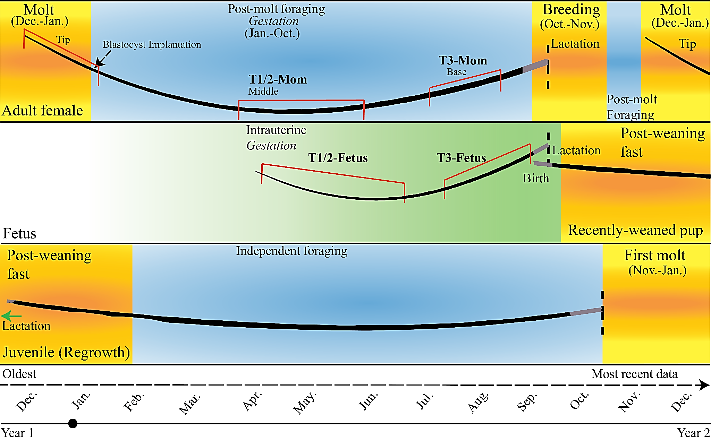
Figure S1.
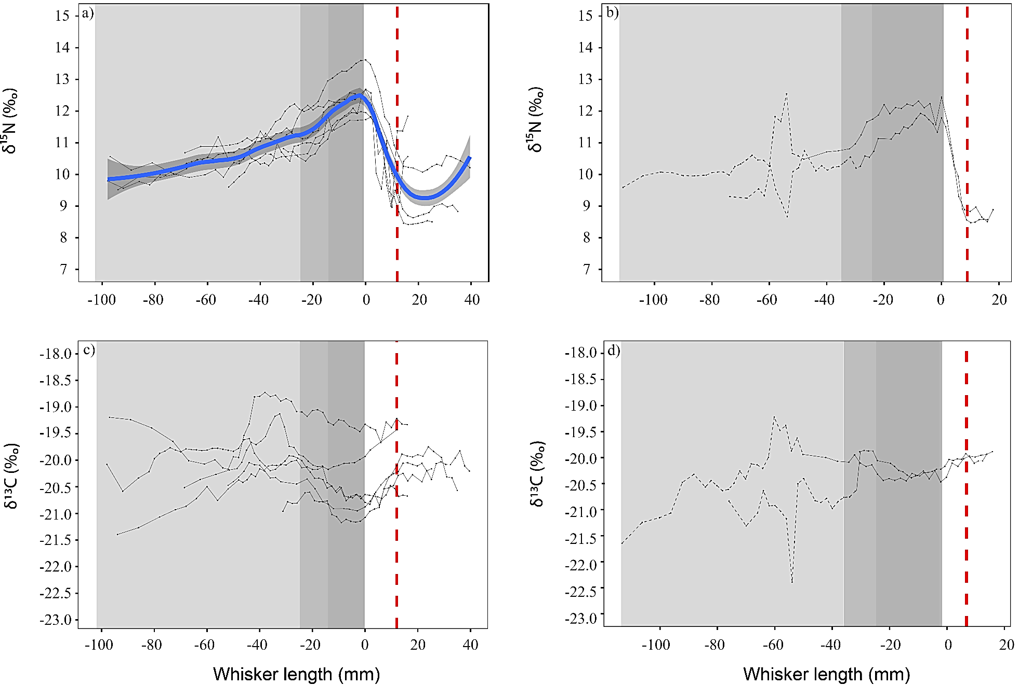
Figure S2.
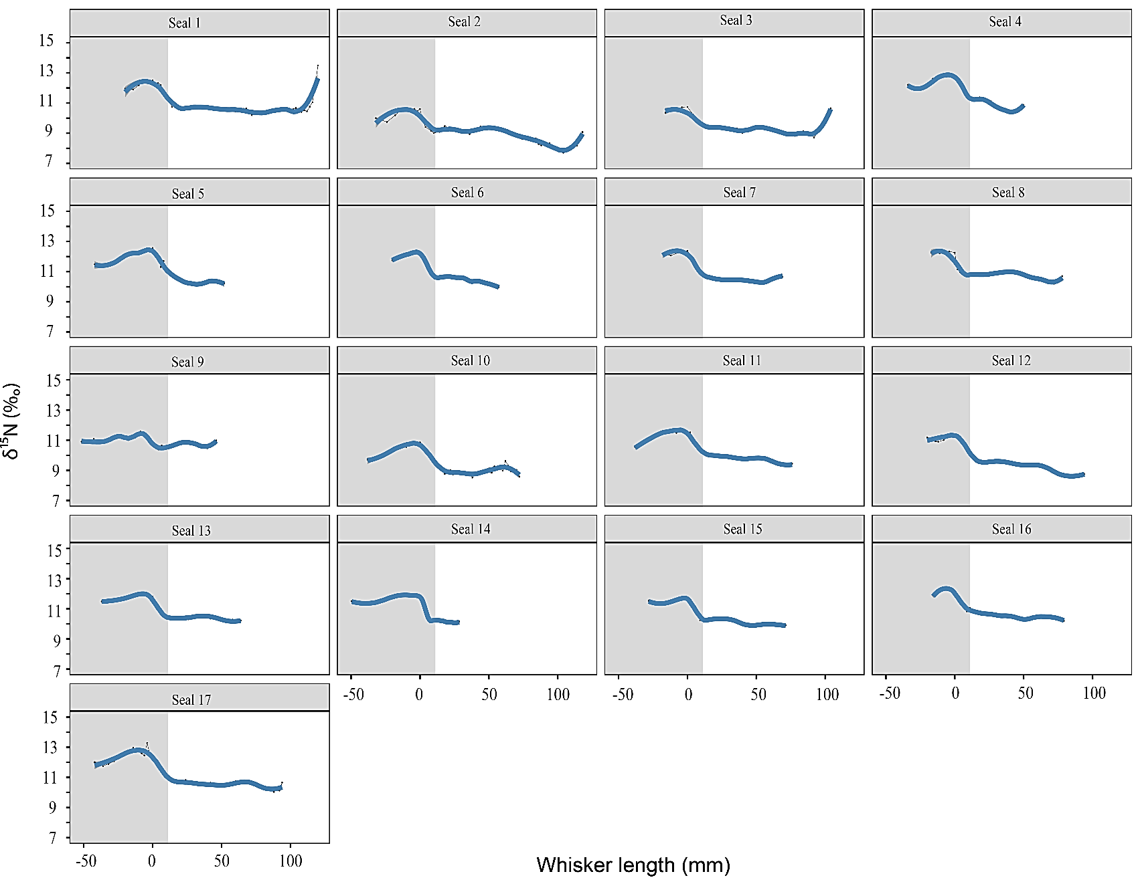
Figure S3.
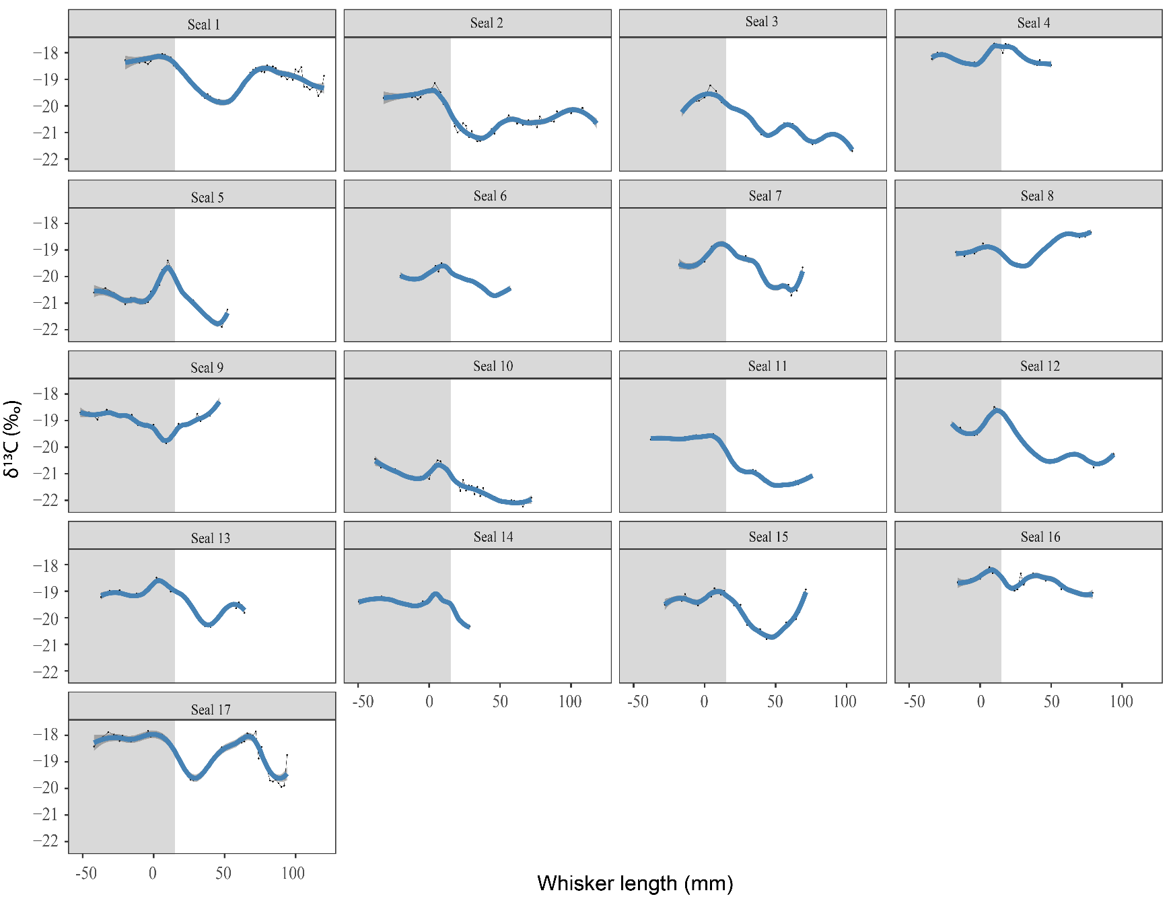
Figure S4.
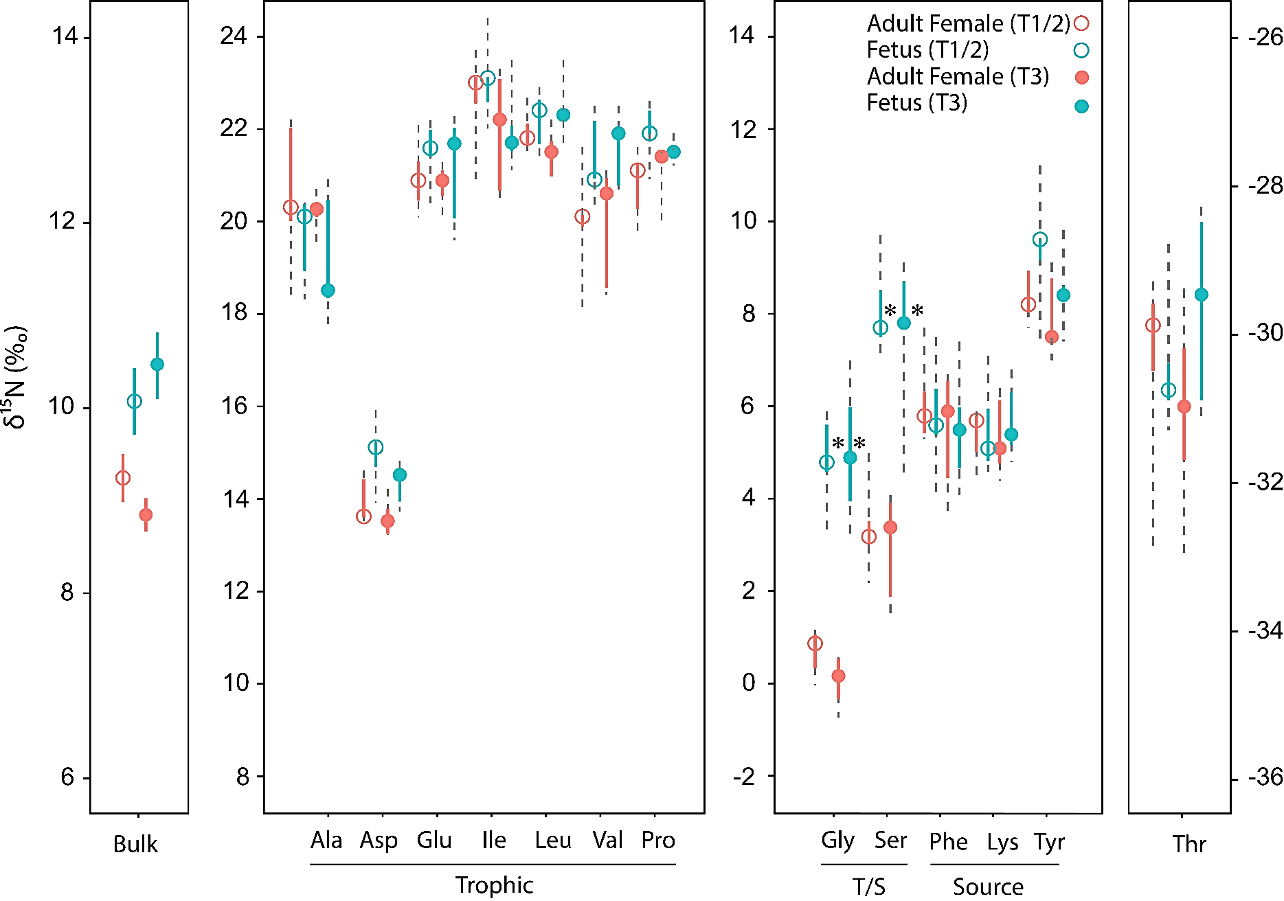
Figure S5.

