MOVEMENTS OF THE FOREARM
The rotation movement

- this is the only movement which involves the forearm with a passive upper arm, a rotating wrist, a relaxed hand and rounded fingers.

- rotation is executed either towards the thumb side or the side if the fifth finger. A pivot or turning point is always present. If the rotation occurs to the thumb’s side the pivot will be on the fifth finger’s side and vice cersa.

The rotation movement of the forearm is used for many simple tasks, like eating and writing. When it relates to the piano it should be taught in different stages. Early rotation movements are usually performed to the thumb’s side and are the logical starting point for a beginner.

- ROTATION TOWARDS THE THUMB (FIRST STAGE)

The rotation movement is used when opening or closing a doorknob. Practise the movement in the air with the arm bent at an angle of approximately 90 degrees. The upper arm and elbow must be passive and relaxed.
To ensure the correct position in front of the piano, let the relaxed arm hang next to the body. In this position lift both forearms to be in line with the keyboard. The hands are now in a position similar to the position of a harpist. Roll both hands to the thumb side with the palms facing the keys. This rolling or turning movement is called rotation. A crucial aspect for successful execution is to keep the elbow and upper arm passive.

Rotation is executed by using the one side of the hand as a pivot. It is vitally important to remember that if rotation occurs towards the thumb side, the pivot is on the other side of the hand and vice versa. The rotation movement is always towards the strong (first) beat and away from the repeated note which forms the pivot.
The following simple exercise can be done at the piano using a comfortable interval of a fifth. Initiate the movement with a relaxed arm hanging next to the body. Pick up the left forearm and bring the bottom of the forearm in line with the keyboard. Put the fifth finger side of a relaxed hand on C (one octave below middle C) keeping it down as a pivot, then roll onto the side of the thumb playing/on G. In a 4/4-time signature rotate down on every first and third beat and pick up on every second and fourth beat. Repeat this movement several times without interruption.
The right hand mirrors this exercise with the fifth finger holding the G and then, using the thumb to fall onto middle C respectively. Do this exercise using a regular beat. (The up movements should fall on the count of two and four and the down movements on one and three).
The “Piekanienie” duet exercise includes the first stage rotation movement in both hands. The next exercise “Sleep Little Boy” includes a horizontal ascending and descending movement towards the rotation side of the hand.

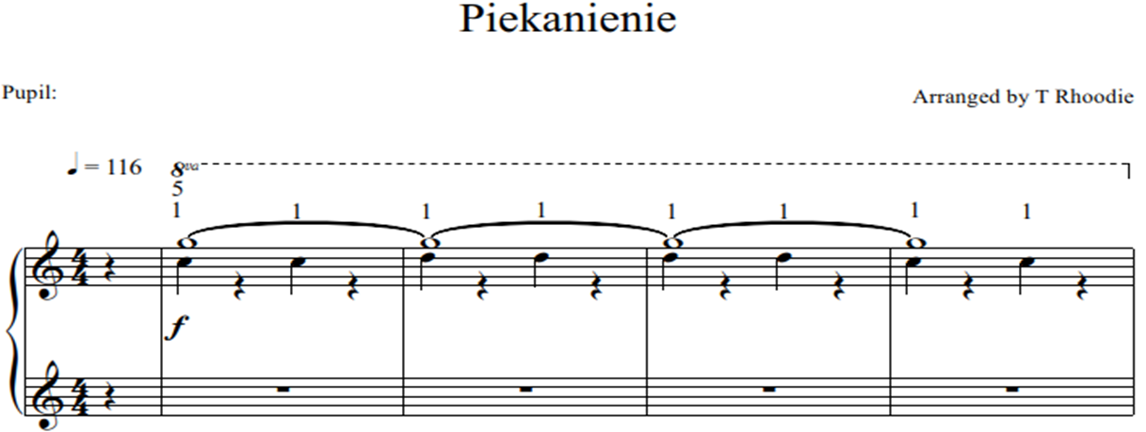

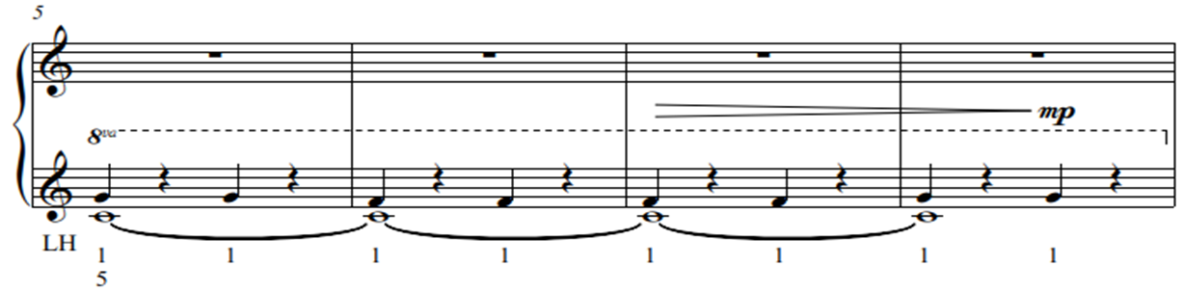

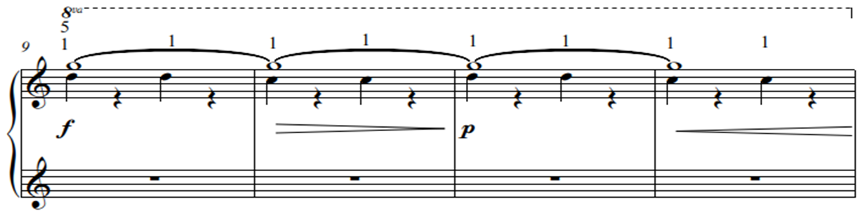

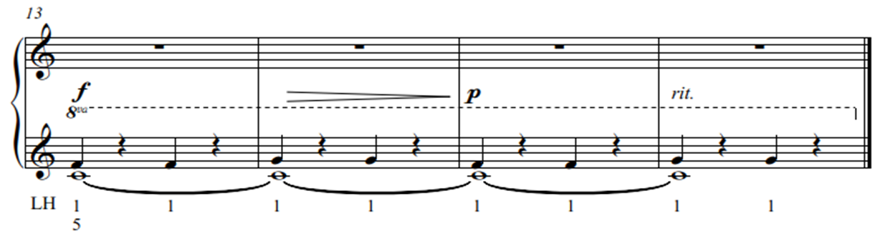

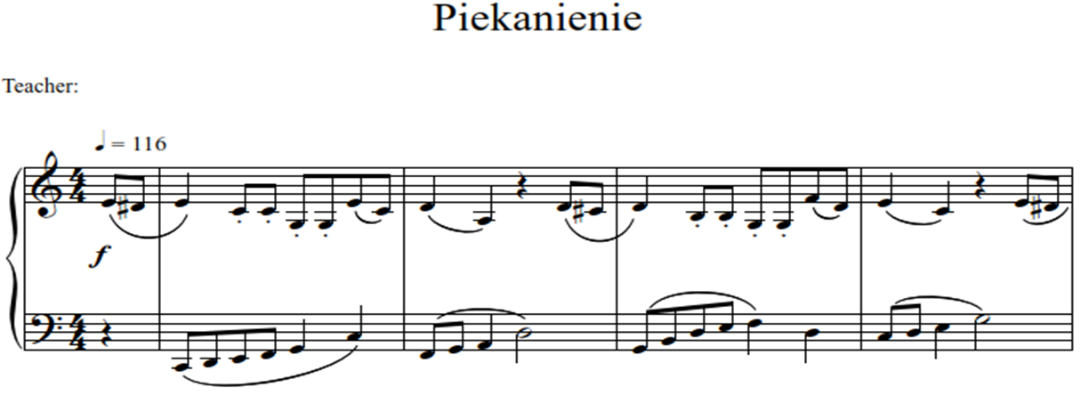

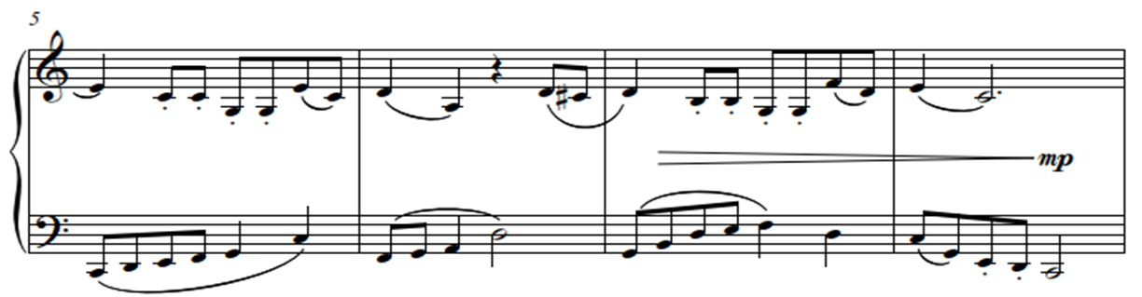

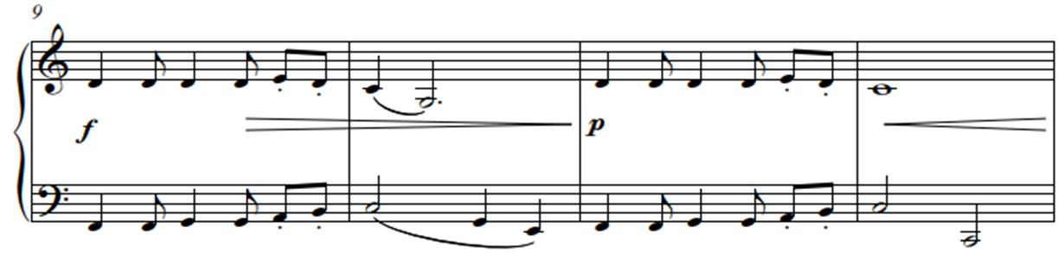

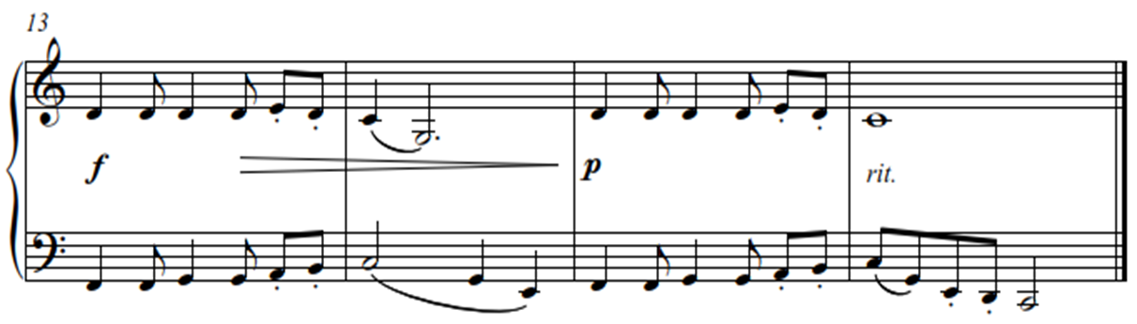

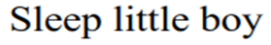
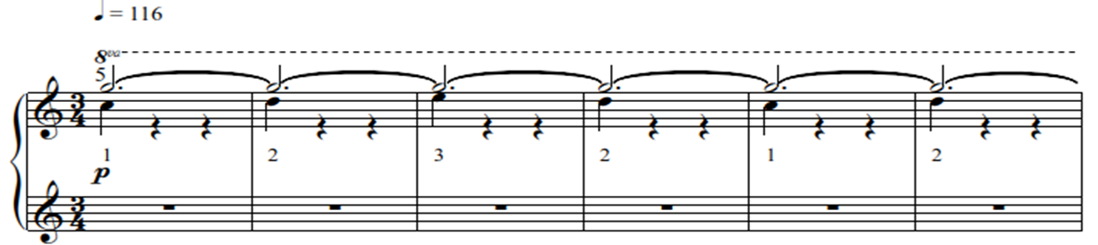

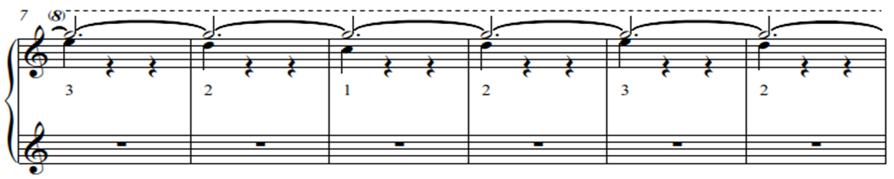

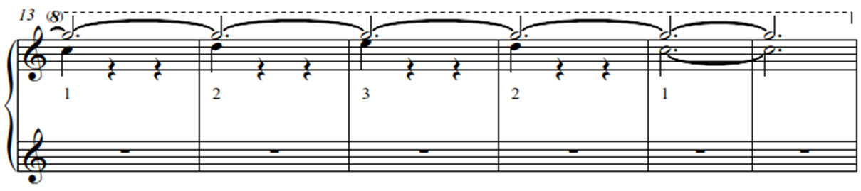

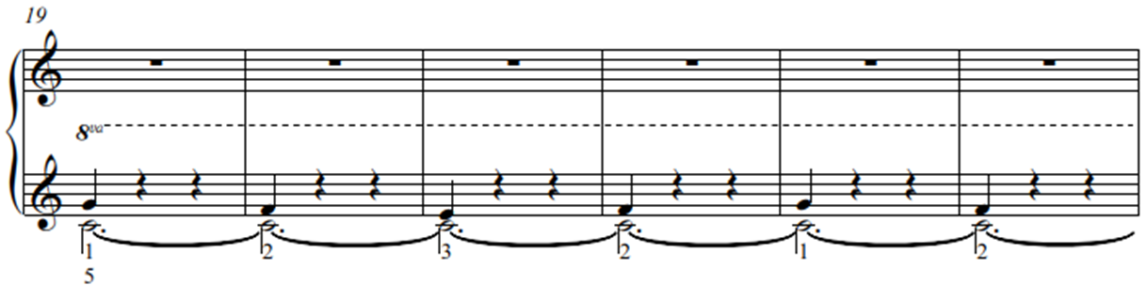

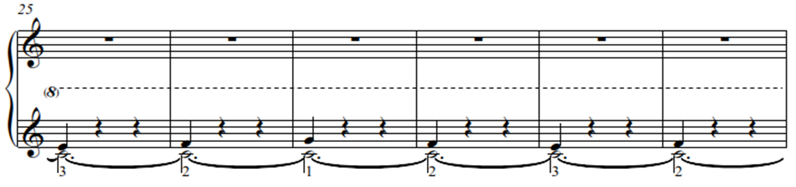

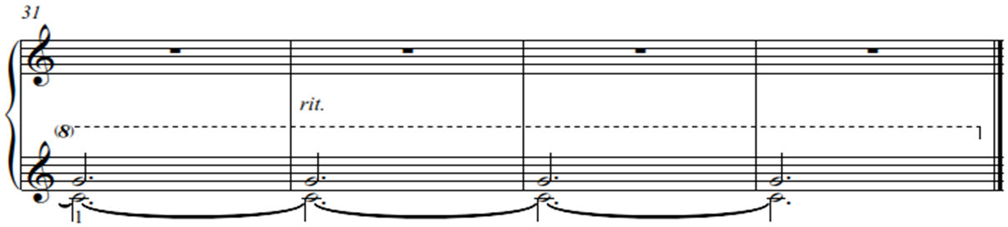

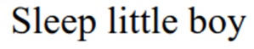
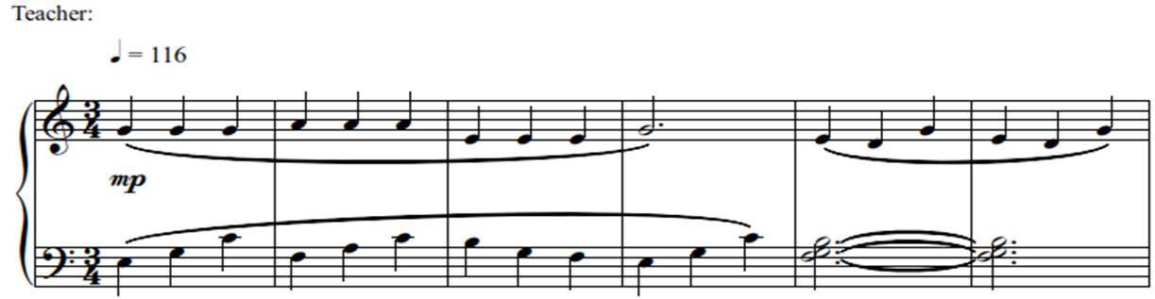

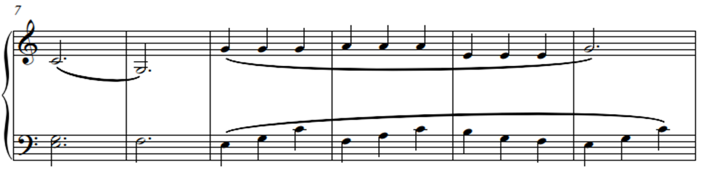

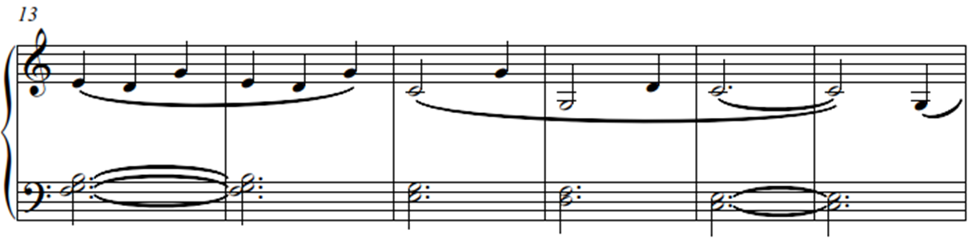

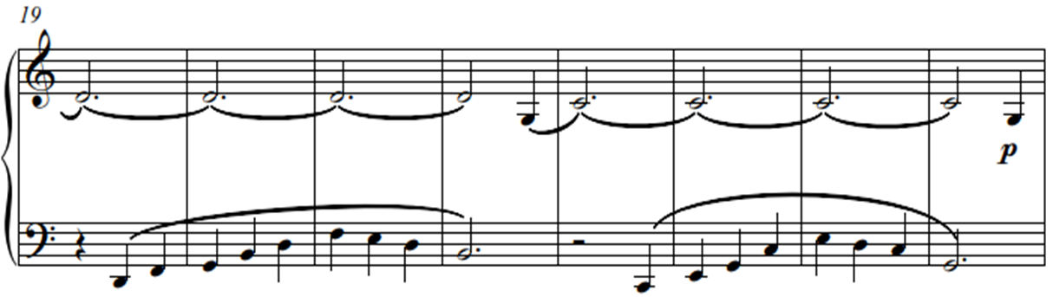

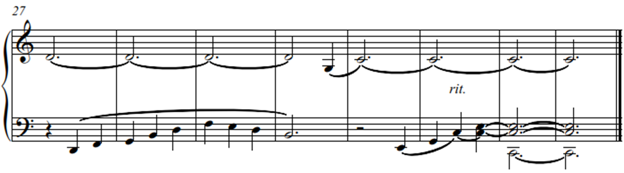

- ROTATION TOWARDS THE THUMB (SECOND STAGE)

Only when Stage one is comfortably mastered, can the ‘pivot note’ be repeated. Keep the movement precisely the same when repeating the ‘pivot note’. Do this in a ¾ time signature, using the right hand, keeping the G or strong beat a minim value, and the C or weak beat, a crotchet. A loud-soft correlation in sound should be the result.
“The Mischievous Donkey” and “The Donkey Again” for the right and left hands respectively, are played hands separately concentrating on the precision of the execution and correlation of sound.

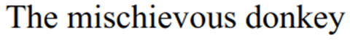

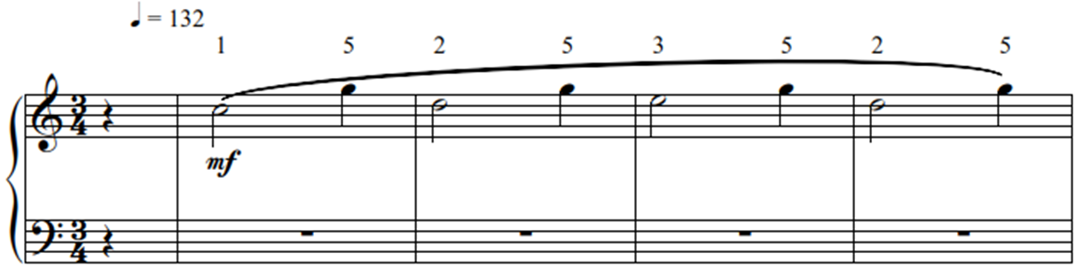

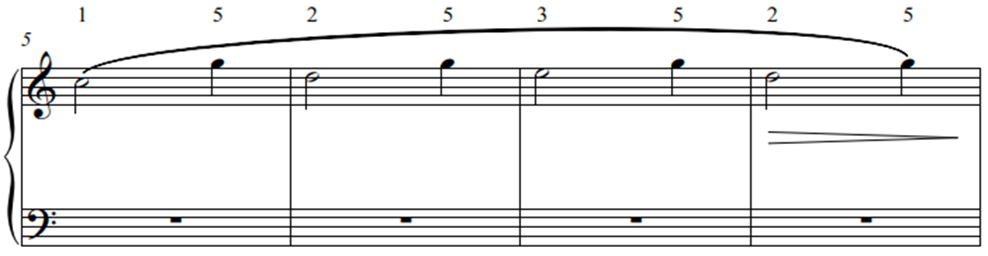

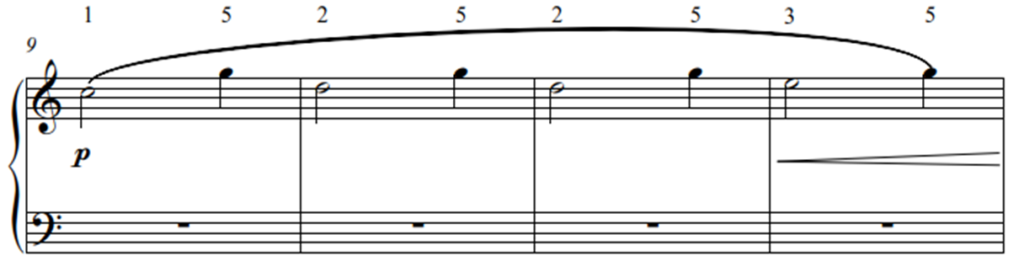

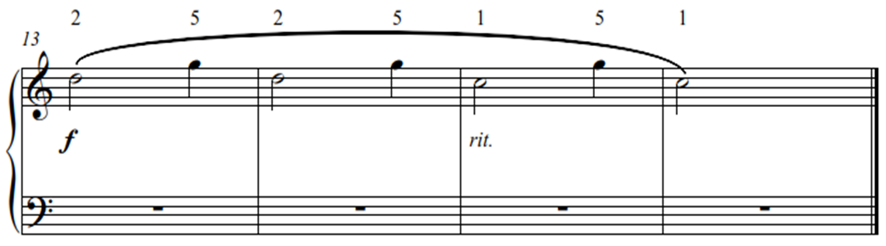

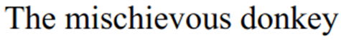
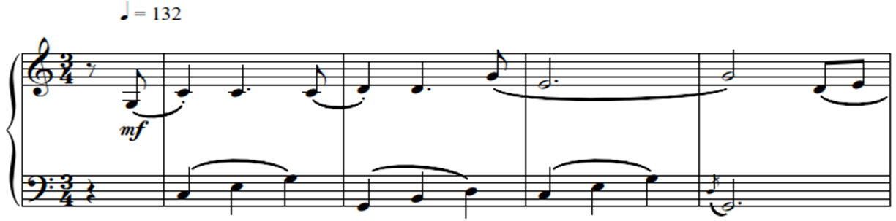

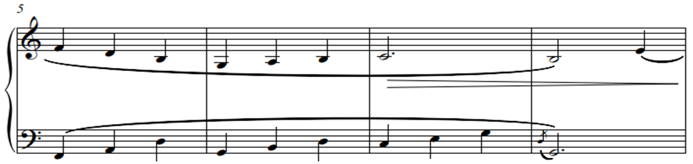

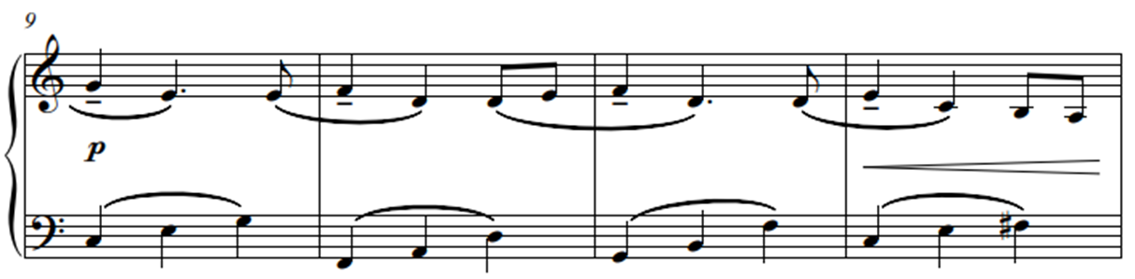

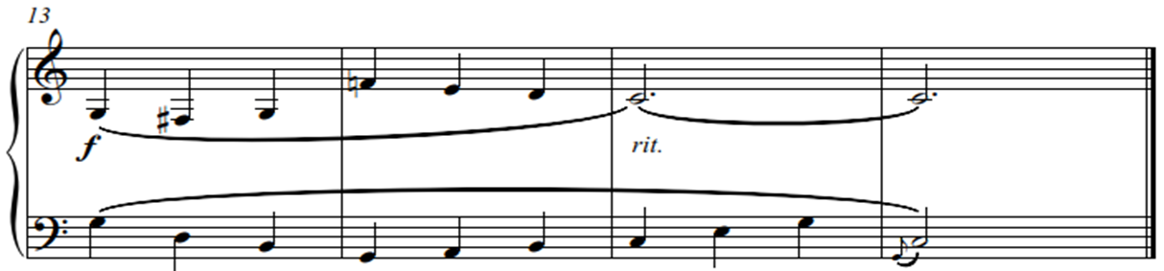

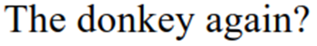
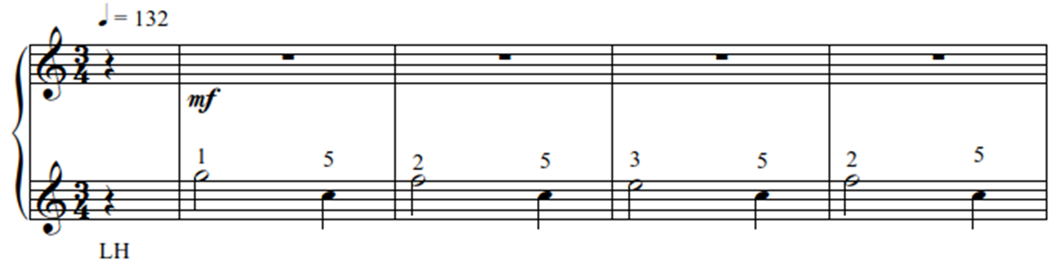

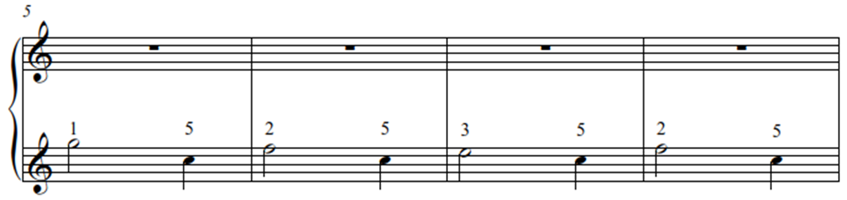

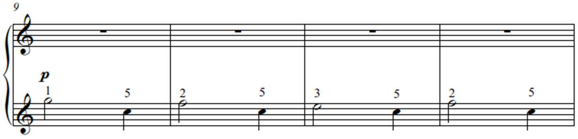

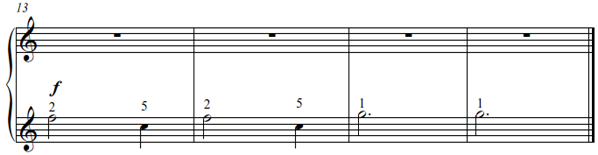

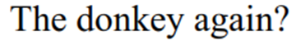
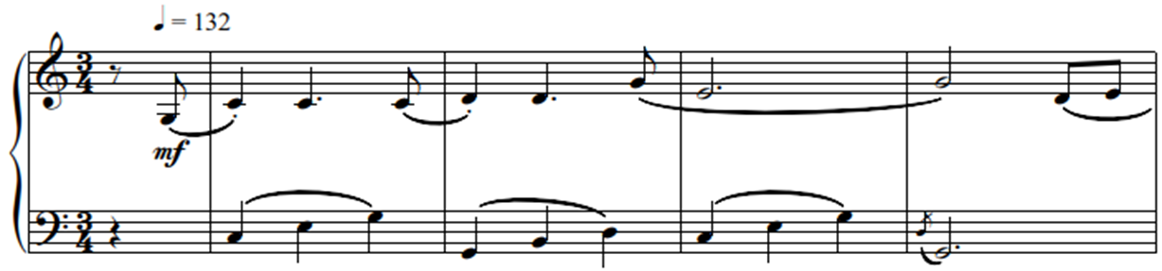

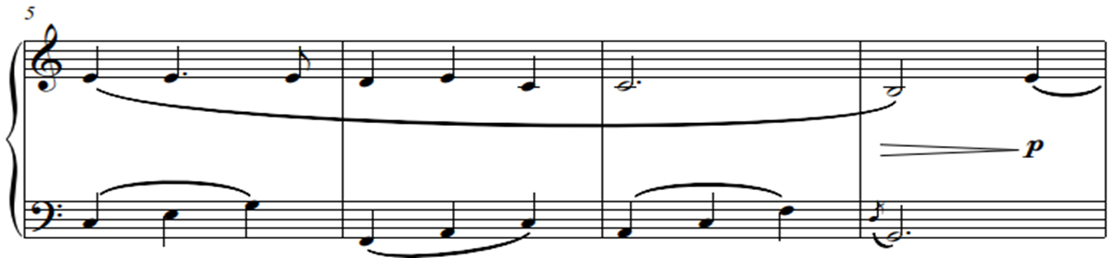

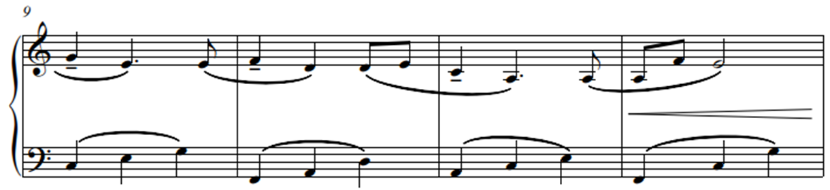

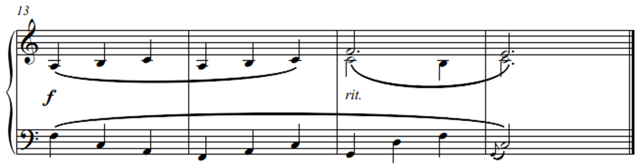

- ROTATION TOWARDS THE FIFTH FINGER (THIRD STAGE)

Rotation to the outside of the hand is the opposite of what has been explained in the previous two stages. Ultimately, the objective is to master the third stage. This will enable the pupil to perform any Alberti bass or similar accompaniment figure, often found in the Classical repertoire. Mastering rotation is an achievement which immediately lifts the level of playing and is often undervalued or not carefully nurtured by teachers. Note that the aim is to master this well-structured accompaniment figure, which is essential for advanced playing.
Place the left-hand thumb on a G below middle C and keep it down. Rotate to the opposite side with the fifth finger on C, initiating the movement from a position where the second finger is directly above the thumb. A helpful hint is to imagine the hand is moving over a small ball. In a 4/4-time signature fall on one and three and pick up on two and four, keeping a regular beat.

In “Galloping Pony” this rotation movement is in the left hand where the accompaniment figure usually occurs.

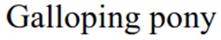
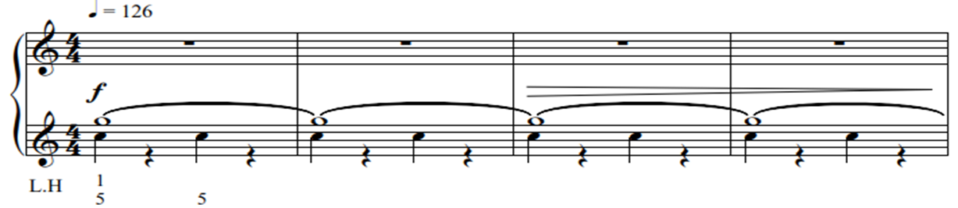

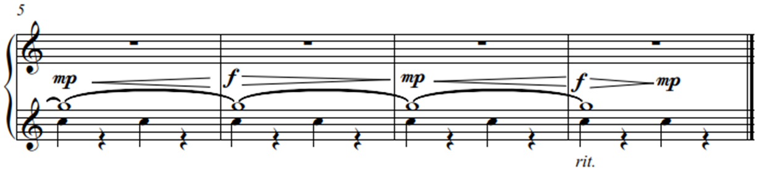

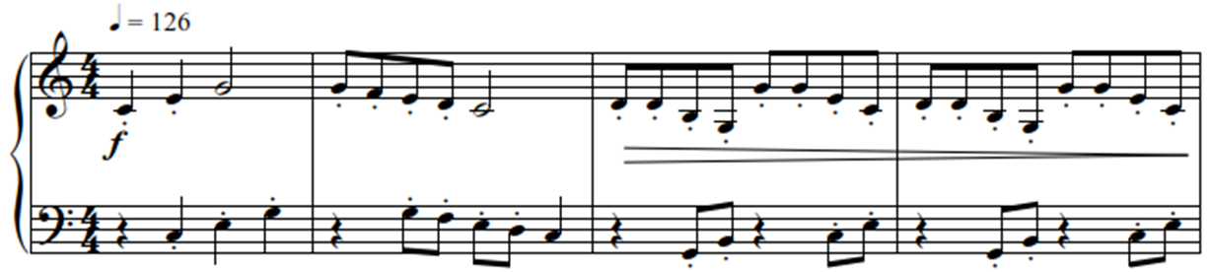

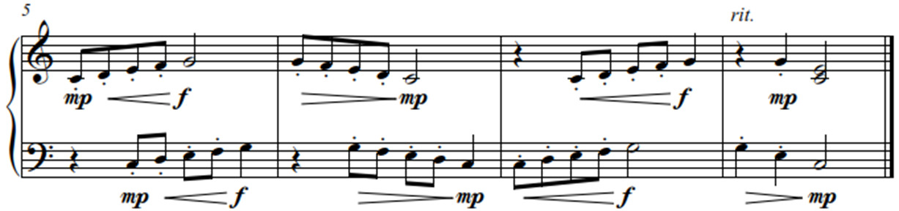

The turning wrist initiates this movement, not the elbow. (The elbow often tries to take the lead in this movement and must not be allowed to do so). The visible movement of the upper part of the wrist is an indication that the hand is moving correctly.
The right hand can now do the same exercise holding the C with the thumb and repeating the G with the fifth finger. In the following two exercises, “Lassie” and “Lassie Again!”, the pivot note is kept down, and rotation performed with horizontal descending and ascending movements in the third, fourth and fifth fingers of both hands separately. These exercises are performed separately to enhance precision of movement at the beginner stage.

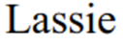
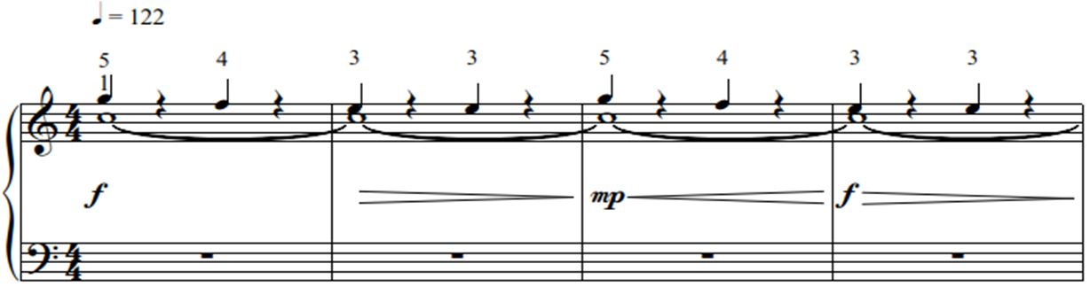

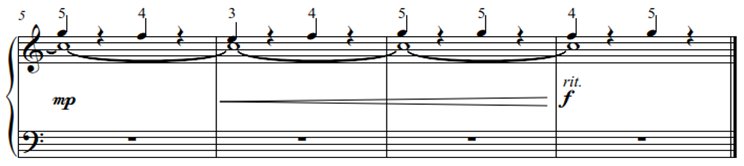

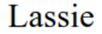
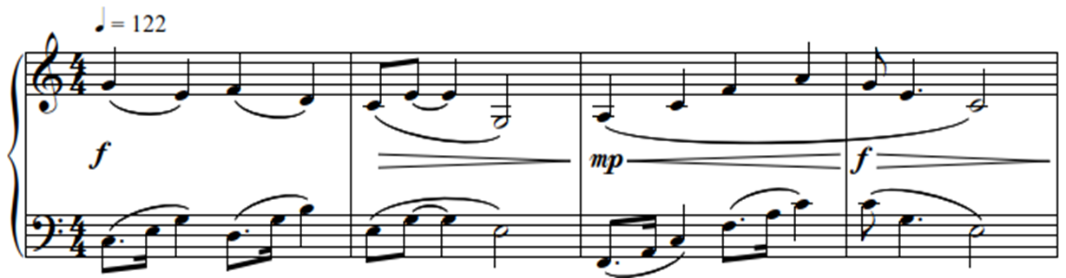

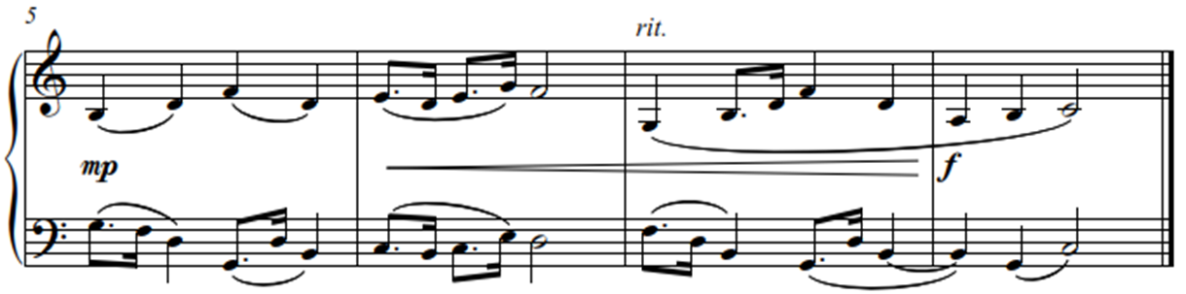

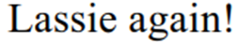
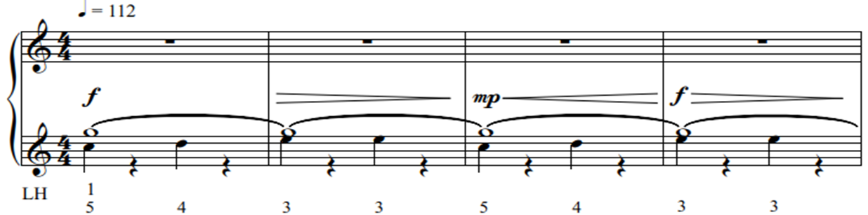

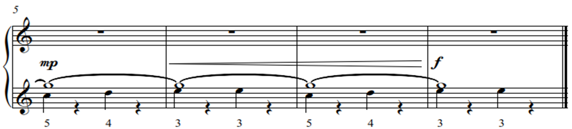

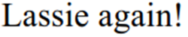
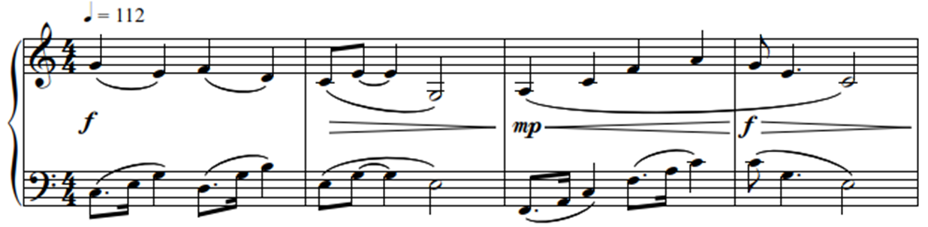

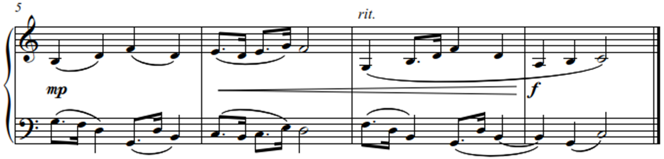

- ROTATION TOWARDS THE FIFTH FINGER (STAGE FOUR)

Only when stage three is comfortably mastered, can the ‘pivot note’ be repeated. Keep the movement exactly the same when repeating it. Do this in a ¾ time signature, the C or strong beat the value of a minim, the G, or weak beat, the value of a crotchet. A loud-soft correlation in sound should be the result.
The movement can now progress to the next stage, an Alberti-bass. On a C major chord follow a similar procedure as in the previous four stages; play and hold G (the pivot), and rotate C and E respectively with the fifth and third fingers in a 4/4-time signature on the first and third beats.
It is essential to explain the two reasons for initially keeping the pivot note:
- firstly, it is to teach or train the thumb to stay as near to the keys as possible
- secondly it is to develop a soft and controlled sound correlation on the pivot or
repeated note
Only when the Alberti bass figure with the kept or firm pivot is comfortably mastered, can the ‘pivot note’ be repeated. Keep the movement exactly the same when repeating the G ‘pivot note’, rotate on C and E respectively with the fifth and third fingers in a 4/4-time signature on the first and third beats. Always initiate the movement from a position where the second finger is directly above the thumb and imagine the hand is moving over a small ball. The small but visible movement of the upper part of the wrist is an indication that the movement is correct.
A structured and controlled accompaniment figure is the end goal. This can only be accomplished by putting the weight of a bigger lever on the louder or strong beats and controlling the repeated or weaker beats.
This movement does not come naturally. It is learnt/a process of development and to accomplish this within the first two years of tuition, is a great achievement.
In “Donkey Riding” and “How do you Ride a Donkey” the slow learning process of this intricate movement for a beginner (Stage Four) is completed when the pivot note is repeated in both hands and the correlation in sound is achieved.

