(a) (b)

(c) (d)

(e) (f)

Continuation.
(g) (h)

(i)

Figure S1. Alignment between the reference genome sequence and the sequenced region for the different single sequence repeat markers (SSR): (a) DS_SSR2, (b) DS_SSR4, (c) DS_SSR6, (d) DS_SSR10, (e) DS_SSR11, (f) DS_SSR13, (g) DS_SSR16, (h) DS_SSR20, and (i) DS_SSR21. Blue colour indicates forward and reverse primers and green indicates the region with the repeats.
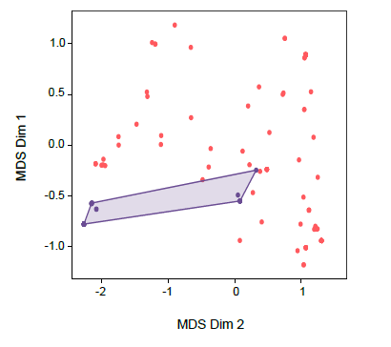
Figure S2. Representation of the multidimensional scaling (MDS) of Spanish (pink) and Californian (purple) Diplodia sapinea populations using a clone-corrected matrix.

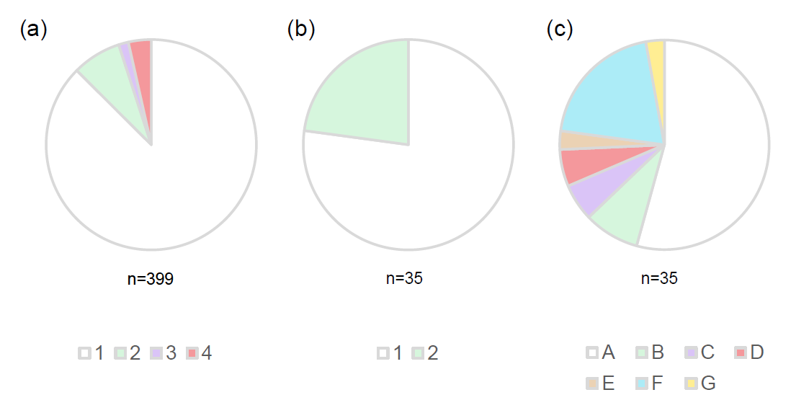
Figure S3. Representation of the different genotypes detected in a Californian Diplodia sapinea population. Each of the different colours represents a different genotype. Genotypes detected when: (a) the total population of 399 isolates was analysed using existing simple sequence repeat (SSR) primers, (b) a subset population of 35 isolates were analysed using existing SSR primers, and (c) the subset population of 35 isolates was analysed using the nine new SSR primers developed in this study.
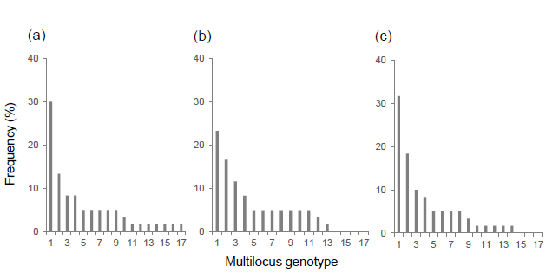
Figure S4. Distribution histogram of multilocus genotypes of Diplodia sapinea isolates from cones obtained from different stands showing Diplodia tip blight associated with drought spells: (a) stand 2, (b) stand 3, (c) stand 4.

Table S1. Description of the location of the sampled stands.
Country | Stand | Location | Coordinates | Abiotic stress
Spain | 1 | Navès | 42°00’01.9’’N, 1°36’27.2’’E | Hail
Spain | 2 | Navès | 41°59’31.4’’N, 1°38’31.9’’E | Drought
Spain | 3 | Navès | 41°59’27.7’’N, 1°39’03.3’’E | Drought
Spain | 4 | Clariana de Cardener | 41°57’32.6’’N, 1°35’52.5’’E | Drought
Spain | 5 | Navès | 41°59’57.3’’N, 1°36’43.6’’E | Hail
USA | 1 | Castle Crag State Park | 41°09’25.0’’N, 122°22’42.3’’W | Drought
USA | 2 | Castle Crag next to I5 (Castella) | 41°08’34.1’’N, 122°17’25.0’’W | Drought
USA | 3 | Highway 89, East of McCloud | 41°16’36.2’’N, 122°06’59.2’’W | Drought
USA | 4 | Edson Creek Road | 41°22’12.1’’N, 121°55’22.2’’W | Drought
USA | 5 | Whitmore | 40°41’21.5’’N, 121°54’39.4’’W | Drought

Table S3. Subset of 35 Californian Diplodia sapinea isolates analysed using existing simple sequence repeat markers (Bihon et al., 2011a; Burgess et al., 2001b).
Genotype | Isolates | Markers
Genotype | Isolates | SS1 | SS2 | SS5 | SS7 | SS8 | SS9 | SS10 | SS11 | SS12 | SS13 | SS14 | SS15 | SS16
1 | 27 | 409 | 192 | 502 | 381 | 279 | 262 | 311 | 174 | 111 | 154 | 157 | 68 | 107
2 | 8 | 409 | 192 | 502 | 381 | 279 | 257 | 311 | 170 | 111 | 154 | 157 | 65 | 107

Table S4. Subset of 35 Diplodia sapinea Californian isolates analysed using the nine new simple sequence repeat (SSR) markers developed in this study.
Genotype | Isolates | Markers
Genotype | Isolates | SSR21 | SSR11 | SSR10 | SSR2 | SSR13 | SSR16 | SSR4 | SSR6 | SSR20
A | 19 | 153 | 167 | 177 | 130 | 181 | 211 | 174 | 202 | 196
B | 3 | 153 | 167 | 177 | 103 | 181 | 211 | 174 | 202 | 196
C | 2 | 153 | 167 | 177 | 133 | 181 | 211 | 174 | 202 | 196
D | 2 | 153 | 167 | 177 | 130 | 181 | 211 | 188 | 202 | 196
E | 1 | 123 | 158 | 177 | 148 | 184 | 211 | 176 | 229 | 205
F | 7 | 123 | 158 | 177 | 148 | 184 | 211 | 162 | 223 | 205
G | 1 | 123 | 158 | 177 | 148 | 184 | 211 | 162 | 229 | 205

Table S5. Genetic diversity of Diplodia sapinea populations in the complete dataset. The number of multilocus genotypes (MLG) found in the population, the expected number of MLG at the lowest common sample size (eMLG), the Shannon– index of diversity (H), the evenness index adapted from the Simpson Index, and the standardized index of association (rbarD) are shown for each population. “Symp.” and “Asymp.” refer to symptomatic and asymptomatic shoots, respectively.
Parameters | Country |  |  | Spanish stands |  |  |  |  |  | Sample type
Parameters | USA | Spain |  | 1 | 2 | 3 | 4 | 5 |  | Cones | Symp. shoots | Asymp. shoots
Sample size (n) | 35 | 285 |  | 15 | 90 | 75 | 90 | 15 |  | 180 | 75 | 30
MLG (G) | 7 | 56 |  | 6 | 28 | 18 | 20 | 5 |  | 36 | 23 | 17
eMLG | 7.00 | 17.70 |  | 6.00 | 9.49 | 9.03 | 8.65 | 5.00 |  | 22.20 | 10.00 | 10.90
Diversity (H) | 1.39 | 3.15 |  | 1.64 | 2.75 | 2.53 | 2.48 | 1.61 |  | 2.83 | 2.78 | 2.65
Evenness | 0.61 | 0.54 |  | 0.39 | 0.60 | 0.72 | 0.65 | 1.00 |  | 0.54 | 0.75 | 0.82
rbarD | 0.85 | 0.24 |  | 0.36 | 0.34 | 0.23 | 0.17 | 0.66 |  | 0.23 | 0.28 | 0.29

