Supporting Information for manuscript: Zoogeochemistry of a protected area: driven by anthropogenic impacts and animal behaviour

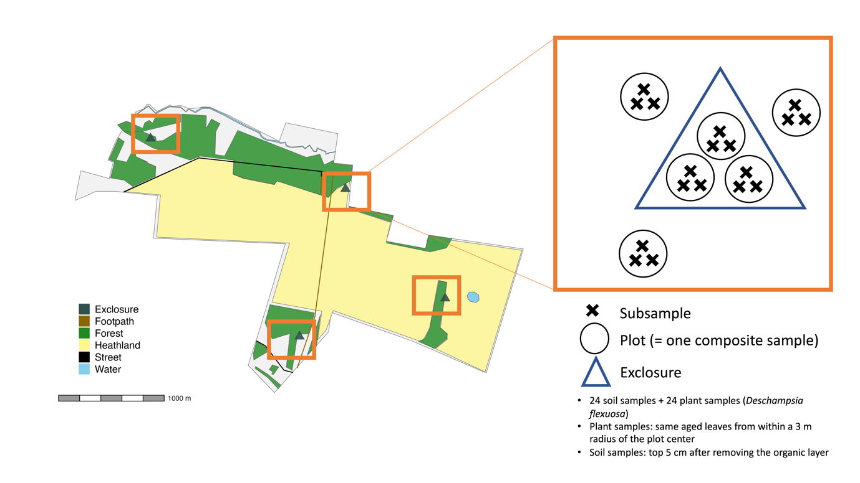
Fig. S1: Data collection design and study area.

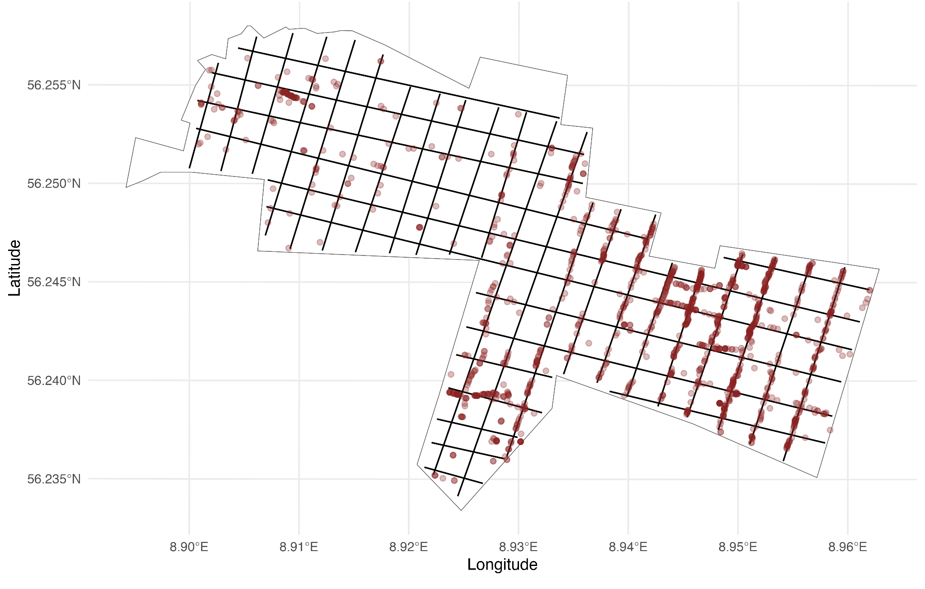

Fig. S2: Transects (black lines) and observed faecal pellets (brown dots). Faecal pellet locations that seem to deviate from the straight mapped transects is as a result of the difficulty of keeping an exact straight line when in a natural environment, and from GPS error. In reality, faecal counts were always within 2 m of the actual walked line. More intense colours indicate an overlap of several points.

GBM training results
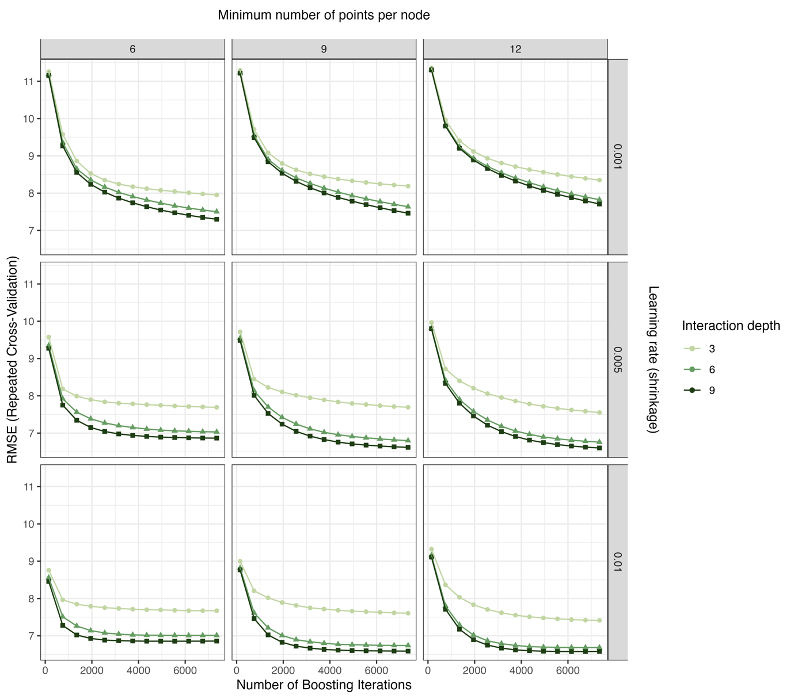
Fig. S3: Outcome of the GBM training process. The lowest error was achieved with the combination of a learning rate (shrinkage) of 0.01, an interaction depth of 9, 6150 boosting iterations (trees) and a minimum of 12 observations per node.

Table S1: Candidate models. These models were run with both soil and vegetation N, P, Ca, N:P, N:Ca, P:Ca as response variables.
Formula
~ 1
~ 1 + (1 | Exclosure ID)
~ Exclosure treatment type + (1 | Exclosure ID)
~ Exclosure treatment type*log(number of faeces) + (1 | Exclosure ID)
~ Exclosure treatment type*log(number of GPS locations) + (1 | Exclosure ID)

Table S2: Estimated nutrient balances of different feeding scenarios. In Scenario 1, red deer would cover 100 % of their energy demand with heathland vegetation from inside the PA while Scenario 6 assumes 100 % of the energy to be covered by supplementary feeding. PA = Protected Area, SF = Supplementary feeding. Turnover rates calculated using equation 1.
Variable | Scenario 1 | Scenario 2 | Scenario 3 | Scenario 4 | Scenario 5 | Scenario 6
Amount of energy covered by heathland vegetation (%) | 100 | 80 | 60 | 40 | 20 | 0
Amount of energy covered by supple-mentary feeding (%) | 0 | 20 | 40 | 60 | 80 | 100
Amount of food eaten from PA (t) | 944.5 | 755.6 | 566.7 | 377.8 | 188.9 | 0
Amount of food eaten from SF (t) | 0 | 161.9 | 323.8 | 485.8 | 647.6 | 809.6
Total N turnover (t) | 8.9 | 9.1 | 9.4 | 9.7 | 9.9 | 10.2
Total P turnover (t) | 0.8 | 0.9 | 1.1 | 1.2 | 1.4 | 1.5
Total Ca turnover (t) | 2.3 | 2.3 | 2.4 | 2.5 | 2.5 | 2.6
Total N removed (t) | 2.3 | 2.3 | 2.3 | 2.3 | 2.3 | 2.3
Total P removed (t) | 0.9 | 0.9 | 0.9 | 0.9 | 0.9 | 0.9
Total Ca removed (t) | 1.6 | 1.6 | 1.6 | 1.6 | 1.6 | 1.6
Balance N (t) | + 6.6 | + 6.8 | + 7.1 | + 7.4 | + 7.6 | +7.9
Balance P (t) | - 0.2 | 0 | + 0.1 | + 0.3 | + 0.4 | + 0.6
Balance Ca (t) | + 0.7 | + 0.8 | + 0.8 | + 0.9 | + 1 | + 1

Table S3: Red deer impact on nutrients. The models listed here are the best models (with the lowest AICc) for the respective response variable. The marginal R² (R²m) gives information about the amount of variance explained by fixed effects while the conditional R² (R²c) refers to the variance explained by the entire model including fixed and random effects.
Response variable | Best model formula |  |  | AICc | R²m | R²c
Soil
N | ~ 1 + (1 | Exclosure ID) |  |  | 96.3 | 0 | 0.27
P | ~ 1 |  |  | -165.6 | 0 | 0
Ca | ~ 1 + (1 | Exclosure ID) |  |  | 29.0 | 0 | 0.48
N:P | ~ 1 |  |  | 305.7 | 0 | 0
N:Ca | ~ 1 |  |  | 145.8 | 0 | 0
P:Ca | ~ 1 |  |  | -94.6 | 0 | 0
Vegetation
N | ~1 |  |  | 130.0 | 0 | 0
P | ~1 |  |  | 29.5 | 0 | 0
Ca | ~1 |  |  | -5.2 | 0 | 0
N:P | ~ 1 + (1 | Exclosure ID) |  |  | 107.8 | 0 | 0.26
N:Ca | ~ 1 |  |  | 150.8 | 0 | 0
P:Ca | ~ 1 |  |  | 20.2 | 0 | 0

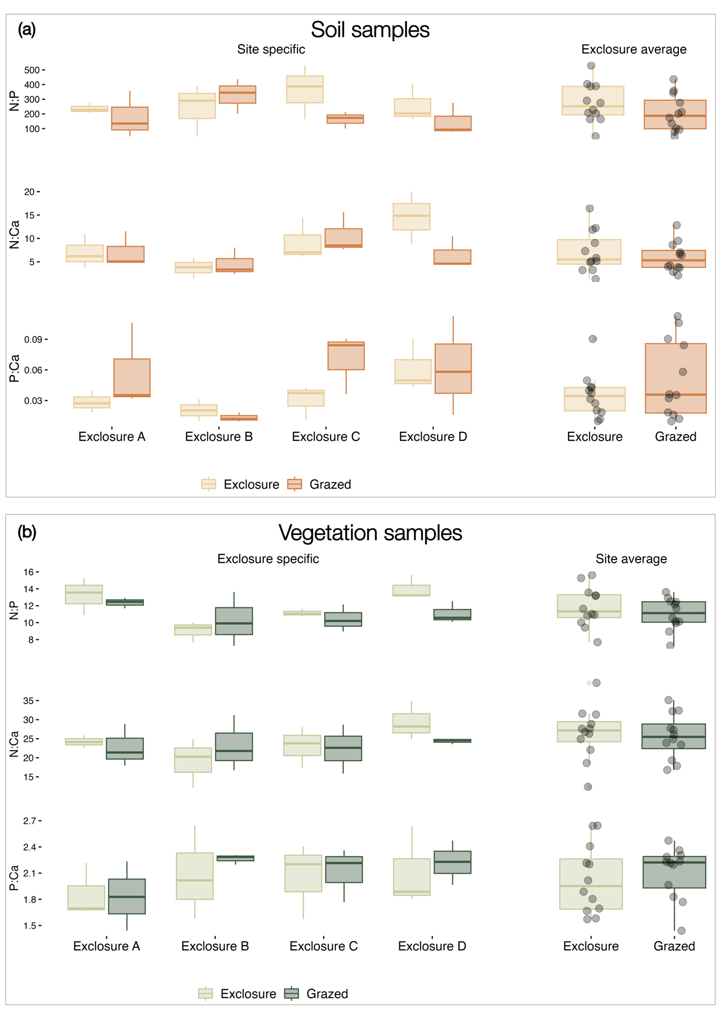
Fig. S4: Nutrient stoichiometry in and outside of the exclosures. The site specific boxplots on the left show the comparison between specific grazed plots and the respective control (e.g, A exclosure vs A grazed) while the site average boxplots show the difference between all grazed and all exclosure plots. The black points indicate individual measurements.(a) soil nutrient stoichiometry; (b) plant nutrient stoichiometry.

