Supplementary Data
Supplementary data. Figure S1: Location of informal outlets in Gauteng Province
from which samples were collected and the number of samples collected (Adigun, 2016)

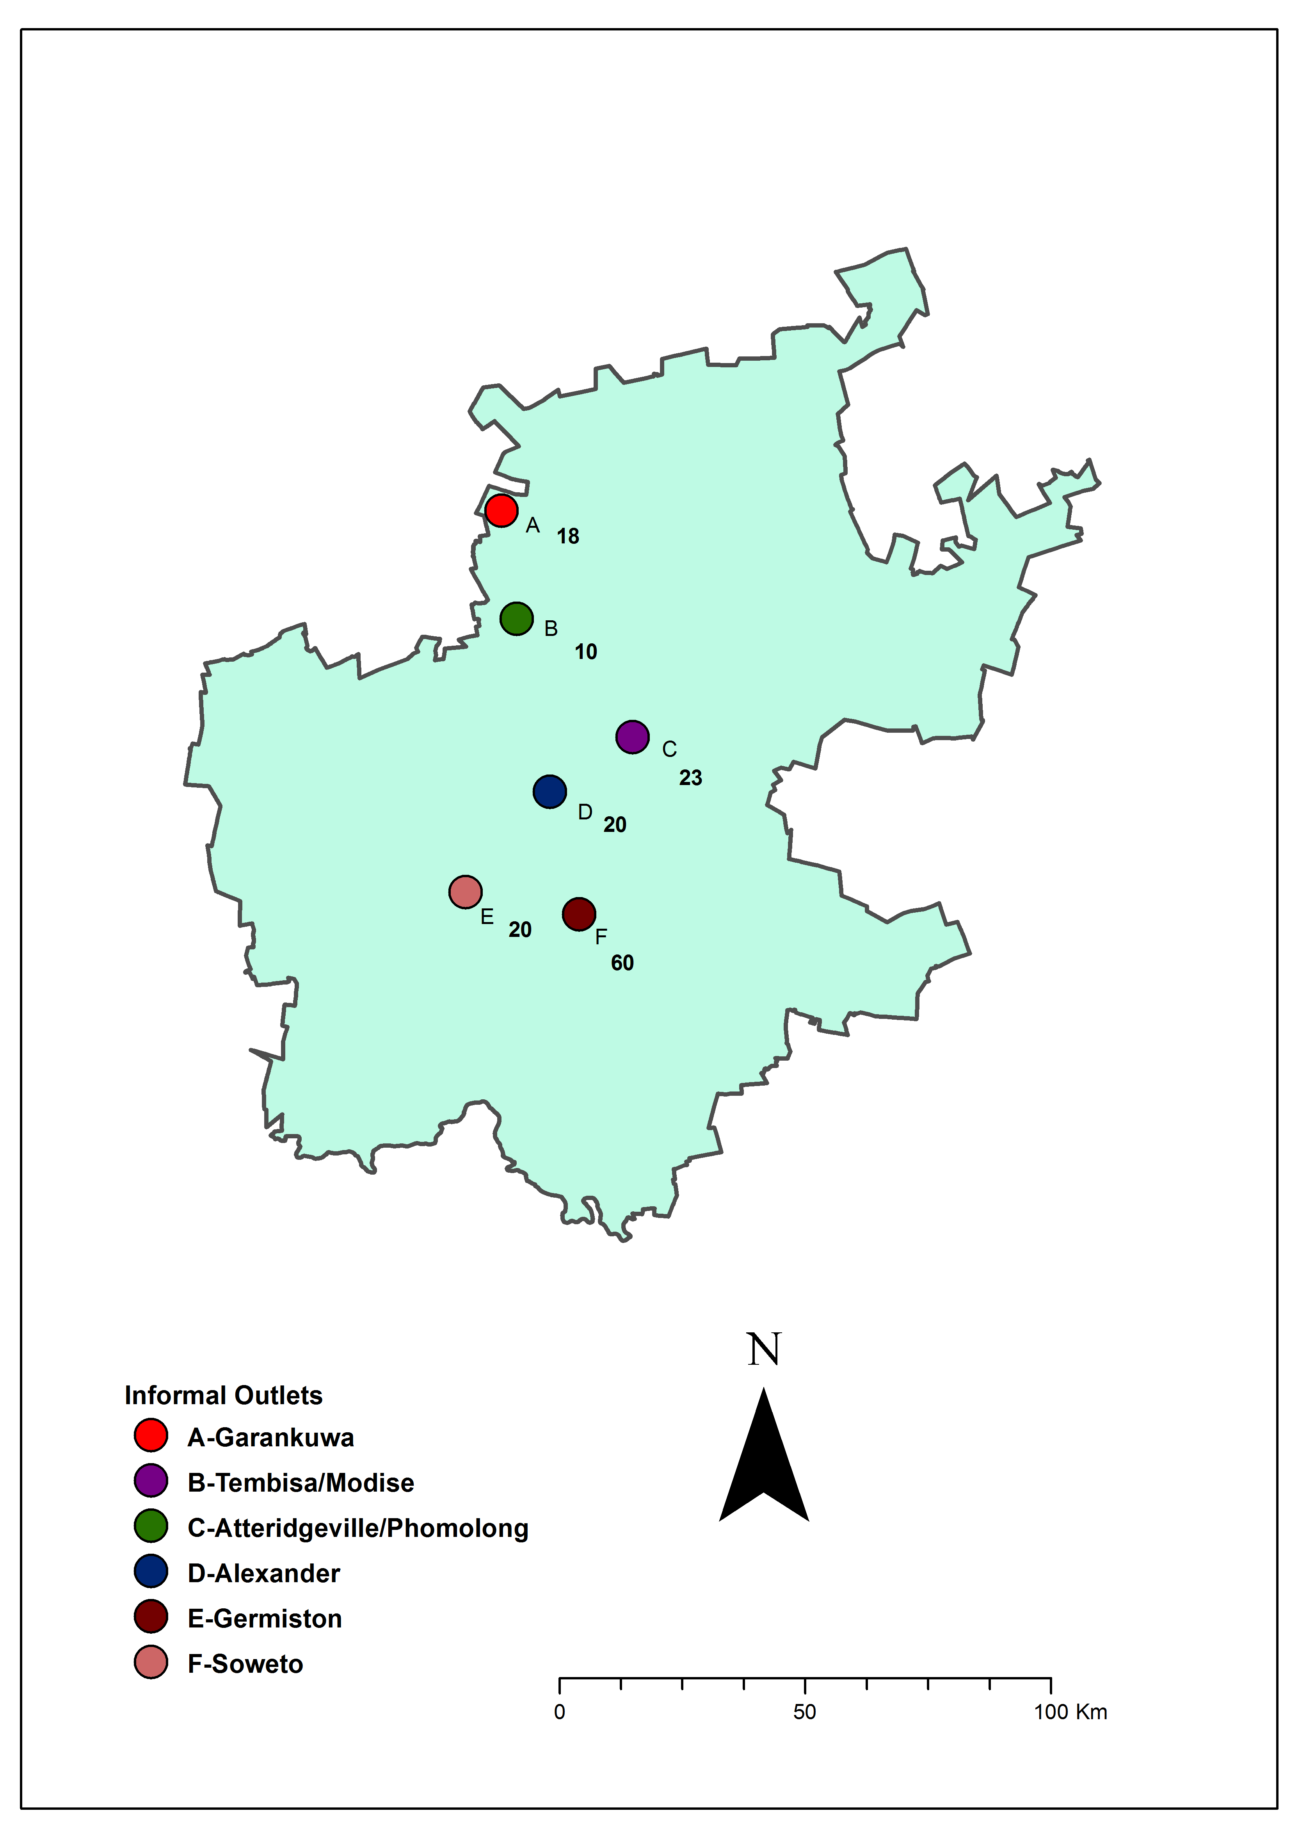

TABLE S1 Targeted virulence gene primers used in this study
Gene | Primer sequence | Location | Size (bp) | Reference
InvA* | 5' GTGAAATTATCGCCACGTTCGGGCAA 3'  5' TCATCGCACCGTCAAAGGAACC 3' | SPI-1 | 284pb | de Oliviera et al. (2002)
SpiC | 5' CCTGGATAATGACTATTGAT 3'  5' AGTTTATGGTGATTGCGTAT 3' | SPI-2 | 309pb | Zishiri et al. (2016)
MgtB | 5' GGCAGGAGTTTCGCACTAAC 3'  5' GCGTACCCACAATGGATTTC 3' | SPI-3 | 445bp | Parvathi et al. (2011)
ShdA | 5' CGTACCGGCAGAGGTAATGT 3'  5' CAACAAGGCAGTACGCTGAA 3' | CS54 | 291bp | Parvathi et al. (2011)
PefC | 5’GACAGTATTATGTCGACGTC 3'  5' CCCATCCAGAACATGCCGTT 3' | PEF/fimbrial/cluster/pSLT plasmid | 940bp | Haneda et al. (2001)
SopE | 5' ACACACTTTCACCGAGGAAGCG 3'  5' GGATGCCTTCTGATGTTGACTGG 3' | SPI-1 | 398bp | Borges et al. (2013)
SpvC | 5' CGGAAATACCATCTACAAATA 3'  5' CCCAAACCCATACTTACTCTG 3' | pSLT | 669bp | Borges et al. (2013)
PipA | 5' CTCATGACAGCCTTGCCATA 3'  5' TCCTGAGCCACGGTAGTTTC 3' | SPI-5 | 283bp | Parvathi et al. (2011)
FliC | 5' GGATACGCTGAATGTGCAACA-3'  5' GAGTCACCTCACCGTTCGTCTTA 3' | Flagellin | 290bp | Uchiya et al. (2008)
spi4d | 5' GTTCATGGTCAGGGCGTTAT 3'  5' CTTAAAGAACGGGTGCCATC 3' | SPI-4 | 275bp | Parvathi et al. (2011)
PagN | 5' TTGGATGCAGCTTTTGTGTC 3'  5' AAGGCGGGCAGGATATTACT 3' | SPI-6 | 390bp | Parvathi et al. (2011)
SefC | 5' GCGAAAACCAATGCGACTGTAG 3'  5' CCCACCAGAAACATTCATCCC 3’ | SEF | 1103bp | Bäumier et al. (1997)
*InvA gene used only to confirm phenotypically identified isolates of Salmonella

TABLE S2. Primer sequences and PCR conditions antimicrobial resistance genes used for in the study
PCR assay | Target gene | Sequence (5’-3’) | Product sizes(bp) | Annealing Temp (°C) | Reference
Tetracycline (n=2) | TetA | GGC GGT CTT CTT CAT CAT CAT GC  CGG CAG GCA GAG CAA GTA GA | 502 | 59 | Goswami et al., 2008; Lanz et al., 2003
Tetracycline (n=2) | TetB | CGC CCA GTG CTG TTG TTG TC  CGC GTT GAG AAG AAG CTG AGG TG | 173 | 59 | Goswami et al., 2008; Lanz et al., 2003
Trimethoprim (n=3) | Dfrl | CGG TCG TAA CAC GTT CAA GT  CTG GGG ATT TCA GGA AAG TA | 220 | 55.3 | Chen et al., 2004)
Trimethoprim (n=3) | DfrXII | AAA TTC CGG GTG AGC AGA AG  CCC GTT GAC GGA ATG GTT AG | 429 | 55.3 | Chen et al., 2004)
Trimethoprim (n=3) | DfrXIII | GCA GTC GCC CTA AAA CAA AG  GAT ACG TGT GAC AGC GTT GA | 294 | 55.3 | Chen et al., 2004)
Sulphonamides (n=3) | sul1 | CGG CGT GGG CTA CCT GAA CG  GCC GAT CGC GTG AAG TTC CCG | 433 | 63 | Kernn et al., 2002; Kozak et al., 2009)
Sulphonamides (n=3) | sul2 | GCG CTC AAG GCA GAT GGC ATT  GCG TTT GAT ACC GGC ACC CGT | 293 | 63 | Kernn et al., 2002; Kozak et al., 2009)
Sulphonamides (n=3) | sul3 | CAA CGG AAG TGG GCG TTG TGG A  GCT GCA CCA ATT CGC TGA ACG | 244 | 63 | Kernn et al., 2002; Kozak et al., 2009)
Phenicol (n=3) | cat1 | CTT GTC GCC TTG CGT ATA AT  ATC CCA ATG GCA TCG TAA AG | 508 | 53.3 | Chen et al., 2004
Phenicol (n=3) | Flo | CTG AGG GTG TCG TCA TCT AC  GCT CCG ACA ATG CTG ACT AT | 673 | 53.3 | Chen et al., 2004
Phenicol (n=3) | cmIA | CGC CAC GGT GTT GTT GTT AT  GCG ACC TGC GTA AAT GTC AC | 394 | 53.3 | Chen et al., 2004
B-lactams (n=4) | bla_{TEM} | TTA ACT GGC GAA CTA CTT AC  GTC TAT TTC GTT CAT CCA TA | 247 | 55.3 | Kozak et al., 2009
B-lactams (n=4) | bla_{CMY-2} | GAC AGC CTC TTT CTC CAC A  TGG ACA CGA AGG CTA CGT A | 1000 | 55.3 | Kozak et al., 2009
B-lactams (n=4) | bla_{SHV} | AGG ATT GAC TGC CTT TTT G  ATT TGC TGA TTT CGC TCG | 393 | 55.3 | Kozak et al., 2009
B-lactams (n=4) | bla_{PSE} | TGC TTC GCA ACT ATG ACT AC  AGC CTG TGT TTG AGC TAG AT | 438 | 55.3 | Kozak et al., 2009
Quinolones (n=3) Quinolones (n=3) | QnrA | ATTTCTCACGCCAGGATTTG  GATCGGCAAAGGTTAGGTCA | 516 | 53 | Gay et al., 2006
Quinolones (n=3) Quinolones (n=3) | QnrB | GATCGTGAAAGCCAGAAAGG  ACGATGCCTGGTAGTTGTCC | 469 | 53 | Gay et al., 2006
Quinolones (n=3) Quinolones (n=3) | QnrS | ACGACATTCGTCAACTGCAA  TAAATTGGCACCCTGTAGGC | 417 | 53 | Gay et al., 2006
( ) Number of antimicrobial genes

Table S3 Relationship between virulence and AMR genes in Salmonella isolates from chickens sampled in the informal market, Gauteng province

 | No. (%) of resistance genes detected in Salmonella isolates:
 | tet(A) | tet(B) | sul2 | sul3 | blaTEM |  | blacm-2 |  | qnrS
Virulence gene | (n=93) | (n=43) | (n=4) | (n=4) | (n=1) |  | (n=1) |  | (n=1)
invA | 93 (100.0) | 43 (100.0) | 4 (100.0) | 4 (100.0) | 1 (100.0) |  | 1 (100.0) |  |  | 1 (100.0)
spiC | 61 (65.6) | 22 (51.2) | 4 (100.0) | 4 (100.0) | 0 (0.0) |  | 1 (100.0) |  |  | 1 (100.0)
mgtB | 78 (83.9) | 39 (90.7) | 4 (100.0) | 4 (100.0) | 1 (100.0) |  | 1 (100.0) |  |  | 1 (100.0)
shdA | 85 (91.4) | 41 (95.3) | 4 (100.0) | 3 (75.0) | 1 (100.0) |  | 1 (100.0) |  |  | 1 (100.0)
pefC | 1 (1.1) | 1 (2.3) | 0 (0.0) | 1 (25.0) | 0 (0.0) |  | 0 (0.0) | 0 (0.0)
sopE | 74 (79.6) | 27 (62.8) | 2 (50.0) | 3 (75.0) | 0 (0.0) |  | 1(100.0) | 0 (0.0)
spvC | 2 (2.2) | 0 (0.0) | 0 (0.0) | 0 (0.0) | 0 (0.0) | 0 (0.0) |  | 0 (0.0)
pipA | 25 (26.9) | 12 (27.9) | 1 (25.0) | 2 (50.0) | 0 (0.0) | 0 (0.0) |  | 1(100.0)
fliC | 14 (15.1) | 4 (9.3) | 0 (0.0) | 2 (50.0) | 0 (0.0) | 0 (0.0) |  | 0 (0.0)
spi4d | 4 (4.3) | 4 (9.3) | 0 (0.0) | 1 (25.0) | 0 (0.0) | 0 (0.0) |  | 0 (0.0)
pagN | 21 (22.6) | 12 (27.9) | 0 (0.0) | 1 (25.0) | 0 (0.0) | 0 (0.0) |  | 0 (0.0)
sefC | 0 (0.0) | 0 (0.0) | 0 (0.0) | 0 (0.0) | 0 (0.0) | 0 (0.0) |  | 0 (0.0)

