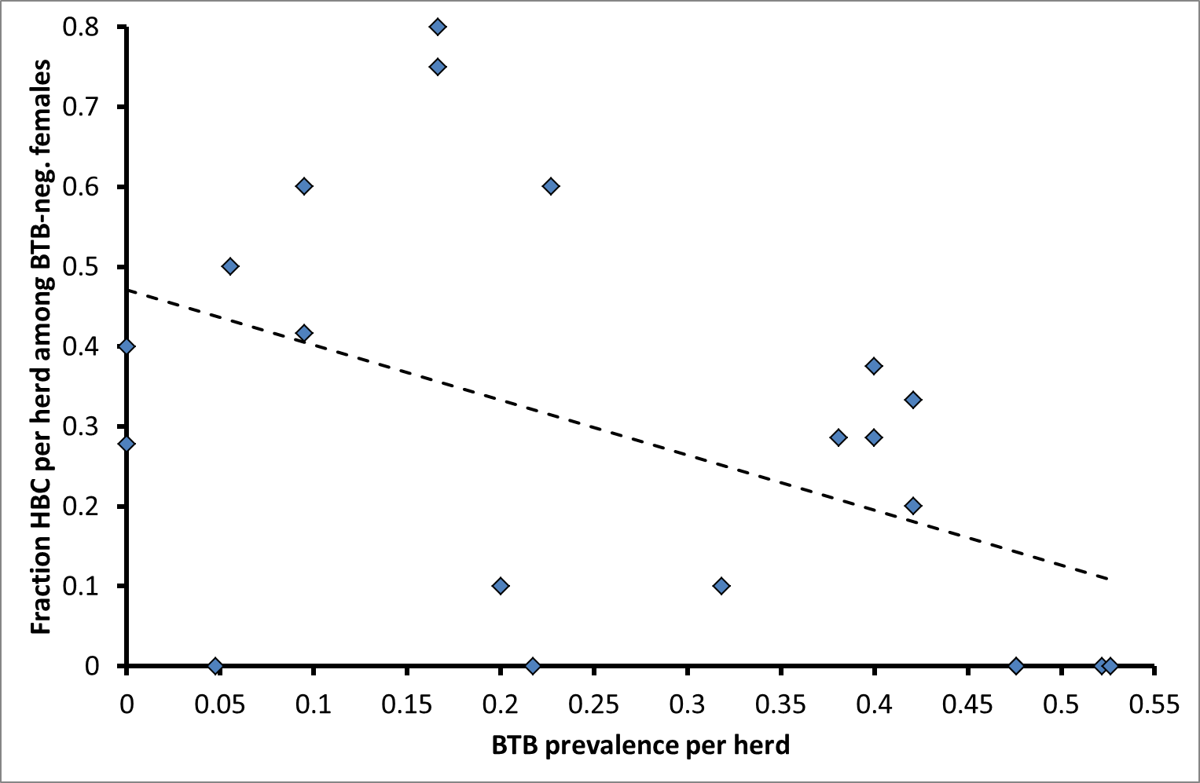
Figure S2: Regression between fraction HBC among BTB-negative females and BTB prevalence per herd
N_{herds} = 21 (20 from southern Kruger and 1 from northern Kruger), BTB prevalence per herd: N_{individuals} = 429, fraction HBC among BTB-negative females: N_{individuals} = 188. Adj. R² = 0.19, P = 0.028. HBC: high body condition, BTB: Bovine tuberculosis

