APPENDIX-1. List of Acronyms

Table 1S. List of Acronyms
ACTRIS ERIC | Aerosol, Clouds and Trace gases Research Infrastructure
AERONET | AErosol RObotic NETwork,
GCOS report | Global Climate Observing System - GCOS | WMO,
ACCC | Atmosphere and Climate Competence Center: A Finnish Flagship project (funded by the Research Council Finland)
AI | Artificial Intelligence
AIFusion | A term that likely refers to the fusion of artificial intelligence (AI) technologies with other domains or fields for enhanced capabilities.
AnaEE ERIC | Analysis and experimentation on ecosystems
AtlantOS | A comprehensive All-Atlantic Ocean Observing System
BAPMoN | Background Air Pollution Monitoring Network
CAB technology
CERN | Chinese Ecosystem Research Network, China: An ecosystem research network in China
CGMS | The Coordination Group for Meteorological Satellites
COPERNICUS | A European system for monitoring the Earth's environment using satellite and in situobservations
CEOS | Committee on Earth Observation Satellites
DataTerra | Data Terra
DIAS | Data Integration and System Program DIAS
DRMCK | The Disaster Risk Management Knowledge Centre
EARLINET | A European Aerosol Research Lidar Network (currently part of ACTRIS)
EFTEON | The Expanded Freshwater and Terrestrial Environmental Observation Network (SAEON)
ERIC | Legal framework for a European Research Infrastructure Consortium
eLTER | The integrated European Long-Term Ecosystem, Critical Zone and Socio-ecology Research Infrastructure.
EMBRC ERIC | European marine biological resource center
EMEP | The European Evaluation and Monitoring Program
ENVRI | ENVironmental Research Infrastructures building FAIR services
ENVRI-FAIR | An ENVRI framework to make environmental research data "Findable, Accessible, Interoperable, and Reusable" (FAIR).
EPOS ERIC | European Plate Observing System - European Research Infrastructure Consortium, which focuses on studying the Earth's physical processes
ERIC | European Research Infrastructure Consortia
ESFRI | The European Strategy Forum on Research Infrastructures
Euro-Argo ERIC | Euro-Argo ERIC
EVE | Earth Virtualization Engines
EWS | Early Warning Systems: Systems designed to provide advance notice of potential threats or hazards
FAIR | Findable, Accessible, Interoperable, Reusable: A set of principles to enhance the accessibility and usability of digital assets, particularly in scientific data.
FLUXNET | Global network: exchanges of CO2, H2O, and energy between the biosphere and atmosphere
G3W | Global Greenhouse Gas Watch – a new operational observation system
GAW | Global Atmosphere Watch (GAW) research programme
GBIF | Global Biodiversity Information Facility
GBON | Global Basic Observing Network (GBON) WMO
GCOS | Global Climate Observing System: A system for observing and assessing the Earth's climate
GEO | Group on Earth Observations (GEO)
GERI | Global Ecosystem Research infrastructure
GHG | Greenhouse Gases: Gases that trap heat in the Earth's atmosphere, contributing to the greenhouse effect and climate change
Global North | Generally refers to the more economically developed countries in the world
Global South | Generally refers to the less economically developed countries in the world
GO3OS | WMO Global Ozone Observing System
GOOS | Global Ocean Observing System (GOOS)
ICOS ERIC | Integrated Carbon Observation System: A research infrastructure that focuses on monitoring carbon dioxide and other greenhouse gases.
INAR | Institute for Atmospheric and Earth System Research: An organization dedicated to atmospheric and earth system research
IOC/GOOS | Global Ocean Observing System
IODE | The International Oceanographic Data and Information Exchange (IODE)
JaLTER | Japan Long-Term Ecological Research Network
JERICO | Joint European RI of Coastal Observatories
LifeWatch ERIC | LifeWatch ERIC
LSC | Low-Cost Sensors: Inexpensive sensors often used for data collection in various research fields
Maona Loa | Mauna Loa Obsevatory
NDACC | The Network for the Detection of Atmospheric Composition Change
NEON | National Ecological Observatory Network in the US
NRT | Near Real Time: Refers to data or information that is available with minimal delay after its collection
NOAA | National Oceanic and Atmospheric Administration (USA)
OBIS | Ocean Biodiversity Information System
ODIS | The Ocean Data and Information System
PEN | The Phenological Eyes Network (PEN)- In situ remote sensing network
QA | Quality Assurance: The systematic process of ensuring the quality of products, processes, or data
RI | research infrastrcture
SAEON | South African Environmental Observation Network, South Africa
SDGs | Sustainable Development Goals: A collection of global goals set by the United Nations to address various social, economic, and environmental challenges
SIOS | Svalbard integrated Arctic Earth Observing System
SMCRI | Shallow Marine and Coastal Research Infrastructure (SAEON)
SMEAR | Stations Measuring Earth surface Atmosphere Interactions
Sonipat | Atmospheric Observatory at Sonipat Campus
TERN | Terrestrial Ecosystem Research Network in Australia
TOAR | The Tropospheric Ozone Assessment Report, the International Global Atmospheric Chemistry project: An initiative assessing tropospheric ozone and atmospheric chemistry on a global scale
UNECE CLRTAP | UNECE’s Convention on Long-range Transboundary Air Pollution
UNESCO, IPCC | The Intergovernmental Panel on Climate Change (IPCC)
WDCGG | The World Data Centre for Greenhouse Gases
WIGOS | Integrated Global Observing System: A system coordinated by the World Meteorological Organization (WMO) for global observations and monitoring.
WMO | World Meteorological Organization: An intergovernmental organization focused on promoting international cooperation in meteorology, climatology, hydrology, and related fields
WMO-Data C | WMO World Data Centre
WMO-GAW | WMO Global Atmosphere Watch (GAW) programme ( BAPMoN+ GO3OS)
APPENDIX 2. Historical overview
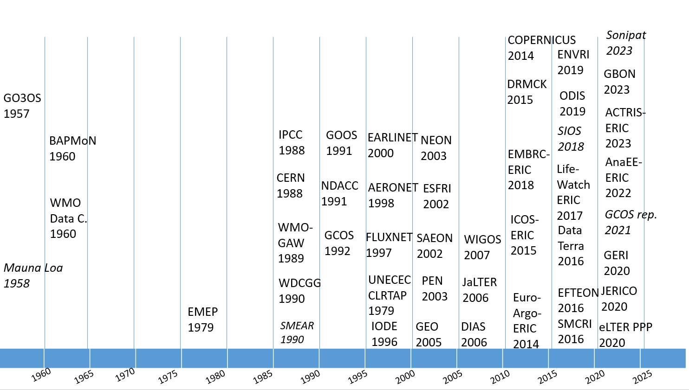
Above is a timeline highlighting key turning points, such as programs and assessments in the advancement of coordinated, comprehensive, high-quality in situ Earth observations. (For the acronyms in the figure, see APPENDIX-1). Over many decades, in situ and remote sensing observation networks have been built for providing essential support, primarily for disciplinary research endeavors and the weather enterprise operational needs. For example, radiosonde data goes back just shy of a century (Grant et al. 2009). Sea level data goes back a few centuries. Internationally coordinated observations started ostensibly in the 1957 with the WMO Global Ozone Observing System (GO3OS). It developed a coordinated Dobson and later Brewer spectrophotometer network to measure total atmospheric ozone. Then in the late 1960s, the Background Air Pollution Monitoring Network (BAPMoN) was established. It focused on precipitation chemistry, aerosol and carbon dioxide measurements, included regional and background stations, and had a WMO World Data Centre established in the United States of America. Finally, in 1989, the two observing networks BAPMoN and GO3OS were consolidated into the current WMO Global Atmosphere Watch (GAW) programme (WMO, 2010, 2023; Dlugokencky et al. 2010). These networks have undergone an evolution into thematic frameworks for specialized knowledge.

1970s
In 1970s, the public notion on the detrimental impacts of acid rain in Europe was alarming scientists and public alike. The UNECE Convention on Long-range Transboundary Air Pollution (CLRTAP) was signed in 1979 and entered into force in 1983. As the first regional environmental convention, CLRTAP was instrumental in the reduction of key harmful pollutants in both Europe and North America. From early on, it was recognized that a good understanding of the magnitude and harmful effects of air pollution was a prerequisite for reaching agreement on effective pollution control. To develop the necessary international co-operation in observations, the Working Group on Effects (WGE) was established under the Convention in 1980. The WGE provides information on the degree and geographic extent of the effects of major air pollutants, such as sulphur and nitrogen oxides, ozone, volatile organic compounds, persistent organic pollutants, heavy metals, particulate matter, including black carbon, and ammonia on human health and the environment. The WGE observations are done in a coordinated manner within the International Cooperative Programmes focusing e.g., on forests (ICP-Forests), waters (ICP-Waters), vegetation (ICP-Vegetation) and integrated monitoring of the effects of pollution on ecosystems (ICP-IM). The European Monitoring and Evaluation Programme (EMEP) is also part of CLRTAP, for monitoring and evaluation of the long-range transmission of air pollutants in Europe.

1980s
The strong increase in different data has been supported by the development of Earth Observation infrastructures starting from late 1980’s in many places. These include e.g., the national and regional infrastructures such as TERN (Terrestrial Ecosystem Research Network in Australia), NEON (National Ecological Observatory Network in the US), SAEON (South African Environmental Observation Network in S-Africa), and CERN (Chinese Ecosystem Research Network in China). In Europe, the European Strategy Forum on Research Infrastructures (ESFRI) was set-up in 2002 (ESFRI, 2018; EC, 2006) and has since then been supporting the establishment of several European-wide Research Infrastructures (RIs) in the field of environment observations e.g. ICOS, ACTRIS, eLTER, AnaEE and EPOS. In the marine domain, two marine RIs were established for marine observation, Euro-ARGO and EMSO, and for marine biological resources, under the theme of food and health. The area of biodiversity is currently not well supported with RIs, however since 2021 EMBRC has launched an initiative to develop ‘omics-based biodiversity observation at the European scale. Global collaboration is currently implemented between the ecosystem RIs (Loescher et al. 2022). The UNESCO IOC (Intergovernmental Oceanographic Commission) and its The Global Ocean Observing System (GOOS) and associated programs have been important assets for organizing the ocean data. Simultaneously, the fast-advancing space observation enterprise led to the explosion of big data and the Earth observation revolution (Remedios et al. 2012) and supportive ground-based networks e.g. NDACC. Overall, there has been large progress in both in situ and remotely sensed observational capabilities over the last few decades (WMO/GAW, 2023).

1990s
The 1990 IPCC assessment report highlighted the need for more coordination in the collection of observations of the climate system. The report led, in 1992, the formation of GCOS – the Global Climate Observing System. Since its foundation, GCOS has worked to refine and complement an existing operational observation system largely designed to improve weather forecasts, to better address the emerging needs of climate science. In addition to coordinating a wealth of observational activities, GCOS has been a leader in defining Essential Climate Variables (ECVs) and initiating programmes to develop and maintain these records.

APPENDIX 3. List of workshop participants e.g. invitation list and their affiliations
Table 2S. List of workshop participants (e.g., invitation list and their affiliations)
Sure name | First name | Affiliation
Achuta Rao | Krishna | Indian Institute of Technology Delhi
Arvanitidis | Christos | LifeWatch-ERIC
Baklanov | Alexander | WMO GAW
Basart | Sara | WMO GAW
Benedetti | Angela | ECMWF/ WMO GAW Aerosol SAG
Bernier | Natacha | ECCC
Berot | Dominique | WMO Earth System Monitoring Division
Bishop | Craig | WMO SAP
Blumenstock | Thomas | FTIR group, NDACC
Bornman | Tommy | SAEON-EFTEON S-Africa
Buttingieg | Pier | UN Ocean Decade bodies on data and omics
Bäck | Jaana | eLTER
Caldas | Alexandre | UNEP (TBC)
Carmichael | Greg | GAW SSC
Crawford | James | NASA, IGAC
Dañobeitia | Juanjo | EMSO-ERIC
De Roeck | Yann-Hervé | EuroArgo
Deutscher | Nicholas | TCCON
Dolman | Han | GCOS
Feig | Georg | SAEON-EFTEON S-Africa
Gani | Shahzad | Indian Institute of Technology Delhi
Gerasopoulos | Evangelos | GEO/ National Observatory of Athens
Glaves | Helen | EPOS
Grant | Mark | TERN Australia
Hannigan | James | FTIR Infrared Working group, NDACC
Häme | Silja | ACTRIS
Juurola | Eija | ACTRIS
Khan | Sean | EMEP Science Division, GEMS/Air
Klausen | Joerg | WMO GAWSIS / MeteoSwiss
Kulmala | Markku | INAR RI, WMO SAP
Kutsch | Werner | ICOS
Laj | Paolo | ACTRIS
Lappalainen | Hanna | INAR RI
Lefer | Barry | NASA, WMO GAW SSC
Loescher | Hank | NEON
Luterbacher | Jürg | WMO
Morris | Beryl | TERN Australia
Mabee | Paula | NEON
Mirtl | Michael | eLTER
Muraoka | Hiroyuki | JaLTER
Morris | Beryl | TERN Australia
Muraoka | Hiroyuki | LTER Japan
Murphy | Clare | IGAC
Noda | Hibiki | GOSAT Japan
Neira | Maria | WHO, Environment, Climate Change and Health
Pade | Nicolas | EMBRC
Petzold | Andreas | IAGOS
Petäjä | Tuukka | ACTRIS
Rathore | Jaswant | Indian Institute of Technology Delhi
Ruti | Paolo | EUMETSAT: chief scientist
Salam | Abdus | IGAC
Salmon | Emmanuel | ICOS
Schaap | Dick | SeaDataNet
Scory | Serge | SeaDataNet
Sokhi | Ranjeet | FOCI, WMO GURME
Steinbacher | Martin | EMPA
Stammer | Detlef | WCRP
Stephens | Graeme | NASA/ESA
Stevens | Björn | EVE/Berlin meeting
Sorvari | Sanna | ESFRI
Teutsch | Georg | eLTER, TERENO, MOSES
Thijsse | Peter | SeaDataNet
Van den Heever | Sue | NASA/ESA
van Dyck | Luc | EURO-ARGO
Vermeulen | Alex | WMO GAW GHG SAG + ICOS
Warneke | Thorsten | TCCON
Wilson | Willie | UN Decade Programme OBON, CPR Survey
Wunch | Debra | TCCON
Yu | Xiubo | CERN
Zacharias | Steffen | eLTER
Zhang | Leiming | CERN

