Supplementary Figure 1 a-f.
Results Phase 1: Pre-intervention barriers and enablers for NeoAMS across 14 hospitals in South Africa, ranked per category (n=100 respondents)
- Personnel resources in unit
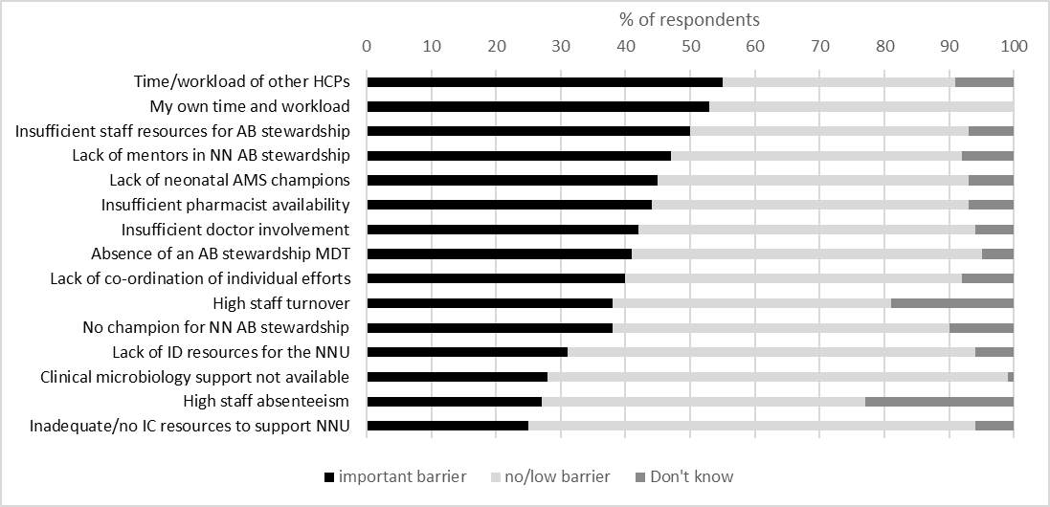
- Data resources
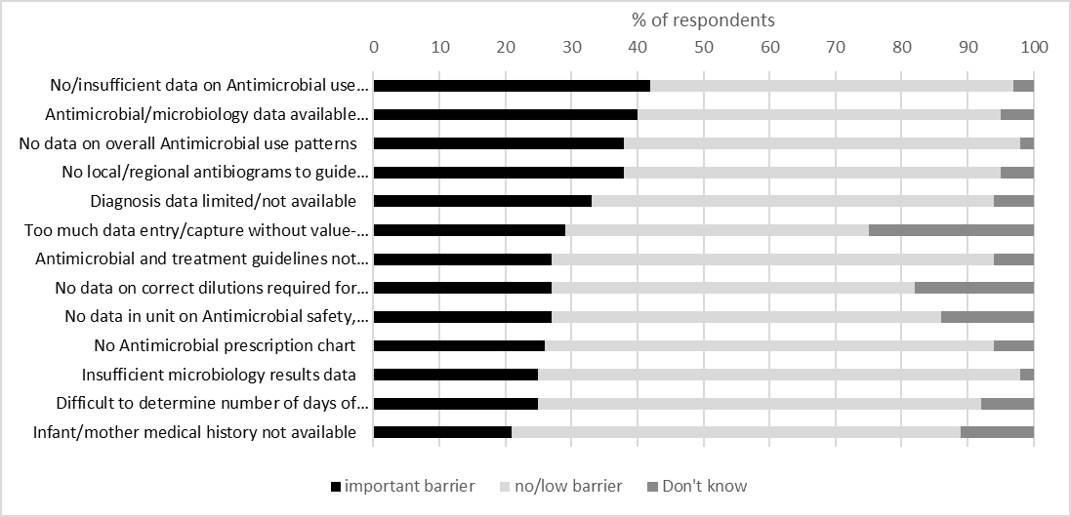

- Neonatal culture
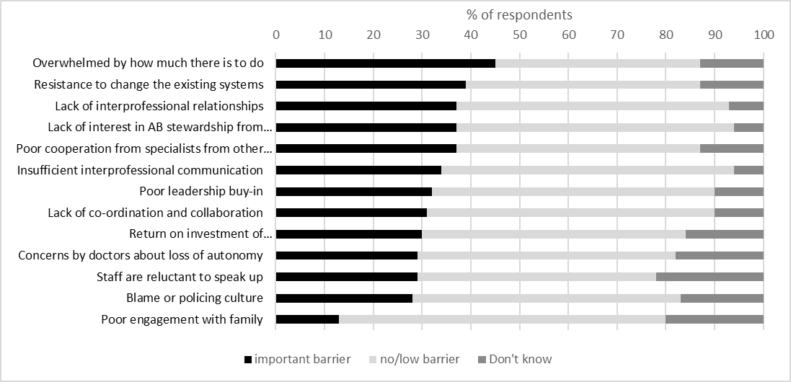
- Knowledge and competence
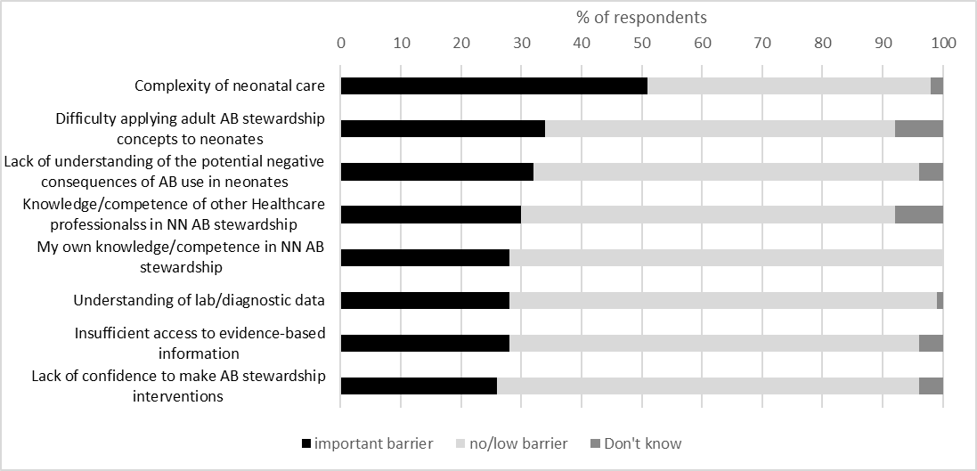
- Information technology
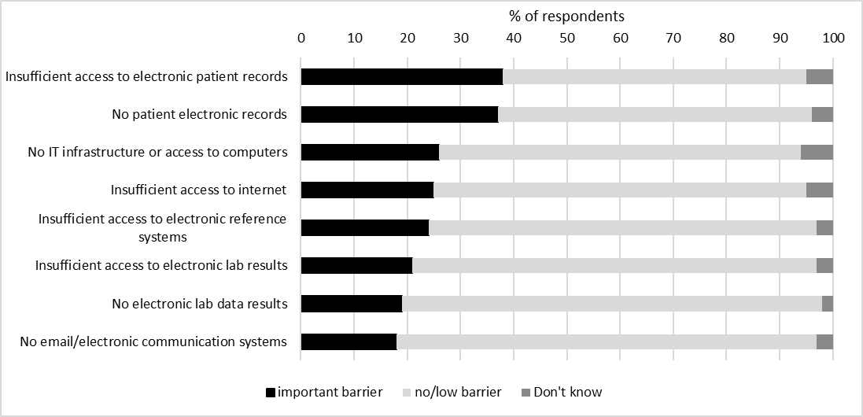
- System barriers
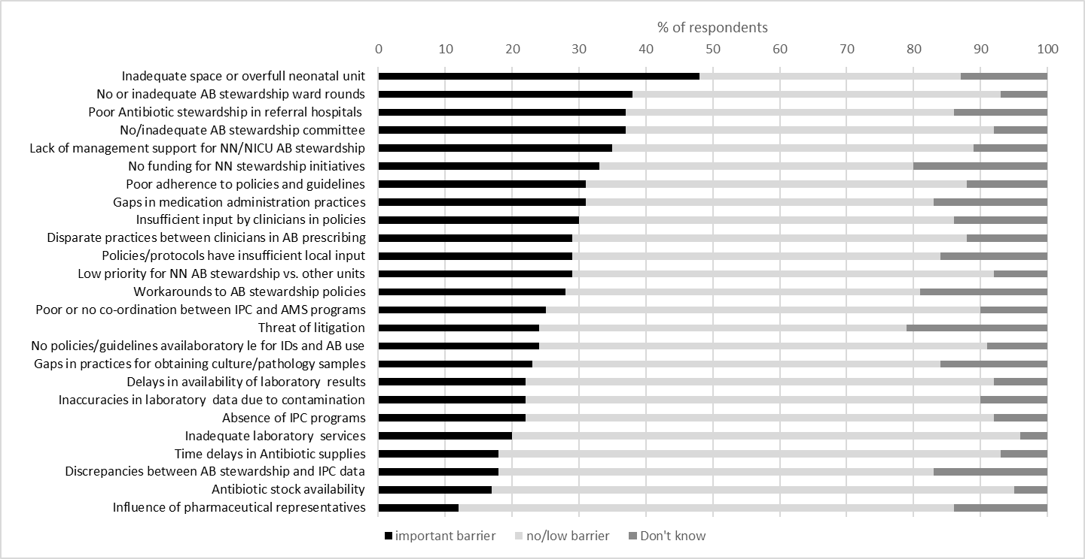
Abbreviations
AB = antibiotics; AMS = Antimicrobial stewardship: ID+ Infectious disease; IPC = Infection prevention and control; HCP = Healthcare professional; IT = Information technology; MDT = Multidisciplinary team; NN = neonatal, NNU = Neonatal unit.

Supplementary Table 2. Phase 2 Standardised questions during implementation of NeoAMS across 14 public and private hospitals in South Africa.

System changes implemented
- State any systems changes you may have implemented as a team to advance neonatal AMS in your hospital.
Benefits and challenges of working as a multidisciplinary team
- What are the benefits of working as a multidisciplinary team?
- What are the challenges of working as a multidisciplinary team?
Gains and obstacles overcome
- What were the gains in NeoAMS achieved?
- What are some of the obstacles you have experienced?
- What improvements have you seen in working as a team?
- What benefits and learning did you experience from being part of the larger collaborative?
Opportunities to improve
- What opportunities to improve neonatal AMS do you still see in your hospital
- Pharmacists
- Nurses
- Clinical Microbiologists
- Doctors
- Team as a whole
Changes in MDT roles in neonatal AMS
- How has this study helped you expand/adjust your role in neonatal AMS in your hospital?
- Pharmacists
- Nurses
- Clinical Microbiologists
- Doctors
Future prospects
- What plans do you have to sustain the progress and take neonatal AMS forward?

Supplementary Table 3. Phase 1. Demographics of participants for barriers and enablers survey for NeoAMS across 14 public and private hospitals in South Africa.
 |  |  |  | Hospital sector
Characteristic | Category | Overall |  | Public |  | Private
 |  | n | % | n | % | n | %
Number of responses |  | 100 |  | 48 |  | 52
Average number of responses per hospital |  | 7.1 |  | 6.9 |  | 7.4
NNU size | <30 beds | 62 | 62 | 10 | 21 | 52 | 100
NNU size | 30+ beds | 38 | 38 | 38 | 79
Profession | Pharmacist | 29 | 29 | 11 | 24 | 18 | 35
Profession | Nurse | 28 | 28 | 9 | 20 | 19 | 37
Profession | Clinician | 27 | 27 | 18 | 40 | 9 | 18
Profession | Microbiologist | 12 | 12 | 7 | 16 | 5 | 10
Profession | Other | 4 | 4 | 3 |  | 1
Gender | Female | 86 | 89 | 44 | 94 | 42 | 84
Gender | Male | 11 | 11 | 3 | 6 | 8 | 16
Gender | Unknown | 3 |  | 1 |  | 2
Age group | 20-30 years | 9 | 9 | 2 | 4 | 7 | 13
Age group | 31-40 years | 41 | 41 | 21 | 44 | 20 | 38
Age group | 41-50 years | 23 | 23 | 11 | 23 | 12 | 23
Age group | >50 years | 27 | 27 | 14 | 29 | 13 | 25
Are you currently involved in any AMS activities in the neonatal unit? | No | 37 | 37 | 15 | 31 | 22 | 42
 | Yes | 63 | 63 | 33 | 69 | 30 | 58
Are you currently involved in an AMS programme in the hospital in general? | No | 36 | 36 | 17 | 35 | 19 | 37
 | Yes | 64 | 64 | 31 | 65 | 33 | 63
What is the length of time that you have worked in the hospital? | less than 1 year | 9 | 9 | 5 | 10 | 4 | 8
 | 1 to 3 years | 17 | 17 | 3 | 6 | 14 | 27
 | more than 3 years | 74 | 74 | 40 | 83 | 34 | 65
What is the length of time that you have worked in the neonatal unit? | less than 1 year | 31 | 31 | 11 | 23 | 20 | 38
 | 1 to 3 years | 10 | 10 | 6 | 13 | 4 | 8
 | more than 3 years | 59 | 59 | 31 | 65 | 28 | 54

Supplementary Table 4
Consolidated criteria for reporting qualitative studies (COREQ): 32-item checklist

Accounting for the contextual drivers in a multi-centre neonatal antimicrobial stewardship programme – a qualitative study across 14 public and private hospitals in South Africa
No. Item | Guide questions |  | Description
Domain 1: Research team and reﬂexivity
Personal Characteristics
1. Interviewer/facilitator | Which author/s conducted the interview or focus group? |  | Learning and feedback sessions were facilitated and exit interviews were conducted by Dr Dena van den Bergh who is one of the co-investigators and the study project manager. Dr Esmita Charani provided ongoing mentorship for the qualitative methods.  Four pharmacists that were members of the study faculty assisted with the coding of the exit interviews (Ama Anor, Michelle Gijzelaar, Angeliki Messina and Andriette van Jaarsveld)
2. Credentials | What were the researcher’s credentials? E.g. PhD, MD |  | Dr van den Bergh - EngD, MSc(Med), BPharm  Dr Charani – PhD, MSc, MPharm  Ama Anor – MPharm, BPharm  Michelle Gijzelaar – MPharm, BPharm  Angeliki Messina- MPharm, BPharm  Andriette van Jaarsveld- MPharm, BPharm
3. Occupation | What was their occupation at the time of the study? |  | Honorary Research Associate at the University of Cape Town, Department of Medicine, Division of Infectious Diseases and HIV. Independent health systems change leader and consultant.
4. Gender | Was the researcher male or female? |  | Female
5. Experience and training | What experience or training did the researcher have? |  | The interviewer has trained as an advance facilitator in generative change leadership. She also used qualitative research during her doctoral studies and completed training on interview methods at the University of Witwatersrand school of Public Health conducted by an experienced qualitative researcher and medical anthropologist Prof Lenore Manderson. In addition, Dr Esmita Charani who is also a co-researcher for the study and has extensive qualitative research experience in antimicrobial stewardship, provided ongoing support and mentorship for the qualitative components of the study. Dr van den Bergh and Dr Charani prepared the framework for the semi-structured interviews together following the feedback collated from the implementation phase of the study.
Relationship with participants
6. Relationship established | Was a relationship established prior to study commencement? |  | The interviewer had facilitated previous collaborative studies with some of the participants.
7. Participant knowledge of the interviewer | What did the participants know about the researcher? e.g. personal goals, reasons for doing the research |  | Respondent was fully aware of the aims and objectives of the study, how the interview would be conducted, and how the data obtained during the interview would subsequently be used.
8. Interviewer characteristics | What characteristics were reported about the inter viewer/facilitator? e.g. Bias, assumptions, reasons and interests in the research topic |  | Personal interest in the research
Domain 2: study design
Theoretical framework
9. Methodological orientation and Theory | What methodological orientation was stated to underpin the study? e.g. grounded theory, discourse analysis, ethnography, phenomenology, content analysis | Thematic content analysis of qualitative data.
Participant selection
10. Sampling | How were participants selected? e.g. purposive, convenience, consecutive, snowball | The study participants were recruited by an open “call to participate” disseminated by the study faculty to their wide professional network. Each participating hospital ensured that representatives of the multidisciplinary team (MDT) including pharmacist, neonatologist/paediatrician, clinical microbiologist and neonatal nurses were invited into the study team. All participants were invited to attend the group exit interviews and could select one of two sessions offered at different times and on different days.
11. Method of approach | How were participants approached? e.g. face-to-face, telephone, mail, email | Study participants were approached by faculty via email and/or telephonically. Feedback provided during learning and feedback sessions (LFS) was collated by the pharmacists and presented by one of the MDT members. The project manager invited participate to join in the group exit interviews during the last online zoom session LFS7. This was followed up with emails sent by the project manager to all participants together with a link to the recording and a copy of the slides used in the session.
12. Sample size | How many participants were in the study? | A total of 76 MDT members participated in the study (26 pharmacists, 14 nurses, 22 neonatologist/paediatricians and 14 clinical microbiologists). Group exit interviews were attended by 16 pharmacists, 4 nurses, 3 neonatologists/paediatricians and 9 clinical microbiologists).
13. Non-participation | How many people refused to participate or dropped out? Reasons? | None of the MDT members dropped out of the overall study. Participation in the exit interviews was voluntary.
Setting
14. Setting of data collection | Where was the data collected? e.g. home, clinic, workplace | Group exit interviews were done via zoom and transcribed verbatim by an independent transcriber.  Data was collected on standardised slides submitted by each participating hospital before presenting the content during LFS5,6 and 7.
15. Presence of non-participants | Was anyone else present besides the participants and researchers? | No
16. Description of sample | What are the important characteristics of the sample? e.g. demographic data, date | Participants were from neonatal units at seven public and seven private hospitals in six of nine provinces in South Africa and ranging from large academic institutions to small community hospitals. MDT members included 27 pharmacists, 18 nurses, 28 neonatologist/paediatricians and 16 clinical microbiologists).
Data collection
17. Interview guide | Were questions, prompts, guides provided by the authors?  Was it pilot tested? | The interviewer used the interview-guide for all ten group sessions. The interviews were conducted as a semi-structured interview. All participants in each group were posed the questions in the interview-guide however the order of the questions were varied, and spontaneous follow-up questions were asked (probing – not being written in the interview guides) to get as detailed descriptions as possible from the interviewees.  No pilot focus group interviews were done prior to the research.
18. Repeat interviews | Were repeat interviews carried out? If yes, how many? | There were no repeat interviews for individual participants. A total of ten group interviews were held two with each of the different professional groups and two separate sessions with MDT members together (1 private and 1 public hospital).
19. Audio/visual recording | Did the research use audio or visual recording to collect the data? | The zoom audio recording was used for data collection.
20. Field notes | Were ﬁeld notes made during and/or after the interview or focus group? | No additional field notes were made.  All interviews were transcribed verbatim by an independent transcriber.
21. Duration | What was the duration of the interviews or focus group? | Variable. From 45 to 100 minutes.
22. Data saturation | Was data saturation discussed? | Yes- data saturation was discussed as part of the analysis between the project manager and Dr Charani. Data saturation was not discussed with study participants.
23. Transcripts returned | Were transcripts returned to participants for comment and/or correction? | No. The consistency of the transcription of the audio recording of the interview was checked by the project manager of the study.
Domain 3: analysis and ﬁndings
Data analysis
24. Number of data coders | How many data coders coded the data? | Five
25. Description of the coding tree | Did authors provide a description of the coding tree? | Two interview transcripts were coded by four members of the study faculty first and was followed by a discussion and consensus on the coding framework facilitated by the project manager.  The framework was then used to code the remaining transcripts.
26. Derivation of themes | Were themes identiﬁed in advance or derived from the data? | The interview questions provided a framework and themes from each question was derived from the data.
27. Software | What software, if applicable, was used to manage the data? | None. Data was collated using Excel spreadsheets.
28. Participant checking | Did participants provide feedback on the ﬁndings? | No (but they have reviewed and approve the manuscript)
Reporting
29. Quotations presented | Were participant quotations presented to illustrate the themes/ﬁndings? Was each quotation identiﬁed? e.g. participant number | Yes, participant quotations were presented to illustrate themes/findings. (Table 4)  Quotations are anonymized and only identified by professional category.
30. Data and ﬁndings consistent | Was there consistency between the data presented and the ﬁndings? | Yes.
31. Clarity of major themes | Were major themes clearly presented in the ﬁndings? | Yes
32. Clarity of minor themes | Is there a description of diverse cases or discussion of minor themes? | The synopsis of findings broadly touch upon the minor themes that emerged.

Supplementary Table 5:
NEONATAL ANTIMICROBIAL STEWARDSHIP (NeoAMS) STUDY TEAM MEMBERS
(Listed alphabetically by hospital and then by surname)

CHRIS HANI BARAGWANATH ACADEMIC HOSPITAL
Azraa Cassim | Pharmacy Department, Chris Hani Baragwanath Academic Hospital, Soweto, Johannesburg, South Africa
Firdose Nakwa | Neonatology Unit, Chris Hani Baragwanath Academic Hospital, Soweto, Johannesburg, South Africa
Reenu Thomas | Neonatology Unit, Chris Hani Baragwanath Academic Hospital, Soweto, Johannesburg, South Africa
Alison Van Kwawegen | Neonatology Unit, Chris Hani Baragwanath Academic Hospital, Soweto, Johannesburg, South Africa
Jeannette Wadula | Department of Clinical Microbiology, Chris Hani Baragwanath Academic hospital, Soweto, Johannesburg, South Africa
DR GEORGE MUKHARI ACADEMIC HOSPITAL
Ama Sakoa Annor | Pharmacy Department, Dr George Mukhari Academic Hospital, Pretoria, South Africa
Dini Mawela | Department of Paediatrics and Child Health, School of Medicine, Sefako Makgatho Health Sciences University, Gauteng, South Africa
Masego Moncho | Department of Medical Microbiology-National Health Laboratory Services, Sefako Makgatho Health Sciences University, Gauteng, South Africa
Martha Tshipo Motau | Department of Nursing, Dr George Mukhari Academic Hospital, Pretoria, South Africa
Maphoshane Nchabeleng | Department of Medical Microbiology-National Health Laboratory Services, Sefako Makgatho Health Sciences University, Gauteng, South Africa
GEORGE PROVINCIAL HOSPITAL
Sharnel Brits | Pharmacy Department, George Provincial Hospital, George, South Africa
Willem Breytenbach | Department of Paediatrics, George Provincial Hospital, George, South Africa
Ilse Els-Goussard | Neonatology Unit, George Provincial Hospital, George, South Africa
Erika Grotepass | Pharmacy Department, George Provincial Hospital, George, South Africa
Alida Portland | Nursing Department, George Provincial Hospital, George, South Africa
Hafsah Tootla | National Health Laboratory Services and Division of Medical Microbiology, University of Cape Town, Cape Town, South Africa
GROOTE SCHUUR HOSPITAL
Ayesha Arendse | Pharmacy Department, Groote Schuur Hospital, Cape Town, South Africa
Christine Fisher | Nursing Department, Groote Schuur Hospital, University of Cape Town, Cape Town, South Africa
Amanda Khumalo | National Health Laboratory Services, Groote Schuur Hospital, Cape Town, South Africa
Simthembile Mjekula | Pharmacy Department, Groote Schuur Hospital, Cape Town, South Africa
Shakti Pillay | Division of Neonatology, Department of Paediatrics and Child Health, Groote Schuur Hospital, University of Cape Town, Cape Town, South Africa
Abdul Qayyum Kader | Pharmacy Department, Groote Schuur Hospital, Cape Town, South Africa
LENMED ETHEKWINI HOSPITAL AND HEART CENTRE
Chetna Govind | Lancet Clinical Microbiologist, Lenmed Ethekwini Hospital & Heart Centre, South Africa
Vinesh Moodley | Neonatology Unit, Lenmed Ethekwini Hospital & Heart Centre, South Africa
Thanusha Naidoo | Pharmacy Department, Lenmed Ethekwini Hospital & Heart Centre, South Africa
Lerina Rungen | Pharmacy Department, Lenmed Ethekwini Hospital & Heart Centre, South Africa
LENMED ROYAL HOSPITAL & HEART CENTRE
Pearl Alexander | Nursing Department, Lenmed Royal Hospital & Heart Centre, Kimberley, South Africa
John Berlyn | Neonatology Unit, Lenmed Royal Hospital & Heart Centre, Kimberley, South Africa
Owen Dreyer | Neonatology Unit, Lenmed Royal Hospital & Heart Centre, Kimberley, South Africa
Arisna Maharaj | Department of Pharmacy, Lenmed Royal Hospital & Heart Centre, Kimberley, South Africa
Dawie Peens | Neonatology Unit, Lenmed Royal Hospital & Heart Centre, Kimberley, South Africa
Madeleine Pieters | Lancet Clinical Microbiology, Lenmed Royal Hospital & Heart Centre, Kimberley, South Africa
Emma van Schalkwyk | Department of Pharmacy, Lenmed Royal Hospital & Heart Centre, Kimberley, South Africa
Marlon Starr | Neonatology Unit, Lenmed Royal Hospital & Heart Centre, Kimberley, South Africa
LIFE BEACON BAY HOSPITAL
Colleen Bamford | Pathcare, East London, South Africa
Teresa Kriel | Pharmacy Department, Life Beacon Bay, East London, South Africa
Mariska van der Wal | Department of Clinical Pharmacy, Life Healthcare, South Africa
Veliswa Mgudlwa | Nursing Department, Life Beacon Bay, East London, South Africa
LIFE SPRINGS PARKLAND HOSPITAL
Colette Beukes | Department of Clinical Pharmacy, Life Healthcare, Johannesburg, South Africa
James Macdonald | Lancet Clinical Microbiology, Life Springs Parkland Hospital, Johannesburg, South Africa
Ronald Nhari | Pharmacy Department, Life Springs Parkland Hospital, Johannesburg, South Africa
Tanya Ndou | Neonatology Unit, Life Springs Parkland Hospital, Johannesburg, South Africa
Gladys Rapoone | Department of Nursing, Life Springs Parkland Hospital, Johannesburg, South Africa
Antia Taljaard | Pharmacy Department, Life Springs Parkland Hospital, Johannesburg, South Africa
MOWBRAY MATERNITY HOSPITAL
Marina Aucamp | IPC Department, Mowbray Maternity Hospital, Cape Town, South Africa
Lucinda Conradie | Pharmacy Department, Mowbray Maternity Hospital, Cape Town, South Africa
Hafsah Tootla | National Health Laboratory Services and Division of Medical Microbiology, University of Cape Town, Cape Town, South Africa
Anika van Niekerk | Division of Neonatology, Department of Paediatrics and Child Health, Mowbray Maternity Hospital, University of Cape Town, Cape Town, South Africa
NELSON MANDELA CHILDREN’S HOSPITAL
Vindana Chibabhai | Department of Clinical Microbiology and Infectious Diseases, School of Pathology, University of Witwatersrand, Johannesburg, Gauteng, South Africa  National Health Laboratory Service, Charlotte Maxeke Johannesburg Academic Hospital, Johannesburg, Gauteng, South Africa
Pinky Chirwa | Neonatal Unit, Nelson Mandela Children’s Hospital, Johannesburg, South Africa
Sonya Kolman | Pharmacy Department, Nelson Mandela Children’s Hospital, Johannesburg, South Africa
Selebaleng Nchwee | Department of Nursing, Nelson Mandela Children’s Hospital, Johannesburg, South Africa
MEDICLINIC WELKOM
Dina Bruwer | Neonatology Unit, Mediclinic Welkom, Welkom, South Africa
Magdel Dippenaar | Pharmacy Department, Mediclinic Welkom, South Africa
Hannelie Erasmus | Pharmacy Department, Mediclinic Welkom, Welkom, South Africa
Madaleen Olivier | Pathcare Clinical Pathologist, Mediclinic Welkom, Welkom, South Africa
Lea van der Westhuizen | Department of Nursing, Mediclinic Welkom, Welkom, South Africa
NETCARE UNITAS HOSPITAL
Juanita Coetzee | Department of Nursing, Netcare Unitas Hospital, Pretoria, South Africa
Pieter Ekermans | Ampath Laboratory, National Reference Laboratory, Department of Medical Microbiology, Pretoria, South Africa
Marleen Engelbrecht | Neonatology Unit, Netcare Unitas Hospital, Pretoria, South Africa
Marli Janse van Rensburg | Department of Pharmacy, Netcare Unitas Hospital, Pretoria, South Africa
Lindie van Tonder | Department of Pharmacy, Netcare Unitas Hospital, Pretoria, South Africa
Tarina Bester | Netcare Clinical Pharmacy, GNE Region, Pretoria, South Africa
NETCARE PRETORIA EAST HOSPITAL
Zanli van Blerk | Department of Pharmacy, Netcare Pretoria East Hospital, Pretoria, South Africa
Anje Laubscher | Department of Pharmacy, Netcare Pretoria East Hospital, Pretoria, South Africa
Johnny Lotter | Neonatology Unit, Netcare Pretoria East Hospital, Pretoria, South Africa
Liesl Venter | Neonatology Unit, Netcare Pretoria East Hospital, Pretoria, South Africa
Heinrich du Toit | Neonatology Unit, Netcare Pretoria East Hospital, Pretoria, South Africa
Jennifer Coetzee | Ampath Laboratory, National Reference Laboratory, Department of Medical Microbiology, Pretoria, South Africa
TYGERBERG HOSPITAL
Deleen Bartman | Nursing Department, Tygerberg Hospital, Cape Town, South Africa
Adrie Bekker | Department of Paediatrics and Child Health, Faculty of Medicine and Health Sciences, Stellenbosch University, Cape Town, South Africa
Sandi Holgate | Department of Paediatrics and Child Health, Faculty of Medicine and Health Sciences, Stellenbosch University, Cape Town, South Africa
Kessendri Reddy | National Health Laboratory Service Tygerberg and Stellenbosch University, Cape Town, South Africa
Sinethemba Hloyi | Pharmacy Department, Tygerberg Hospital, Cape Town, South Africa
Trudie Isobel | Nursing Department, Tygerberg Hospital, Cape Town, South Africa
Leticia Radloff | Nursing Department, Tygerberg Hospital, Cape Town, South Africa

