The impact of telomere length on prostate cancer aggressiveness, genomic instability and health disparities

Ruotian Huang, M.S. Riana Bornman, Phillip D. Stricker, Ilma Simoni Brum, Shingai B.A. Mutambirwa, Weerachai Jaratlerdsiri and Vanessa M. Hayes

SUPPLEMENTARY INFORMATION

Supplementary Tables

Table S1. Geo-ancestral and clinicopathological features of study cohort.

Features |  | Prostate cancer patients
Ancestral origin |  | African | European
Cohort number |  | 117 | 62
Geographical origin | Australia | 0 | 53
Geographical origin | Brazil | 1 | 4
Geographical origin | South Africa | 116 | 5
Mean age ± standard deviation  (range) |  | 67.060 ± 8.329  (45 – 99)¹ | 62.241 ± 6.321  (46 – 78)
PSA (ng/mL)² | 0 – 9.99 | 11 | 40
PSA (ng/mL)² | 10 – 19.99 | 12 | 17
PSA (ng/mL)² | 20 – 500 | 73 | 5
PSA (ng/mL)² | > 500 | 14 | 0
ISUP grading³ | High (3 – 5) | 83 | 54
ISUP grading³ | Low (1 – 2) | 30 | 7
ISUP grading³ | No (0) | 2 | 1
¹One South African patient of African ancestry was not recorded age.
²Seven South African patients of African ancestry were not recorded PSA level.
³Two South African patients of African ancestry were not recorded ISUP grading.

Table S2. Details of optimal TL cut-offs in European BCR and metastasis cohorts.

Clinical Outcomes |  | Short BTL | Long BTL | Short TTL | Long TTL
BCR | Mean ± standard deviation | 2828.298 ±  218.285 bp | 3758.199 ±  443.127 bp | 2421.961 ±  261.572 bp | 3566.665 ±  649.352 bp
BCR | Range | 2384.698 –  3192.148 bp | 3276.430 –  4979.750 bp | 1816.568 –  2848.052 bp | 2874.085 –  5153.815 bp
BCR | Cohort Number | 36 | 17 | 18 | 35
Metastasis | Mean ± standard deviation | 2841.508 ±  207.177 bp | 3756.625 ±  338.587 bp | 2640.870 ±  384.443 bp | 4021.605 ±  627.265 bp
Metastasis | Range | 2447.072 –  3192.148 bp | 3288.910 –  4403.118 bp | 1816.568 –  3311.560 bp | 3327.870 –  5153.815 bp
Metastasis | Cohort Number | 28 | 11 | 25 | 14
BCR (validation) | Mean ± standard deviation | 3370.282 ±  389.559 bp | 5033.766 ±  1348.707 bp | 1740.030 ±  272.442 bp | 3490.110 ±  781.914 bp
BCR (validation) | Range | 2097.895 –  3870.685bp | 3914.157 –  14989.210 bp | 1032.885 –  1982.288 bp | 2021.933 –  6452.088 bp
BCR (validation) | Cohort Number | 67 | 223 | 11 | 279
Note – BCR and Metastasis included the European cohort from this study, BCR (validation) using the European validation cohort.

Table S3. Associations between sequencing impacts and TL.
Sequencing impacts | BTL | TTL
Sequencing coverage (SC) | 0.188 | 0.687
Tumour purity (TP) | - | 0.714
Ploidy (P) | - | 0.144
SC + TP + P | - | 0.883 + 0.746 + 0.146
Note – P-values calculated by one-way ANOVA of BTL and TTL with three sequencing and tumour quality assessments, sequencing coverage, tumour purity, and ploidy with age adjustment.

Table S4: Associations between 13 genomic impacts and 35 driver genes, with age adjustment, and tumour TL and ratio using P-values by ancestry.
Genomic impacts | African (n = 117) |  | European (n = 62)
Genomic impacts | TTL | TL ratio | TTL | TL ratio
PGA | 1.716e-03 | 1.660e-03 | 1.184e-04 | 8.820e-05
TMB | 0.031 | 4.885e-02 | 0.568 | 0.156
Somatic SNV | 0.028 | 4.945e-02 | 0.560 | 0.220
Somatic indel | 0.037 | 4.988e-02 | 0.473 | 0.020
Somatic SV | 0.370 | 0.242 | 0.307 | 0.665
Gain | 1.369e-03 | 2.645e-03 | 7.167e-03 | 1.769e-03
Loss | 8.517e-03 | 4.464e-03 | 3.959e-05 | 1.041e-04
GMS | 1.090e-07 | 3.480e-10 | 6.520e-08 | 4.310e-10
Clonality | 0.495 | 0.338 | 0.219 | 0.136
SBS | 0.208 | 0.387 | 0.870 | 0.812
DBS | 0.011 | 0.048 | 0.287 | 0.644
ID | 0.020 | 0.153 | 0.950 | 0.358
SV | 3.275e-03 | 7.644e-03 | 0.418 | 0.472
TMPRSS2 | 0.182 | 0.297 | 0.419 | 0.561
ERF | 0.205 | 0.224 | NA | NA
RB1 | 0.681 | 0.675 | 0.0402 | 0.077
PTEN | 0.043 | 0.101 | 2.589e-03 | 0.029
FAT1 | 0.440 | 0.379 | 0.470 | 0.298
THADA | 0.137 | 0.171 | 0.274 | 0.444
LSAMP | 0.914 | 0.452 | 0.976 | 0.635
FOXA1 | 0.041 | 2.706e-03 | 0.259 | 0.135
TP53 | 0.016 | 0.030 | 3.186e-03 | 0.021
KMT2C | 0.011 | 0.055 | 0.353 | 0.833
SPOP | 0.080 | 0.063 | 0.019 | 0.020
MSH2 | 0.959 | 0.862 | 3.276e-04 | 2.673e-04
BRAF | 0.111 | 0.157 | 0.159 | 0.507
MYC | 0.548 | 0.884 | 0.378 | 0.518
ZMYM3 | 0.110 | 0.314 | 0.211 | 0.556
SETBP1 | 9.236e-04 | 4.462e-03 | 2.570e-08 | 1.050e-09
ZFHX3 | 0.279 | 0.731 | 0.822 | 0.846
CDK12 | 0.265 | 0.247 | 0.344 | 0.143
DDX11L1 | 0.019 | 0.014 | 1.700e-06 | 3.350e-05
STK19 | 0.760 | 0.259 | 0.131 | 8.069e-03
NCOA2 | 0.336 | 0.258 | 0.365 | 0.170
PCAT1 | 0.560 | 0.265 | 0.662 | 0.708
MSH6 | NA | NA | 0.994 | 0.912
PAPSS2 | NA | NA | 0.120 | 0.879
MTCH2 | 0.866 | 0.619 | 0.950 | 0.664
ATR | 0.557 | 0.841 | NA | NA
BRCA1 | 0.068 | 0.081 | NA | NA
POLE | 0.243 | 0.379 | NA | NA
TP53BP1 | 0.777 | 0.884 | NA | NA
ATM | 0.012 | 5.044e-02 | NA | NA
BRCA2 | 0.029 | 0.055 | NA | NA
ERCC5 | 0.313 | 0.482 | NA | NA
ERF | 0.205 | 0.224 | NA | NA
PIK3CA | 0.027 | 0.067 | NA | NA
APC | 0.240 | 0.040 | NA | NA
Note – P-values calculated by one-way ANOVA. NA: data not available.
Table S5: Associations between four genomic impacts, with age adjustment, and tumour TL and ratio using P-values from the 321 European validation cohort.
Genomic impacts | European Validation (n = 321)
Genomic impacts | TTL | TL ratio
PGA | 5.393e-04 | 0.041
Somatic SNV | 1.077e-05 | 0.018
Somatic Indels | 6.232e-05 | 4.315e-03
Somatic GRs | 0.669 | 1.843e-05
Note – P-values calculated by one-way ANOVA.

Supplementary Figures

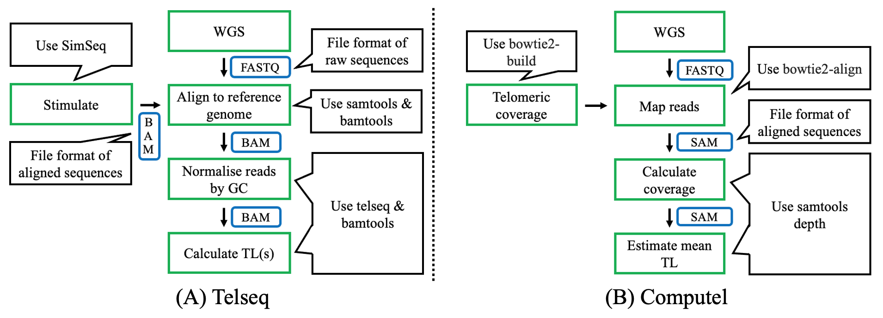

Figure S1: Schematic workflow of Telseq (A) and Computel (B).

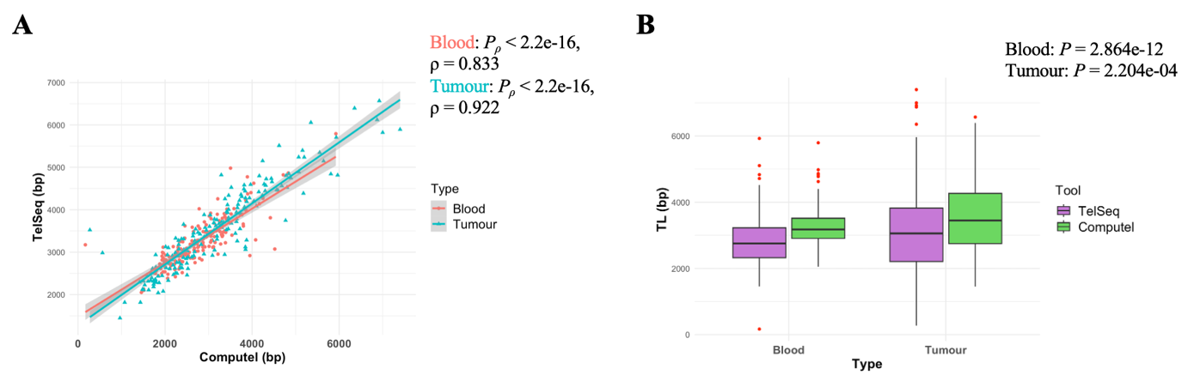
Figure S2: P-values are from Spearman’s correlation of 179 BTL and TTL estimates by TelSeq and Computel (A). Performance comparisons between TelSeq and Computel for the BTL and TTL (B), P-values from Mann-Whitney U Test. Red dots are outliers.

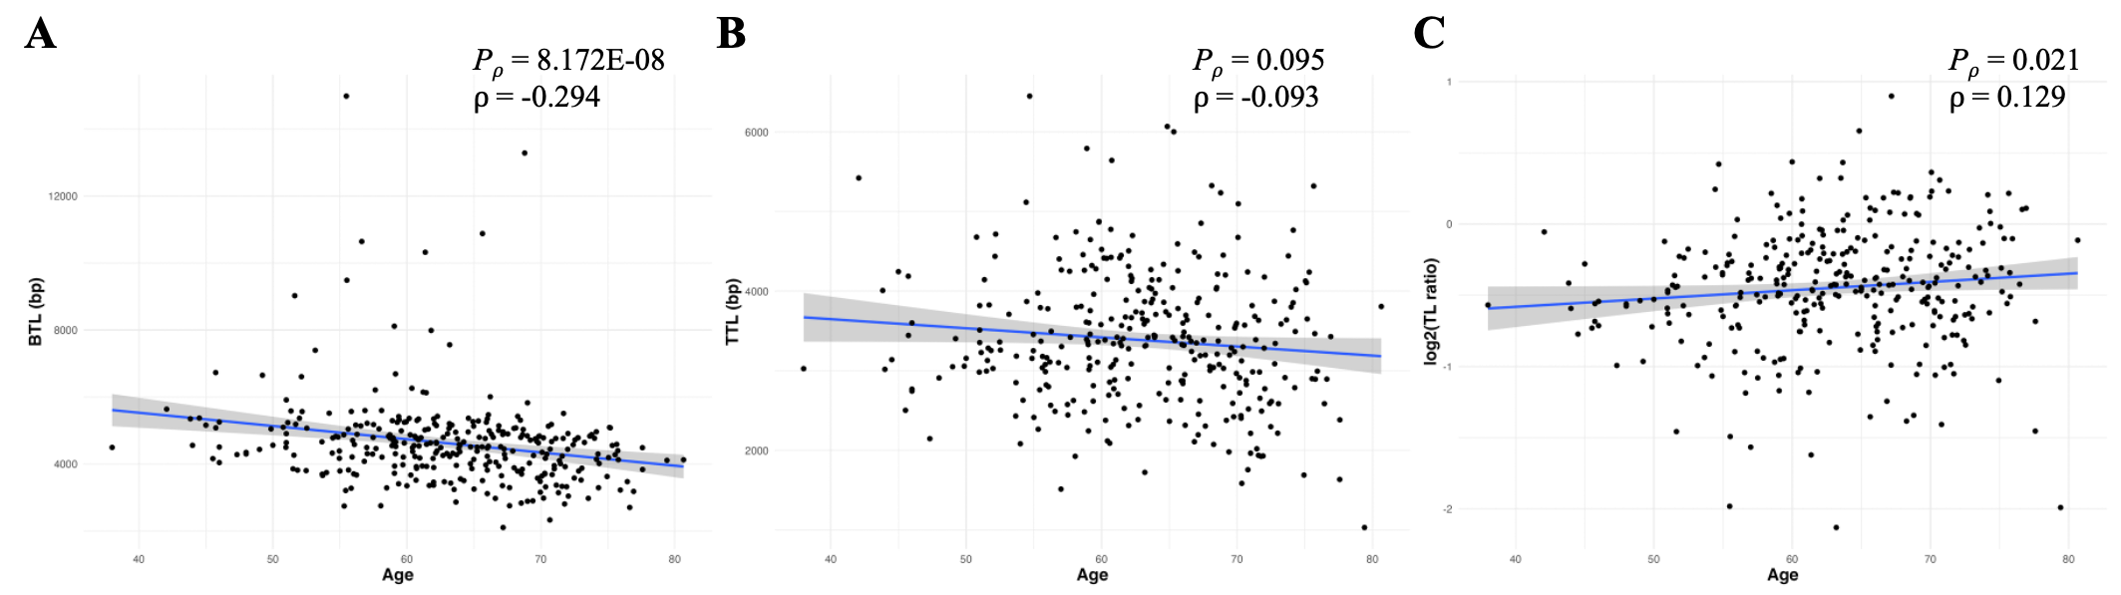
Figure S3: Correlations of BTL (A), TTL (B), and TL ratio (C) with age for 321 patients from the European validation cohort, with P-values derived from Spearman’s correlation.

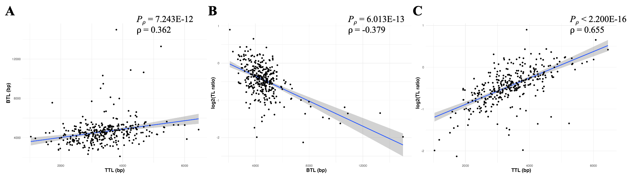
Figure S4: Spearman’s correlations of BTL and TTL estimates (A), TL ratios in log₂ transformation and BTL (B), and TL ratios in log₂ transformation and TTL (C) for 341 patients from the European validation cohort.

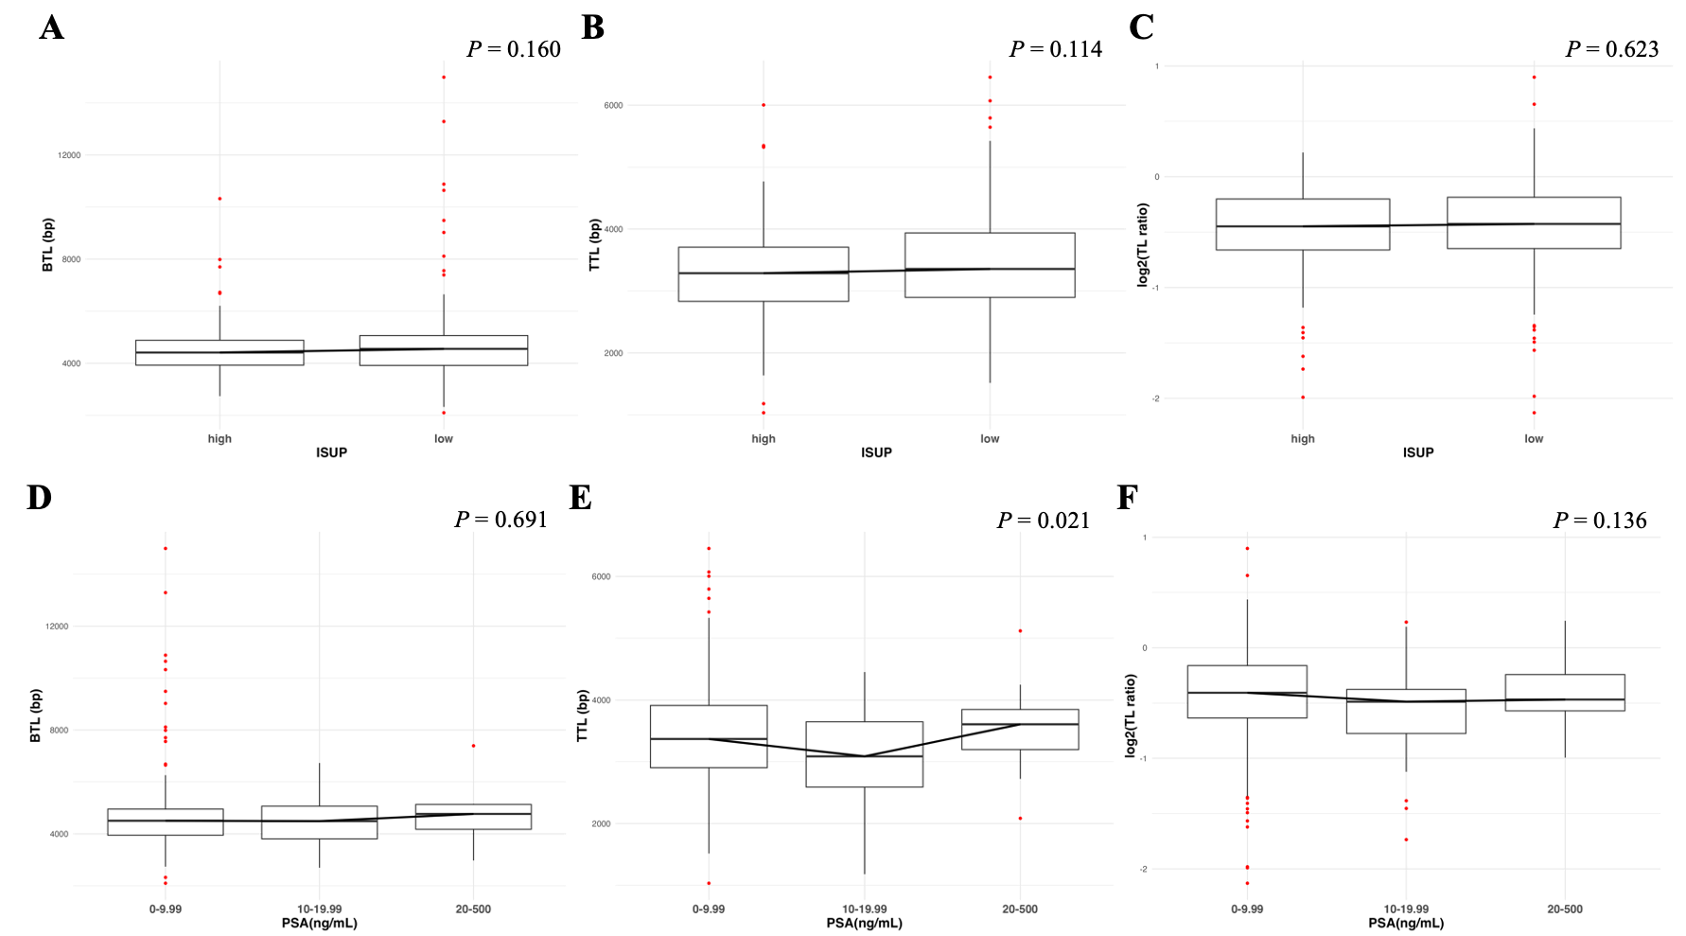

Figure S5: Correlations of BTL (A), TTL (B) and TL ratios (C) between low (1-2) and high (3-5) ISUP Grading Groups in 341 patients from the European validation cohort. P-values are from one-way ANOVA with age adjustment. Correlations of BTL (D), TTL (E) and TL ratios (F) with the following PSA levels (ng/mL): 0-9.99, 10-19.99 and 20-500 in 336 patients. P-values from one-way ANOVA with age adjustment.

